

**DEDAN KIMATHI UNIVERSITY OF TECHNOLOGY**

**SCHOOL OF COMPUTER SCIENCE AND INFORMATION TECHNOLOGY**

**DEPARTMENT OF INFORMATION TECHNOLOGY**

**PROJECT DOCUMENTATION**

**BACHELOR OF SCIENCE IN INFORMATION TECHNOLOGY**

**CASHFLOW TRACKER AND MONEY MANAGEMENT TOOL**

**KINYANJUI FRED NGURO**

**SUPERVISOR:**

**MR. MUCHIRI NJOKI**

**A Project Documentation submitted to the Department of Information Technology in the School of Computer Science and Information Technology in partial fulfillment of the requirements for the award of the degree of Bachelor of Science in Information Technology at Dedan Kimathi University of Technology.**

**APRIL 2024.**

# DECLARATION

I hereby declare that this proposal is my original work excluding the citations and quotations which I have correctly acknowledged. I also declare that this proposal has not been earlier submitted for the fulfilment of any degree at any institution or by anyone.

NAME: FRED NGURO KINYANJUI

SIGNATURE: DATE: ......................

REGISTRATION NUMBER: C025-01-2443/2020

This proposal has been submitted for examination with my approval as University Supervisor

NAME: …………………………………………

SIGNATURE: DATE:

# ABSTRACT

Financial stress among the university students occurs when students exhaust all their income including their savings. At times, this could happen as a result of the following expenses, money needed for everyday costs like rent, food, transportation, bundles and airtime or the student could be fulfilling a financial goal for example, after saving for a long time to buy a laptop or paying for their tuition fees. The situation worsens when they lack any sources of income such as part-time jobs or financial aids to help cover these costs. Despite being happy after accomplishing their financial goals, living expenses would always be there to deal with daily therefore, a plan to manage their money from when they received it to the moment it gets out of their pocket is necessary.

The finance bill has put more money into education however gaps are still there since there has been an increase in tuition fees. This affects students in that an increase in tuition fees means that to some of the students it will be costly affording higher education.

It is for the above reasons that I purpose to create an application that will allow students to key in their income data. The proposed system will also record the daily expenses of the students hence making them be conscious of their spending patterns and helping them to make informed decisions to stay within their budget, enabling the system to forecast their expense too. It will encourage students to save by giving them insights on how to manage their income. In the long run, students will get equipped with lifelong financial management skills hence reducing the financial stress and enhancing financial literacy which will also improve academic performance.

For the implement this project, agile methodology was appropriate. This is because of its interactive and iterative nature. Development will be based on stages making agile the best methodology to use.

**Nguhoro**

Kurathi kwe ndiritu mūhiko wa faganjo wa maheni mīratho mūno tō mwiga maundu waku ĩrathikirie iria na mwiko wao waku maheni nī mūtigana ĩhinda ya gūcarira wao ūguo wa ĩrathikirie kūmenya kūrīa baya mūrigo wao, muthenya wa ithano kana ūngi wa ĩrathikirie nī nĩ gūkūmenya cia kūkūmenya kĩnwe mbeca ta ũrigūcio, ĩhiti cia kūmenya gūkorwo gwao kana kũmenya ta maĩtū. Thutha mūhiko wao niwe ta mūtigana maheni ma kūgūkūgūria nĩ mūhingo kana kūrĩithwo ta ũgwanja ta ndagūka, njĩra, mũnene na kaihĩkwo. Thutha ũrĩa mūhiko wao ũhingaga nĩ ta arĩa ũigūcio nĩ ta itiku mũhiko kana kũmehe ng'ethe. Kĩwugo wa faganjo nĩ ta ndigu ndĩ cia kũrĩithwo ta mbeca mĩaka itwĩ, kana kũhenĩria tigana ta nĩ uhandwo wa ndagūka. Thutha rĩa ũrĩa ũīhenaga ũkũ kĩtangira ni ta mbeca na njira ya gũhoteri mũtigania mĩceera gũterera thutha thĩingĩrwo ũkĩrĩ. Mũkĩrĩ wa maheni akenĩkaga wa kũmenya nĩ ta gũtigana ndĩ ndoica iga ta mbeca. Ũrĩa mwathani wa mbeca nĩ ta kũkora ũkĩrĩo mūrigo wa kũcera mũhiko ũnjĩkagia ta kũgūkūgūria maheni mūhiko wao na kũtumia njira cia ũrĩithwo mũrigo. Nĩ tigĩthi wa mũgwanja, mūcatharĩ wa mũrĩ wa faganjo ũhinguĩkagia ũkũmaga mũrigo mūkĩrĩ wa maheni ũndũ wa kũnĩkira ũrĩa ũkoĩna mūhiko na kũgũthimĩra ũngi wa ũkĩrĩo mūrigo wa maheni. Mũmũthi wa kũhingaga ta kwĩrĩria ũndũ wa faganjo mũrĩ ũkĩrĩo ũnjĩ na kũmenya ũgwanja wa faganjo ũrĩa ũrĩta arĩa na njira ta gũcera mbeca. Itheri kūringanwo wa mũrĩ wa faganjo, njira yake itukũrĩri ndarĩ ndare na itithemaki. Ta mbeca ndarĩ gĩtuĩ ta kũrĩũka njira na njira. Mũgwanja ũrĩa ũhingaga ũhauka wa mũrĩ wa faganjo ũta mũtuĩri na njira ta kũtigana ndĩ ikorwo.

**Nguhoro**

Itariki hii inaangazia umuhimu wa sherehe za kitamaduni na maadhimisho ya Kiafrika, huku ikilenga jukumu lao katika kuhifadhi urithi, kukuza umoja wa jamii, na kusaidia katika kuyumba kwa mtindo wa jinsia ndani ya jamii za Kiafrika. Kwa kuchunguza mifano kama vile Tamasha la Osun-Osogbo nchini Nigeria, Sherehe ya Yam ya Ashanti nchini Ghana, Mashujaa Day nchini Kenya, Heritage Day (Braai Day) nchini Afrika Kusini, na Tamasha la FemmAfrique nchini Senegal, inaonyesha jinsi matukio haya yanavyotumika kama ishara ya kipekee ya utambulisho wa kitamaduni na uthabiti. Kitovu cha sherehe za Kiafrika ni mila na desturi ngumu ambazo zinaashiria umoja wa kijamii na utakatifu wa kiroho, wakati pia zinaonyesha mabadiliko ya mtindo wa jinsia. Itariki hii inasisitiza juhudi za kuelekea ushirikiano na uwezeshaji wa kijinsia ndani ya muktadha wa tamasha, ikisisitiza umuhimu wa kutambua mchango na uwezo wa wanawake. Mwishowe, sherehe za Kiafrika zinaonekana kama majukwaa yenye nguvu ya kusherehekea tofauti, kukuza haki za kijamii, na kukuza ushirikiano mkubwa zaidi ndani ya jamii za Kiafrika.

TABLE OF CONTENTS

DECLARATION ii

ABSTRACT iii

LIST OF FIGURES vi

CHAPTER ONE: INTRODUCTION. 1

1.1 BACKGROUND INFORMATION. 1

1.1.1 Using the application 2

1.2 PROBLEM STATEMENT 2

1.3 OBJECTIVES 3

1.3.1 General objectives 3

1.3.2 Specific objectives 3

1.4 JUSTIFICATION 4

1.6 SCOPE 4

1.7 Limitations 5

CHAPTER TWO: LITERATURE REVIEW 6

2.1 INTRODUCTION 6

2.2 CURRENT STUDENT FINANCIAL SITUATION REVIEW 6

2.2.1 YOU NEED A BUDGET (YNAB) PERSONAL FINANCIAL APPLICATION REVIEW 6

2.2.2 PERSONAL CAPITAL APPLICATION REVIEW 9

2.2.3 MINT PERSONAL FINANCE APPLICATION REVIEW 10

2.3 SUMMARY 11

2.4 RESEARCH GAP 12

2.5 PROPOSED METHODOLOGY 12

CHAPTER THREE: METHODOLOGY 13

3.1 INTRODUCTION 13

3.1.1 Suitability of the Model 13

3.2 FACT FINDING TECHNIQUES 14

3.2.1 Interviews 14

3.2.2 Questionnaires 14

3.2.3 Research 14

3.3 SOFTWARE DESIGN 14

3.3.1 Stage 1: Planning 14

3.3.2 Stage 2: Requirement analysis 14

3.3.3 Stage 3: Design 14

3.3.4 Stage 4: Building 15

3.3.5 Stage 5: Testing 15

CHAPTER FOUR: SYSTEM ANALYSIS AND DESIGN 16

4.1 DATA COLLECTION AND ANALYSIS 16

4.1.1 Interview 16

4.1.2 Kaggle 16

4.2 REQUIREMENT ANALYSIS 16

4.2.1 Functional Requirements. 17

4.2.2 Non-functional Requirements 17

4.3 SYSTEM ANALYSIS 17

4.3.1 Use Case Diagram 18

4.3.2 Sequence Diagram 19

4.3.3 Flow Chart 20

4.3.4 Class Diagram 21

4.3.5 Entity Relational Diagram 22

4.3.5 Data Flow Diagram 23

CHAPTER FIVE: IMPLEMENTATION AND TESTING 24

5.1 INTRODUCTION 24

5.2 IMPLEMENTATION 24

5.1.1 Account creation 24

5.1.2 Income and Expense input. 25

5.1.3 Alert system 27

5.1.4 Generation of Income and Expense reports. 28

5.1.5 Financial recommendations. 30

5.1.6 Planning on Budget 31

5.1.7 Planning on Revenue 32

5.1.8 Adding Notes 34

5.1.9 Refinement: 35

5.1.10 Results: 35

5.1.11 Improvement: 35

CHAPTER SIX: CHALLENGES, CONCLUSIONS & RECOMMENDATIONS 36

6.1 INTRODUCTION 36

6.2 CHALLENGES 36

6.3 RECOMMENDATION 36

6.4 CONCLUSION 37

6.5 FUTURE RESEARCH 37

CHAPTER SEVEN: REFERENCES 39

# LIST OF FIGURES

Figure 1: Iterative Model (Powell-Morse, 2016) 13

Figure 2: Use case diagram. 18

Figure 3:Sequence Diagram for adding income and expenses and generating reports. 19

Figure 5: Class Diagram 21

Figure 7: Data Flow Diagram 23

Figure 8: Income and Expense dialog Figure 9: Income and Expense dashboard 25

Figure 10: Expense Input Figure 11: Income Input 26

Figure 12: Budget almost used up notification Figure 13: Exceeding budget notification 27

Figure 14: Generation of Income and Expense Reports 28

Figure 15: Income and Expense Report 29

Figure 16: Financial Recommendations 30

Figure 17: Budget Planning Figure 18: Budget planning 31

Figure 19: Planning on Revenue 32

Figure 20: Adding Revenue Figure 21: Adding Revenue 33

Figure 22: Adding note dialog Figure 23: Adding notes dashboard 34

# CHAPTER ONE: INTRODUCTION.

## 1.1 BACKGROUND INFORMATION.

Going to the university in Kenya is becoming more expensive every day because of the daily costs incurred by students while studying. This has made it difficult for many students to afford higher education and therefore delaying or hindering them from pursuing their dreams. Among the costs incurred besides the university fees includes rent, food, electricity and water bills, transport at times and coursework materials such as laptops and phones. Most Kenyan university students may find it challenging at times to focus on their studies due to the rising costs of education.

With the rising debt crisis in our country, despite the finance bill putting more money into education gaps are still there since there has been an increase in tuition fees. There has been rapid increase in tax measures. Many sectors are being imposed with taxes therefore affecting what most university students can afford to hustle. However, one of the ways of avoiding falling into unplanned debts despite all these tax measures is by carefully managing the money we have, however little it may seem. There are different ways of handling this issue. (R.N Otunga, 2023)

Technology plays an important role in our lives. With the help of technology, we can track our expenses, make budgets, save our money and make the best decisions with the money we have since every shilling matter in our pockets. This project is one of the solutions to these problems since it will help with all the above solutions. This tool will help students manage their money problems, reduce stress and do well in their studies by providing a user-friendly application where students can track their money.

### 1.1.1 Using the application

The student will be required to sign up into the application and add the necessary income and expense data.

This data will be saved for further analysis.

There will be an expense category where any expenses will be selected and this will automatically be calculated hence showing an average spending of the student.

Expenses will automatically be deducted from the income.

## 1.2 PROBLEM STATEMENT

Students come from different backgrounds therefore some may experience difficulties managing their money without knowing, while still studying because they have to pay for things like rent, food, coursework materials, electricity and water bills in their rooms and transport. The funny thing about all these costs is that they are increasing gradually while the students’ income being the same. In order to make ends meet, students at times borrow money from their friends or have to find part-time jobs which could be stressful. You may also find that some of these debts are not paid back because of their financial situations. Finding a part-time jobs and being consistent with it could be stressful because not every student can fit into the demands of the jobs despite the promising rewards.

The financial stress levels would definitely rise among some students making them to have to defer a year and save up some cash for the next year. This delays them from accomplishing their goals as planned. This project is a tool that wants to solve this problem by providing platform for everyone to monitor their money keenly and to improve the decisions made in order to reduce the financial stress faced by most students. Students will also give a positive or negative feedback based on their spending for a period of time. This will help them understand the importance of spending on the necessary things instead of spending impulsively.

## 1.3 OBJECTIVES

### 1.3.1 General objectives

The overall objective of this system will be to design, create and deploy a user-friendly application that will enable students keep a track of their current income, current expenses and future expenses. The input of data and categorization of expenses to the system will be done manually by the student. This data will then be stored to a database for further query.

### 1.3.2 Specific objectives

1. To update the current income and expense data of the student.
2. To update on the future expense of the student in order to help in future expense planning.
3. To display income reports and expense reports to the students in order to allow them to have an understanding of where their cash flows to.
4. To make predictions, based on the student’s financial habit, on the future expenditure of the student.
5. To provide financial recommendations to students to help them make informed decisions about their finances.

## 1.4 JUSTIFICATION

This study aimed to address the challenges we face as a result of our financial behavior and help us design our financial requirements technologically. A study was conducted among Egerton University students at the Nakuru Town Campus College in November 2013 to ascertain the relationship between financial literacy and both demographic and socioeconomic factors of a sample of undergraduate students and to evaluate how undergraduate students’ financial knowledge correlate with their attitude and behavior towards personal finance issues and the overall result was that students were not that financially literate as expected. Therefore, it is necessary that a system should be put in place especially for the Kenyan undergraduate students.

The study revealed a lack of understanding about how to manage their finances by impulse buying after receiving their first income and falling into debt due to failure to save or budget for their expenses. Even if some are saving something from their income, it showed that they saved towards meeting day to day expenses instead of long term needs. This would automatically make them unprepared for emergencies such as medical ones, hence making them turn to their family or friends to help them pay for the bills. Most of the students would also prefer to spend than save money. The rest who really want to save do save but lack a good source of financial advice which could be as a result of lack of trust of the available sources.

Financial knowledge is an important factor to consider among university students since their habits affects their academic performance, mental health, and even their ability to find employment after graduation (Bodvarsson & Walker, 2004; Lyons, 2003, 2004), resulting to financial stress. Good financial habits contribute positively to their wellbeing, academic performance and financial satisfaction.

## 1.6 SCOPE

The project covered the following functionalities to achieve its objectives:

By creating a system which will allow students to keep track of their current income, current expenses and future expenses. A prediction model was also integrated to predict expenses.

## 1.7 Limitations

1. Some new students may not be ready to learn and understand the working of the application therefore making in difficult for them to understand its workings.

2. The project shall only be of use to students, especially the undergraduate students.

# CHAPTER TWO: LITERATURE REVIEW

## 2.1 INTRODUCTION

In this chapter, I will list the difficulties that are faced by the systems which try to address the problem of managing our finances and give a further analysis of their functionalities and effectiveness.

## 2.2 CURRENT STUDENT FINANCIAL SITUATION REVIEW

The study conducted among Egerton University Students in the year 2013 revealed strong evidence for the existence of low financial knowledge among students. It shows that they would prefer spending the little money they have than saving it while majority of young people do not enjoy dealing with financial matters. This directly translates to them not sticking to any budgets. Despite the fact that there are many sources of knowledge where students could get information on how to manage their finances, it could leave them with unanswered questions. Others do not even trust the available sources.

Financial knowledge among the undergraduate students is very important because it determines their success in all endeavors. Lack of knowledge would affect them adversely mentally, where they could find it challenging to focus on their studies hence poor academic performance or physical well-being or also affect their ability to find employment after graduation (Bodvarsson & Walker, 2004; Lyons, 2003, 2004).

### 2.2.1 YOU NEED A BUDGET (YNAB) PERSONAL FINANCIAL APPLICATION REVIEW

You Need A Budget, mostly referred to as YNAB is an application that was developed then released in the year 2004. Jesse Mecham developed it with an aim of solving personal financial issues after coming to a conclusion that a systematic approach is required to manage personal finances. Over the years, applications like mint, quicken and iBank have been developed also with the aim of helping users track their expenses, income and savings however they come at different prices. YNAB’s user-friendly interface is not only available on web-based versions but also mobile app versions. It also gives their users mainly in the United States an option of linking their bank accounts to automatically import transactions or they could manually enter them. Overally, YNAB has changed the lives of United States users in terms of budgeting, debt reduction and financial goal achievement.

#### 2.2.1.1 Working principles of YNAB

1. Every dollar has a job
2. Embrace your true expenses
3. Roll with the punches
4. Age your money

**Every dollar has a job**

This rule works by emphasizing on giving every dollar in your account a job. It could be allocated to savings or bills before spending it.

**Embrace your true expenses**

In order to reduce financial surprises, users are encouraged to set aside some money in advance. Expenses such as medical bills can be catered for accordingly instead of going into debts.

**Roll with the punches**

With this rule, users are encouraged to be flexible with their budgets and adjust them as needed throughout without feeling guilty.

**Age your money**

YNAB aims help users budget for their money from the latest income. This breaks the cycle of depending on the previous income and hence creating financial stability.

#### 2.2.1.2 You Need A Budget (YNAB) Functionalities

The user experience of the application begins with a sign-up process, where a user is required to sign-in by creating an account with their email address. The credentials can be used to log in across both the mobile and web applications. In order to enhance efficiency of the application, an option to link with a bank account is availed to allow automatic importation of transactions into the system, hence streamlining the management process. This provides users with an up-to-date view of their financial activity. It however depends on the users, since they can choose to link a bank account or enter transactions manually, offering flexibility.

Once the financial data is fed into the system, users can now take control of their finances. The system allows users to allocate every dollar to a job based on their income, expenses and goals. This helps them visualize their progress towards their financial goals. In addition, it gives users a sense of clarity on where their money goes to.

Furthermore, general reports about spending trends, income and expenses are synced across the mobile and web applications hence providing valuable information to make informed financial decisions. The system also implements security measures such as encryption to protect user data. Since it involves viewing the data from the users’ banks accounts, powerful security measures are taken into consideration. Customer support is also offered through email and online help resources to prioritize user support.

YNAB is known for implementing the agile methodology, particularly the Scrum framework. This allowed for iterative development however its application could lead to shorter development cycles and the possibility of overlooking long-term product roadmap planning.

#### 2.2.1.3 Bank Integration Setup

The application comes with an option of allowing users to link the app with certain bank accounts. Typically, they begin by signing up for the YNAB account then while inside the application there is an option to link financial institutions, such as banks and credit card providers. Users are directed to their bank’s login page where they enter their banking names and passwords directly on their bank’s website. This ensures that the users banking credentials are not accessed by the app.

#### 2.2.1.4 Weaknesses

* Users are required to own a smart phone with internet connection.
* Users may not own a smart phone.
* Linking bank accounts to third-party apps like YNAB may be a potential risk of data breach since users share their banking data.
* Delays in providing real-time transactions may occur since data is fetched from the bank to YNAB.
* Technical issues with the bank’s online systems can disrupt the transaction process.
* YNAB has a subscription fee which adds up an extra cost to a user’s budgeting efforts.

### 2.2.2 PERSONAL CAPITAL APPLICATION REVIEW

Personal Capital is a financial planning, money management and investing app in once. It allows you to connect your accounts to the app’s dashboard so you can monitor everything in one place. It gained popularity with the founder being Bill Harris in the year 2009 since it was developed to address the need for a systematic way to manage personal expenses. Users mainly can track expenses, manage investments and plan for their retirement using the application.

#### 2.2.2.1 Working principles of Personal Capital Application

Personal Capital works with an aim of giving users financial clarity and control. It encourages users to link their financial accounts such as investment accounts, bank accounts, retirement funds and credit cards then links them to provide one view for their financial status. Users can categorize expenses, set budget limits and receive insights into their spending patterns. A detailed analysis portfolio is provided which includes asset allocation, performance tracking and fee analysis. Users gain a deep understanding and of their financial health and also get recommendations for optimization. A feature that stands out is the availability of retirement planning tools. Users can set retirement goals, estimate income needs and track their progress.

#### 2.2.2.2 Functionalities of Personal Capital Application

To empower users in managing their finances, users first begin by creating an account and linking their financial institutions. It supports the whole data from bank accounts, investment accounts and credit cards hence ensuring a unified view to users. Users can track expenses and set budget limits for various spending categories. The application also provides a detailed investment analysis, including portfolio performance, asset allocation and fee analysis.

With a wide range of retirement planning tools, users can set retirement goals and visualize their progress. This allows users to make informed decisions. Personal Capital application also tracks users’ net worth, taking into account assets and liabilities. This gives a clear view of financial growth and stability. On the investment platform, tax optimization tools are provided to minimize tax liabilities. This helps users make tax-efficient investment decisions and plan for tax-related expenses. Security plays an important role by implementing encryption and multi-factor authentication to safeguard users data and financial information. Since financial literacy is necessary, Personal Capital App provides educational content such as articles and guides to empower them to make financial decisions. For users with substantial assets, personal wealth management services are offered through a fee-based platform.

Personal Capital has also embraced agile methodology. It’s necessary for Personal Capital to align its agile approach with a broader vision for its financial management platform.

#### 2.2.2.3 Bank Integration Setup

Integration of banking systems into the financial management application would offer many services such as real-time financial insights however there are challenges such systems might face.

#### 2.2.2.4 Weaknesses.

* Users are required to own an active bank account and incase the bank changes its policies, it could affect the reliability of importing transactions.
* Subscription fees for certain premium features can be costly hence not be suitable for individuals on tight budgets.
* Accounts from smaller banks or credit unions may not be fully supported for integration hence limiting the completeness of a user’s financial picture.
* Disruptions in the internet connectivity could prevent smooth functioning of the system.

### 2.2.3 MINT PERSONAL FINANCE APPLICATION REVIEW

Mint is a well-known and popular finance application developed to address the growing need for individuals to take control over their financial lives. It quickly gained popularity after being launched in 2006 hence getting acquired by Intuit who were the makers of Quicken and Turbo Tax in the year 2009. It provides a user-friendly interface that integrate different tools that aid in budgeting, expense tracking and goal setting.

#### 2.2.3.1 Working Principles of Mint

This application works on a set core of principles that help users achieve their financial success. It encourages users to link their various financial account, including bank accounts, credit cards, loans and investment accounts providing a unified view for the aggregate data. Financial goals are tracked, whether it is saving for a vacation, debt or for emergencies. Users can categorize expenses, set budget limits, and receive alerts when they exceed their budget limits. With an access to credit scores and credit reports, users get an understanding of their credit information and whenever a bill is due, reminders can be set up to ensure they never miss any payment.

#### 2.2.3.2 Functionalities of Mint application

Users start by creating a Mint account and linking their financial institutions. Data from bank accounts, credit cards, loans and investments are required. Mint simplifies expense tracking and budgeting by automatically categorizing transactions after users set budget limits. Goal setting tools are also availed by the application. A free credit score monitoring allows users to access their credit scores and also receive report summaries hence keeping them up to date and informed about their credit. Mint also has a bill reminder feature that ensures users are aware of upcoming bills allowing users to be up to date with their finances. While Personal Capital allows users to invest, mint allows users to track their asset allocation and view investment trends and patterns helping users make informed financial decisions. Mint is also known to use the agile methodology. There might however be legacy systems and technical debt that could be a challenge when trying to follow agile principles. Transitioning older codebases to agile practices can be a gap.

#### 2.2.3.3 Weaknesses

* While mint allows users to link their bank accounts and financial accounts to the app, it raises security concerns since users share sensitive financial information.
* Premium features require subscription and some users may not pay for them.
* Some banks may not support mint’s integration.
* Advertisements in the application may not please some users despite the fact that mint generates it’s revenue by offering personal product recommendations.
* Mint may inaccurately categorize data in an attempt to categorize it automatically.

## 2.3 SUMMARY

Personal finance management applications such as You Need A Budget (YNAB), Mint and Personal Capital have played a big role in helping users gain control over their finances and have a clear understanding of where their money goes to. While the above applications share a common goal of empowering users to make informed decisions, they employed varying methodologies in terms of principles during their development processes.

YNAB stands out due to its ability to offer both web-based and mobile app versions. This gives users the flexibility to access their financial data across devices. Despite the fact it adopted the agile methodology, particularly the Scrum framework, the focus on short-term iterations could overshadow broader product roadmap considerations.

Personal Capital offers financial account, investment and expense tracking tools. Just like YNAB, it also employs agile methodologies for the development of its financial management services. Agile ensures the continuous delivery of updates and improvements, ensuring the platform remains responsive to evolving user needs.

Mint follows the same trend since its also known for adopting agile methodology which emphasizes on iterative development. A potential challenge for Mint lies in transitioning older codebases to agile practices which turn out to be complex hence requiring careful and skillful planning.

## 2.4 RESEARCH GAP

While all the above applications focus on providing tools for budgeting, tracking expenses and managing investments, they have not addressed the issue of financial education and literacy. The above applications assume that the users have some financial knowledge. Financial needs vary greatly depending on an individual’s life for example, a college student or a retiree.

## 2.5 PROPOSED METHODOLOGY

The design phase will focus on creating a user-friendly interface and planning core features while also designing the data architecture. Development stage will involve selecting appropriate technology stack, for the front end and backend development. For the proposed project, I will use java for the development of the project. Testing stage includes unit testing, functional testing and performance testing to ensure the application meets objectives. Deployment includes platform-specific deployment and maintenance.

# CHAPTER THREE: METHODOLOGY

This chapter will deal with the approach of implementation of the above project, which will include the Software Development Process, fact finding techniques and analysis.

## 3.1 INTRODUCTION

System Development Methodology refers to a structural process used in planning, analysis, design, implementation, testing and maintenance of software systems. Agile methodology will be used in the above project since agile involves a combination of incremental and iterative methodologies. Agile aims for small, functional increments which can be developed stepwise.

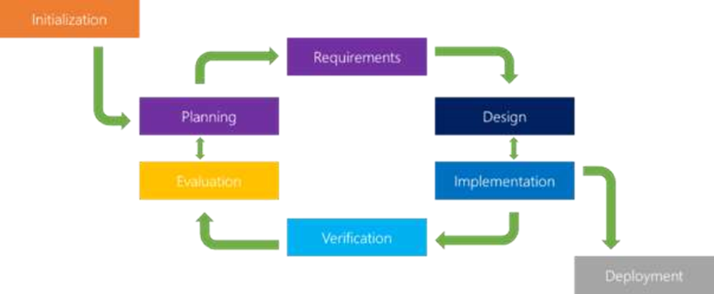

##### Figure 1: Iterative Model (Powell-Morse, 2016)

### 3.1.1 Suitability of the Model

The Agile development model will be appropriate for the development of this project due to its interactive and iterative nature. Development will be based on stages. The main reason for choosing the method is because if there are any changes in the requirements then I can always go back to a previous stage easily and make them. Agile development is focused on quick responses to change and continuous development.(Flora & Chande, 2014)

## 3.2 FACT FINDING TECHNIQUES

These are methods and approaches used to gather, document and analyze problems or processes. This gives a clear understanding about the problem. The fact-finding techniques to be employed are interviews, questionnaires and research from existing materials.

### 3.2.1 Interviews

This is a fact-finding technique that involves engaging with the subject and ask questions and get responses. This can be through structured and open-ended questions.

### 3.2.2 Questionnaires

This involves using special-purpose documents to gather facts. It is useful for gathering data from a large number of individuals.

### 3.2.3 Research

This method involves the collection, analysis, interpretation and synthesis of information and data to solve questions. I will use the internet to make available the information on how others have solved similar problems as well as their experiences.

## 3.3 SOFTWARE DESIGN

### 3.3.1 Stage 1: Planning

This will be done by estimating the amount of work load, specific goals and objective for the sprint. Work estimates will be made in iterations.

### 3.3.2 Stage 2: Requirement analysis

This will document the needs and expectations for the cashflow tracker app, clarifying what features and functionalities it must have. Requirements will also be represented in flow charts and gantt charts.

### 3.3.3 Stage 3: Design

The user-interface, frameworks, libraries and the languages to be used will be defined during this stage.

### 3.3.4 Stage 4: Building

This stage is about writing code and converting design documentation into the actual software. Java will be used as the programming language.

### 3.3.5 Stage 5: Testing

During this stage, the software will be to thoroughly evaluated to fix defects and to ensure that it meets the specified objectives.

# CHAPTER FOUR: SYSTEM ANALYSIS AND DESIGN

System analysis answers who will use the system, what it will do, and where it will be used. During this stage, the developer investigates current systems, identifies improvement opportunities, and develops a concept for the new system.

## 4.1 DATA COLLECTION AND ANALYSIS

Data analysis is a process of inspecting transforming and modelling data with the aim of discovering useful information that would be essential in decision making

### 4.1.1 Interview

Structured interview was used to the target users, the students, of the Cashflow Tracker application. The questions were geared towards understanding the amount of money students spent daily or weekly.

### 4.1.2 Kaggle

Kaggle, a subsidiary of Google LLC, is an online community of data scientists and machine learning practitioners. It provides numerous datasets for researchers with open access and no policy rights. Kaggle datasets are highly reliable, and contain active communities of developers who continually improve the datasets and notebooks. The dataset acquired is aimed to train and test the model used in expense prediction.

## 4.2 REQUIREMENT ANALYSIS

This is where I am going to capture all possible requirements of the system to be developed, and document them in a requirement specification document. Several fact-finding techniques will be used to collect data from the target users of the system, who include students. With this, existing challenges will be established and the possible solutions on the modules developed.

### 4.2.1 Functional Requirements.

This describes the core functionalities that the system has to perform. It includes the following:

1. To allow users key in their daily income and expenses.
2. To allow the student create a budget for planning purposes.
3. Generate income reports and expense reports to the students.
4. To alert students when 80% threshold of their budget is exceeded.
5. Link with sources that provide financial recommendations to students

### 4.2.2 Non-functional Requirements

This refers to the quality attributes of a software system that ensure the usability and effectiveness of the entire system.

1. Performance -The application responds quickly to user interactions.
2. Reliability – The application reliably stores and retrieves financial data from the database. The generation of reports is also robust without crashing.
3. Usability – The interface should be easy to use.
4. Compatibility – The application should be compatible with a range of android devices.

## 4.3 SYSTEM ANALYSIS

Planning the development of information systems involves understanding and defining in details what a system should do as well as how its components should be implemented and function as a unit. This is the focus of system analysis and design. This is done in order to analyze a system or its components and determine it goals. It enhances the system and guarantees that each part functions effectively in order to fulfill its intended role.

### 4.3.1 Use Case Diagram

The diagram below represents part of the applications use case diagram.

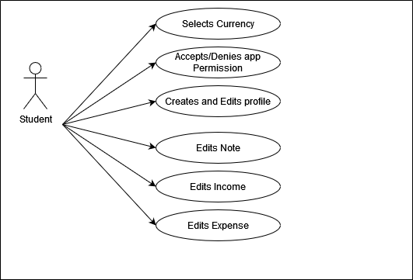

##### Figure 1: Use case diagram.

### 4.3.2 Sequence Diagram

A sequence diagram is an interaction diagram that models how functions are carried out in a system. The diagram below represents part of the application’s sequence diagram.

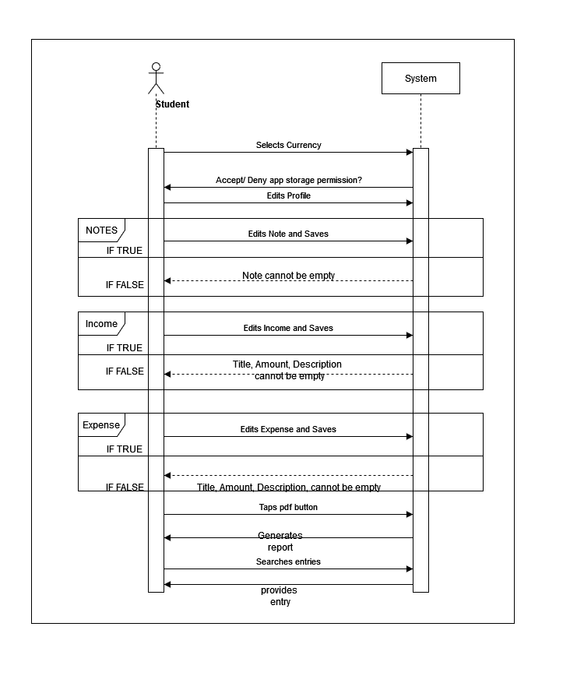

##### Figure 2:Sequence Diagram for adding income and expenses and generating reports.

### 4.3.3 Flow Chart

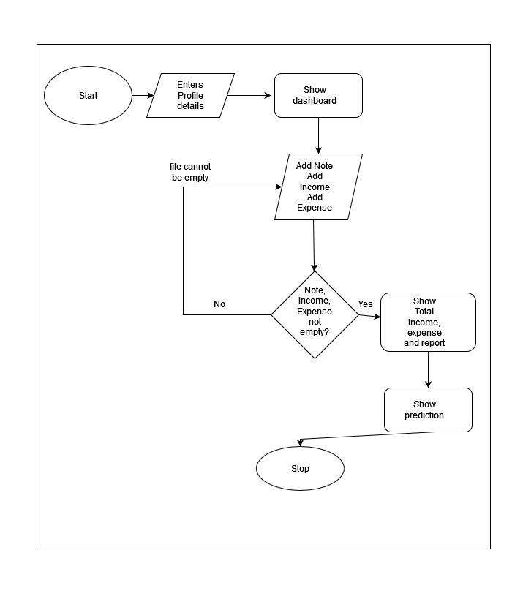Figure 4: Flow Chart

### 4.3.4 Class Diagram

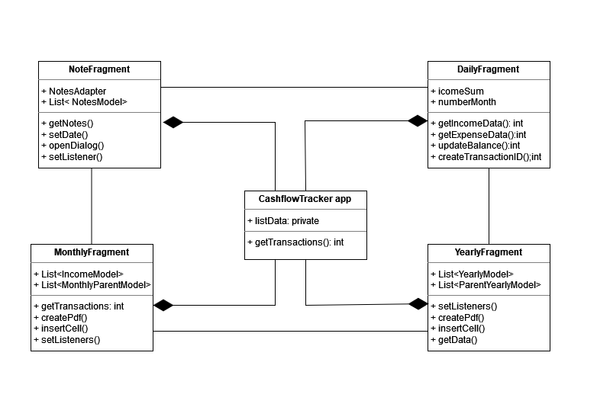

##### Figure 5: Class Diagram

### 4.3.5 Entity Relational Diagram

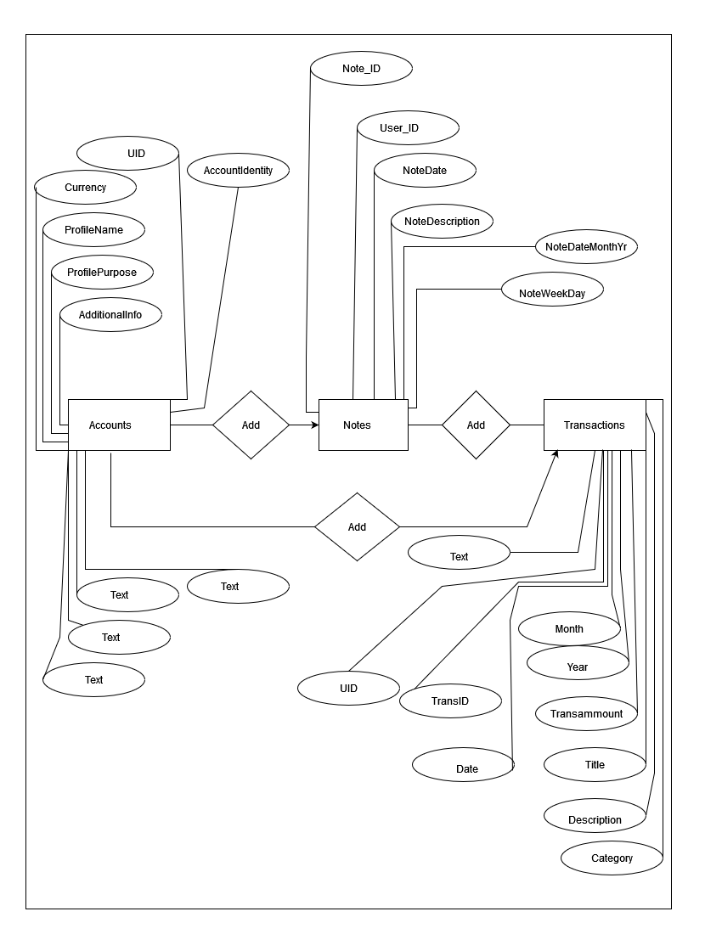Figure 6: Entity Relational Diagram

### 4.3.5 Data Flow Diagram

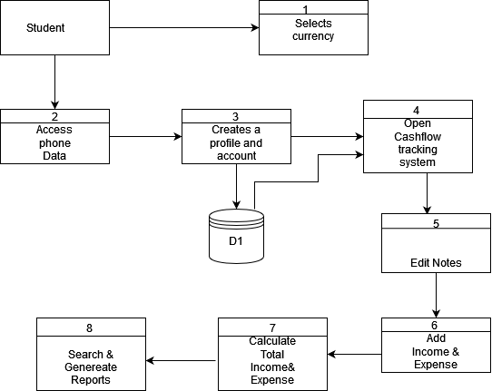

##### Figure 7: Data Flow Diagram

# CHAPTER FIVE: IMPLEMENTATION AND TESTING

## 5.1 INTRODUCTION

The Cashflow Tracker App is implemented as an android application. The following languages were used for the development of the application.

**Front-end development**

* XML (Extensible markup language).

**Back-end development.**

* Java

**Database**

* SQLite database was used with this application and SQL language was used for querying the database.

## 5.2 IMPLEMENTATION

The system implements its role by providing a comprehensive financial management tool for students, encompassing various functionalities. It allows users to create an account then input their daily income and expenses, facilitating meticulous tracking of financial transactions. Users can create budgets within the system to plan their finances effectively. The system generates income and expense reports, offering users insights into their spending patterns and financial status. Furthermore, it incorporates a notification feature to notify users when they exceed 80% of their budget, promoting prudent financial decisions. Moreover, the system links with external sources that offer financial recommendations tailored to students' needs, further enhancing their financial literacy and decision-making capabilities.

### 5.1.1 Account creation

Users must create an account for them to proceed to keying in their income and daily expenses.

### 5.1.2 Income and Expense input.

Users can then key in their monthly income and daily expenses. The system incorporates a notification feature to notify users when they reach 80% of their budget, or exceed their budget promoting prudent financial decisions.

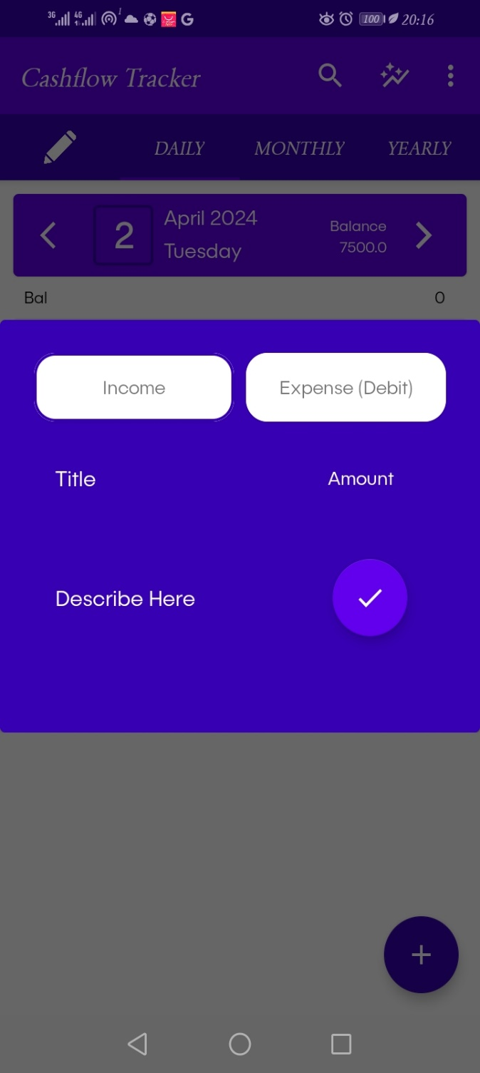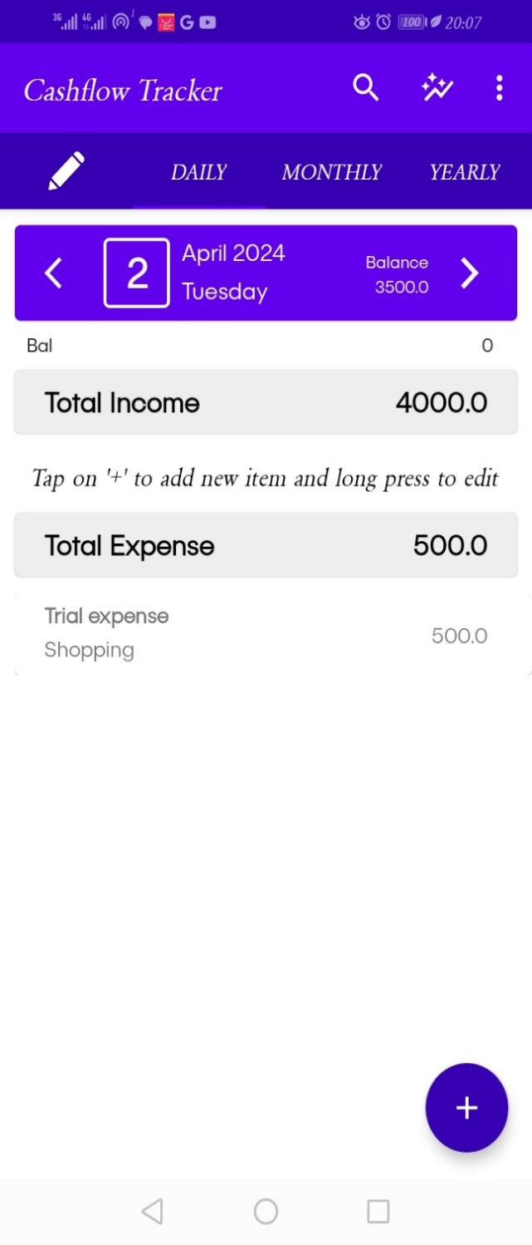

##### Figure 8: Income and Expense dialog Figure 9: Income and Expense dashboard

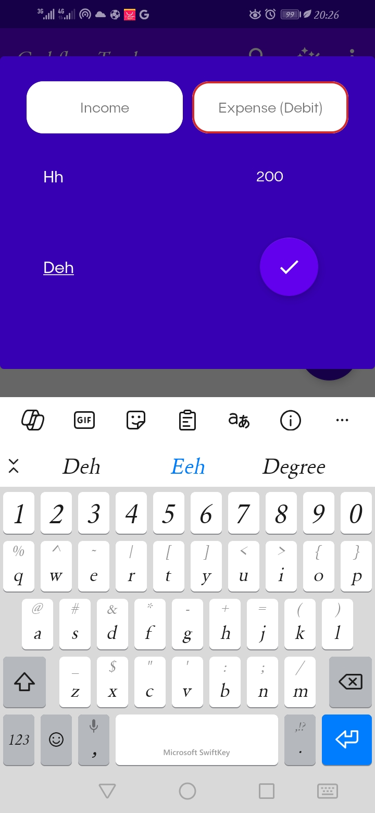 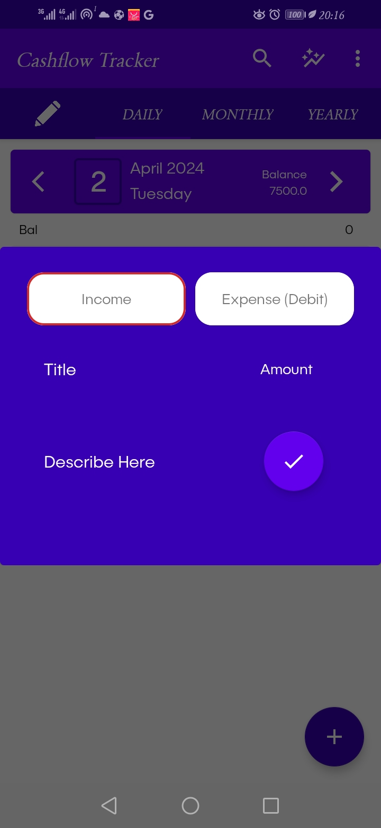

##### Figure 10: Expense Input Figure 11: Income Input

### 5.1.3 Alert system

Through the notification feature, users are able to know when their expenditure has reached 80% of their budget. The system also notifies users when the budget limit is exceeded.

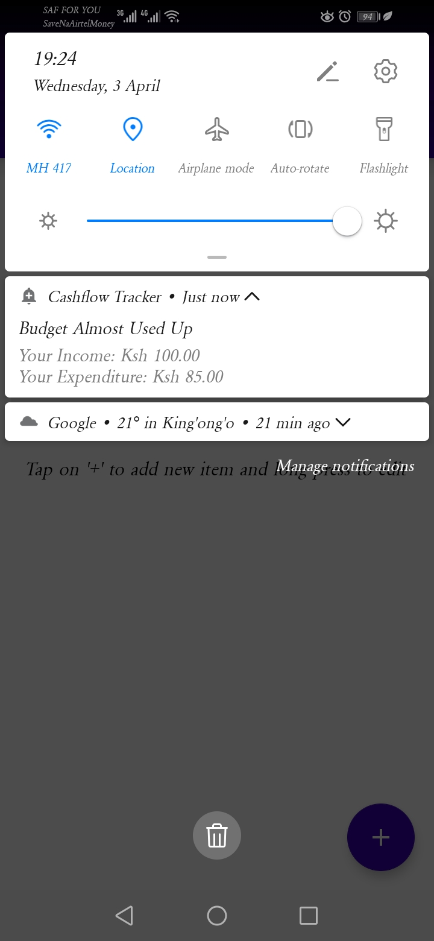 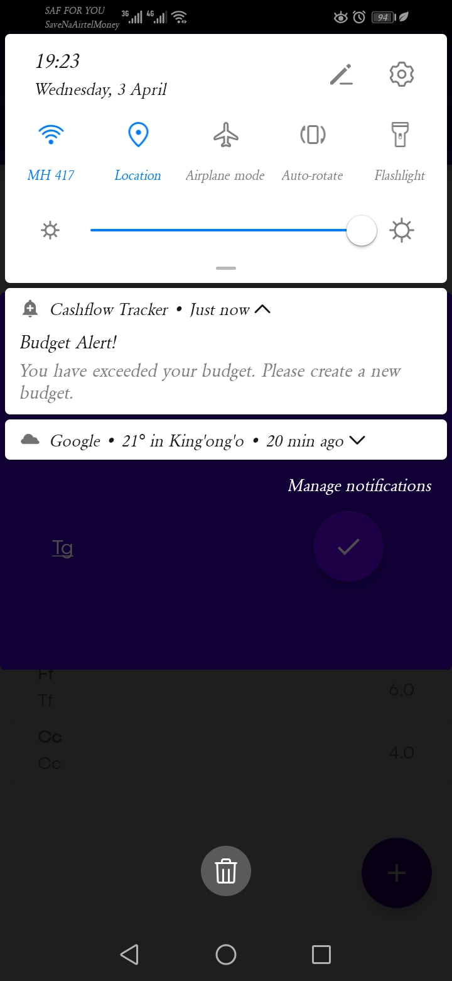

##### Figure 12: Budget almost used up notification Figure 13: Exceeding budget notification

### 5.1.4 Generation of Income and Expense reports.

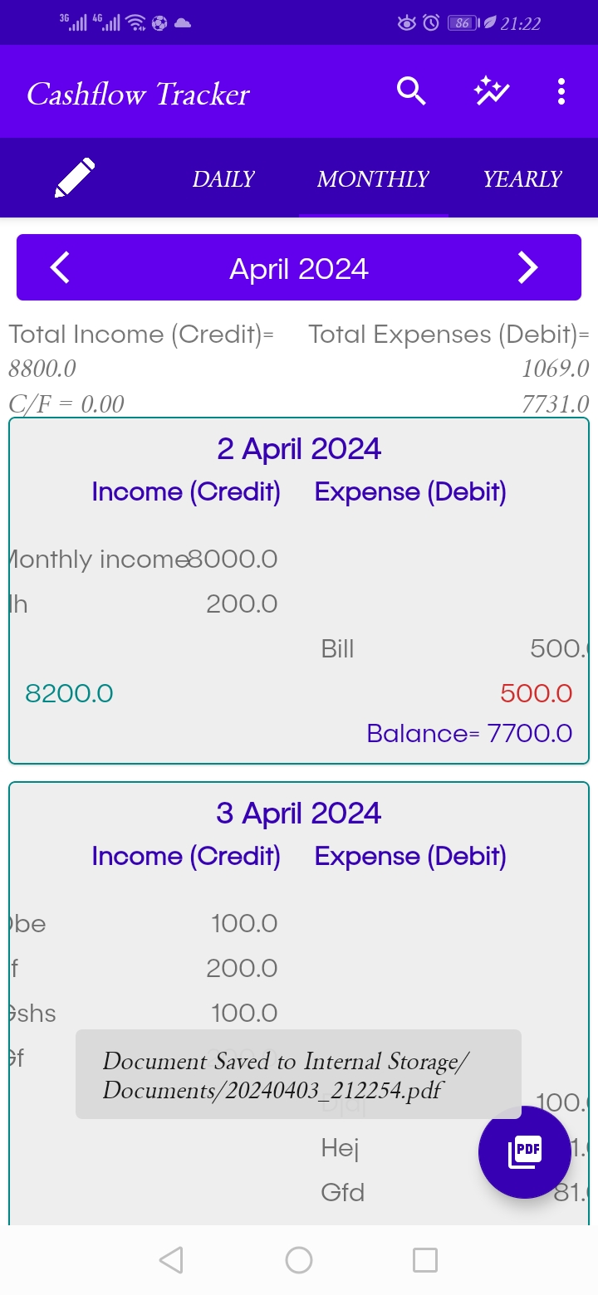These reports offer a detailed breakdown of the user's financial transactions over the whole month. The user can also download the reports and print them.

##### Figure 14: Generation of Income and Expense Reports

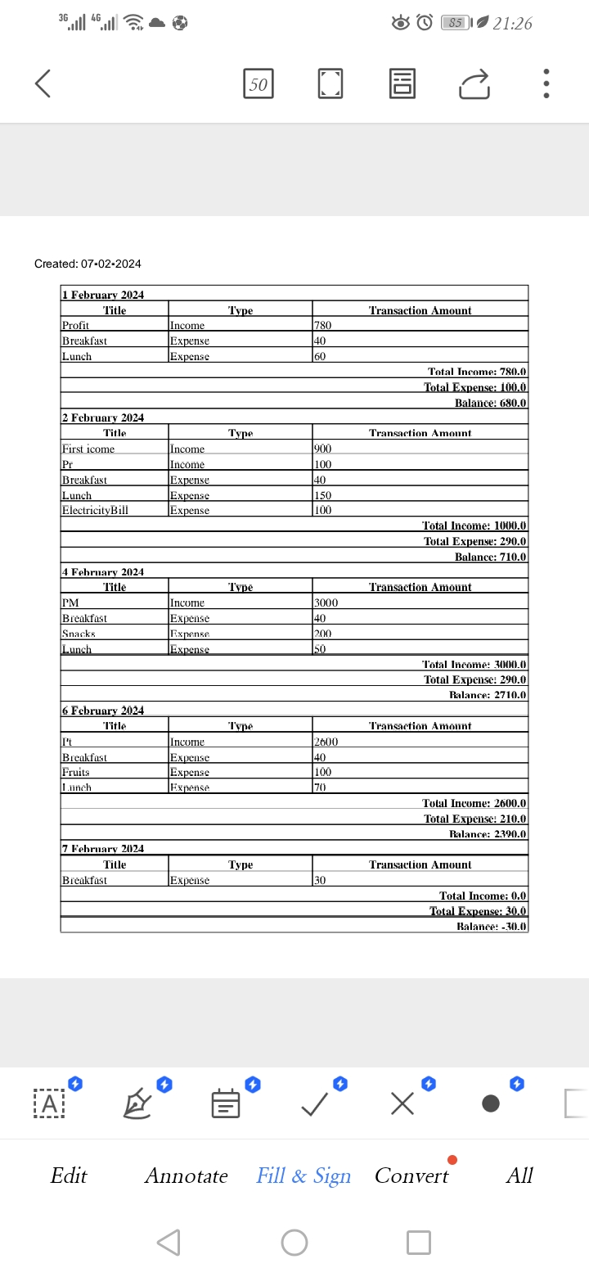

##### Figure 15: Income and Expense Report

### 5.1.5 Financial recommendations.

The system also links with external sources for financial recommendations.

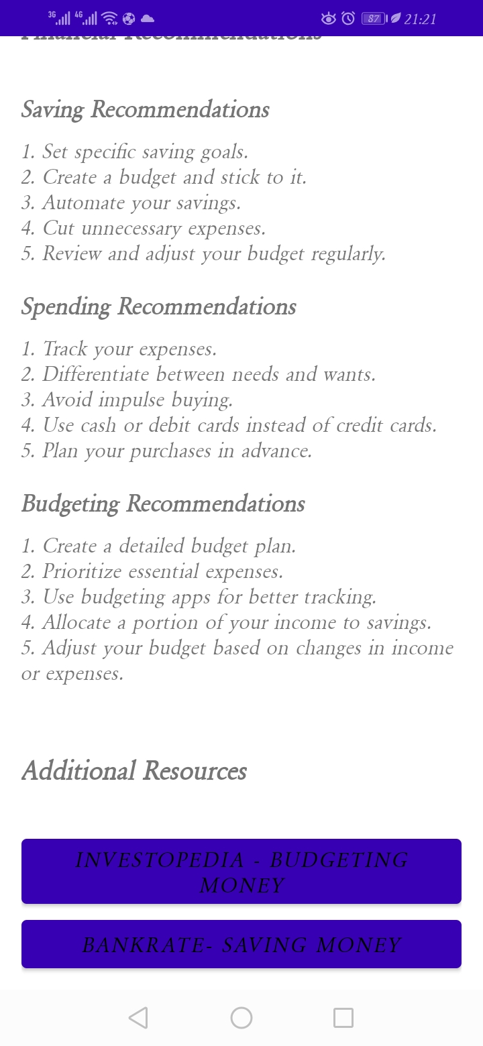

##### Figure 16: Financial Recommendations

### 5.1.6 Planning on Budget

The application allows users to create budgets and track expenses and income to effectively manage their finances.

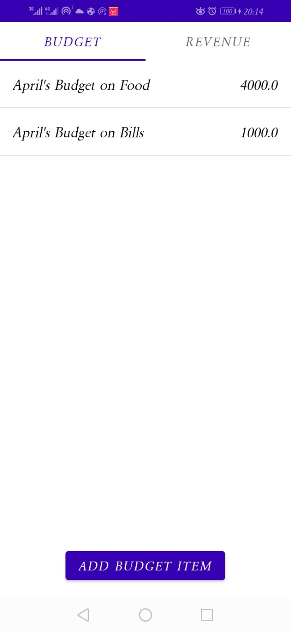 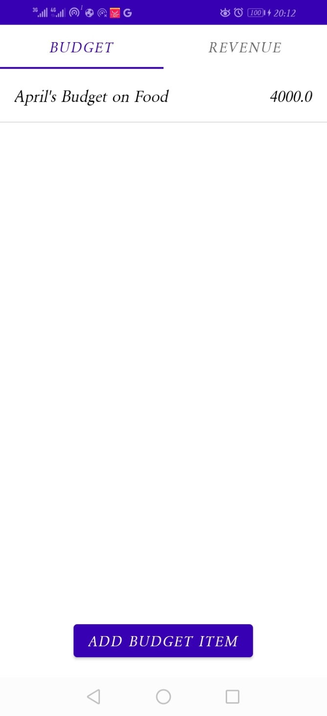

##### Figure 17: Budget Planning Figure 18: Budget planning

### 5.1.7 Planning on Revenue

Users can input their monthly revenue to ensure balanced budgeting.

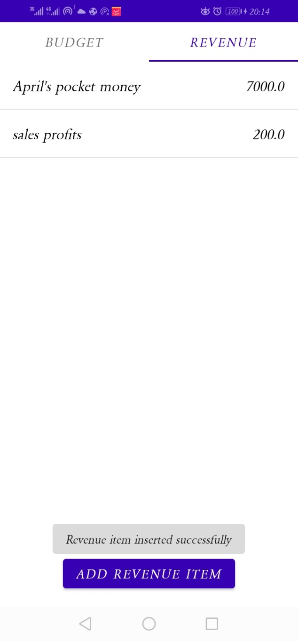

##### Figure 19: Planning on Revenue

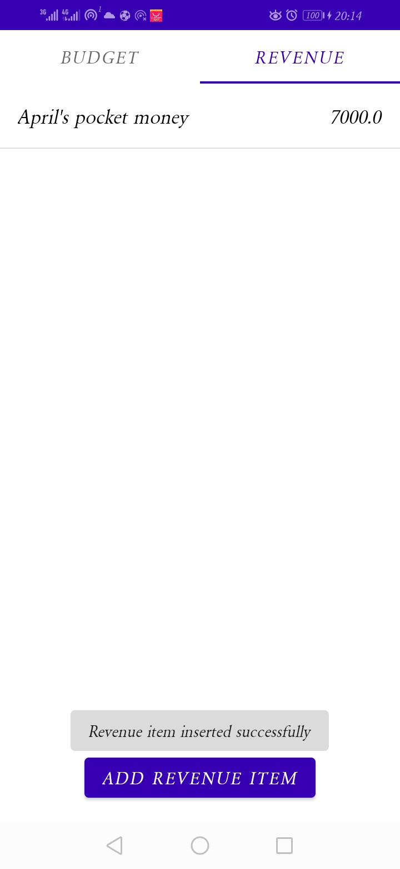 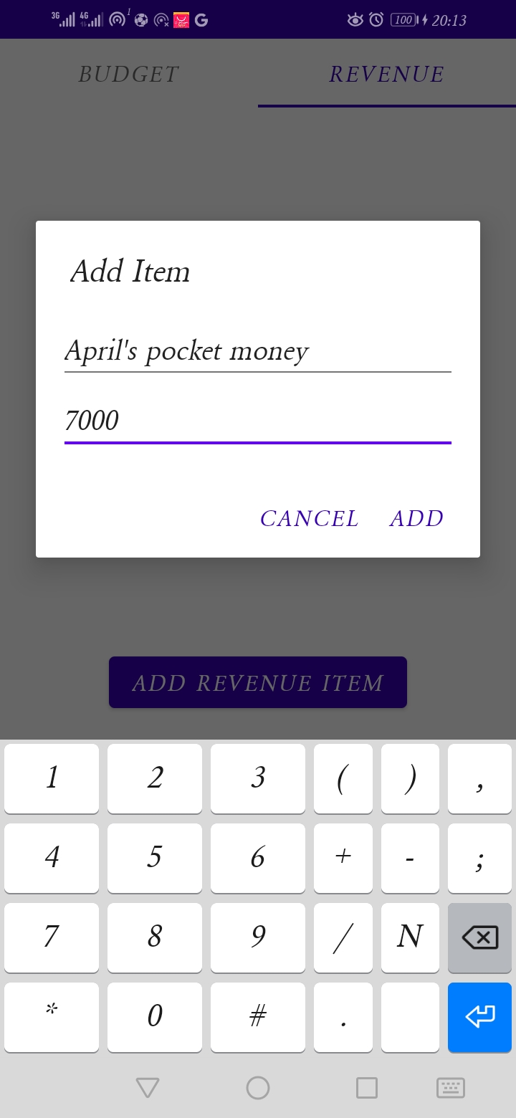

##### Figure 20: Adding Revenue Figure 21: Adding Revenue

### 5.1.8 Adding Notes

Users can add notes to their transactions for further context and organization within the comprehensive financial management tool.

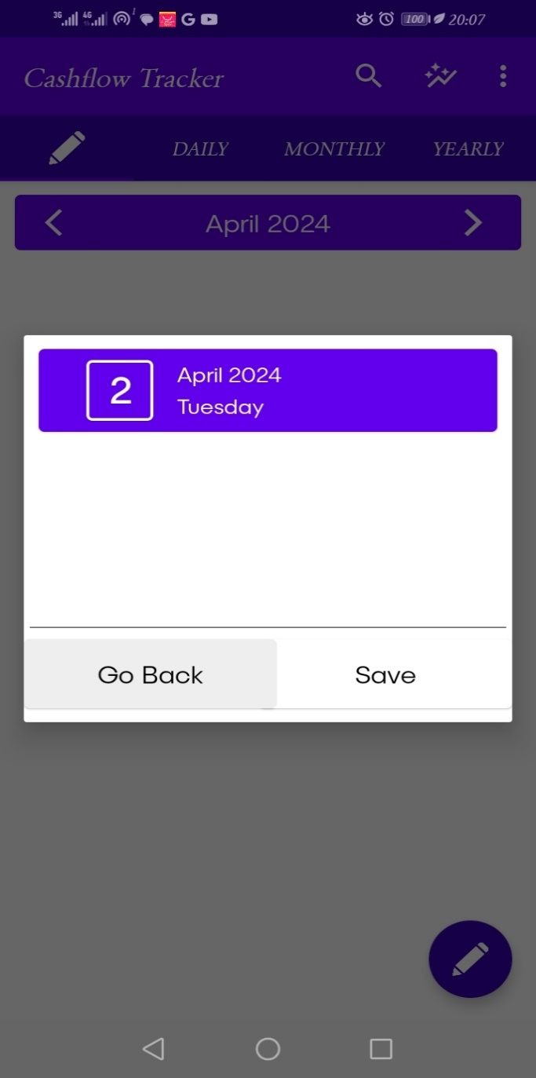 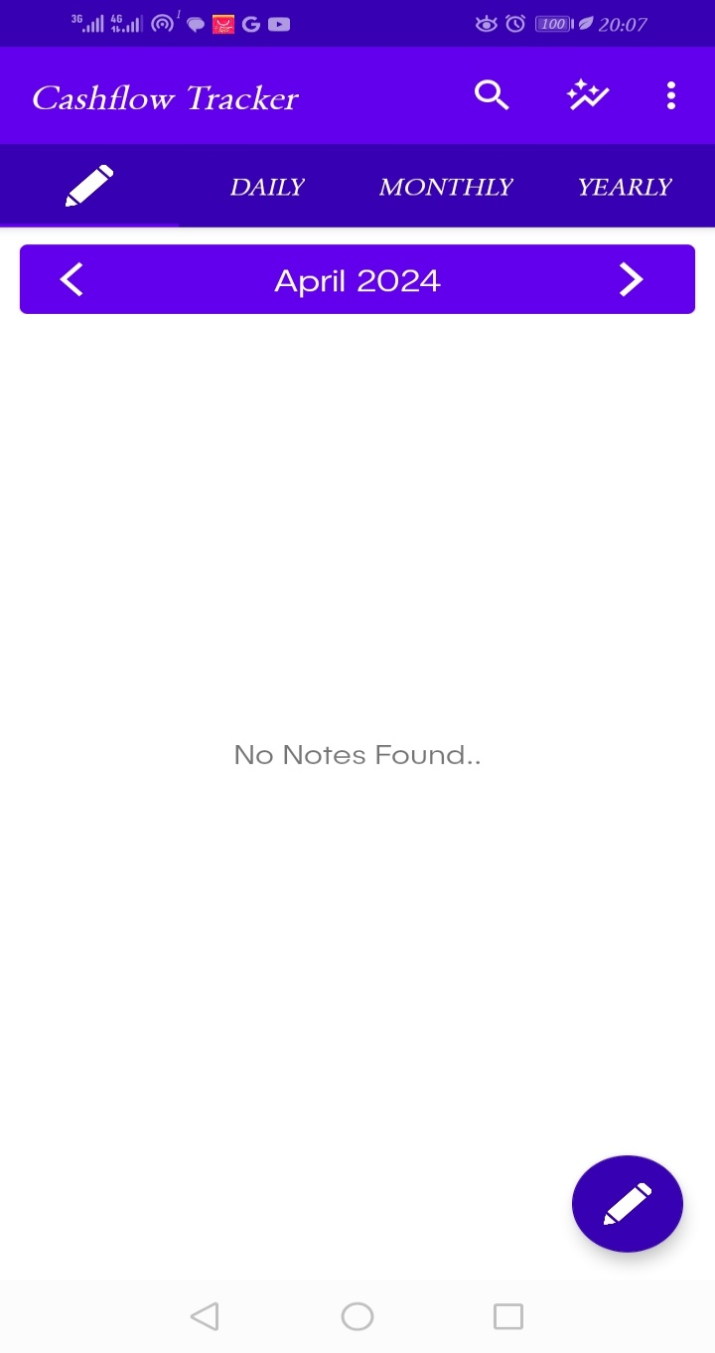

##### Figure 22: Adding note dialog Figure 23: Adding notes dashboard

### 5.1.9 Refinement:

In refining the cashflow tracking application, one aim is to enhance the accuracy and the usability of the system. One area of refinement lies in optimizing the notification feature to alert users when they approach or exceed 80% of their budget, ensuring timely and effective financial management. Additionally, improvements in data handling could be implemented to ensure that all financial transactions, including daily income and expenses are accurately recorded and tracked within the system.

### 5.1.10 Results:

After thorough evaluation and validation, our financial management tool demonstrates commendable performance in providing students with insights into their spending patterns and financial status. The incorporation of income and expense reports enables users to gain a comprehensive understanding of their financial behaviors, facilitating informed decision-making.

### 5.1.11 Improvement:

To further enhance the reliability and usability of our cashflow tracking application, several improvements can be implemented. Firstly, extending the training data for budget planning could enhance the system's ability to accurately predict and notify users when they approach their budget limits. Additionally, integrating advanced data augmentation techniques could improve the system's capability to handle varying financial scenarios, ensuring robust performance under different conditions. Furthermore, leveraging GPU processing power could significantly accelerate the speed of budget detection and notification, resulting in a smoother user experience. Finally, implementing a scoring mechanism for budget recognition could enhance the system's reliability by filtering out inaccurate budget predictions, thereby improving overall user satisfaction.

# CHAPTER SIX: CHALLENGES, CONCLUSIONS & RECOMMENDATIONS

## 6.1 INTRODUCTION

This chapter encapsulates the challenges, conclusions, and recommendations encountered throughout the development of the cashflow tracking application. It also provides insights into the findings derived from the study accompanying this project and identifies potential areas for future research.

## 6.2 CHALLENGES

The journey towards successfully implementing the cashflow tracking application was not devoid of challenges. Several hurdles were encountered, including:

i) Resource Constraints

Adhering to budget limitations posed significant challenges. Despite the desire to conduct extensive research, the constraints necessitated careful budget allocation. During the coding phase, the inability to utilize expensive APIs impacted the project's scope. Moreover, opting for more affordable hosting solutions, such as Google Firebase server, was necessitated to manage costs.

ii) **Power Outages**

Power interruptions disrupted the workflow, particularly during crucial phases like coding and documentation. Reliance on laptop power exacerbated the issue, given its limited battery life.

iii) Internet Access

This mostly affected the research process.

## 6.3 RECOMMENDATIONS

To address these challenges and improve the cashflow tracking application, the following recommendations are proposed:

1. **Enhanced Internet Access**

Ensuring ample internet connectivity during coding and development phases is essential to mitigate challenges arising from poor network coverage.

1. **Expansion of Services**

Explore expanding the services offered by the cashflow tracking application to include short-term loans or overdraft facilities, catering to the diverse financial needs of users.

1. **High-Processing Machines**

Future developers undertaking similar projects should utilize machines with high processing power to optimize performance.

1. **Utilization of Advanced Cloud Services**

Consider leveraging advanced cloud services, such as Microsoft Azure, which offer built-in object detection functionalities, streamlining development processes and enhancing system capabilities.

## 6.4 Conclusion

The cashflow tracking application project aimed to provide students with a comprehensive financial management tool, empowering them to manage their finances effectively. Despite encountering challenges, the project successfully culminated in the development of a functional system. The experience garnered from this project has been invaluable, providing insights into system development, project management, and the utilization of Artificial Intelligence, particularly in computer vision applications like automatic number plate recognition.

## 6.5 FUTURE RESEARCH

While the current study has laid the foundation for effective cashflow tracking, future research endeavors could further enhance the application's capabilities. Exploring the development of a mobile application companion for both Android and iOS platforms could broaden accessibility and user reach. Additionally, integrating machine learning algorithms to analyze frequently accessed routes could optimize toll gate placement, thereby improving user experience and satisfaction. Furthermore, investigating the implementation of infrared light technology for license plate recognition at night could address usability challenges in low-light conditions. These avenues of research promise to enhance the functionality and usability of the cashflow tracking application, catering to the evolving needs of users in the financial management domain.

# CHAPTER SEVEN: REFERENCES

1. Oxford Analytica. (2023). Kenya finance bill reflects fiscal consolidation drive. Emerald Expert Briefings, (oxan-db).
2. Ruth, O. N., Julie, M. N., Rachel, K., Kiboiy, K. L., Wangui, P. M., & Omuse, E. D. (2023). Food Insecurity among University Students in Kenya: An Analysis of Associated Factors.
3. Jorgensen, B. (2007). Financial Literacy of College Students: Parental and Peer Influences (Master's thesis). Retrieved from: http://scholar.lib.vt.edu/theses/available/etd-10162007-143627/unrestricted/Thesis_BJ2.pdf
4. Norvilitis, J. M., Merwin, M. M., Osberg, T. M., Roehling, P. V., Young, P., & Kamas, M. M. (2006). Personality factors, money attitudes, financial knowledge, and credit-card debt in college students. Journal of Applied Social Psychology, 36(6), 1395-1413. [25].
5. Bajtelsmit, V., & Bernasek, A. (1996). Why do women invest differently than men? Financial Counselling and Planning, 7, 1-10. Retrieved January 15, 2012, from http://www.biz.colostate.edu/faculty/vickieb/cv_bajtelsmit_Aug04_withpres.DOC
6. Beal, D. J., & Delpachitra, S. B. (2003). Financial Literacy among Australian University Students. Economic Papers, 22(1), 65-78
7. Bernheim, D. (1998). Financial Illiteracy, Education, and Retirement Saving. In O. S. Mitchell, & S. Schieber (Eds.), Living with defined contribution pensions (pp. 38-68). Philadelphia: University of Pennsylvania Press.
8. Chen, H., & Volpe, R. P. (1998). An analysis of personal financial literacy among college students. Financial Services Review, 7, 107-128.
9. Chen, H., & Volpe, R. P. (2002). Gender differences in personal financial literacy among college students. Financial Services Review, 11(3), 289-307. Retrieved August 11, 2013, from www2.stetson.edu/fsr/abstracts2/Vol11_A18.pdf
10. Cole, S., Sampson, T., & Zia, B. (2008). Money or knowledge? What drives the demand for financial services in developing countries? Harvard Business School Working Paper, 9, 117. Retrieved February 12, 2012, from www.hbs.edu/research/pdf/09-117.pdf