**Abstract**

This comprehensive essay delves into the intertwined challenges of poverty, income inequality, and food insecurity, examining their causes, consequences, and potential solutions. It begins by defining these issues and exploring their structural, economic, and social determinants. The essay highlights the far-reaching impacts of poverty and income inequality on individuals, communities, and societies, including health disparities, educational inequalities, and economic stagnation. It then discusses various strategies and interventions to address these challenges, ranging from social safety nets and progressive taxation to investments in education, healthcare, and sustainable agriculture. Furthermore, it emphasizes the importance of empowering marginalized communities, promoting social cohesion, and fostering research and innovation to create more inclusive and equitable societies. Through a combination of policy reforms, community-based initiatives, and global cooperation, the essay advocates for a holistic approach to tackle poverty, income inequality, and food insecurity, ultimately striving towards a more just, resilient, and sustainable future for all.

**Muhtasari**

Karatasi hii kinaingia kwa kina katika changamoto zilizounganishwa za umaskini, kutokuwa na usawa wa mapato, na kutokuwa na uhakika wa chakula, ikichunguza chanzo chake, matokeo yake, na suluhisho zake inavyowezekana. Inaanza kwa kufafanua masuala haya na kuchunguza wakalimani wao wa kimuundo, kiuchumi, na kijamii. Karatasi hii inaonyesha athari za mbali zilizopo za umaskini na kutokuwa na usawa wa mapato kwa watu binafsi, jamii, na jamii, ikiwa ni pamoja na tofauti za afya, kutokuwa na usawa wa elimu, na kudorora kwa kiuchumi. Kisha inajadili mikakati na njia mbalimbali za kushughulikia changamoto hizi, ikiwemo mitandao ya usalama wa kijamii na kodi za kisasa hadi uwekezaji katika elimu, huduma za afya, na kilimo endelevu. Zaidi ya hayo, inasisitiza umuhimu wa kuwawezesha jamii zilizotengwa, kukuza mshikamano wa kijamii, na kuchochea utafiti na ubunifu ili kuunda jamii zenye ujumuishaji na usawa zaidi. Kupitia mchanganyiko wa mageuzi ya sera, mipango inayoendeshwa na jamii, na ushirikiano wa kimataifa, karatasi hii inatetea njia kamili ya kukabiliana na umaskini, kutokuwa na usawa wa mapato, na kutokuwa na uhakika wa chakula, hatimaye ikilenga kuelekea mustakabali wenye haki, imara, na endelevu kwa wote.

**Ntugatagatia**

Irathi ria atia niyo iriairikia kuuma mitungati ya gutura utongoria, uhoro wa maundu no uhono wa mawira, na gutongoria uhoro wa gutagira irimwo. Irathi ria ici rikuhitukiriria ririkira na riaga mbeca ngono mihinga ya njira ya uriru wa kiumwe, wa kiruraga, na wa kiringa. Irathi ria ici riakurira niyo igaturiria akenji kiautu na kutoguru kwa utongoria na uhoro wa mawira kwa abarimu, maita, na mariika, kiringira ni kumera na kiringa mohoni, gutogurira ruciru wa mariika, na kureuta kwa kiruraga. Ihuro kai urari cio kuhakikio ya ciuganacuru, iri tiguiririria niyo iti ituriria mariika, mariika, na mariika. Na ici irathi itiririra ndega ngono kuhakikio, kuri, na gurema njira ciuganacuru, niakuririra iriahi, iriahi, na kiruraga kienda kugatithurwo. Niugurira ni utiririria niyo ungugi wa mariika, maita niaga na kiruraga kiuriri, kiuriri, na kiuriri. Na na na, ni tigatuririria mariika cina, kuringa ni kumera na kuringa kwa njira ya uturiri wa mariika, kuringa ni gutandia irihi cia ici, iri tigatuririria niuo, niuo na niuo wa kuringa niuo, niakuririria kuringa niakuririria kuringa, na kugacia iri ngima kiwa mariika, kana umaga, na kuhakikio wa kiruraga, ni kuiririria niuo kuhoro wa kiruraga kana ni kuraruha wigi wa njira ya njira na njira ya njira ni kuhakikio wa kihita.

**A Plate Full of Promise: Fighting Food Insecurity with Sustainable Solutions**

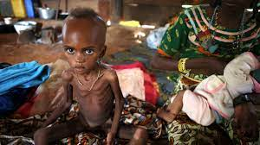

Food insecurity is a pervasive global challenge characterized by inadequate access to safe, sufficient, and nutritious food to meet dietary needs and lead an active, healthy life. It affects individuals, households, and communities across the socioeconomic spectrum, undermining human health, well-being, and economic development. This essay provides a comprehensive overview of food insecurity, exploring its causes, consequences, and significance in many communities.

**Causes of Food Insecurity**

Food insecurity is a complex issue rooted in various socioeconomic, environmental, and political factors. Poverty is one of the primary drivers of food insecurity, as low-income individuals and families often lack the financial resources to purchase an adequate and diverse diet. Additionally, income inequality exacerbates disparities in food access and affordability, leaving marginalized groups particularly vulnerable to food insecurity.

Limited access to productive resources such as land, water, and agricultural inputs hinders food production and agricultural livelihoods, contributing to food insecurity in rural communities. Environmental factors such as climate change, natural disasters, and land degradation further exacerbate food insecurity by disrupting food production, reducing crop yields, and increasing food prices.

Inadequate infrastructure, including transportation networks, storage facilities, and market access, can impede food distribution and market integration, exacerbating food insecurity in remote and marginalized communities. Moreover, conflict, political instability, and humanitarian crises can disrupt food supply chains, displacement, and livelihoods, leading to acute food shortages and famine in affected regions.

**Consequences of Food Insecurity**

Food insecurity has far-reaching consequences for individuals, households, and communities, impacting physical health, mental well-being, and socio-economic development. Hunger and malnutrition are among the most immediate consequences of food insecurity, leading to under nutrition, micronutrient deficiencies, and impaired growth and development, particularly among children and pregnant women.

Chronic food insecurity can contribute to a range of health problems, including stunted growth, wasting, anemia, and compromised immune function, increasing the risk of infectious diseases and premature death. Moreover, food insecurity is associated with poor mental health outcomes such as anxiety, depression, and stress, as individuals and families grapple with uncertainty, deprivation, and social stigma.

Economically, food insecurity undermines productivity, human capital development, and economic growth, as individuals and communities struggle to meet their nutritional needs and fulfill their potential. Health care costs associated with food-related illnesses and nutrition-related diseases impose a significant burden on healthcare systems and social services, diverting resources from other essential priorities.

 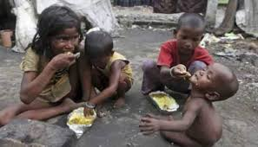

*Empty stomachs and hunger pangs convey the physical and emotional toll of food insecurity on individuals and families.*

 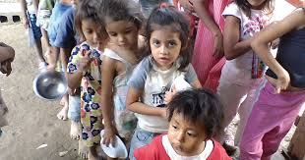

*Long lines form as communities await food rations, highlighting the reliance on external assistance to meet basic nutritional needs.*

 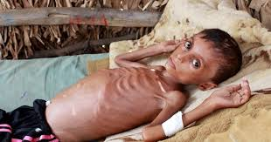

*Malnutrition-related illnesses take their toll on communities affected by food insecurity, leading to increased healthcare costs and diminished well-being.*

 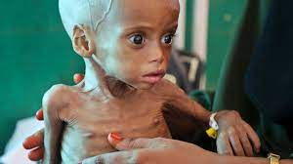

*Malnutrition-related illnesses take their toll on communities affected by food insecurity, leading to increased healthcare costs and diminished well-being.*

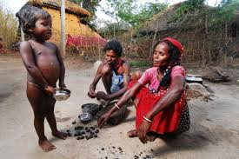 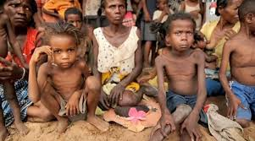

*Rural communities face isolation and limited access to resources, exacerbating the challenges of food production and distribution.*

 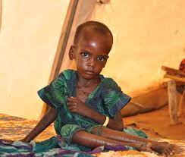

*Micronutrient deficiencies contribute to poor health outcomes in food-insecure communities, affecting cognitive development and overall well-being.*

 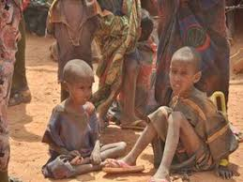

*Seasonal hunger intensifies food insecurity during lean periods, when food stocks are depleted and agricultural production is low.*

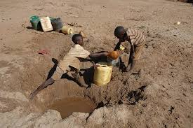 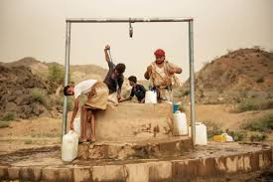

*Water scarcity compounds the challenges of food production and agricultural livelihoods, exacerbating food insecurity in drought-affected regions.*

**Significance in Many Communities**

Food insecurity is a significant concern in many communities due to its profound impact on human health, well-being, and socio-economic development. It is not only a matter of food availability but also accessibility, affordability, and utilization, encompassing broader issues of poverty, inequality, and social justice. Addressing food insecurity requires comprehensive, multi-sectoral approaches that address its root causes, including poverty, inequality, environmental degradation, and conflict.

**Efforts to Address Food Insecurity**

Food insecurity is a complex and multifaceted issue that affects millions of individuals and communities worldwide. Addressing this challenge requires a comprehensive approach that encompasses various strategies aimed at improving food access, promoting sustainable agriculture, and addressing the underlying causes of hunger and malnutrition. In recent years, numerous efforts have been made by governments, non-governmental organizations (NGOs), international agencies, and grassroots movements to combat food insecurity and promote food security for all.

**1. Social Safety Nets and Food Assistance Programs:** One of the primary efforts to address food insecurity is through the implementation of social safety nets and food assistance programs. These programs aim to provide immediate relief to individuals and families facing hunger and malnutrition by distributing food aid, vouchers, or cash transfers. Examples of such programs include the Supplemental Nutrition Assistance Program (SNAP) in the United States, the Food Distribution Program on Indian Reservations (FDPIR), and the National Food Security Mission (NFSM) in India.

**2. Agricultural Development and Investment:** Investments in agricultural development are crucial for enhancing food production, improving farm productivity, and increasing farmers' incomes. Efforts to address food insecurity often involve supporting smallholder farmers through training, access to credit, and technology transfer. Additionally, investments in irrigation infrastructure, research and development, and market access can help boost agricultural productivity and ensure food security for rural communities. Organizations like the Food and Agriculture Organization of the United Nations (FAO) and the International Fund for Agricultural Development (IFAD) play a vital role in supporting agricultural development initiatives globally.

 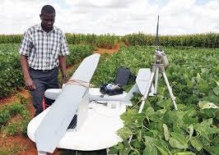

**3. Sustainable Farming Practices:** Promoting sustainable farming practices is essential for ensuring long-term food security while preserving natural resources and mitigating environmental degradation. Sustainable agriculture techniques, such as organic farming, permaculture, agroforestry, and conservation agriculture, focus on maximizing yields while minimizing the use of synthetic inputs, conserving soil fertility, and enhancing biodiversity. These practices not only contribute to food security but also promote resilience to climate change and support ecosystem health. Organizations like the World Food Programme (WFP) and Oxfam support initiatives that promote sustainable agriculture and empower smallholder farmers in adopting climate-smart agricultural practices.

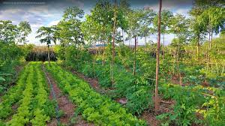 

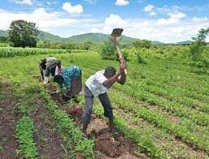 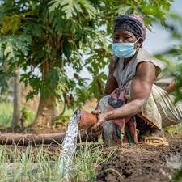

**4. Nutrition Education and Health Interventions:** Improving nutrition education and healthcare services is crucial for addressing the underlying causes of malnutrition and promoting healthy eating habits. Efforts to combat food insecurity often include nutrition education programs, maternal and child health interventions, and micronutrient supplementation campaigns aimed at reducing malnutrition and promoting optimal health outcomes. Additionally, initiatives such as school feeding programs, community nutrition centers, and maternal and child health clinics play a vital role in ensuring access to nutritious food and healthcare services for vulnerable populations.

 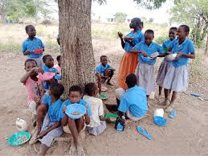

**5. Food Policy and Governance:** Effective food policy and governance mechanisms are essential for addressing food insecurity at the national and global levels. Governments play a critical role in formulating policies that promote food security, regulate food markets, and ensure equitable access to food resources. International agreements such as the Sustainable Development Goals (SDGs) and the Paris Agreement on climate change provide frameworks for addressing food insecurity, poverty, and environmental sustainability on a global scale. Civil society organizations, advocacy groups, and grassroots movements also play an important role in holding governments and corporations accountable for addressing food insecurity and promoting food justice.



**6. Disaster Preparedness and Emergency Response:** Efforts to address food insecurity must also include disaster preparedness and emergency response strategies to mitigate the impact of natural disasters, conflicts, and humanitarian crises on food security. Emergency food aid, humanitarian assistance, and disaster relief efforts are crucial for providing immediate relief to populations affected by food shortages and displacement. Organizations such as the Red Cross, Médecins Sans Frontières (MSF), and the United Nations Office for the Coordination of Humanitarian Affairs (OCHA) play a critical role in coordinating emergency response efforts and delivering life-saving assistance to affected communities.

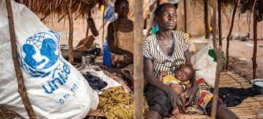 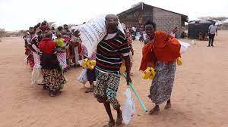

**7. Empowerment and Community Participation:** Empowering communities and promoting participatory approaches to food security are essential for building resilience and ensuring sustainable solutions to hunger and malnutrition. Efforts to address food insecurity should involve engaging local communities in decision-making processes, supporting community-led initiatives, and strengthening local food systems. Initiatives such as community gardens, farmers' cooperatives, and women's self-help groups empower individuals and communities to take control of their food security and improve their livelihoods.

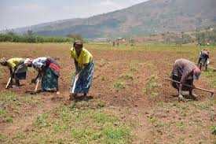 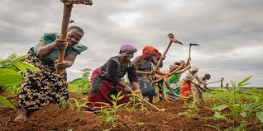

**8. Research and Innovation:** Investments in research and innovation are crucial for developing new technologies, practices, and policies to address food insecurity and promote sustainable food systems. Research institutions, universities, and private sector organizations play a vital role in conducting research on topics such as crop breeding, soil management, climate adaptation, and nutrition science. Innovation hubs, technology incubators, and social enterprises also contribute to developing innovative solutions to food insecurity, such as mobile apps for smallholder farmers, blockchain technology for food traceability, and alternative protein sources.

 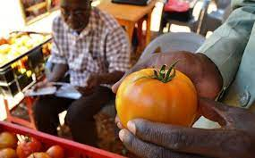

Addressing food insecurity requires a multi-faceted approach that encompasses social, economic, environmental, and political strategies. By implementing social safety nets, investing in agricultural development, promoting sustainable farming practices, improving nutrition education and healthcare services, strengthening food policy and governance, enhancing disaster preparedness and emergency response, empowering communities, and fostering research and innovation, we can work towards achieving food security for all and building a more resilient and sustainable food system for future

**Impact and Success Stories**

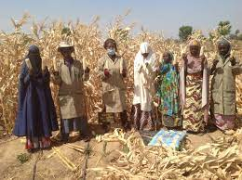

*"By adopting climate-smart agricultural practices, we've become more resilient to droughts and erratic weather patterns, safeguarding our food supply." - Daniel, Community Leader.*

In the face of food insecurity, there exists a profound resilience and unwavering hope that permeates communities worldwide. While the challenges may seem insurmountable, the human spirit perseveres, finding innovative solutions, fostering solidarity, and cultivating resilience in the pursuit of a brighter future.

In the final images of this photographic essay, we witness scenes of triumph amidst adversity, showcasing the indomitable spirit of individuals and communities confronting food insecurity head-on. Amidst fields once barren and depleted, vibrant crops now flourish, testament to the transformative power of sustainable farming practices and agricultural innovation. Farmers, once burdened by the uncertainty of food shortages, now stand tall, their faces illuminated by the promise of a bountiful harvest and the realization of their agricultural dreams.

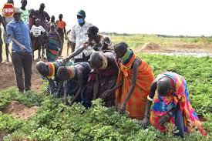 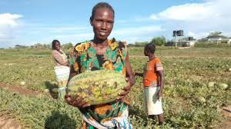

Amidst the backdrop of natural disasters and humanitarian crises, we witness the resilience of communities banding together in the face of adversity. Volunteers distribute food aid to those in need, their actions fueled by compassion and a shared commitment to alleviating hunger and suffering. Relief workers navigate treacherous terrain and navigate through conflict zones, bringing hope and sustenance to those displaced by violence and turmoil. In the eyes of survivors, we see a glimmer of hope, a testament to the resilience of the human spirit in the face of unimaginable hardship.

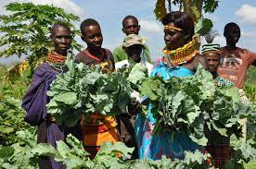 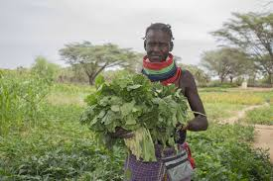

But perhaps most inspiring of all are the stories of individuals who refuse to be defined by their circumstances, who rise above adversity to create a brighter future for themselves and their communities. In the testimonies of farmers, activists, and advocates, we hear tales of perseverance, innovation, and determination. These are the voices of change-makers, whose tireless efforts are transforming the landscape of food security, one community at a time.

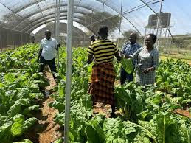 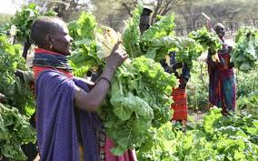

As the final images fade into the horizon, we are left with a profound sense of hope and possibility. Despite the myriad challenges that lie ahead, we are reminded that the human spirit is resilient, and that together, we have the power to overcome even the most daunting of obstacles. In the face of food insecurity, let us stand united in our commitment to building a more equitable, sustainable, and resilient future for all.

I urge everyone to take action and support organizations and initiatives dedicated to combating food insecurity and promoting food justice in their communities. By donating funds, volunteering time, or advocating for policy changes, individuals can make a tangible difference in the lives of those affected by hunger and malnutrition. Supporting local food banks, community gardens, and sustainable agriculture projects helps ensure that everyone has access to nutritious food and fosters a more equitable food system. Additionally, advocating for policies that address the root causes of food insecurity, such as poverty and inequality, can create lasting change and promote social justice. Together, we can work towards a future where no one goes hungry and everyone has the opportunity to thrive.