**Fred Nguro Kinyanjui**

**C025-01-2443/2020**

**BSc. IT 4.2**

**IGS COMMUNICATION SKILLS**

**SOCIAL MEDIA ACCOUNTS**

**Facebook account:**

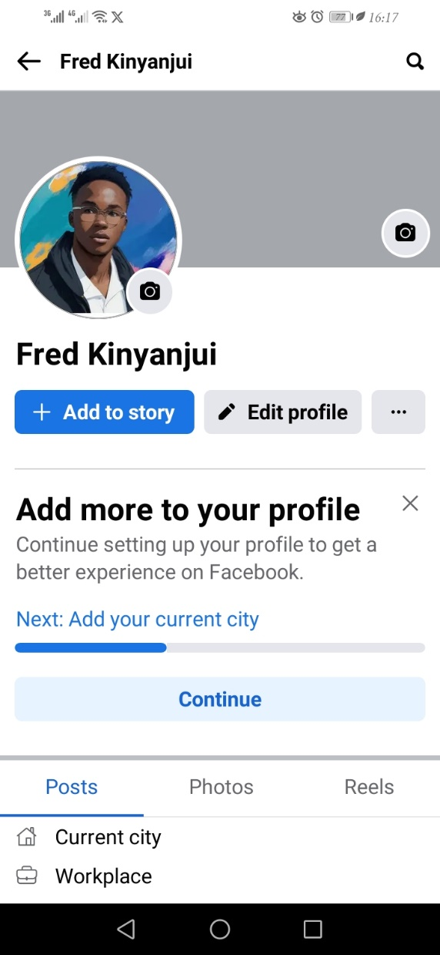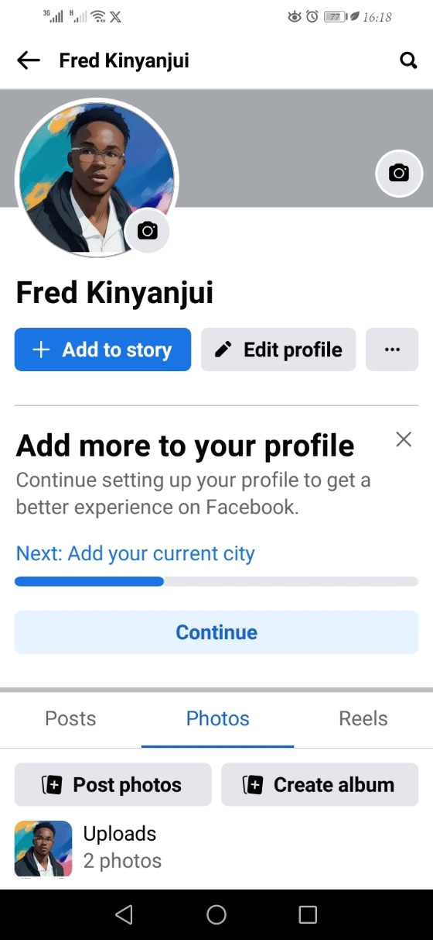

**Twitter account:**

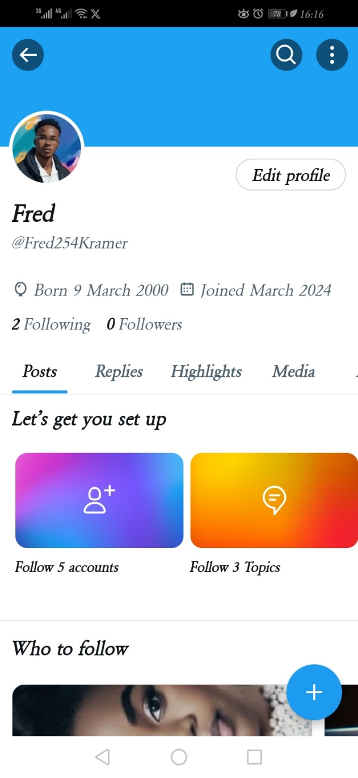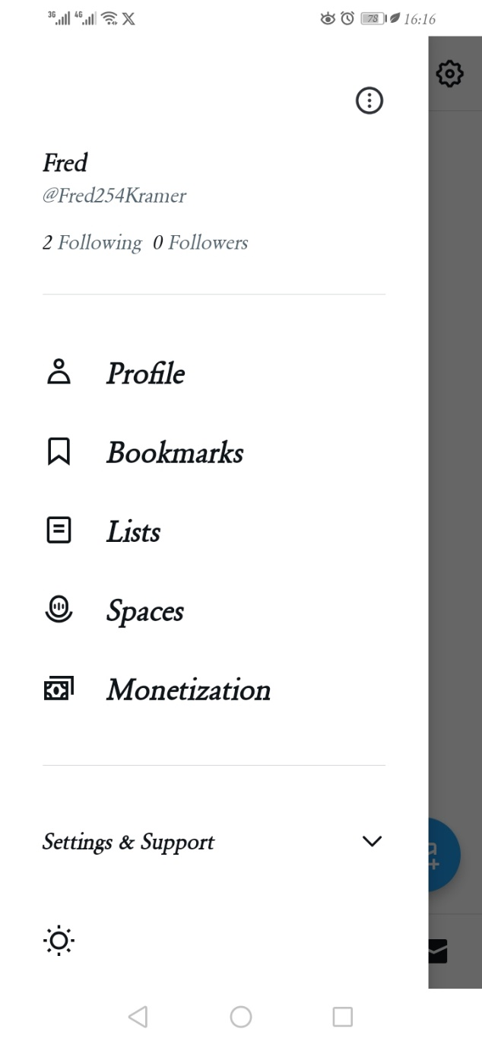

**LinkedIn account:**

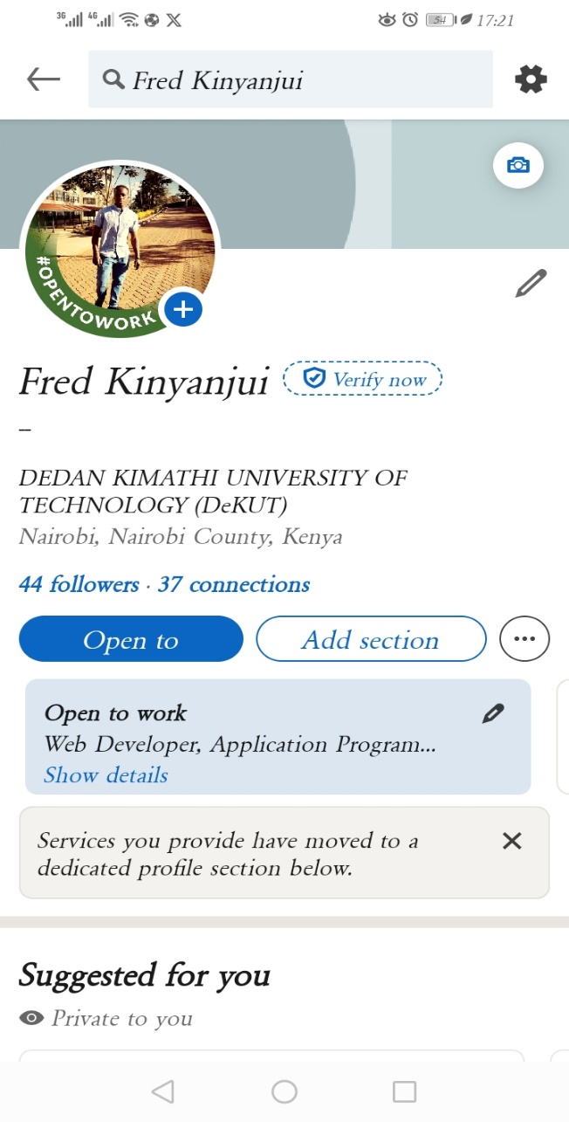 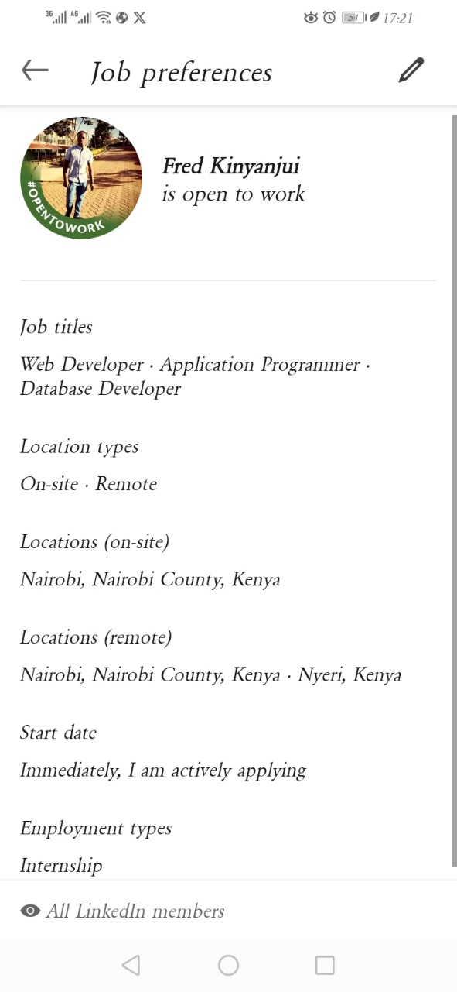

**WhatsApp account:**

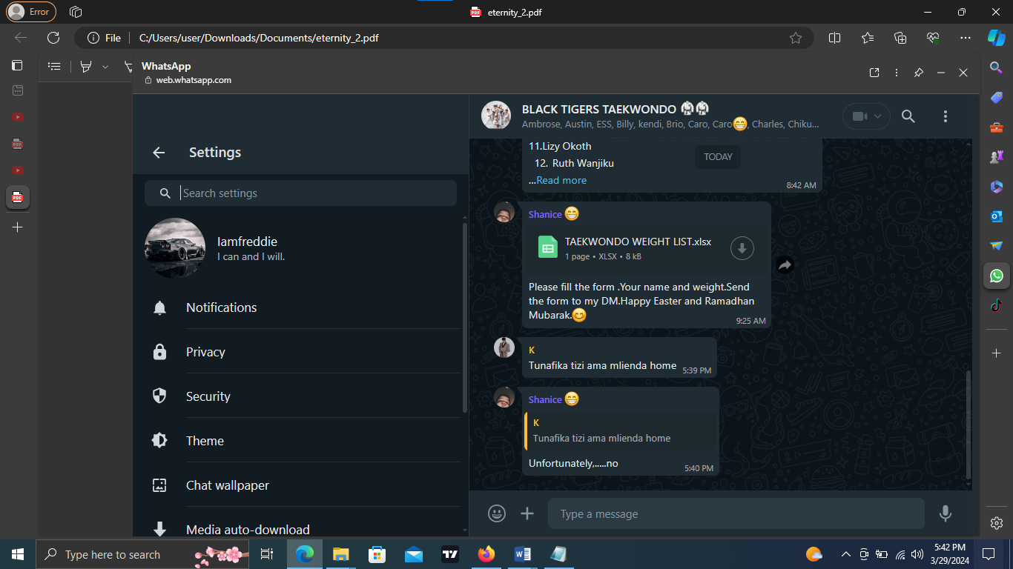

**Instagram account:**

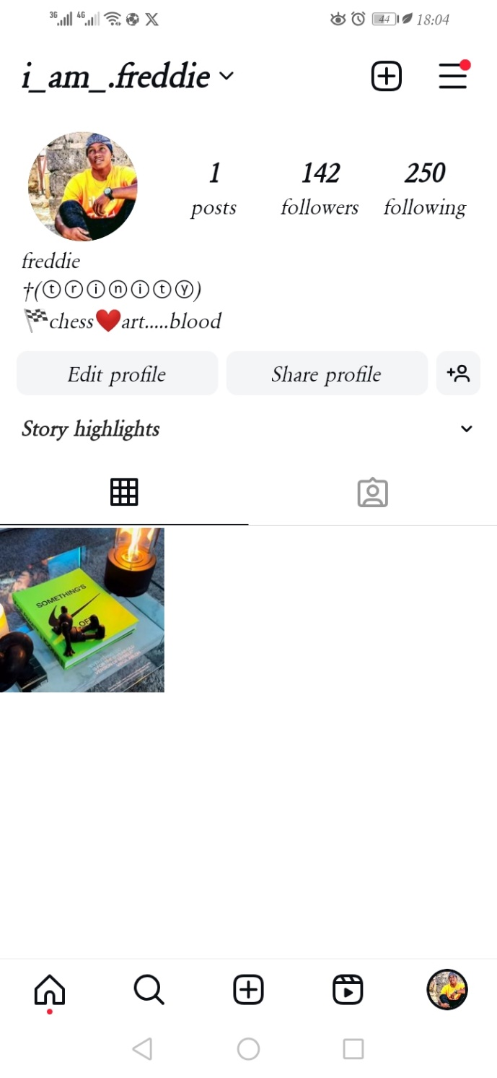

**Youtube:**

