*“****Got a Flat Tire? Change it like a Pro****”*

**Introduction/Overview**

Are you driving a car? It only takes one of your four tires to go flat to throw off your day. But don’t worry, you don’t need to be a mechanic or have a deep understanding of how cars work. By following the steps in this guide, you can change a flat tire in under 20 minutes and handle what might seem like an overwhelming situation with confidence.

**Tools**

* Jack
* Lug Wrench
* Spare tire
* Warning Triangle (Highly recommended for safety)
* Tire Pressure Gauge (Optional)
* Gloves (Optional)
* Flashlight (Optional, if need it)
* Chock (Optional)

**Safety Notes**

If your car has been involved in a major accident and your life is in danger, call 911 immediately. Otherwise, ensure your life is safe and any passengers as well.

**Quick Start**

1. Find a Safe Place to Pull Over.
2. Secure the Vehicle
3. Ensure Passenger Safety
4. Get all the Necessary Tools
5. Set up the Surroundings and Vehicle for Work
6. Loose the Lug Nuts
7. Raise the Vehicle
8. Remove the Lug Nuts and Flat Tire
9. Mount the Spare Tire and the Lug Nuts
10. Lower the Car and Tighten the Lug Nuts
11. Check the Spare Tire Pressure
12. Drive to an Auto Shop

**Glossary**

**Jack** *noun* (EQUIPMENT): a piece of equipment that can be opened slowly under a heavy object such as a car in order to raise it off the ground.

**Lug Wrench** *noun*:a tool for holding and turning objects, especially one that can be made larger and smaller to hold different sized objects.

**Tire Pressure Gauge** *noun:* a tool used to measure the air pressure inside a vehicle's tires.

**Chock** *noun*: a block of wood that can be put under a wheel or a heavy object to prevent it from moving

**Lug Nut** *noun*: a small metal object used for fastening a wheel onto a vehicle

All Definitions are from the *Cambridge Advanced Learner's Dictionary & Thesaurus* © Cambridge University Press

**Steps**

1. ***Find a Safe Place to Pull Over.***

If possible, pull over to a flat, stable area away from traffic. Search for a wide shoulder, parking lot, or quiet side street. Make sure you’re not stopping in front of a fire hydrant, an exit, or any area where parking is illegal. Your safety is the top priority, so choose a spot where you can work without risking harm or violating traffic laws.

1. ***Secure the Vehicle***

Once in a safety area, apply the emergency brake to prevent the car from rolling. Turn on your hazard lights to alert other drivers. Make sure the engine is turned off, this helps keep the car stable, reduces vibrations, and allows the vehicle to cool down while you work.

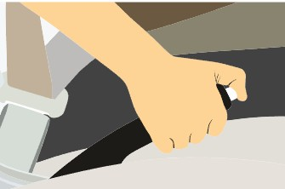

Figure 1. Apply the emergency Brake

1. ***Ensure Passenger Safety***

If you have passengers, make sure they exit the vehicle and move to a safe area away from the road. This helps prevent any potential accidents or distractions while you work. Passengers should remain in the safe area until the tire change is complete and it’s safe to return to the vehicle.

1. ***Get all the Necessary Tools***

Gather your Spare Tire, Jack, Lug Wrench, Warning Triangle, Wheel Chock, and any other useful tools so they’re ready to use.

1. ***Set up the Surroundings and Vehicle for Work***

Place a warning triangle about 10 feet behind the vehicle, facing oncoming traffic, as recommended by the Federal Motor Carrier Safety Administration (FMCSA). Put the wheel Chock in front of or behind the tires to prevent rolling.

Next, Position the Jack under the designated jack points, usually a reinforced area on the frame or under the body. Typically located behind the front wheels or in front of the rear wheels. But **do not raise the vehicle yet.**

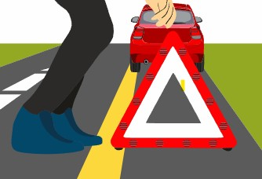

Figure 2. Place Warning Triangle

1. ***Loose the Lug Nuts***

Now, using the lug wrench loose each lug nut on the flat tire. **Do not remove them completely yet** just break the resistance so they’ll be easier to take off later. Place the wrench over a lug nut and turn it counterclockwise (to the left). You may need to use your foot or body weight to get them started if they’re tight.

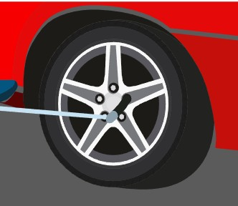

Figure 3. Loosen Lug Nuts

1. ***Raise the Vehicle***

After all the lug nuts are loosened, use the jack to lift the car. Raise the vehicle until the flat tire is completely off the ground and no longer touching the road. If the tire is still in contact with the ground, it may be difficult to remove it due to friction.

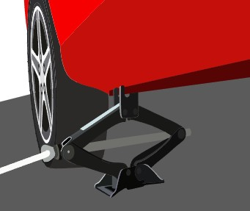

Figure 4. Raise the Vehicle with a Jack

1. ***Remove the Lug Nuts and Flat Tire***

Proceed to fully unscrew and remove the lug nuts by hand. Be sure to place them in a safe spot where they won’t get lost. Once all the lug nuts are off, carefully pull the flat tire straight toward you to remove it from the wheel bolts.

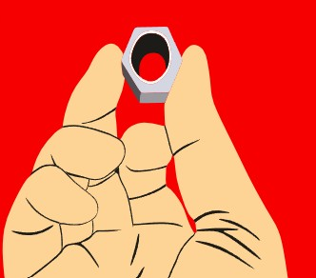

Figure 5. Unscrew the Lug Nuts

1. ***Mount the Spare Tire and the Lug Nuts***

At this point, it's time to mount the spare tire. Line up the holes in the spare tire with the wheel bolts and carefully slide it into place. Once the tire is positioned, screw the lug nuts on by hand. **Do not tighten them all the way yet**, just secure them enough to hold the tire in place**.**

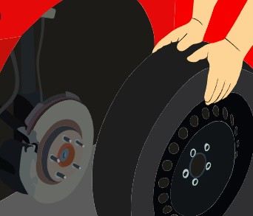

**F**igure 6. Mount the Spare Tire

1. ***Lower the Car and Tighten the Lug Nuts***

Carefully lower the vehicle using the jack, this should be easier than raising it. Once the spare tire is fully in contact with the ground, remove the jack. If it doesn’t come out easily, lower it a bit more until it does.

Now, tighten all the lug nuts firmly using the wrench. Turn them clockwise (to the right) in a crisscross pattern if possible. This helps ensure the tire is secured evenly and safely.



Figure 7. Tighten the Lug Nuts

1. ***Check the Spare Tire Pressure***

Make sure the pressure in the spare tire is the one listed in your vehicle’s owner’s manual or on the driver’s side door sticker. If it has low tire pressure, drive carefully to the nearest service station to inflate it properly.

Proceed to collect all the tools and place them back in your car. Allow your passengers to be back in the vehicle.

1. ***Drive to an Auto Shop***

It’s generally recommended not to drive more than 50-70 miles on a temporary tire. Therefore, head to the nearest tire shop or the one you trust, as soon as possible to get your regular tire repaired or replaced.

**Conclusion**

To summarize, the top priority is your life and your passenger’s life. Always ensure the area is safe to do the work. Also, make sure surrounding drivers are aware of your stranded car by using hazard lights and warning triangles.

By following these steps, you can change a flat tire in minutes, save some money, and manage an overwhelming situation. You can get your car back on the road in minutes. Although, once the spare tire is installed remember to head to the nearest tire shop as soon as possible for a proper replacement or repair.