**Sexual Reproductive Health and Rights (SRHR) CONTENTS**

"Young girls and women are viewed as too youthful to even think about approaching sexuality schooling and family planning or in any event, discussing it, yet in many spots and around us they are getting hitched, getting pregnant, conceiving an offspring and are moms."

* **Key definitions of Sexual Reproductive Health and Rights components**

**KEY MESSAGES**

Access to modern contraception and reproductive health, including access to safe abortion, is an essential aspect of gender equality, economic development, humanitarian response,and progress for all.

For a girl or a woman to reach their greatest potential, they must have control over their sexual and reproductive lives.

Gender equality can be achieved when women and girls sexual health and rights are respected,protected, and accessed.

A world without fear, stigma, or discrimination drives equality and progress for all.

To fulfill women and girls Sexual Reproductive Health and Rights **(**SRHR), adolescents and women in reproductive age must have the knowledge, skills, and tools needed to make safe and informed decisions.

* **Sexual Reproductive Health and Rights Definitions**

A • **Sexual Health (SH):**

Is a state of physical, emotional, mental, and social wellbeing in relation to sexual feelings, considerations, attractions and practices towards others Sexuality.

It encompasses the possibility of pleasurable and safe sexual experiences, free of coercion,

discrimination, and violence. For sexual health to be attained and maintained, the sexual rights

of all persons must be respected, protected, and fulfilled

.

Sexual health include:

• Counselling and care related to sexuality, sexual identity, and sexual relationships

• Prevention and management of sexually transmitted infections (STIs)

• Psychosexual counselling, and treatment for sexual dysfunction and disorders

B. **Sexuality** : sexual feelings, considerations, attractions and practices towards others Sexuality.

.

C **Reproductive Health(RH)**:

Reproductive health is a state of complete physical, mental, and social wellbeing, and not merely the absence of disease or infirmity, in all matters relating to the reproductive system and to its functions and processes.

Reproductive health means people are able to have a satisfying and safe sex life, and that they have the capability to reproduce and the freedom to decide if, when, and how often to do so.

**Reproductive health includes:**

• You receiving accurate information about the reproductive system and the services needed to maintain reproductive health

•You managing menstruation in a hygienic way, in privacy, and with dignity

• You having access to protection services to prevent and respond to intimate partner violence and other forms of gender-based violence, Safe, effective, affordable, and acceptable methods of the contraception method of their choice

• Appropriate healthcare services to ensure safe and healthy pregnancy and childbirth, and healthy infants

• Safe abortion services, including post-abortion care

D **Sexual Rights(SR):**

Sexual rights are human rights and include the right of all persons to

live free from discrimination, coercion, and violence. These are fundamental human rights that are related to sexuality. E.g comprehensive sexuality education, Female Genital Mutulation (FGM), Gender Based Violence(GBV) etc.

**Sexual Rights(SR) includes:**

• Your right to access sexual and reproductive health services

•Your right to look for, receive, and share information related to sexuality and complete, evidence-based,sexuality education

•Your right to having your bodily integrity respected

. Your right to choose your sexual partner(s)

• Your rights to decide whether to be sexually active or not, and to engage in consensual sexual relations

•Your rights to choose whether, when, and whom to marry and to enter into marriage with free and full consent and with equality between spouses during and right to end marriage

•Your rights to pursue a satisfying, safe, and pleasurable sexual life, free from stigma and discrimination

•Rightd to make free, informed, and voluntary decisions about sexuality, sexual orientation, and gender identity

E. **Reproductive Rights(RR):** There are fundamental human rights that are related to a person’s reproductive health.

Reproductive rights gives you the power to decide freely on the number of children you want, space in between your children and timing of their children,

It gives every individual the right to attain the highest standard of reproductive health.

**Reproductive rights include:**

• The right to make decisions concerning reproduction free of discrimination, coercion, and violence

• The right to privacy, confidentiality, respect, and informed consent

• The right to mutually respectful and equitable gender relations

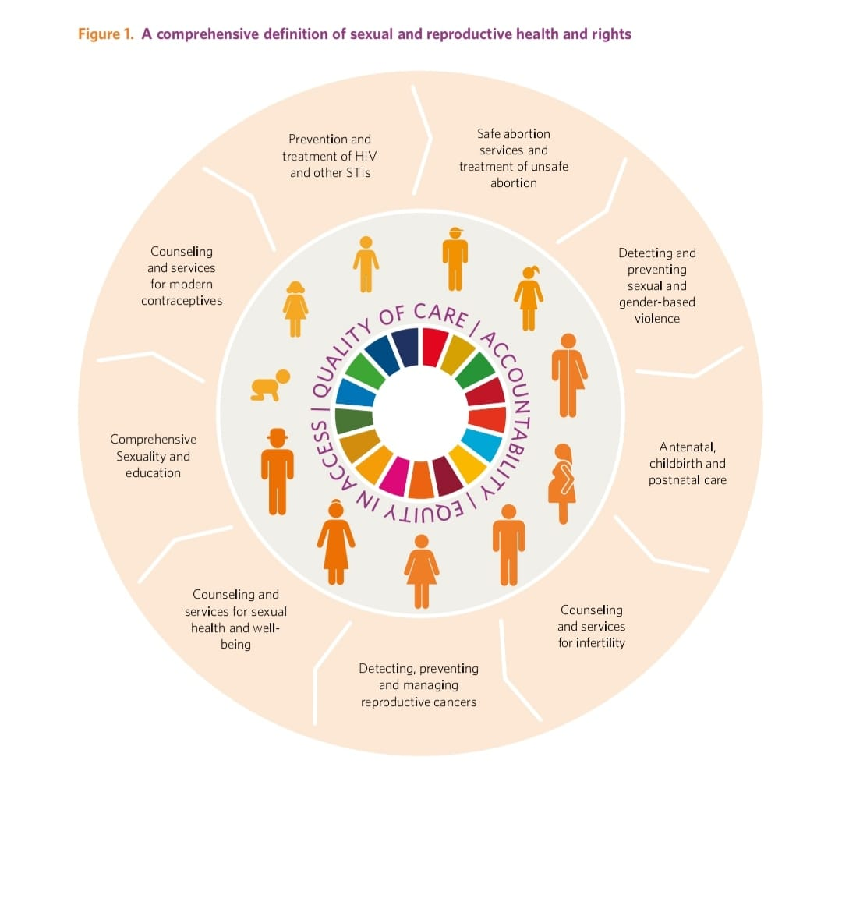

IMAGE SOURCE………………………………… Fig 1. Page 9, **Sexual Reproductive Health and Rights:** an essential element of Universal Health Coverage

• 3. **Why you need Sexual Reproductive Health and Rights (SRHR)**

* + Sexual and reproductive rights gives women and girls the ability to make decisions about their own bodies and sexuality.
  + It keeps women healthy, dignified and safe.
  + SRHR enables girls to decide on their own accord when they want to have sex, how they want it and with who they want it with.
  + Because healthy girls and women are the cornerstone of healthy societies, providing girls and women access to health services throughout their lives creates a healthier and wealthier world.

SOURCE ………………….Adek Bassey

* • **Available Sexual Reproductive Health and Rights services:**
* **Family planning:**  A service provided to allow you decide if and when to be pregnant, have children and control the spacing between your children.

This includes a wide range of contraceptives – including pills, implants, intrauterine devices, surgical procedures that limit fertility, and barrier methods such as condoms – as well as non-invasive methods such as the calendar method and abstinence. (unfpa.or/family planning)

* **Sexual education:** The provision of knowledge about body development, sex,, and relationships. It helps young people in talking about sex and making informed decisions about their sexual health
* **Safe motherhood:** These are services provided to ensure that all women have access to the information and services they need to go safely through pregnancy and childbirth.
* Good management of Sexual Transmitted Infections (STIs) and Sexual TTransmitted Diseases;
* • **Key 5 AvailableSexual Reproductive Health and Rights (SRHR) issues/Barriers:**
* Sexual and reproductive health care service: This is when people have limited access or no access to AvailableSexual Reproductive Health and Rights services available to them.
* Maternal and newborn health and nutrition: issues that come up during pregnancy, childbirth and the first weeks after giving birth, most time it can be death or other complications
* Gender-based violence and harmful practices: This violence that is intentionally directed at an individual based on sex, gender identity, or perceived adherence to socially-defined norms. It includes physical, sexual, and psychological abuse, threats, coercion, arbitrary deprivation of liberty, and economic deprivation.
* Poor overall quality of healthcare system which refers to low standard of healthcare that is being provided
* Inequality : this is a phenomenon in which people are not treated equally as seen in patriarchy. Patriarchy isa system of society or government in which men hold the power and women are largely excluded from it.
* Discrimination: this is an unjust treatment of different categories of people especially on the grounds of sex, race, age and disability, example is seen in racism and sexism
* Access for youths and other marginalized groups: Service delivery models must be modified to serve marginalized groups in a manner that is free of stigma and discrimination. These services need to be youth-friendly, affordable, and respect patient’s privacy and confidentiality.The right to protection and the freedom to live a safe and fulfilling sexual life cannot be denied due to an individual’s sexual orientation, expression, characteristics, or gender identity.
* Societal myths and belief: refers to widely held facts that are false or incorrect. An example is a woman menstruating should not cook in the house or a woman menstruating should not go out and mix with people.m
* Service entirely unavailable: this can be referred to as a situation in which health services can not be obtained or reached
* Unaffordable care: this is when healthcare is too expensive for low income earners
* Lack of information and/or misinformation of sexual reproductive health information services and services available to them.
* Intimate partner attitude and power dynamics. Example the make telling females dont have right over their body or to say no when they dont want to have sex.
* Provider attitudes and bias : A service provider either the nurse or Doctor judging you for coming to seek either for condoms or any other reproductive services.
* Discrimination based on identity factors, such as age, race and disability
* Politics
* Religious opposition. Example your religion can say do not commit abortion or take any family planning services.
* Coercion and lack of informed consent :Example a spouse or husband or guardian forcing you not take have access to any reproductive services.
* Unavailability or stock-outs of preferred contraceptive methods
* Sexual health and rights: An issue where women and girls or individuals are denied or deprived access to their sexual health and rights . which includes the right of all persons to live free from coercion, discrimination and violence related to their sexual rights, such rights include but are not limited to;
* Achieving the highest attainable standard of sexual health, including access to sexual and reproductive health services
* Seeking, receiving, and imparting information related to sexuality and comprehensive, evidence-based sexuality education
* Having their bodily integrity respected and choose their sexual partner(s)
* To decide whether to be sexually active or not, and to engage in consensual sexual relations
* Choosing whether, when, and whom to marry and to enter into marriage with free and full consent and with equality between spouses during and at the dissolution of marriage
* Pursuing a satisfying, safe, and pleasurable sexual life, free from stigma and discrimination •
* Make free, informed, and voluntary decisions about sexuality, sexual orientation, and gender identity.

**What to do after an unprotected sexual intercourse:**

* Visit a health center to see a medical personnel or service provider and seek medical advice

**What are some of the symptoms of a normal menstruation?**

* Moodiness
* Trouble sleeping
* Food cravings
* Cramps in the lower abdomen and back
* Bloating
* Tenderness in the breasts
* Acne
* mood swings
* Irritability
* Headaches
* Tiredness
* low back pain

**Note:** Please note that these symptoms varies for individuals so is possible to have normal menstruation without seeing all of these symptoms.

**Key things to know about menstruation:**

**Your cycle:** Your menstrual cycle begins on the first day of your period.

You either have the following cycles:

1. short cycle that lasts (15 days)
2. Long cycle that lasts for (28 days)
3. Long cycle that lasts for( 35 Days),

However, the cycle varies with individuals and the mid of your cycle is your ovulation day. An example is 28days divided by 2 = 14days which is most people's ovulation day.

**-Right hygienic products to use: explain**

* **Reusable cloth pads:** This are cloths pad that can be used more than one time to manage the female monthly blood flow(Menstruation)
* **Tampons:** A tampon is another menstrual product that absorb blood and vaginal secretions by insertion into the vagina during menstruation.
* **Commercial sanitary pads:** A menstrual pad, or simply pad, is an absorbent item worn by women in their underwear when menstruating, bleeding after giving birth, recovering from gynecologic surgery, experiencing a miscarriage or abortion, or in any other situation where it is necessary to absorb a flow of blood from the vagina.
* **menstrual cups:** These are soft, medical-grade silicone or rubber cups that are put into the vagina to catch the blood flow. You empty the cup every 8-12 hours, rinse it under water, and put it back in.

.

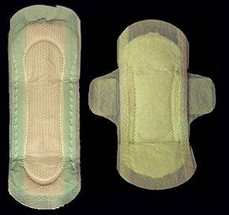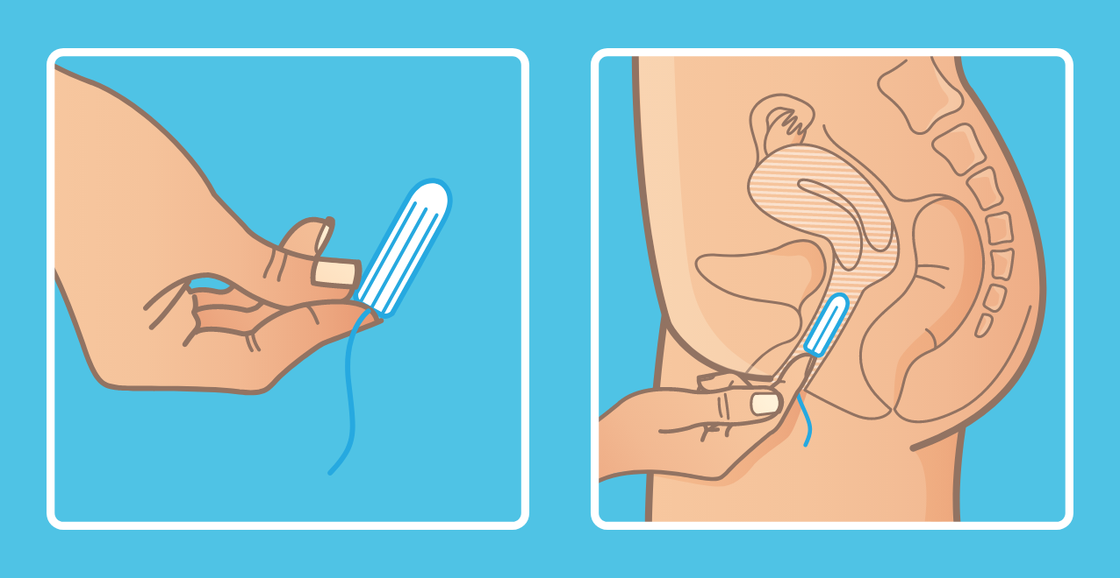

-**Healthy menstrual practices:** Good menstrual hygiene practices includes;

* Washing your vagina at regular intervals don't wait till 8 hours
* Do not keep your pad on for too long
* Do not use soap or other vagina products to wash up
* Dispose your sanitary pads the right way
* Ensure your menstrual products are always clean.

**-Don’ts during menstruation**

Things to avoid during menstruation are:

* Having unprotected sex
* Going to bed without a pad on
* Wearing one pad for a whole day
* Taking coffee
* Eating junk food
* Smoking
* Shaving down there
* Staying up late
* Skipping meals
* Taking sugar
* **Common questions and answers asked**

**What does SRHR stand for?**

Sexual Reproductive Health and Rights

**When we say contraceptive service and supply, what does it mean?**

This includes internal and external condoms, a full array of short-

term methods and long-acting reversible contraception (LARC), and emergency contraception.

**What it means to have access to safe abortion services**:

Access to safe abortion services, including post-abortion care, is a key component of SRH care and an urgent public health need. Restrictive abortion laws and policies put girls’and women’s health in peril.

**What pregnancy related care means**

This consists of antenatal care (also known as prenatal care), skilled attendance at delivery, emergency obstetric care, postpartum, and newborn care.

**Prevention, Diagnosis and Treatment of Sexually Transmitted Infections (STIs)**

This includes, but is not limited to, HIV/AIDS, human papillomavirus (HPV), and other sexually transmitted infections and diseases.

**What age exactly is the most appropriate age for sex?**

The Nigerian constitution defines the age of consent as 18. Hence, you can only consent to engage in sex at the age of 18. But note that sex comes with responsibilities, and puts you at risk of pregnancy, sexually transmitted infections, including HIV/AIDS. Do not engage in sex when you are not ready.

**At what point can someone give consent to sex? Is it before or during sex?**

When you're engaging in sexual activity, consent is about communication. And it should happen every time for every type of activity. It should be given before and during sex

**What symptoms may indicate a need to contact my doctor about my period?**

Contact your doctor or healthcare provider if:

* You have not started menstruating
* Your period stops suddenly
* You are bleeding for more days than 5-7 days
* You are bleeding more heavily than your regular
* You have severe pain during your period
* You have bleeding between periods
* You suddenly feel sick after using tampons
* You think you might be pregnant—for example, you have had sex and your period is at least five days late
* Your period has not returned within three months after stopping birth control pills and you know you are not pregnant
* You have any questions or concerns about your period or possible pregnancy

**Where can you find more informationon Sexual Reproductive Health and Rights(SRHR)?**

* You can get access to more information and link to service providers who you can chat with through downloading the SMARTRR APP from google play store and using the Chatbot.
* You can visit any health facility around you

**Who should learn more about Sexusl Reproductive Health and Rights(SRHR)?**

Everyone should learn more about Sexusl Reproductive Health and Rights(SRHR)

Because Reproductive health is a lifetime concern for both women and men, from infancy to old age, therefore everyone need access

**References**:

* Unfpa.org
* Definitions from Oxford Languages
* Women deliver digital University ( <http://digitaluniversity.womendeliver.org>)
* IMAGE SOURCE………………………………… Fig 1. Page 9, **Sexual Reproductive Health and Rights:** an essential element of Universal Health Coverage
* <https://healththink.org/sex-education-a-step-in-the-right-direction/>
* (unfpa.or/family planning)
* Encyclopedia
* <https://www.familyplanning.org.nz/advice/periods/period-products>