Zonke database
Entity relationship diagram and relationship guide

1. Overview
This document explains how the tables in the Zonke MySQL schema relate to each other. The schema has 21 tables that support jobs, freelancers, proposals, projects, payments, reviews, bounties, messaging, the blog and the contact form.
The diagram on the next page uses crow’s-foot notation and shows only primary keys (PK) and foreign keys (FK) so the relationships stay readable.

How to read the diagram
- A single bar (||) means exactly one.
- A circle and bar (o|) means zero or one.
- A circle and crow’s foot (o{) means zero or many.

2. Entity relationship diagram
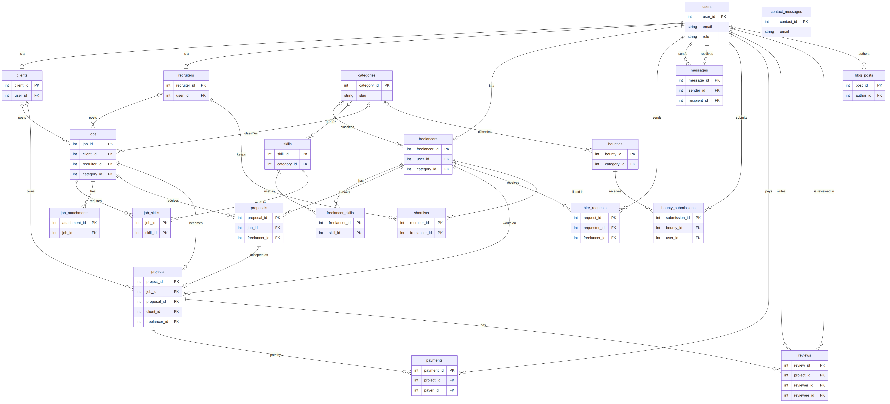

3. How the relationships work

Users are the hub
Clients, recruiters and freelancers are not separate logins. Each is a profile row linked one-to-one to a users row through a UNIQUE user_id. The role column on users says which kind of user it is.

Categories are a shared lookup
Freelancers, skills, jobs and bounties all point to categories. The link is optional, so deleting a category sets the reference to NULL instead of deleting the row.

Skills use two many-to-many links
freelancer_skills joins freelancers to skills and also stores proficiency and years of experience. job_skills joins jobs to the skills they require. Both use composite primary keys.

A job belongs to a client or a recruiter
The jobs table has both client_id and recruiter_id, but only one should be filled in. The schema does not enforce this, so the API layer has to.

The job lifecycle: jobs, proposals, projects
A freelancer submits a proposal to a job, and UNIQUE (job_id, freelancer_id) stops duplicate applications. An accepted proposal becomes a project. Both projects.job_id and projects.proposal_id are UNIQUE, so each job and each proposal produces at most one project.

Payments and reviews hang off projects
One project can have many payments and up to two reviews, one from each side. UNIQUE (project_id, reviewer_id) enforces that limit. Reviews link to users twice, as reviewer and as reviewee. Payments link to users through payer_id.

Hiring, shortlists and messaging
hire_requests goes from a requesting user to a freelancer. shortlists is a many-to-many table between recruiters and freelancers. messages links to users twice, as sender and as recipient.

Bounties
Bounties are a separate mini-system. bounty_submissions links bounties to users, and UNIQUE (bounty_id, user_id) allows one submission per user per bounty.

Blog and contact form
blog_posts only links to users for the author. contact_messages has no foreign keys because it stores public form submissions.

4. Relationship summary
Table | Connects to | Type | Key / rule
clients | users | One-to-one | user_id is UNIQUE
recruiters | users | One-to-one | user_id is UNIQUE
freelancers | users | One-to-one | user_id is UNIQUE
freelancers | categories | Many-to-one | Optional (SET NULL)
skills | categories | Many-to-one | Optional (SET NULL)
freelancer_skills | freelancers, skills | Many-to-many | Composite primary key
job_skills | jobs, skills | Many-to-many | Composite primary key
jobs | clients or recruiters | Many-to-one | One of the two is set
jobs | categories | Many-to-one | Optional (SET NULL)
job_attachments | jobs | Many-to-one | Cascade delete
proposals | jobs, freelancers | Many-to-one | UNIQUE (job_id, freelancer_id)
projects | jobs | One-to-one | job_id is UNIQUE
projects | proposals | One-to-one | proposal_id is UNIQUE
projects | clients, freelancers | Many-to-one | Denormalised for speed
hire_requests | users, freelancers | Many-to-one | requester_id is a user
shortlists | recruiters, freelancers | Many-to-many | Composite primary key
messages | users (twice) | Many-to-one | sender_id, recipient_id
bounties | categories | Many-to-one | Optional (SET NULL)
bounty_submissions | bounties, users | Many-to-one | UNIQUE (bounty_id, user_id)
payments | projects, users | Many-to-one | payer_id is a user
reviews | projects, users (twice) | Many-to-one | UNIQUE (project_id, reviewer_id)
blog_posts | users | Many-to-one | Optional (SET NULL)
contact_messages | None | Standalone | Public contact form

5. Design notes
- Denormalisation: projects stores client_id and freelancer_id even though both can be derived from the job and the proposal. This is deliberate and makes queries faster.
- Cascade deletes: most foreign keys use ON DELETE CASCADE, so deleting a user removes all their dependent rows.
- Payments: the schema stores only the method, status and provider reference, never card numbers or CVVs.
- Views: five views (v_open_jobs, v_freelancer_profiles, v_proposals_detail, v_projects_detail, v_open_bounties) join these tables for the frontend.

