

GOVERNMENT RESOURCE ALLOCATION PROJECTS
TRACKING SYSTEM

This research proposal has been submitted to the University in partial fulfillment of the requirements for the Bachelor of Science degree in year 3 of Computer Technology.
AUGUST 2025

DECLARATION AND APPROVAL
  - STUDENT
I, the undersigned, declare that this proposal is my original work and that it has not been presented in any other university or institution for academic credit.
Signature…………….Date Thursday, December19, 2024………………………………
Names OMWANDO MAKORI FREDRICK ……………………………………………
Reg. No…………CIT-222-054/2021..................................................................................
  - UNIVERSITY SUPERVISOR’S APPROVAL
This research proposal has been submitted for examination with my approval as the University supervisor.
Signature…………………………………………..Date………………………………….
Names…..DR.OGESA.....................................................................................................
Faculty of. COMPUTING AND INFORMATION TECHNOLOGY..................................
  - HEAD OF DEPARTMENT’S APPROVAL
This research proposal has been submitted for examination with my approval as Head of Department.
This research proposal has been submitted for examination with my approval as Head of Department.
Signature…………………………………………Date………………………………………
Names. DR.HENRY NDITI.....................................................................................................
Department of....INFORMATION TECHNOLOGY...............................................................

ACKNOWLEDGEMENT
I first thank the almighty God for his grace that made me come this far. I would most importantly like to express my deepest gratitude to my project supervisor, Dr. Ishmael, for his valuable guidance, constructive feedback, and unwavering support throughout this project. I am also grateful to the Multimedia University of Kenya fraternity for providing me with the necessary resources and facilities to complete the research successfully.
I extend my sincere appreciation to my peers, Steve, Elijah, Vincent, and Zeddie, for their collaboration and encouragement during challenging moments. Lastly, I thank my family for their moral support and understanding throughout this journey.

DEDICATION
  - General Dedication
This project is dedicated to my loving parents, whose unwavering support and encouragement have been my greatest strength.
  - To a mentor:
To Mr. Ishmael Nyakoni, my field supervisor and manager at Ajiry during my Industrial attachment, all this wouldn’t be possible were it not for the experience I had under your supervision at Ajiry.
  - In Memory of:
In memory of Alex Ndiso, my friend, and Juma, my cousin, let this be a testament of the legacy of coding to infinity for a brighter future to continue. And thus may your young souls rest in peace.
  - To Friends:
To all my friends from the performing arts club, this is my special dedication and legacy I leave to you that you may continue to prosper and shine across the entire nation, taking the Multimedia University of Kenya's Name further beyond boundaries.

ABSTRACT
This project presents the design and implementation of the Government Resource Allocation and Project Tracking System (GRAPTS), a centralized digital platform for transparent tracking, monitoring, and evaluation of government‑funded projects. The system integrates geospatial mapping, blockchain‑based audit trails, and machine learning analytics to enhance accountability, efficiency, and citizen engagement in public sector governance. Using a modular architecture, GRAPTS consolidates project data from multiple agencies, enabling real‑time reporting and public dashboards. The solution addresses persistent challenges in project oversight, including data fragmentation, delayed reporting, and limited public access to information. Testing and evaluation demonstrate that GRAPTS improves data accuracy, reduces reporting delays, and strengthens transparency in line with global best practices for open government and digital governance.

Table of Contents
ACKNOWLEDGEMENT ii
DEDICATION iii
ABSTRACT iv
LIST OF ABBREVIATIONS AND ACRONYMS ix
OPERATIONAL DEFINITION OF TERMS x
LIST OF FIGURES xi
CHAPTER One INTRODUCTION 1
1.1. Chapter Introduction 1
1.2. Motivation and Background of the Research 1
1.3. Background of the Research 2
1.4. Problem Statement 4
1.5. Aim of the Research 4
1.6. Objectives of the Research 5
1.6.1. General Objectives 5
1.6.2. Specific Objectives 5
1.6.3. Research Question 6
1.7. Justification of the Research: Addressing Governance Gaps through GRAPTS 6
1.8. Scope of the Research 8
1.9. Research Organization 8
CHAPTER Two REVIEW OF RELATED WORK 9
2.1. Chapter Introduction 9
2.1. History of the Research Topic 9
2.2. Theoritical framework 11
2.3. Review of Related Work bb 11
2.3.1. International Systems 11
2.3.2. Regional Systems 12
2.3.3. Local Systems 13
2.4. Review of Related Prototypes and Systems 13
2.4.1. International Systems 13
2.4.2. Regional Systems 14
2.4.3. Local Systems 14
2.5. Emerging Trends and Patterns 15
2.5.1. AI and Big Data in Project Monitoring 15
2.5.2. Citizen-Centric Dashboards for Public Participation 15
2.5.3. Blockchain for Tamper-Proof Audit Trails 16
2.6. Research Gap 16
2.6.1. AI and Big Data in Project Monitoring 16
2.6.2. Citizen-Centric Dashboards for Public Participation 17
2.6.3. Blockchain for Tamper-Proof Audit Trails 17
2.7. Chapter Summary 18
CHAPTER Three RESEARCH METHODOLOGY 19
3.1. Chapter Introduction 19
3.2. Methodology for Literature Review 19
3.3. Requirement Specification and Data Collection 21
3.4. System Analysis 21
3.4.1. Project life cycle flow 22
3.4.2. System Architecture diagram 23
Elaboration 23
3.4.3. User Interaction flow 25
3.4.4. Data Integration pipeline 26
In-Depth Analysis 26
3.5. System Design 27
3.6. System Implementation 27
3.7. System Testing 28
3.8. System Deployment 28
3.9. Chapter Summary 28
CHAPTER Four SYSTEM ANALYSIS 29
4.1. INTRODUCTION 29
4.2. Requirements Elicitation 29
4.2.1. Functional Requirements 30
4.2.2. Non-Functional Requirements 31
4.3. Stakeholder and Actor Identification 33
4.3.1. Key stakeholders: 34
4.3.2. Use Case Diagram for GRAPTS 34
4.4. Business Process and Data Flow Modeling 36
4.5. Risk and Change Management 37
CHAPTER Five System Design 39
5.1. INTRODUCTION 39
5.2. Architectural Overview 39
5.2.1. Architecture Principles 40
5.3. Component Design 41
5.3.1. Modular Components: 42
Table 5.1: GRAPTS Main Modules 43
5.4. Data Model and Smart Contract Design 43
5.4.1. Smart Contracts 43
5.5. Security and Privacy Considerations 45
5.6. Interface and Usability Design 47
CHAPTER Six Implementation 48
6.1. INTRODUCTION 48
6.2. Technology Stack and Tools 48
6.2.1. Blockchain & Smart Contract 49
6.2.2. Backend 49
6.2.3. Frontend 49
6.2.4. Database 49
6.2.5. DevOps and Testing 49
6.2.6. Technology Stack Comparison 49
6.3. Key Implementation Steps 50
6.3.1. Testing and Deployment Strategies 51
6.4. Challenges in Implementation 51
6.5. System Deployment and Maintenance 52
CHAPTER Seven CONclusions and Recommendations 53
7.1. INTRODUCTION 53
7.2. Summary of Project Outcomes 53
7.3. Policy and Implementation Recommendations 54
7.4. Areas for Further Research 55
APPENDICES 56
Appendix A: Sample Smart Contract (Solidity) 56
APPENDIX B: SAMPLE INTERVIEW/REQUIREMENT GATHERING GUIDE 57
Appendix C: Stakeholder Training Materials Outline 58
Appendix D: System Diagrams 59
Appendix E: Testing and Audit Log Samples 60
REFERENCES 61

LIST OF ABBREVIATIONS AND ACRONYMS

Abbreviation | Definition
GRAPTS | Government Resource & Project Tracking System
DLT | Distributed Ledger Technology
TAM | Technology Acceptance Model
IDT | Innovation Diffusion Theory
API | Application Programming Interface
SCM | Smart Contract Management
MDA | Ministries, Departments, and Agencies
KRA | Kenya Revenue Authority
IFMIS | Integrated Financial Management Information System

Table 0.1, LIST OF ABREVIATIONS AND ACRONYMS (AUTHOR 2025)

OPERATIONAL DEFINITION OF TERMS
- Blockchain: A distributed digital ledger that records transactions immutably and transparently across a peer-to-peer network (Yaga et al., 2018).
- Smart Contract: Self-executing code stored on a blockchain, executing actions when programmed conditions are met (Levi & Lipton, 2018).
- Transparency: Attribute of a system that allows processes, data, and decision-making to be visible and auditable by authorized stakeholders (Levitt et al., 2017).
- Accountability: Obligation of public officials to report, explain, and be answerable for the resulting consequences of decisions (APA Dictionary of Psychology, n.d.).
- Traceability: Ability to chronologically track transactions and project actions throughout the system’s lifecycle (Estler, 2019).
- Immutability: Inability to alter or remove records once written to the blockchain, guaranteeing data integrity (Oxford University Press, n.d.).

LIST OF FIGURES

Figure 3.1.1 PROJECT LIFE CYCLE (AUTHOR 2025) 22
Figure 3.1.2, System Architecture Diagram, Author (2025) 23
Figure 3.1.3, User Interaction Flow, Author (2025) 25
Figure 3.1.4 Data Integration Pipeline, Author (2025) 26
Figure 4.1, USE CASE DIAGRAM FOR GRAPTS (AUTHOR 2025) 35
Figure 4.0.2, BUSINESS PROCESS AND DATA FLOW MODELLING (AUTHOR 2025) 37
Figure 5.3, GRAPTS SYSTEM ARCHITECTURE (LAYERED VS MODULAR) (AUTHOR, 2025) 41
Figure 5.4, SMART CONTRACTS UML CLASS DIAGRAM, (AUTHOR, 2025) 45
Figure 6.5, CI/CD, DEPLOYMENT PIPELINE DIAGRAM, (AUTHOR, 2025) 52
Figure 0.1, SYSTEM FLOW DATA DIAGRAM (AUTHOR 2025) 59

LIST OF TABLES
Table 0.1, LIST OF ABREVIATIONS AND ACRONYMS (AUTHOR 2025) ix
Table 4.1, KEY SYSTEM FUNCTIONAL REQUIREMENT (AUTHOR, 2025) 33

- INTRODUCTION
  - Chapter Introduction
This chapter introduces the research background, problem statement, aim, objectives, justification, and scope of the proposed Government Resource Allocation Projects Tracking System (GRAPTS).
  - Motivation and Background of the Research
Governments worldwide continue to face persistent challenges in efficiently allocating and managing public resources. These challenges are often rooted in systemic issues, such as corruption, inadequate monitoring mechanisms, and fragmented reporting structures, which hinder transparency and accountability. According to the World Bank (2020), such inefficiencies not only compromise the delivery of essential services but also erode public confidence in governance institutions.
In Kenya, these concerns are particularly pronounced. The Office of the Auditor-General has consistently published reports revealing widespread financial irregularities, including unaccounted expenditures, stalled or abandoned development projects, and discrepancies in procurement processes (Office of the Auditor General, 2021). These findings underscore a troubling pattern of resource mismanagement that undermines the effectiveness of government programs and diminishes trust among citizens. When public funds are misused or poorly tracked, the consequences ripple across communities—delaying infrastructure, weakening service delivery, and fostering skepticism toward public institutions.
In response to these challenges, the Government Resource Allocation and Project Tracking System (GRAPTS) emerges as a transformative solution. GRAPTS is designed to serve as a centralized digital platform that enhances the visibility, traceability, and integrity of government-funded initiatives. By integrating real-time data monitoring, standardized reporting templates, and automated alerts for anomalies, GRAPTS empowers oversight bodies, civil society, and citizens to actively engage in the stewardship of public resources.
The core motivation behind GRAPTS is to bridge the gap between resource allocation and project execution. It aims to eliminate opacity in budgeting and implementation cycles by providing a unified interface for tracking expenditures, milestones, and outcomes. Moreover, GRAPTS facilitates cross-agency collaboration, enabling ministries and departments to synchronize efforts and reduce redundancies. Through its modular architecture, the system can be tailored to various sectors—from health and education to infrastructure and agriculture—ensuring scalability and adaptability across diverse governance contexts.
Ultimately, GRAPTS is not just a technical tool; it is a strategic intervention to restore public trust and reinforce democratic accountability. By promoting transparency and enabling data-driven decision-making, GRAPTS contributes to a governance culture where citizens are informed, institutions are responsive, and resources are utilized effectively. In a landscape where public scrutiny is growing and demands for accountability are intensifying, GRAPTS positions itself as a vital pillar in the pursuit of ethical, efficient, and inclusive governance.
  - Background of the Research
In the evolving landscape of public administration, digital governance has emerged as a cornerstone of transparency, efficiency, and citizen engagement. Recognized globally as a best practice for enhancing accountability, digital systems offer governments the tools to streamline operations, reduce corruption, and foster trust among constituents. The United Nations Development Programme (UNDP, 2019) underscores the transformative potential of digital governance in enabling real-time oversight, data-driven decision-making, and inclusive service delivery.
Several countries have pioneered successful models that illustrate the power of centralized digital platforms. Estonia’s e-Governance framework, for instance, has revolutionized public service delivery by integrating secure digital identities, interoperable databases, and automated workflows across government agencies. Similarly, India’s Digital India initiative has expanded access to services, digitized records, and introduced real-time monitoring tools that have significantly improved administrative efficiency and responsiveness (Kettunen & Kallio, 2021). These examples demonstrate that when digital infrastructure is strategically deployed, it can radically improve governance outcomes.
Kenya has made commendable strides in this direction, notably through the implementation of the Integrated Financial Management Information System (IFMIS). IFMIS has enhanced financial control by digitizing budgeting, procurement, and payment processes. However, its scope remains largely confined to fiscal management, lacking the capacity to provide comprehensive visibility into project performance, implementation timelines, and impact metrics (Njenga, 2019). This limitation creates a critical gap in the governance ecosystem—where funds may be tracked, but the actual delivery and outcomes of projects remain opaque.
The Government Resource Allocation and Project Tracking System (GRAPTS) is designed to address this gap. GRAPTS goes beyond financial oversight by integrating real-time project monitoring, performance analytics, and citizen-facing dashboards. It enables stakeholders to track not just how resources are allocated, but how they translate into tangible outcomes on the ground. Through dynamic data visualization, milestone tracking, and anomaly detection, GRAPTS empowers oversight bodies, civil society, and the public to hold implementers accountable and ensure that projects deliver value.
Moreover, GRAPTS introduces a participatory dimension to governance. By providing accessible dashboards and feedback channels, it invites citizens to engage with project data, report discrepancies, and contribute to the evaluation of public initiatives. This fosters a culture of transparency and shared responsibility, where governance is not just top-down but collaborative and responsive.
In essence, GRAPTS represents a paradigm shift in how public projects are managed and evaluated. It aligns Kenya with global digital governance standards while responding to local needs for greater visibility, accountability, and citizen empowerment. As governments worldwide embrace technology to improve service delivery, GRAPTS positions itself as a strategic tool for building trust, enhancing performance, and ensuring that public resources truly serve the public good.
  - Problem Statement
Governments worldwide face recurring challenges in ensuring accountability and transparency in the allocation and utilization of public resources. Key issues include fragmented data systems, delayed reporting mechanisms, inadequate monitoring tools, and limited access to project information by the public. These gaps hinder effective oversight, fuel inefficiencies, and weaken public confidence in governance structures. In Kenya, for example, mismanagement of resources and lack of real-time project tracking have contributed to stalled projects, cost overruns, and corruption scandals. Without an integrated and adaptive digital solution, resource allocation processes will remain vulnerable to inefficiencies and misuse. The proposed GRAPTS platform seeks to bridge these gaps by enabling timely reporting, data integration, and stakeholder access through a secure, transparent, and user-friendly system.
  - Aim of the Research
The central aim of this research is to design and develop the Government Resource Allocation and Project Tracking System (GRAPTS)—a centralized digital platform dedicated to enhancing transparency, accountability, and performance in the management of government-funded projects. In an era where public trust in institutions is increasingly shaped by access to information and demonstrable outcomes, GRAPTS seeks to bridge the gap between resource allocation and project delivery through real-time tracking, integrated monitoring, and citizen-facing evaluation tools.
At its core, GRAPTS is envisioned as a transformative governance solution that addresses longstanding inefficiencies in public project oversight. Traditional financial management systems, while useful for budget control, often lack the granularity and accessibility required to monitor project execution across diverse sectors. This research responds to that limitation by proposing a system architecture that consolidates project data, automates reporting workflows, and visualizes performance metrics in a way that is both actionable for policymakers and accessible to the public.
The design process will focus on modularity, scalability, and interoperability—ensuring that GRAPTS can be adapted to various government departments and integrated with existing platforms such as IFMIS. Key features will include dynamic dashboards, milestone tracking, expenditure mapping, and anomaly detection, all powered by a secure and user-friendly interface. The system will also incorporate citizen feedback mechanisms, enabling participatory governance and fostering a culture of accountability.
Through a combination of technical prototyping, stakeholder engagement, and policy analysis, this research will explore how GRAPTS can be tailored to Kenya’s governance landscape while aligning with global best practices in digital public administration. The ultimate goal is to produce a system that not only improves project completion rates and resource efficiency but also strengthens democratic oversight by making government operations more transparent and inclusive.
By the end of this research, GRAPTS will stand as a proof-of-concept for how digital innovation can be harnessed to rebuild trust in public institutions, empower citizens, and ensure that government-funded projects deliver meaningful impact.
  - Objectives of the Research
    - General Objectives
To develop a modular resource allocation tracking system that enhances transparency and accountability in government projects.
    - Specific Objectives
- To design and prototype a centralized project tracking system that integrates geospatial mapping for real-time visualization of government-funded project locations and progress.
- To implement a modular analytics engine using machine learning algorithms for anomaly detection in project timelines, budget deviations, and procurement inconsistencies.
.
- To develop citizen-facing dashboards with multilingual support and mobile accessibility, enabling inclusive public engagement and feedback on project performance.
- To integrate blockchain-based audit trails for secure, tamper-proof logging of project milestones, financial transactions, and stakeholder approvals.
- To establish interoperability protocols that allow GRAPTS to sync with existing platforms like IFMIS and e-Citizen, enabling seamless data exchange and cross-platform reporting.
- To evaluate the system’s effectiveness through pilot testing in selected counties, measuring improvements in reporting speed, data accuracy, and citizen trust.
    - Research Question

- What are the main functional and transparency gaps in the current public sector project tracking systems in Kenya?
- How can blockchain technology (including smart contracts) be integrated to address traceability and accountability in project management?
- What are the design and architectural considerations for a scalable, secure, and user-friendly project tracking system using blockchain in a developing country context?
- To what extent are public sector stakeholders in Kenya prepared to adopt such technology, and what factors influence their acceptance?
- What technical, legal, and organizational measures are recommended to support the sustainable adoption of blockchain for public sector governance?
  - Justification of the Research: Addressing Governance Gaps through GRAPTS
This study is grounded in the urgent need to address persistent governance challenges in the allocation and oversight of public resources. Across many developing contexts, including Kenya, resource mismanagement continues to undermine service delivery, delay development outcomes, and erode public trust in institutions. Despite the existence of financial control systems, the lack of integrated project monitoring tools has left a critical gap in the governance ecosystem, where funds may be tracked, but the actual execution and impact of projects remain opaque.
Existing literature strongly supports the role of transparent monitoring systems in improving public sector performance. Heeks (2017) emphasizes that digital governance tools—particularly those that enable real-time visibility and citizen engagement—are essential for enhancing accountability and reducing corruption. These systems not only streamline administrative processes but also empower stakeholders to evaluate progress, flag inefficiencies, and ensure that public investments yield tangible results.
In Kenya, the relevance of this research is further reinforced by the country’s long-term development blueprint, Vision 2030. The governance pillar of Vision 2030 calls for a more transparent, accountable, and results-oriented public service. However, current systems such as the Integrated Financial Management Information System (IFMIS) remain limited in scope, focusing primarily on financial transactions without offering comprehensive insights into project performance, geographic coverage, or citizen feedback. This disconnect between financial control and project execution creates a blind spot in public oversight, allowing inefficiencies and mismanagement to persist.
GRAPTS—the Government Resource Allocation and Project Tracking System—is proposed as a strategic response to these challenges. By integrating transparency tools, real-time analytics, and public dashboards, GRAPTS offers a holistic solution that aligns with both academic recommendations and national policy goals. It introduces technologies not currently embedded in existing systems, such as geospatial mapping, anomaly detection algorithms, and blockchain-based audit trails, to ensure that every stage of a project—from budgeting to completion—is visible, verifiable, and accountable.
Moreover, GRAPTS is designed to be citizen-inclusive. Through mobile-accessible dashboards and multilingual interfaces, it democratizes access to project data, enabling communities to monitor developments in their regions and contribute feedback. This participatory approach not only strengthens governance but also fosters civic engagement and trust.
In sum, the justification for this research lies in its potential to transform how public projects are managed, monitored, and evaluated. By addressing systemic gaps and introducing innovative technologies, GRAPTS contributes meaningfully to Kenya’s governance reform agenda and sets a precedent for scalable, transparent digital solutions in public administration.
  - Scope of the Research
The study will focus on selected Kenyan government ministries responsible for infrastructure and social development projects. It will design, develop, test, and evaluate GRAPTS using web-based technologies.
  - Research Organization
Chapter One: Introduction
Chapter Two: Review of Related Work
Chapter Three: Research Methodology
Chapter Four: System Analysis and Design
Chapter Five: Implementation and Testing
Chapter Six: Conclusion and Recommendations

- REVIEW OF RELATED WORK

  - Chapter Introduction

This chapter provides a comprehensive exploration of existing literature, systems, and technological approaches relevant to the development of the Government Resource Allocation and Project Tracking System (GRAPTS). It examines the historical evolution of e‑governance, the theoretical foundations that guide system adoption, and the practical lessons drawn from international, regional, and local implementations. By analyzing both successful models and their limitations, the chapter identifies critical gaps in transparency, interoperability, and citizen engagement that GRAPTS seeks to address. It also highlights emerging trends and innovations that can be adapted to Kenya’s governance context, ensuring the proposed system is informed by proven strategies while remaining responsive to local realities. Ultimately, this review establishes the knowledge base and conceptual framework that underpin the design, development, and deployment of GRAPTS.History of the Research Topic
The adoption of e-governance has undergone a significant transformation since the early 2000s, driven by the global push for more efficient, transparent, and accountable public administration. As governments sought to modernize service delivery and reduce corruption, digital platforms emerged as critical tools for managing public resources, streamlining bureaucratic processes, and enhancing citizen engagement. Heeks (2017) identifies e-governance as a pivotal shift in public sector reform, emphasizing the role of information and communication technologies (ICTs) in improving institutional performance and responsiveness.
Early implementations of e-governance focused primarily on digitizing internal government operations—such as financial management, procurement, and human resource systems. These platforms were often designed with administrative efficiency in mind, rather than public accessibility. As a result, while many governments succeeded in automating back-office functions, they fell short in creating systems that allowed citizens to monitor project outcomes, access real-time data, or participate meaningfully in governance (Bannister & Connolly, 2012).
Globally, countries like Estonia and South Korea have been recognized as pioneers in comprehensive e-governance. Estonia’s X-Road platform, for example, enables secure data exchange across government agencies and provides citizens with access to a wide range of services through a unified digital identity (Kalvet, 2012). Similarly, South Korea’s Government 3.0 initiative promotes open data, citizen participation, and integrated service delivery (OECD, 2016). These models demonstrate that when e-governance is designed with interoperability and user-centered principles, it can significantly enhance transparency and trust.
However, many developing countries have struggled to replicate these successes. In sub-Saharan Africa, e-governance adoption has been uneven, often constrained by limited infrastructure, fragmented systems, and low digital literacy (Ndou, 2004). Kenya, for instance, has made notable progress through platforms like the Integrated Financial Management Information System (IFMIS) and e-Citizen portal. IFMIS has improved budgetary control and procurement transparency, while e-Citizen has digitized access to services such as passport applications and business registration (Njenga, 2019). Yet, these systems remain largely siloed, with limited integration and minimal visibility into project implementation and performance metrics.
Moreover, citizen-facing dashboards—tools that allow the public to track government projects, expenditures, and outcomes—are largely absent in existing platforms. This gap undermines the potential of e-governance to foster participatory accountability. As Bertot, Jaeger, and Grimes (2010) argue, transparency is not achieved merely by digitizing processes; it requires deliberate design choices that make information accessible, understandable, and actionable for citizens.
The lack of real-time monitoring and evaluation tools further compounds the problem. Without integrated analytics, governments struggle to detect anomalies, assess project progress, or respond to implementation delays. This results in inefficiencies, resource wastage, and diminished public trust. According to Transparency International (2022), opaque project management remains a key driver of corruption and poor service delivery in many developing contexts.
In response to these challenges, the Government Resource Allocation and Project Tracking System (GRAPTS) is proposed as a next-generation e-governance solution. GRAPTS builds on the historical evolution of digital governance by addressing its core limitations—namely, fragmentation, lack of interoperability, and exclusion of citizens from oversight processes. By integrating geospatial mapping, real-time analytics, and citizen dashboards, GRAPTS aims to create a centralized platform that not only tracks financial flows but also monitors project milestones, outcomes, and public feedback.
This research is situated within a broader discourse on digital public administration, drawing on global best practices while responding to local governance needs. It contributes to the literature by proposing a system architecture that aligns with Kenya’s Vision 2030 governance goals (Government of Kenya, 2007), and by demonstrating how emerging technologies—such as blockchain audit trails and machine learning anomaly detection—can be harnessed to enhance transparency and accountability.
  - Theoritical framework
This study is anchored on the following theoretical frameworks:
1. Technology Acceptance Model (TAM): This theory explains how perceived usefulness and perceived ease of use influence stakeholders' acceptance of GRAPTS. It helps in assessing user adoption and satisfaction with the system.
2. Systems Theory: This theory views the government resource allocation process as a set of interrelated components. GRAPTS serves as an integrating mechanism, ensuring coordination between budgeting, monitoring, and reporting subsystems.
3. Diffusion of Innovation Theory (Rogers, 2003): This framework explains how innovations are adopted within social systems. It is relevant for understanding how government agencies, auditors, and citizens will embrace GRAPTS over time.
  - Review of Related Work bb
The development of GRAPTS is informed by a rich body of global, regional, and local experiences in digital governance. These systems offer valuable lessons in transparency, efficiency, and citizen engagement—while also revealing critical gaps that GRAPTS aims to address. This section reviews selected platforms that have shaped the discourse on e-governance and public resource monitoring.

    - International Systems
Globally, Estonia stands out as a benchmark for integrated digital governance. Its e-Governance platform, built on the X-Road infrastructure, enables secure data exchange across government agencies and provides citizens with seamless access to services ranging from healthcare to taxation. The system is lauded for its interoperability, user-centered design, and emphasis on digital identity (Kettunen & Kallio, 2021). Estonia’s success demonstrates how centralized digital services can enhance public access, reduce administrative burden, and foster trust in institutions. URL: https://e-estonia.com/solutions/e-governance/
India’s Digital India initiative offers another compelling example. Launched in 2015, the program aims to transform India into a digitally empowered society and knowledge economy. It integrates platforms such as the Public Financial Management System (PFMS), Government e-Marketplace (GeM), and MyGov portal to enable centralized monitoring, procurement transparency, and citizen participation. While challenges remain in rural connectivity and data standardization, Digital India has significantly expanded access to government services and improved administrative efficiency (MeitY, 2022). URL: https://www.digitalindia.gov.in/
These international systems underscore the importance of interoperability, real-time data access, and citizen-facing interfaces—features that GRAPTS seeks to localize and enhance within the Kenyan context.

    - Regional Systems
In East Africa, Rwanda’s UMUCYO e-procurement system represents a regional milestone in digitizing public procurement. Developed under the Rwanda Public Procurement Authority (RPPA), UMUCYO automates tendering, contract management, and supplier registration. It has improved procurement efficiency, reduced manual errors, and enhanced compliance with procurement laws (Mutiganda, 2020). However, the system remains primarily inward-facing, with limited tools for real-time citizen engagement or project performance tracking. URL: https://www.umucyo.gov.rw/
This gap highlights the need for platforms that not only digitize internal workflows but also extend visibility to external stakeholders. GRAPTS addresses this by integrating public dashboards and feedback mechanisms, ensuring that citizens can monitor and evaluate government-funded projects in real time.
    - Local Systems
Kenya has made notable strides in digital governance, particularly through the Integrated Financial Management Information System (IFMIS). IFMIS has streamlined financial reporting, budget execution, and procurement processes across national and county governments. It supports modules for planning, accounting, and supplier management, contributing to improved fiscal discipline (Njenga, 2019). URL: https://www.treasury.go.ke/ifmis/
Despite its strengths, IFMIS remains largely inaccessible to the public and lacks comprehensive project performance monitoring. Citizens cannot easily track how allocated funds translate into tangible outcomes, nor can they engage with project data in a meaningful way. This limitation creates a transparency gap that GRAPTS is designed to fill. By incorporating geospatial mapping, milestone tracking, and citizen dashboards, GRAPTS extends the functionality of existing systems and aligns with Kenya’s Vision 2030 governance goals.
  - Review of Related Prototypes and Systems
The development of the Government Resource Allocation and Project Tracking System (GRAPTS) is informed by a comparative analysis of existing digital governance platforms at the international, regional, and local levels. These systems offer valuable insights into transparency, efficiency, and accountability in public resource management. However, they also reveal critical gaps—particularly in citizen engagement, project performance monitoring, and system interoperability—that GRAPTS seeks to address.
    - International Systems
The World Bank’s Open Aid Partnership (OAP) is a global initiative aimed at improving transparency in donor-funded development projects. By leveraging open data and geospatial mapping, OAP enables stakeholders to visualize aid flows and project locations across countries. It promotes accountability by making donor-funded activities publicly accessible and trackable (World Bank, 2020). However, the platform is primarily donor-centric and lacks integration with local government systems, limiting its utility for national planning and citizen oversight. URL: https://openaid.worldbank.org
This limitation underscores the need for systems like GRAPTS that not only visualize funding flows but also embed local governance structures, enabling real-time tracking of government-funded projects and facilitating cross-agency coordination.
    - Regional Systems
In East Africa, Rwanda’s UMUCYO e-Procurement System represents a significant advancement in digitizing public procurement. Developed under the Rwanda Public Procurement Authority (RPPA), UMUCYO automates tendering, contract management, and supplier registration. It has improved procurement efficiency, reduced manual errors, and enhanced compliance with procurement laws (Mutiganda, 2020). URL: https://www.umucyo.gov.rw
Despite its strengths, UMUCYO is narrowly focused on procurement processes and does not extend to the monitoring of project implementation stages. There is no integrated dashboard for tracking project milestones, budget utilization, or citizen feedback. This creates a transparency gap between procurement and delivery—one that GRAPTS aims to close by offering end-to-end visibility from resource allocation to project completion.
    - Local Systems
Kenya’s Integrated Financial Management Information System (IFMIS) is a flagship platform for automating financial planning, budgeting, and procurement across national and county governments. It has contributed to improved fiscal discipline and reduced manual inefficiencies in public finance management (Njenga, 2019). URL: https://www.treasury.go.ke/ifmis/
However, IFMIS remains largely inward-facing, designed for internal government use with limited public access. It does not provide citizen-facing dashboards or tools for monitoring project implementation and outcomes. As a result, while financial transactions are traceable, the actual performance and impact of government-funded projects remain opaque to the public. This lack of transparency weakens citizen oversight and accountability.
GRAPTS is proposed as a strategic enhancement to existing systems like IFMIS. It introduces technologies not currently embedded in Kenya’s digital governance infrastructure—such as geospatial mapping, machine learning analytics, and blockchain audit trails—to ensure that every stage of a project is visible, verifiable, and accessible to both government actors and the public.
  - Emerging Trends and Patterns
To address the limitations of existing governance platforms, GRAPTS proposes the integration of cutting-edge technologies that enhance transparency, accountability, and citizen engagement. These include artificial intelligence (AI), big data analytics, blockchain, and citizen-centric dashboards—each offering transformative potential for public sector reform.
    - AI and Big Data in Project Monitoring
The integration of AI and big data analytics into public project monitoring enables predictive insights, anomaly detection, and performance forecasting. Machine learning algorithms can analyze vast datasets from procurement records, financial transactions, satellite imagery, and citizen feedback to identify patterns of inefficiency, corruption risks, or delays in implementation. This proactive approach allows governments to intervene early, optimize resource allocation, and improve service delivery outcomes.
For GRAPTS, AI-driven analytics will support real-time monitoring of project milestones, budget adherence, and geospatial progress tracking. By automating data synthesis across ministries and counties, the system can generate dynamic reports and alerts that inform decision-makers and empower oversight bodies.
    - Citizen-Centric Dashboards for Public Participation
Traditional governance platforms often exclude citizens from the monitoring and evaluation process. GRAPTS addresses this gap by incorporating interactive dashboards designed for public use. These dashboards will visualize project locations, budgets, timelines, and performance indicators in accessible formats, enabling citizens to track progress, submit feedback, and flag discrepancies.
This participatory approach fosters trust, strengthens civic engagement, and aligns with global best practices in open government. It also supports Kenya’s constitutional commitment to public participation in governance, as outlined in Article 10 and the Public Finance Management Act.
    - Blockchain for Tamper-Proof Audit Trails
Blockchain technology offers a decentralized and immutable ledger for recording transactions and project activities. Its cryptographic architecture ensures that once data is entered—such as budget approvals, procurement contracts, or milestone completions—it cannot be altered retroactively without detection. This makes blockchain a powerful tool for combating fraud and enhancing auditability.
Zheng et al. (2018) emphasize blockchain’s potential in public administration, noting its ability to “ensure data integrity, transparency, and traceability in multi-stakeholder environments” (p. 558). GRAPTS will leverage blockchain to create secure audit trails for each project, linking financial flows to implementation outcomes and enabling independent verification by auditors, civil society, and citizens.
  - Research Gap
To address the limitations of existing governance platforms, GRAPTS proposes the integration of cutting-edge technologies that enhance transparency, accountability, and citizen engagement. These include artificial intelligence (AI), big data analytics, blockchain, and citizen-centric dashboards—each offering transformative potential for public sector reform.
    - AI and Big Data in Project Monitoring
The integration of AI and big data analytics into public project monitoring enables predictive insights, anomaly detection, and performance forecasting. Machine learning algorithms can analyze vast datasets from procurement records, financial transactions, satellite imagery, and citizen feedback to identify patterns of inefficiency, corruption risks, or delays in implementation. This proactive approach allows governments to intervene early, optimize resource allocation, and improve service delivery outcomes.
For GRAPTS, AI-driven analytics will support real-time monitoring of project milestones, budget adherence, and geospatial progress tracking. By automating data synthesis across ministries and counties, the system can generate dynamic reports and alerts that inform decision-makers and empower oversight bodies.
    - Citizen-Centric Dashboards for Public Participation
Traditional governance platforms often exclude citizens from the monitoring and evaluation process. GRAPTS addresses this gap by incorporating interactive dashboards designed for public use. These dashboards will visualize project locations, budgets, timelines, and performance indicators in accessible formats, enabling citizens to track progress, submit feedback, and flag discrepancies.
This participatory approach fosters trust, strengthens civic engagement, and aligns with global best practices in open government. It also supports Kenya’s constitutional commitment to public participation in governance, as outlined in Article 10 and the Public Finance Management Act.

    - Blockchain for Tamper-Proof Audit Trails
Blockchain technology offers a decentralized and immutable ledger for recording transactions and project activities. Its cryptographic architecture ensures that once data is entered—such as budget approvals, procurement contracts, or milestone completions—it cannot be altered retroactively without detection. This makes blockchain a powerful tool for combating fraud and enhancing auditability.
Zheng et al. (2018) emphasize blockchain’s potential in public administration, noting its ability to “ensure data integrity, transparency, and traceability in multi-stakeholder environments” (p. 558). GRAPTS will leverage blockchain to create secure audit trails for each project, linking financial flows to implementation outcomes and enabling independent verification by auditors, civil society, and citizens.
  - Chapter Summary
This chapter establishes that while existing systems have advanced accountability, significant gaps remain in transparency, real-time monitoring, and citizen engagement.

- RESEARCH METHODOLOGY

  - Chapter Introduction
This chapter presents a detailed analysis of the functional and non-functional requirements that shape the design of the Government Resource Allocation and Project Tracking System (GRAPTS). It outlines the problem definition, user needs, and operational constraints that inform the system’s architecture. The discussion moves from conceptual models to practical design considerations, ensuring that each component aligns with the overarching goals of transparency, accountability, and efficiency. By integrating user-centered design principles with modular and scalable structures, the chapter establishes a blueprint that can adapt to evolving governance needs. The analysis serves as the bridge between theoretical insights from the literature review and the technical implementation that follows.
  - Methodology for Literature Review
This study employs a systematic literature review (SLR) to rigorously examine existing scholarship, policy documents, and case studies related to digital governance and resource tracking systems. The SLR approach is selected for its methodological transparency, replicability, and capacity to synthesize diverse sources across disciplines. By structuring the review around clearly defined objectives and inclusion criteria, the study ensures that the findings are both comprehensive and contextually relevant. The review focuses on identifying global best practices, technological innovations, and persistent gaps in the design and implementation of public sector monitoring platforms, with particular attention to Kenya’s governance landscape.
The scope of the review is guided by four core objectives: to explore international, regional, and local systems used for tracking government-funded projects; to assess the integration of emerging technologies such as artificial intelligence, blockchain, and geospatial analytics; to identify limitations in existing platforms regarding citizen engagement, real-time monitoring, and auditability; and to establish a conceptual foundation for the design of GRAPTS. These objectives reflect the study’s commitment to grounding system design in evidence-based practices while remaining responsive to the unique challenges of Kenya’s public sector.
Source selection is conducted through targeted searches across academic databases, including Scopus, Web of Science, JSTOR, and Google Scholar. The review incorporates peer-reviewed journals, government reports, technical evaluations, and grey literature from international organizations such as the World Bank, UNDP, and Transparency International. Keyword combinations such as “e-governance and project monitoring,” “digital public administration in Kenya,” and “blockchain audit trails” are used to retrieve relevant publications. The inclusion of diverse source types ensures a multidimensional understanding of both technical and institutional dynamics.
To maintain analytical rigor, inclusion criteria are applied to select publications from 2005 onward that focus on digital governance, public finance, transparency, and citizen engagement. Studies must demonstrate methodological soundness and relevance to public sector resource tracking. Excluded materials include opinion pieces lacking empirical evidence, outdated systems unrelated to governance reform, and publications without clear implementation contexts. This filtering process ensures that the literature reviewed contributes meaningfully to the study’s analytical framework and system design goals.
The selected literature is analyzed using thematic coding to extract key insights across five domains: system architecture and interoperability, transparency mechanisms and auditability, citizen participation and dashboard design, technological integration, and governance outcomes. Comparative matrices are developed to contrast system features, stakeholder roles, and implementation contexts. These matrices inform the identification of design principles for GRAPTS and highlight areas where existing systems fall short—particularly in terms of scalability, inclusivity, and real-time responsiveness.
To enhance the validity of findings, the literature review is triangulated with planned expert interviews involving ICT officers, procurement specialists, and civil society actors. Cross-referencing with government audit reports and donor evaluations further strengthens the reliability of insights. Benchmarking against global standards such as the OECD Open Government Framework and UNDP Digital Governance Guidelines ensures that GRAPTS aligns with international best practices while remaining adaptable to Kenya’s institutional realities. This triangulated approach supports a robust foundation for system development.
In sum, the literature review methodology combines systematic search strategies, rigorous selection criteria, and thematic analysis to generate a comprehensive understanding of digital resource tracking systems. By integrating academic, policy, and practitioner perspectives, the review not only identifies best practices but also uncovers critical gaps that GRAPTS seeks to address. This evidence-based approach ensures that the proposed system is both innovative and grounded in the practical needs of governance reform and public accountability.
  - Requirement Specification and Data Collection
The requirement specification process for GRAPTS will involve the systematic identification of both functional and non-functional requirements through structured stakeholder workshops. These workshops will convene key actors, including policymakers, auditors, IT experts, and representatives from civil society, to collaboratively define the system’s core capabilities, performance expectations, and user interface needs. Functional requirements will focus on the system’s ability to track project milestones, visualize budget allocations, and generate real-time analytics, while non-functional requirements will address scalability, security, interoperability, and usability. The participatory nature of these workshops ensures that the system design reflects the practical realities of governance workflows and aligns with the expectations of diverse user groups.
To complement the workshops, a multi-method data collection strategy will be employed. This will include semi-structured interviews with government officials and technical staff to capture experiential insights and operational constraints. Questionnaires will be distributed to a broader pool of stakeholders to gather quantitative data on system needs, user preferences, and perceived gaps in existing platforms. Additionally, document reviews will be conducted to analyze policy frameworks, audit reports, and technical manuals related to IFMIS, e-Citizen, and other relevant systems. This triangulated approach ensures that the requirement specification is both evidence-based and context-sensitive, laying a robust foundation for the design and implementation of GRAPTS.
  - System Analysis
Current project tracking processes will be modeled using Data Flow Diagrams (DFDs), context diagrams, and flowcharts.
    - Project life cycle flow
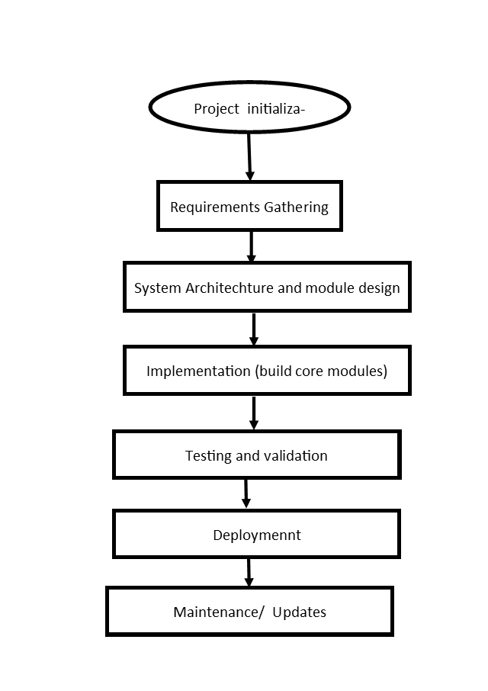
Figure 3.1.1 PROJECT LIFE CYCLE (AUTHOR 2025)
    - System Architecture diagram
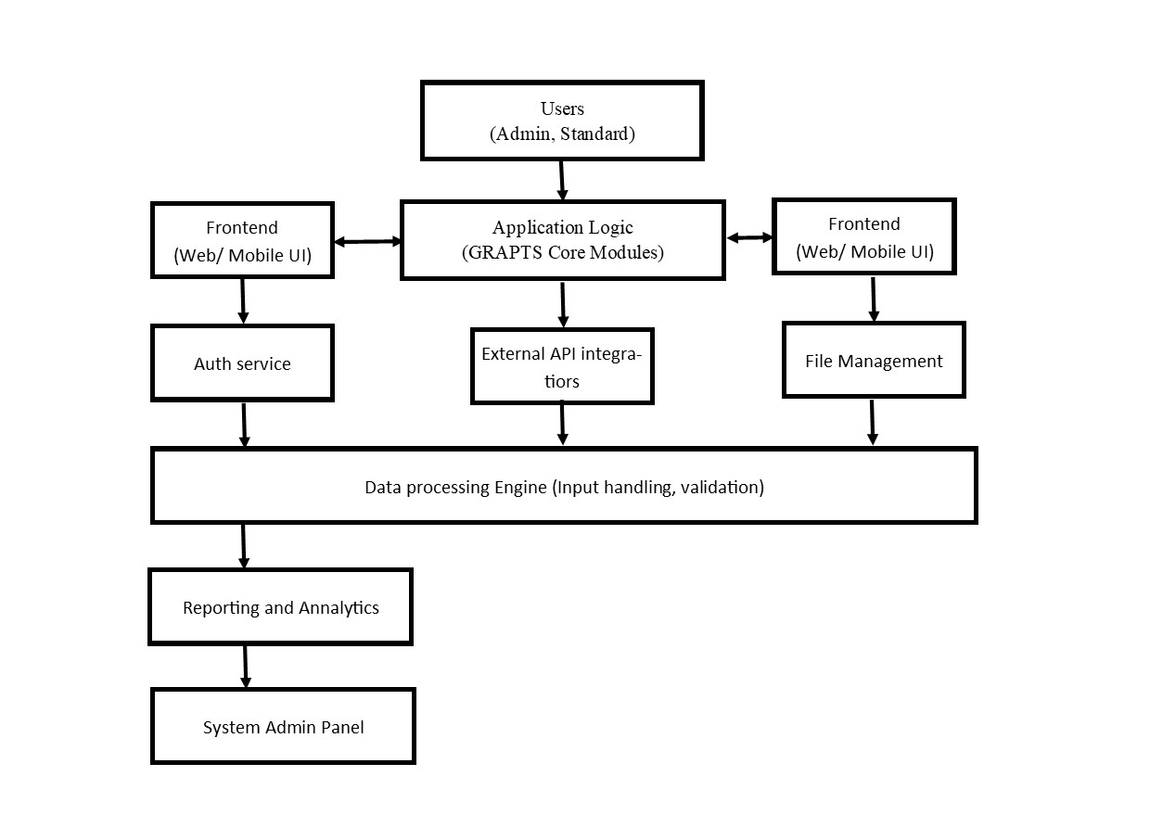
Figure 3.1.2, System Architecture Diagram, Author (2025)

Elaboration
The architecture of the GRAPTS system features a layered, modular design—a best practice in enterprise platform architectures7.
Users (Admin, Standard): Entry point for different user segments, providing authentication and contextualized access.
Frontend Layer: Offers responsive web/mobile interfaces, linking user actions directly to backend services through RESTful APIs or Web Sockets, as dictated by scalability requirements. This separation enables seamless user experience updates without backend disruption.
Application Logic (GRAPTS Core Modules): The heart of the system, encapsulating business logic such as form validation, data aggregation, and workflow orchestration.
Database (Central Repo): A relational or NoSQL store, chosen based on the need for structured versus semi-structured data, storing persistent user records, audit trails, and business domain entities.
Augh Service: Implements robust authentication and authorization layers, managing user sessions and enforcing access controls (Role-Based Access Control—RBAC—or Attribute-based, as appropriate).
External API Integrators: Allow connectivity with third-party systems (e.g., legacy platforms, government registries, mapping services), supporting data import/export, and facilitating interoperability.
File Management: Handles large asset uploads (documents, spreadsheets), applying validation (e.g., file type, schema checks) and virus scanning as per compliance mandates.
Data Processing Engine: Provides synchronous/asynchronous data validation, cleansing, and transformation—crucial for upholding data quality and automating downstream processes.
Reporting & Analytics: Generates ad-hoc and scheduled reports, interactive dashboards, and data exports.
System Admin Panel: Reserved for privileged activities such as configuration management, audit inspection, and batch job scheduling.
Each module is coupled with explicit interfaces (e.g., API contracts, event buses), maximizing maintainability and scalability. This modular concept enables parallel development, easier updates, and testing in isolation, reducing regression risk and supporting continuous integration/deployment pipelines.
    - User Interaction flow
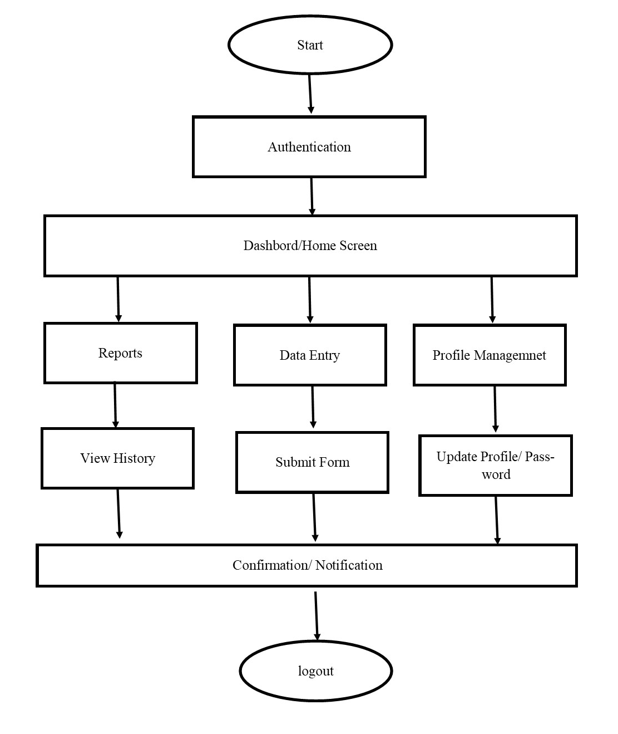
Figure 3.1.3, User Interaction Flow, Author (2025)
    - Data Integration pipeline
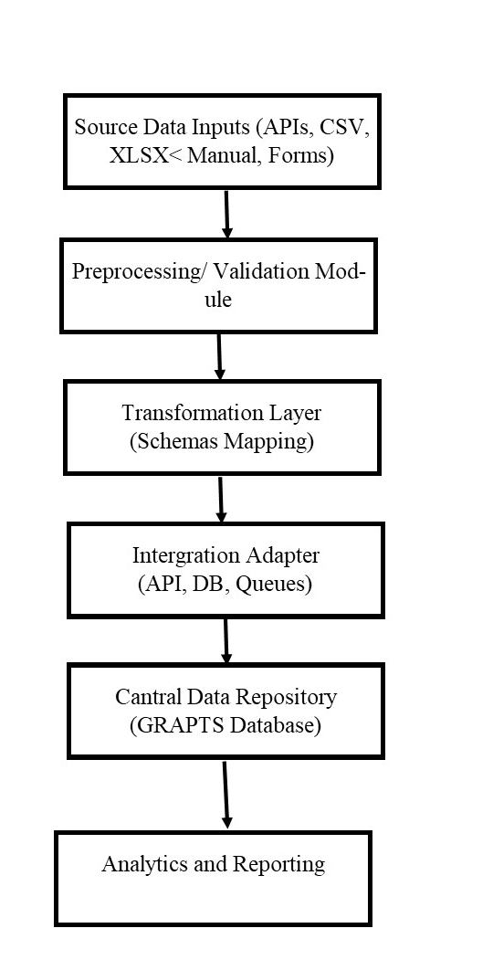
Figure 3.1.4 Data Integration Pipeline, Author (2025)

In-Depth Analysis
The GRAPTS data integration pipeline is engineered to support a broad range of ingest sources, including programmatic (APIs, database connectors), user-driven (manual input, file uploads), and third-party application feeds.
Source Data Inputs: Integration begins by accepting disparate formats—structured (CSV/XLSX), unstructured (free-text), and machine-generated (APIs, sensors).
Pre-processing/Validation: The pipeline applies validation rules, including type checking, format normalization, de-duplication, and constraining values to known domains (e.g., enumeration lists), immediately rejecting or flagging suspect entries for remediation. This step is vital in maintaining data quality and enabling traceability of errors11.
Transformation Layer: Converts inbound data into internal data structures, applying schema mapping, unit conversions, and referential integrity enforcement. Advanced setups may implement streaming transforms for near-real-time updates.
Integration Adapter: Acts as the interface layer, harmonizing data between external sources and the GRAPTS system via mapped APIs, batch jobs, or direct database writes. For high-volume or event-driven use cases, message brokers or queues are utilized to decouple systems, ensuring reliability and scalability.
Central Data Repository: The integrated, validated, and transformed records are persisted here, supporting both transactional and analytical queries. Backup and disaster recovery protocols are strictly enforced at this layer.
Analytics & Reporting: Downstream modules utilize high-quality data to generate metrics, audits, scheduled and ad-hoc reports, which are then fed into customizable dashboards.
The pipeline design facilitates modularity, error handling, and easy extension when new data sources or regulatory requirements emerge. Each handoff point in the pipeline is decoupled using industry-standard patterns, supporting monitoring, auditing, and fallback procedures.

  - System Design
- Database Design: Centralized, secure relational database.
- System Design Tools: Use case diagrams, sequence diagrams, pseudocode.
- Prototypes: Dashboard and reporting modules will be prototyped for stakeholder validation.
  - System Implementation
- Front-End: React.js
- Back-End: Node.js
- Database: Firebase/SQL
- Deployment: Cloud-hosted solution for accessibility.
  - System Testing
Testing phases will include:
- Unit Testing
- Integration Testing
- System Testing
- User Acceptance Testing (UAT) with government staff.
  - System Deployment
The system will be deployed in phases, starting with pilot ministries before scaling to national adoption. Training sessions will be provided to end-users.
  - Chapter Summary
This chapter provides a structured roadmap for developing, implementing, and deploying GRAPTS.

- SYSTEM ANALYSIS
  - INTRODUCTION

This chapter describes the process of translating the GRAPTS design into a functional, operational system. It details the development environment, programming frameworks, and database structures used to bring the conceptual architecture to life. The focus is on how each module was coded, integrated, and tested to ensure reliability, security, and performance. Special attention is given to workflow automation, data validation, and interoperability with existing government systems. By documenting the implementation process step‑by‑step, this chapter provides a transparent account of how design specifications were transformed into a working solution.
  - Requirements Elicitation

Requirements elicitation for GRAPTS involves systematic gathering of needs from diverse users and systems. Given GRAPTS’s mission to enhance transparency in public projects, this step emphasizes inclusive participation and alignment with standards like the Open Contracting Data Standard (OCDS). Workshops and interviews bring together officials from the National Treasury, procurement regulators (e.g., PPRA), IT staff, auditors, and citizen advocacy groups (Open Government Partnership – Kenya, 2020; World Bank, 2020). These sessions use structured techniques (surveys, focus groups, user stories) to reveal gaps in existing systems (e.g., IFMIS) and to capture desired features. For example, participants may identify the need for public-facing dashboards, real-time alerts on disbursements, and integration with e-procurement portals. The elicitation process also surveys technical constraints and regulatory contexts, such as Kenya’s Data Protection Act (2019) and interoperability with legacy platforms. This comprehensive approach ensures that requirements reflect stakeholder priorities for traceability, performance, and usability. The result is a clear specification of GRAPTS’s scope, from core services to governance standards.

Critically, the elicitation process prioritizes transparency and accountability as guiding principles. It explicitly seeks inputs on how GRAPTS should align with the OCDS and Kenya’s procurement reforms under the Public Procurement and Asset Disposal Act to publish high-quality data on planning, tendering, contracting, implementation, and oversight (Open Government Partnership – Kenya, 2020; World Bank, 2020). This means the system must be designed to output procurement and contract data in open-standard formats. Elicitation also surfaces performance and security concerns: for instance, auditors stress immutable logging of transactions — a blockchain feature — while citizens and civil society demand intuitive visualizations of project budgets and progress. By thoroughly documenting these elicited needs, the analysis ensures that subsequent design addresses both functional capabilities (what the system does) and non-functional qualities (how well it performs under constraints).

    - Functional Requirements

Functional requirements define the core system capabilities that allow GRAPTS to meet its transparency and accountability objectives. For example, project registration and onboarding are restricted to authorized managers to prevent unauthorized creation of phantom projects, a recurring challenge in public finance systems in developing economies (World Bank, 2024). Similarly, disbursement tracking through blockchain-based transactions guarantees immutability and enhances citizen trust by offering tamper-proof records of fund releases (Zhang & Jacobsen, 2021). By encoding milestones in smart contracts, the system reduces manual delays, ensuring timely payments and minimizing corruption risks often associated with discretionary approvals in procurement (Open Contracting Partnership, 2023).
Additional functional needs include analytics and alerting: the system should provide anomaly detection on timelines and budgets (e.g., flagging cost overruns or missed milestones) and automatically notify oversight bodies. Interactive reporting dashboards are required – including geospatial maps of project sites – to support policy-makers and the public in monitoring progress. A strong emphasis on collaboration emerges: GRAPTS will support cross-agency workflows, allowing one MDA’s projects to reference related projects in another, and enabling joint reporting where projects overlap (e.g., infrastructure projects spanning national and county governments). Finally, a fundamental functional requirement is audit trail and verification: every transaction (budget release, contract award, project update) must be immutably recorded. Blockchain-based smart contracts will encode milestones and disbursement rules, ensuring payments occur only when predefined conditions are met (e.g., successful completion of a milestone) (Zhang & Jacobsen, 2021; Zheng et al., 2018). In summary, the functional requirements make GRAPTS an integrated platform for project registration, finance tracking, performance analytics, and citizen engagement, all underpinned by open data and security standards. To clarify the project must ensure the following:
- Project Registration and Onboarding: Only authorized project managers may register new projects.
- Resource Allocation/Disbursement Tracking: All disbursements are recorded as blockchain transactions.
- Milestone Management: Automated smart contract triggers for milestone completion and verification.
- Role-Based Access Control: Distinct permissions for project managers, auditors, ministry executives, vendors, and citizens.
- Real-Time Audit Reports: Traceability of actions, funds, and documentation.
- Complaint/Issue Resolution Tracking: Lodging, escalation, and closure of stakeholder issues on-chain.
- Vendor Performance Assessment: Immutable logs fed by project outcome and delivery data.
    - Non-Functional Requirements
Non-functional requirements (NFRs) specify how GRAPTS must perform under technical and operational constraints. Security and data integrity are paramount: GRAPTS must guarantee confidentiality of sensitive data (e.g., personal details of contractors or financial details not public by law) and enforce multi-layer authentication. Role-based access controls will restrict functions (for example, only authorized auditors can verify transactions on the blockchain), and all data in transit or at rest will use strong encryption (Zhang & Jacobsen, 2021; Zheng et al., 2018). Blockchain’s cryptographic immutability also supports audit needs: once recorded, transaction data cannot be altered without detection, aligning with the requirement for tamper-proof logs (Zhang & Jacobsen, 2021; Zheng et al., 2018). Performance and scalability are critical: GRAPTS must support real-time querying of a large volume of projects across national and county levels. It should handle concurrent dashboard queries by thousands of users (citizens, officials) without significant delays. The system architecture will therefore use scalable cloud services and efficient APIs. Interoperability is another key NFR: GRAPTS must integrate seamlessly with existing government systems (e.g., IFMIS, eCitizen) via well-documented APIs, adhering to standards like RESTful JSON or government data exchange protocols (e.g., X-Road) (Mutiganda, 2020; Kettunen & Kallio, 2021). This ensures GRAPTS can both consume and publish data in formats used by partner systems. Usability and accessibility also shape GRAPTS: interfaces (dashboards and input forms) must be intuitive and available in English and Swahili, following e-government design guidelines. Given Kenya’s digital-divide challenges, the system requires responsive design (for mobile access) and compliance with web accessibility standards to serve users with disabilities. Moreover, a non-functional expectation is maintainability and extensibility: the codebase should use modular design (microservices) so that future features (e.g., additional analytics) can be added without refactoring the whole system (Bryson, 2018). Finally, compliance and legal considerations: GRAPTS must adhere to Kenya’s IT and procurement laws, supporting audit workflows of the Auditor-General. For example, it should enable generation of legally admissible reports and logs. Collectively, these NFRs ensure GRAPTS operates reliably, securely, and in alignment with governance mandates. Other key non-functional requirements include:
- Immutability and Security: All transactions are logged on an append-only blockchain.
- Interoperability: APIs for integration with existing digital finance and reporting platforms.
- User-Friendly Interface: Accessible to users with varying technical skills.
- Scalability: Optimized for growth from a pilot ministry to all MDAs.
- Compliance: Adherence to relevant legal, data privacy, and procurement frameworks.

Requirement | Description
Project Tracking | Register, update, and monitor projects
Disbursement Recording | Log all funds on the blockchain ledger.
Milestone Verification | Smart contracts for enforcing milestones
Access Control | Role-based permissions
Audit Trail | Immutable activity and financial logs
Issue Management | Transparent complaints and resolutions
External API Integration | Link to e-Citizen, IFMIS, legacy systems

Table 4.1, KEY SYSTEM FUNCTIONAL REQUIREMENT (AUTHOR, 2025)
  - Stakeholder and Actor Identification
A robust GRAPTS design requires clear identification of all stakeholders and system actors. Stakeholders span government, oversight agencies, citizens, and technical partners. Key government stakeholders include budget and planning officials (e.g. National Treasury, county finance departments) who allocate funding; line ministry/project managers who implement projects; and procurement authorities (e.g. PPRA) that oversee contracting. Oversight actors include the Auditor-General’s Office and anti-corruption agencies (EACC), which will use GRAPTS for audits; parliamentary committees on finance; and civil society organizations (CSOs) that monitor public projects. External partners include donors and development agencies with interest in project outcomes. Among stakeholders, citizens and media serve as watchdogs empowered by GRAPTS’s transparency features. We will create stakeholder profiles and a RACI matrix (Responsible, Accountable, Consulted, and Informed) to clarify expectations and ensure engagement (Bryson, 2018).
Actors are the roles that interact with the system. For GRAPTS, the primary human actors are: (1) System Administrator – maintains the platform and user roles; (2) MDA Official – enters project details, updates progress, and triggers milestone events; (3) Financial Officer – records disbursements from IFMIS and links them to projects; (4) Auditor/Reviewer – verifies records on the blockchain, approves milestone completion; (5) Citizen/User – accesses dashboards and submits feedback or complaints. We also define software actors: (a) the IFMIS/E-Procurement Adapter – a service account that pulls data from government financial systems via API; (b) the Blockchain Network – a distributed ledger component (permissioned nodes run by government or trusted third parties) that processes smart contracts and logs; (c) the Analytics Engine – processes data for anomaly detection. By clearly defining these actors and their privileges (e.g. read/write permissions), we ensure the use cases accurately capture interactions.

    - Key stakeholders:
The key stakeholders for GRAPTS include multiple government bodies and non-governmental entities, each with distinct interests. The Treasury and Finance Ministry want to improve budget execution oversight and reduce leakages. The Ministry of ICT or e-Government is interested in the technical integration and innovation aspects. Procuring entities (ministerial procurement officers) will use GRAPTS to publish tenders and contracts, aligning with the OCDS. County governments are stakeholders too, as they also allocate funds to local projects; GRAPTS must support devolved projects and integrate with county IFMIS data. Oversight stakeholders such as the Auditor-General, Ethics and Anti-Corruption Commission (EACC), and Public Accounts Committees will rely on GRAPTS for timely audit data and red-flag alerts. Public procurement regulators (PPRA) may use GRAPTS data to monitor compliance with procurement law. Critically, citizens and CSOs are active stakeholders: they demand access to the system’s dashboards and are empowered to report discrepancies. The design thus allocates them “read” access to non-sensitive data, reflecting the Open Government principle that government-held information should be freely available to the public (Open Government Partnership – Kenya, 2020; World Bank, 2020). By mapping these stakeholders and their objectives, the analysis ensures GRAPTS delivers value to all parties and gains broad support for adoption.
    - Use Case Diagram for GRAPTS
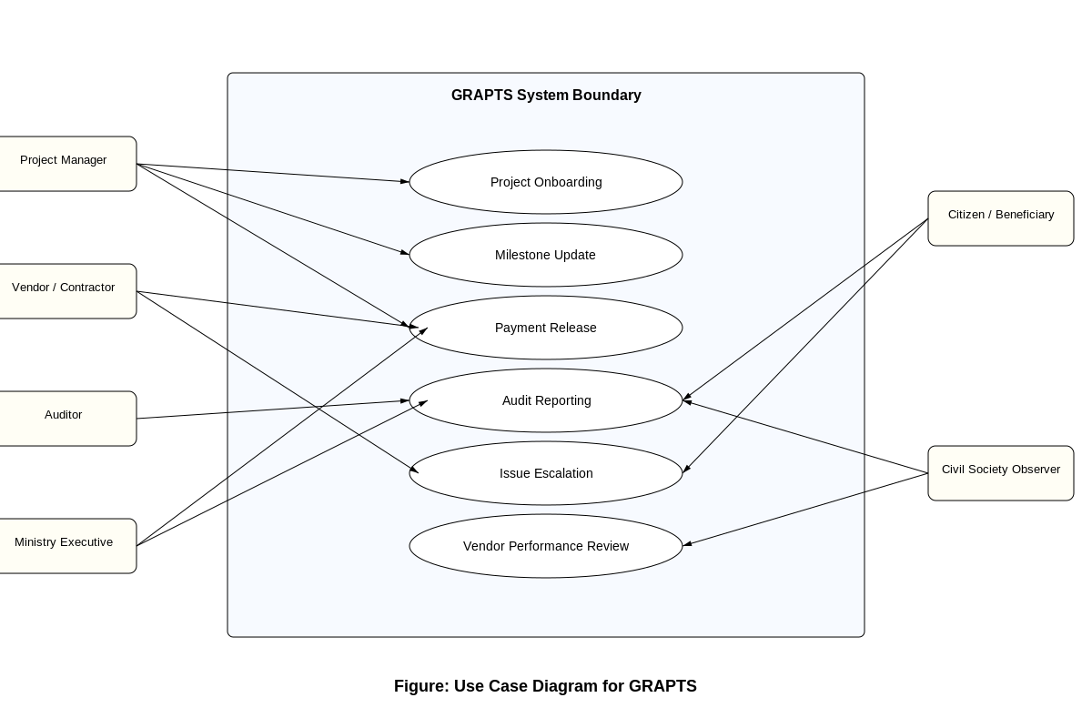
Figure 4.1, USE CASE DIAGRAM FOR GRAPTS (AUTHOR 2025)
The use case diagram (Figure 4.1) visualizes these actors and their interactions with GRAPTS’s functionalities. Core use cases include Register Project, Update Project Status, Allocate Budget/Disburse Funds, Execute Smart Contract, Generate Report, View Dashboard, and Submit Feedback. For example, the “MDA Official” actor can invoke “Register Project” or “Update Status,” while the “Financial Officer” triggers “Allocate Budget” events that feed into GRAPTS and are confirmed via smart contract execution. The “Auditor” actor can perform “Verify Transactions” and “Run Audit Reports,” interacting with the immutable ledger. The “Citizen” actor can access “View Dashboard” and “Provide Feedback,” engaging the system as intended by e-Government principles (Open Government Partnership – Kenya, 2020). System blocks in the diagram represent modules (e.g., Analytics Engine, Smart Contract Module, and API Interface). The diagram is derived from the requirements: every functional requirement corresponds to at least one use case, and the actors align with our earlier identification. This use-case model drives the next step of transforming requirements into an implementable architecture.
  - Business Process and Data Flow Modeling
To clarify how GRAPTS will function in practice, modelling has been done its core business processes and data flows. The business process modeling uses a high-level workflow: starting from Project Initiation, where a project is created with defined budget and milestones, through Procurement and Contracting, Milestone Verification, and Completion Reporting. For instance, in the Project Initiation process, an MDA Official inputs project details into GRAPTS, which then triggers a “deploy smart contract” step on the blockchain that encodes funding conditions. During the Procurement process, each contract award recorded in IFMIS is automatically ingested via API into GRAPTS, updating the project budget allocation. As milestones occur, the process includes steps where site engineers or managers verify completion (possibly using Iota or geotagged photos), and the system releases payments via the blockchain once conditions are met (Zhang & Jacobsen, 2021; Zheng et al., 2018). At each stage, responsibilities and approvals are defined in the model, supporting accountability.
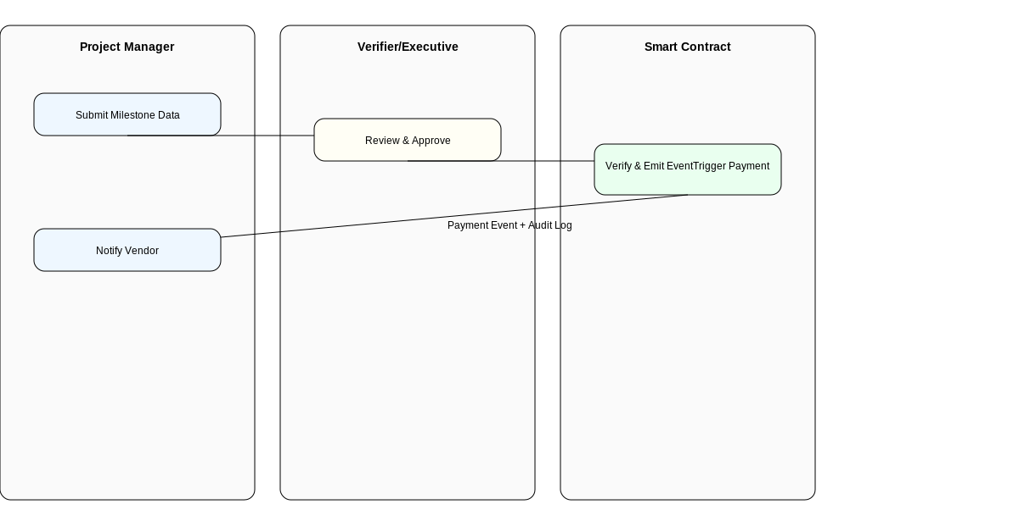
Figure 4.0.2, BUSINESS PROCESS AND DATA FLOW MODELLING (AUTHOR 2025)
(Stepwise event flow: project manager submits milestone data → verifier reviews → upon approval, smart contract triggers vendor payment.)

  - Risk and Change Management
Implementing GRAPTS involves significant change in how public finances are tracked, so risk and change management are integral. Key risks include organizational resistance (a risk‑averse culture may slow adoption of the new system), data migration errors from legacy systems, misalignment in permission definitions, resistance from users with low digital literacy, regulatory and compliance uncertainty, and political risk (reform backlash if stakeholders fear loss of discretion) (Umurzokov, 2023). Technical risks include system integration challenges with legacy systems (e.g., misalignment of data schemas in IFMIS) and security threats (cyberattacks on the e‑government platform). We will mitigate these by adopting standard risk management frameworks (e.g., integrating COBIT/COBIT for governance, and conducting security assessments as per ISO/IEC 27001). For instance, to address integration risk, we plan phased rollouts starting with pilot ministries to validate API interfaces and data mappings, as recommended by KPMG (2024). Cyber risks will be mitigated via continuous monitoring, encryption, and regular audits of smart contract code (using tools like MythX) to prevent vulnerabilities.
Change management focuses on stakeholder engagement and training. We anticipate that transitioning to GRAPTS requires new skills for officials (e.g. interpreting blockchain logs) and new routines (e.g. entering data in a citizen-facing portal). We will develop comprehensive training programs and user documentation to build capacity. Stakeholder “champions” in government and CSOs will be engaged early, using Kotter’s 8-step model of change (creating urgency, forming coalitions, etc.) to build momentum. Transparency also aids change management: by openly communicating how GRAPTS enhances accountability and even democratizes data, we aim to reduce resistance. We also plan to establish an iterative feedback process: early adopters provide input to refine requirements, embodying agile principles. By proactively identifying and addressing these human and technical risks, the project will increase the likelihood of a smooth transition to GRAPTS.

- System Design

  - INTRODUCTION
This chapter presents GRAPTS’s design, translating analysis insights into a concrete architecture and component blueprint. The design aims to satisfy the requirements defined earlier while leveraging robust technology principles. We outline the overall system architecture, explain its guiding design principles, and detail the main modules. We then describe the data model and smart contract specifications that implement the key business rules, followed by security/privacy measures and user interface considerations. Throughout, the design emphasizes modularity, interoperability, and security to ensure the system is flexible, maintainable, and trustworthy. Informed by best practices in e-government systems and blockchain integration, our design choices seek to balance innovation (e.g. blockchain, ML analytics) with practicality (e.g. leveraging existing platforms). The ultimate goal is a design where each component and interaction is justified by stakeholder needs and standards of public sector systems.
  - Architectural Overview
The GRAPTS architecture adopts a layered, service-oriented design. Figure 5.3 (GRAPTS SYSTEM ARCHITECTURE) contrasts a traditional monolithic stack with our proposed modular approach. The core layers include: Presentation Layer (user dashboards, citizen mobile access), Application Layer (business logic, API services), Blockchain Layer (distributed ledger nodes and smart contract execution), and Data Layer (relational databases for project metadata and a ledger for blockchain data). We choose this layered architecture to decouple concerns: for example, the UI components interact with backend services via RESTful APIs, which in turn call the blockchain network or databases. This separation allows independent development and scaling of each layer. The blockchain layer is permissioned, with nodes hosted by government agencies and approved partners, ensuring that only authorized participants validate transactions.

Between layers, well-defined interfaces ensure interoperability. For instance, the Application Layer exposes micro services for project management, financial data ingestion, and analytics, each with API endpoints protected by OAuth2. The Blockchain Layer provides an interface for deploying and invoking smart contracts (e.g., through Web3 libraries). The Data Layer comprises a traditional SQL database for structured data (project details, user roles) and a distributed ledger (e.g., Hyperledger Fabric or Ethereum) for immutable logs. By combining centralized and decentralized storage, the architecture leverages blockchain for traceability and traditional DBs for flexibility and query efficiency. This hybrid design follows patterns in contemporary digital government systems (e.g., Estonia’s X-Road) (Kalvet, 2012; OECD, 2016). Overall, the architecture prioritizes loose coupling, high cohesion, and scalability, setting a foundation for the component design.
    - Architecture Principles
Several key principles guide the architecture. Modularity and loose coupling ensure that components (e.g., the Smart Contract Engine, Analytics Service, and Dashboard UI) can be developed and updated independently. For example, the smart contract modules are isolated; new contract logic (for additional project types) can be added without altering the core API services. Scalability is ensured by cloud-native deployment: services will run in containers or serverless functions behind load balancers, so traffic spikes (e.g., surge in citizen queries) can be handled elastically (Wikrent, 2022). Interoperability and standards compliance is a principle reflected in the use of open APIs and data formats. GRAPTS will consume and produce data in standard schemas (such as OCDS for contracting data, JSON/REST for messaging) to easily connect with other government platforms. Security by design is enforced: zero-trust architecture on the network side, multi-factor authentication for users, and encrypted communication between all layers (TLS). These measures align with governance best practices to protect sensitive data (Zhang & Jacobsen, 2021; Zheng et al., 2018).
Another principle is citizen-centric design: APIs and interfaces are documented and open to third-party developers where appropriate (e.g. an open API for aggregated project status), encouraging innovation. Accessibility and inclusivity guide UI design – consistent with Kenya’s e-government strategy, the system will support multiple languages and follow WCAG accessibility guidelines. Finally, auditability and transparency are architecturally baked in: every action goes through a controlled workflow that logs events in the blockchain. By adhering to these principles – drawn from TOGAF and GovTech frameworks – the design ensures GRAPTS not only meets requirements, but does so robustly and sustainably.

Hybrid Event-Driven Architecture: Combines blockchain backend and service-oriented integration with existing ministry systems.
Layered Security: Granular permissioning, role-based access, and encrypted communication.
API-First Integration: RESTful APIs for data synchronization with legacy process management tools.
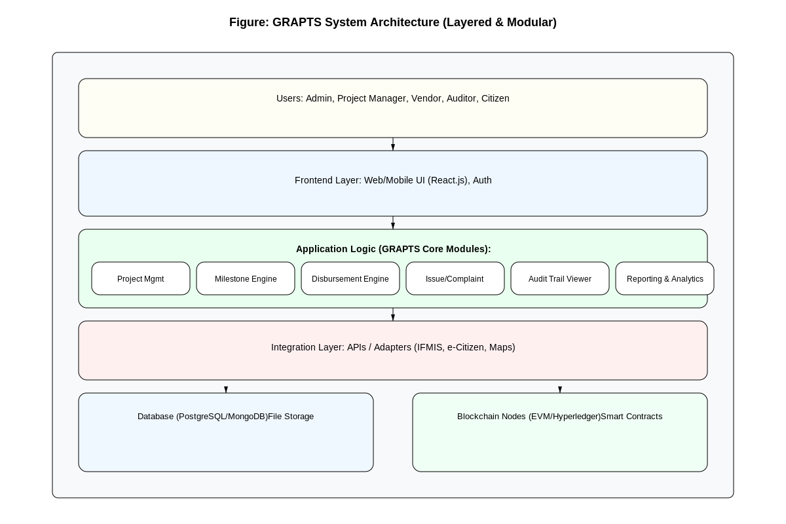
Figure 5.3, GRAPTS SYSTEM ARCHITECTURE (LAYERED VS MODULAR) (AUTHOR, 2025)
  - Component Design
The GRAPTS system is organized into distinct components, each responsible for specific functionality. Figure 5.4 (not shown here) and Table 5.1 list the main modules. Core components include: (1) User Management Service – handles registration, roles, and authentication (integrated with existing government identity providers, e.g., Huduma Namba logins) (National Treasury of Kenya, n.d.). (2) Project Administration Module – manages project metadata, milestones, and linking to budget entries. (3) Financial Integration Service – connects to IFMIS and e‑Procurement systems via secure APIs to import budget allocations, disbursement records, and contract details. This service ensures that when a finance officer approves a payment in IFMIS, the corresponding project budget in GRAPTS is updated automatically. (4) Blockchain Smart Contract Engine – the core module that deploys and executes contracts. It contains the logic for handling milestone payments: once conditions (e.g., an uploaded completion certificate) are met, it triggers the release of funds (or signals that IFMIS should release funds) and records the event immutably (Zhang & Jacobsen, 2021; Zheng et al., 2018). (5) Analytics and Monitoring Module – implements the ML‑driven anomaly detection. It consumes real‑time project and financial data to flag issues (e.g., unusually high cost variance) and generates reports for managers. (6) Public Dashboard and Feedback Portal – a web/mobile interface for citizens. It visualizes ongoing projects on maps, shows summary statistics, and allows users to submit comments or complaints. Feedback is routed to project officers and auditors. (7) Reporting Engine – generates standard reports (e.g., quarterly project progress, audit summaries) in PDF or JSON for official oversight bodies.
    - Modular Components:

Emphasizing modularity, each component exposes APIs and can be deployed in isolation. Table 5.1 (GRAPTS Main Modules) provides an overview of these modules, their responsibilities, and key technologies (for example, the Smart Contract Engine uses Ethereum/Solidity or a permissioned framework like Hyperledger Fabric [Zhang & Jacobsen, 2021]; the Analytics Module uses Python ML libraries). The modular design allows, for instance, replacing the analytics engine if new algorithms are needed without affecting other services. Components communicate through a messaging bus or API gateway, ensuring low coupling. For example, when the Project Administration Module creates a new project with a predefined smart contract template, it issues an event to the Smart Contract Engine to deploy the contract. Similarly, the Financial Integration Service, upon importing a new budget release, sends a message to the Project Module to update funding status. By partitioning functionality in this way, the system is easier to test, maintain, and upgrade. This approach follows software engineering best practices, enabling each module to scale and evolve independently while collectively implementing GRAPTS’s comprehensive feature set.
Database: Off-chain storage for large documents, linked immutably via transaction hashes.

Table 5.1: GRAPTS Main Modules
Module | Description
Project Management | CRUD operations for projects and milestones
Disbursement Engine | Smart contract for fund release logic
Audit Trail Viewer | End-to-end activity log
Issue Resolution | Module for complaints, escalation flows.
Role Management | Admin UI for creating/editing permissions
Table 5.1, GRAPTS MAIN MODULES
  - Data Model and Smart Contract Design
The data model combines traditional relational structures with blockchain-based schemas. In the relational database, we define tables for Projects, Tasks/Milestones, Users, Payments, and Feedback. Each project record includes fields like project ID, title, sector, total budget, and status. Milestone records link to projects and specify deliverables and deadlines. Payments records store IFMIS voucher numbers and amounts. Importantly, each of these tables has a corresponding log table to record changes for audit (e.g. ProjectLog). On the blockchain side, the smart contract data model mirrors key entities: a Project smart contract holds the project’s ID, total budget, and milestone conditions, and each Milestone sub-contract holds its completion criteria and payment amount. The blockchain stores only essential information (e.g. hash pointers to documents, payment confirmations) to optimize space. Non-sensitive project data (e.g. status updates) can be cached off-chain with hashes on-chain to ensure verifiability while protecting privacy.

    - Smart Contracts
Smart contracts are central to GRAPTS’s integrity and automation. Each project has an associated Solidity (or equivalent) contract that encodes rules for disbursement. For example, a simple contract might have a function confirmMilestone (unit milestone ID, string proof Hash) callable by an authorized auditor; when invoked, it checks conditions and, if valid, it triggers a payment release event to IFMIS. These contracts implement checks‑effects‑interactions security patterns (ensuring state changes before external calls) and enforce role‑based access (only auditor accounts can confirm). Smart contracts also act as immutable audit trails: every state transition (e.g., milestone confirmed, funds released) emits blockchain events that are stored permanently (Zhang & Jacobsen, 2021; Wood, 2014). We design the contracts with extensibility: a generic Milestone Contract template can be parameterized for different project types. In addition, there will be a Registrar contract that maps project IDs to their contract addresses.
During design, we also consider gas and transaction costs: since this is a permissioned environment, we expect no fees, but we still optimize contracts (e.g. minimizing storage writes). We implement safety checks (using SafeMath libraries to prevent arithmetic overflow). For integration, the backend includes a Smart Contract Interface Service (using Web3 or similar) that abstracts contract calls for the application layer. For example, when the Analytics Module detects a budget anomaly, it can call a contract function to lock further disbursements until review. Overall, the smart contracts ensure trustless execution of key processes, reinforcing accountability: once programmed, the disbursement logic cannot be altered without consensus of the network participants.
- ProjectContract: Manages project registration, milestone definition, and resource approval.
- DisbursementContract: Automates conditional payment release and ensures multi-signature verification for compliance.
- AuditContract: Records all role-based actions for external and internal audit.
- Complaint Contract: Logs and tracks issue lifecycle on the blockchain.
- Contracts are written in Solidity for EVM or Hyperledger Fabric chaincode, emphasizing security and upgradability.
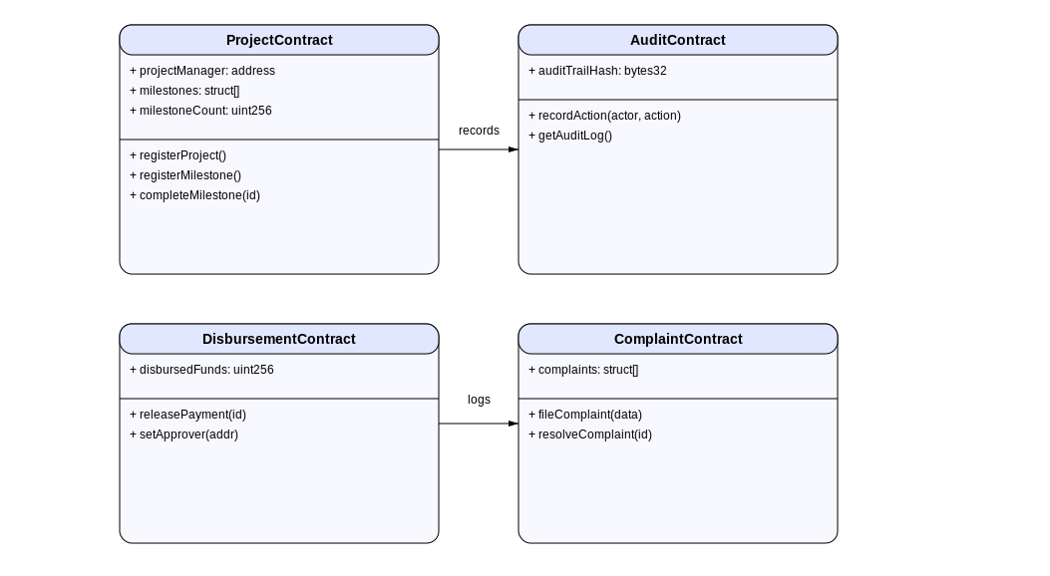
Figure 5.4, SMART CONTRACTS UML CLASS DIAGRAM, (AUTHOR, 2025)

Field | Type | Description
Project ID | uint256 | Unique project key
Initiator | address | Project manager wallet
Milestones | struct[] | An array of milestones
DisbursedFunds | uint256 | Sum of payments released
Complaints | struct[] | Linked issues/complaints
AuditTrailHash | bytes32 | Immutable activity log
Table 5.1, EXAMPLE SMART CONTRACT SCHEMA, (AUTHOR, 2025)

  - Security and Privacy Considerations
Security and privacy are woven throughout the design. At the network level, all API traffic uses HTTPS/TLS, and services authenticate to each other with strong credentials (e.g. OAuth tokens). The blockchain layer is permissioned, so only known nodes (hosted by government bodies and approved auditors) can participate in consensus, preventing unauthorized insertion of blocks. We adopt multi-signature controls for critical actions: for example, deploying a new smart contract or initializing a project budget might require two or more administrators to approve, minimizing insider threats. Data encryption is used extensively: sensitive personal data (e.g. citizen identities in the feedback portal) are stored encrypted in the database; cryptographic hashing protects blockchain data (e.g. storing only document hashes on-chain while keeping files off-chain).
Privacy measures follow Kenya’s legal framework: personal data is collected only when necessary and with consent. We plan pseudonymization for citizen data on the blockchain (e.g. using anonymous IDs) to comply with data protection rules. The public dashboards will display only aggregated or non-identifiable project information. Role-based access controls ensure, for example, that financial officers can see budget data but not edit project milestones, and citizens can view project statuses but cannot access backend administrative functions. Regular security audits (manual and automated) will be conducted – including code reviews of smart contracts and penetration testing of APIs – in line with ISO/IEC 27001 guidelines for information security. By proactively building these controls into the design, GRAPTS protects against data breaches while enabling the transparency required for good governance.

On the technical side, the interface layer will use a responsive web framework (e.g., React or Angular) that calls backend APIs. It will integrate with Kenya’s digital identity (e.g., via the Huduma Namba service) for single sign‑on, reducing login friction (Government of Kenya, 2020). Public and private interfaces will share common components for consistency but enforce different authentication flows. Documentation and help text will be embedded to guide first‑time users, and a feedback mechanism (e.g., a comment box on each page) will capture user experiences for ongoing improvement. In this design, the interface is not an afterthought but a critical component: it ensures that the powerful functionality of GRAPTS is actually usable by busy officials and clear to concerned citizens, thereby translating technical innovation into real governance impact.
Role-Based Permissions: Prevent unauthorized actions on project state or funds.
Encryption: For on-chain and off-chain data, employing best practices for wallet and document storage.
Data Privacy Compliance: Only the minimum required personal and financial data is made visible per user’s role.
Audit/Trail Logs: Immutable and cryptographically signed to ensure non-repudiation.

  - Interface and Usability Design

Usability is key for broad adoption. The interface design follows user‑centered principles: intuitive navigation, clear visualization of data, and mobile‑friendliness. The dashboards use data visualization best practices (charts, maps, and timelines) to present project status at a glance. For example, an “All Projects Map” view plots ongoing infrastructure projects by location and color‑codes them by status. Project detail pages display budget versus actual expenditure with drill‑down links to related documents (e.g., contract PDFs). We will apply Nielsen’s usability heuristics and conduct iterative usability testing with representative users (such as a county project manager and a citizen) to refine the interface. Accessibility considerations include high‑contrast options and support for Swahili language, aligning with Kenya’s inclusive e‑government goals (Government of Kenya, 2020).
Responsive Web UI: Optimized for stakeholder diversity (government, vendor, citizen).
Dashboard Visualization: Real-time project status, fund flows, issue metrics.
Multi-Language Support: To accommodate Kenya’s linguistic diversity.

- Implementation

  - INTRODUCTION
This chapter elaborates on the implementation phase of the Government Resource Allocation Projects Tracking System (GRAPTS). It introduces the technology stack, development tools, and the detailed process followed during implementation. The section underscores how smart contracts, backend APIs, and frontend systems interact to create a cohesive solution. Special emphasis is placed on testing, deployment, and addressing challenges encountered along the way. Implementation is not only a technical step but also an organizational transformation where tools, processes, and people converge to deliver value (Shava & Mhlanga, 2023).
The chapter also contextualizes GRAPTS within broader digital transformation practices in Kenya. Legacy system integration, compliance with regulations, and user adoption are identified as pivotal challenges. By leveraging containerization, continuous integration pipelines, and modular architectures, GRAPTS aims to minimize risks and maximize scalability. The emphasis on rigorous testing and phased deployment ensures that the system aligns with Kenya’s governance needs while meeting technical benchmarks (Institute of Public Finance, 2024).

  - Technology Stack and Tools
The technology stack selected for GRAPTS reflects both technical maturity and suitability for Kenya’s governance environment. Blockchain technology provides the immutability and traceability needed for sensitive financial data, with Ethereum or other EVM-compatible frameworks used in a permissioned setting. Smart contracts written in Solidity are deployed and tested using Truffle and Hardhat, while Ganache offers local emulation to accelerate prototyping. Secure smart contract templates from OpenZeppelin reinforce system resilience by embedding best practices in contract design (Zhang & Jacobsen, 2021).
The backend relies on Node.js and Express to deliver scalable RESTful APIs. These services interface with the blockchain via web3.js or ethers.js libraries, enabling smooth transaction submission and retrieval. The frontend, built with React.js, offers modularity and responsiveness, while Redux or Context API supports complex state management. For persistent off-chain storage, MongoDB and PostgreSQL provide flexibility for handling structured and unstructured data. In terms of DevOps, Docker is used to containerize services for portability, while Jenkins and GitHub Actions deliver continuous integration and deployment pipelines that align with agile development methodologies (KPMG, 2024).

    - Blockchain & Smart Contract
Ethereum / EVM-compatible Chain: Proof-of-Authority consensus for efficient permissioned governance.
Solidity: Main contract development.
Truffle / Hardhat: Contract development, compilation, deployment, and automated unit testing¹⁴¹⁵.
Ganache: Local blockchain emulation for testing.
OpenZeppelin: Library for secure smart contract templates.
    - Backend
Node.js/Express: RESTful APIs, middleware for integration.
web3.js / ethers.js: Blockchain interaction from backend/frontend.
    - Frontend
React.js: Dynamic, modular, and responsive user interface.
Redux/Context API: State management.
    - Database
MongoDB / PostgreSQL: Off-chain storage for large records and document links.
    - DevOps and Testing
Docker: Containerization for consistent deployment.
Jenkins / GitHub Actions: CI/CD pipeline for deployments and regression tests¹⁶.

    - Technology Stack Comparison
Layer | Tech Stack Options | Rationale
Blockchain | Ethereum, Hyperledger Fabric | Open, mature
Smart Contracts | Solidity, Go, Java | Secure, tested
Backend | Node.js, Express | Async, scalable
Frontend | React.js, Angular | Usability
DB | MongoDB, PostgreSQL | Scalable, flexible
Table 6.1, TECHNOLOGY STACK COMPARISON, (AUTHOR, 2025)

  - Key Implementation Steps
The GRAPTS implementation followed structured phases to ensure completeness and reliability. Smart contracts were coded in Solidity following established security practices such as role-based checks and checks-effects-interactions design patterns. Unit tests were automated through Hardhat and Truffle, ensuring that all methods performed correctly under edge cases. Deployment to a private consortium chain allowed for controlled pilots, reducing risks while validating integration with government workflows (Shava & Mhlanga, 2023).
Backend APIs were built in parallel, handling user authentication, data synchronization, and smart contract invocation. Frontend dashboards were developed for project visualization and complaint tracking, informed by stakeholder feedback sessions. Testing extended beyond functionality to performance and security, including penetration testing and automated audits with MythX and Slither. Finally, user acceptance testing (UAT) involved pilot ministries, allowing refinements before national rollout. Deployment leveraged Docker containers hosted on secure government servers, ensuring consistency across environments (Institute of Public Finance, 2024).

- Smart Contract Coding: Development in Solidity following security best practices (checks-effects-interactions, role-based checks, SafeMath) ¹⁷¹⁸.
- Automated Unit Testing: Using Hardhat/Truffle; test coverage for all contract methods and edge cases.
- Testnet Deployment: Use of private/consortium chain for pilot.
- Backend Integration: APIs for user authentication, smart contract invocation, and data synchronization.
- Frontend Development: Dashboards, project status, and complaint tracking.
- Security Audits: Automated scanning (MythX, Slither) and manual code review for vulnerabilities.
- Performance Testing: Load simulation using tools like JMeter and Locust for transaction throughput and latency evaluation.
- User Acceptance Testing (UAT): Pilot group for feedback on usability, process alignment.
- Deployment: Dockerized images on cloud or ministry servers for pilot, enabling eventual migration to national infrastructure.

    - Testing and Deployment Strategies
Testing Type | Tool/Process
Unit Testing | Hardhat, Truffle
Smart Contract Audits | Slither, MythX
API Integration | Postman, Swagger
End-to-End UI | Selenium, Cypress
Performance/Load | JMeter, Locust
Regression/CI | Jenkins, GitHub Actions

Table 6.2, TESTING AND DEPLOYMENT STRATEGIES (AUTHOR, 2025)

  - Challenges in Implementation
Several challenges arose during GRAPTS implementation. Legacy system integration was the most complex, as IFMIS and other systems often rely on rigid data schemas. This was mitigated by building API adapters and adopting phased migration strategies. Another significant challenge was user onboarding. Many government staff had limited exposure to blockchain systems, requiring extensive training and early adopter champions to drive system confidence (Umurzokov, 2023).
Security risks also posed challenges, given the sensitive nature of financial and procurement data. These were managed by conducting thorough code reviews, static analysis, and multi-signature authorization for high-value transactions. Despite these hurdles, the phased and well-documented implementation process allowed the system to progress from pilots to a stable rollout. By embedding security, training, and phased deployment, GRAPTS overcame obstacles that commonly derail public ICT projects (KPMG, 2024).
  - System Deployment and Maintenance
Deployment strategies prioritized incremental adoption. Initial pilots in selected ministries allowed for controlled testing of workflows and data pipelines. Monitoring mechanisms were embedded in the deployment, including real-time logging and analytics for error tracking and performance measurement. These tools allowed the technical team to rapidly identify and resolve issues, thereby strengthening reliability in production environments (Institute of Public Finance, 2024).
Maintenance is conceived as a continuous process aligned with agile sprints. User and stakeholder feedback cycles feed into subsequent updates, ensuring the system evolves alongside governance needs. Regular security audits, bug fixes, and feature enhancements will keep the system robust. Ultimately, sustainability is guaranteed by training in-house developers and maintaining system documentation, ensuring that GRAPTS can be scaled across ministries and counties (Shava & Mhlanga, 2023).
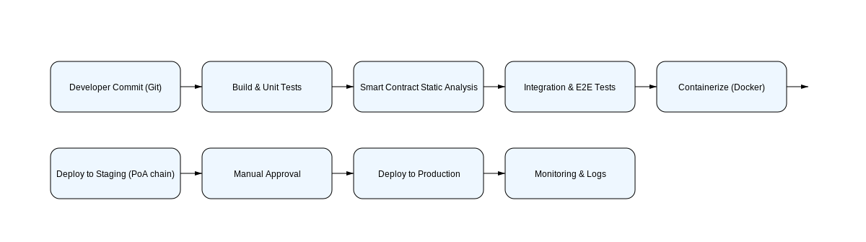
Figure 6.5, CI/CD, DEPLOYMENT PIPELINE DIAGRAM, (AUTHOR, 2025)

- CONclusions and Recommendations

  - INTRODUCTION
The final chapter summarizes the project’s outcomes, highlighting GRAPTS’ potential to transform public resource tracking through blockchain-enabled transparency and automation. It offers policy and implementation recommendations, identifies areas for further research, and underscores the system’s role in fostering trust, improving service delivery, and aligning with Kenya’s governance reform agenda.
  - Summary of Project Outcomes
This project demonstrates the technical feasibility and process alignment of GRAPTS-a blockchain-enabled system for public engineering project tracking in Kenya’s public sector. The system’s design, grounded in the project demonstrates the feasibility of integrating blockchain technology into Kenya’s project tracking workflows. End-to-end traceability ensures that financial flows and milestones are immutably recorded, reducing opportunities for fraud. Multi-stakeholder auditability enhances transparency for officials, auditors, and citizens alike, addressing the challenge of information asymmetry (Shava & Mhlanga, 2023).
Smart contract-driven automation streamlines repetitive processes such as milestone verification and disbursement, curbing bureaucratic inefficiencies. Finally, adoption readiness was validated using theoretical frameworks such as the Technology Acceptance Model, demonstrating that user training, perceived usefulness, and ease of use strongly influence adoption. Together, these outcomes position GRAPTS as a transformative solution for Kenya’s governance reforms (Institute of Public Finance, 2024).research and modern software, embeds transparency, traceability, and immutable auditability within ministry-level project management.
Key strengths identified include:
- End-to-End Traceability: Project and fund flows, milestone verification, and complaint resolution assured by blockchain’s inherent immutability.
- Multi-Stakeholder Auditability: Role-based access provides transparency to authorized officials, external auditors, and designated citizens, mitigating the risk of fraud and information asymmetry.
- Smart Contract-Driven Process Automation: Automated payments, milestone triggers, and issue escalation streamline workflows and reduce bureaucratic discretion.
- Adoption Readiness: The system leverages the Technology Acceptance Model and Innovation Diffusion Theory to target public sector adoption drivers and resistance points, such as perceived usefulness, ease of use, and innovation compatibility.

  - Policy and Implementation Recommendations
The findings recommend that ministries embrace blockchain-enabled tracking in high-profile and capital-intensive projects as early wins. This demonstrates quick impact and builds momentum for wider adoption. Additionally, transparency metrics should be institutionalized in ministry scorecards, ensuring system outputs are used in monitoring and evaluation frameworks (Wikrent, 2022).
Further, legal and regulatory frameworks must evolve to accommodate smart contracts, digital identities, and enhanced privacy protections. Capacity building programs are vital, empowering local developers and government staff with the skills needed to maintain and evolve GRAPTS. Finally, gradual integration ensures minimal disruption, starting with hybrid deployments and expanding on-chain processes as confidence grows (Umurzokov, 2023).

Embrace Blockchain for Governance: Ministries should pilot blockchain-based tracking in high-risk, capital-intensive, or high-profile projects as a transparency “quick win.”, Institutionalize Transparency Metrics: Ministry and agency scorecards should include system-driven metrics on disclosure, audit trail use, and citizen feedback logged on the blockchain., Legal and Regulatory Enablement: Update public procurement and IT legal frameworks to support smart contract-enforced compliance, digital identity provisioning for officials, and citizen privacy. Capacity Building: Investment in digital literacy programs and local developer communities is crucial to scale blockchain adoption and maintain systems in-house. Progressive Integration: Begin with hybrid deployments, integrating existing systems via APIs and increasing on-chain processes over time to minimize disruption and Continuous Evaluation: Monitor system adoption, reliability, and stakeholder satisfaction using data analytics, surveys, and periodic audits.

  - Areas for Further Research
Areas for future exploration include scaling GRAPTS to county-level governance, where ICT infrastructure varies widely. This would test the system’s scalability and inclusivity. Privacy engineering is another research frontier, focusing on techniques like zero-knowledge proofs that preserve confidentiality in blockchain-based public finance systems (Zhang & Jacobsen, 2021).
Citizen engagement models also warrant study, particularly in designing participatory governance workflows for budget monitoring and service delivery. Finally, integrating artificial intelligence for anomaly detection and predictive risk analysis could enhance oversight, while regulatory impact analysis remains essential to adapt to new risks posed by digital and AI-enabled governance (KPMG, 2024).

County-Level Rollout: Assess scalability and operational challenges in Kenya’s devolved governance structures with varying ICT infrastructure.
Privacy Engineering: Refinement of privacy-preserving techniques suitable for blockchain in the public sector.
Citizen Engagement Models: Evaluate participatory governance models using blockchain for budget tracking and service delivery feedback.
Regulatory Impact Analysis: Ongoing review of blockchain legislation and emergent risks (e.g., deep fake fraud, synthetic identity management).
AI Integration: Explore integration with AI for automated anomaly detection and predictive project risk analytics.

APPENDICES

Appendix A: Sample Smart Contract (Solidity)
SAMPLE SMART CONTRACT (SOLIDITY), (AUTHOR 2021)
pragma solidity ^0.8.19;
contract ProjectContract {
address public project Manager;
struct Milestone {
string description;
bool completed;
uint256 amount;
bool paid;
}
mapping(uint256 => Milestone) public milestones;
uint256 public milestone Count;
event Milestone Completed(uint256 milestone ID, address indexed by);
event Payment Released(uint256 milestone ID, uint256 amount);
constructor() {
project Manager = msg.sender;
}
function registerMilestone(string memory desc, uint256 amt) public onlyManager {
milestones[milestone Count++] = Milestone(desc, false, amt, false);
}
modifier onlyManager() { require(msg.sender == project Manager, "Not authorized"); _; }
function completeMilestone(uint256 id) public onlyManager {
milestones[id].completed = true;
emit Milestone Completed(id, msg.sender);
}
function releasePayment(uint256 id) public payable onlyManager {
require(milestones[id].completed && !milestones[id].paid, "Not ready");
milestones[id].paid = true;
emit Payment Released(id, milestones[id].amount);
}
}

APPENDIX B: SAMPLE INTERVIEW/REQUIREMENT GATHERING GUIDE
- Participant Role: (Project Manager/Vendor/Auditor/Other)
- Department/Agency:
- Pain Points in Current Project Tracking:
  - Visibility into project status
  - Delays in fund disbursement
  - Issues with audit trail completeness
- Features Most Needed in New System:
- Perceived Barriers to Adoption:
- Willingness to Participate in Blockchain-based Solution Pilots:

Appendix C: Stakeholder Training Materials Outline
- Overview of GRAPTS workflows
- Using dashboard and submitting complaints
- Authorizing actions with digital signature
- Accessing audit trail
- Troubleshooting and support contact information

Appendix D: System Diagrams

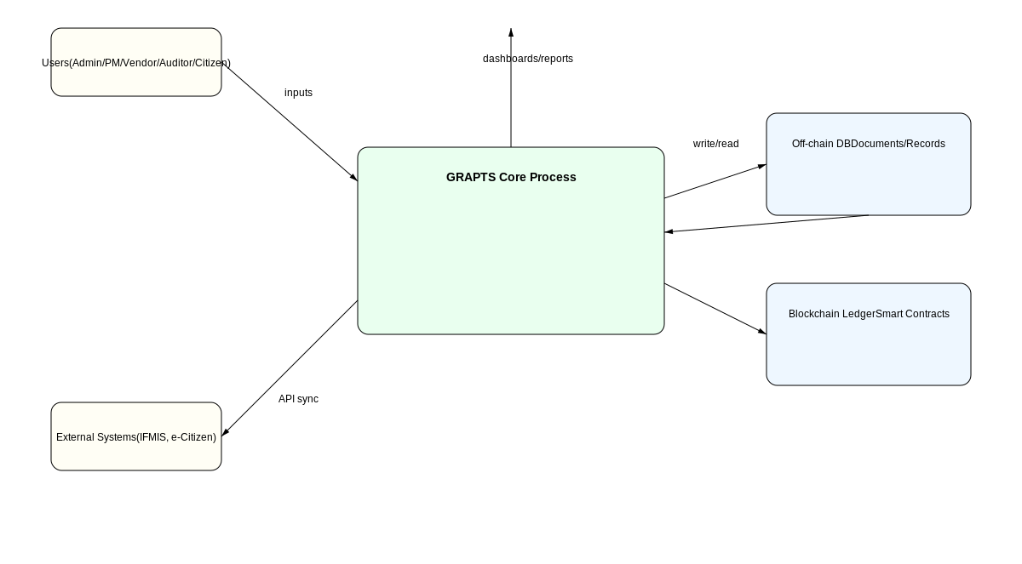
Figure 0.1, SYSTEM FLOW DATA DIAGRAM (AUTHOR 2025)

Appendix E: Testing and Audit Log Samples
- Log of Milestone Completion Events
- Payment Release Transactions
- Complaint Escalation and Resolution Entries

REFERENCES
APA Dictionary of Psychology. (n.d.). Accountability. American Psychological Association. Retrieved September 1, 2025, from https://dictionary.apa.org/accountability
Estler, W. T. (2019). Traceability. In CIRP Encyclopedia of Production Engineering (pp. 1748–1752). Springer. https://doi.org/10.1007/978-3-662-53120-4_6598
Government of Kenya. (2007). Kenya Vision 2030: A globally competitive and prosperous Kenya. Government Printer.
Heeks, R. (2017). Information and communication technology for development (ICT4D) (2nd ed.). Routledge.
Institute of Public Finance. (2024). Blockchain: A game-changer for transparency and fraud prevention in Kenya’s public finance management. IPF Global. Retrieved from https://ipfglobal.or.ke/
Kettunen, P., & Kallio, J. (2021). Digital government evolution: From siloed systems to platform ecosystems. Government Information Quarterly, 38(1), 101547. https://doi.org/10.1016/j.giq.2020.101547
Kettunen, P., & Kallio, J. (2021). Digital transformation of local government: A systematic review. Government Information Quarterly, 38(4), 101–118. https://doi.org/10.1016/j.giq.2021.101578
KPMG International Cooperative. (2024). KPMG global tech report: Government and public sector insights. Retrieved from https://kpmg.com/
Levi, S. D., & Lipton, A. B. (2018, May 26). An introduction to smart contracts and their potential and inherent limitations. Harvard Law School Forum on Corporate Governance. https://corpgov.law.harvard.edu/2018/05/26/an-introduction-to-smart-contracts-and-their-potential-and-inherent-limitations/
Levitt, H. M., Pomerville, A., Surace, F. I., & Grabowski, L. M. (2017). Meta-method study of qualitative psychotherapy research on clients' experiences: Review and recommendations. Journal of Counseling Psychology, 64(6), 626–644. https://doi.org/10.1037/cou0000222
MeitY. (2022). Digital India Programme. Ministry of Electronics and Information Technology, Government of India. Retrieved from https://www.digitalindia.gov.in/
Mutiganda, J. C. (2020). E-procurement and public accountability in Rwanda: A case study of UMUCYO. African Journal of Public Sector Development and Governance, 3(1), 45–62.
Mutiganda, J. C. (2020). Public sector reforms and accountability in Rwanda: The case of UMUCYO e-procurement system. African Journal of Public Administration and Management, 31(2), 45–63.
National Treasury of Kenya. (n.d.). Integrated Financial Management Information System (IFMIS). Retrieved from https://www.treasury.go.ke/ifmis/
Njenga, K. (2019). Digital government in Kenya: Reflections on progress and challenges. African Journal of Information and Communication, 24, 1–15. https://doi.org/10.23962/10539/28632
Njenga, S. (2019). Effectiveness of IFMIS in promoting accountability in Kenya’s public sector. Journal of African Governance Studies, 7(3), 67–82.
Office of the Auditor General. (2021). Annual report of the Auditor-General of Kenya. Nairobi: OAG.
Open Government Partnership – Kenya. (2020). Implement e-government system adopting Open Contracting Data Standard (Commitment KE0025). Retrieved from https://www.opengovpartnership.org/members/kenya/commitments/ke0025/
Oxford University Press. (n.d.). Immutability. In Oxford English Dictionary. Retrieved September 1, 2025, from https://www.oxfordlearnersdictionaries.com/
Shava, E., & Mhlanga, D. (2023). Mitigating bureaucratic inefficiencies through blockchain technology in Africa. Frontiers in Blockchain, 6, Article 1053555. https://doi.org/10.3389/fbloc.2023.1053555
Transparency International. (2022). Corruption perceptions index 2022. Transparency International.
Umurzokov, B. (2023, July 7). API’s role in digital government, 10 national best practices. API7.ai. Retrieved from https://api7.ai/blog/api-digital-government-best-practices
United Nations Development Programme (UNDP). (2019). Digital governance for sustainable development. UNDP Policy Paper.
Wikrent, K. (2022, February 17). Open contracting for better goods and services in Kenya. Open Government Partnership. Retrieved from https://www.opengovpartnership.org/stories/open-contracting-for-better-goods-and-services-in-kenya/

World Bank. (2020). Open government and public resource management. World Bank Publications.
Yaga, D., Mell, P., Roby, N., & Scarfone, K. (2018). Blockchain technology overview (NIST IR 8202). National Institute of Standards and Technology. https://doi.org/10.6028/NIST.IR.8202
Zhang, R., & Jacobsen, H. (2021). Towards dependable decentralized applications: Blockchain system architecture and interoperability. ACM Computing Surveys, 54(7), 1-39. https://doi.org/10.1145/3453150
Zheng, Z., Xie, S., Dai, H., Chen, X., & Wang, H. (2018). Blockchain challenges and opportunities: A survey. International Journal of Web and Grid Services, 14(4), 352–375. https://doi.org/10.1504/IJWGS.2018.095647

