Blackwood High
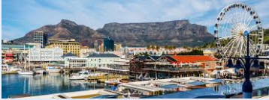
www.blackwood.org.za
info@blackwood.org.za
078 556 8325

Newsletter 2 / 2026 27 February 2026
Dear Parents
School Trip


The road over the past months and year has admittedly been a rocky one. There have been ups and down (rather more ‘downs’ than ‘ups’, some would say!), and not only in the educational sector, but in all sectors and spheres of society – across the globe. There is little need to elaborate on specifics, except to mention that we have all been touched in some way by the ravages of the pandemic, and we must look to specifics – common sense and scientific – to help steer us out of the woods. While it is certainly not all plain sailing from now on, there are some positive indications that we shall presently (within a space of months?) be able to return to some semblance of ‘normality’. We need to reset our compass.
Buoyed up by the expectation of better things to come, the Staff and Governing Body of Blackwood High have determined to embark upon the steady reintegration of aspects of our school that have fallen by the wayside – naturally within the guidelines and protocols set at the National level. These include certain sporting and cultural events, and other fixtures in the School Calendar.

Background

As far back as July 2012 we have organised an annual tour to one or more parts of our country. There is no shortage of interesting places to visit, and the challenge has always been to tailor our itinerary to fit within budgetary and time constraints.
Previous | Venue and Period |  | Nights | Learners
 | Sea & Sky | Sep 19 | 5 | 35
 | Copper Kettle | Jul 17 | 3 | 50
 | Tugela Manor | Sep 15 | 4 | 49
 | Travellers Rest | Jul 08 | 3 | 46
 | Golden Egg | Jul 14 | 5 | 44
 | Total learners

Transport
Circumstances this year have compelled us to consider additional options for transporting learners, teachers and others to the different venues. The idea is to involve more parents and teachers in various aspects – including transport. There are several advantages to this approach:
- Lower transport costs
- Greater flexibility
- Enhanced safety protocols
- Better networking
Parents listed below have already pledged their support. Please contact Mrs Kennedy at the school office if you wish to add your name to the list.
Parent EmailTransport
Saungweme, J j.saungweme@romens.co.za own +2
Pillay, SF pillay101@gmail.com 4
Paxton, B bloxton@adventurezone.com own +3
Groves, L robin.g@outfitters.africa own+2
Mohapi, HP h.mohapi@mohapitravel.co.za 6
Patterson, AM antonie@amconair.africa own+2
Abrahams, N abie27@outlook.com 4

Finance
The costs involved in mounting an undertaking of this kind can be considerable. The following measures – in order of their effectiveness – can reduce costs:
Sponsorship and bursary schemes
Discounts for school groups(Many venues are prepared to negotiate excellent deals)
Other innovations, as described in the section Transport above.
The other side of the finance coin is of course the fund-raising schemes, whereby we actively set out to ‘make money’ in order to boost our reserves.

Wrapping up
I close this newsletter with words of encouragement and incentive. Let us all put shoulder to the wheel and do what it takes to make Tour2026 happen. Where the good will and resolve are in place, the results are predictable. Further hard work and planning will have their reward!
The Appendix below contains a few extracts from presentations that have been made to promote some places of interest that have been considered.
Warm regards,
L. Muller: Principal of Blackwood High

Appendix: Places of Interest

iSimangaliso Wetland Park
THIS SITE IS HOME TO THE LARGEST ESTUARINE SYSTEM ON THE CONTINENT. THE AREA SUPPORTS A HUGE VARIETY OF WILDLIFE – MORE THAN 256 SPECIES OF BIRDS, AND THE HIGHEST CONCENTRATION OF HIPPOS AND CROCODILES ON THE CONTINENT (800 AND 1,200 RESPECTIVELY). THE REASON FOR THE PARK’S RICH DIVERSITY OF WILDLIFE AND VEGETATION IS THE GREAT DIVERSITY OF ECOSYSTEMS IN THE PARK – CORAL REEFS, SANDY BEACHES, WETLANDS, SAVANNAS AND SUBTROPICAL FORESTS.
The V&A Waterfront in Cape Town
The V&A Waterfront was established in 1988 by Transnet Ltd to redevelop the historic Cape Town docklands into a mixed-use destination. While the company was formed in 1988, official commercial trading began in November 1990. It is located in the southern hemisphere's oldest working harbour. The V&A Waterfront is BIG – about the size of Israel. 2 million hectares of prime African bush, home to an amazing variety of life forms. The park as we know it today was first established in May 1988, and the first tourists drove inside in 1927 – for the princely fee of one pound!
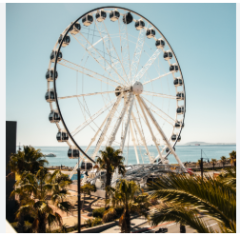
Purpose: To transform disused, historic docklands into a vibrant, mixed-use, and tourist area.
Development: Development focused on retail, tourism, and residential areas while maintaining a working fishing harbour.
Milestones: The Victoria Wharf Shopping Centre opened in 1992, accelerating its growth.

Two Oceans Aquarium
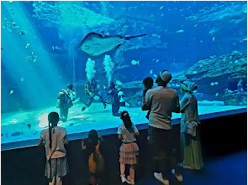

The exciting Save Our Seas Foundation Shark Exhibit gives you the chance to experience a close encounter with some of the most misunderstood species in South Africa's oceans. Meet the shiver of ragged-tooth sharks, watch schools of giant yellowtail hunt for their next meal and watch the curious, but territorial, yellowbelly rockcod stand its ground with much larger predators. Whether you relax in front of the exhibit's large window, or spiral around the accessible viewing ramp - there is an awesome underwater world to discover.

