platypus summary

Learn about the characteristics and reproduction of platypus

The Editors of Encyclopaedia Britannica
Below is the article summary. For the full article, see platypus.
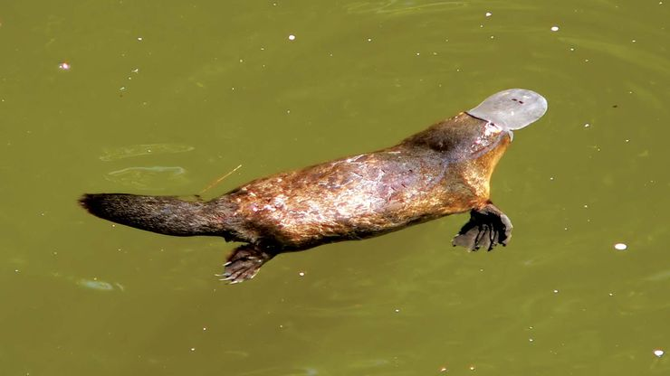
platypusThe duck-billed platypus (Ornithorhynchus anatinus), or duckbill, is common in the waterways of eastern Australia.
platypus, or duckbill, Monotreme amphibious mammal (Ornithorhynchus anatinus) of lakes and streams in eastern Australia and Tasmania. About 23 in. (60 cm) long, the squat-bodied platypus has a ducklike snout, short legs, webbed feet, and a beaverlike tail. Each day it eats nearly its own weight in crustaceans, fishes, frogs, mollusks, tadpoles, and earthworms; lacking teeth, it crushes its food with ridges in the bill. The female lays one to three eggs in a nest in a long twisting passage above the waterline. The young are weaned about four months after hatching. The male’s heel bears a spur connected to a poison-secreting gland. Large fishes and perhaps snakes prey on platypuses. Formerly trapped for their dense, soft fur, they are now protected by law.
Source:  https://www.britannica.com/summary/platypus

