POC 1.
  - Bevaka en specific product.

Hittat en datormus att bevaka priset på
https://www.elgiganten.se/product/datorer-kontor/datortillbehor/mus-tangentbord/datormus/deltaco-pm80-tradlos-gamingmus/768865
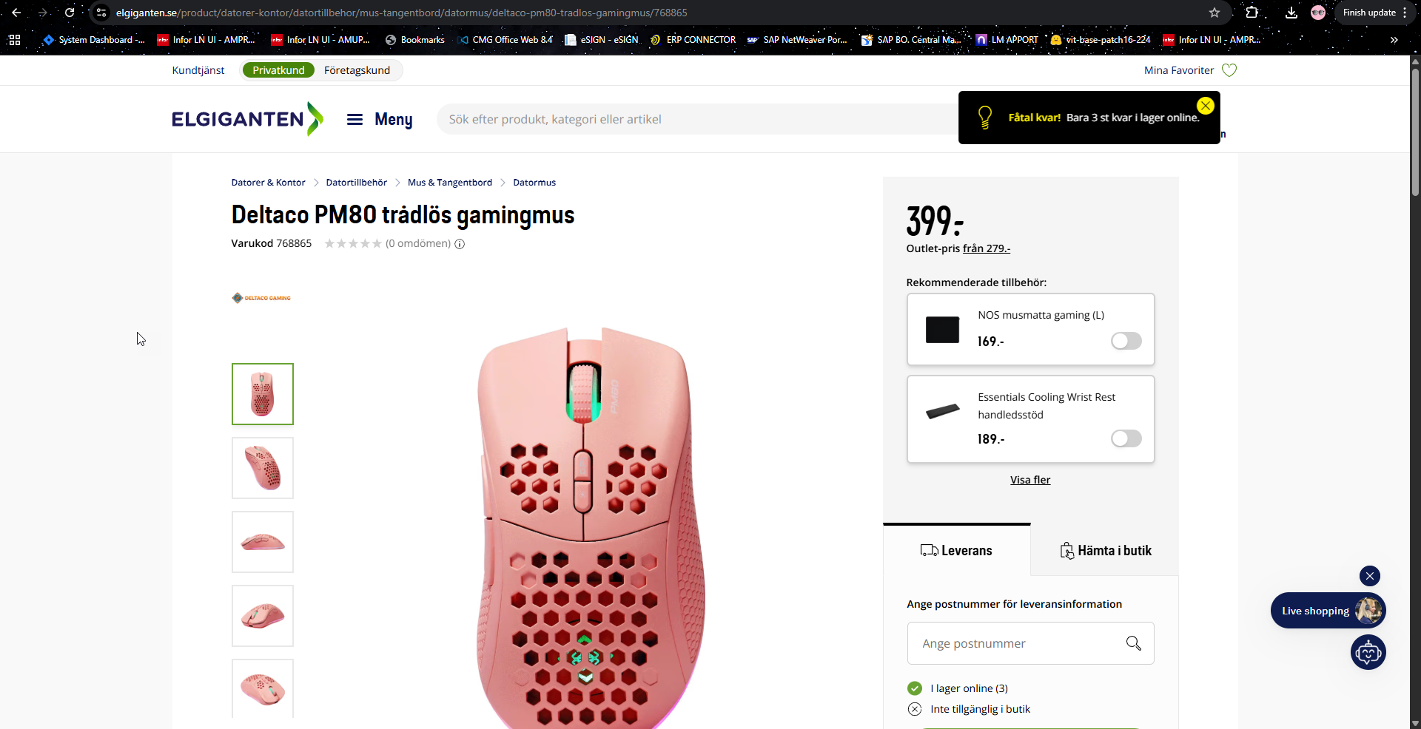

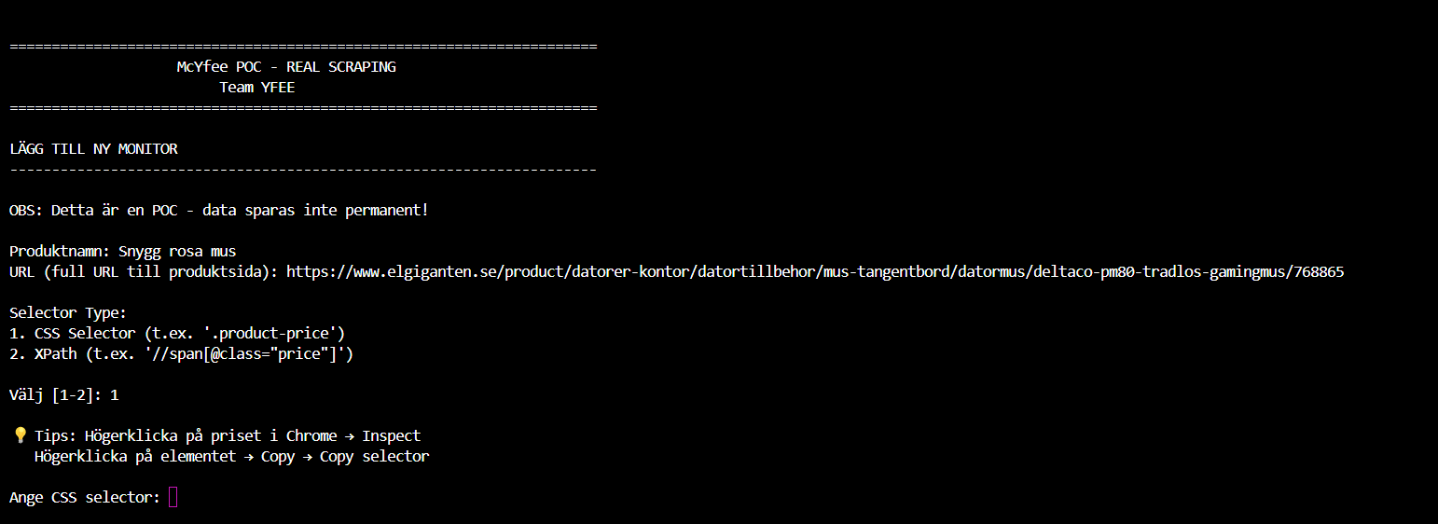

Antingen kan vi monitorera via CSS selector eller XPATH, beroende på sidans komplexitet och uppbyggnad så kan det ena eller andra alternativet vara mer passande.
Om man inspektar sidan i Chrome så kan man leta på lämpligt element > högerklicka > Copy selector / Copy XPatch.
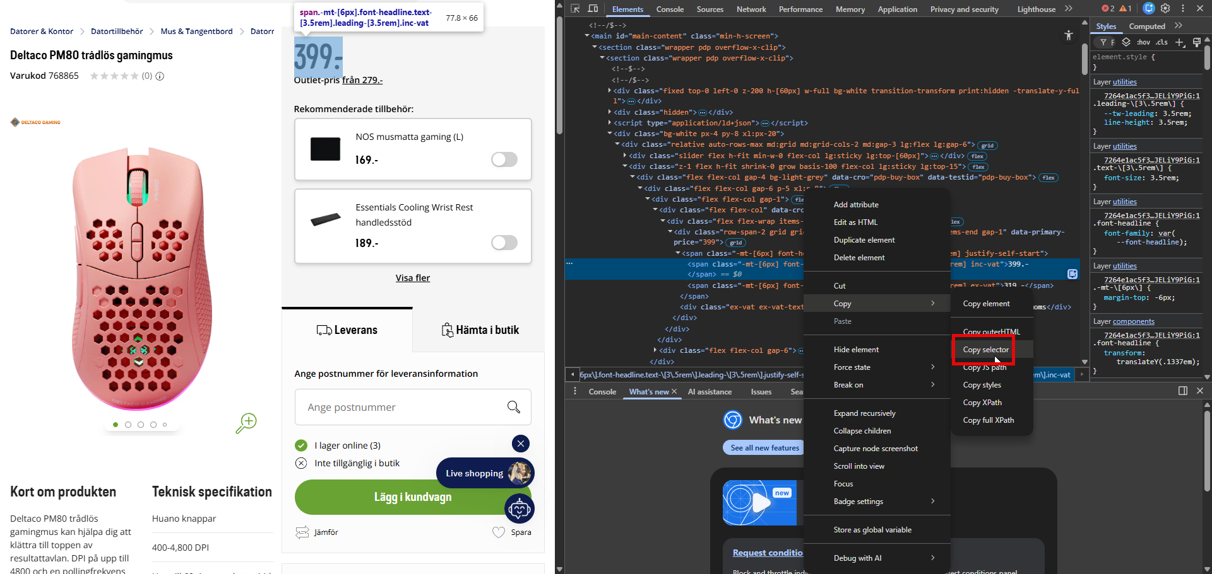

I det här fallet kör jag Selector och pekar på elementet med 399.-
#main-content > section > section > div.bg-white.px-4.py-8.xl\:px-20 > div > div.z-1.flex.h-fit.shrink-0.grow.basis-100.flex-col.lg\:sticky.lg\:top-15 > div.flex.flex-col.gap-4.bg-light-grey > div.flex.flex-col.gap-6.p-5.xl\:p-8 > div:nth-child(1) > div:nth-child(1) > div > div > span > span.-mt-\[6px\].font-headline.text-\[3\.5rem\].leading-\[3\.5rem\].inc-vat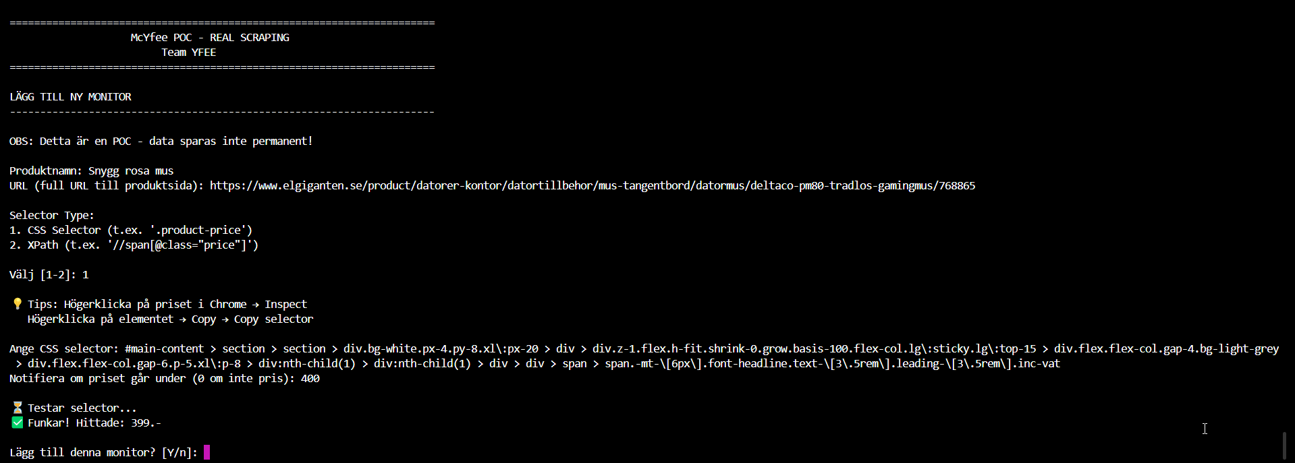
Om priset går under 400 så vill jag få en notis.

Jag sparar monitorn med Y

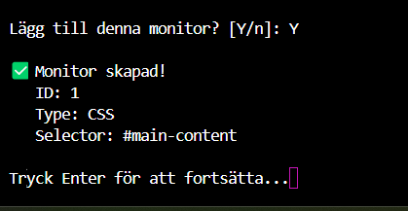

Nu är monitorn sparad och vi behöver trigga scrapern och kontrollfunktionen
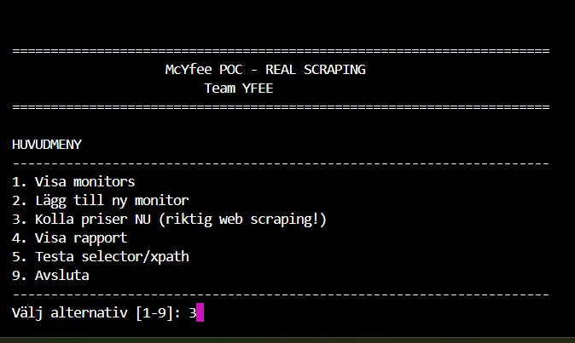

Detta skulle trigga en notis att skickas ut eftersom den hittar att priset är 399.-
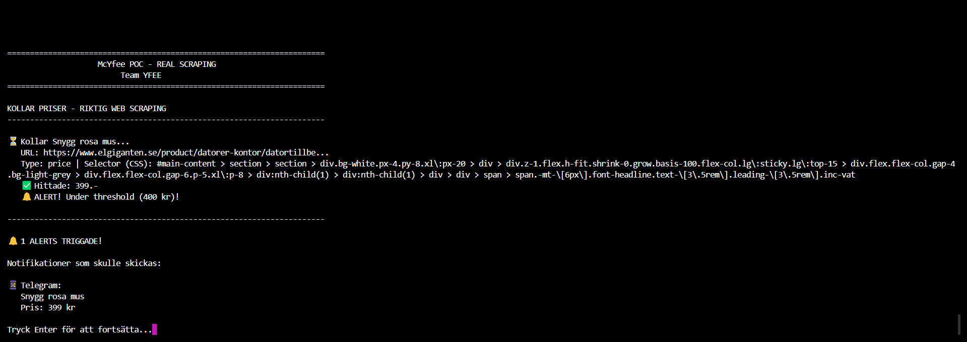

Vi bör peka på ett så specifikt element som möjligt på sidan vi scrapar, annars blir det problem när vi har massa andra priser och erbjudanden med på samma sida, dvs det kan bli problem för vår app att veta vad det är som är priset på produkten vi är ute efter och vad som är något annat krafs.
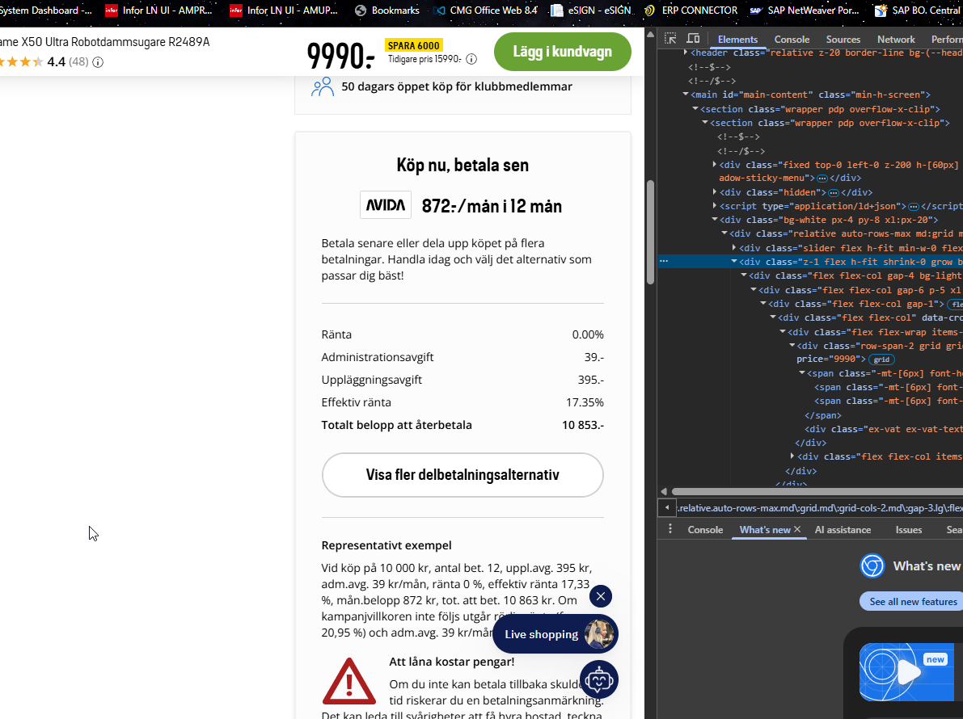

POC 2.
  - Monitorera flera produkter.
Här får jag använda någon enklare sida för min POC-app är för kass.

https://webscraper.io/test-sites/e-commerce/allinone/computers/laptops

Inspectar sidan och kopierar selectorn som innehåller griden med produkterna.
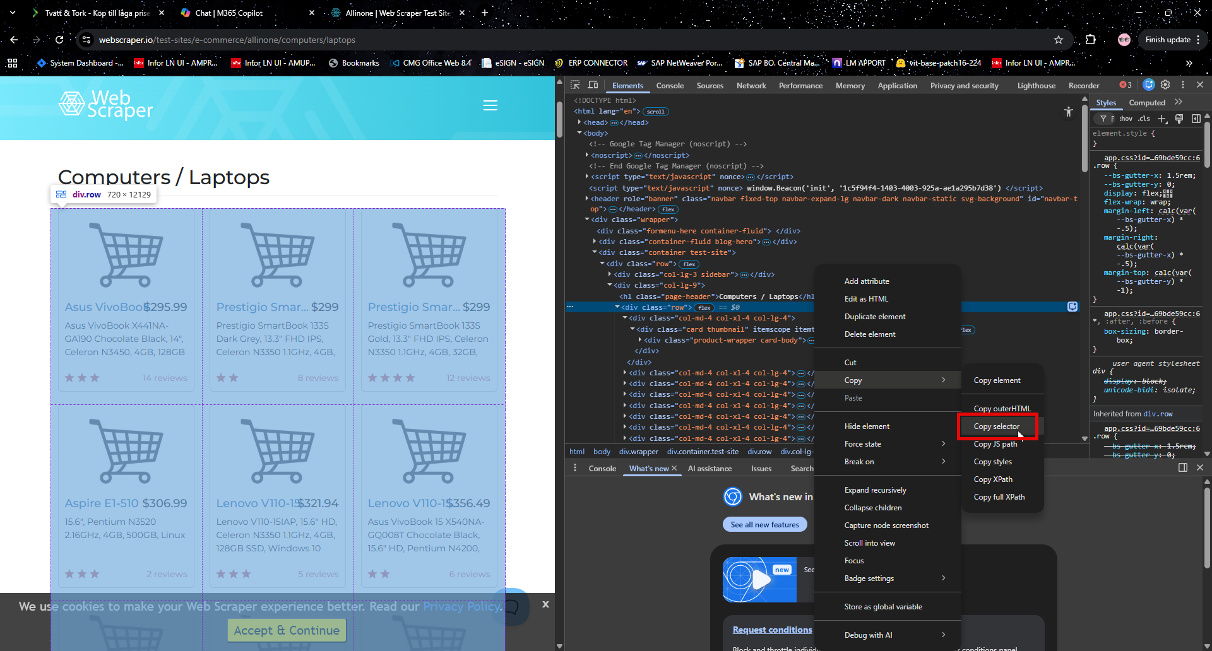

Selector:
body > div.wrapper > div.container.test-site > div > div.col-lg-9 > div.row

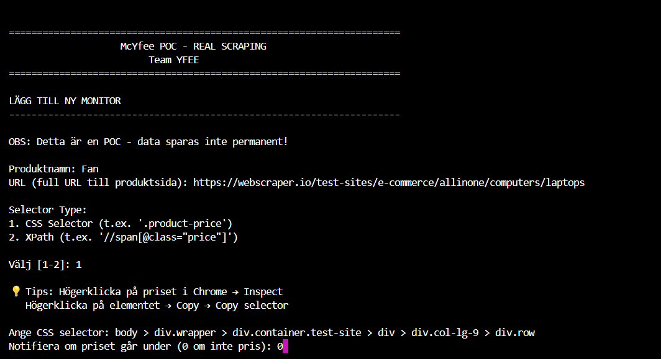

Resultat:
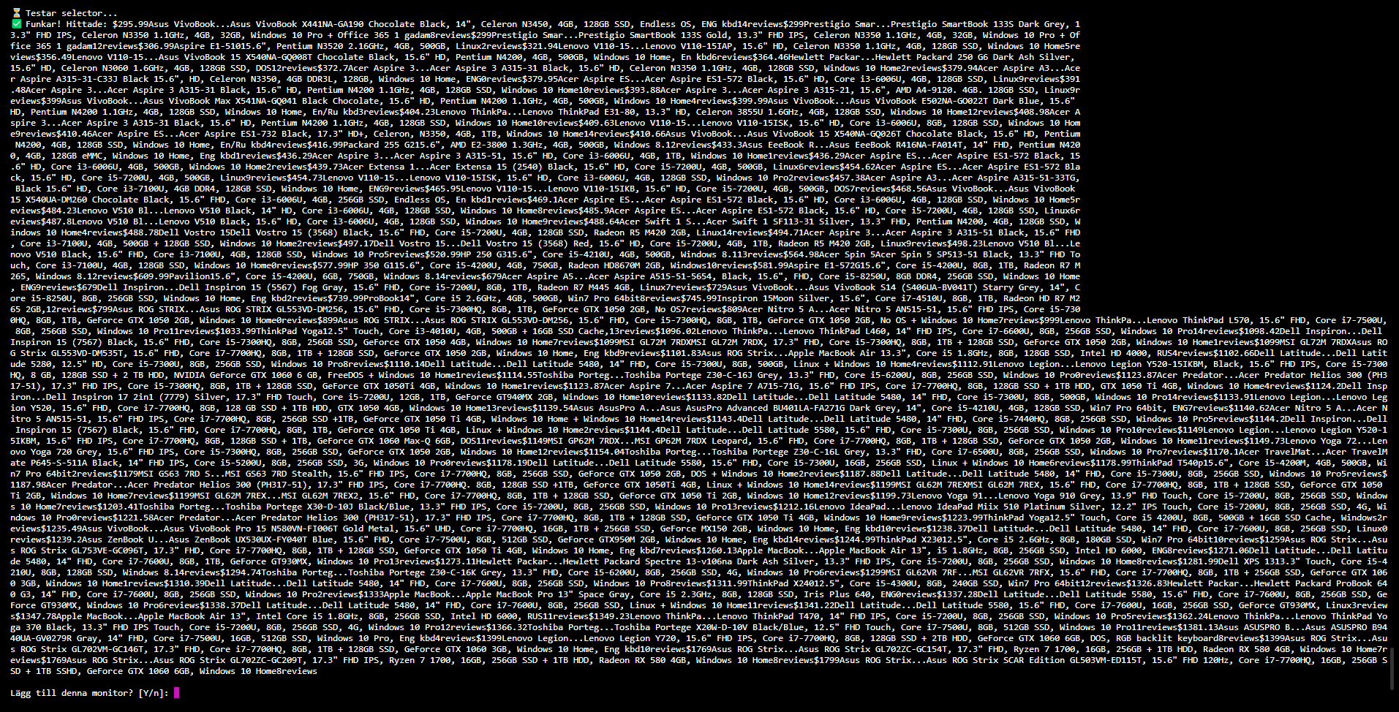

$295.99Asus VivoBook...Asus VivoBook X441NA-GA190 Chocolate Black, 14", Celeron N3450, 4GB, 128GB SSD, Endless OS, ENG kbd14reviews$299Prestigio Smar...Prestigio SmartBook 133S Dark Grey, 13.3" FHD IPS, Celeron N3350 1.1GHz, 4GB, 32GB, Windows 10 Pro + Office 365 1 gadam8reviews$299Prestigio Smar...Prestigio SmartBook 133S Gold, 13.3" FHD IPS, Celeron N3350 1.1GHz, 4GB, 32GB, Windows 10 Pro + Office 365 1 gadam12reviews$306.99Aspire E1-51015.6", Pentium N3520 2.16GHz, 4GB, 500GB, Linux2reviews$321.94Lenovo V110-15...Lenovo V110-15IAP, 15.6" HD, Celeron N3350 1.1GHz, 4GB, 128GB SSD, Windows 10 Home5reviews$356.49Lenovo V110-15...Asus VivoBook 15 X540NA-GQ008T Chocolate Black, 15.6" HD, Pentium N4200, 4GB, 500GB, Windows 10 Home, En kbd6reviews$364.46Hewlett Packar...Hewlett Packard 250 G6 Dark Ash Silver, 15.6" HD, Celeron N3060 1.6GHz, 4GB, 128GB SSD, DOS12reviews$372.7Acer Aspire 3...Acer Aspire 3 A315-31 Black, 15.6" HD, Celeron N3350 1.1GHz, 4GB, 128GB SSD, Windows 10 Home2reviews$379.94Acer Aspire A3...Acer Aspire A315-31-C33J Black 15.6", HD, Celeron N3350, 4GB DDR3L, 128GB, Windows 10 Home, ENG0reviews$379.95Acer Aspire ES...Acer Aspire ES1-572 Black, 15.6" HD, Core i3-6006U, 4GB, 128GB SSD, Linux9reviews$391.48Acer Aspire 3...Acer Aspire 3 A315-31 Black, 15.6" HD, Pentium N4200 1.1GHz, 4GB, 128GB SSD, Windows 10 Home10reviews$393.88Acer Aspire 3...Acer Aspire 3 A315-21, 15.6", AMD A4-9120. 4GB. 128GB SSD, Linux9reviews$399Asus VivoBook...Asus VivoBook Max X541NA-GQ041 Black Chocolate, 15.6" HD, Pentium N4200 1.1GHz, 4GB, 500GB, Windows 10 Home4reviews$399.99Asus VivoBook...Asus VivoBook E502NA-GO022T Dark Blue, 15.6" HD, Pentium N4200 1.1GHz, 4GB, 128GB SSD, Windows 10 Home, En/Ru kbd3reviews$404.23Lenovo ThinkPa...Lenovo ThinkPad E31-80, 13.3" HD, Celeron 3855U 1.6GHz, 4GB, 128GB SSD, Windows 10 Home12reviews$408.98Acer Aspire 3...Acer Aspire 3 A315-31 Black, 15.6" HD, Pentium N4200 1.1GHz, 4GB, 128GB SSD, Windows 10 Home10reviews$409.63Lenovo V110-15...Lenovo V110-15ISK, 15.6" HD, Core i3-6006U, 8GB, 128GB SSD, Windows 10 Home9reviews$410.46Acer Aspire ES...Acer Aspire ES1-732 Black, 17.3" HD+, Celeron, N3350, 4GB, 1TB, Windows 10 Home14reviews$410.66Asus VivoBook...Asus VivoBook 15 X540NA-GQ026T Chocolate Black, 15.6" HD, Pentium N4200, 4GB, 128GB SSD, Windows 10 Home, En/Ru kbd4reviews$416.99Packard 255 G215.6", AMD E2-3800 1.3GHz, 4GB, 500GB, Windows 8.12reviews$433.3Asus EeeBook R...Asus EeeBook R416NA-FA014T, 14" FHD, Pentium N4200, 4GB, 128GB eMMC, Windows 10 Home, Eng kbd1reviews$436.29Acer Aspire 3...Acer Aspire 3 A315-51, 15.6" HD, Core i3-6006U, 4GB, 1TB, Windows 10 Home1reviews$436.29Acer Aspire ES...Acer Aspire ES1-572 Black, 15.6" HD, Core i3-6006U, 4GB, 500GB, Windows 10 Home2reviews$439.73Acer Extensa 1...Acer Extensa 15 (2540) Black, 15.6" HD, Core i5-7200U, 4GB, 500GB, Linux6reviews$454.62Acer Aspire ES...Acer Aspire ES1-572 Black, 15.6" HD, Core i5-7200U, 4GB, 500GB, Linux9reviews$454.73Lenovo V110-15...Lenovo V110-15ISK, 15.6" HD, Core i3-6006U, 4GB, 128GB SSD, Windows 10 Pro2reviews$457.38Acer Aspire A3...Acer Aspire A315-51-33TG, Black 15.6" HD, Core i3-7100U, 4GB DDR4, 128GB SSD, Windows 10 Home, ENG9reviews$465.95Lenovo V110-15...Lenovo V110-15IKB, 15.6" HD, Core i5-7200U, 4GB, 500GB, DOS7reviews$468.56Asus VivoBook...Asus VivoBook 15 X540UA-DM260 Chocolate Black, 15.6" FHD, Core i3-6006U, 4GB, 256GB SSD, Endless OS, En kbd1reviews$469.1Acer Aspire ES...Acer Aspire ES1-572 Black, 15.6" HD, Core i3-6006U, 4GB, 128GB SSD, Windows 10 Home5reviews$484.23Lenovo V510 Bl...Lenovo V510 Black, 14" HD, Core i3-6006U, 4GB, 128GB SSD, Windows 10 Home8reviews$485.9Acer Aspire ES...Acer Aspire ES1-572 Black, 15.6" HD, Core i5-7200U, 4GB, 128GB SSD, Linux6reviews$487.8Lenovo V510 Bl...Lenovo V510 Black, 15.6" HD, Core i3-6006U, 4GB, 128GB SSD, Windows 10 Home9reviews$488.64Acer Swift 1 S...Acer Swift 1 SF113-31 Silver, 13.3" FHD, Pentium N4200, 4GB, 128GB SSD, Windows 10 Home4reviews$488.78Dell Vostro 15Dell Vostro 15 (3568) Black, 15.6" FHD, Core i5-7200U, 4GB, 128GB SSD, Radeon R5 M420 2GB, Linux14reviews$494.71Acer Aspire 3...Acer Aspire 3 A315-51 Black, 15.6" FHD, Core i3-7100U, 4GB, 500GB + 128GB SSD, Windows 10 Home2reviews$497.17Dell Vostro 15...Dell Vostro 15 (3568) Red, 15.6" HD, Core i5-7200U, 4GB, 1TB, Radeon R5 M420 2GB, Linux9reviews$498.23Lenovo V510 Bl...Lenovo V510 Black, 15.6" FHD, Core i3-7100U, 4GB, 128GB SSD, Windows 10 Pro5reviews$520.99HP 250 G315.6", Core i5-4210U, 4GB, 500GB, Windows 8.113reviews$564.98Acer Spin 5Acer Spin 5 SP513-51 Black, 13.3" FHD Touch, Core i3-7100U, 4GB, 128GB SSD, Windows 10 Home0reviews$577.99HP 350 G115.6", Core i5-4200U, 4GB, 750GB, Radeon HD8670M 2GB, Windows10reviews$581.99Aspire E1-572G15.6", Core i5-4200U, 8GB, 1TB, Radeon R7 M265, Windows 8.12reviews$609.99Pavilion15.6", Core i5-4200U, 6GB, 750GB, Windows 8.14reviews$679Acer Aspire A5...Acer Aspire A515-51-5654, Black, 15.6", FHD, Core i5-8250U, 8GB DDR4, 256GB SSD, Windows 10 Home, ENG9reviews$679Dell Inspiron...Dell Inspiron 15 (5567) Fog Gray, 15.6" FHD, Core i5-7200U, 8GB, 1TB, Radeon R7 M445 4GB, Linux7reviews$729Asus VivoBook...Asus VivoBook S14 (S406UA-BV041T) Starry Grey, 14", Core i5-8250U, 8GB, 256GB SSD, Windows 10 Home, Eng kbd2reviews$739.99ProBook14", Core i5 2.6GHz, 4GB, 500GB, Win7 Pro 64bit8reviews$745.99Inspiron 15Moon Silver, 15.6", Core i7-4510U, 8GB, 1TB, Radeon HD R7 M265 2GB,12reviews$799Asus ROG STRIX...Asus ROG STRIX GL553VD-DM256, 15.6" FHD, Core i5-7300HQ, 8GB, 1TB, GeForce GTX 1050 2GB, No OS7reviews$809Acer Nitro 5 A...Acer Nitro 5 AN515-51, 15.6" FHD IPS, Core i5-7300HQ, 8GB, 1TB, GeForce GTX 1050 2GB, Windows 10 Home0reviews$899Asus ROG STRIX...Asus ROG STRIX GL553VD-DM256, 15.6" FHD, Core i5-7300HQ, 8GB, 1TB, GeForce GTX 1050 2GB, No OS + Windows 10 Home7reviews$999Lenovo ThinkPa...Lenovo ThinkPad L570, 15.6" FHD, Core i7-7500U,ad L570, 15.6" FHD, Core i7-7500U, 8GB, 256GB SSD, Windows 10 Pro11reviews$1033.99ThinkPad Yoga12.5" Touch, Core i3-4010U, 4GB, 500GB + 16GB SSD Cache,13reviews$1096.02Lenovo ThinkPa...Lenovo ThinkPad L460, 14" FHD IPS, Core i7-6600U, views$1098.42Dell Inspiron...Dell 8GB, 256GB SSD, Windows 10 Pro14reviews$1098.42Dell Inspiron...Dell Inspiron 15 (7567) Black, 15.6" FHD, Core i5-7300HQ, 8GB, 256GB SSD, GeForce GTX 1050 4GB, Windows 10 Home7reviews$1099MSI GL72M 7RDXMSI GL72M 7RDX, 17.3" FHD, Core i51reviews$1099MSI GL72M 7RDXAsus RO-7300HQ, 8GB, 1TB + 128GB SSD, GeForce GTX 1050 2GB, Windows 10 Home1reviews$1099MSI GL72M 7RDXAsus ROG Strix GL553VD-DM535T, 15.6" FHD, Core i7-7700HQ, 8GB, 1TB + 128GB SSD, GeForce GTX 1050 2GB, Windows 10 Home, Eng kbd9reviews$1101.$1102.66Dell Latitude...Dell Latit83Asus ROG Strix...Apple MacBook Air 13.3", Core i5 1.8GHz, 8GB, 128GB SSD, Intel HD 4000, RUS4reviews$1102.66Dell Latitude...Dell Latitude 5280, 12.5" HD, Core i5-7300U, 8GB, 256GB SSD, Windows 10 Pro8reviews$1110.14Dell Latitude...DeBlack, 15.6" FHD IPS, Core i5-7300ll Latitude 5480, 14" FHD, Core i5-7300U, 8GB, 500GB, Linux + Windows 10 Home4reviews$1112.91Lenovo Legion...Lenovo Legion Y520-15IKBM, Black, 15.6" FHD IPS, Core i5-7300HQ, 8 GB, 128GB SSD + 2 TB HDD, NVIDIA GeForce GTX 1060 6 GB, Freor...Acer Predator Helios 300 (PH3eDOS + Windows 10 Home1reviews$1114.55Toshiba Porteg...Toshiba Portege Z30-C-16J Grey, 13.3" FHD, Core i5-6200U, 8GB, 256GB SSD, Windows 10 Pro0reviews$1123.87Acer Predator...Acer Predator Helios 300 (PH317-51), 17.3" FHD IPS, Core i5-ws 10 Home4reviews$1124.2Dell Insp7300HQ, 8GB, 1TB + 128GB SSD, GeForce GTX 1050Ti 4GB, Windows 10 Home1reviews$1123.87Acer Aspire 7...Acer Aspire 7 A715-71G, 15.6" FHD IPS, Core i7-7700HQ, 8GB, 128GB SSD + 1TB HDD, GTX 1050 Ti 4GB, Windows 10 Home4reviews$1124.2Dell I$1133.91Lenovo Legion...Lenovo Legnspiron...Dell Inspiron 17 2in1 (7779) Silver, 17.3" FHD Touch, Core i5-7200U, 12GB, 1TB, GeForce GT940MX 2GB, Windows 10 Home10reviews$1133.82Dell Latitude...Dell Latitude 5480, 14" FHD, Core i5-7300U, 8GB, 500GB, Windows 10 Pro14reviews$1140.62Acer Nitro 5 A...Acer News$1133.91Lenovo Legion...Lenovo Legion Y520, 15.6" FHD, Core i7-7700HQ, 8GB, 128 GB SSD + 1TB HDD, GTX 1050 4GB, Windows 10 Home13reviews$1139.54Asus AsusPro A...Asus AsusPro Advanced BU401LA-FA271G Dark Grey, 14", Core i5-4210U, 4GBreviews$1144.2Dell Inspiron...Dell, 128GB SSD, Win7 Pro 64bit, ENG7reviews$1140.62Acer Nitro 5 A...Acer Nitro 5 AN515-51, 15.6" FHD IPS, Core i7-7700HQ, 8GB, 256GB SSD +1TB, GeForce GTX 1050 Ti 4GB, Windows 10 Home + Windows 10 Home14reviews$1143.4Dell Latitude...Dell novo Legion...Lenovo Legion Y520-1Latitude 5480, 14" FHD, Core i5-7440HQ, 8GB, 256GB SSD, Windows 10 Pro5reviews$1144.2Dell Inspiron...Dell Inspiron 15 (7567) Black, 15.6" FHD, Core i7-7700HQ, 8GB, 1TB, GeForce GTX 1050 Ti 4GB, Linux + Windows 10 Home2reviews$1144.4Deleviews$1149.73Lenovo Yoga 72...Lenl Latitude...Dell Latitude 5580, 15.6" FHD, Core i5-7300U, 8GB, 256GB SSD, Windows 10 Pro10reviews$1149Lenovo Legion...Lenovo Legion Y520-15IKBM, 15.6" FHD IPS, Core i7-7700HQ, 8GB, 128GB SSD + 1TB, GeForce GTX 1060 Max-Q 6GB, DOS11rev170.1Acer TravelMat...Acer TravelMiews$1149MSI GP62M 7RDX...MSI GP62M 7RDX Leopard, 15.6" FHD, Core i7-7700HQ, 8GB, 1TB + 128GB SSD, GeForce GTX 1050 2GB, Windows 10 Home11reviews$1149.73Lenovo Yoga 72...Lenovo Yoga 720 Grey, 15.6" FHD IPS, Core i5-7300HQ, 8GB, 256GB S.6", Core i5-4200M, 4GB, 500GB, WiSD, GeForce GTX 1050 2GB, Windows 10 Home12reviews$1154.04Toshiba Porteg...Toshiba Portege Z30-C-16L Grey, 13.3" FHD, Core i7-6500U, 8GB, 256GB SSD, Windows 10 Pro7reviews$1170.1Acer TravelMat...Acer TravelMate P645-S-511A Black, 14" F256GB SSD, Windows 10 Pro5reviews$HD IPS, Core i5-5200U, 8GB, 256GB SSD, 3G, Windows 10 Pro0reviews$1178.19Dell Latitude...Dell Latitude 5580, 15.6" FHD, Core i5-7300U, 16GB, 256GB SSD, Linux + Windows 10 Home6reviews$1178.99ThinkPad T540p15.6", Core i5-4200M, 4GB, 5001TB + 128GB SSD, GeForce GTX 1050 GB, Win7 Pro 64bit2reviews$1179MSI GS63 7RD S...MSI GS63 7RD Stealth, 15.6" FHD IPS, Core i7-7700HQ, 8GB, 256GB SSD, GeForce GTX 1050 2GB, DOS + Windows 10 Home2reviews$1187.88Dell Latitude...Dell Latitude 5480, 14" FHD, Core i5-7300U,e i5-7200U, 8GB, 256GB SSD, Window 8GB, 256GB SSD, Windows 10 Pro5reviews$1187.98Acer Predator...Acer Predator Helios 300 (PH317-51), 17.3" FHD IPS, Core i7-7700HQ. 8GB, 128GB SSD +1TB, GeForce GTX 1050Ti 4GB, Linux + Windows 10 Home14reviews$1199MSI GL62M 7REXMSI GL62e i5-7200U, 8GB, 256GB SSD, 4G, WiM 7REX, 15.6" FHD, Core i7-7700HQ, 8GB, 1TB + 128GB SSD, GeForce GTX 1050 Ti 2GB, Windows 10 Home7reviews$1199MSI GL62M 7REX...MSI GL62M 7REX2, 15.6" FHD, Core i7-7700HQ, 8GB, 1TB + 128GB SSD, GeForce GTX 1050 Ti 2GB, Windows 10 Home12 500GB + 16GB SSD Cache, Windows2rreviews$1199.73Lenovo Yoga 91...Lenovo Yoga 910 Grey, 13.9" FHD Touch, Core i5-7200U, 8GB, 256GB SSD, Windows 10 Home7reviews$1203.41Toshiba Porteg...Toshiba Portege X30-D-10J Black/Blue, 13.3" FHD IPS, Core i5-7200U, 8GB, 256GB SSD, We i7-7600U, 8GB, 256GB SSD, Linux0indows 10 Pro13reviews$1212.16Lenovo IdeaPad...Lenovo IdeaPad Miix 510 Platinum Silver, 12.2" IPS Touch, Core i5-7200U, 8GB, 256GB SSD, 4G, Windows 10 Pro0reviews$1221.58Acer Predator...Acer Predator Helios 300 (PH317-51), 17.3" FHD IP10reviews$1259Asus ROG Strix...AsuS, Core i7-7700HQ, 8GB, 1TB + 128GB SSD, GeForce GTX 1050 Ti 4GB, Windows 10 Home9reviews$1223.99ThinkPad Yoga12.5" Touch, Core i5 4200U, 8GB, 500GB + 16GB SSD Cache, Windows2reviews$1235.49Asus VivoBook...Asus VivoBook Pro 15 N580VN-F1271.06Dell Latitude...Dell LatituI006T Gold Metal, 15.6" UHD, Core i7-7700HQ, 16GB, 1TB + 256GB SSD, GeForce MX150 2GB, Windows 10 Home, Eng kbd10reviews$1238.37Dell Latitude...Dell Latitude 5480, 14" FHD, Core i7-7600U, 8GB, 256GB SSD, Linux0reviews$1239.2Asus ZenBoo9Dell XPS 1313.3" Touch, Core i5-4k U...Asus ZenBook UX530UX-FY040T Blue, 15.6" FHD, Core i7-7500U, 8GB, 512GB SSD, GeForce GTX950M 2GB, Windows 10 Home, Eng kbd14reviews$1244.99ThinkPad X23012.5", Core i5 2.6GHz, 8GB, 180GB SSD, Win7 Pro 64bit10reviews$1259Asus ROG St, 1TB + 256GB SSD, GeForce GTX 106rix...Asus ROG Strix GL753VE-GC096T, 17.3" FHD, Core i7-7700HQ, 8GB, 1TB + 128GB SSD, GeForce GTX 1050 Ti 4GB, Windows 10 Home, Eng kbd7reviews$1260.13Apple MacBook...Apple MacBook Air 13", i5 1.8GHz, 8GB, 256GB SSD, Intel HD 6000, ENGackar...Hewlett Packard ProBook 648reviews$1271.06Dell Latitude...Dell Latitude 5480, 14" FHD, Core i7-7600U, 8GB, 1TB, GeForce GT930MX, Windows 10 Pro13reviews$1273.11Hewlett Packar...Hewlett Packard Spectre 13-v106na Dark Ash Silver, 13.3" FHD IPS, Core i5-7200U, 8GB Core i7-7600U, 8GB, 256GB SSD, Ge, 256GB SSD, Windows 10 Home8reviews$1281.99Dell XPS 1313.3" Touch, Core i5-4210U, 8GB, 128GB SSD, Windows 8.14reviews$1294.74Toshiba Porteg...Toshiba Portege Z30-C-16K Grey, 13.3" FHD, Core i5-6200U, 8GB, 256GB SSD, 4G, Windows 10 ProSSD, GeForce GT930MX, Linux3review6reviews$1299MSI GL62VR 7RF...MSI GL62VR 7RFX, 15.6" FHD, Core i7-7700HQ, 8GB, 1TB + 256GB SSD, GeForce GTX 1060 3GB, Windows 10 Home1reviews$1310.39Dell Latitude...Dell Latitude 5480, 14" FHD, Core i7-7600U, 8GB, 256GB SSD, Windows 10enovo ThinkPa...Lenovo ThinkPad Yo Pro8reviews$1311.99ThinkPad X24012.5", Core i5-4300U, 8GB, 240GB SSD, Win7 Pro 64bit12reviews$1326.83Hewlett Packar...Hewlett Packard ProBook 640 G3, 14" FHD, Core i7-7600U, 8GB, 256GB SSD, Windows 10 Pro2reviews$1333Apple MacBook...A3Asus ASUSPRO B...Asus ASUSPRO B94pple MacBook Pro 13" Space Gray, Core i5 2.3GHz, 8GB, 128GB SSD, Iris Plus 640, ENG0reviews$1337.28Dell Latitude...Dell Latitude 5580, 15.6" FHD, Core i7-7600U, 8GB, 256GB SSD, GeForce GT930MX, Windows 10 Pro6reviews$1338.37Dell Latitud8reviews$1399Asus ROG Strix...Asude...Dell Latitude 5480, 14" FHD, Core i7-7600U, 8GB, 256GB SSD, Linux + Windows 10 Home11reviews$1341.22Dell Latitude...Dell Latitude 5580, 15.6" FHD, Core i7-7600U, 16GB, 256GB SSD, GeForce GT930MX, Linux3reviews$1347.78Apple MacBookdeon RX 580 4GB, Windows 10 Home7r...Apple MacBook Air 13", Intel Core i5 1.8GHz, 8GB, 256GB SSD, Intel HD 6000, RUS11reviews$1349.23Lenovo ThinkPa...Lenovo ThinkPad T470, 14" FHD IPS, Core i5-7200U, 8GB, 256GB SSD, Windows 10 Pro5reviews$1362.24Lenovo ThinkPa...Lenovo0Hz, Core i7-7700HQ, 16GB, 256GB S ThinkPad Yoga 370 Black, 13.3" FHD IPS Touch, Core i5-7200U, 8GB, 256GB SSD, 4G, Windows 10 Pro12reviews$1366.32Toshiba Porteg...Toshiba Portege X20W-D-10V Black/Blue, 12.5" FHD Touch, Core i7-7500U, 8GB, 512GB SSD, Windows 10 Pro11reviews$1381.13Asus ASUSPRO B...Asus ASUSPRO B9440UA-GV0279R Gray, 14" FHD, Core i7-7500U, 16GB, 512GB SSD, Windows 10 Pro, Eng kbd4reviews$1399Lenovo Legion...Lenovo Legion Y720, 15.6" FHD IPS, Core i7-7700HQ, 8GB, 128GB SSD + 2TB HDD, GeForce GTX 1060 6GB, DOS, RGB backlit keyboard8reviews$1399Asus ROG Strix...Asus ROG Strix GL702VM-GC146T, 17.3" FHD, Core i7-7700HQ, 8GB, 1TB + 128GB SSD, GeForce GTX 1060 3GB, Windows 10 Home, Eng kbd10reviews$1769Asus ROG Strix...Asus ROG Strix GL702ZC-GC154T, 17.3" FHD, Ryzen 7 1700, 16GB, 256GB + 1TB HDD, Radeon RX 580 4GB, Windows 10 Home7reviews$1769Asus ROG Strix...Asus ROG Strix GL702ZC-GC209T, 17.3" FHD IPS, Ryzen 7 1700, 16GB, 256GB SSD + 1TB HDD, Radeon RX 580 4GB, Windows 10 Home8reviews$1799Asus ROG Strix...Asus ROG Strix SCAR Edition GL503VM-ED115T, 15.6" FHD 120Hz, Core i7-7700HQ, 16GB, 256GB SSD + 1TB SSHD, GeForce GTX 1060 6GB, Windows 10 Home8reviews

Här blir utmaningen att vidare bearbeta datan till det vi vill göra med den!!

