# Impact Gui Help

ImpactGui is a graphical user interface for post processing data from a recording  of an impact test. Files should follow the documentation for impact test files that you can find in the ABRAVIBE user manual, and the file name should end with the .imptime filename extension.

# Short summary

Here is a quick guide to how to use the impact processing software:

* Select input files to process, and an output directory, prefix, and first file number for the results files.
* To change the Settings, select one of the files and a channel in the pretest panel, and press Start. In the Optimize FFT Settings window that opens, you can adjust the FFT settings and Export the results.
* Select Continue in the main GUI. Select which processing mode to use, and go through each .imptime file and process it into frequency response functions etc.

# ****Main Gui****

# 

## Input Files

This panel allows you to select files, and reports how many files were selected. If you have input files in several directories, you can use the Merge Files GUI to copy files into an output directory so that you can process all .imptime files in one operation.

## Output Files

In this panel you can select an output directory, a file prefix, and a start number for the first file. The FRFs etc. will be stored in files with the names <Prefix><Number>H.mat, <Prefix><Number>C.mat, and <Prefix><Number>F.mat for FRF, Coherence function, and Force spectrum, respectively.

## Pretest

The pretest panel allows you to select one of the input files, and select one out of the (possibly more than one) response channels to use for optimizing the FFT settings, see below.

## Load Settings

This allows you to load a previously saved file with all settings.

## Save Settings

This allows you to save all settings to a file.

## Browse Files

Starts the ABRABROWSE Gui to allow you to browse and plot data.

## Continue

The Continue button opens the Post Processing GUI, see below.

# Merge Files GUI

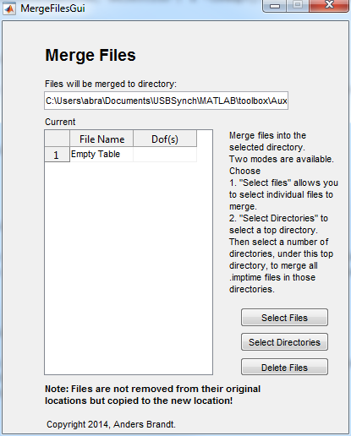

The merge files GUI contains a list window with all files in the output directory, and three buttons; one to select individual files to add to the output directory, one to select one or more directories under which .imptime fiels are located, and one to delete files.

## Select Directories

This button allows you to first select a top directory. Then a separate Gui is opened, in which several subdirectories of the top directory can be selected. ALL .imptime files located in those selected subdirectories will be merged into the output directory. If needed (if the files have the same file names, or if the files lack file numbers), the files will be renamed in the output directory.

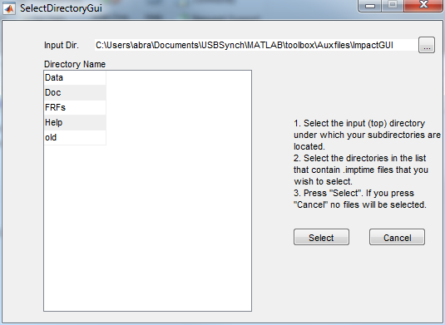

# Pretest – Optimize FFT Settings

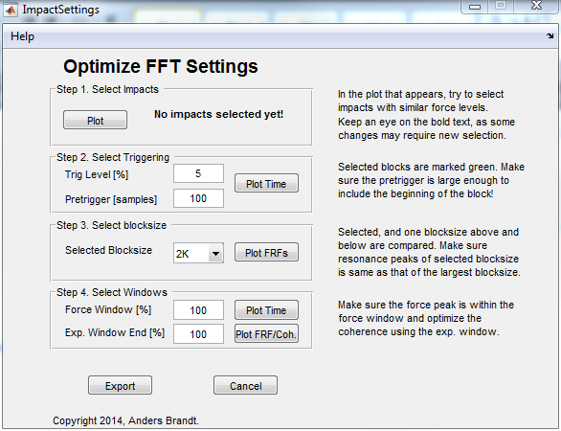

This GUI allows changing all FFT settings; the trigger conditions, blocksize, and window settings.

## Step 1 – Select Impacts

Press the Plot button, which produces the following plot window.

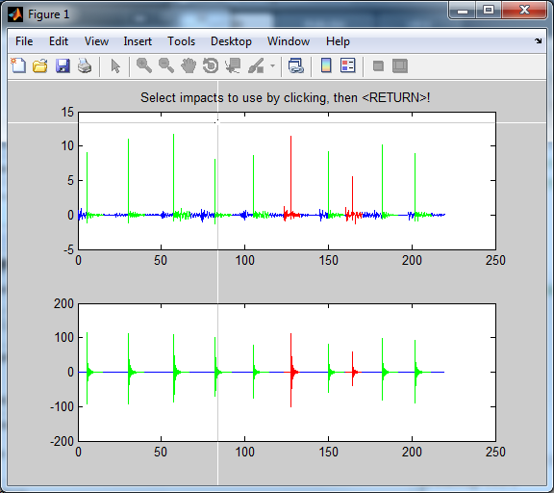

The window shows the raw time data in blue, each block defined by the trigger conditions and blocksize in green, and possible double impacts in red as in the above plot. Click on the impacts to use for FRF/Coherence calculation for the optimization.

## Step 2 – Select Triggering

After selecting a trig level and number of pretrigger samples, you can press the Plot Time button to get a plot of the result. You can zoom in and examine the data in more detail in the plot that opens. Note that after changing trig level and/or pretrigger, you need to reselect the impacts you wish to use in the “Select Impacts” panel, as trigger settings may change what blocks are detected as double impact blocks, etc.

## Step 3 – Select Blocksize

This choice allows you to plot the FRFs for three blocksizes; the blocksize chosen in the popup menu, and one blocksize smaller and larger, respectively, by pressing Plot FRF. The idea with this is to investigate the bias errors at the resonance peaks in the FRFs. When the blocksize is sufficiently large, and thus the frequency increment sufficiently small, the bias error “vanishes”. So, you should try to obtain a plot like the following, in which the two larger blocksizes have approximately the same peak, which means that the bias is negligible.

Note! After changing the blocksize setting, you may need to reselect the impacts to use for the analysis, this is then indicated by the text in the “Select Impacts” panel saying “**No Impacts Selected!**”. This is because the double impact detection has been affected by the selected blocksize.

Note 2! This function does not apply any force, nor any exponential window.

## Step 4 – Select Windows

In this panel you can adjust the force and exponential window factors and plot the results in both time domain and frequency domain by the two buttons Plot Time and Plot FRF/Coherence, respectively.

# Continue GUI

The Continue button opens a GUI, and two plots as in the next figures: The plots show the results depending on the selected settings.

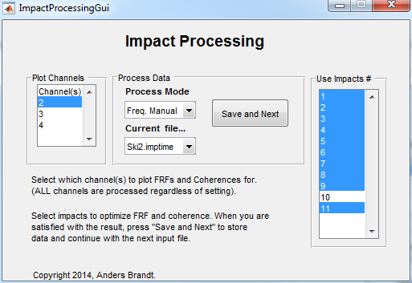

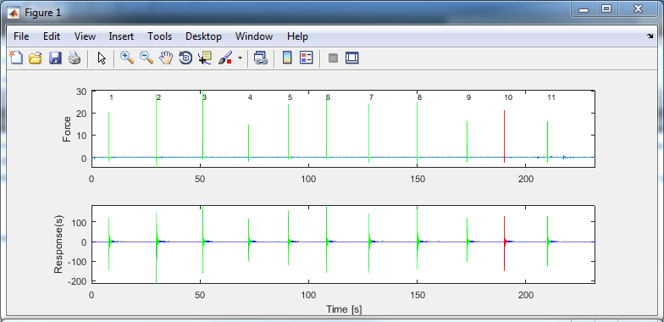

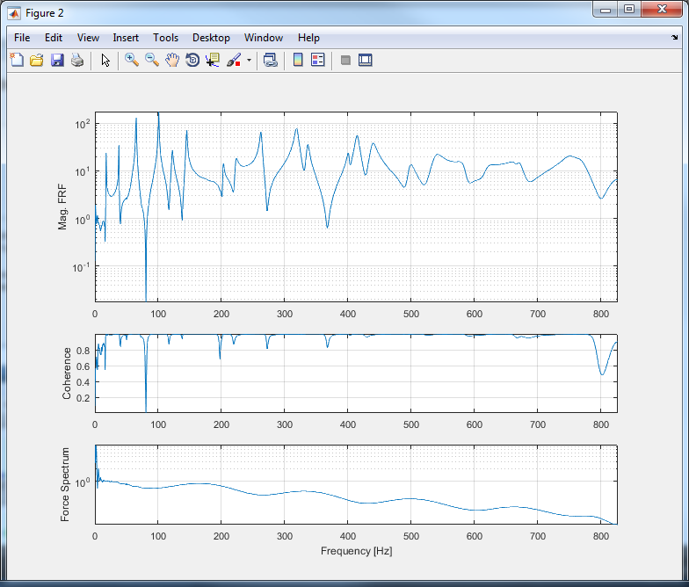

In this GUI you can process each .imptime file into FRFs, coherence functions, and force spectra. There are several different modes to process the data; see below.

## Plot Channels

In this selection list you can select one or more of the response channels in the .imptime file to use for plotting FRFs and coherence functions. Since the impact hammer is on channel 1, you can only select a channel from 2 and upwards. This choice is only affecting the plots; all channels are always processed!

## Process Data

In this panel you should first select the process mode. The action is then a little different depending on the Process Mode selected.

### Process Mode

#### Freq. Manual

This choice, is performing “standard” impact testing, i.e. with averaging in the frequency domain. This GUI also allows you to select which impacts to use in the Use Impacts # selection list.

#### Time Synchr. Manual

This choice is performing the averaging in the time domain. Note that the Coherence function is undefined in this mode, although it is plotted as a function equaling 1.

#### Best Two

This choice performs an automatic processing of all files starting with the Current file… and all succeeding files in the file list using an optimization algorithm. The algorithm used is the one described in the paper [2],

## Current File

This popup menu shows which file is currently being processed. You can select any file, if you for some reason want to skip a .imptime file, or go back and reprocess a file. Note however! The output files are incremented each time you press the Save and Next button (see below), so you risk ending up with either some files unprocessed, or with multiple results for the same .imptime file!

## Save and Next

This button saves the currently displayed results (including the results for the channels that are not displayed) and processes the next .imptime file in the list. If the current file is the last in the list, the GUI is closed after saving the results.

## Use Impacts #

In this selection list you can select the impacts you want to use for the averaging process, if the process is one of the manual modes; otherwise this list is irrelevant. The default for each new .imptime file is to use all impacts except those with detected double impact. You should try to optimize the coherence by deselecting impacts which are deviating from the others. You can also sometimes note that the coherence drastically improves when you deselect a particular impact; this is an indication that the impact in question was erroneous, for example because the point of the impact was slightly off compared to the other impacts.

# References

[1] Brandt, A., *Noise and Vibration Analysis – Signal Analysis and Experimental Procedures*, John Wiley and Sons, 2011.

[2] Brandt, A. & Brincker, R. Impact Excitation, in *Processing for Improved Frequency Response Quality Proc. 28th International Modal Analysis Conference, Jacksonville, FL*, 2010.

Copyright © 2014, Anders Brandt.