### John Doe’s VOX Analysis

*Evaluation date: 2024-08-23*

The VOX analysis (*verbal operant experimental*) evaluates the language repertoire for John Doe, in order to provide an accurate autism spectrum disorder diagnosis.

A balanced repertoire implies that the speaker has a normal language development. An imbalance, measured and visualized below, implies the speaker has autism spectrum disorder.

### Clinician’s Conclusions / Recommendations

***Please provide any supplemental information or conclusions here. Otherwise, you can delete this section***

### Responses

During a session, John Doe was supplied with several referants to interact with (i.e., toys and other objects). The listener engaged with John Doe to solicit a positive response to a verbal operant (conversing, listening, echoing, and repeating).

The table below shows the way John Doe responded:

| date_of_evaluation | referent | conversing | labeling | echoing | requesting |
| --- | --- | --- | --- | --- | --- |
| 2024-08-23 | Apple | 0 | 1 | 1 | 0 |
| 2024-08-23 | Ball | 0 | 1 | 1 | 0 |
| 2024-08-23 | Tablet | 0 | 0 | 1 | 1 |
| 2024-08-23 | Pencil | 0 | 1 | 1 | 0 |
| 2024-08-23 | Army Man | 0 | 0 | 0 | 0 |
| 2024-08-23 | Mouse | 1 | 1 | 1 | 1 |

### Area Q Plot

The Area Q plot helps visualize variance. A speaker with normal language development will have roughly equal points on each axis. A speaker with abnormal language development will have unequal points on each axis.

* Centroid: **(1.33, -2.67)**
* Centroidal distance: **3**
* First moment of area Q: **648**

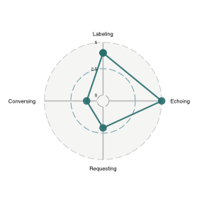

### VOX Chart

The VOX Chart shows the responses based on the verbal episode. A speaker with normal language development will have relatively straight lines that overlap one another most of the time.

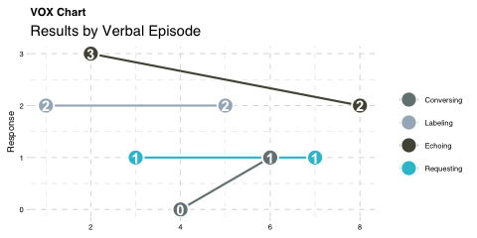

### Cochran’s Q

Cochran’s Q is a statistical test is used to verify whether the speaker has a balanced repertoire. A p-value less than 0.05 means we reject the null in favor of the alternative that the speaker does have an imbalance.

| label | value |
| --- | --- |
| Cochran’s Q | 7.5000 |
| Chance-corrected R | 0.1875 |
| P-value | 0.0600 |

### SCoRE

The speaker has a SCoRE of **0.6**.

*Stimulus Control Ratio Equation (SCoRE)* measures the proportionality of the speaker’s repertoire on a scale of 0 to 1. A higher number indicates balanced language assessment.

The pie chart below further illustrates this balance or imbalance.

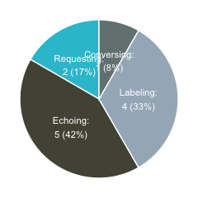

### Prompt Hierarchy

| Percent | Conversing | Labeling | Echoing | Requesting |
| --- | --- | --- | --- | --- |
| 100.0 | CELR | LERC | ELRC | RELC |
| 91.7 | - | LER | ELR | REL |
| 83.3 | CEL | LEC | ELC | - |
| 75.0 | - | LE | EL | - |
| 66.7 | CER | - | ERC | REC |
| 58.4 | - | - | ER | RE |
| 58.3 | CLR | LRC | - | RLC |
| 50.0 | CE | LR | EC | RL |
| 41.7 | - | - | E | - |
| 41.6 | CL | LC | - | - |
| 33.3 | - | L | - | - |
| 25.0 | CR | - | - | RC |
| 16.7 | - | - | - | R |
| 8.3 | C | - | - | - |