Test Bench for CCounterOprLevel

# Core description

The core ***CCounterOprLevel_T*** is almost identical to the core ***CCounterLevel_T***. There is a template parameter to define the type of the counter, for example if TYPE = ubyte, an 8 bits unsigned counter is created. The counter is clocked at each step, i.e. at FPGA clock. Instead of individual signals, the input ***iOpr*** controls the operation. Its type is:

enumOpr_t{cOprNone,cOprReset,cOprUp,cOprDown,cOprLoad};

Therefore, if ***iOpr*** equals ***cOprUp*** then the counter counts up.

# Test bench

This test bench uses the ***Signal Editor*** and the ***Signal Viewer*** to test the core. The test will be done in single step simulation. Follow the instructions to:

* Create signals in the ***Signal Editor.***
* Execute with the ***Single Step*** function (F8).
* Use the ***Watch Window*** in single step mode.
* View the result in the ***Signal Viewer.***

# Description

The ***Signal Editor*** is an Excel like spreadsheet to edit the input signals and view the output signals, including the events. The signal editor saves its information in a ***.evdoc*** file.

Virtual Board

Simulator (RVM)

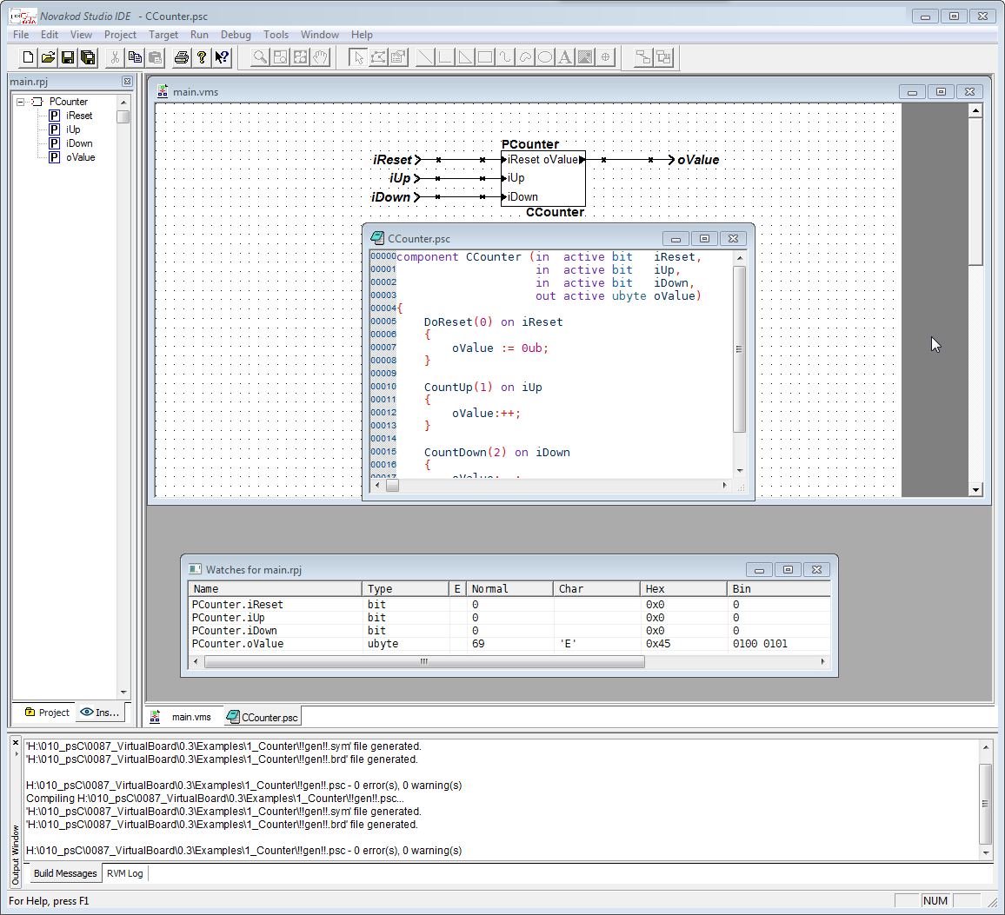

Debug Connection

Novakod Studio

Watch Window

Signal and event files (.evi, .evo, .evdoc, .vcd)

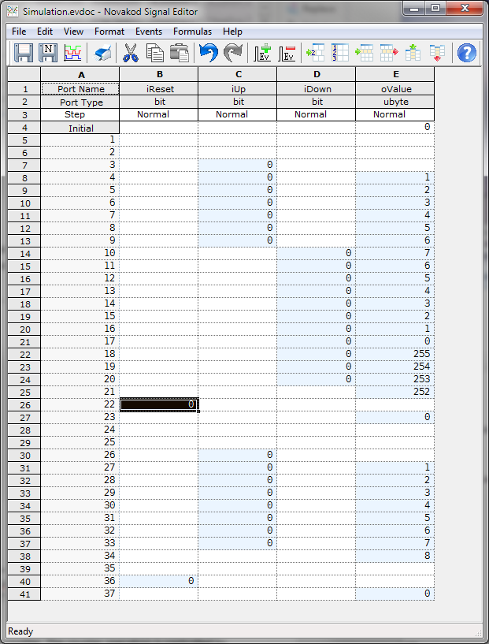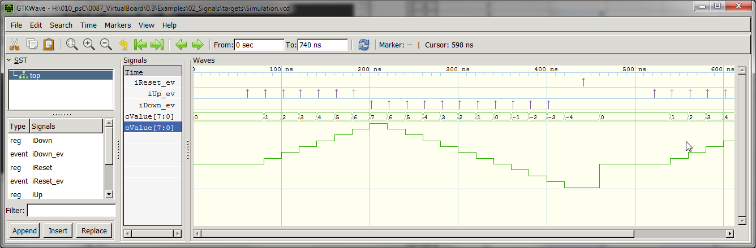

Signal Editor

Signal Viewer

During simulation, the signals are read from an input event file (***.evi***) and written to an output event file (***.evo***). After simulation, the ***Signal Editor*** is used to view the resulting output signals. Then, the ***Signal Viewer*** will display the signal in the more common temporal view, with digital or analog representation. The signal viewer is ***GTK Wave*** and it uses ***.vcd*** (value change dump) files.

# The psC test program

The test program consists of a single component, the core to be tested, and IO connections. The counter operation is controlled by the value of the input ***iOpr***.

1. Double-click on ***Counter.rpj*** to start Novakod Studio.
2. Double-click on the ***main*** component to view the schematic.
3. Double-click on the ***CCounterOprLevel_T*** component to view the counter code.

# Compiling the test program

You will now compile the program, start execution, and use the editor signals to test it.

1. Graphical user interface, application

   Description automatically generatedUnder ***Targets*** open the ***Simulation*** properties and verify that the target is the Novakod Virtual Board.
2. Text

   Description automatically generatedExpand ***Targets*** then ***Simulation***, you should see the two event files:

# Viewing and editing input signals

The signals are already set, but you can change them as you wish.

1. Double-click on ***targets\Simulation.evi*** to start the ***Signal Editor***.

As you can see, the signal ***iOpr*** takes different values to control the counter. The values are displayed as their ***enum*** names. You can easily interpret the signal to predict the counter value. If you change the signals, don’t forget to save.

# Running the test program

You are now ready to run and use the ***Single Step*** execution mode.

1. Select the menu ***Run🡪 Start Paused*** to begin simulation, accept the build confirmation.
2. Right click on each port in the project ***Inspect*** tab to add them to the ***Watch window***.
3. Graphical user interface, application, table

   Description automatically generatedYou should see the initial values.
4. Graphical user interface, text, application

   Description automatically generatedThe RVM is in pause, and you can execute step by step.
5. ***For single step, simply type F8.*** Repeat until you reach step 30. You will see all the input signals being applied at each step.
6. After 30 or more steps, stop the simulation by selecting menu ***Run🡪 Stop***.

# View results in signal editor

You can now view the results.

1. Double-click on ***targets\Simulation.evo***, the ***Signal Editor*** window starts with the values in ***oValue*** column.
2. Verify the counter operation.

# Graphical user interface, application, table, Excel Description automatically generatedView results in signal viewer

Novakod Studio integrates the well-known signal viewer called ***GTK Wave***.

1. A screenshot of a computer

   Description automatically generated with medium confidenceSelect menu ***File🡪 View Signals*** or click the shortcut . The GTK Wave windows appears. GTK Wave has been pre-configured to show the desired signals. You can see the inputs and the output in hexadecimal or as an analog signal.