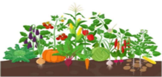
Sponsored by Upper Merion Community Garden at Sunny Hill Farm & 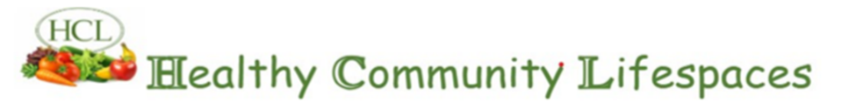
An inclusive program for students preschool through all grades.

Join us for a fun, hands‑on garden experience for all students!
Children will learn how to plant and care for a garden, what plants need to grow, and why vegetables are important for our health. Every student will get to plant something of their own.
We’ll also share information about CHOP’s “Food as Medicine” programs and local food pantries that help keep families healthy.
We are looking for students and teen advocates who want to promote healthy eating and wellness in our schools.

Date: Saturday, May 23th at 12:00-1:00 pm
Location: Upper Merion Community Garden at Sunny Hill Farm, 135 E Valley Forge Rd

This free event will be led by a Registered Dietitian and an Occupational Therapist to ensure a hands-on, wellness-focused experience.
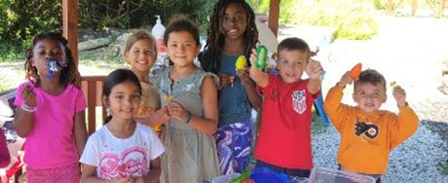

Email or text your name and phone number and age to register healthycommunitylifespaces@gmail.com or 610-505-0515 for questions or information

