
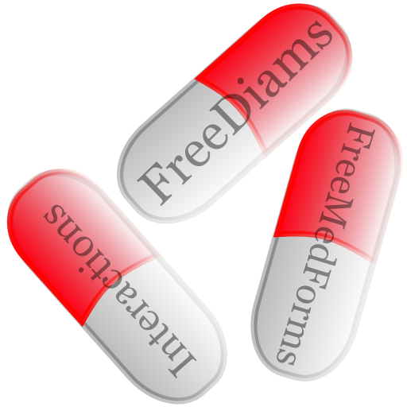
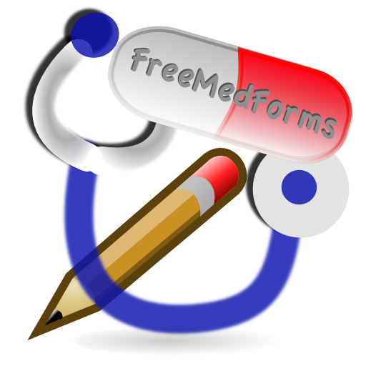



The FreeMedForms project
managing drug-drug interactions
an Open Source experimentation
Eric Maeker MD, Christian A. Reiter MD
freemedforms.com

INTRODUCTION: Drug-drug interactions (DDI) can lead to severe health outcome and are all avoidable. Electronic medical record (EMR) managers can help to improve patient safety, as prescribers' and pharmacists' ability to recognize potentially interacting drug pairs is limited . Unfortunately, many DDI software products are not optimal .
THE PROJECT: The FreeMedForms project was started in October 2008. The main objective is to provide a full EMR and an open source DDI software for practitioners and pharmacists. The project is coded using C++ and the Qt framework. The project is driven by a volunteer community of medical doctors, pharmacists and computer scientists. The code is released under the GPLv3 license. FreeMedForms is supported by open source medical teams like Debian Med, OpenSuse Medical and Fedora Medical.
DATA SOURCES: The drug databases are based on free governmental data and the DDI engine is based on a compilation of data sets (mainly extracted from governmental web sites and scientific publications ). The ATC classification [xx] is used to compute DDI and other patient-drug interactions. The main work consists of translating drugs components to their ATC equivalents. This is done using a specific application called FreeToolBox and has to be checked «by hand». There is no automated data-mining.
THE DDI ENGINE: As drugs can contain multiple components, he DDI engine analyzes prescription by pair of components. Each drug component that can be translated to its ATC equivalent gets analyzed. The DDI engine takes the route of administration into account as some drugs do not have any (or a weak) systemic passage. Two kinds of alerts are then defined to inform the user: non-blocking alerts are represented by an icon next to the drug inside the prescription view, and blocking alerts that require a user validation to pass through. The threshold of alerts can be defined separately for each type of alert, to avoid alert fatigue. Alert fatigue is well known and defined as a phenomenon caused by excessive warnings including irrelevant, non-significant, or repetitious alerts. The timing of the alert system is also clearly defined and the engine analyses prescriptions during three different moments: when user searches for a drug (allergy warning), when a drug is selected and when the posology is defined.
INTEROPERABILITY: FreeDiams, the DDI software of the project, can be connected to any EMR that wishes to take advantage of its expertise using an interoperability interface. This interface uses simple XML files. The GnuMED and other EMR projects already implemented this interoperability.

Repartition of interactions according to their level of risk
Contra-indication | 10880 | 2%
Unadvised | 25316 | 6%
Glycoprotein P interaction | 40936 | 10%
P450 cytochrome interaction | 25900 | 6%
Take into account | 216718 | 55%
Precaution for use | 79882 | 20%
Information | 1722 | < 1%
Undefined | 398 | < 1%
Total DDI per INN | 390376 | 100%

Repartition of interactions according to their level of risk
Contra-indication | 10880 | 2%
Unadvised | 25316 | 6%
Glycoprotein P interaction | 40936 | 10%
P450 cytochrome interaction | 25900 | 6%
Take into account | 216718 | 55%
Precaution for use | 79882 | 20%
Information | 1722 | < 1%
Undefined | 398 | < 1%
Total DDI per INN | 390376 | 100%

CURRENT AND FUTURE DEVELOPMENTS: Some developments are actually started to implement more complex interactions like potentially inappropriate medication , renal failure detection. A scientific validation of the DDI engine is required and should be done by independent scientists (to avoid competing conflict and any conflict of interest).

Committee on Identifying and Preventing Medication Errors. Preventing Medication Errors: Quality Chasm Series. Washington, DC: National Academies Press, 2007.
Ko Y, Malone DC, Skrepnek GH, et al. Prescribers’ knowledge of and sources of information for potential drugedrug interactions: a postal survey of US prescribers. Drug Saf 2008;31:525e36.
Weideman RA, Bernstein IH, McKinney WP. Pharmacist recognition of potential drug interactions. Am J Health Syst Pharm 1999;56:1524e9.
Saverno KR, Hines LE, Warholak TL, et al. Ability of pharmacy clinical decision-support software to alert users about clinically important drug-drug interactions. J Am Med Inform Assoc 2011;18:32e37
Rodríguez-Terol A, Caraballo MO, Palma D, et al. [Quality of interaction database management systems]. Farm Hosp 2009;33(3):134-46
The Qt project : http://qt-project.org Inform Assoc 2011;18:32e37
http://wiki.debian.org/DebianMed
http://en.opensuse.org/Portal:Medical
http://fedoraproject.org/wiki/SIGs/FedoraMedical
http://fedoraproject.org/wiki/SIGs/FedoraMedical
Flockhart DA. Indiana University School of Medicine. Drug Interactions: Cytochrome P450 Drug Interaction Table.
Oesterheld Jessica. P-glycoprotein Table - the Effect of Drugs and Foods.
Shobha Phansalkar, Judy Edworthy, Elizabeth Hellier, et al. A review of human factors principles for the design and implementation of medication safety alerts in clinical information systems. JAMIA 2010 17: 493-501
http://wiki.gnumed.de
Fick DM, Cooper JW, Wade WE, et al. Updating the Beers criteria for potentially inappropriate medication use in older adults: results of a US consensus panel of experts. Arch Intern Med. 2003 Dec 8-22;163(22):2716-24.
Holt S, Schmiedl S, Thürmann PA. Potentially inappropriate medications in the elderly: the PRISCUS list. Dtsch Arztebl Int. 2010 Aug;107(31-32):543-51
Laroche ML, Bouthier F, Merle L, Charmes JP. [Potentially inappropriate medications in the elderly: a list adapted to French medical practice]. Rev Med Interne. 2009 Jul;30(7):592-601.
McLeod PJ, Huang AR, Tamblyn RM, Gayton DC. Defining inappropriate practices in prescribing for elderly people: a national consensus panel. CMAJ. 1997 Feb 1;156(3):385-91.

