Volume

1

U.S. National Library of Medicine

Lister Hill National Center for Biomedical Communications

PHR Users Guide

U.S. National Library of Medicine

PHR Users Guide

U.S. National Library of Medicine

Lister Hill National Center for Biomedical Communications

Computer Science Branch

38A, 9S911

8600 Rockville Pike

Bethesda, MD 20894

Phone 301-435-3169

Table of Contents

1. Overview and Background 1

1.1. Features and Capabilities 1

1.2. Health Information That Can Be Recorded 1

1.3. Privacy and Security 2

1.4. PHR Limitations 2

1.5. System Requirements 2

1.5.1. Operating Systems 2

1.5.2. Browsers 2

1.5.3. Browser Settings 3

1.5.4. Accessibility 3

2. About the PHR Account ID 4

2.1. Account Maintenance 4

2.1.5. Forgotten Account ID 4

2.1.6. Forgotten Password 5

2.1.7. Changing Your Password 5

2.1.8. Changing Your Security Questions or Answers 5

3. The PHR Home Page 6

3.1. Personal Health Records I Manage 6

3.2. Inactive PHRs I Manage 7

4. The PHR Health Record Details Page 8

5. Create a New Personal Health Record (PHR) 10

6. View or Edit an Existing PHR 11

7. Print a PHR 12

7.1. Google Chrome 12

7.2. Internet Explorer 12

7.3. Mozilla Firefox 12

7.4. Safari 13

8. Download PHR Data to a Computer 14

9. Make a PHR Inactive 15

10. Restore an Inactive PHR 16

11. Delete a PHR 17

12. Data Entry Tips and Shortcuts 18

12.1. Opening and Closing Sections in the PHR 18

12.2. Using the PHR's Drop-down Lists to Enter Data 18

12.3. Bypassing Drop-down Lists 19

12.4. Entering Dates 19

12.4.9. Shortcuts for entering today's date and related dates 19

12.5. Entering Times 20

12.6. Fixing Input Errors 20

12.7. Table of User Functions and Shortcut Keys 20

13. The Research Studies and Information Buttons 24

13.1. The Blue Information Button 24

13.2. The Research Studies Button 24

14. Working with Test Results and Health Trackers 25

14.1. Adding New Test Results or Health Trackers 25

14.2. Adding New Measurements to a Test Result or Health Tracker 26

14.3. Editing Test Results and Health Trackers 26

14.4. Deleting Test Results or Health Trackers 27

14.5. Using the View & Edit Results Timeline 27

14.6. View & Edit the Results Timeline Screen 28

14.7. View Test or Tracker Results as a Graph 28

15. Date Reminders 30

16. Health Reminders 32

17. Sharing a PHR 33

Index 36

Chapter

1

# Overview and Background

The National Library of Medicine (NLM) Personal Health Record (PHR) is a web-based software tool designed to be used by a patient or family caregiver. The PHR is supported “behind the scenes” by the clinical vocabulary standards that are NLM-supported and required by Meaningful Use of Electronic Medical Records (Stage 2) regulations to help with health information exchange.

You will find a brief overview about the NLM PHR project on the NLM web site: <http://go.usa.gov/KTyW>. Additionally, a demo version of the PHR <https://phr-demo.nlm.nih.gov/>, which is accessible from any computer, allows you to create a temporary account to explore the software.

## Features and Capabilities

* You can store and manage the health data – health conditions, medications, vaccine history, allergies, surgeries, etc. – for each of your family members. The PHR can yield a summary of key health data to unify the fragments and notes from different visits to different doctors and hospitals.
* The PHR features auto-complete and synonyms for easier data entry.
* You can track and graph laboratory test results to see improvements over time, relationships between activities and outcomes (for example, exercise and blood pressure), and areas that might need more attention.
* You and your family members receive “smart” preventive health reminders, described in simple language based on national guidelines and specific to each PHR.
* You can access trusted consumer health education resources about the medical conditions and medications of you and your family members through the user of the PHR’s http://i.stack.imgur.com/qOXqp.png information button.
* You and your family members can prepare for doctor appointments by printing a PHR health summary and recording questions to ask the doctor.
* Individual PHRs can be downloaded and exported to your computer.

## Health Information That Can Be Recorded

* Medical conditions
* Medications
* Allergies and other dangerous reactions
* Major surgery and implants
* Risk factors
* Vaccinations
* Questions to ask your doctor
* Medical contacts
* Laboratory tests and procedures
* Personal health trackers

## Privacy and Security

The PHR employs strict privacy rules. No one can look at the data except you or those designated by you.

## PHR Limitations

* The PHR does not automatically link to the hospital’s medical record.
* The PHR will allow you to pull in the summary of care documents that are supposed to be produced by hospitals and physicians although it is too early to tell if these will be well standardized and easy to import.

## System Requirements

### Operating Systems

The PHR will work with the following operating systems:

* Windows 8, 7, Vista, or XP
* Macintosh OS X
* Linux

### Browsers

The PHR will work with the following browsers:

* Internet Explorer Version 9 or later
* Mozilla Firefox
* Google Chrome
* Safari Version 5.0 or later (not extensively tested, but we believe it works with all of the PHR's features)

**Note:** *When accessing the PHR, you should avoid opening more than one instance of the PHR at the same time. Using multiple windows to view and enter data within the PHR may result in unexpected behavior such as errors when attempting to save data. This applies to both the basic and standard versions of the PHR.*

### Browser Settings

* **Enable JavaScript:** Regardless of browser type, the browser must support JavaScript and your browser must be set to enable JavaScript. (Does not apply to Basic HTML Mode.)
* **Enable Session Cookies:** You must also enable session cookies in the browser to use the PHR.

### Accessibility

To adjust the size of the PHR text, increase or decrease the zoom level of Internet Explorer, Firefox, Chrome, and Safari as follows:

**Keyboard**

* To zoom in, increasing the size of the text, press and hold CTRL while pressing +.
* To zoom out, decreasing the size of the text, press and hold CTRL while pressing -.
* To reset the size back to normal, press and hold CTRL while pressing 0.

**Mouse**

* If your mouse has a scroll wheel, press and hold CTRL while scrolling up to zoom in and down to zoom out.

The PHR application is heavily dependent on JavaScript, graphics, and CSS for its user interface; however the PHR Has a **Basic HTML** mode that does not use JavaScript. To use the PHR with assistive technology such as screen readers, use the PHR’s Basic HTML Mode by clicking the **Accessibility** link at the bottom of the **PHR Welcome** page and then clicking on the **Basic HTML** mode link in the Help text.

Chapter

2

# About the PHR Account ID

The PHR Account ID is the unique identifier you use to access all of the Personal Health Records maintained by you.

Longer and more complex Account IDs are more secure; however, you should choose an Account ID that will be easy to remember. Avoid using any personal identifiers as part of your Account ID to ensure your privacy. Personal identifiers include information such as names, social security numbers, addresses, or telephone numbers.

The PHR account ID

* can be from 6 to 32 characters long
* must begin with a letter
* can contain a combination of letters, numbers, and underscore (\_) characters
* is not case-sensitive

You can create multiple Personal Health Records using the same PHR account ID.

The PHR includes an Account ID recovery option through the **Account ID** recovery link in the middle of the **PHR Login** page. You must supply the answers to three security questions that you established when the account was created and you must have access to the email address associated with your PHR Account ID in order to recover your account without assistance.

## Account Maintenance

### Forgotten Account ID

To have your PHR Account ID sent to your email address, you must recover it using the email address associated with your PHR account. If you do not have access to the email address associated with the account, send an email to us using the **PHR Support** link at the bottom of the PHR page.

To recover your PHR Account ID:

1. Click the **Forgot your account ID?** link in the middle of the **PHR Welcome** page and follow the steps to recover your Account ID.
2. Supply the answers to the security questions you created answered when you established your account.

### Forgotten Password

To recover your PHR password:

1. Click the **Forgot your password?** link in the middle of the **PHR Welcome** page and follow the steps to reset your password.
2. You will need to supply the answers to the security questions you created and answered when you established your account.
3. If you do not have access to the email address associated with the account or if you have difficulty resetting your password, send an email using the **PHR Support** link at the bottom of the PHR home page.

### Changing Your Password

To change your password:

1. Log in to the PHR with your current password.
2. Click the **Account Settings** link at the top of the right side of the **PHR Home** page.
3. Follow the instructions for changing your password. You will be prompted for your current password prior to entering a new password. Your password must be at least 8 characters long and include at least 3 of the following: capital letters, lower case letters, numeric characters, or special characters. Your password is case-sensitive.

### Changing Your Security Questions or Answers

To change the security questions and answers associated with your PHR account:

1. Log in to the PHR.
2. Click the **Account Settings** link at the top of the right side of the **PHR Home** page
3. You will be prompted for your current password prior to changing your security questions and answers.

Chapter

3

# The PHR Home Page

The **PHR Home** page provides you with a summary of all of the PHRs that you create under your account and includes the option to create additional PHRs by clicking the **Add New Person** button. The page is separated into active and inactive PHRs. Active PHRs are located in the **Personal Health Records I Manage** section and inactive PHRs are located in the **Inactive PHRs I Manage** section of the **Home** page.

## Personal Health Records I Manage

New and existing **Health Reminders** and **Date Reminders** are located next to each PHR. Expand any PHR entry by clicking the yellow expand button next to the record name. Expanding the PHR entry will allow you to navigate directly to the section of the PHR you want to access.

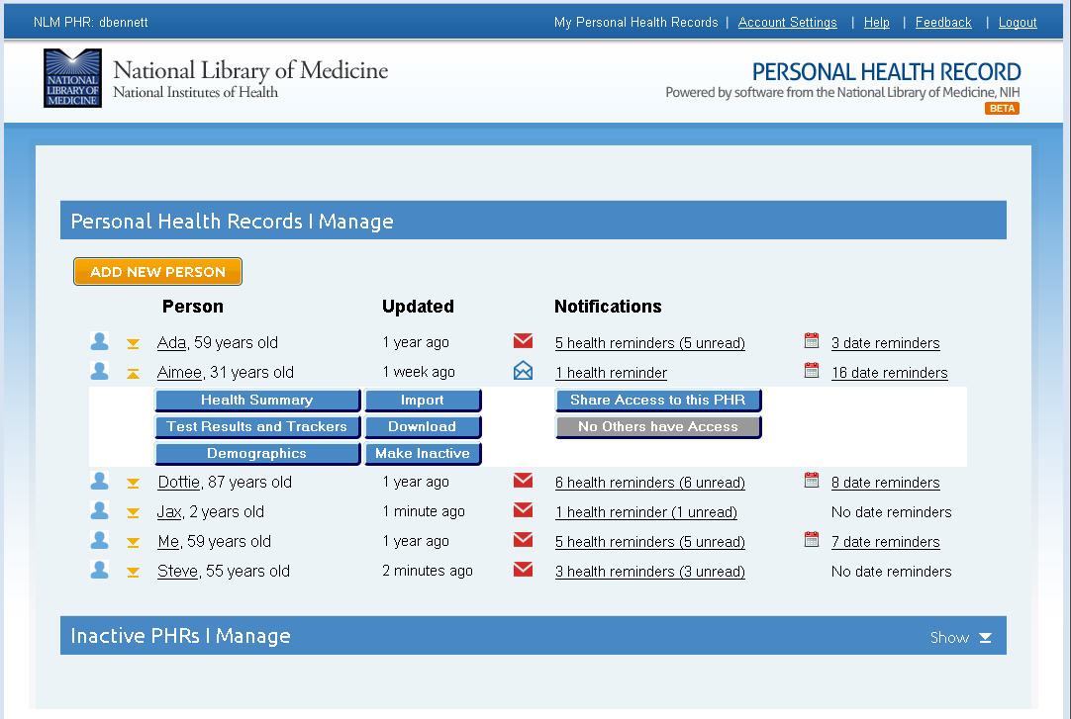

The expanded entry contains the following buttons:

|  |  |
| --- | --- |
| Health Summary | Takes you to the **Health Summary** page of the person’s PHR. |
| Test Results and Trackers | Takes you to the **Test Results and Trackers** page of the person’s PHR. |
| Demographics | Allows you to change the basic information of the PHR, including the PHR name, birthdate, gender, and ethnicity. |
| Import | This functionality has not yet been implemented. |
| Download | Allows you to download the PHR to a file on your computer. You can use most spreadsheet programs to view the information and to print a copy |
| Make Inactive | Removes the PHR from the **Personal Health Records I Manage** section of the Home page and move it to **the Inactive PHRs I Manage** section of the **Home** page. You can make a PHR inactive in order to prepare it for deletion. |
| Share Access | Allows you to issue a share invitation to a trusted family member or health care provider. |
| Shared button | Provides you with sharing information about the PHR. |

## Inactive PHRs I Manage

The Inactive PHRs I Manage section of the PHR Home page contains a list all PHRs that you have made inactive using the Make Inactive button. By default, inactive PHRs are not automatically displayed on the PHR Home page, however, clicking the Show button on the right side of the Inactive PHRS I Manage banner will display a list of your inactive PHRs.

Chapter

4

# The PHR Health Record Details Page

Using the PHR’s **Health Record Details** page, you can enter information about health conditions, surgeries, medications, allergies, and vaccinations. You can also enter due dates for doctor’s appointments, medication refills, and tests and procedures, and create custom due date reminders.

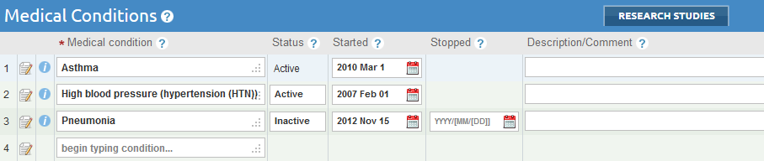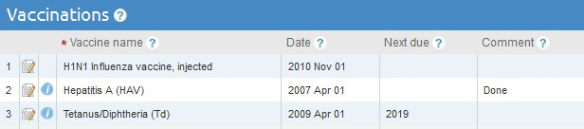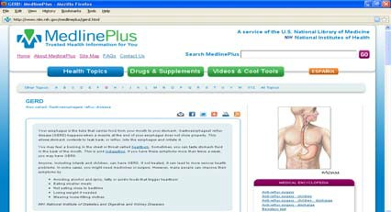

The http://i.stack.imgur.com/qOXqp.png information buttonsto the left of each row provide links to trusted educational resources, such as NLM MedlinePlus and CDC vaccine information sheets.

The **Health Record Details** page uses the individual’s demographic data (age, gender) to display fields for entering appropriate preventive screening results. For example, women in certain age groups have a place to enter mammogram and Pap smear results, while both men and women have a section for colon cancer screening and only men have prostate screening results.

Chapter

5

# Create a New Personal Health Record (PHR)

You can create a Personal Health Record (PHR) for all family members using a single PHR Account ID. The PHR health record form automatically tailors itself to the age, gender and other characteristics of you or your family members. For example, the PHR system will only insert space for recording a mammogram result when the health record is for a woman who is the appropriate age for mammography. The PHR will also generate a unique form for each type of medical test, procedure, or health tracker.

To create a new PHR:

1. Click the **Add New Person** button on the **PHR Home** page. The PHR will generate a form to prompt for the following information about the new PHR being created. Fields highlighted with a **\***required fieldrequired field are required fields.
   1. **required field\*PHR Record Name:** Create a name for the personal health record. Use an alias or invented name such as "Self", "Son 1", or "Father" to maximize your privacy.
   2. required field**\*Date of Birth:** Enter the date of birth for the family member whose health data is being entered. You can use either the full date or just the year of birth. The birth date is used to generate health reminders tailored to the gender, age, and risk factors for each individual.
   3. **required field\*Gender:** Select the gender of the person from the drop down list.
   4. **Race or Ethnicity:** Select the race/ethnicity of the person from the drop down list.
2. Click the **Save** button below the form fields to create the new PHR. The system will then display the **Health Record Details** page.
3. On the **Health Record Details** page, enter medical conditions, medications, allergies, tests, vaccinations, and medical contacts by selecting the name of each item from the drop down list, or select from the lists that appear as you start typing and get more specific as you enter more characters.
4. Enter questions you want to ask the doctor as you think of them and bring them along on the next appointment.
5. To save the PHR, click the **Save** button at the top or bottom of the page.

Chapter

6

# View or Edit an Existing PHR

To view or edit an existing PHR, select the name of the profile to be edited from the list of PHRs on the **PHR Home** page. Then, select one of the following links:

* **Health Summary** - to edit items on the **PHR Record Details** page including medical conditions, medications, allergies, surgeries, vaccinations, medical contacts, questions to ask your doctor, and notes sections.
  + To view all of the sections of the PHR, click the **Show All** link on the top right of the **PHR Record Details** page.
  + To add new information to any section of the PHR, click on the heading of the PHR section you wish to edit and begin typing in the blank field.
  + To make changes to an item that has already been saved, click on the Paper and PencilC:\Users\dbennett\Pictures\PHR symbols\paper_pencil.gif icon at the beginning of the row to edit or delete the item.
  + To save your changes, click the **Save** button at the top or bottom of the page.
* **Test Results & Trackers** - to edit existing test results and health trackers on the **View & Edit Results Timeline** page.
* **Demographics** - to edit the person's name, date of birth, gender, or ethnicity. Information

Chapter

7

# Print a PHR

Use your browser’s **Print** function to print the **Health Record Details** and the **View & Edit Results Timeline** pages of the PHR.

* Before printing the **Health Record Details** page, make sure that the **Show All** option on the PHR's **Health Record Details** page is selected.
* Before printing the **View & Edit Results Timeline** page, display all of the results to be printed by selecting one or more test results to print and then clicking the **Show Results Timeline** button.

## Google Chrome

1. Press **Ctrl+P** to bring up the Print dialog box.
2. Select the **Landscape** radio button and check the **Print Background Colors and Images** checkbox.
3. Click the **OK** button in the **Print** dialog box.

## Internet Explorer

1. Select **File** then **Page setup...** at the top of the browser page to bring up the **Page Setup** dialog box.
2. Select the **Landscape** radio button and check the **Print Background Colors and Images** checkbox.
3. Click the **OK** button to dismiss the dialog box.
4. Press **Ctrl+P** to bring up the Print dialog box. You can also select **File** then **Print...** at the top of the browser page or click the **Tools** icon to bring up the Print dialog box.
5. Click the **Print** button.

## Mozilla Firefox

1. At the top of the Firefox window, click on the orange **Firefox** button (or the **File** menu in Windows XP) and mouse over to the **Print...** menu item, then click **Page Setup...**. The Page Setup dialog box will appear.
2. Select **Landscape** orientation in the pop-up window and the **Print Background (colors and images)** checkbox in the Page Setup dialog box.
3. Click the **OK** button to dismiss the dialog box.
4. Click the orange **Firefox** button again and click **Print...**. The Print dialog box will appear.
5. Click **OK** to print.

## Safari

1. Select **Print** from the **File** menu to bring up the **Print** dialog box.
2. Select **Landcape** orientation and then select the **Print backgrounds** and  **Print headers and footers** checkboxes.
3. Click the **Print** button at the bottom of the **Print** dialog box.

Chapter

8

# Download PHR Data to a Computer

You can download data from a PHR to a computer for use by other spreadsheet programs such as Microsoft Excel. The browser will open a dialog box and prompt you to download the file from the PHR server to the computer. The file will be saved in the XLS spreadsheet file format and include data from the Health Summary and Test Results and Trackers; however, it will not include documents you have uploaded (imported).

To download a PHR to a computer:

1. On the **PHR Home** page, click on the name of the PHR you wish to download from the **My Personal Health Records** area.
2. Click the **Download** button beneath the person's name to begin the download process.
3. A dialog box will appear with instructions on how to download the file. The file name that will be generated will begin with the name of the PHR, followed by the date and time it was generated. i.e., child2\_2014Feb0795122.xls
4. You can use most spreadsheet programs to view the information and to print a copy for your records or for your health care provider.

Chapter

9

# Make a PHR Inactive

PHRs that you are no longer using can be made inactive to keep them from displaying in your list of active PHRs or to prepare them for deletion.

Removed PHRs will be moved to the **Inactive PHRs I Manage** list at the bottom of the **PHR Home** page and will no longer appear in the list of PHRs in the **Personal Health Records I Manage** area of the page.

Inactive PHRs can also be restored should you wish to make them active again.

To make a PHR inactive:

1. On the PHR Home page, click on the name of the PHR you wish to remove from the **Personal Health Records I Manage** area.
2. Click the **Make Inactive** button beneath the person's name.
3. The removed PHR record will now appear in the **Inactive PHRs I Manage** area at the bottom of the **PHR Home** page.

See Chapter 11 for information on how to permanently delete a PHR.

Chapter

10

# Restore an Inactive PHR

Inactive PHRs can be restored if desired. Inactive PHRs are placed at the bottom of the **PHR Home** page under the **Inactive PHRs I Manage** section of the **PHR Home** page. Once a PHR is made inactive, it can either be restored or deleted permanently.

To restore an inactive PHR:

1. On the PHR Home page, locate the **Inactive PHRs I Manage** section at the bottom of the page.
2. Click the **Show** link at the right side of the section heading to display all inactive PHRs you manage.
3. Click the **Restore** button next to the PHR you would like to be restored.
4. The PHR will be restored and placed back in the list of PHRs in the **Personal Health Records I Manage** section of the **PHR Home** page.

Chapter

11

# Delete a PHR

To permanently delete a PHR:

1. First, make the PHR inactive by navigating to the **PHR Home** page and clicking the **Make Inactive** button beneath the name of the PHR you wish to delete.
2. Once the PHR has been made inactive, it will be moved to the **Inactive PHRs I Manage** section of the **PHR Home** page.
3. Click the **Inactive PHRs** link at the bottom of the **PHR Ho**me page to see a list of all inactive PHRs.
4. Click the **Delete** button next to the name of the PHR you wish to delete.
5. The system will prompt you to confirm deletion of the selected PHR.

Chapter

12

# Data Entry Tips and Shortcuts

## Opening and Closing Sections in the PHR

Expand or collapse all sections or the PHR by clicking **Show All** or **Hide All** links near the top right of the **Health Summary** page.

Show or hide individual sections by clicking the **Show** or **Hide** links in the top right corner of each section.

## Using the PHR's Drop-down Lists to Enter Data

Once the user begin typing in a field with many possible responses, such as **Medical Conditions** or **Drugs**, the PHR will display a list of options based on the first few characters typed. The list of suggestions will become shorter as more letters are typed. Additionally, the PHR will offer synonyms based on the words entered. For example, the terms **chest** and **thorax** are synonyms. If the word **thorax** is typed in the **Medical Conditions** section, the list of selections will include **chest pain**, **chest trauma**, **thoracic surgery**, **hemothorax**, etc., all of which relate to medical conditions associated with the chest.

For fields with only a few possible responses, such as **Status** or **Allergy Type**, the PHR will immediately display a list of options before a response is typed. For example, when you click inside the **Allergy Type** field, a list will pop up with the options **Food**, **Medication classes**, **Medications specific** and **Other**.

There are several ways to select an option from the list:

* **Continue typing** until the correct option is highlighted, then press the **Tab** or **Enter** key.
* **Point to the correct option** on the choice list with your mouse and click it.
* Use the **Up Arrow** or **Down Arrow** keys to move the highlight bar to the correct option and press the **Enter** key.
* If the list of options is a numbered list, you need only **enter the item number next to your selection** and the text will be filled into the form.

If you are unable to find your desired option in the drop-down list, describe the condition in your own words. The system will italicize the text and turn the input field orange to remind you that you are not choosing an item from the selection list; however, the system will still accept and store the text.

## Bypassing Drop-down Lists

In most fields selecting from the drop-down lists is optional. For example, if you do not find the name of a drug you are taking in the drop-down list, you may type it in yourself. The system will italicize the text and change the background of the field to orange to remind you that you are not choosing an item from the drop-down list; however, the system will still accept and store the text.

In a few special fields, such as the **Status** field in the **Medical Conditions** section of the PHR, the system will limit entry to one of the valid items from the list. Any invalid data you enter into the field will be deleted.

## Entering Dates

There are three ways to enter a date in any date field in the PHR:

1. Manually **type the date in your preferred format**. Once you type your entry, the PHR will convert it to the standard format used by the PHR system.
2. **Click on the calendar** to the right of the field, find the correct date in the pop-up, and click it.
3. **Use one of the date shortcuts** outlined below which will allow you to enter dates using a minimum number of keystrokes.

### Shortcuts for entering today's date and related dates

* You can enter today's date by typing **T** or **today** (either upper or lower case).
* You can also type the words **tomorrow** or **yesterday** as a substitute for entering numeric dates.
* The letters **D**, **W**, **M**, and **Y** (either upper or lower case) can be used as shorthand to for the words **days**, **weeks**, **months** (30 days), or **years** (365 days).
* You can enter days of the week by entering the full name of the day or an abbreviation for the day such as **mon**, **tue**, **wed**, **thur**, or **fri**.
* The letters **D**, **W**, **M**, and **Y** (either upper or lower case) can be used in conjunction with a whole number *n*, and a plus or minus sign (**+** or **-**) or the words **next** or **last** as shorthand to for the words **days**, **weeks**, **months** (30 days), or **years** (365 days). For example,
* To enter dates in the future, you can use a plus sign (**+**) or the word **next**. Typing **T+***n* (**D**,**W**,**M,Y**) will allow you to enter a specific number of days, weeks, months, and years in the future. For example, entering **T+3M** will input a date that is exactly three months from today's date. Entering **next y** will input a date one year from today's date.
* For dates in the past use a minus sign (**-**) or the word **last**. Typing **T-***n* (**D**,**W**,**M,Y**) will allow you to enter a specific number of days, weeks, months, or years in the past. For example, entering **T-1W** or **T-7D** or the words **last w** will enter a date of one week ago. Entering **last m** will input a date exactly one month ago.
* *Please note that entering the letters* ***D****,* ***W****,* ***M****, or* ***Y*** *alone will input the current date.* For example, entering the letter **y** will input today's date; however, entering **yesterday** will input yesterday's date. The fastest way to enter yesterday's date is by entering **t-1**.

## Entering Times

Enter times using either whole numbers (*hours*) or using *hours***:***minutes* format.

* Once you enter a time, the PHR will convert it to a standard time format with either an **AM** or **PM** designation.
* If you enter the time using numbers between 1 and 12 and do not designate AM or PM, the time will be set to AM hours.
* Use the numbers 13 through 24 for PM hours or enter the time followed by **P** or **PM**.
* You can enter a time of "now" by typing **N** or **Now** (case is not important).
* For times in the future, use a plus sign(**+**). That is, **N+***n* would be the current time plus *n* number of minutes.
* For times in the past, use minus sign(**-**). That is, **N-***n* would be *n* minutes before the current time.

## Fixing Input Errors

If information that the PHR does not understand is entered (such as a date in an incorrect format), the system will sound a soft beep, highlight the field in red and shake the field from right to left (as in “no”).

To make changes to an item that has already been saved, click the C:\Users\dbennett\Pictures\PHR symbols\paper_pencil.gifPaper and Pencilicon at the beginning of the row to edit or delete the item. Note that fields prefixed with a required field**\*** are required fields.

## Table of User Functions and Shortcut Keys

The following table of user functions and shortcut keys provides alternative methods of navigation and data input that will allow users to minimize typing when creating or updating PHRs.

|  |  |  |  |
| --- | --- | --- | --- |
| **Function** | **Click on(icon)** | **Key short cut** | **Comment** |
| **Information links** | | | |
| Access field help | HelpC:\Users\dbennett\Documents\PHR\information.png | None | A Helphelp icon appears adjacent to every field name. The system will display a pop-up help text window when you click this icon. |
| Dismissing pop-ups; including field help, information buttons, and reminders | Close button Red X | Return, Tab or any alpha key. |  |
| Obtaining clinical information specific to a problem, drug, allergy (and most other items chosen from a menu) | http://i.stack.imgur.com/qOXqp.png  button | None | Click the Informationbutton adjacent to the name of a medical condition, drug, test, allergen, or other item selected from a menu and the system will link to a page of information about the item. |
| Editing previously saved health information | Paper and PencilC:\Users\dbennett\Pictures\PHR symbols\paper_pencil.gif | None | Click the Paper and Pencilicon adjacent to the name of a medical condition, drug, test, allergen, or other item selected to edit or delete the item. *Note: On the* ***View & Edit Results Timeline*** *page, the Paper and Penciledit icon will appear at the top of the data column you wish to edit.* |
| **Navigation** | | | |
| Move to next (R to L) open field in form | Click on the field of interest with the mouse. | Return Tab Ctrl+Right Arrow | Form navigation is from left to right and then down (as on a typewriter) When you get to the last viewable field on a given screen, the focus of the navigation returns to the top field of the form. |
| Return (back up) to the previous field (L to R) | Click on the field of interest with the mouse. | Shift+Return Shift+Tab Ctrl+Left Arrow |  |
| Navigating through a table | Click on the field of interest with the mouse. | Use Ctrl+Arrow to move up down, right or left |  |
| Up one row in the same column | Click on the field of interest with the mouse. | Ctrl+Up Arrow | When in the top row, Ctrl+Up Arrow leaves the table and goes to closest field before that table. |
| Move right one column in the same row | Click on the field of interest with the mouse. | Ctrl+Right Arrow | Moves right one column at a time across the table. When at the left-most column, wraps to first column of the next row. When at the end of table, behaves like a Tab. |
| Move down one row | Click on the field of interest with the mouse. | Ctrl+Down Arrow | Moves down one row at a time in the same column. When at the end of a table, jumps to the first field after the table. |
| Move left | Click on the field of interest with the mouse. | Ctrl+Left Arrow | Moves left one column at a time across the table. When at the left-most column, wraps to first column and last field of the row above. When at top left-most field, moves to the field immediately preceding that table. Behaves like a Shift+Tab. |
| Select menu item | Click on the menu item. | Down Arrow moves the menu highlighting to the next lower menu item | Pressing return places you on a highlighted menu item and selects it. |
| Select menu item | Click on the menu item. | Up Arrow moves the menu highlight to the preceding item in the menu.  When you reach the top you wrap to the bottom of the list. | Pressing return selects that item and puts it in the current input field. |
| **Miscellaneous** | | | |
| Storing the information in a form | Press the **Save** button at the bottom of the form | Ctrl+Return (also used for enlarging field size) |  |
| Enlarging field size |  | F2 toggles between open and close. Press F2 once to open and once again to close | The field will open as large as it can to accommodate what you have been typing. As you keep typing, the system adds additional lines as needed. |
| Adding hard returns within field |  | Ctrl+Return | Adds hard returns in a field. |
| **Editing** | | | |
| Cut and paste |  | Highlight with shift keys, Ctrl+X to remove, Ctrl+C to copy, Ctrl+V to paste somewhere else in the current form or another program. |  |
| Deleting Rows | Right-click mouse, select **Delete** |  | Place your cursor in the row to be deleted, right-click the mouse, and select **Delete** from the list of actions. |
| Undo | Highlight the text with your mouse and press the Backspace key. | Ctrl+Z | Changes the contents of the field to the previous value. |
| Sort by table column | Click on top of column | Not applicable | For columns that are sortable. Clicking on the header of that column will sort the table by that column via an arrow icon in the header. Clicking twice sorts in the other direction. This works for tables in the form and for tables in the menu selection box. |

Table of User Functions and Shortcut Keys

Chapter

13

# The Research Studies and Information Buttons

## The Blue Information Button

The PHR system provides a http://i.stack.imgur.com/qOXqp.png Informationbutton next to many of the medical conditions, drugs, allergies, and vaccines entered into the PHR. Click this button for additional reliable consumer health information from the National Institutes of Health and other trusted sources.

## The Research Studies Button

You can find the latest medical research studies related to particular medical diseases or conditions by clicking on the **Research Studies** button at the top of the **Medical Conditions** section of the PHR. The button will open a window that will allow you to search for research studies entered into the National Institute of Health’s ClinicalTrials.gov web site. When you click the search button, you will be taken to a list of studies on the ClinicalTrials.gov web site that are actively recruiting volunteers.

ClinicalTrials.gov is a Web-based resource that provides patients, their family members, health care professionals, researchers, and the public with easy access to information on publicly and privately supported clinical studies on a wide range of diseases and conditions.

Chapter

14

# Working with Test Results and Health Trackers

## Adding New Test Results or Health Trackers

You can enter laboratory, radiology, and diagnostic test results on the **Add Tests Results & Trackers** screen of the PHR. You can also keep track of disease and symptoms such as diabetes and wheezing associated with asthma, as well as lifestyle measures such as sleep, mood, nutrition, and exercise. These panels are easy to customize for a particular group or institution’s needs.

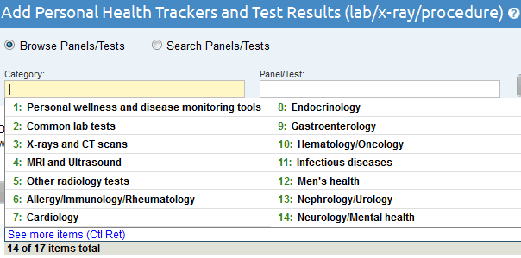

To add new test results or trackers:

1. On the PHR Home page, click the link to the name of the PHR you wish to update. This will expand the PHR entry to display action buttons for the individual's PHR.
2. Select the **Test Results & Trackers** button.
3. In the **View & Edit Results Timeline** window, click the **Add Test Results & Trackers** button.
4. On the **Add Test Results & Trackers** page, either browse for a test or health tracker using the drop-down list of test panel categories, or select the **Search Panels/Tests** radio button to search for the name of the test or health tracker you want to add.
5. Click the **Add** button.

## Adding New Measurements to a Test Result or Health Tracker

1. If the test or tracker is already displayed on the **Health Record Details** page, click the **Add More** link next to the test. This will open the **Add Test Results & Trackers** page.
2. Enter the new measurement to the test or tracker.
3. If needed, add another measurement using the **Add More** link next to the test or tracker.
4. You can also add a new measurement to a test or tracker by clicking the **Add Test Results & Trackers** link at the top of the **PHR Record Details** page and searching or browsing for the test or tracker and then clicking the **Add** button

## Editing Test Results and Health Trackers

Test result and health tracker data is only editable when the **Group Data Columns** option is not selected and when the **Combine records in one timeline table** and/or **Include test data from other panels** checkboxes are not selected.

Click the **Show Panel Info** button to view and edit the **Comments**, **Where Done**, and **Due Date** fields.

Click the **Show Empty Rows** button to view and edit rows that have no data in them.

To edit test results or health trackers that have already been entered:

1. Click the **View & Edit Results Timeline** link at the top of the PHR.
2. On the **View & Edit Results Timeline** page, select the checkbox next to the test results or health tracker data you want to edit and then click the **Show Results Timeline** button.
3. Move your mouse over the column of test results you want to change. A C:\Users\dbennett\Pictures\PHR symbols\paper_pencil.gifPaper and Pencil edit icon will appear at the top of the data column. If the edit icon does not appear, make sure you have not selected the **Group Data Columns** option or checked the **Combine records in one timeline table** and/or **Include test data from other panels** checkboxes.
4. Right-click the Paper and PencilC:\Users\dbennett\Pictures\PHR symbols\paper_pencil.gif edit icon and select **Revise** or **Delete** from the drop-down menu.
5. Optionally, click the **Show Panel Info** button to view and edit the **Comments**, **Where Done**, and **Due Date** fields or click the **Show Empty Rows** button to view and edit empty rows.
6. Make the changes needed or delete the test or tracker.
7. Once you have finished editing, click the **Save** button at the bottom of the page.

## Deleting Test Results or Health Trackers

Test result and health tracker data can only be deleted when the **Group Data Columns** option is not selected and when the **Combine records in one timeline table** and/or **Include test data from other panels** checkboxes are not selected.

To delete test results or health trackers that have already been entered:

1. Click the **View & Edit Results Timeline** link at the top of the PHR.
2. On the **View & Edit Results Timeline** page, select the checkbox next to the test results or health tracker data you want to delete and then click the **Show Results Timeline** button.
3. Move the mouse over the column of test results you want to delete. A C:\Users\dbennett\Pictures\PHR symbols\paper_pencil.gif ePaper and Pencildit icon will appear at the top of the data column. If the icon does not appear, make sure you have not selected the **Group Data Columns** option or checked the **Combine records in one timeline table** and/or **Include test data from other panels** checkboxes.
4. Right-click the Paper and Pencilicon and select **Delete** from the drop-down menu.
5. Optionally, click the **Show Panel Info** button to view and delete the **Comments**, **Where Done**, and **Due Date** fields or click the **Show Empty Rows** button to view and edit empty rows.
6. Make the changes needed or delete the test or tracker.
7. Once you have finished editing or deleting data, click the **Save** button at the bottom of the page.

## Using the View & Edit Results Timeline

The PHR Results Timeline allows you and your physicians to see test and other data over time. The graphing feature makes it easy to look at trends over time as well as get detailed information about specific data points.

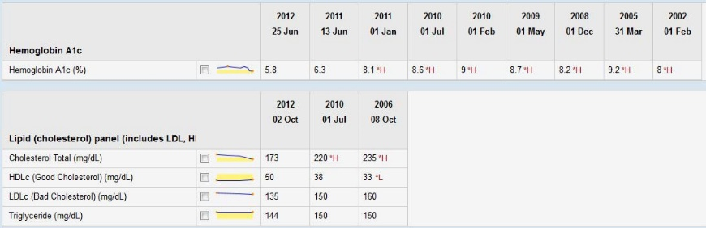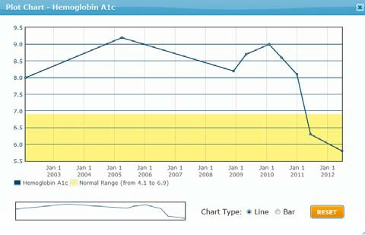

Use the **View & Edit Results Timeline** page to:

* Display a summary of test results and trackers as either a timeline chart or a [graph](https://phr-master-build.nlm.nih.gov/help/view_as_graph.shtml).
* [Add new test or tracker results](https://phr-master-build.nlm.nih.gov/help/add_new_test.shtml) to saved tests or health trackers
* [Edit test or tracker results](https://phr-master-build.nlm.nih.gov/help/edit_flowsheet_data.shtml) you the have been previously entered
* [Delete test or tracker results](https://phr-master-build.nlm.nih.gov/help/delete_flowsheet_data.shtml) previously entered
* [Print](https://phr-master-build.nlm.nih.gov/help/how_to_print_PHR.shtml) all of your test results

## View & Edit the Results Timeline Screen

To view test results from all saved tests or health trackers, click the **Select All** checkbox or select one or more tests or health trackers from the list. Click the **Show Results Timeline** button to display the selected results.

Click on the graph icons next to individual measurement results to view them as a graph. See Section 14.7 to learn more about viewing test results as graphs.

The **Show Panel Info** button allows you to view or hide the **Comments**, **Where Done**, and **Due Date** fields for tests and trackers.

The **Show Empty Rows** button allows you to view or hide all empty test value rows within the test or tracker.

The **Add Test Results & Trackers** button takes you to the **Add Test Results & Trackers** page to search or browse for new tests or trackers.

## View Test or Tracker Results as a Graph

The **View & Edit Results Timeline** page allows you and your health care provider to quickly and easily track test results such as blood pressure, cholesterol, weight, and others over time. You can also view test results or health trackers as a graph. To view test results or trackers as a graph:

1. From the **View & Edit Results Timeline** page, select one or more tests or health trackers from the list of results or click the **Select All** checkbox at the top of the list of results.
2. Optionally, choose to group your results by day, week, month, or year by choosing a date range from the **Group Data Columns** drop-down list. You may also choose to limit the date range by selecting a subset of recent results using the **Date Range** drop down list.
3. Click the **Show Results Timeline** button to display the selected test or tracker results.
4. If you wish to see graphs for multiple test result values, select the checkbox next to the graph icon for each set of values you wish to graph.
5. Click the graph icon. A separate graph will be shown for each set of test results you have pre-selected.
6. To view a graph as either a line chart or a bar graph, select the appropriate radio button and then click the **Reset** button to display the new graph type.
7. To zoom in to a portion of the large graph, left click on the large graph, hold and drag to select an area, and then release the mouse button. You can also select an area on the small graph at the bottom of the window to view it on the large graph.
8. Click the **Reset** button to reset the graph to full size, or to change the graph type.

Chapter

15

# Date Reminders

The **Date Reminders** list displays upcoming or past due event reminders as defined by the time period set in the PHR's **Date Reminder Settings**.

A date reminder is generated when you enter due dates into some sections of the PHR. Due dates that have passed will continue to show up on the **Date Reminders** list until the **Hide** checkbox for the due date is checked or until new dates are entered in the PHR.

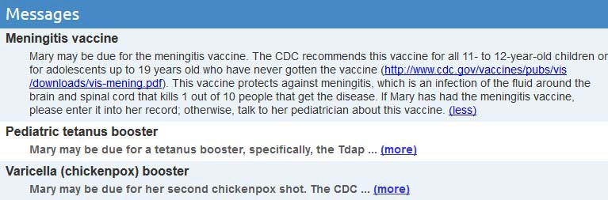

The Date Reminders list generates the following reminder types:

|  |  |  |
| --- | --- | --- |
| **User enters** | **in PHR section** | **to get date reminder type** |
| Resupply Date | Drugs | Active drugs resupply date |
| Next Appt. | Medical Contacts | Medical appointments Next Appt. |
| Next Due | Test Results & Trackers | Test Results & Trackers Next Due |
| Next Due | Vaccinations | Vaccination Next Due |

Change and view date reminder settings by clicking on the **Date Reminders** link at the top of the **Health Record Details** page and then clicking on the **Date Reminder Settings** button at the bottom of the **Date Reminders** page.

Any dates that have been entered but not yet saved will not be included in the list.

Both the **Date Reminders** and **Date Reminder Settings** lists can be sorted by clicking any of the column headings in the lists.

Chapter

16

# Health Reminders

The PHR will help you keep track of preventive tests and screenings and remind you when you are due for important screening tests. You can view health reminders recommended by the [U.S. Preventive Services Task Force](http://www.ahrq.gov/CLINIC/uspstfix.htm) (USPSTF) and other esteemed sources such as the Centers for Disease Control (CDC) by clicking on the **Health Reminders** link at the top of the PHR.

The PHR analyzes all of the demographic and clinical data entered for each individual and creates customized health reminders based on USPSTF and CDC guidelines. The reminders include brief informative text as well as links to the appropriate USPSTF or CDC recommendation.



We provide links to reliable health information so you can explore the evidence for these recommendations. The PHR offers reminders as a cue to you and your doctor about these preventive services, not as the final statement about which test is required and which is not.

To view a complete list of your drug refill dates, immunization and appointment reminders, and test due dates, click the **Date Reminders** link at the top of the **Health Record Details** page.

Chapter

17

# Sharing a PHR

The PHR system allows you to share any PHR with a trusted family member or physician by sending them an invitation using their email address. PHRs that are shared can only be viewed by the invitee. Invitees do not have permission to change any of the data in your PHR.

To ensure confidentiality of shared PHRs, the invitee’s email address must be the same address they will use to access the shared PHR and to create a PHR account (if they do not already have one). If the invitee already has a PHR account, the invitation address used to send the invitation must match the email address associated with their existing PHR account.

To share a PHR, from the **PHR Home** page, expand the PHR using the yellow expand button and click the **Share Access to this PHR** button. A pop-up window will open that will allow you to send an email invitation to another person. The person does not need to have an existing PHR account, however, they will be asked to create an account if they do not already have one.

View or edit the invitation before sending it by clicking the **Click to view the invitation and add a personal note** link in the popup window. Click the Send Invitation button to send the invitation to the email address you entered.

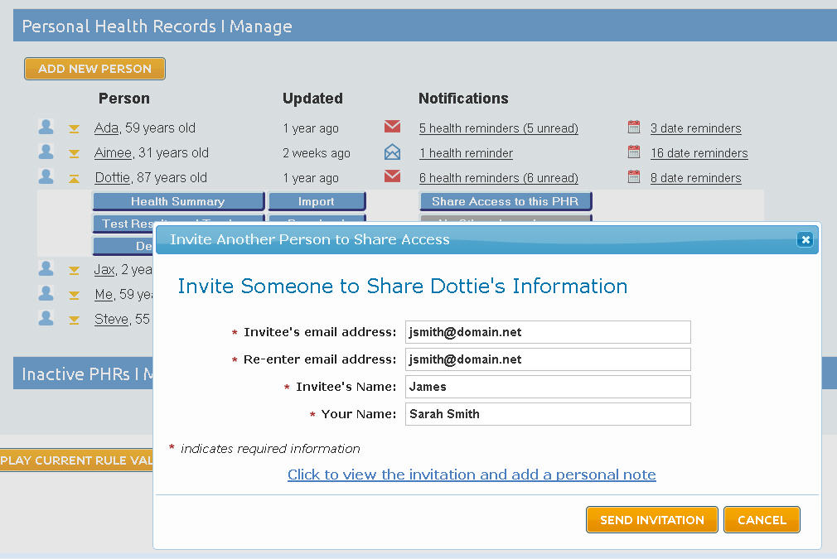

The invitee will receive the invitation via email and they will be able to click on the **Yes, I accept the invitation** link within the email to accept your invitation. The invitee has 30 days to accept the invitation before it expires. You will have to send the invitee a new invitation if the old invitation expires before they accept it. If the invitee tries to accept the invitation after 30 days, they will be informed that the invitation has expired and asked to request another invitation from you.

If the user already has an existing PHR account using the email address used to send the invitation, they will be redirected to the **PHR Welcome** page and asked to log in to the PHR system.

If the user does not have an existing account, they will be directed to the **PHR Welcome** page and invited to register for a PHR account. *It is important to note that the user must use the same email account used to send the invitation to sign up for their PHR account.* The invitee cannot change their email address and still retain access to the PHR shared by you. Once the user has created a PHR account, they can login and view the PHR shared by you.

When the invitee has successfully created an account and logged in to the PHR, the invitation has been fully accepted and you will receive an email notifying you that the invitation has been accepted. You can confirm that the invitee has access by expanding the PHR on the PHR Welcome page and clicking the **See Others with Access** button.

The invitee will see the PHR you shared in a section of their **PHR Welcome** page under the **PHRs I can Access** section of their **PHR Home** page.

# Index

accessibility, 3

Account ID, 4

forgotten, 4

recovery, 4

account settings, 5

add new person, 6

add test results & trackers, 26

basic HTML mode, 3

blue information button, 25

browser settings, 3

browsers, 2

bypassing drop-down lists, 19

ClinicalTrials.gov, 25

combine records in one timeline, 27

create new PHR, 10

data entry shortcuts, 18

date range, 30

date reminder settings, 31

date reminders, 6, 31

date shortcuts, 19

dates, 19

delete

health trackers, 28

PHR, 17

test results, 28

delete health trackers, 28

delete PHR, 17

delete test results, 28

download PHR data, 14

drop-down lists, 18

edit existing PHR, 11

editing health trackers, 27

editing test results, 27

Firefox, 12

Google Chrome, 12

graph, 29

group data columns, 27, 30

health record details page, 8

health reminders, 6, 33

health trackers, 26

hide all, 18

inactive PHR, 15

include test data from other panels, 27

information button, 8

input errors, 20

Internet Explorer, 12

invitation

PHR sharing, 35

item number, 19

lists, 18

medical record, 2

Mozilla Firefox, 12

National Library of Medicine, 1

navigation, 21

operating systems, 2

page setup, 13

password

changing, 5

forgotten, 5

personal identifiers, 4

PHR, 1

sharing, 35

PHR home, 6

PHRs I can access button, 37

print, 12

reminders

date, 31

health, 33

research studies button, 25

Research Studies button, 25

reset button, 30

Reset button, 30

restore inactive PHR, 16

Safari, 13

security questions

changing, 5

see others with access button, 37

shortcut keys, 21

shortcuts

date, 19

time, 20

show all, 18

show empty rows, 27

show panel info, 27, 28

show results timeline, 30

synonyms, 18

system requirements, 2

test results, 26

time shortcuts, 20

times, 20

U.S. Preventive Services Task Force, 33

view & edit results timeline, 28, 29

zoom, 3