Pulse Oximetry Documentation

# Background Theory

When making medical decisions within a hospital setting it is very important for clinicians to be given as much information as possible about their patient. Historically, there were four measurements considered so important when examining a patient that they are now termed vital signs. These four metrics are: blood pressure, temperature, heart rate and respiration rate.

However, in recent years, a fifth metric has been recognized for its utility. Oxygen saturation ($S_{p}O_{2}$) is now widely considered as the fifth vital sign. Continuous monitoring of a patient’s ability to oxygenate their blood through pulse oximetry useful in many situations and also allows for intervention during hypoxic emergencies.

### Biology

Blood is the medium by which materials are transported throughout the body. Blood is made up of many components including plasma, proteins, cells, ions and hormones among other molecules. The main factor of interest with respect to pulse oximetry is hemoglobin which is found in red blood cells. The vast majority of oxygen in the blood is carried bound to a hemoglobin molecules. Each hemoglobin molecule can carry up to 4 molecules of oxygen and each red blood cell contains roughly 280 million hemoglobin molecules [1].

There are four different types of hemoglobin found within normal adult blood:

1. Oxyhemoglobin (**HbO2**)
2. Reduced hemoglobin / Deoxyhemoglobin (**Hb**)
3. Methemoglobin (**metHb**)
4. Carboxyhemoglobin (**COHb**)

Under normal conditions, *HbO2* binds to oxygen in the lungs and travels to the tissues where it is delivered to myoglobin. This causes oxyhemoglobin to become *Hb* which has a higher affinity for carbon dioxide. Two molecules of carbon dioxide are then picked at the tissues and returned to the lungs before where the gas can be expelled. The other two species of hemoglobin (*metHb* and *COHb*) do not contribute to oxygen transport, which allows for the functional saturation of hemoglobin to be expressed as follows:

${Functional S}_{a}O_{2}=\frac{HbO_{2}}{HbO_{2}+Hb}$ (1)

Each species of hemoglobin has a unique absorption spectra be used to differentiate them. Pulse oximetry takes advantage of this fact in order to determine the proportion of *HbO2* and *Hb* present in a given sample

# Engineering

From (1), oxygen saturation is defined as the amount of oxygen being carried by hemoglobin as a fraction of the maximum amount of oxygen that hemoglobin could carry. This allows for the total oxygen content of blood to be calculated as the amount of oxygen being carried by hemoglobin **1** added to the amount of oxygen carried in solution**2**.

(2)

Under normal conditions, the term representing oxygen dissolved in plasma is much smaller in comparison to term representing oxygen bound to hemoglobin and can be ignored.

$O_{2} Content≈\left(1.34×S_{a}O_{2}×\left[Hb\right]\right)$ (3)

Assuming that concentrations of hemoglobin are relatively constant (large changes may occur during trauma/bleeding etc.) it can be seen from 3 that the oxygen carrying ability of the blood is dependent on saturations. Historically the only way to measure this value was to sample blood and perform different spectroscopy tests in a lab. This is method is invasive, labor intensive and fails to offer real time measurement that could be beneficial in patient outcomes . It wasn’t until the late 1970’s that technology was developed that used light absorbance to give a continuous, live reading of a patients $S_{a}O_{2}$

### Theory of Operation

As previously mentioned, different species of hemoglobin absorb light differently. It is well known, in accordance to the Beers-Lambert law **3** that light attenuation is related to thickness and concentration of the substance that the light is being projected through. This relation is shown in 4

|  |  |
| --- | --- |
| **Symbol** | **Meaning** |
| $$I$$ | Intensity of radiation after passing through medium |
| $$I_{0}$$ | Intensity of incident radiation before passing through medium |
| $$α$$ | Linear absorption coefficient |
| $$d$$ | Thickness of sample |

$\frac{I}{I_{0}}={10}^{-αd}$ (4)

Taking the logrithim of each side of the equation and rearranging for the linear absorption coefficient yields equation (5):

$α=- \frac{\log_{10}\left(\frac{I}{I_{0}}\right)}{d}$ (5)

This relationship is the basis of pulse oximetry. Using a light source of known intensity, the beam can be projected through a known thickness of tissue and the intensity measured on the other side. Once the attenuation is calculated it can be compared to a table of known values. Absorption spectra for each type of hemoglobin is shown in the figure on the following page

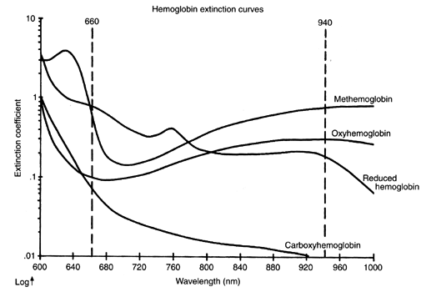

**Figure 1: Absorption Spectra of Different Hemoglobin Species**

There is one additional fact that needs to be taken into account before using this approach to measure $S_{a}O_{2}$. It is known that blood will have some mixture of each hemoglobin species present and as such the total absorbance**1** will be a linear combination of all species present.

$A_{total}=A_{HbO_{2}}+A_{Hb}+A_{metHb}+A_{COHb}$ (5)

In order to determine the proportion of each numerous different measurements need to be made to create a system of equations. Oxygen saturation can be thought of as the amount of hemoglobin carrying oxygen relative to all hemoglobin present in a patient’s blood stream. This measurement is known as true saturation:

${True S}_{a}O_{2}= \frac{HbO_{2}}{HbO_{2} + Hb + metHb + COHb}$ (6)

In order to compute this value 4 different wavelengths of light would be required and 4 simultaneous Beer-Lambert equations would need to be solved. In practice however, a simplification is often made. Both $metHb$ and $COHb$ are unable to carry oxygen as they are bound to other chemical species. Functional saturation is dependant only on *Hb* and *HbO2*. For this reason, the problem can be simplified to two different wavelengths and two simultaneous Beer-Lambert equations.

$α_{λ_{1}}=A \left(\left[Hb\right]+k\left[HbO_{2}\right]\right)$ (7)

$α_{λ_{2}}=B\left(\left[Hb\right]+\left[HbO_{2}\right]\right)$ (8)

The values of A, B and k are constants which depend on the solution which the light source is being shone through as well as the wavelength of light being used. In practice these values are known for $Hb$ and $HbO_{2}$. In equations 7 and 8, this leaves two unknowns to be solved for, $[Hb]$ and $[HbO_{2}]$. This process is shown on the following page:

To simplify notation, let $\left[Hb\right]+\left[HbO_{2}\right]=[H]$: and rearranging each equation allows for $S_{a}O_{2}$ to be determined:

$α_{λ_{1}}=A \left(\left[Hb\right]+k\left[HbO_{2}\right]\right)$ (7)’

$α_{λ_{2}}=B\left([H]\right)$ (8)’

Working with equation 7, add and subtract the term $[HbO_{2}]$ to take advantage of this simplified notation:

$$α_{λ_{1}}=A\left(\left[Hb\right]+\left[HbO_{2}\right]-\left[HbO_{2}\right]+k\left[HbO_{2}\right]\right)$$

$$= (A \left(\left[H\right]-\left[HbO_{2}\right]+k\left[HbO_{2}\right]\right)$$

$=A(\left[H\right]-(1-k)[HbO_{2}])$ (7)’’

At this point this system of equations (7’’ and 8’) can be solved using any method desired. An example is shown below where the ratio of the expressions are taken and simplified:

$$\frac{α_{λ_{1}}}{α_{λ_{2}}}=\frac{A\left(\left[H\right]-\left(1-k\right)[HbO_{2}]\right)}{B\left(\left[H\right]\right)}$$

$$=\frac{A}{B} \left(\frac{\left[H\right]}{\left[H\right]}-\left(\frac{1-k\left[HbO_{2}\right]}{\left[H\right]}\right)\right)$$

$$=\frac{A}{B}\left(1-\left(1-k\right)\frac{\left[HbO_{2}\right]}{\left[H\right]}\right)$$

At this point it is noted that expression for functional oxygen saturation of hemoglobin $\left(\frac{\left[HbO_{2}\right]}{\left[Hb\right]}\right)$ is present in this expression. Isolating for Functional Oxygen saturation algebraically yields the desired result below:

$\frac{\left[HbO_{2}\right]}{[H]}= Functional S_{a}O_{2}=\left(1-\frac{{Bα}_{λ_{1}}}{{A α}_{λ_{2}}}\right)\frac{1}{1-k}$ (9)

This relationship demonstrates how using two different wavelengths of light produces two different Beer-Lambert equations can be solved to yield the functional oxygen saturation. This idea could also be extend to four wave lengths of light if a measurement of the true oxygen saturation (equation 6) was desired. However, there is one additional consideration to make before applying this idea to the design of a pulse oximeter. When light is projected through the tissue of a patient, it will interact with substances other than arterial blood as shown in figure 2.

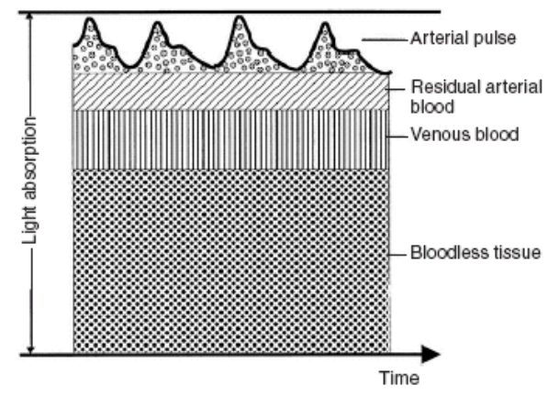

**Figure 2: Time Dependant Light Absorption**

This interaction will leads to absorbance which means the intensity of light measured exiting the tissue cannot solely be attributed to arterial blood. It is also noted when observing this figure that there is a constant component of absorption made up of tissue, venous blood and residual blood as well as a pulsatile component that is solely arterial blood. As the heart beats, new blood enters the field of light which is full of freshly oxygenated hemoglobin. This temporarily increases local $HbO_{2}$ concentrations leading to a decreased in light intensity exiting the tissue. This change in attenuation can be solely attributed to arterial flow as there is no other source of time varying concentration changes within the tissue. With this in mind, if this component could be isolated the oxygenation of only arterial blood could be determined using a Beer-Lambert relationship. In order to do this, the signals are separated based on frequency. This yields a pulsatile AC component and a static DC component.

Analyzing the AC component at two different wave lengths using the process outlined in the previous pages the $S_{a}O_{2}$ can be determined. In practice however this approach has some short comings. As light travels through blood it will be both be absorbed and scattered by $Hb$. The Beer-Lambert law does not take into account this scattering and as a result $S_{a}O_{2}$ may be incorrectly estimated as shown in Figure 3.

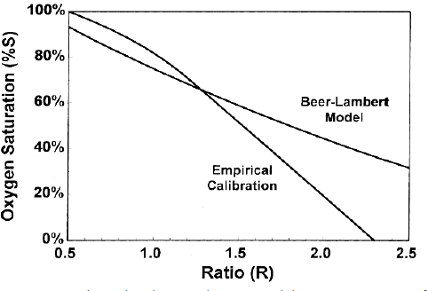

**Figure 3: Beer-Lambert Model of Hb Absorption vs. Empirical Measurements**

Instead of measuring absorption to solve the Beer-Lambert equation directly, instead an intermediate value known the R constant is calculated. The R constant is the ratio of AC-DC absorbance of red light (660nm) normalized to the AC-DC ratio of infra-red light (940nm).

$R=\frac{\left(\frac{AC_{660}}{DC_{660 }}\right)}{\left(\frac{AC_{940}}{DC_{940 }}\right)}$ (10)

Prior to use, a device is calibrated with a table containing oxygen saturations and the R values they correspond to. In a clinical setting, R is calculated numerous times per minute and referenced to these empirically determined values to determine 1

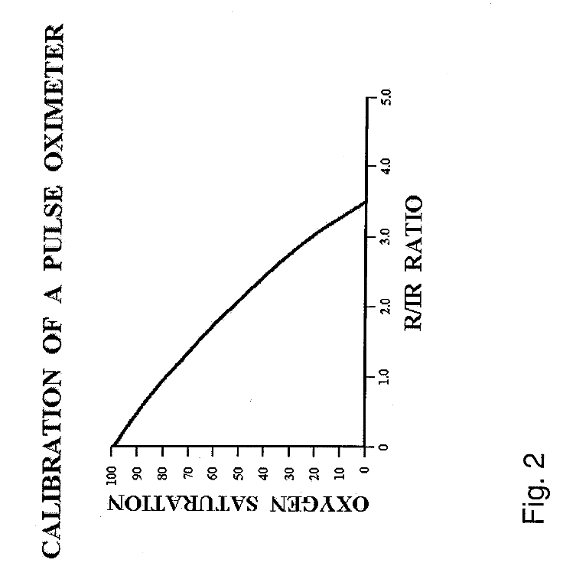

**Figure 3: R/IR ratio vs $O_{2}$ Sat**

### Circuit Design - Theory

When designing any circuit the most straight forward approach is identify individual problems and design a modules to solve these issues. The challenges, as well as their solutions are given in the table below:

|  |  |
| --- | --- |
| **Challenge** | **Solution** |
| Emit and Detect Light Signal | LEDs & Photodiode |
| Condition Analog Signal | Analog Front End |
| Interpret and Display Signal | Microchip & Display |

#### Light Emission and Detection

Measuring the attenuation of a light signal is the primary challenge in designing a pulse oximeter. Depending on the design of the device, 2-4 emitters are needed as well as a detector. Due to the fact that these emitters are being used in a sma

#### Analog Signal Conditioning

#### Data Interpretation and Presentation

# Clinical 🡪 Tarek

[2] - Sears, Duane W. 1999. Overview of Hemoglobin's Structure/Function Relationships.

# Appendix A – Basic Sciences Background

## Beer-Lambert Law

It is simplest to understand the Beer-Lambert law using an example. Assume that there are 2 beakers with different concentrations of a solute. The first beaker contains a solution that is less concentrated than the second beaker as shown in figure 2 below:

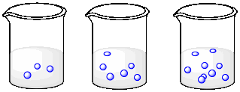 

**Figure 1: Beakers with different concentrations**

Assume that a light of a given wave length, $λ_{1}$, was shone through each of these beakers with an initial intensity of $I_{0}$. The intensity of the light exiting the sample is measured and denoted as $I$. This setup is shown below in figure 2:



$$I_{0}$$

$$I$$

**Figure 2: Experimental Setup**

As the light passes through a beaker, some of the light will interact with the solute held in solution. This is a random interaction and will depend on the concentration of solute present in each beaker. From this setup it can be that the beaker with a higher concentration of solute will allow less light to pass through it. Due to the fact there are more molecules in the more concentrated solution, there is a higher probability that the light will interact with a molecules and be absorbed. In conclusion, the light passing through beaker 1 ( $I_{1})$ will be brighter than the light exiting beaker 2 ($I_{2})$.

$$I_{2}<I_{1}$$

This concept of a solutions ability to pass light is summarized by a property known as *transmittance*. *Absorbance* of a solution is also related to this value

**Transmittance**: The fraction of an incident light that passes through a sample at a specified wavelength

$T=\frac{I}{I_{0}}$ (1)

**Absorbance**: The fraction of light at a given wavelength that is absorbed by a solution

$A= -\log_{10}\left(T\right)= -\log_{10}{\frac{I}{I_{0}}}$ (2)

With these two quantities in mind, assume the experiment previously discussed was modified slightly. A third beaker is added to the test which has the same concentration as beaker two but is twice as wide.



$$I_{0}$$

$$I_{3}$$

**Figure 2: Experimental Setup for Third Beaker**

In this case, the intensity of light, $I_{3}$, that is observed exiting the beaker will be less than that of beaker 2. This can once again be attributed to the probability of light interacting with a molecule in the solution. When the path length that the light travelled through was increased, the probability of light being absorbed also increased. The absorbance of all three lights relative to eachother would then be :

$$I_{3}<I_{2}<I_{1}$$

The dependence of absorbance on path length and concentration is known as the *Beer-Lambert* law.

**Beer-Lambert’s Law**: The absorbance of light of a given wavelength projected through a sample is linearly related to the concentration of that sample, the path length the light must travel through and some constant which is dependent upon the solute.

$A=ϵ×d×c$ (3)

Working with equation 2 and 3, a more familiar form of this law can be derived:

$$-\log_{10}{\frac{I}{I_{0}}}=edc$$

Defining a linear absorption coefficient, $α= ϵ×c$ yields the familiar expression used in the engineering section of this document.

$α= -\frac{\log_{10}\left(\frac{I}{I_{0}}\right) }{d}$ (4)

Appendix B – Circuit Theory Background