Pulse Oximetry Documentation

# Background Theory

When making medical decisions within a hospital setting it is very important for clinicians to be given as much information as possible about their patient. Historically, there were four measurements considered so important when examining a patient that they are now termed vital signs. These four metrics are: blood pressure, temperature, heart rate and respiration rate.

However, in recent years, a fifth metric has been recognized for its utility. Oxygen saturation ($S_{p}O_{2}$) is now widely considered as the fifth vital sign. Continuous monitoring of a patient’s ability to oxygenate their blood through pulse oximetry useful in many situations and also allows for intervention during hypoxic emergencies.

### Biology

Blood is the medium by which materials are transported throughout the body. Blood is made up of many components including plasma, proteins, cells, ions and hormones among other molecules. The main factor of interest with respect to pulse oximetry is hemoglobin which is found in red blood cells. The vast majority of oxygen in the blood is carried bound to a hemoglobin molecules. Each hemoglobin molecule can carry up to 4 molecules of oxygen and each red blood cell contains roughly 280 million hemoglobin molecules [1].

There are four different types of hemoglobin found within normal adult blood:

1. Oxyhemoglobin (**HbO2**)
2. Reduced hemoglobin / Deoxyhemoglobin (**Hb**)
3. Methemoglobin (**metHb**)
4. Carboxyhemoglobin (**COHb**)

Under normal conditions, *HbO2* binds to oxygen in the lungs and travels to the tissues where it is delivered to myoglobin. This causes oxyhemoglobin to become *Hb* which has a higher affinity for carbon dioxide. Two molecules of carbon dioxide are then picked at the tissues and returned to the lungs before where the gas can be expelled. The other two species of hemoglobin (*metHb* and *COHb*) do not contribute to oxygen transport, which allows for the functional saturation of hemoglobin to be expressed as follows:

${Functional S}_{a}O_{2}=\frac{HbO_{2}}{HbO_{2}+Hb}$ (1)

Each species of hemoglobin has a unique absorption spectra be used to differentiate them. Pulse oximetry takes advantage of this fact in order to determine the proportion of *HbO2* and *Hb* present in a given sample.

# Engineering

From (1), oxygen saturation is defined as the amount of oxygen being carried by hemoglobin as a fraction of the maximum amount of oxygen that hemoglobin could carry. This allows for the total oxygen content of blood to be calculated as the amount of oxygen being carried by hemoglobin ${\left(1.34\frac{ml}{g}\right)}^{*}$ added to the amount of oxygen carried in solution ${\left(0.03×P_{a}O_{2}\right)}^{*}$.

**\*These numbers were derived experimentally and are generally accepted as constants**

$O_{2} Content=\left(1.34×S_{a}O_{2}×\left[Hb\right]\right)+\left(0.03×P_{a}O_{2}\right)$ (2)

Under normal conditions, the term representing oxygen dissolved in plasma is much smaller in comparison to term representing oxygen bound to hemoglobin and can be ignored.

$O_{2} Content≈\left(1.34×S_{a}O_{2}×\left[Hb\right]\right)$ (3)

Assuming that concentrations of hemoglobin are relatively constant (large changes may occur during trauma/bleeding etc.) it can be seen from 3 that the oxygen carrying ability of the blood is dependent on saturations. Historically the only way to measure this value was to sample blood and perform different spectroscopy tests in a lab. This is method is invasive, labor intensive and fails to offer real time measurement that could be beneficial in patient outcomes . It wasn’t until the late 1970’s that technology was developed that used light absorbance to give a continuous, live reading of a patients $S_{a}O_{2}$

### Theory of Operation

As previously mentioned, different species of hemoglobin absorb light differently. It is well known, in accordance to the Beers-Lambert law that light attenuation is related to thickness and concentration of the substance that the light is being projected through. This relation is shown in 4

|  |  |
| --- | --- |
| **Symbol** | **Meaning** |
| $$I$$ | Intensity of radiation after passing through medium |
| $$I_{0}$$ | Intensity of incident radiation before passing through medium |
| $$α$$ | Linear absorption coefficient |
| $$d$$ | Thickness of sample |

$\frac{I}{I_{0}}={10}^{-αd}$ (4)

Rearranging this expression to isolate for linear absorption coefficient:

$α= \frac{\log_{10}\left(\frac{I}{I_{0}}\right)}{d}$ (5)

This relationship is the basis of pulse oximetry. Using a light source of known intensity, the beam can be projected through a known thickness of tissue and the intensity measured on the other side. Once the attenuation is calculated it can be compared to a table of known values. Absorption spectra for each type of hemoglobin is shown in the figure on the following page:

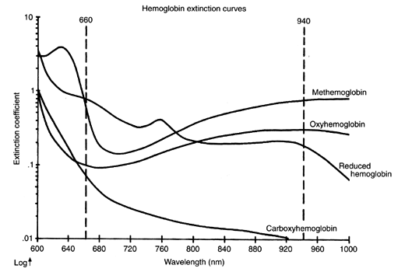

**Figure 1: Absorption Spectra of Different Hemoglobin Species**

There is one additional fact that needs to be taken into account before using this approach to measure $S_{a}O_{2}$. It is known that blood will have some mixture of each hemoglobin species present and as such the attenuation will be a linear combination of each species. In order to determine the proportion of each numerous different measurements need to be made to create a system of equations. Although there are 4 different species, functional saturation is dependant only on *Hb* and *HbO2*. For this reason, two light sources of different wavelength are projected through the tissue leading to a system of two equations which can easily be solved, as shown below

$α_{λ_{1}}=A \left(\left[Hb\right]+k\left[HbO_{2}\right]\right)$ (6)

$α_{λ_{2}}=B\left(\left[Hb\right]+\left[HbO_{2}\right]\right)$ (7)

Where A, B and k are constants determined by the relative absorption coefficients for each species of hemoglobin.

Letting $\left[Hb\right]+\left[HbO_{2}\right]=[H]$ and rearranging each equation allows for $S_{a}O_{2}$ to be determined:

$α_{λ_{1}}=A \left(\left[H\right]-\left[HbO_{2}\right]+k\left[HbO_{2}\right]\right)=A(\left[H\right]-(1-k)[HbO_{2}])$ (6)’

$α_{λ_{2}}=B\left([H]\right)$ (7)’

Taking the ratio of each expression:

$\frac{α_{λ_{1}}}{α_{λ_{2}}}=\frac{A}{B}\left(1-\frac{\left(1-k\right)\left[HbO_{2}\right]}{\left[H\right]}\right)=\frac{A}{B}(1-\left(1-k \right)S_{a}O_{2})$ (8)

Isolating for Oxygen saturation:

$Functional S_{a}O_{2}=\left(1-\frac{B}{A}\frac{α_{λ_{1}}}{α_{λ_{2}}}\right)\frac{1}{1-k}$ (9)

Using this relationship, as well as parameters obtained from the graph in Figure 1, the approximate oxygen saturations can be calculated using two different light sources. Due to the fact Hb and HbO2 are of primary interest red light (660nm) and near infrared light (940nm) are used because these species show different absorbance characteristics at these wavelengths.

In most clinical situations, taking two measurements is more than adequate to give insight to the oxygenation of blood. However, there are certain situations in which it is necessary to measure all four species concentrations to give the true oxygen saturations. A true oxygen saturation is defined as follows:

${True S}_{a}O_{2}= \frac{HbO_{2}}{HbO_{2} + Hb + metHb + COHb}$ (10)

In order to measure these additional two species, four total light sources are required to differentiate the absorbance of each species. The mathematics are not detailed here but a similar process is used as shown on the previous page.

One final consideration to be made is how to determine the saturation of only the arterial blood within a patient. When using the Beer-Lambert law it has been assumed that the sample the light is being transmitted through is homogenous. This is obviously not true within a living tissue and it becomes necessary to delineate the attenuation caused by arterial blood flow versus other sources.. A method of separating these different signals becomes apparent when observing figure 2:

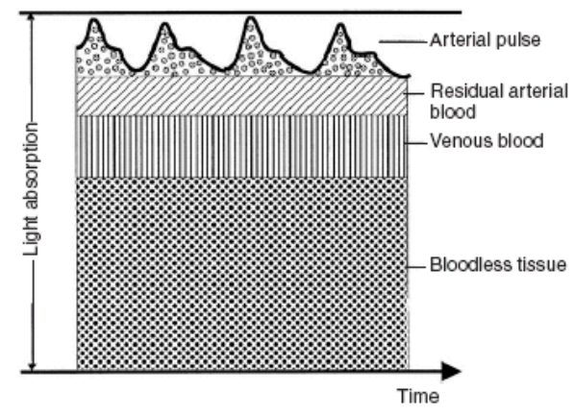

**Figure 2: Time Dependant Light Absorption**

When examining a waveform representing light absorbance by different tissues it is seen that attenuation varies with time. This change is related to an influx of arterial blood with each heart beat that increases the local concentration of hemoglobin temporarily. An increased concentration causes more attenuation and results in a signal that alternates with the patients pulse. This AC signal is representative of the arterial oxygen saturations and is the value of interest in this situation. It is worth noting however that this AC signal doesn’t represent all the arterial blood. There will some amount of blood that remains within the vessels during diastole and will not be pulsatile. It would be nearly impossible to separate this DC component from the other static attenuation sources to accurately calculate arterial ${ S}_{a}O_{2}$. Instead, an intermediate constant known as the R value is calculated. This number is a ratio of AC to DC absorbance red light referenced to the same ratio of infrared light. Values of $S_{p}O_{2}$* have been calculated previously for R value and can be referenced in real time.

$S_{p}O_{2}$**\* represents $S_{a}O_{2}$ as measured by a pulse oximeter**

$R=\frac{\left(\frac{AC_{660}}{DC_{660 }}\right)}{\left(\frac{AC_{940}}{DC_{940 }}\right)}$ (11)

The result of this calculation is compared to a look up table of predetermined values to yield $S_{p}O_{2}$

*

### Circuit Design - Theory

Approaching the design of this circuit, the simplest approach is to break down the entire system into discrete blocks based on theory of operation. The primary module in this circuit chain will be a transmitter/receiver of light for attenuation measurements. After this patient-machine interface there will need to be an analog signal conditioning block to amplify and filter the signal. Once the signal is adequately processed it will be fed to a microcontroller where it can be interpreted.

# Clinical 🡪 Tarek

[2] - Sears, Duane W. 1999. Overview of Hemoglobin's Structure/Function Relationships.