**Exercise #3 snapshot:**

**Exercise #5 snapshot:**

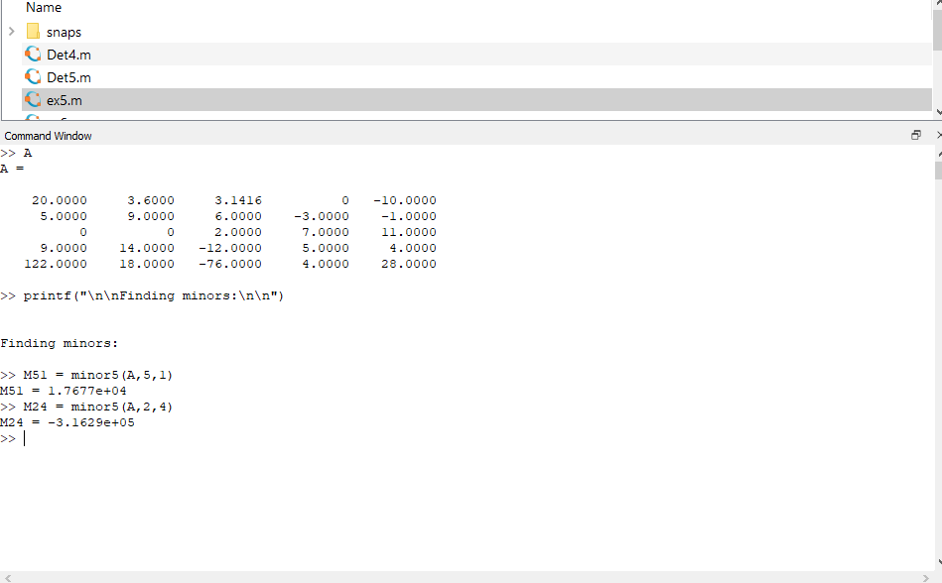**Exercise #7 snapshot:**

**Exercise #9 snapshot:**

