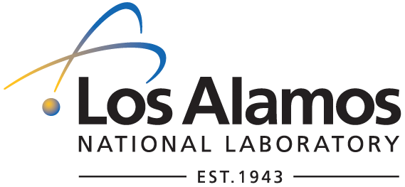
To/MS: W. Matthew Challacombe, T-12, MS B268
From/MS: Christine T. Ramos, TT, MS C333
Phone/FAX: 5-6846/5-3125

Technology Transfer Division

SUBJECT: APPROVAL RECEIVED FOR ASSERTION AND OPEN SOURCE DISTRIBUTION OF MondoSCF, Version 1.0 alpha

We received DOE's permission to assert copyright on the C-04,085, MondoSCF, Version 1.0 alpha. Therefore, you may proceed with the open source distribution of the software. Attached you will find a copy of the DOE approval memo.
From this point forward, please apply the following copyright notice:
Open Source Software (GPL):
Copyright (2004). The Regents of the University of California. This material was produced under U.S. Government contract W-7405-ENG-36 for Los Alamos National Laboratory, which is operated by the University of California for the U.S. Department of Energy. The U.S. Government has rights to use, reproduce, and distribute this software. NEITHER THE GOVERNMENT NOR THE UNIVERSITY MAKES ANY WARRANTY, EXPRESS OR IMPLIED, OR ASSUMES ANY LIABILITY FOR THE USE OF THIS SOFTWARE. If software is modified to produce derivative works, such modified software should be clearly marked, so as not to confuse it with the version available from LANL.
Additionally, this program is free software; you can redistribute it and/or modify it under the terms of the GNU General Public License as published by the Free Software Foundation; either version 2 of the License, or (at your option) any later version. Accordingly, this program is distributed in the hope that it will be useful, but WITHOUT ANY WARRANTY; without even the implied warranty of MERCHANTABILITY or FITNESS FOR A PARTICULAR PURPOSE. See the GNU General Public License for more details.

Thank you for your patience.

Att.: DOE Approval Memo (copy)

