FreeSpirit Merchandise Order Form 2009

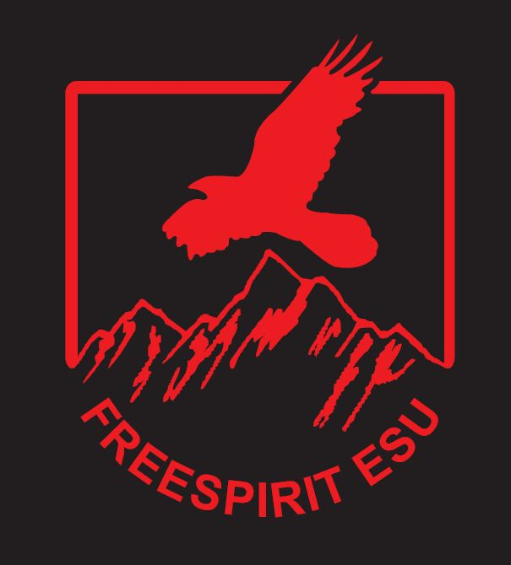

Polo Shirt – Cost £8.50

How many? Size: S ◻ M ◻ L ◻ XL ◻ XXL ◻

Name on back (max 10 letters)

Hoody – Cost £13

How many? Size: S ◻ M ◻ L ◻ XL ◻ XXL ◻

Name on back (max 10 letters)

Rugby Shirt – Cost £13

How many? Size: S ◻ M ◻ L ◻ XL ◻ XXL ◻

Name on back (max 10 letters)

Fleece Jacket – Cost £15

How many? Size: S ◻ M ◻ L ◻ XL ◻ XXL ◻

Baseball Cap – Cost £6.50 FreeSpirit cloth badge – Cost £2.00

How many? How many?

WINGS panel T-Shirt – Cost £12.50 WINGS Polo shirt – Cost £13.99

How many? How many?

Total £ Name………………………………………...............................

Please make cheque payable to FreeSpirit Explorers and write your name on the back.

