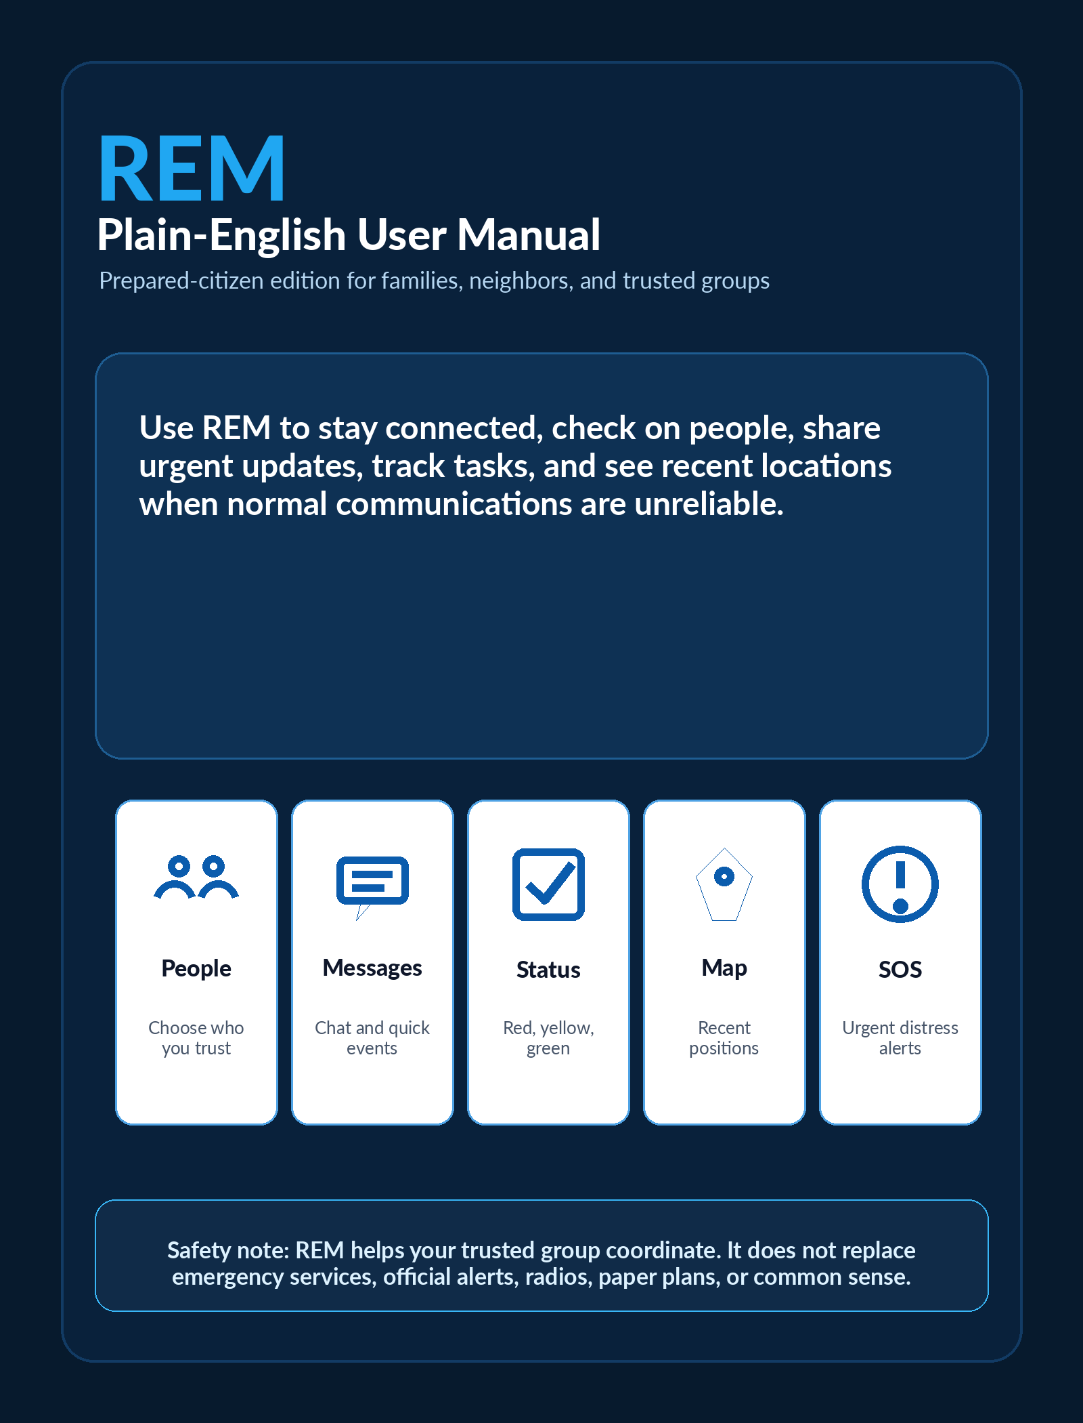

Start here
This is a simpler, less technical, REM user manual. It is written for prepared citizens, families, neighbors, and small trusted groups.
Plain-language promise
This guide explains what each part of REM is for, when to use it, and what to expect. It avoids technical setup details unless they help you make a good decision.

What you can do with REM
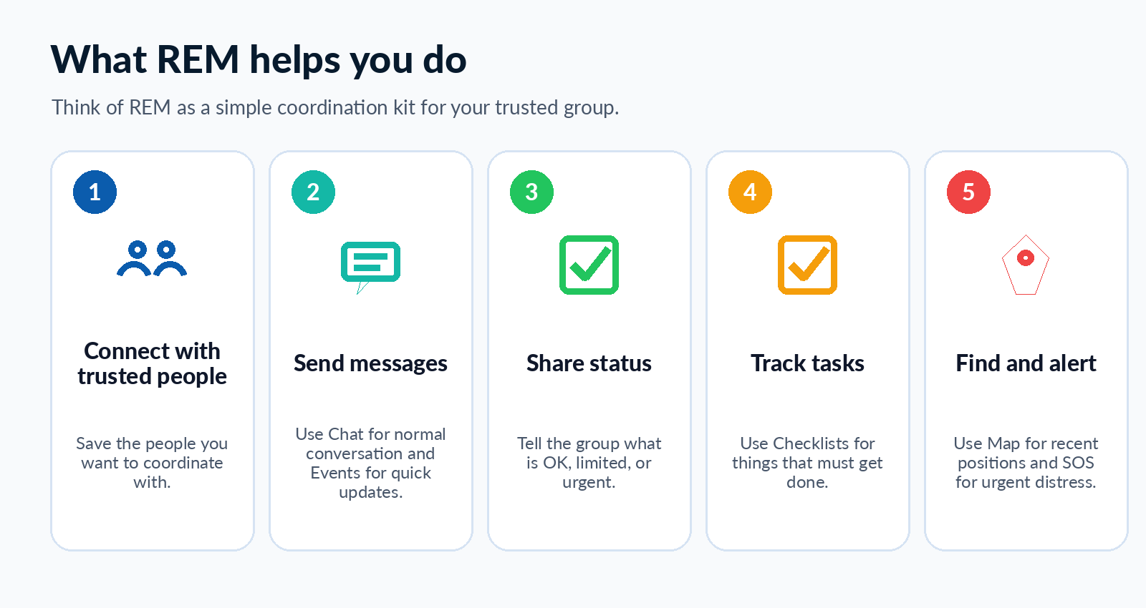

What is in this guide
Get ready before an emergency  Set your name, add trusted people, and test REM. | Use the right screen  Dashboard, Chat, Events, Action Messages, Checklists, Map, Peers, Settings, and SOS.
Send clear updates  Use simple status colors and event choices. | Coordinate safely  Use trusted peers, privacy choices, checklists, and HomeBase.
Practice common situations  Power outage, evacuation, shelter-in-place, storm prep, wildfire/flood, and comms drill. | Appendix  detailed information on the type and meaning of messages

0. Getting REM and keeping it updated
REM is an Android app.
The safest place to get it is the official FreeTAKTeam REM GitHub release page. The REM release page provides Android installation files for the app
use the APK file, not the source-code ZIP files. (GitHub)
To keep REM updated more easily, use Obtainium.
Obtainium is an Android app that watches release pages, such as GitHub releases, and tells you when a new version is available. It can also help install the update from the same source. (Obtainium)

Step 1: Install Obtainium
Install Obtainium from its official website or from F-Droid. The official Obtainium site says it gets Android app updates directly from the source, and F-Droid also lists Obtainium as an app that can install and update apps from release pages. (Obtainium) (F-Droid)

Step 2: Add REM to Obtainium
Open Obtainium and choose Add App.
Paste this REM source address:
https://github.com/FreeTAKTeam/reticulum_mobile_emergency_management
If Obtainium asks what kind of source this is, choose GitHub. Obtainium supports GitHub as an app source. (wiki.obtainium.imranr.dev)

Step 3: Install REM
After adding REM, Obtainium should automatically find the latest REM release.
Choose the Android APK file. It should have a name similar to:
reticulum-mobile-emergency-management-vX.X.X-release.apk
Do not install files named Source code, ZIP, or tar.gz. Those are for developers, not normal app installation.
Android may ask if you want to allow Obtainium to install apps. Allow it only if you trust the source you are using.

Step 4: Keep REM updated
After REM is added to Obtainium, open Obtainium from time to time and check for updates.
When a new REM version is available:
- Open Obtainium.
- Tap REM.
- Tap Update or Install.
- Let Android install the new version.
- Open REM and confirm it still says Ready.
Obtainium can also notify you when new releases are available, so you do not have to manually check the GitHub page every time. (GitHub)

Simple safety rule
Only install REM from the official REM GitHub source, and only update it from that same source. This helps avoid installing the wrong APK.

1. Get ready before you need REM
Do the first setup while things are calm. A short practice session helps everyone understand what REM will do during stress.
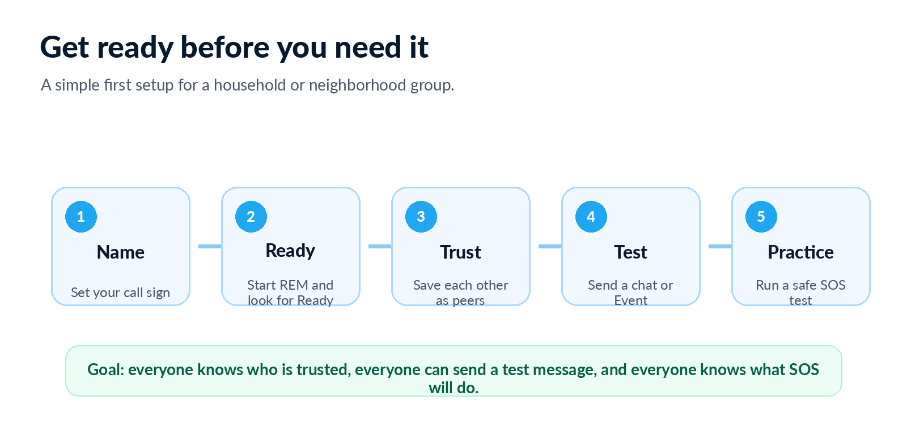

Your first setup checklist
- Peform the wizard and choose a clear call sign. Use a name your group will immediately recognize.
- Select some server from the list. Make sure REM shows Ready. If it says Not Ready, sending may be limited.
- Open Peers and save only the people you trust.
- Ask each person to save you too. Two-way sharing works only when both sides choose each other.
- Send a small Chat message or Event to confirm the group can communicate.
- Review SOS settings and run a safe test with your trusted group.
Good practice
Make a habit of a monthly communications drill: start REM, check Ready, send a test message, send a test Event, and confirm the group can respond.

2. Choose the right Capability
REM has several screens, but each has a simple purpose. Use this section as your quick selector.
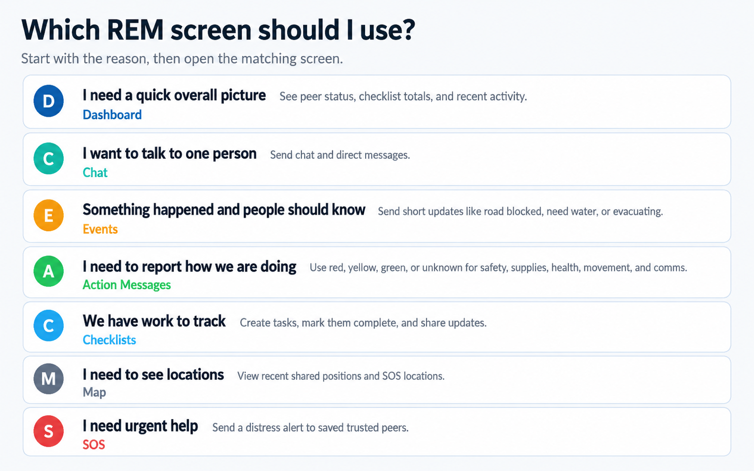
The Ready indicator
The top of REM shows whether the app is Ready. If it is Not Ready, the connection engine may not be running yet and sending may be limited.

3. Dashboard: your quick picture

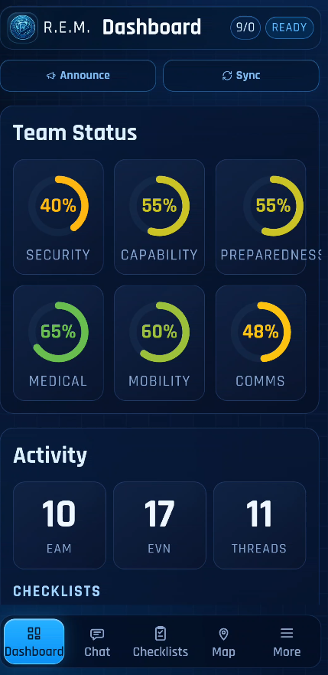
What the Dashboard is for
Use the Dashboard when you need the big picture first.
- Use it when you want a fast overview of the group.
- The status rings come from Action Messages.
- Checklist totals show how much work is active, late, or complete.
- Announce and Sync are quick controls for visibility and updates.

- If the Dashboard is empty, the group may not have sent status yet.
- Tapping one of the sections will bring you to that page.

Team Status
Green rings  Things are working or acceptable right now. | Yellow rings  Something is limited or needs attention. | Red rings  There is a serious problem or urgent limit. | Zero rings  No status has been shared yet.

4. Trusted people: Peers
Peers are other REM users you trust. For prepared citizens, it may help to think of them as trusted people rather than devices.
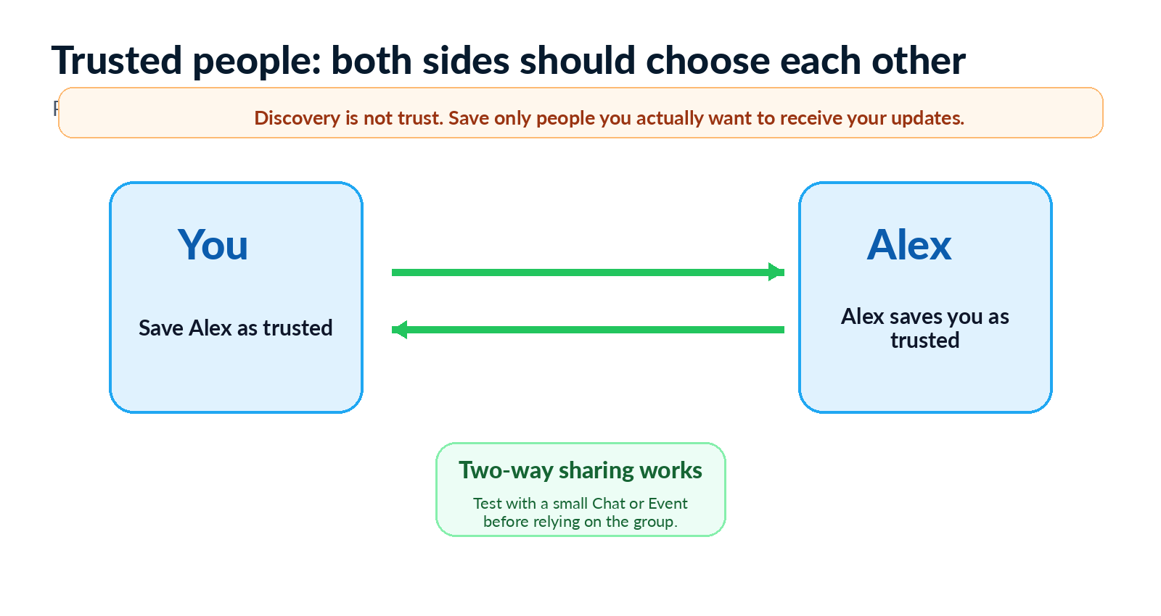

Using the Peers screen
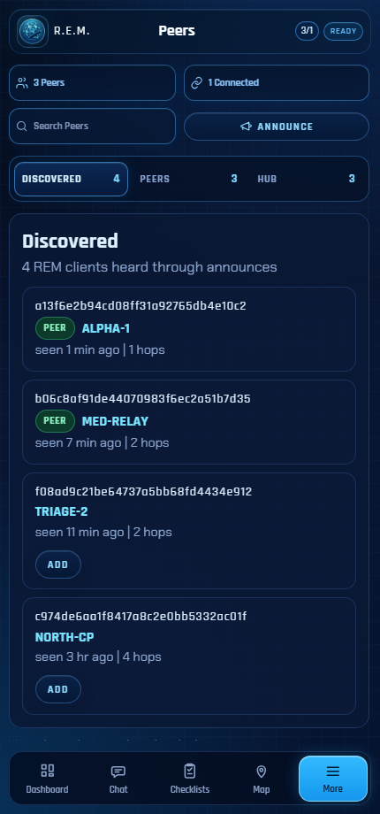 | A saved peer is someone you have chosen to trust.  - See REM users that have been discovered nearby or through the Hub (FUTURE FEATURE).  - Save only people you actually want to work with.  - Connect or disconnect saved peers when needed.  - Search by name if the list is long.  - Use Announce so other REM users can discover you.

5. Chat and Events: two ways to communicate
Use Chat when...  You want to talk directly with one selected person or continue a conversation. | Use Events when...  Something happened and the group should see a short timeline update. | Use SOS when...  You need urgent help and want to alert saved trusted peers quickly.

Chat: direct messages
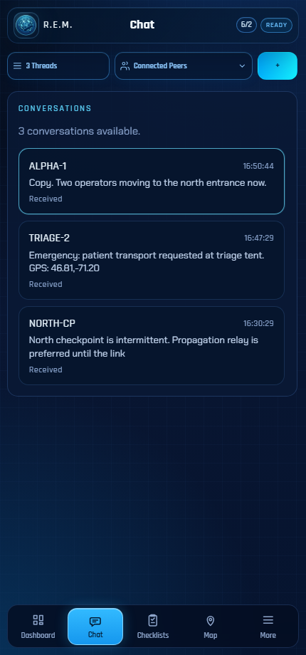 | Chat is best for regular, more complex conversations.  - Open Chat when you want a normal message conversation.  - Choose the peer you want to message.  - Use a short test message to confirm your connection.  - Emergency messages are also displayed here . They may include location thatt can be opened on the Map .

Events: quick updates without memorizing codes
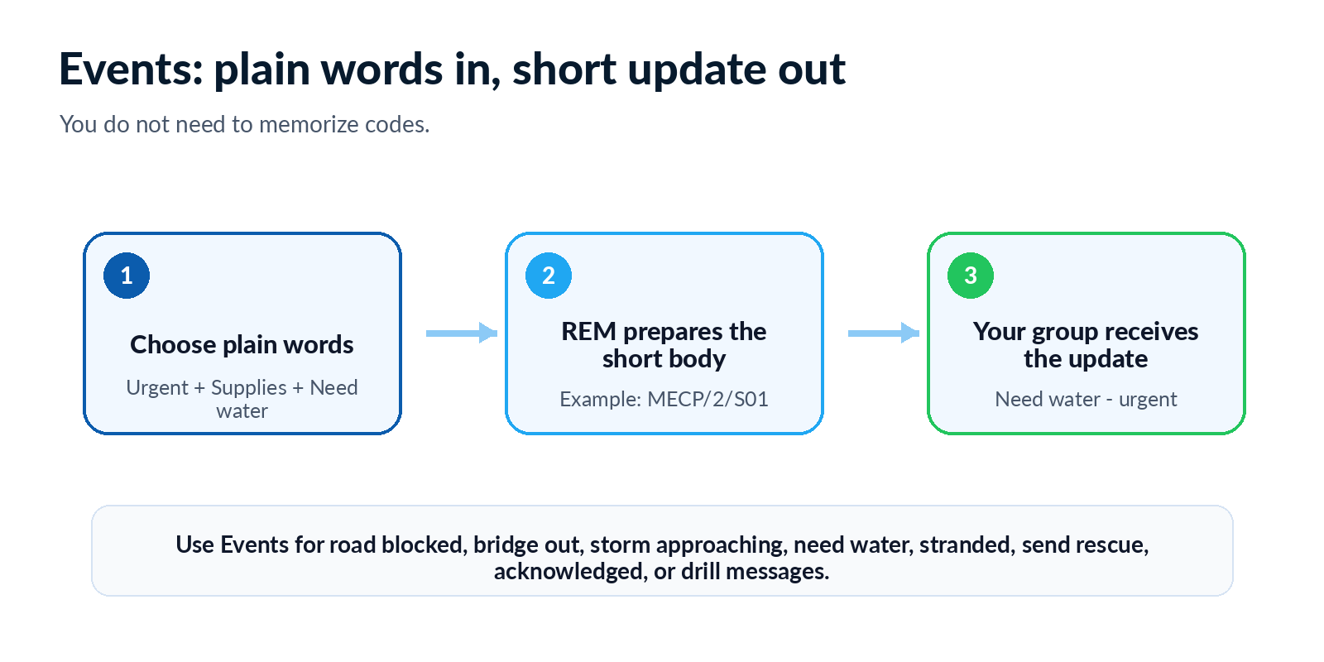

Event Severity
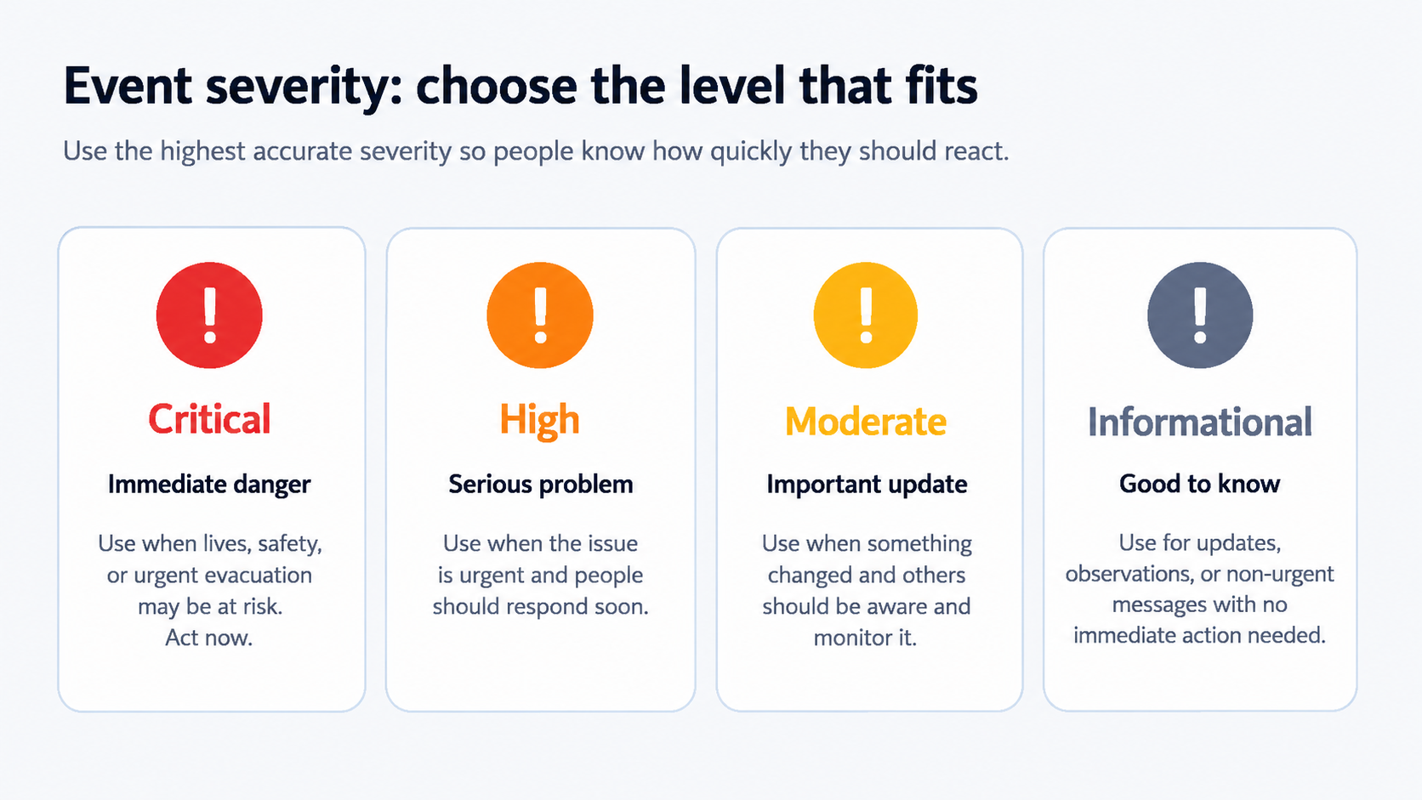

Events: examples you may send
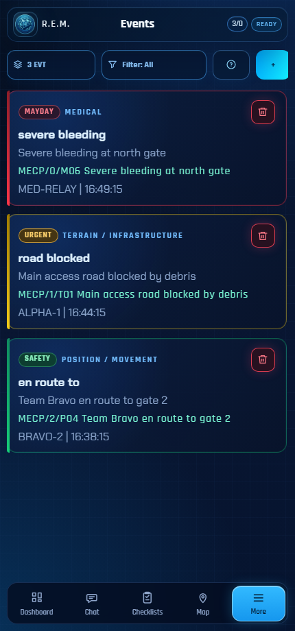 | Events are short timeline updates for the group.  - Road blocked or bridge out.  - Storm approaching or visibility low.  - Need water, food, medication, fuel, tools, or power.  - Stranded, evacuating, sheltering, en route, or lost.  - Send rescue, rendezvous, help coming, ETA, all clear, or drill/test.

6. Action Messages: report how you are doing
Action Messages are simple status reports. They feed the Dashboard so the group can see what is OK, limited, unknown, or urgent.
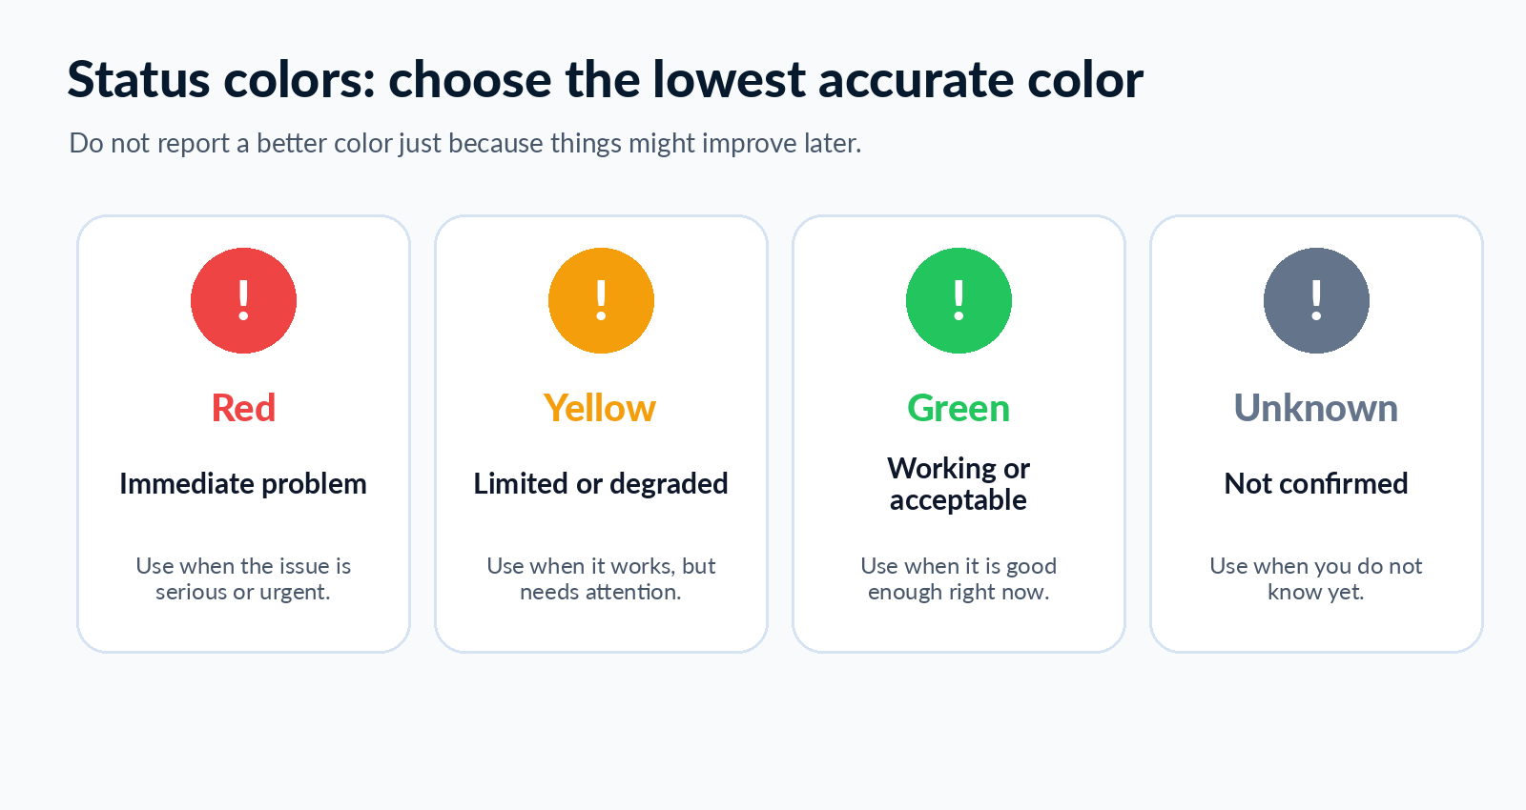

Action Message areas
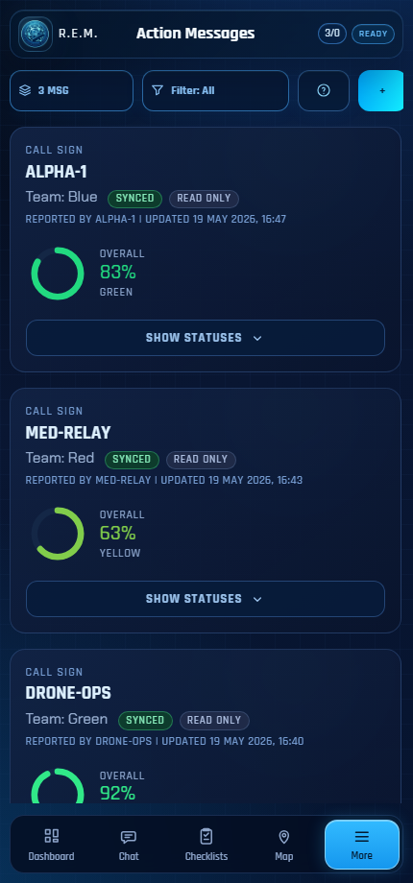 | Choose the lowest accurate color for each area.  - Security: Is the area safe enough for the current plan?  - Capability to protect or stay safe: Is the group able to manage immediate safety concerns?  - Supplies and power: Are water, food, batteries, and power adequate?  - Health: Are there medical issues or special needs?  - Movement: Can people move or travel if needed?  - Communications: Are messages getting through?

7. Checklists: track what needs to get done

What Checklists are for
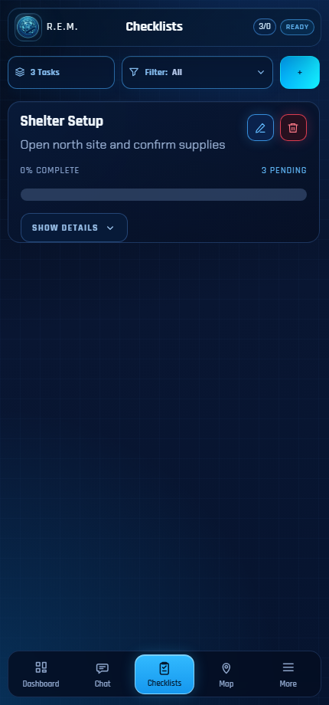 | Checklists turn plans into visible tasks.  - Create a task list from a template.  - Upload a checklist template when your group has prepared one.  - Track active, late, and completed tasks.  - Open a checklist and mark rows complete.  - Share task updates with trusted peers.

Good prepared-citizen checklists
Power outage  Charge devices, check battery banks, start generator safely, reduce loads. | Evacuation  Grab bags, documents, pets, medication, route, destination, contact check-in.
Shelter-in-place  Water, food, sanitation, safety, communications schedule. | Storm prep  Secure outdoor items, charge devices, check sump pump, monitor weather.
Wildfire/flood  Go-bag, route, fuel, documents, masks, neighbor check. | Comms drill  Start node, announce, send chat, send Event, confirm response.
Tip
Create checklist templates before an emergency. During a crisis, you should be choosing from prepared playbooks, not inventing steps from scratch.

8. Map and location: useful, but choose privacy first

What the Map shows
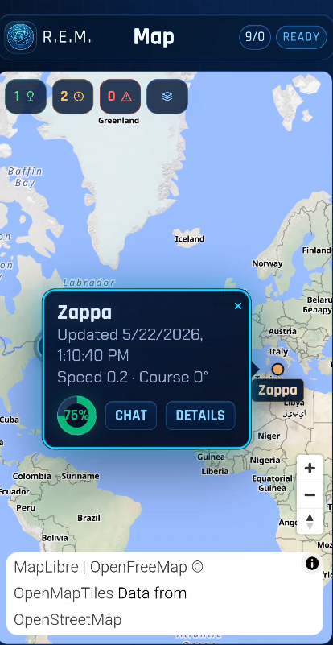 | Use the Map when location is part of the plan.  - Recent peer positions when location sharing is enabled.  - Emergency locations from SOS messages when a location is included.  - Position age, so you can tell whether a location is fresh or stale.  - An empty map usually means no one has shared telemetry yet.  - Tapping on your peer allow you to perform several actions
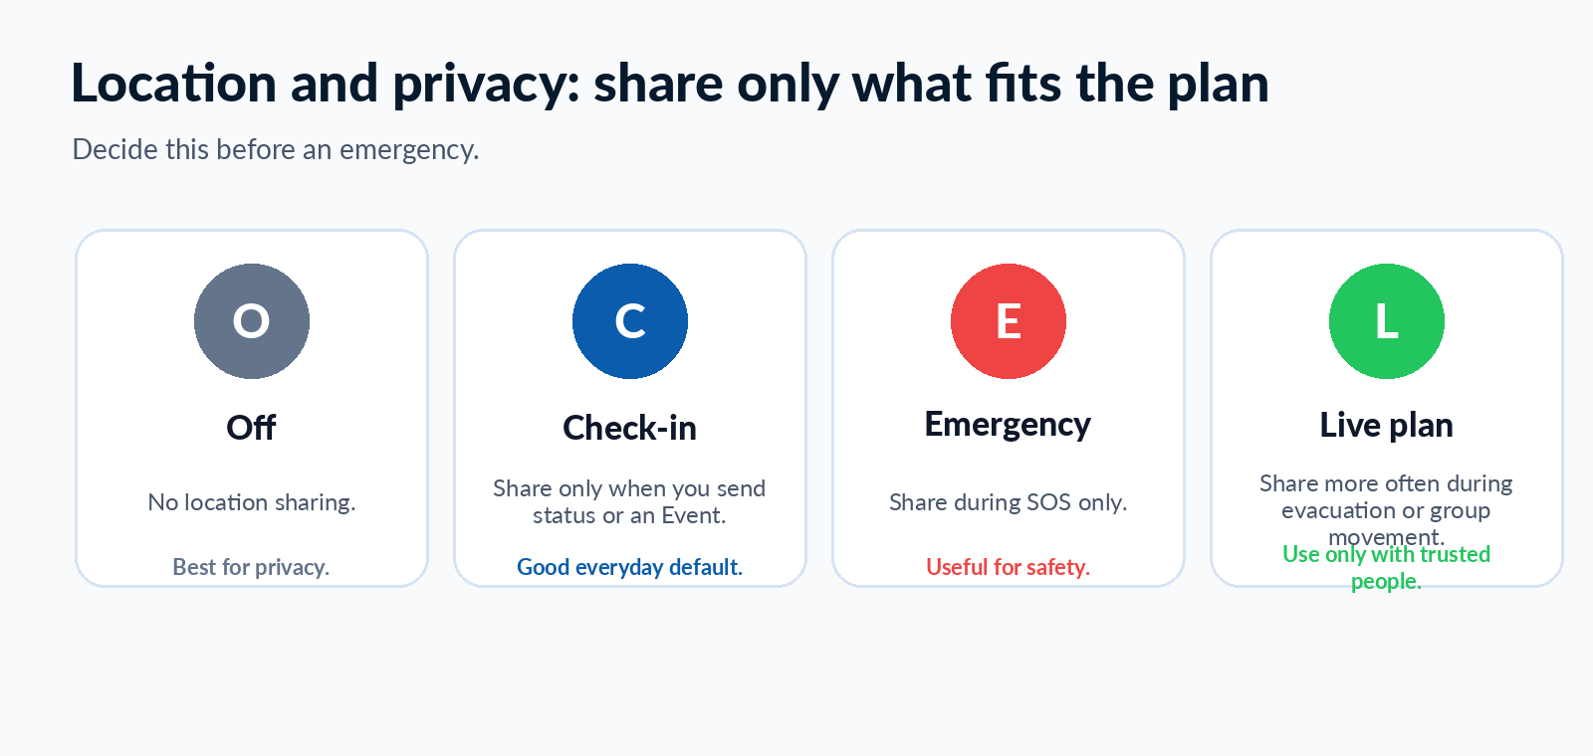
Before you share location
Agree with your group when location sharing is appropriate. Household members may need different settings than neighbors or wider community contacts.

9. SOS Emergency: urgent distress alerts
SOS is for urgent distress messages to saved trusted peers. It should be configured and tested before you depend on it.
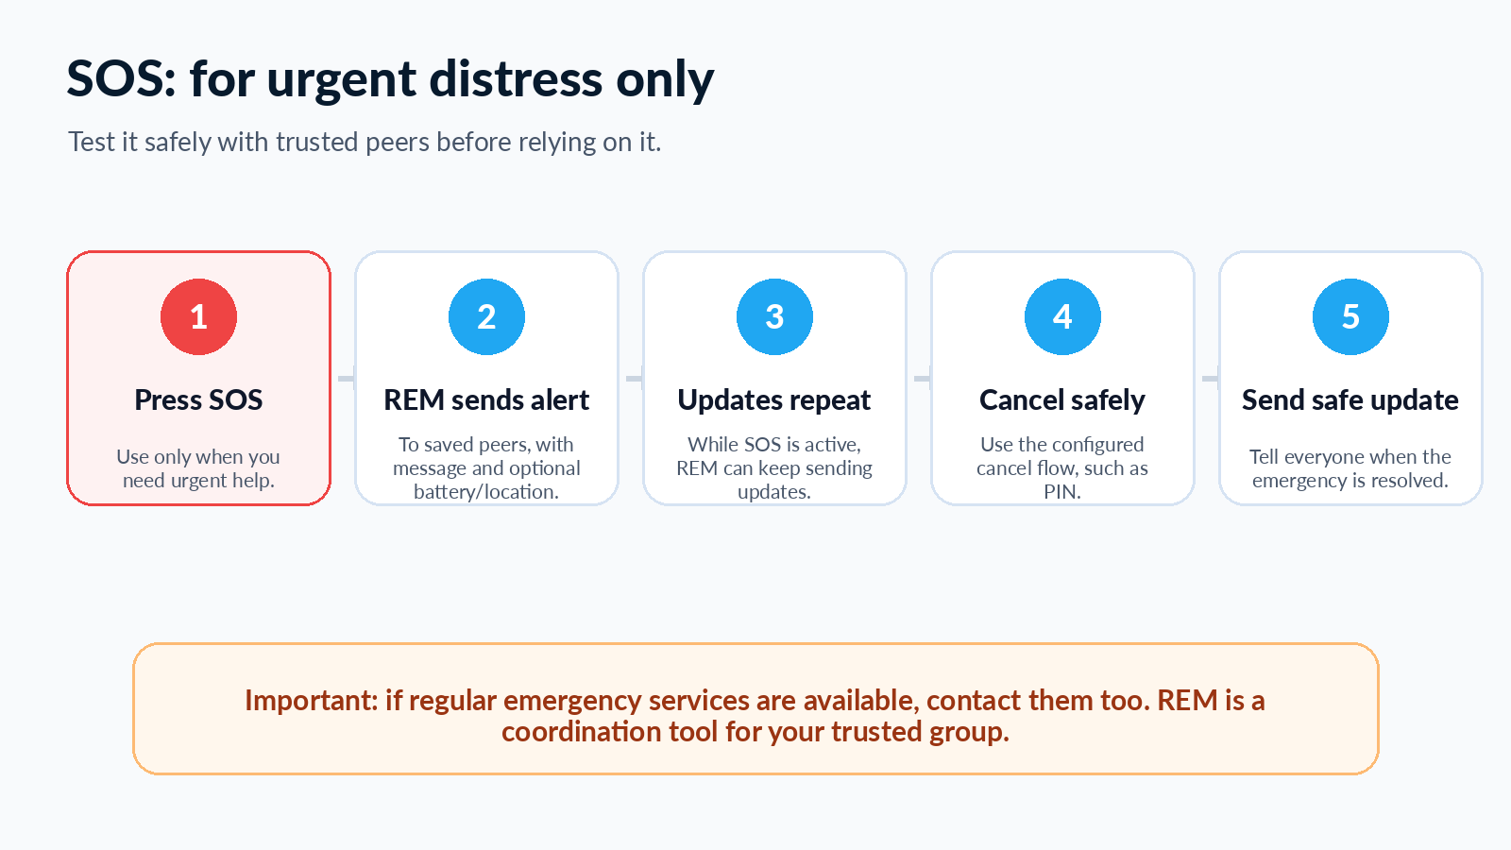

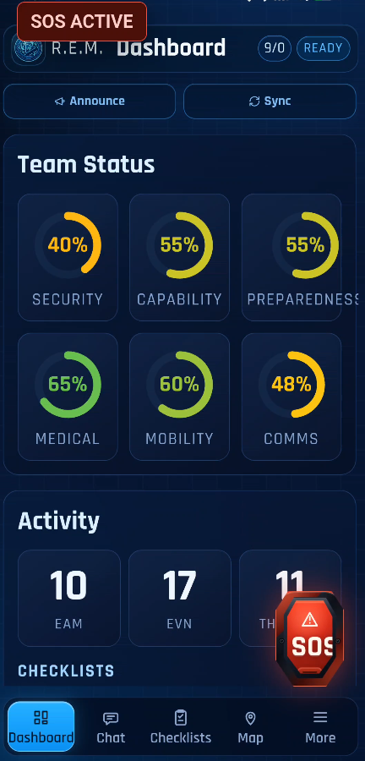
What SOS can include
- Your configured emergency message.
- Battery information, if enabled.
- Your position, if a recent location fix is available and location sharing is enabled.
- Repeated updates while the emergency is active.
- A cancel step such as a PIN, if configured.

Safe testing
Before relying on SOS, tell your trusted group you are running a test. Use a clear test message so nobody mistakes it for a real emergency.

10. Settings and HomeBase

Settings: prepare the app before field use
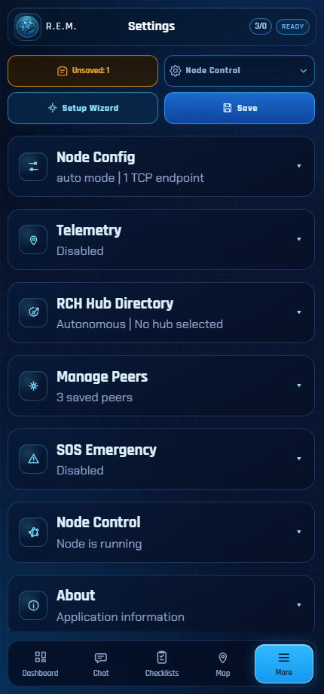 | Settings is where you prepare REM before field use.  - Set or review your call sign.  - Prepare network access and announce behavior.  - Choose telemetry and privacy options.  - Set checklist timing defaults.  - Turn on RCH hub mode when your group uses a hub.  - Import or export peer lists.  - Configure SOS options.  - Start, stop, or restart the REM node if needed.

HomeBase (RCH) in plain words
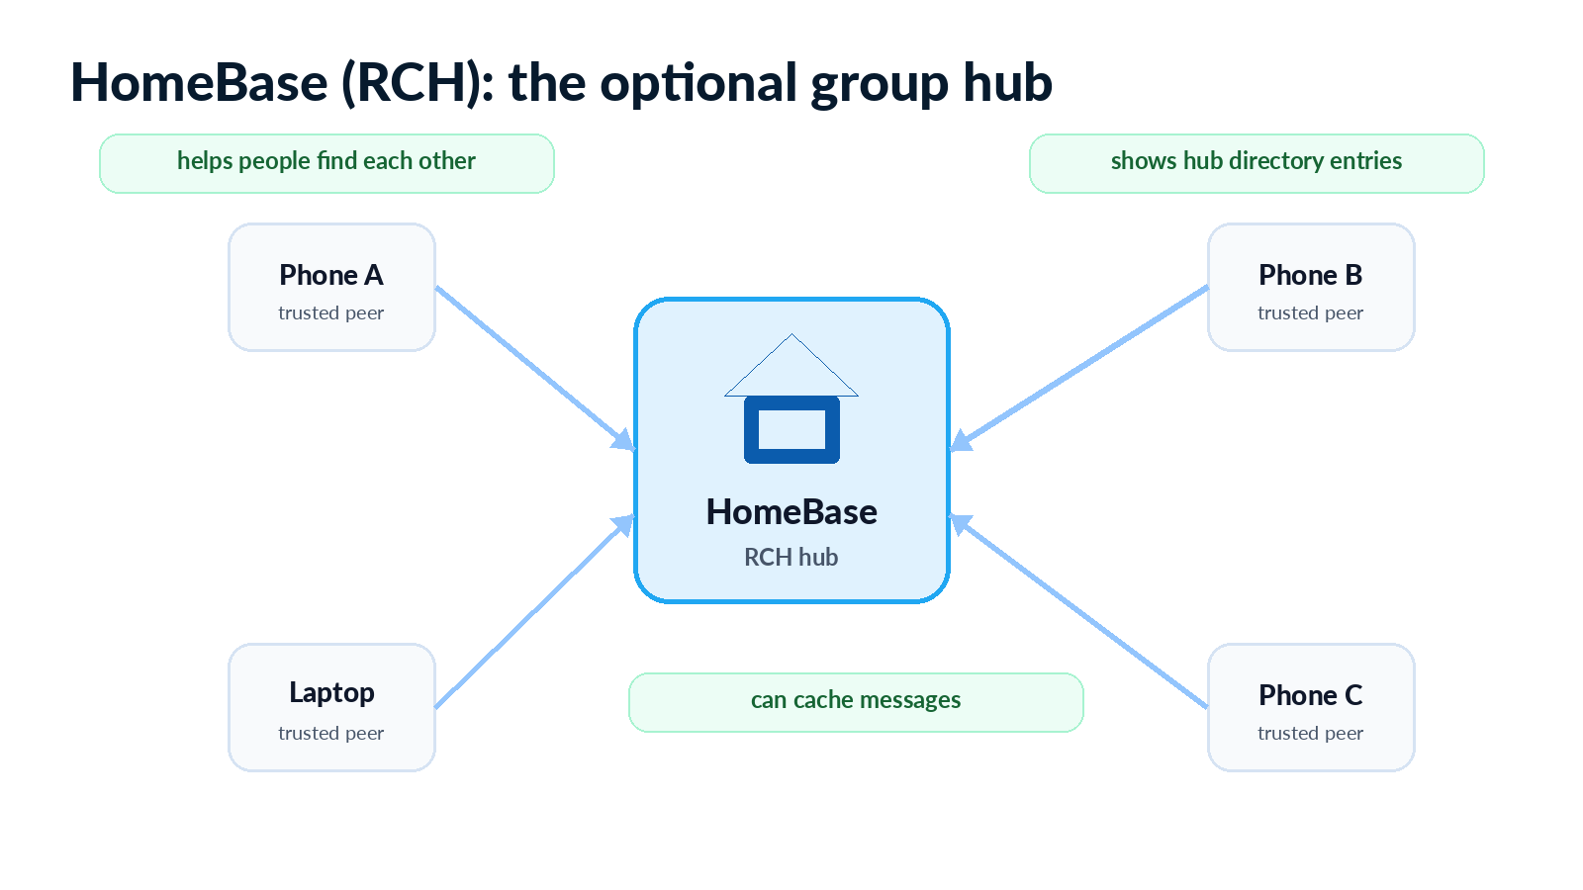

11. Common prepared-citizen workflows
Use the same simple REM pattern in many situations: prepare, connect, report, coordinate, and recover.
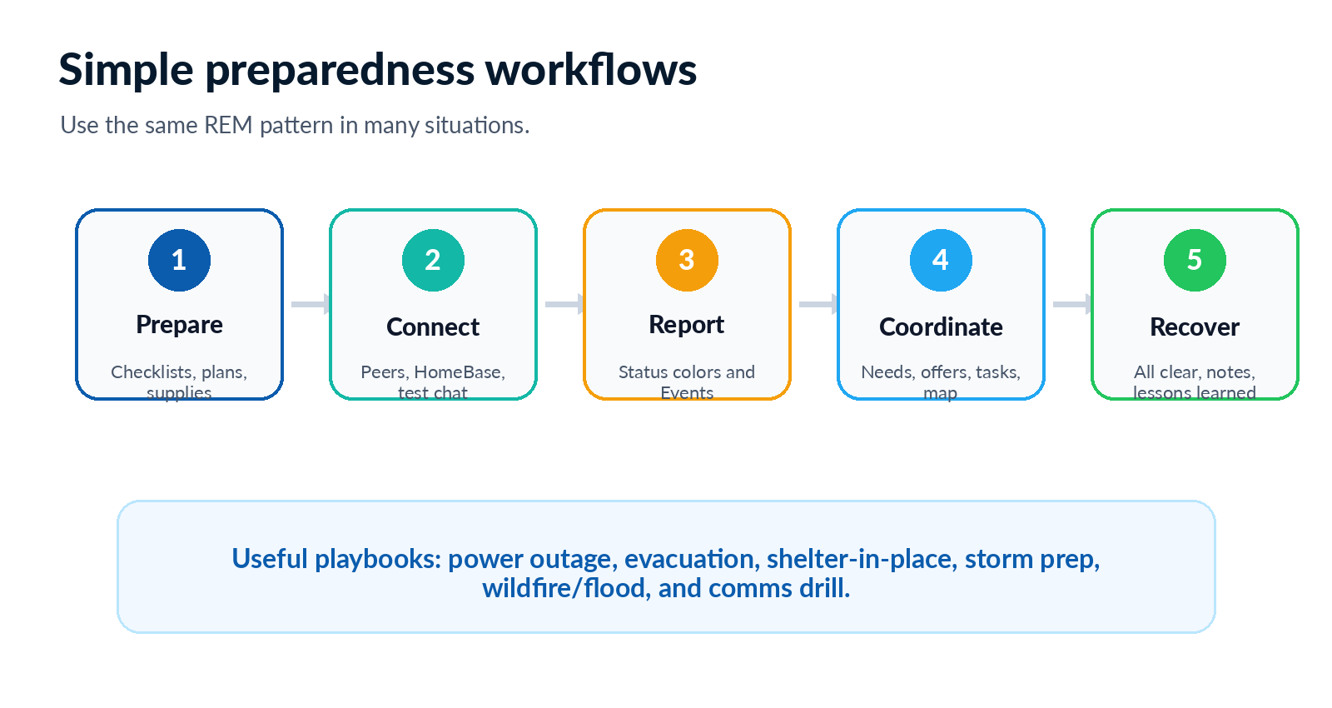

Example playbooks
Situation | Use REM for | Good first message or task
Power outage | Check Ready, send group status, track battery/power tasks. | Event: power limited. Checklist: charge devices.
Evacuation | Share movement status, route notes, rally point, and urgent needs. | Event: evacuating. Checklist: grab bags and documents.
Shelter-in-place | Use check-ins, supplies status, and timed communications. | Action Message: supplies/power and comms status.
Storm prep | Track prep tasks and send weather/road updates. | Checklist: secure items and charge batteries.
Wildfire/flood | Share hazards, routes, masks, fuel, and neighbor checks. | Event: road blocked or evacuating.
Comms drill | Practice Ready, peers, Chat, Event, Map, and SOS test. | Event: drill/test. Chat: confirm received.

12. Empty screens and simple troubleshooting
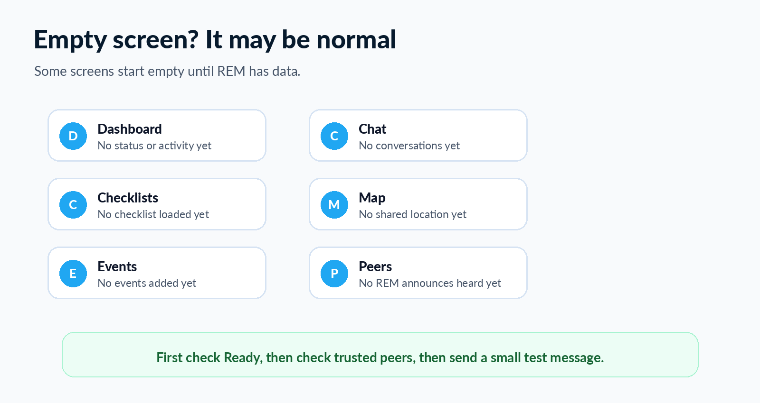

Try these checks first
- Look at the top of REM. If it says Not Ready, wait for the node to start or use Settings to restart it.
- Open Peers. Make sure the person you want is saved, and ask them to save you too.
- Send a small Chat message or Event as a test.
- If the Map is empty, check whether location sharing is enabled and whether anyone has sent a recent position.
- If Checklists are empty, create a checklist or load a prepared template.
- If Dashboard rings are zero, send an Action Message first.
Do not panic over an empty page
Many REM pages are empty until the app has local data, peer traffic, or a Ready connection.

13. Safety and privacy habits
Save only trusted people  A discovered device is not automatically safe or trusted. | Test before emergencies  A tool you never practice with is easy to misuse under stress.
Share location by plan  Decide when household, neighbors, or wider contacts can see location. | Use clear test labels  For drills, say drill/test so nobody mistakes it for a real emergency.
Keep paper backups  Have printed contacts, rally points, and fallback communication plans. | Use official help too  When normal emergency services are available, contact them as appropriate.

A simple group agreement
Before using on REM, agree on these items as a group:
- Who is in the trusted group.
- When to use Chat, Events, Action Messages, Checklists, Map, and SOS.
- Which status colors mean what for your group.
- When location sharing is allowed.
- How often the group will run a communications drill.
- What to do when a message is urgent but not acknowledged.

Appendix

Plain-Language Glossary
Term | Plain meaning
Action Message | A structured status report that feeds the Dashboard.
Announce | A signal that helps other REM users discover your device.
Call sign | The name your group sees for your device.
Checklist | A shared task list used to track work.
Dashboard | The screen that summarizes group status, tasks, and activity.
Event | A short timeline update such as road blocked, need water, or evacuating.
HomeBase / RCH | An optional hub that can help with directory and connected workflows.
LXMF | The background message delivery method. You usually do not need to manage it.
Map | The screen that shows recent shared positions when location sharing is enabled.
MECP | A short message format. REM lets you choose plain words and prepares the short body.
Node | The connection engine inside REM. Ready usually means it is running.
Peer | Another REM-capable device or person.
Ready | REM is prepared to send and receive through the local node.
Reticulum | The mesh networking system REM uses in the background.
Saved peer | A peer you have chosen to trust and work with.
Selected peer | A peer chosen as a sharing target. Two-way sharing works best when both sides select each other.
SOS | Emergency mode for urgent distress alerts to trusted peers.
Telemetry | Position information used by the Map when enabled.

EAM
Category | Green  working / acceptable | Yellow  limited, degraded, or needs attention | Red  immediate problem or serious limit | Unknown  not confirmed
Safety / Security:  Is the area safe enough for the group to continue normal activity? | Area appears safe. No immediate threat observed. People can remain in place or move normally with normal caution. | Possible concern exists. Unusual activity, nearby hazard, uncertain people, minor conflict, or changing conditions. Extra caution or monitoring is needed. | Immediate danger or serious safety concern. Unsafe area, active threat, violence, fire nearby, severe hazard, forced evacuation, or group cannot safely remain. | Safety has not been checked, reports conflict, or the person sending the EAM is not in a position to confirm conditions.
Capability  the Ability to Protect and Operate. Can the group still function and protect itself if needed? | People, equipment, tools, and plans are usable. The group can continue its intended work or household plan. | Some capability is reduced. Missing person, tired team, limited tools, low staffing, partial equipment failure, or reduced ability to watch, assist, move, or respond. | Group cannot operate safely or protect itself. Key people unavailable, essential equipment lost, serious exposure, panic, no ability to respond, or immediate outside help needed. | Capability has not been checked, the group is separated, or the sender does not know whether people/equipment are available.
Supplies & Power / Preparedness:  Do we have enough supplies and power for the current situation? | Current supplies and power are adequate. Water, food, medication, batteries, fuel, lighting, and charging are acceptable for now. | Supplies or power are limited. Low battery, low water, limited food, fuel concern, generator/solar issue, missing kit item, or need to ration soon. | Critical shortage. No water, no essential medication, no safe food, no power for required devices, no heat/cooling where needed, or urgent resupply required. | Supply or power status has not been checked, inventory is unclear, or the sender is away from the supplies.
Medical / Health  Is anyone injured, ill, medically vulnerable, or in need of care? | No known medical problem. People appear stable. Required medications and basic first-aid supplies are available. | Non-life-threatening medical concern. Minor injury, illness, fatigue, stress, missed medication risk, limited first-aid supplies, or a vulnerable person needs monitoring. | Serious or urgent medical issue. Severe injury, uncontrolled bleeding, breathing trouble, unconscious person, severe allergic reaction, missing medication for critical condition, or immediate medical help needed. | Medical condition has not been checked, some people are unreachable, or the sender cannot confirm health status.
Mobility  Can people move, evacuate, travel, or reach planned places? | People can move as planned. Vehicle, route, fuel, mobility aids, and timing are acceptable. | Movement is possible but degraded. Road delay, low fuel, route uncertainty, minor vehicle issue, mobility limitation, weather concern, or group is moving slower than expected. | Movement is blocked or unsafe. Stranded, vehicle disabled, route cut off, bridge/road blocked, person cannot walk or be moved, evacuation impossible, or urgent pickup/rescue needed. | Location, route, vehicle, fuel, or mobility status is not confirmed.
Communications  Can the group send, receive, and coordinate messages? | REM node is ready, trusted peers can be reached, messages are working, and the group has a usable communication plan. | Communications are degraded. Some peers unreachable, weak signal, delayed messages, low battery, uncertain telemetry, intermittent node readiness, or hub/relay issue. | Communications are failing for the current need. Cannot reach trusted peers, no working device, no power, no node, no relay, SOS cannot be sent, or group is effectively isolated. | Communications have not been tested, peer status is unclear, or the sender cannot confirm whether messages are being delivered.

Events

Severities
Severity | Plain meaning | more
MAYDAY | Life-threatening | Immediate danger. Use when life, safety, or urgent evacuation may be at risk.
URGENT | Time-critical | Serious problem. Use when the issue is urgent and people should respond soon.
SAFETY | Important | Important update. Use when others should be aware and monitor the situation.
ROUTINE | Normal | Informational. Use for normal updates, observations, or practice messages.

Category and Types
Category | Code | Event type
Medical | M01 | Injury
Medical | M02 | Unconscious person
Medical | M03 | Breathing difficulty
Medical | M04 | Cardiac event
Medical | M05 | Hypothermia
Medical | M06 | Severe bleeding
Medical | M07 | Fracture / immobile
Medical | M08 | Burns
Medical | M09 | Multiple casualties
Medical | M10 | Deceased
Medical | M11 | Animal bite / sting
Medical | M12 | Allergic reaction / anaphylaxis
Medical | M13 | Poisoning / toxic exposure
Medical | M14 | Persons located alive
Medical | M15 | Area searched, no victims found
Terrain / Infrastructure | T01 | Road blocked
Terrain / Infrastructure | T02 | Bridge out
Terrain / Infrastructure | T03 | Building collapsed
Terrain / Infrastructure | T04 | Flooding
Terrain / Infrastructure | T05 | Landslide
Terrain / Infrastructure | T06 | Power out
Terrain / Infrastructure | T07 | Fire
Terrain / Infrastructure | T08 | Avalanche
Terrain / Infrastructure | T09 | Path impassable
Terrain / Infrastructure | T10 | Shelter available
Terrain / Infrastructure | T11 | Drowning / water rescue needed
Terrain / Infrastructure | T12 | Water contamination
Terrain / Infrastructure | T13 | Earthquake
Terrain / Infrastructure | T14 | Gas leak
Terrain / Infrastructure | T15 | Chemical spill / HAZMAT
Terrain / Infrastructure | T16 | Vehicle accident
Terrain / Infrastructure | T17 | Vehicle fire
Weather / Environment | W01 | Storm approaching
Weather / Environment | W02 | Visibility zero
Weather / Environment | W03 | Extreme cold
Weather / Environment | W04 | Extreme heat
Weather / Environment | W05 | Air quality danger
Weather / Environment | W06 | Tsunami / tidal surge warning
Supplies | S01 | Need water
Supplies | S02 | Need food
Supplies | S03 | Need medication
Supplies | S04 | Need battery / power
Supplies | S05 | Need fuel
Supplies | S06 | Need tools / equipment
Position / Movement | P01 | Stranded / stuck
Position / Movement | P02 | Evacuating toward
Position / Movement | P03 | Sheltering in place
Position / Movement | P04 | En route to
Position / Movement | P05 | At GPS coordinates
Position / Movement | P06 | Lost
Position / Movement | P07 | Group separated
Coordination | C01 | Send rescue
Coordination | C02 | Need transport
Coordination | C03 | Relay this message
Coordination | C04 | Confirm received
Coordination | C05 | How many people
Coordination | C06 | What is status
Coordination | C07 | Can you reach
Coordination | C08 | Rendezvous at
Response | R01 | Acknowledged
Response | R02 | Help coming
Response | R03 | ETA [minutes]
Response | R04 | Cannot assist
Response | R05 | Redirecting to
Response | R06 | Stand by
Response | R07 | Situation resolved / all clear
Drill / Test | D01 | This is a drill
Drill / Test | D02 | This is a test
Drill / Test | D03 | End of drill
Drill / Test | D04 | Ignore previous — sent in error
Life / Leisure | L01 | Beer / drinks
Life / Leisure | L02 | Coffee
Life / Leisure | L03 | Food ready
Life / Leisure | L04 | Summit reached
Life / Leisure | L05 | At camp
Life / Leisure | L06 | Running late
Life / Leisure | L07 | Good signal here
Life / Leisure | L08 | Photo opportunity
Life / Leisure | L09 | Wildlife spotted
Life / Leisure | L10 | Beautiful view
Life / Leisure | L11 | Trail conditions good
Life / Leisure | L12 | Trail conditions bad
Life / Leisure | L13 | Need a break
Life / Leisure | L14 | Heading home
Life / Leisure | L15 | Good morning / check-in
Life / Leisure | L16 | Good night
Life / Leisure | L17 | Thank you
Life / Leisure | L18 | Having fun
Life / Leisure | L19 | Festival / event here
Life / Leisure | L20 | Node test / ping
Threat / Security | X01 | Dangerous person / threat nearby
Threat / Security | X02 | Area unsafe — avoid
Threat / Security | X03 | Gunfire / explosions heard
Threat / Security | X04 | Civil unrest / crowd danger
Threat / Security | X05 | Theft / looting reported
Threat / Security | X06 | Authorities / emergency services present
Threat / Security | X07 | Checkpoint / road closure, authority
Have / Offer Resources | H01 | Have water available
Have / Offer Resources | H02 | Have food available
Have / Offer Resources | H03 | Have medical supplies
Have / Offer Resources | H04 | Have power / charging
Have / Offer Resources | H05 | Have fuel
Have / Offer Resources | H06 | Have tools / equipment
Have / Offer Resources | H07 | Have shelter / space for [N] people
Have / Offer Resources | H08 | Have transport / vehicle
Beacon | B01 | Automated distress beacon active — sender may be unresponsive
Beacon | B02 | Beacon acknowledged — reduce transmission rate
Beacon | B03 | Cancel beacon — I am OK

One-page field card
Print this page or keep it as a quick reminder.
Need the big picture?  Open Dashboard. | Need one person?  Open Chat.
Need to report status?  Open Action Messages and choose red, yellow, green, or unknown. | Need to tell the group something happened?  Open Events and choose the plain-language option.
Need to track work?  Open Checklists. | Need location?  Open Map, but respect the group privacy plan.
Need urgent help?  Use SOS and contact emergency services when available. | Need to check setup?  Open Settings and Peers, then send a test message.
Remember
Prepare first. Test often. Share clearly. Keep backups. Use SOS only for urgent distress.

