R.E.M. User Manual
Reticulum Emergency Management
A plain-language guide for using REM to coordinate with trusted peers over Reticulum mesh networking.

R.E.M. stands for Reticulum Emergency Management.
It is a secure Mesh coordination app for small teams. It helps people share status, send chat messages, record events, manage checklists, and see recent positions over Reticulum mesh networking.
This manual uses plain language. It focuses on what each screen is for, what you can do there, and what to expect.

Quick Start
- Open Settings and confirm your call sign.
- Open Peers and save the people you trust.
- Use Chat for direct messages.
- Use Action Emergency Messages to report team status.
- Use Events to add short timeline updates.
- Use Checklists to track shared tasks.
- Use Map to see positions when telemetry is enabled.
- Use Dashboard to see the overall picture.

Main Navigation
The top of the app shows:
- the current page name
- saved peer and connected peer count
- whether REM is Ready
If the app says Not Ready, sending may be limited until the node starts.
The bottom bar gives fast access to:
- Dashboard
- Chat
- Checklists
- Map
- More
Use More to open:
- Action Messages
- Events
- Peers
- Settings

Dashboard
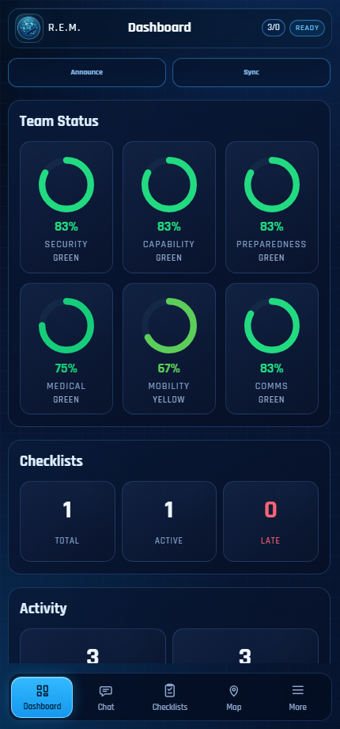
REM dashboard
The Dashboard gives a quick team picture.
Use it to see:
- readiness across security, capability, preparedness, medical, mobility, and communications
- checklist totals
- action message and event totals
- quick Announce and Sync controls
The status rings come from Action Messages. If there are no Action Messages yet, the rings stay at zero.

Chat
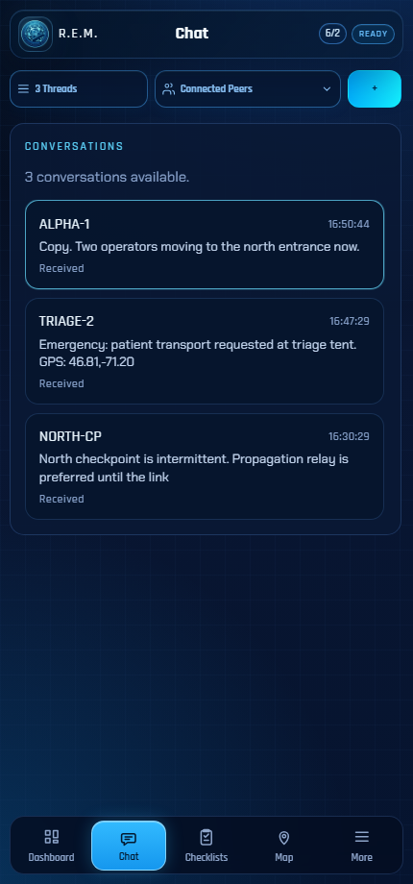
REM chat
Chat is for direct peer-to-peer messages.
Use it to:
- review conversations
- send a message to a selected peer
- read incoming LXMF messages
- open SOS positions on the Map when an emergency message includes location
If the page is empty, discover and save peers first, or wait for an incoming message.

Action Messages
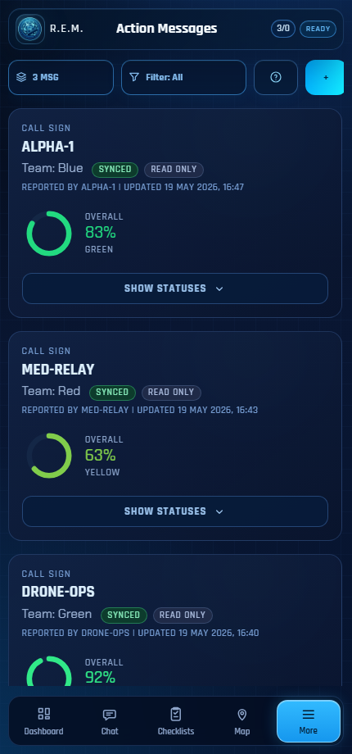
REM action messages
Action Messages are structured status reports. They also feed the Dashboard.
Use them to tell the team:
- whether the area is secure
- whether the team has defensive capability
- whether supplies and power are adequate
- whether there is a medical problem
- whether people can move
- whether communications are working
The status colors are:
Color | Plain meaning
Red | Immediate problem or serious limit
Yellow | Limited, degraded, or needs attention
Green | Working or acceptable
Unknown | unclear, Not confirmed yet

Choose the lowest accurate color. Do not choose a better color just because conditions might improve later.

Status Help
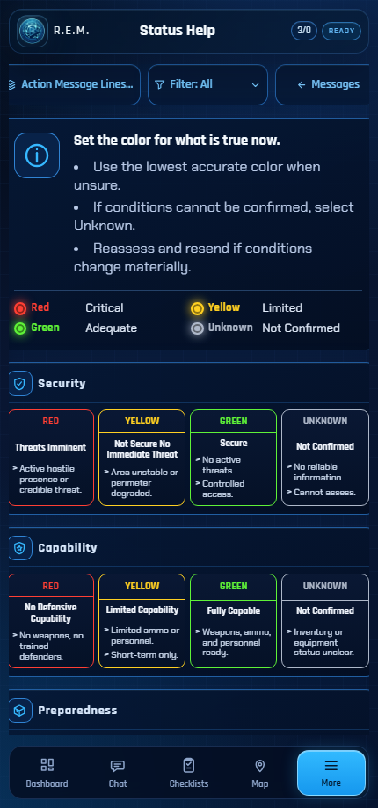
REM status help
The help page explains how to choose the Action Message colors. Use it when a team needs a shared rule for what Red, Yellow, Green, and Unknown mean.

Events
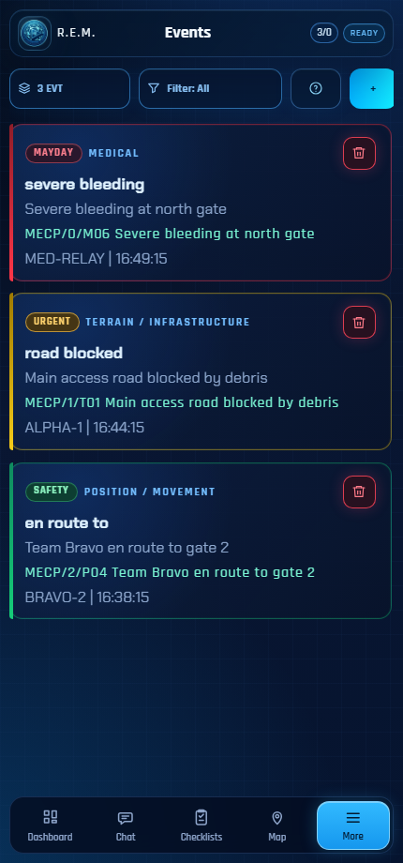
REM Events MECP composer
Events are short timeline updates. Use them for things the team should know, such as:
- road blocked
- bridge out
- storm approaching
- need water
- stranded
- send rescue
- acknowledged
- drill message
REM Events now use MECP, the Mesh Emergency Communication Protocol. MECP is a short text code for emergency and everyday mesh messages. It is designed for low-bandwidth links and for people who may not share the same spoken language. See the MECP project here: xiang-dev-1/MECP.
You do not need to memorize MECP codes. REM lets you choose the plain-language options and shows the body before the event is added.
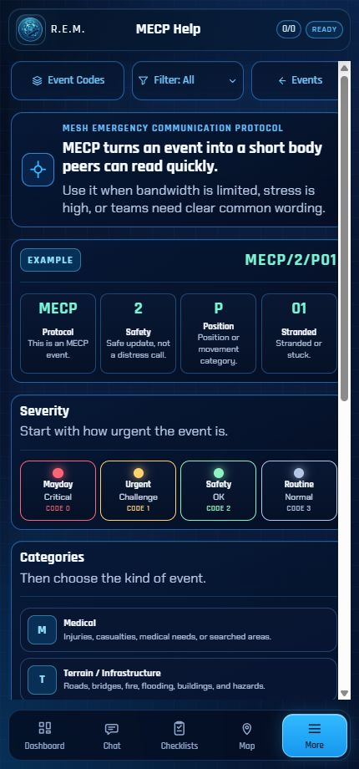
REM MECP help
The MECP Help screen explains the short message body, the urgency levels, and the event categories in one place.

MECP Event Choices
Part | What you choose | What REM sends
Severity | Mayday, Urgent, Safety, or Routine | The number after MECP/
Category | Medical, Terrain, Weather, Supplies, Position, Coordination, Response, Drill, Life, Threat, Resources, or Beacon | The first letter of the event code
Event | A specific item, such as Injury, Road blocked, Need water, or Stranded | A short code like M01, T01, S01, or P01
Details | Optional extra words | Added after the code
Body preview | The exact message that will be shared | Example: MECP/2/P01

MECP Categories
Code | Category | Used for
M | Medical | Injuries, bleeding, burns, missing or found people
T | Terrain / Infrastructure | Roads, bridges, buildings, flooding, fire, hazards
W | Weather / Environment | Storms, visibility, cold, heat, air quality
S | Supplies | Water, food, medication, fuel, tools, power
P | Position / Movement | Stranded, evacuating, sheltering, en route, lost
C | Coordination | Send rescue, relay, confirm received, rendezvous
R | Response | Acknowledged, help coming, ETA, all clear
D | Drill / Test | Drill, test, end of drill, sent in error
L | Life / Leisure | Low-risk everyday messages that help people practice
X | Threat / Security | Unsafe areas, dangerous people, unrest, checkpoints
H | Have / Offer Resources | Available water, food, medical supplies, shelter, transport
B | Beacon | Distress beacon, beacon acknowledged, cancel beacon

How To Add An Event
1. Open Events.
2. Tap +.
3. Choose the severity.
4. Choose the category.
5. Choose the event.
6. Add optional details if needed.
7. Review the Body preview.
8. Tap Add Event.
Events require the node to be Ready before they can be sent.

Checklists
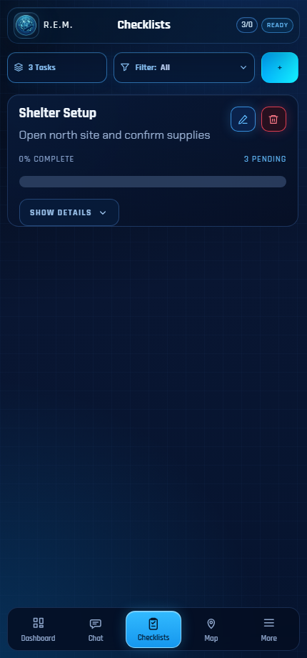
REM checklists
Checklists are shared task lists.
Use them to:
- create a task list from a template
- upload a CSV checklist template
- track active, late, and completed tasks
- open a checklist and mark rows complete
- share task updates with peers
The checklist page shows task counts and a filter. If no checklist data is loaded yet, the page tells you that nothing is available.

Creating A Checklist
1. Open Checklists.
2. Tap +.
3. Enter a title.
4. Add a subtitle or assignment label if useful.
5. Choose the checklist date and time.
6. (optional) Choose a template.
7. Tap Create checklist.

Map
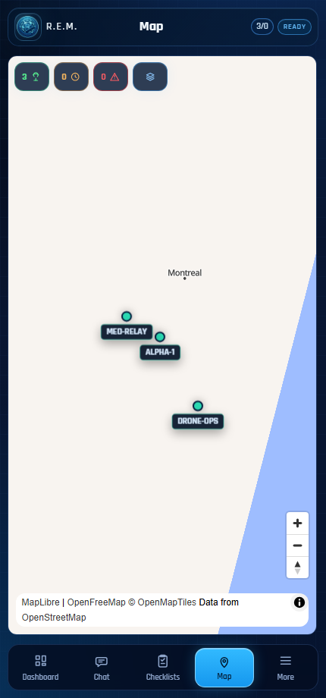
REM map
The Map shows recent peer positions when telemetry is available.
Use it to:
- see live or recent positions
- open emergency locations from SOS messages
- review position age
- tell whether a location is fresh or stale
If nobody has shared telemetry yet, the map may be empty.

Peers
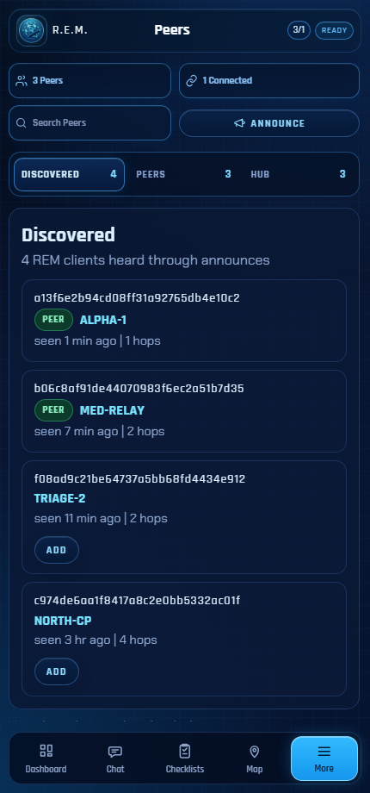
REM peers
Peers are other REM-capable devices.
Use the Peers page to:
- see discovered REM clients
- save trusted peers
- connect or disconnect saved peers
- search peer names or destination text
- review hub directory entries when hub support is in use
- announce your presence
Discovery does not mean trust. Save only the peers you want to work with.

How Peer Sharing Works Today
When you save or select a peer, you are choosing who REM should try to share information with. This can include chat messages, Action Messages, Events, checklist updates, telemetry, and SOS updates, depending on what is enabled.
In the current version, peer sharing is not fully automatic in both directions. The other person also needs to save or select you on their device. If you select them but they do not select you, your device may try to share with them, but their device may not share the same kind of information back to you.
For a working team setup:
1. You save or select the other peer.
2. The other peer saves or selects you.
3. Both devices show Ready.
4. Send a small chat message or Event to confirm that sharing works.
Think of the peer list as your trusted working group. If someone should receive your operational updates, they should be in your peer list, and you should be in theirs.

Settings
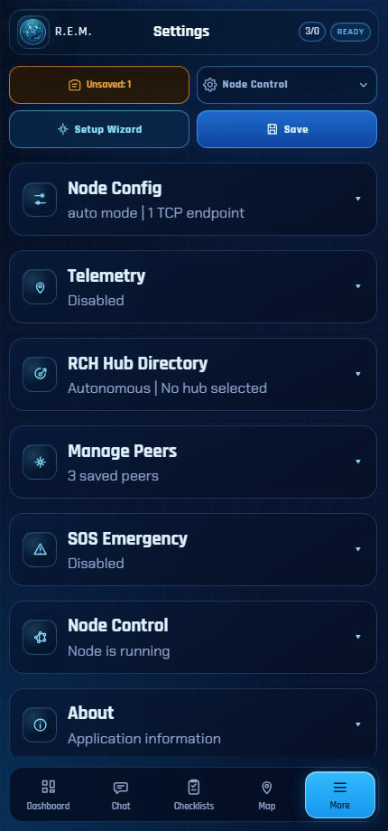
REM settings
Settings is where you prepare the app before field use.
Use it to configure:
- call sign
- Reticulum network access
- announce behavior
- telemetry sharing
- checklist timing defaults
- RCH hub mode
- peer list import and export
- SOS emergency options
- node start, stop, and restart controls

SOS Emergency
SOS is for urgent distress messages.
When enabled, it can:
- show a floating SOS button
- send the configured emergency message to saved peers
- include battery information
- include position if a recent fix is available
- keep sending updates while the emergency is active
- require a PIN to cancel, if configured
Before relying on SOS, test it with trusted peers in a safe setting.

Typical Field Workflow
1. Set your call sign in Settings.
2. Confirm networking and telemetry choices.
3. Save trusted devices in Peers.
4. Send or receive a chat message to confirm contact.
5. Create an Action Message for your current team status.
6. Watch the Dashboard for the group picture.
7. Add Events when something important changes.
8. Use Checklists for assigned work.
9. Use the Map when location sharing is part of the plan.

Empty Screens
Some pages start empty on purpose.
Screen | Why it may be empty
Dashboard | No Action Messages or activity yet
Chat | No conversations yet
Checklists | No checklist data or templates loaded yet
Map | No telemetry received yet
Events | No local or shared events yet
Peers | No REM announces heard yet

An empty screen does not always mean something is wrong. It often means the app is waiting for local data, peer traffic, or a ready node.

Glossary
Term | Plain meaning
Action Message | A structured team status report. It feeds the Dashboard status rings.
Announce | A Mesh signal that tells REM devices that your device is online.
Call sign | The name your team sees for your device.
Checklist | A shared task list used to track work during an operation.
Connected peer | A saved peer that REM currently has an active connection with.
Dashboard | The screen that summarizes team status, checklist counts, and recent activity.
Destination | The Reticulum cryptographic address used to reach a device.
Event | A short timeline update about something relevant.
LXMF | The message protocol used by Reticulum for direct or delayed messages.
Map | The screen that shows recent positions when telemetry is available.
MECP | Mesh Emergency Communication Protocol. A short text format for clear emergency and field messages.
Node | The local Reticulum part of REM that sends, receives, announces, and connects.
Peer | Another REM-capable device or operator.
Ready | REM is prepared to send and receive through the local node.
RCH | Reticulum Community Hub. A hub service that can help with directory and connected-mode workflows.
Reticulum | The mesh networking system REM uses to communicate without normal internet protocol.
Saved peer | A peer you have chosen to trust and work with.
Selected peer | A peer you have chosen as a sharing target. In the current version, they also need to select you for two-way sharing.
SOS | An emergency mode for sending urgent distress information to trusted peers.
Telemetry | Position information, such as a recent location shown on the Map.

