webBMD

A web based FreeBMD Transcribing Programme.

Table of Contents
Introduction 4
Changes to this Document 5
Licence 6
FreeBMD Account 7
First-time use 8
1) Start webBMD 8
2) Create New Identity 8
3) Create Allocation 9
4) Create Header 10
4) Select header and action 12
5) Happy Transcribing! 12
Architecture of webBMD 13
Detailed Help 15
Dialogue Header 15
Dialogue Footer 15
Sign-out 15
Housekeeping and Interesting Facts 16
Manage Allocations 16
Manage Syndicates 16
Manage Surnames, Manage Firstnames 16
Interesting facts 17
Show given names 17
Show family names 18
Dialogue message area 18
The Sign-on screen 19
General Announcements 19
Create New Identity Dialogue 20
Change your password 21
Select Header to work on 22
Create a new Transcription Header 25
Create New Allocation 26
Manage Allocations 27
Manage Syndicates 29
Transcribe from Scan 31
The scan image 31
Change the image parameters 32
The Data Entry 33
Action Buttons 37
Transcribing History 38
The Line Sequence Number 38
Transcribing tips 39
Requirements 40
Installation 41
Using the automatic installation programme. 41
Using the manual install process. 41

Introduction
This document will help you to understand the structure and use of the webBMD FreeBMD Transcribing Programme. It is intimately linked to the FreeBMD system and its website, FreeBMD.org.uk, and cannot be used without that link.

Changes to this Document
Date | Change | Applies to Version
15/05/2022 | First version of this document | All

Licence
Copyright (c) 2014-2019 British Columbia Institute of Technology
Copyright (c) 2019-2020 CodeIgniter Foundation
Copyright (c) 2020-2022 Hilary Wright for FreeBMD

Permission is hereby granted, free of charge, to any person obtaining a copy
of this software and associated documentation files (the "Software"), to deal
in the Software without restriction, including without limitation the rights
to use, copy, modify, merge, publish, distribute, sub-license, and/or sell
copies of the Software, and to permit persons to whom the Software is
furnished to do so, subject to the following conditions:

The above copyright notice and this permission notice shall be included in
all copies or substantial portions of the Software.

THE SOFTWARE IS PROVIDED "AS IS", WITHOUT WARRANTY OF ANY KIND, EXPRESS OR IMPLIED, INCLUDING BUT NOT LIMITED TO THE WARRANTIES OF MERCHANTABILITY,
FITNESS FOR A PARTICULAR PURPOSE AND NON INFRINGEMENT. IN NO EVENT SHALL THE AUTHORS OR COPYRIGHT HOLDERS BE LIABLE FOR ANY CLAIM, DAMAGES OR OTHER LIABILITY, WHETHER IN AN ACTION OF CONTRACT, TORT OR OTHERWISE, ARISING FROM, OUT OF OR IN CONNECTION WITH THE SOFTWARE OR THE USE OR OTHER DEALINGS IN THE SOFTWARE.

FreeBMD Account
To use webBMD you must have an account on FreeBMD and belong to a syndicate. Go to FreeBMD.org.uk to start the registration process. Once you are registered you will be allocated some scans to transcribe by your syndicate leader; this is called an “allocation” in webBMD.
To start using webBMD make a note of your FreeBMD user name and password. These will be required on each sign-on to webBMD.
Make a note of your syndicate name.
Finally, make a note of your allocation.

First-time use
When you use webBMD for the first time, here are the steps to take to get you going.
Remember that you have to have a FreeBMD user name and password, belong to a syndicate and have an allocation provided by your syndicate leader before you can start to use webBMD.
Now that you have these elements, follow the sequence below.
A simple explanation; webBMD basically works with two cycles,
Allocation cycle – this is a group of scans that need to be transcribed. You will be transcribing each scan in turn until the allocation is complete. An allocation can contain one to many scans.
So the cycle here is, create allocation → transcribe scans (headers) → close allocation → request new allocation from syndicate leader.
Header cycle – you will transcribe lines from the scan, line by line, until all lines on the scan are complete.
The cycle here is, create header → transcribe → verify → upload to FreeBMD → close header.

1) Start webBMD
Open your browser and go to this URL
https://webBMD.freebmd.org.uk
You will be shown the sign-in screen, like this,
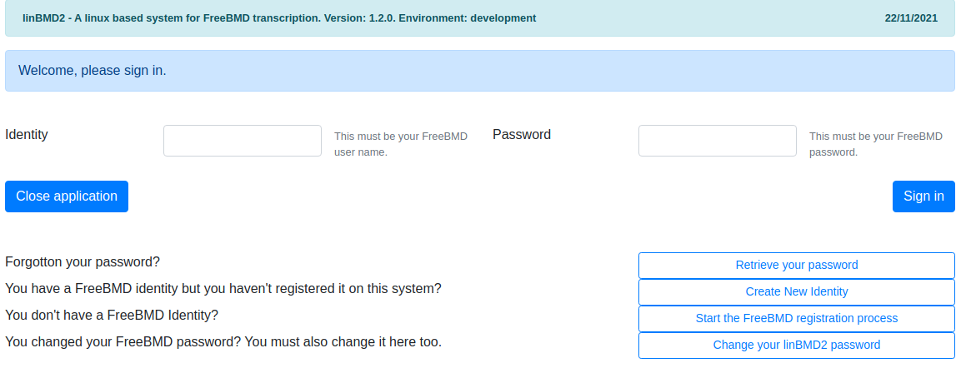
Click on the Create New Identity button.

2) Create New Identity
Create your webBMD identity. All of the fields must be entered. You can find full instructions for this action in the “Create New Identity Dialogue” chapter in this manual.
Once you have created your identity you will be presented with the sign-in screen again. Enter your user name and password.
You will be presented with the header screen which is used to select a header (scan) to work with. On first time use, the list of headers will be empty! Totally normal.
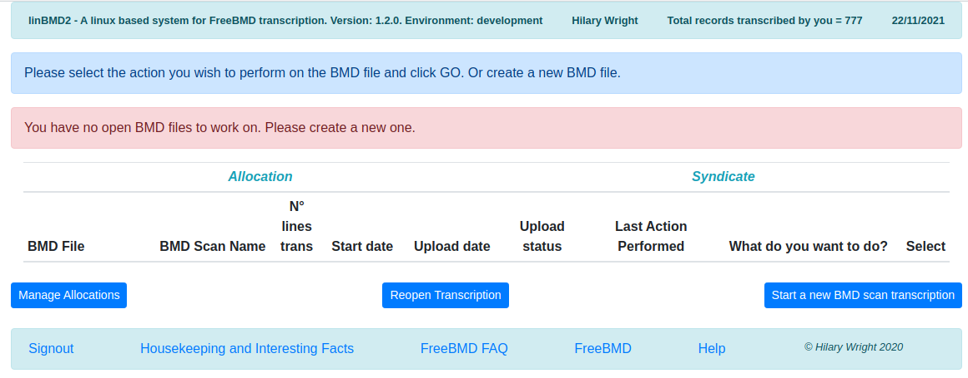
Click on the “Manage Allocations” button.

3) Create Allocation
Click on the “Create a New Allocation” button,

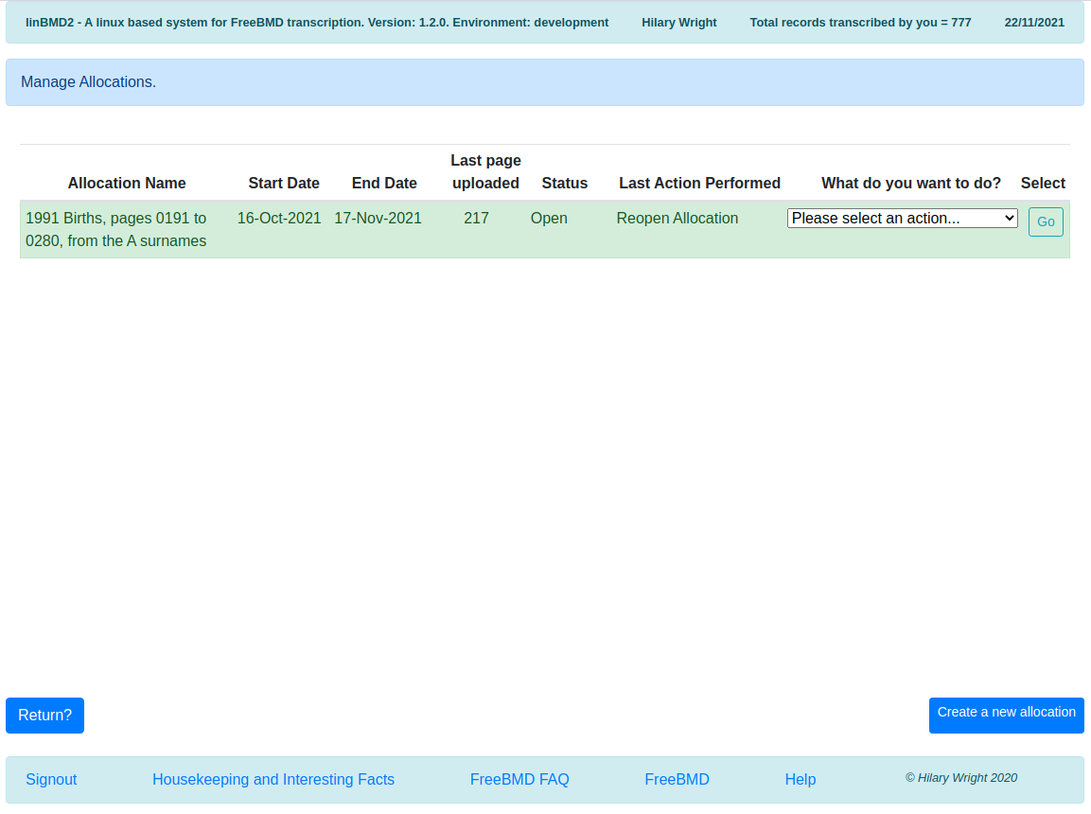
You will be shown the create allocation screen,
On first time use this list will be empty
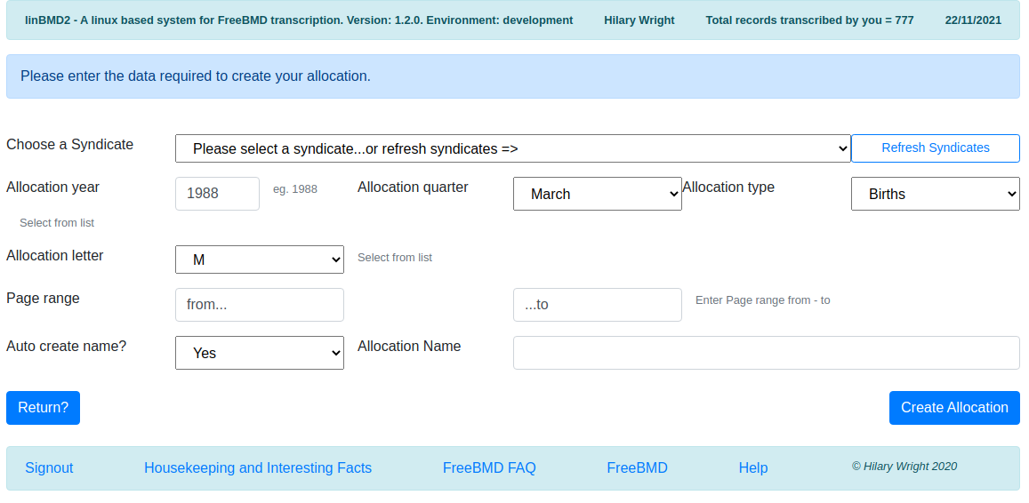
Follow the instructions in the “Create New Allocation” chapter to create your first allocation.
Once your allocation is created you will be returned to the header screen which will still be empty because you need to create your first header.

4) Create Header
You will see this screen. Click the “Start a new BMD scan Transcription” button.
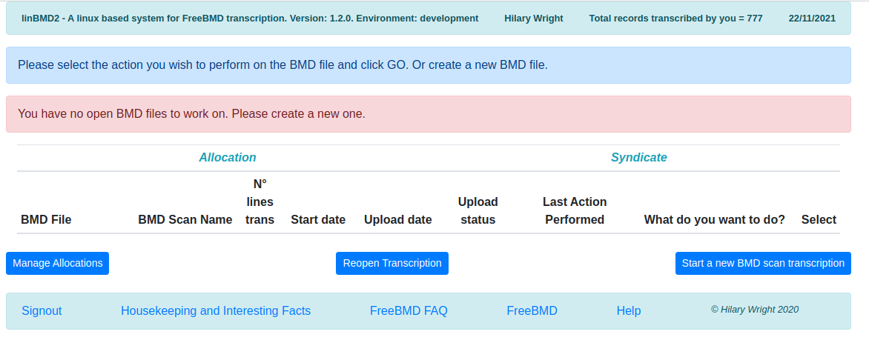
You will be shown the following screen,
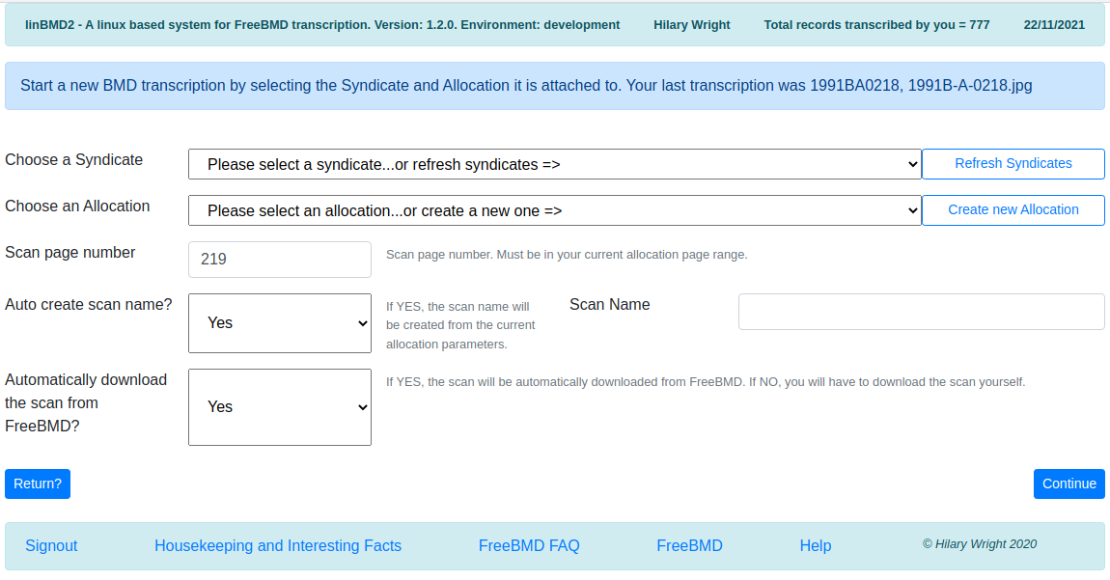
See the “Create a new Transcription Header” chapter for instructions to help you to fill in this screen.
Once you have entered the required data you will be returned to the list of headers screen. You will see a screen with your first header shown.

4) Select header and action
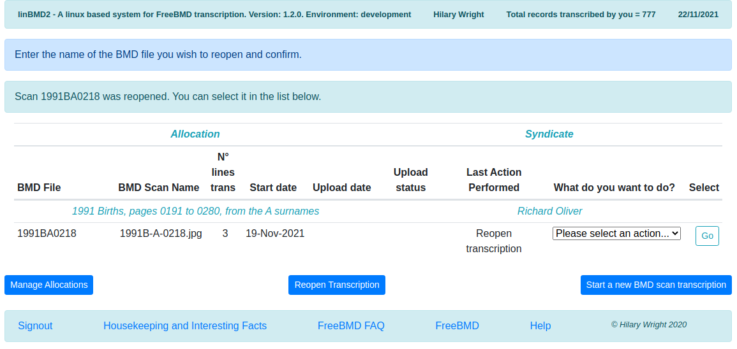
Select what you want to do from the drop down list and then press go.

5) Happy Transcribing!
Help for transcribing can be found in the chapter “Transcribe from Scan”.

Architecture of webBMD
webBMD is designed around the concept of a scan “header”. See the diagram below,
Header
Allocation
User
Syndicate
Scans
Detail transcription records
Upload to FreeBMD

A user is you. webBMD asks you to register your name, email, FreeBMD user name and password. This is essential information required to interact with the FreeBMD system.
A syndicate is the syndicate you belong to. You can belong to more than one syndicate at the same time.
The allocation is the list of scans that have been allocated to use to transcribe by your syndicate leader. It will be something like, “1988 Births, pages 301 to 392, from the L surnames”. You can have multiple active allocations at any one time.
The header is created for each scan you start transcribing. It contains information about the scan, how many records you have transcribed so far from the scan; whether the transcribed data has been uploaded to FreeBMD and if so what was the upload status. You can have multiple headers open at any one time.
The detail line by line transcriptions are held in the detail transcription database by header, by allocation, by syndicate, by user.
The detail lines are used to upload the transcribed data by header to the FreeBMD server.
Once a header has been successfully uploaded to the FreeBMD server you can close it.
Once you have transcribed all scans in an allocation you can close the allocation and request a new one from your syndicate leader.

Detailed Help
Each of the webBMD dialogues has a header, a message area, a body and a footer.

Dialogue Header
The dialogue header looks like this,
Total records transcribed
webBMD title
Your name
Today’s date

Dialogue Footer
The dialogue footer looks like this,
Click to return to sign-in dialog
Go to FreeBMD

Go to housekeeping menu
Copyright
Help

Sign-out
The sign-out button takes you back to the sign-in screen. On the way it forgets all the information
you have provided for this session including your identity. Don’t worry the data you transcribed in the session is saved. In order to continue using webBMD sign-in again.

The system performs a backup of the database and stores it here.

To exit completely either press the X = close browser window or press the “Close Application” button and then ATL+F4.

Housekeeping and Interesting Facts
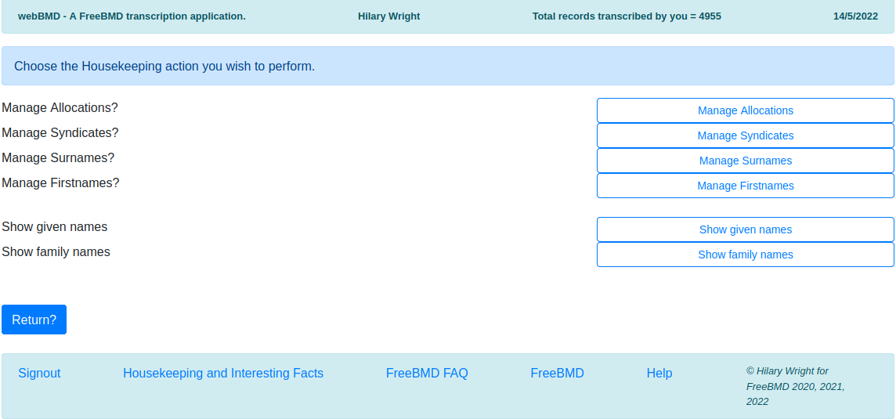
This screen allows you to perform various housekeeping activities and look at some interesting facts.

Manage Allocations
Press this button to manage allocations – see below for a description of this functionality.

Manage Syndicates
Press this button to manage syndicates – see below for a description of this functionality.

Manage Surnames, Manage Firstnames
As you key names into the system, webBMD adds them to a database of names that it uses to provide you with hints as you type names. If you want to correct the spelling of a name or delete the name, you can do so by selecting this option.
You will see this screen (screenshot is for the surnames but the firstnames is the same),
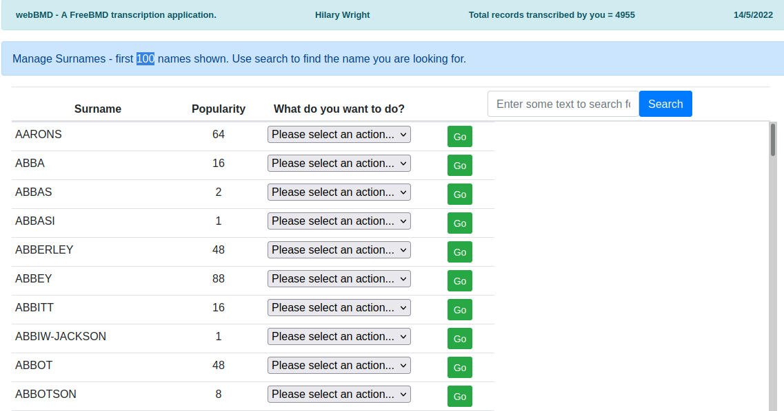
Find the entry that you want to change / delete by using the search field. Pick the option from the drop-down menu and select the action you want.

Interesting facts

Show given names
This button will show you a list of forenames that you have keyed in popularity order, ie,
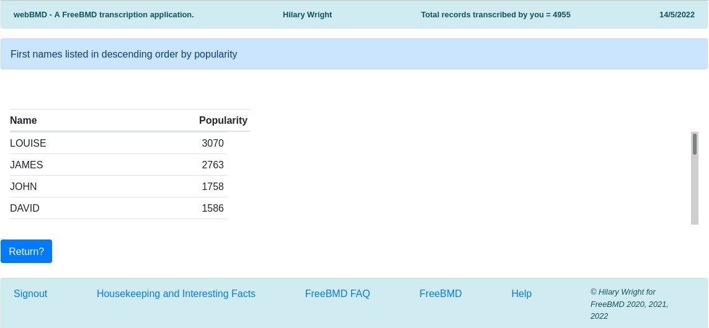
Use the scrollbar to reveal other names.

Show family names
This button will show you a list of family names that you have keyed in popularity order. The screen looks the same as above

Dialogue message area
The dialogue message area has two parts, the dialogue purpose and any error messages, It looks like this,
Dialogue purpose and brief instructions

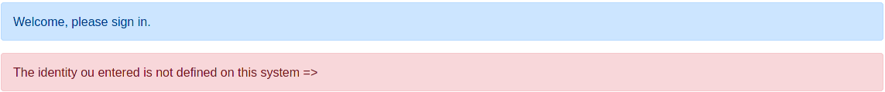
Error messages, these can be very detailed

The Sign-on screen
When you start the system you will be asked to sign-on. You need to enter you FreeBMD user name and password.
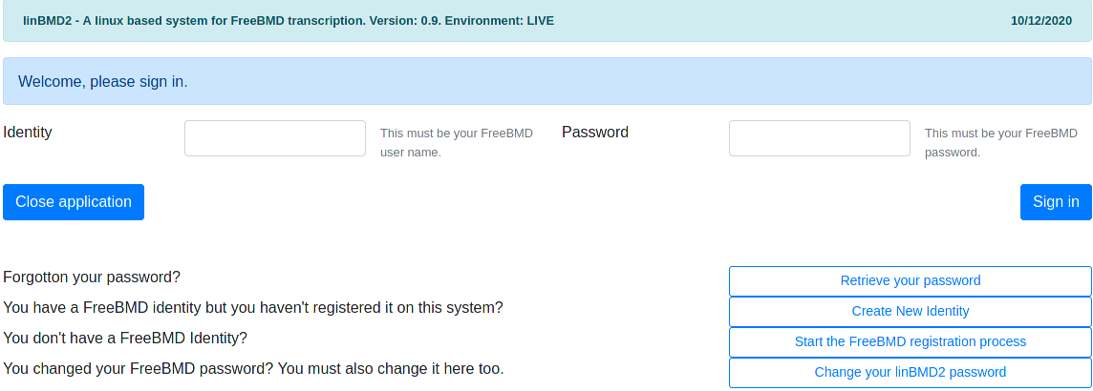
Identity = your FreeBMD user name
Password = your FreeBMD password
Press “Sign in” to complete the sign in process.
If you have forgotten your password, press the “Retrieve your password” button. You will be shown a dialogue asking you to enter your FreeBMD identity and your email. The email will be checked against the email held against the identity you created using the “Create New Identity” option. If the email entered is valid, you will be sent an email message with your password.
If this is the first time you use the system, you will need to register your identity. Do this by pressing the “Create New Identity” button.
If you changed your FreeBMD password on the FreeBMD site, you need to change it here too. To do that press the “Change your webBMD password” button.

General Announcements
As of version 1.3.0, webBMD is able to provide you with general announcements from the administrators. The administrator sets up the announcement text and for how long it will be displayed. If the announcement text exists and it is within the announcement period, webBMD will show the announcement on the sign-in screen. The announcement is for information only.

Create New Identity Dialogue

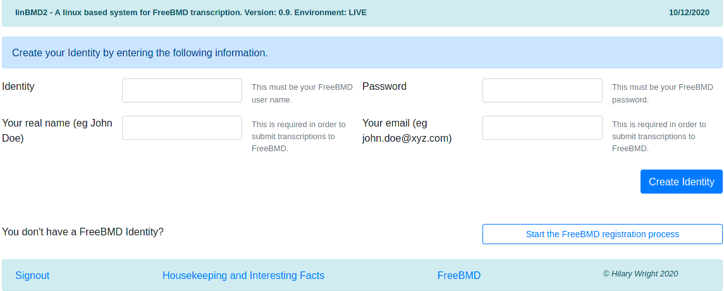
Enter your FreeBMD identity and password. These will be validated against the identity held on the FreeBMD server.
Enter your real name. This will be shown in the header and will be used to upload transcribed data to FreeBMD.
Enter your email. This is required for uploading to FreeBMD and for recovering your password.
If you don’t yet have a FreeBMD identity, press the “Start the FreeBMD registration process” button. You will be taken to the FreeBMD web site. You can also start this process from the sign on screen.

Change your password
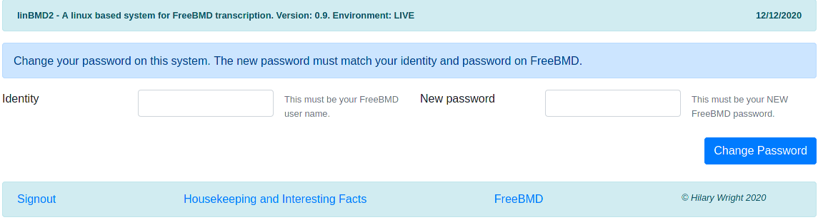
If you changed your FreeBMD password, you MUST change it in webBMD too. If you don’t you will not be able to sign-in to webBMD.

Select Header to work on
When you have successfully signed in you will be asked to select a header to work on. If this is your first use of the system you will need to create an allocation first in order to attach your new header new header to it.
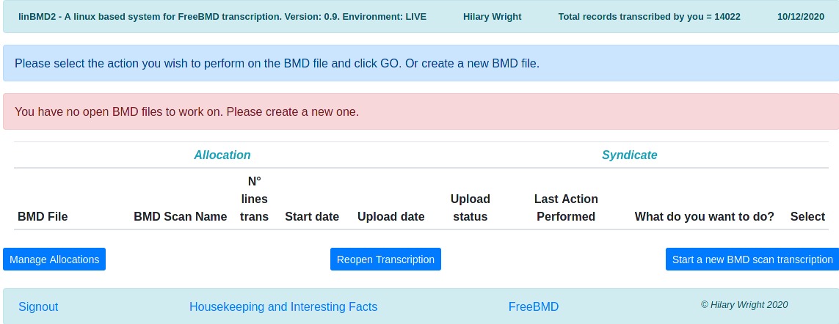
Click the “Start a new BMD scan transcription” button to create a new Header. You will also use this button to create a header for the next scan in your allocation.
Once you have created a header, you will see the following screen,
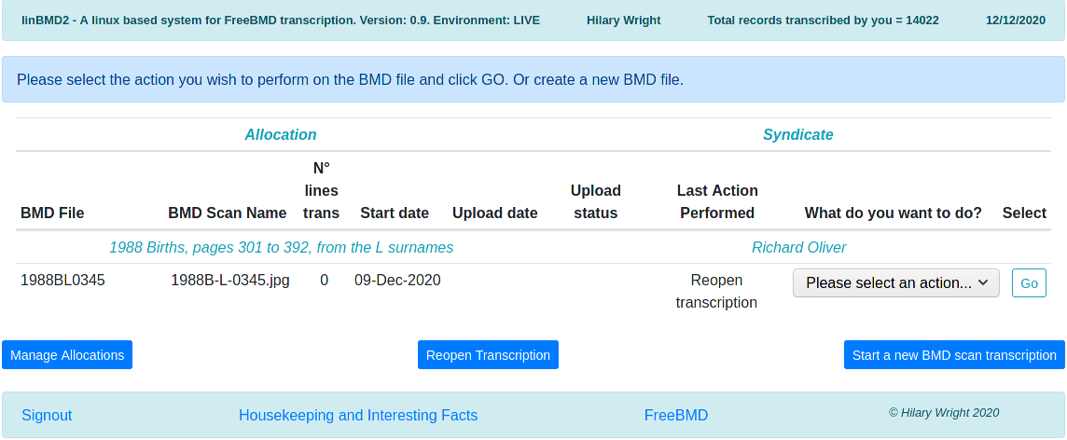
In light blue you will see the allocation and the syndicate that this header is attached to.
On the header line you will see,
- the header name (BMD file). This is built from information taken from the allocation with the page number you selected when you created the header. In the example above,
  - 1988 is the year
  - B = births
  - L = letter
  - 0345 = page number
- the name of the scan that you are transcribing.
- the number of records you have transcribed so far from this scan
- the date when you started this scan
- the upload date and upload status are filled in once you have uploaded the transcribed data to FreeBMD. The upload status and details are provided by FreeBMD when you initiate the upload from the “What do you want to do?” drop-down menu. The upload status can have several codes,
  - OK – the data was uploaded to FreeBMD successfully with no errors
  - failed – the data upload failed for some reason. You can see the reason by selecting the “See upload status details” in the “What do you want to do?” drop-down menu.
  - warnings – the file was uploaded to FreeBMD successfully but there were warnings. You can see the reason by selecting the “See upload status details” in the “What do you want to do?” drop-down menu.
- The last action performed shows you the last action you selected from the “What do you want to do?” drop-down menu. Use this as a memory jogger to help you remember where you are in the transcription process.
- “What do you want to do?” is a drop-down menu where you select the action you want to perform related to this header. To use the menu select the action from the drop-down and press the “GO” button. The following actions are available,
  - Transcribe from scan = start or continue transcribing the scan attached to this header.
  - Verify Transcription = once you have completed transcribing a scan, it is a good idea to verify what you have typed before uploading it.
  - Create BMD file only; no upload = webBMD will create the .BMD file and store it in ~/.local/share/applications/webBMD/public/BMD_files
  - Show raw BMD file = shows you the raw .BMD file contents. You cannot change them.
  - Send BMD file to syndicate leader = Some Syndicate Leaders require their transcribers to send the .BMD to them for prior approval before upload to FreeBMD. This option sends an email to the syndicate leader for this transcription asking for approval to upload to FreeBMD and asking for a new scan to transcribe. In order to use this option you must have already created the BMD file using, Create BMD file only; no upload
  - Upload BMD file = upload your transcribed data to FreeBMD. This can take a few seconds depending on the speed of your internet connection.
  - See upload status details = described above
  - Close transcription = once you are satisfied that the transcribed data has been uploaded successfully you can close the header. If you do so, you will no longer see the transcription in the “Select header to work on” screen. If you need to reopen the header you can do so by selecting the “Reopen Transcription” button. You will be asked to enter the header file name and to confirm the reopen. Once reopened the header will be shown again and you can select the action you want to perform on it. You can make changes to the transcription records and re-upload the data. If you re-upload and the upload is successful, the system will tell you that the file was replaced on the FreeBMD server.
- You manage allocations by clicking on the “Manage Allocations” button.
- You create a new header by clicking the “Start a new BMD transcription” button.

Create a new Transcription Header
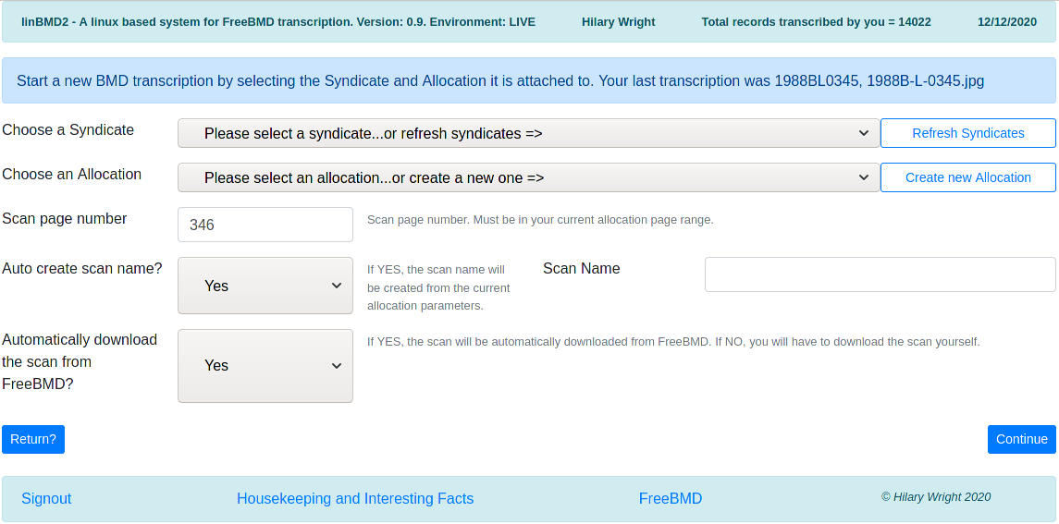
You cannot start transcribing a scan without creating the header first.
You will notice that the system tells you the last header which you successfully uploaded to FreeBMD and its scan name, if any.
First choose the syndicate that you are working for by clicking on the drop-down arrow on the right-hand side of the field. You can enter the first few letters of the syndicate in order to position the list. Syndicate names are downloaded from FreeBMD and stored locally for faster access. You can refresh the list of syndicates by selecting the “Refresh Syndicates” button. You cannot create a syndicate; to use one it must first exist in FreeBMD. Remember that you can be working for more than one syndicate at a time.
Now choose the Allocation this header is attached to. If you are starting a new allocation received from your syndicate leader, you will need to create it first. Press the “Create new Allocation” button to do this.
Enter the page number of the header you are starting.
Generally you should leave the “Auto create scan name” and “Automatically download the scan from FreeBMD” alone. If you know that your scan name is in some way particular, you can enter it manually. In this case you should manually download the scan.
Once the required information is entered webBMD will create the header. It will verify that the scan is in the syndicate scope.
When you have successfully created an allocation you will be returned to the “Select Header to Work on” screen.

Create New Allocation
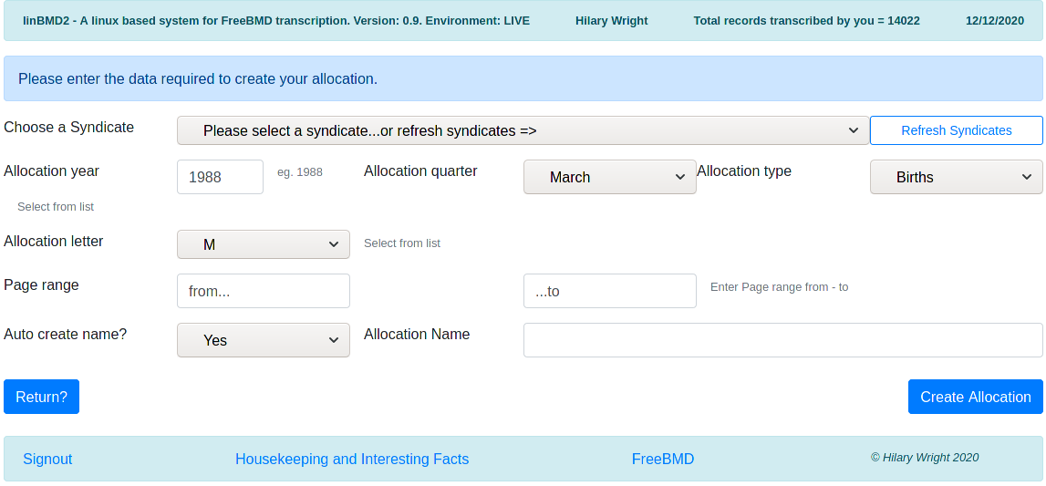
Just as every header must be attached to an allocation, every allocation must be attached to a syndicate, so choose the syndicate from the drop down list. You can also refresh the syndicates from here by pressing the “Refresh Syndicates” button.
Enter the year the allocation is from and the quarter.
Allocations are year based or quarter based (if in doubt ask your syndicate leader). Scans belonging to a year based allocation are all held by the year on FreeBMD. If your allocation is year based, choose December from the drop-down for the Allocation Quarter. Those that are quarter based are held by quarter on the FreeBMD server so choose the appropriate quarter from the drop-down.
Allocation types are Births, Deaths, Marriages. Select the one that applies.
Select the letter. Sometimes this can be, for example, AB. More often just a single letter.
The allocation page range.
The system can automatically create the allocation name. Generally you should let the system generate the name, but if for any reason you wish to create it yourself, just enter the name you want in the designated field.
Once the required data is entered the system will make sure that the allocation is in the scope of the syndicate and will identify the path to the scans on the FreeBMD server. If webBMD finds an ambiguity it will ask you to clarify from some choices. This can occur several times as webBMD navigates FreeBMD to the path for the scans for this allocation.
When the allocation has been created you will be returned to the Create Header dialogue.

Manage Allocations
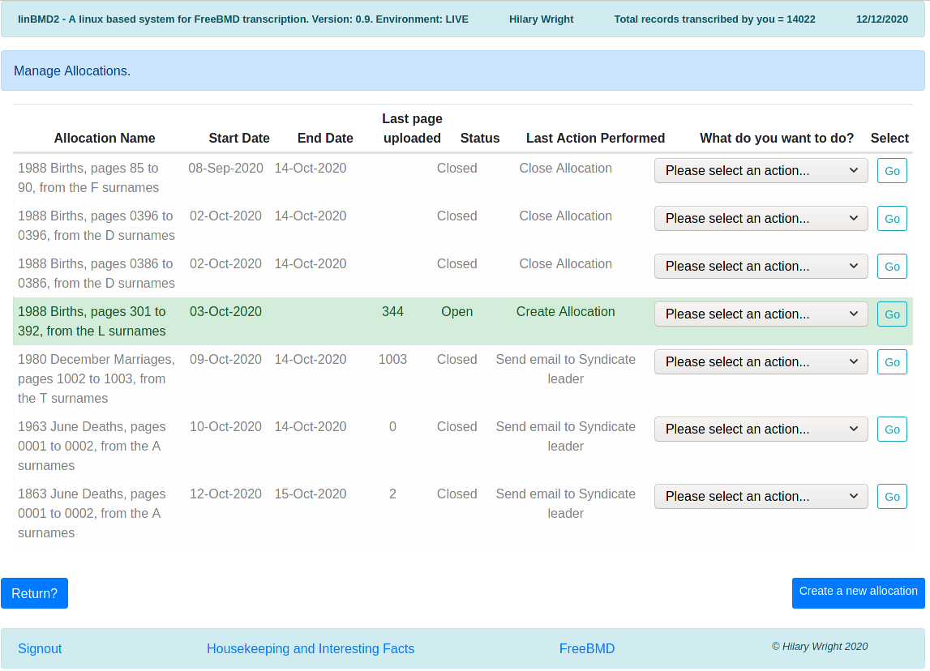
The Manage Allocations screen allows you see all the Allocations that you have created. You are shown,
- the Allocation name
- the date on which the Allocation was created
- its end date if you have closed the allocation
- the number of the last page (=header) you uploaded
- the status of the Allocation, Open or Closed
- the last action performed
- the “What do you want to do” menu and its “GO” button.
The “What do you want to do?” menu contains the following options,
- Close the Allocation – the Allocation will be closed. Consequence is that you will no longer be able to select it when creating a new header
- Re-open the Allocation – in case you closed it by mistake
- Send email to syndicate leader – this sends an email to the leader of the syndicate to which this allocation is attached informing him that the Allocation has been finished and asking him to send you a new one. This is a standard email; you are sent a copy of it to the email you entered on your identity record.

Manage Syndicates
This function is available from the Housekeeping menu and from the Select Header to Work On screen.
Syndicates cannot be created, changed or deleted in webBMD. They are managed exclusively from FreeBMD. But syndicates need to be available to webBMD because Allocations are attached to a Syndicate and Headers are attached to Allocations.
When webBMD is installed a database of the current FreeBMD syndicates is provided with the installer.
Syndicates occasionally change (very rarely), so webBMD provides a refresh syndicates option from the Create Allocation screen. Taking this option will update the database of syndicates held by webBMD.
There is, however, one instance where webBMD needs to store some extra information against a syndicate.
When webBMD creates a BMD file for upload to FreeBMD after you have finished transcribing a scan, it creates some header statements at the beginning of the file. These statements are used by FreeBMD to validate the data in the BMD file and by WinBMD if the BMD file is opened subsequently by WinBMD.
One of these statements is optional and is called the “Credit” statement. This statement credits the transcriber as the originator of the BMD file.
Some syndicate leaders do not want their transcribers to include this statement, while others do. Hence it is optional. Ask your syndicate leader for his preference.
In order to tell linBMD whether to include the this statement or not, you need use the Manage Syndicates function.
Here is a screen-shot,

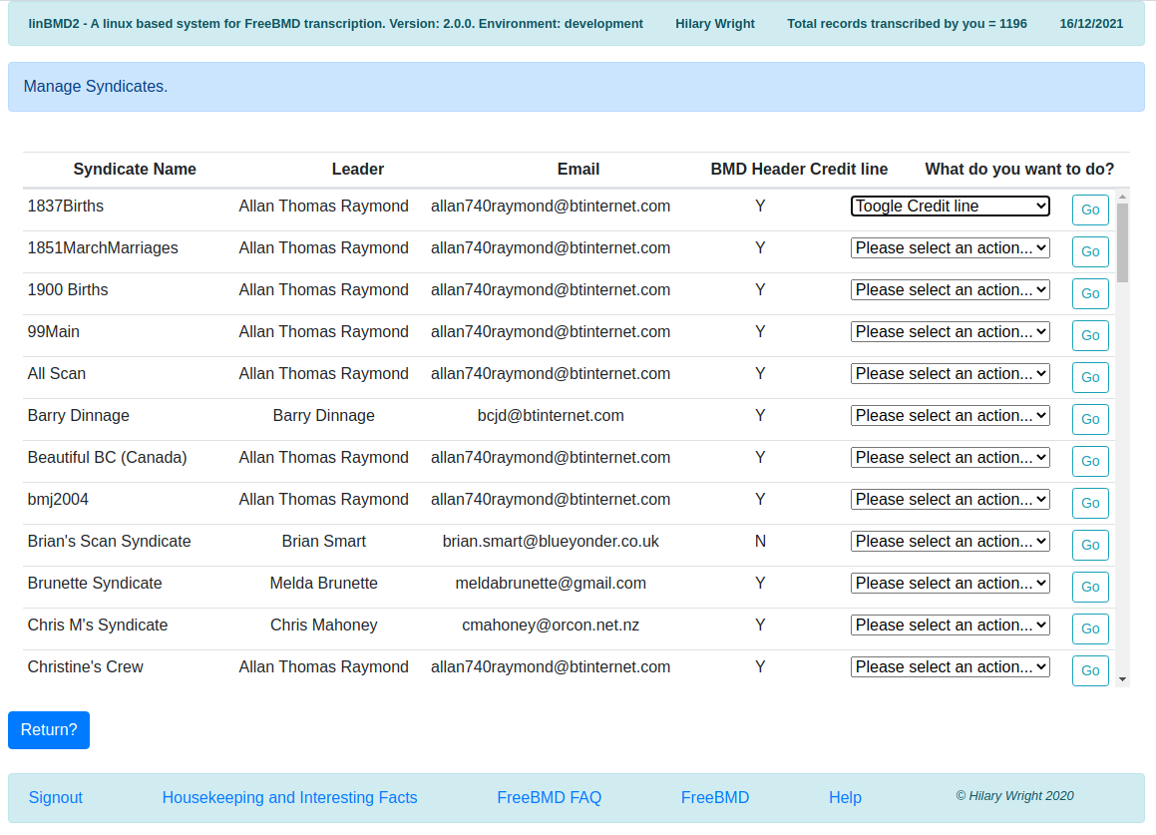
Scroll the list to find additional syndicates.
To stop the “credit” statement from being added to the BMD header Toogle Credit line and press Go. If the credit line is ‘Y’, it will be changed to ‘N’ and vice versa. The default for webBMD is ‘Y’.
Refreshing the syndicates will not affect the credit line switch.

Transcribe from Scan
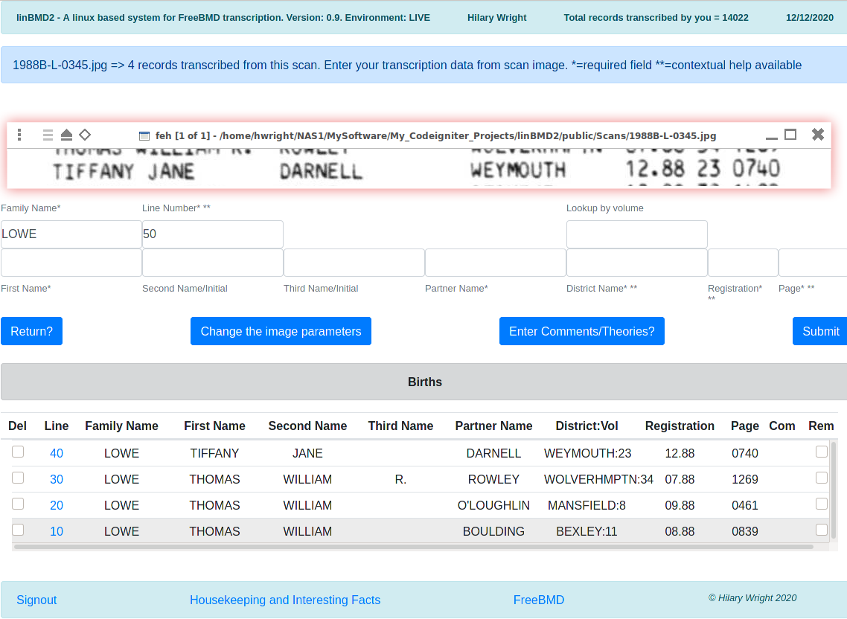
The scan image
Data entry
Transcribing History
Action Buttons
When you select the “Transcribe from Scan” option against the header the screen above is shown.
webBMD tells you the scan you are transcribing from and the number of records you have transcribed.
There is a lot going on here but essentially there are three sections.

The scan image
The scan is shown using the FEH image viewer in an entirely independent window. It is shown as 'always on top'. If for any reason it isn't, right click on the image title bar and select the 'always on top' option.
When the image is shown for the first time, you will need to move the image in the window to the beginning of the scan by dragging the image with the cursor.
webBMD has defaults for the size of the window and the zoom factor. If these do not suit your image you can change them.
You can move, resize the image as you wish by selecting the window edges and pulling as required or you can use the “Change the Image Parameters” button. This is useful if you want to change the zoom factor and to make the changes 'permanent' for this image. The system will remember the image parameters you enter and will always apply them to this scan even if you close and reopen the application.
The idea is to adjust the parameters to show one line at a time from the scan in the window. This means that webBMD will automatically advance to the next line of the scan when you have transcribed the current line.

Change the image parameters
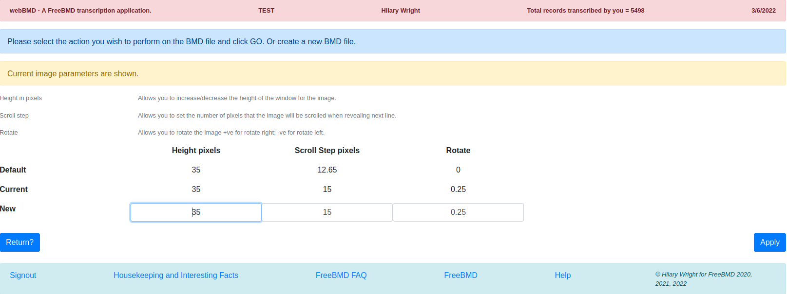
You can change,
- the height of the image window – for most scans a height of 35 pixels is good.
- the scroll step – this is used for two purposes, the scroll step depends on the scan, but start with something around 15 pixels and adjust as required. If you get this right, you should never have to manually move the scan in the window by dragging it with the mouse. You will save a great deal of time by getting this set correctly.
  - when you submit a line and all validations pass the image is advanced by this amount automatically in order to position the image to the next line
  - when you manually scroll the image using the page up or page down keyboard hot keys
- rotate the image – sometimes the image is slightly skewed. To rotate right, use +r°, left, use -r°. Start off with something like 0.25 or -0.25. The idea here is to get the image horizontal in the image window so that the scroll step positions the image correctly. Again, get this right to save a lot of time.

The Data Entry
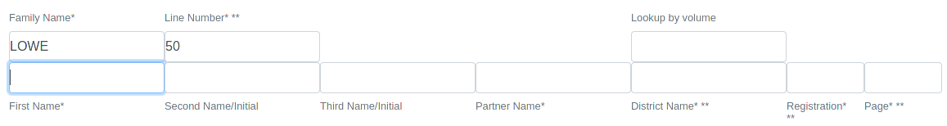
The data entry section will change depending on which type of scan you are transcribing; Births, Deaths, Marriages. The principles of keying the data are the same as described below.
Deaths will include a registration field in the data entry. If you have a deaths scan without the registration field, just leave it blank.
The Family Name is empty when you first start transcribing a scan but it defaults to the last name entered as you start entering data. The line number is supplied automatically by webBMD and increases in steps of 10. More about the line number later.
As you select the next line in the image, remember to place the cursor in the first name field to start typing.
As you type data in all fields except the Registration and Page fields, a drop-down list of suggestions will be shown after you have typed at least two letters. As you type more letters the suggestions are narrowed down. Suggestions in all fields except the District Name are shown in most popular order. webBMD keeps a database of forenames and surnames with the number of times they have been seen. You can see the most popular names by using the “Housekeeping and Interesting facts” button. The District Name suggestions are shown in alphabetical order.
To select a suggestion move the cursor to it by using either the arrow down key or by selecting it with the mouse and pressing either enter or tab. Selecting with enter, puts the suggestion into the field and leaves the cursor in the field; selecting by tab puts the selection into the field and moves the cursor to the next field.
You can repeat the last name keyed in the First and Second name fields by positioning the cursor in the field and pressing the Insert key.
You can repeat the whole line except the page field by pressing the Home key.
You can copy the existing family name to the partner name field by pressing PageUp key.
Sometimes it is useful to search for the district using its number. This is especially useful when transcribing hand written records. You will see a field above the District Name field to allow you to do this.
For the registration field you can either enter the month and year manually, ie 12.88, or type just the month number. The system will add the year automatically using the Allocation year.
The page number is checked to see if it matches the length of the number for the type of record being transcribed. Thus, for births, webBMD checks that the entry is 4 characters long. This means that you must key the leading 0 for three digit numbers. If you key an entry that is not 4 characters long, webBMD will ask you for confirmation before accepting the record. Here is the screen you will see in this case,
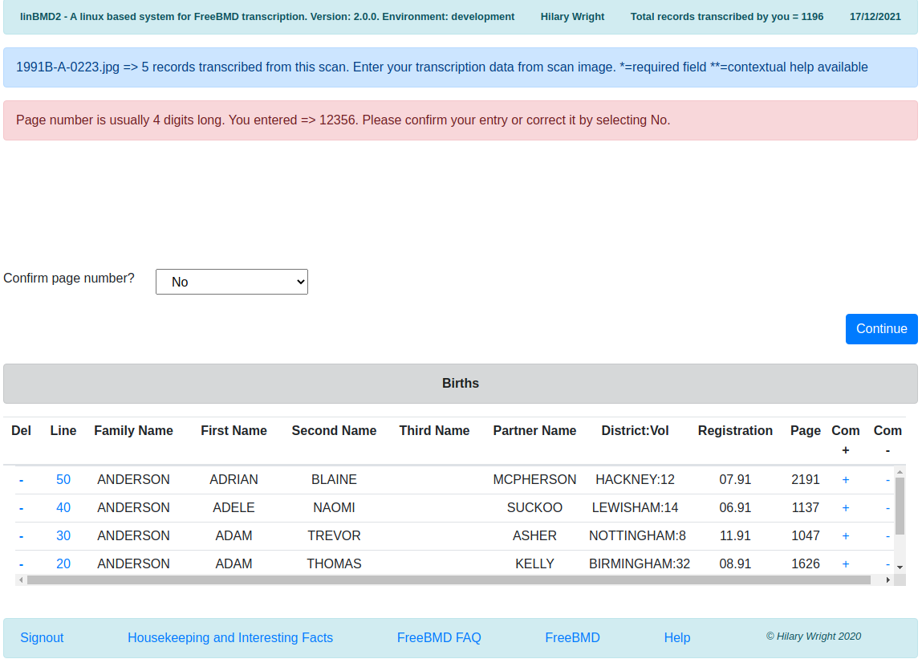
In the pink message field, you will see what you keyed.
If it is wrong, just press “Continue” button and you will return to the data entry screen to allow you to change the entry.
If is correct, you confirm the entry by selecting “Yes” in the drop-down and pressing “Continue” button and the record will be added to the history list.
The district you enter is checked against known districts in order to find its volume for the month and year you entered for the registration. If found you will see the district and its volume like this, MANSFIELD:8 in the history list.
The volume may not be found for the district you entered for two reasons,
- the district is not at all found in the database.
- The district is found in the database but there is no volume for the month/year you entered.
In either case you will be shown the following screen,
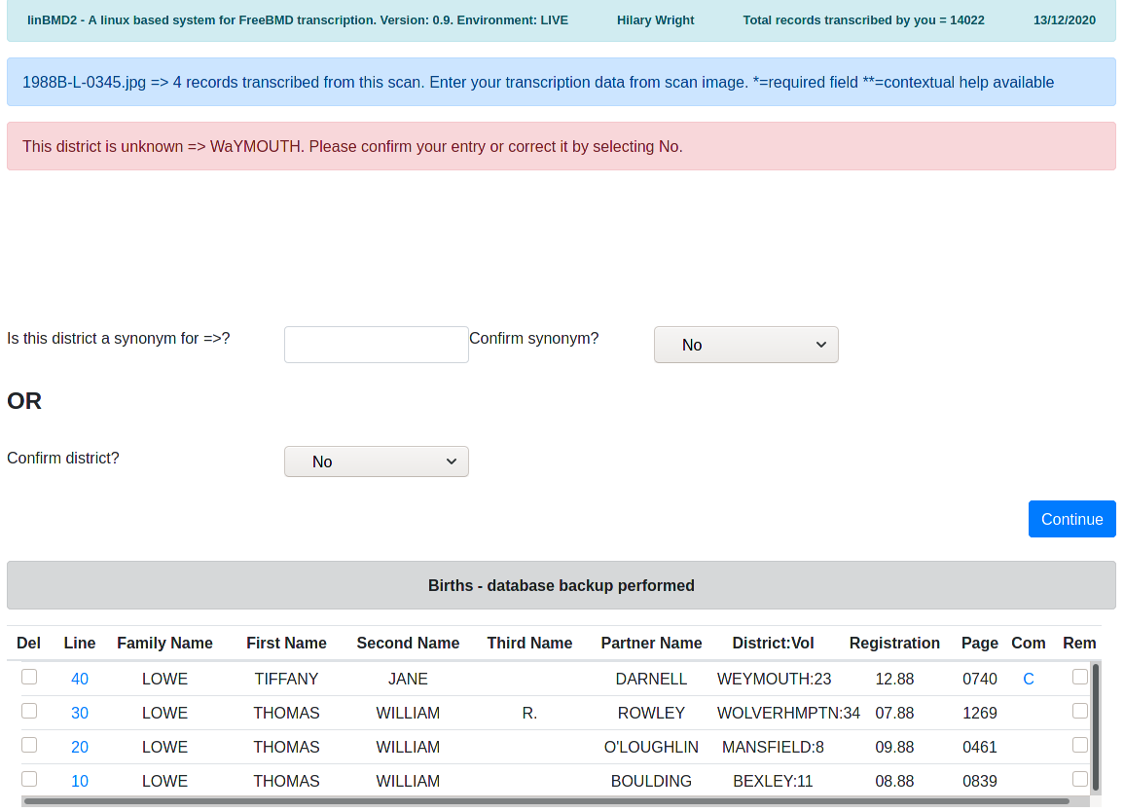
The error message shows what you keyed into the district field.
If it not correct as per the scan, you can correct it by just pressing the “Continue” button. Now you can change it in the data entry screen.
If it is correct as per the scan, it is most probably a 'synonym' for an existing district. If that is the case try to find the synonym by searching the database for the real district name. In the case above imagine that “WAYMOUTH” is a synonym for “WEYMOUTH”. You would enter “wey” into the search field, select the district, confirm the action by selecting “Yes” in the confirm synonym drop-down and pressing the “Continue” button. webBMD will add “WAYMOUTH” to the database by cloning the records for “WEYMOUTH” so that, in future, “WAYMOUTH” would be considered correct. You have to be a bit imaginative to find the correct district, especially if you have, for example, “ST HELENS” on the scan. The district might be “ST.HELENS”, “ST. HELENS”, “HELSNS ST” etc. in the database. Try your hardest to find the district in the database. If you can, it will save you lots of time in the future.
If you really can't find a district for the entry on the scan (you did try, didn't you?) then you can confirm the entry by changing the 'Confirm district' drop-down to “Yes” and pressing the “Continue” button. webBMD will show you the following screen,
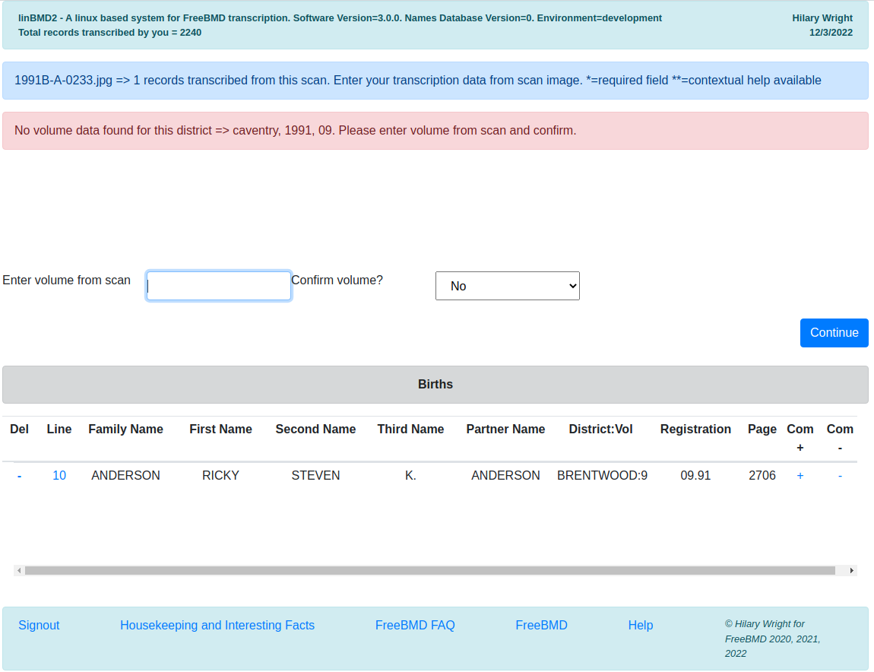
You will see that the message in pink shows you the district, year and month, check these, make sure they are what you entered from the scan.
If everything is correct, enter the volume number from the scan, confirm it and press the “Continue” button. webBMD will add this volume to the districts database.
When you have completed transcribing a line, either press enter or click the “Submit” button.
The transcription history will be updated with the line you just entered.

Action Buttons
Return? = return to the previous screen.
Change the image parameters = as discussed above.
Enter Comments/Theories = enter comments or theories against the last line transcribed. Here is the screen that is shown,
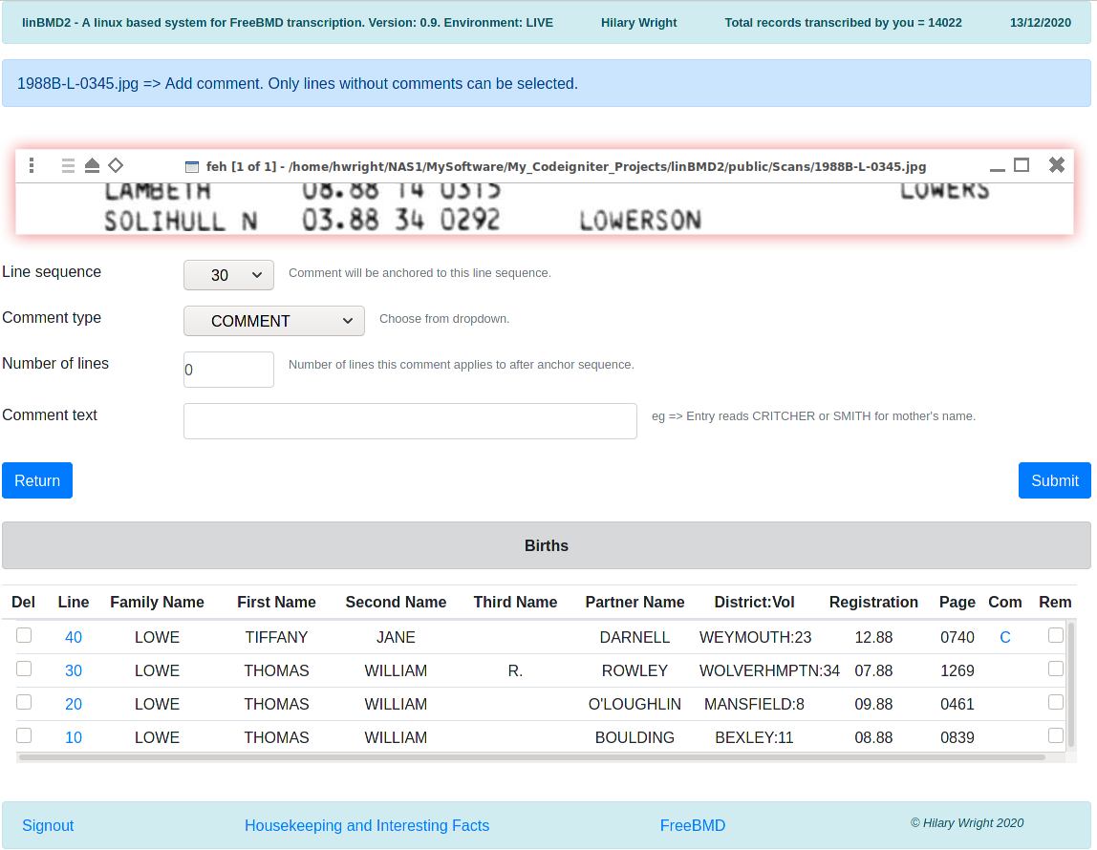
Line sequence = the line that these comments/theories will be attached to.
The comment type = COMMENT, THEORY or remark. Use the drop-down to select which one. See FreeBMD site for when to use COMMENT or THEORY. See here, https://www.freebmd.org.uk/comments-help.html
Number of lines = the number of lines, including this one, the comment refers to. So, for example if the COMMENT refers to mother's maiden name, JONE or BLACK you would enter 2 here.
Comment text = the text of the comment or the theory, ie Entry reads CRITCHER or SMITH for mother's name.
Press “Submit” button to continue.

Transcribing History
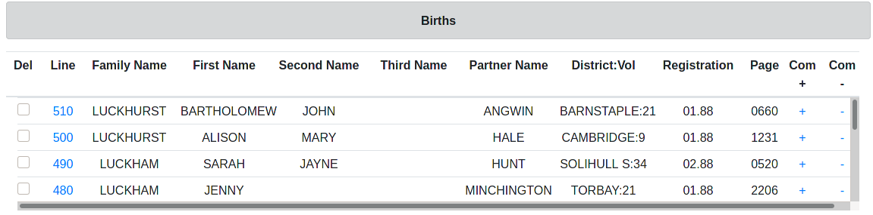
This section shows the history of the records you have transcribed so far from the scan. The title changes depending on what type of records you are transcribing. webBMD performs a backup on every fifth record transcribed and when it does, the title changes to indicate that backup has been performed.
As you confirm a line transcription it is added to the history as the first record in the list, ie the list is shown in descending line sequence order. Each line is given a line sequence number.
The data shown for the line is self explanatory, however you can affect the line data by clicking or selecting different options,
Del – select the line you want to delete by clicking on the delete box against the line. This will delete the line for the transcription. Lines are not resequenced so this will create a 'gap' in the sequence.
Line – click on the line to change it. Data from the line will be shown in the Data entry screen.
Com + – if no comments exist against a line a “+” will be shown here. Click it to add comments. If you have already entered comments against this line a “C” will be shown here against the line. If you entered a theory, a “T” will be shown here. If you entered a simple comment line, a “*” will be shown. If you click on the “C”, “T” or “*” you can change the comments.
Com - – click here to remove any comments/remarks you made against this line.

The Line Sequence Number
The line sequence number is used by webBMD to sequence the lines transcribed. It is not at all used by FreeBMD and is not uploaded to FreeBMD when you upload the records from a scan. It increases in steps of 10.
If you realise that you made a transcription error on a line, you can correct it by clicking on the line number. The line data keyed will be shown in the Data Entry screen allowing you to change the data. All data entry checks will be made again.
If you inadvertently missed a line on the scan you can add it by changing the the line sequence in the Data Entry screen to something like “35” if you want to insert the line between the line 30 and 40.

Transcribing tips

- Take your time!
- Check your entries as you type.
- Use webBMD's auto-complete.
- Key at least 3 or 4 characters in order to narrow down the auto-complete. Sometimes you'll have to type more.
- Think of the auto-complete as a “dictionary” to validate your entry.
- If the entry you are typing is not found by the auto-complete it's probably not correct. Check it!
- A good way to check an entry is to split it into 3 character sections in your mind and compare with the scan.
- Take particular care when keying and checking the page number.
- Be careful of names such as Philip and Phillip or Antony and Anthony.

Requirements
This manual assumes that you have knowledge about installing, maintaining and modifying your Linux system: that you are familiar with using the terminal and have knowledge of bash commands. However the installation instructions are detailed and you just need to follow them.
To use this programme you will need the following on your linux system,
- a linux system, eg. Debian, Fedora, Ubuntu
- a database system, eg MariaDB. Mariadb is a drop in replacement for mysql. Since this is the case it uses many mysql statements.
- an active internet connection in order to start your transcribing with webBMD.
  - You need to be online to,
    - create your user identity
    - create allocations
    - create transcription page headers
    - upload finished pages to FreeBMD
  - You do not need to be online to transcribe pages from the scans, so if you go on holiday and won't have internet, make sure that you have created all the transcription page headers that you will need before you go.
- FEH, an image viewer
- A web browser
- wmctrl, a window management system
- evince – a PDF file viewer
- knowledge of the root password for your MySql or MariaDB system if you have already installed a database system.
- the webBMD software package
If you don’t already have these requirements installed you can find many tutorials on the web to help you install them for your distribution.
You should find MariaDB, FEH, midori, winctrl and evince in your distribution repository.
webBMD software is available from the FreeBMD.org.uk site.
See Installation chapter for step by step installation instructions.

Installation

Using the automatic installation programme.

Download the install programme from FreeBMD
Make it executable
Run it as sudo or su.
Follow the on-screen prompts.
It performs the manual installation, as described below, but in an automated way and is much faster than a manual install.

Using the manual install process.

Depending on your linux distribution, you will probably be using one of two package installation systems, “apt” for debian based distributions, or “dnf” for fedora based distributions. These instructions use “apt” in examples to keep things easy to understand. If you use “dnf” you can replace “apt” with “dnf”.
You will be using the terminal to enter system commands. You should find your terminal in your menu, usually under “System tools”. Commands are shown in italics.
You must be connected to the internet while installing webBMD.
Installation is simple. Follow these steps in the order given.
- install your Linux system if you don't already have one installed. You can install any distribution that has access to the above requirements. Instructions for installing a Linux distribution are beyond the scope of this manual.
- make sure your user has sudo privileges. If you already have sudo privileges skip this step. Sudo is the linux command used to allow you to temporarily adopt superuser privileges in order to perform sensitive operations that modify your system such as installing new software. In a Debian system, this can be done by running,
  - open a terminal
    - su
    - enter your “root” password
    - give sudo rights to your user name. Enter your user name in the command below.
      - usermod -aG sudo <your_username>
    - if you get message saying that the command usermod is not found, you need to add /usr/sbin to your PATH variable, here's how,
      - open a terminal
        - su
      - enter your system “root” password
        - export PATH=$PATH:/usr/sbin
      - the usermod mod command above again.
  - Close the terminal – this is important
  - Reboot your system
  - See here for a good guide to using visudo, https://www.unixtutorial.org/how-to-use-visudo/
- download the webBMD software from FreeBMD
  - TBD
  - unpack the software to this directory ~/webBMD.
- install webBMD dependencies,
  - open a terminal
    - sudo apt install midori feh wmctrl evince geany
  - enter your linux user password if prompted to do so
  - answer yes to any prompts.
- install the database server if you don't have it already installed.
  - Open a terminal
    - sudo apt install mariadb-server
  - enter your linux user password if prompted to do so
  - answer yes to any prompts but be sure to read what is printed in the terminal!
- make sure you secure your mariadb database server
  - Open a terminal
    - sudo mysql_secure_installation
  - enter your linux user password if prompted to do so
  - the first thing you will be asked to do is to enter your “root” password. If this is your first time install it will be blank, so just press enter.
  - The next prompt will ask you to enter your mariadb (mysql) “root” password. This should not be the same as your your system “root” password. If you are installing mariadb just for webBMD use, you can safely use “webBMD” as the password.
  - follow the instructions printed in the terminal to secure your mariadb installation by answering yes to all questions.
- Create the webBMD database and user,
  - sudo mysql -u root -p
  - enter your linux user password if prompted to do so
  - This tells mariadb to enter a shell using the root user and to ask you for the root password. Enter the password you created above
  - You should see a prompt like this,
    - MariaDB [(none)]>
  - create the webBMD database by entering after the prompt
    - CREATE DATABASE webBMD;
  - you should see a “Query OK ..” if the command worked.
  - create webBMD user webBMD with password webBMD by entering the following after the prompt. Just copy and paste. You MUST use webBMD for the user and the password.
    - GRANT ALL ON webBMD.* to 'webBMD'@'localhost' IDENTIFIED BY 'webBMD' WITH GRANT OPTION;
  - you should see a “Query OK ..” if the command worked.
  - apply the changes,
    - FLUSH PRIVILEGES;
  - you should see a “Query OK ..” if the command worked.
  - All done so exit the mariadb prompt
    - exit;
  - mariadb will say BYE.
- Check that everything worked by using your new user and password to go back into mariadb shell
  - mysql -u webBMD -p
  - enter your password = webBMD
  - if OK, you will see the mariadb prompt,
    - MariaDB [(none)]>
  - check that the webBMD database exists,
    - SHOW DATABASES;
  - you will be shown a list of databases that webBMD has access to. One of them should be the webBMD database.
  - All done so exit,
    - exit;
  - mariadb will say BYE.
- Load the webBMD initial data to the webBMD database. To do this you will import the initial data tables into the webBMD database.
  - Open a terminal
  - Import the data
    - mysql -u webBMD -p webBMD < ~/webBMD/public/Backups/webBMD.sql
    - enter your password = webBMD
    - this can take some time, so be patient!
    - You will see any error messages in the terminal screen.
- Check that the data was loaded to the database
  - mysql -u webBMD -p
  - enter your password = webBMD
  - if OK, you will see the mariadb prompt,
    - MariaDB [(none)]>
  - enter the command,
    - SHOW TABLES FROM webBMD;
    - You should see a list of tables in the database all prefixed with “webBMD_”. There are 14 in total.
  - Some of the tables are empty because they are waiting for you to start keying data. Others are preloaded in order to kick start your use of webBMD. Tables with pre-loaded data are
    - districts_master, firstnames, parameters, surnames, transcription_cycle, volume_ranges, volumes.
  - Tables, language_definition and language_english are not used at present.
- Check that data exists in one of the pre-loaded tables,
  - SELECT COUNT(*) FROM webBMD.webBMD_surnames;
  - you should see a table with the number of rows in the table. In this case over > 4700.
- All done so exit,
  - exit;
  - mariadb will say BYE.
- Install PHP and PHP modules
  - The webBMD software is written in PHP, a very popular client server software. To run it it needs the PHP engine to be install. PHP should be available in you linux system package repositories.
    - sudo apt install php
    - enter your linux user password if asked to do so.
  - Install PHP modules
    - sudo apt install php-common php-cli php-curl php-gd php-json php-mbstring php-mysql php-mysqlnd php-xml php-intl php-opcache php-pdo
    - enter your linux user password if asked to do so.
- Create a menu item in order to start the application
  - modify the delivered webBMD.desktop file to use your linux user name.
    - How to find your linux user name?
      - Open a terminal and run this command
        - printenv | grep USER
        - This command will print your user name to the terminal. Make a note of it.
    - Now modify the menu option to point to your linux user name
      - Open a terminal and run this command,
        - sudo geany ~/webBMD/webBMD.desktop
        - this will open the desktop file.
        - follow the instructions in the file.
  - copy the webBMD.desktop to the menu
    - create the folders required
      - mkdir -p ~/.local/share/applications/
      - cp ~/webBMD/webBMD.desktop ~/.local/share/applications
      - chmod 0777 ~/.local/share/applications/webBMD.desktop
      - chmod 0777 ~/webBMD/app/Controllers/webBMD.sh
  - the new entry will show in the “Other” menu group
  - select the menu item to launch the application. The first time it may take a while. Be patient.
- All done! Start transcribing.

