Cls

Rem program to find the average of the data set using arrays

Print "________________________________________________-"

Print "program : to find the average of a data set using array"

Print "________________________________________________"

Print date$; " and "; Time$

Print " prasoon mishra "

Print " 2131202 "

Print "________________________________________________"

Let S = 0

Let N = 0

Dim A(10)

For I = 1 To 5

Read A(I)

S = S + A(I)

N = N + 1

Next

Data 5,10,15,20,25,30

Avg = S / N

Print " avg of given no. "; Avg

End

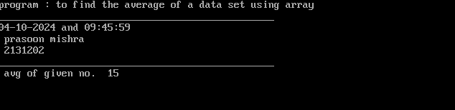

Cls

Rem program to find the average of the data set using arrays

Print "________________________________________________-"

Print "program : to find the average of a data set using array"

Print "________________________________________________"

Print Date$; " and "; Time$

Print " prasoon mishra "

Print " 2131202 "

Print "________________________________________________"

Dim a(10)

s = 0

n = 0

sd = 0

For i = 1 To 10

Read a(i)

n = n + 1

s = s + a(i)

Next

mean = s / n

For j = 1 To 10

x = (a(j) - mean)

sd = sd + x

Next j

Data 2,4,6,8,10,12,14,16,18,20,22,24,26,28,30

Print " the avg of the no.array ="; (s / 10)

Print "the value of standard deviation ="; (Sqr(sd / (n - 1)))

End

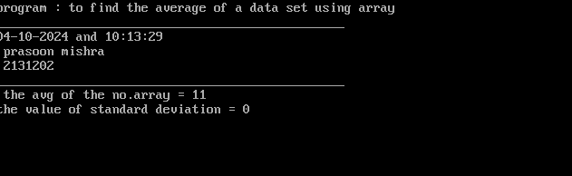

Cls

Rem program to obtain fibonacci series

Print "________________________________________________-"

Print "program : to obtain fibonacci series"

Print "________________________________________________"

Print Date$; " and "; Time$

Print " prasoon mishra "

Print " 2131202 "

Print "______________________________________________"

t1 = 1

t2 = 3

For p = 1 To 15

Print t1

t3 = t1 + t2

t1 = t2

t2 = t3

Next p

End

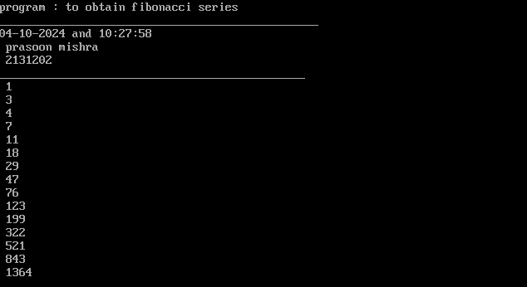

Cls

Rem program to obtain fibonacci series using array

Print "________________________________________________-"

Print "program : to obtain fibonacci series using array"

Print "________________________________________________"

Print Date$; " and "; Time$

Print " prasoon mishra "

Print " 2131202 "

Print "______________________________________________"

a = 0

b = 1

Input "enter the number of terms to be printed in the fibonacci series : "; n

Dim x(n)

x(1) = a

x(2) = b

Print x(1);

Print x(2);

For i = 3 To n

x(i) = x(i - 1) + x(i - 2)

Print x(i);

Next i

End

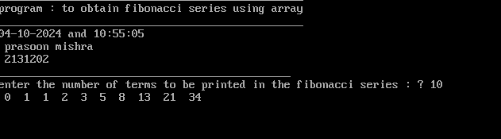

Cls

10 Rem program to calculate sum of two matrices

20 Print "______________________________________________"

30 Print " Program:- To calculate sum of two matrices"

40 Print "______________________________________________"

50 Print Date$; " and "; Time$

60 Print "Prasoon mishra"

70 Print "2131202"

80 Print "_______________________________________________"

90 Dim A(20, 20): Dim B(2, 2): Dim C(2, 2): Dim D(2, 2)

100 NC = 2

110 NR = 2

120 Print " Matrix A= "

130 For I = 1 To NR

140 For J = 1 To NC

141 Read A(I, J)

142 Print A(I, J);

150 Next J

160 Print

170 Next I

180 BC = 2

190 BR = 2

200 Print " Matrix B= "

210 For I = 1 To BR

220 For J = 1 To BC

221 Read B(I, J)

222 Print B(I, J);

230 Next J

240 Print

250 Next I

260 Print " Sum of matrices A and B is ="

270 For I = 1 To 2

280 For J = 1 To 2

281 C(I, J) = A(I, J) + B(I, J)

282 Print C(I, J);

290 Next J

291 Print

300 Next I

310 Print " Difference of matrices A and B is ="

320 For I = 1 To 2

330 For J = 1 To 2

331 D(I, J) = A(I, J) - B(I, J)

332 Print D(I, J);

340 Next J

351 Print

360 Next I

370 Data 1,2,2,1,3,1,3,1

380 End

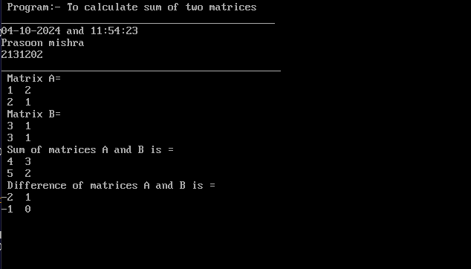

Cls

Rem display the sum of the following series ln(1+x) = x -x^2/2 + x^3/3 - x^4/4.......

Input "enter the value of x"; x

Dim a(50)

a(1) = x

s = x

For i = 2 To 50

t(i) = (((-1) ^ (i - 1)) * (x ^ i)) / i

s = s + t(i)

If Abs(t(i) - t(i - 1)) < 0.001 Then GoTo 60

Next

60 Print " the sum of the series is = "; s; " which converges to the actual value = "; Log(1 + x); "ln"; i; " terms."

End

