PROGRAM 1

10 Rem "TO FIND THE SUM, PRODUCT, DIVISION AND DIFFERENCE OF TWO NUMBERS"

20 Input "ENTER THE TWO NUMBERS"; A, B

30 Let C = A + B

40 Let D = A \* B

50 Let E = A / B

60 Let F = A - B

70 Print "THE SUM F THE TWO NUMBERS"; C

80 Print "THE PRODUCT OF THE TWO NUMBERS"; D

90 Print "THE DIVISION OF THE TWO NUMBERS"; E

100 Print "THE DIFFERENCE OF THE TWO NUMBERS"; F

110 End

PROGRAM 2

10 Rem "TO FIND THE AREA OF A CIRCLE (A)"

20 Input "ENTER THE RADIUS"; R

30 Let A = 3.14 \* (R ^ 2)

40 Print "THE AREA OF THE CIRCLE"; A

50 End

PROGRAM 3

10 Rem "TO FIND THE VOLUME OF AN IDEAL (V)"

20 Input "PRESSURE OF THE IDEAL GAS"; P

30 Input "NUMBER OF MOLES OF THE GAS"; N

40 Let R = 8.314

50 Let T = 300

60 Let V = (N \* R \* T) / P

70 Print "THE VOLUME OF THE IDEAL GAS, V IS"; V

80 End

PROGRAM 4

10 Rem "TO FIND THE PRESSURE OF CO2 GAS AT 500K AS VANDER WAAL'S GAS"; P

20 Input "ENTER THE VANDER WAAL'S CONSTANTS"; A, B

30 Input "ENTER THE NUMBER OF MOLES OF CO2"; N

35 Input "ENTER THE VOLUME OF CO2"; V

40 Let T = 500

50 Let R = 8.314

60 Let P = ((N \* R \* T) / (V - (N \* B))) - ((N \* A) / (V ^ 2))

70 Print "THE PRESSURE OF CO2 AT 500K IS "; P

80 End

PROGRAM 5

10 Rem "TO FIND THE AVERAGE VELOCITY, ROOT MEAN SQUARE VELOCITY AND MOST PROBABLE VELOCITY OF N2 GAS AT 300K"

20 Let M = 28

30 Let R = 8.314

40 Let T = 300

50 Let A = ((8 \* R \* T) / (3.14 \* M)) ^ 0.5

60 Let B = ((3 \* R \* T) / M) ^ 0.5

70 Let C = ((2 \* R \* T) / M) ^ 0.5

80 Print "THE AVERAGE VELOCITY OF N2 AT 3OOK IS"; A

90 Print "THE RMS VELOCITY OF N2 AT 3OOK IS"; B

100 Print "THE MOST PROBABLE VELCITY OF N2 GAS AT 300K IS"; C

110 End

PROGRAM 6

10 Rem "TO FIND THE SUM OF FIRST TEN NATURAL NUMBERS"

20 N = 0

30 S = 0

40 N = N + 1

50 S = S + N

60 If N < 10 Then GoTo 40

70 Print "THE SUM OF FIRST TEN NATURAL NUMBERS"; S

80 End

PROGRAM 7

10 Rem "TO FIND THE SUM OF ODD NATURAL NUMBERS LESS THAN 20"

20 N = 1

30 S = 1

40 N = N + 2

50 S = S + N

60 If N < 19 Then GoTo 40 Else GoTo 70

70 Print "THE SUM OF ODD NATURAL NUMBERS LESS THAN 20 IS"; S

80 End

PROGRAM 8

10 Rem "TO FIND THE SUM OF EVEN NATURAL NUMBERS LESS THAN 20"

20 N = 2

30 S = 2

40 N = N + 2

50 S = S + N

60 If N < 18 Then GoTo 40 Else GoTo 70

70 Print "THE SUM OF EVEN NATURAL NUMBERS LESS THAN 20 IS"; S

80 End

Program 1-8 OUTPUTS

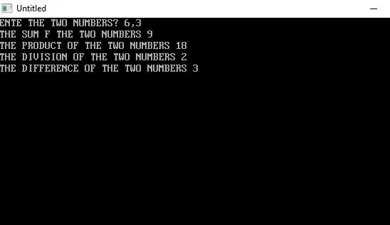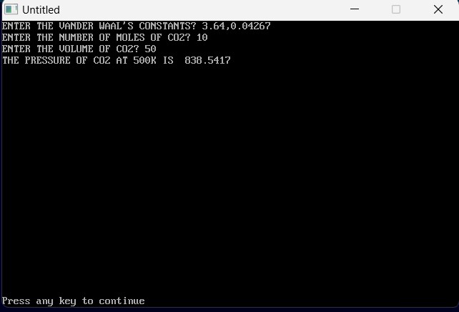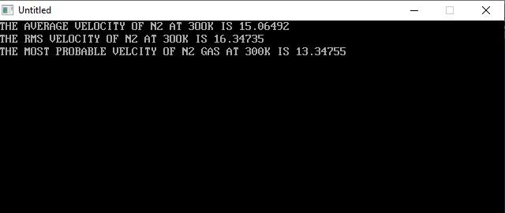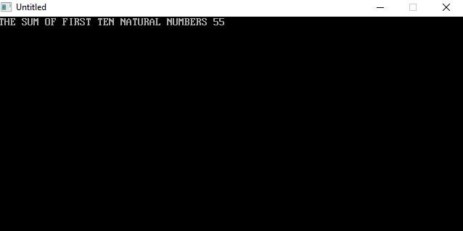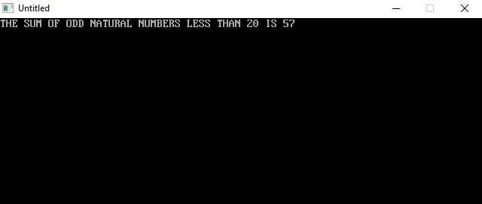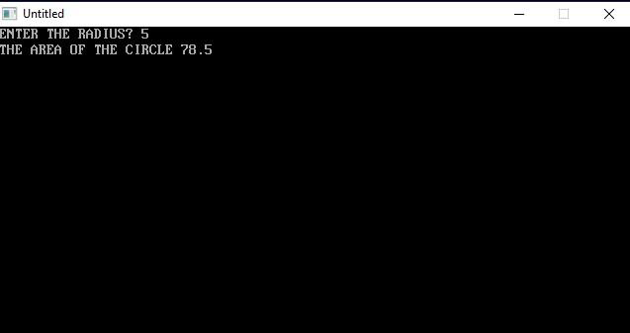



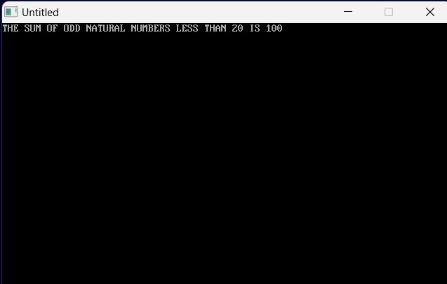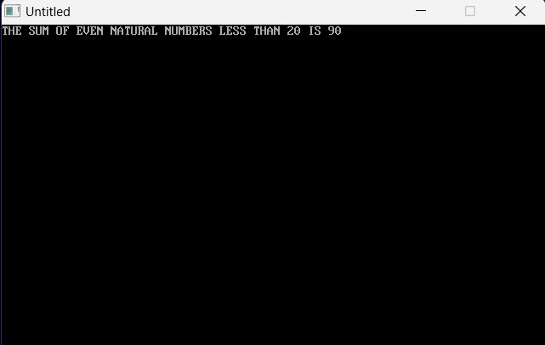

2131163

PROGRAM 9

10 Rem "TO COMPARE TWO NUMBERS"

20 Cls

30 Input "ENTER THE TWO NUMBERS"; A, B

40 If A = B Then GoTo 60

50 If A > B Then GoTo 80 Else GoTo 100

60 Print "THE TWO NUMBERS ARE EQUAL"; A, B

70 GoTo 110

80 Print "A IS GREATER THAN B"; A

90 GoTo 110

100 Print "B IS GREATER THAN A"; B

110 End

PROGRAM 10

10 Rem "TO COMPARE TWO NUMBERS"

20 Cls

30 Input "ENTER THE THREE NUMBERS"; A, B, C

40 If A = B Then GoTo 45 Else GoTo 50

45 If B = C Then GoTo 60

50 If A > B Then GoTo 55 Else GoTo 59

55 If A > C Then GoTo 80 Else GoTo 110

59 If B > C Then GoTo 100 Else GoTo 110

60 Print "THE THREE NUMBERS ARE EQUAL"; A, B, C

70 GoTo 120

80 Print "A IS GREATEST NUMBER"; A

90 GoTo 120

100 Print "B IS GREATEST NUMBER"; B

105 GoTo 120

110 Print "C IS GREATEST NUMBER"; C

120 End

PROGRAM 11

10 Rem "TO FIND THE ROOTS OF A QUADRATIC EQUATION"

20 Cls

30 Input "ENTER THE VALUE OF COEFFICIENT X^2"; A

40 Input "ENTER THE VALUE OF COEFFICIENT X"; B

45 Input "ENTER THE VALUE OF CONSTANT"; C

50 Let D = (B ^ 2) - (4 \* A \* C)

55 If D = 0 Then GoTo 60 Else GoTo 95

60 Print "THE ROOTS ARE EQUAL"

70 Let R1 = -B / (2 \* A)

75 Let R2=R1

80 Print "THE VALUE OF THE ROOTS ARE"; R1, R2

90 GoTo 170

95 If D > 0 Then GoTo 96 Else GoTo 110

96 Print "THE ROOTS ARE REAL AND DISTINCT"

97 Let R1 = ((-B) + Sqr(D)) / (2 \* A)

98 Let R2 = ((-B) - Sqr(D)) / (2 \* A)

100 Print "THE ROOTS ARE"; R1, R2

105 GoTo 170

110 If D < 0 Then GoTo 120

120 Print "THE ROOTS ARE IMAGINARY"

130 Let REAL = (-B) / (2 \* A)

140 Let IMG = (Sqr(Abs(D))) / (2 \* A)

150 Print "THE VALUE OF ROOT IS"; REAL; "+i"; IMG

160 Print "THE VALUE OF ROOT IS"; REAL; "-i"; IMG

170 End

PROGRAM 12

10 Rem "TO FIND FACTORIL OF A NUMBER"

20 CLS

30 Input "ENTER THE VALUE OF NUMBER WHOSE FACTORIAL IS TO BE FOUND OUT"; N

40 I = 1

50 F = 1

60 I = I + 1

70 F = F \* I

80 If I > (N - 1) Then GoTo 90 Else GoTo 60

90 Print "THE FACTORIAL OF"; N; "IS"; F

100 End

PROGRAM 13

10 Rem "TO FIND THE SUM OF THE SERIES 1+X+X^2+X^3+...+X^N "

20 Cls

30 Input "ENTER THE VALUE OF X"; X

40 Input "ENTER THE VALUE OF N"; N

50 Let S = 0

60 Let I = 0

70 Let S = S + (X ^ I)

80 Let I = I + 1

90 If I <= N Then GoTo 70 Else GoTo 100

OR

90 If I > N Then GoTo 100 Else GoTo 70

100 Print "THE SUM OF THE GIVEN SERIES IS"; S

110 End

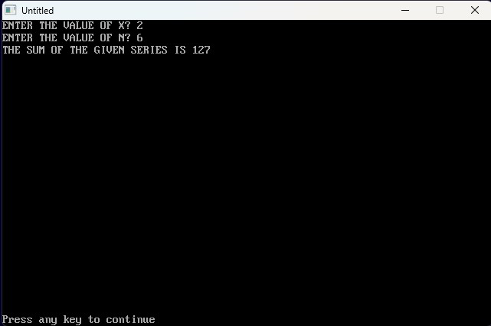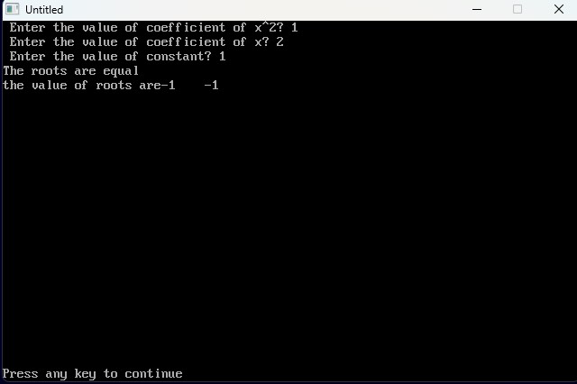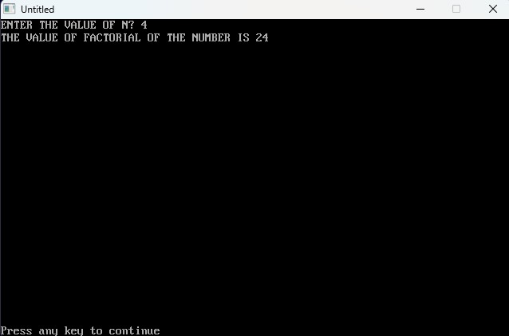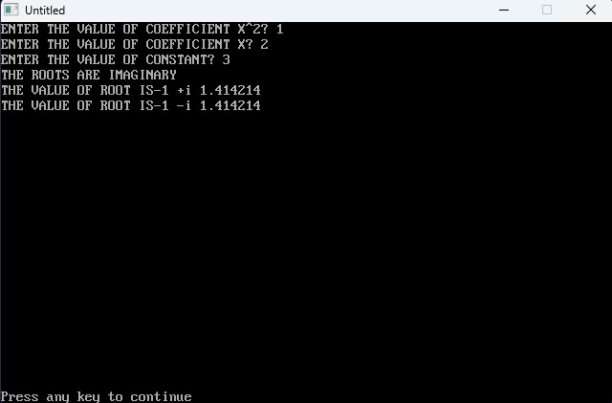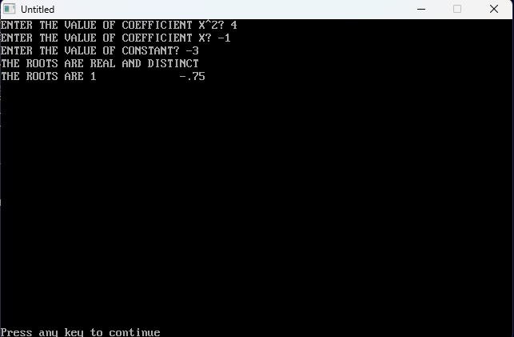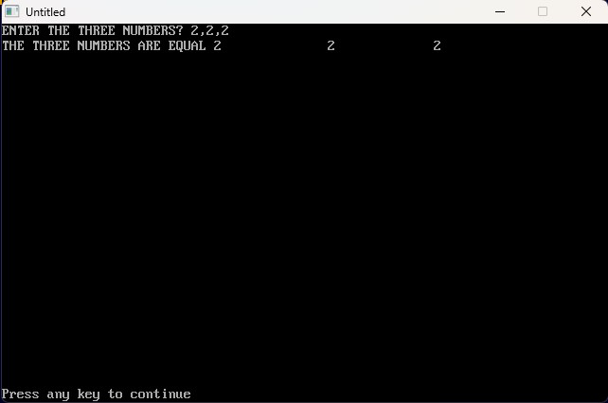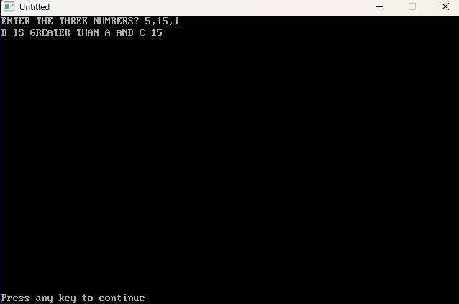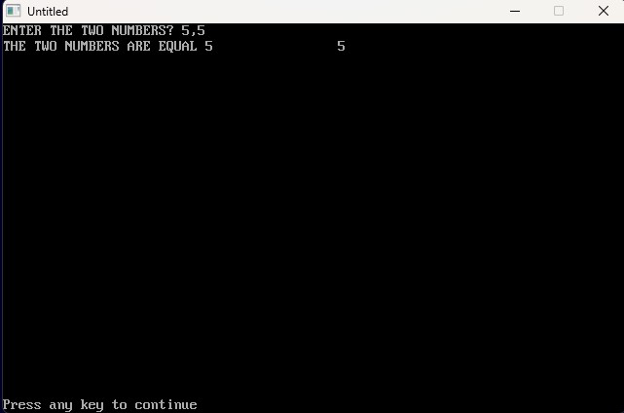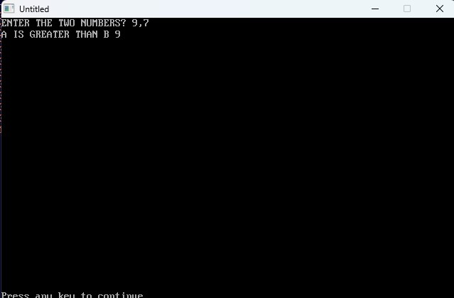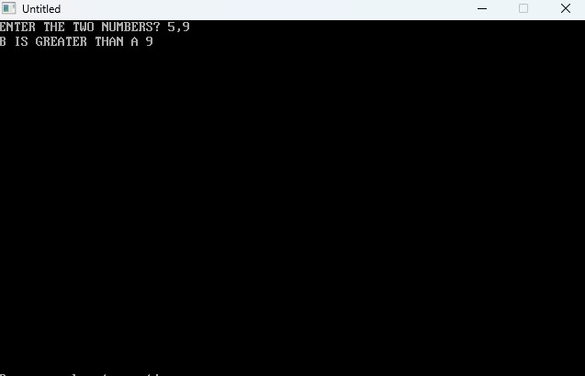

PROGRAM 14

10 Rem "TO FINDF SUM OF N NATURAL NUMBERS"

20 Input "ENTER THE VALUE OF N TILL WHICH THE SUM IS TO BE FOUND"; N

30 I = 0

40 S = 0

50 I = I + 1

60 S = S + I

70 If I < N Then GoTo 50 Else GoTo 80

OR

70 If I > = N Then GoTo 80 Else GoTo 50

OR

70 If I > (N - 1) Then GoTo 80 Else GoTo 50

80 Print "THE SUM OF FIRST"; N; "NATURAL NUMBERS IS"; S

90 End

PROGRAM 15

10 Rem "TO FIND PRODUCT OF FIRST N NATURAL NUMBERS"

20 Input "ENTER THE VALUE OF N TILL WHICH THE PRODUCT IS TO BE FOUND OUT"; N

30 I = 1

40 P = 1

50 I = I + 1

60 P = P \* I

70 If I < N Then GoTo 50 Else GoTo 80

80 Print "THE PRODUCT OF FIRST"; N; "NATURAL NUMBERS IS"; P

90 End

PROGRAM 16

10 Rem "TO FIND THE SUM AND PRODUCT OF FIRST N NATURAL NUMBERS"

20 Input "ENTER THE VALUE OF N TILL WHICH THE SUM AND PRODUCT IS TO BE FOUND"; N

30 I = 1: S = 1: P = 1

35 I = I + 1

40 S = S + I: P = P \* I

50 If I < N Then GoTo 35 Else GoTo 60

60 Print "THE SUM AND PRODUCT OF FIRST"; N; "NATURAL NUMBERS IS"; S; "AND"; P; "RESPECTIVELY"

70 End

PROGRAM 17

10 Rem "TO FIND THE SUM OF SERIES 1+(X/1)+((X^2)/(2\*1))+((X^3)/(3\*2\*))+...+((X^N)/(N\*(N-1)\*...\*2\*1)"

20 Input "ENTER THE VALUE OF X AND N"; X, N

30 I = 1: S = 1: P = 1

50 P = P \* I: S = S + ((X ^ I) / P)

60 I = I + 1

70 If I > N Then GoTo 80 Else GoTo 50

80 Print "THE SUM OF THE SERIES IS"; S

90 End

Program 18

10 Rem "TO FIND SUM OF FIRST N NATURAL NUMBERS"

20 Input "ENTER THE VALUE OF N TILL WHICH THE SUM IS TO BE FOUND"; N

25 S = 0

30 For I = 1 To N

40 S = S + I

50 Next I

60 Print "THE SUM OF FIRST"; N; "NATURAL NUMBERS IS"; S

70 End

PROGRAM 19

10 Rem "TO DISPLAY FIBONACCI SERIES UPTO N TERMS"

20 Input "ENTER THE VALUE OF N"; N

30 F1 = 1: F2 = 2

40 For I = 1 To N

50 F = F1 + F2

60 Print F

70 F1 = F2: F2 = F

80 Next I

90 End

PROGRAM 20

10 Rem "TO READ AND PRINT A MATRIX A"

20 Dim A(3, 3)

30 Print "THE MATRIX A IS"

40 For I = 1 To 3

50 For J = 1 To 3

60 Read A(I, J)

70 Print A(I, J);

80 Next J

90 Print

100 Next I

110 Data 2,4,6,9,12,15,30,45,60

120 End

PROGRAM 21

10 Rem "TO READ AND PRINT A MATRIX AND IT'S TRANSPOSE"

15 Input M, N

20 Dim A(3, 3), T(3, 3)

30 Print "THE MATRIX A IS"

40 For I = 1 To M

50 For J = 1 To N

60 Read A(I, J)

70 Print A(I, J);

80 Next J

90 Print

100 Next I

110 Data 2,4,6,9,12,15,30,45,60

120 Print: Print

130 Print "TRANASPOSE OF MATRIX A IS T"

140 For I = 1 To N

150 For J = 1 To M

160 T(I, J) = A(J, I)

170 Print T(I, J);

180 Next J

190 Print

200 Next I

210 End

PROGRAM 22

10 Rem "TO READ AND PRINT A MATRIX A"

15 Input M, N

20 Dim A(3, 3), B(3, 3), C(3, 3)

30 Print "THE MATRIX A IS"

40 For I = 1 To M

50 For J = 1 To N

60 Read A(I, J)

70 Print A(I, J);

80 Next J

90 Print

100 Next I

110 Data 3,-1,0,4,7,2,5,0,5

120 Print: Print

130 Rem "TO READ AND PRINT A MATRIX B"

150 Print "THE MATRIX B IS"

160 For I = 1 To M

170 For J = 1 To N

180 Read B(I, J)

190 Print B(I, J);

200 Next J

210 Print

220 Next I

230 Data 9,1,-1,7,2,8,1,20,15

240 Print: Print

250 Print "THE RESULTANT MATRIX C IS"

260 For I = 1 To M

270 For J = 1 To N

280 C(I, J) = A(I, J) + B(I, J)

290 Print C(I, J);

300 Next J

310 Print

320 Next I

330 End

PROGRAM 23

10 Rem "TO READ AND PRINT A MATRIX A"

15 Input M, N

20 Dim A(3, 3), B(3, 3), C(3, 3)

30 Print "THE MATRIX A IS"

40 For I = 1 To M

50 For J = 1 To N

60 Read A(I, J)

70 Print A(I, J);

80 Next J

90 Print

100 Next I

110 Data 3,-1,0,4,7,2,5,0,5

120 Print: Print

130 Rem "TO READ AND PRINT A MATRIX B"

150 Print "THE MATRIX B IS"

160 For I = 1 To M

170 For J = 1 To N

180 Read B(I, J)

190 Print B(I, J);

200 Next J

210 Print

220 Next I

230 Data 9,1,-1,7,2,8,1,20,15

240 Print: Print

250 Print "THE RESULTANT MATRIX C IS"

260 For I = 1 To M

270 For J = 1 To N

280 C(I, J) = A(I, J) - B(I, J)

290 Print C(I, J);

300 Next J

310 Print

320 Next I

330 End

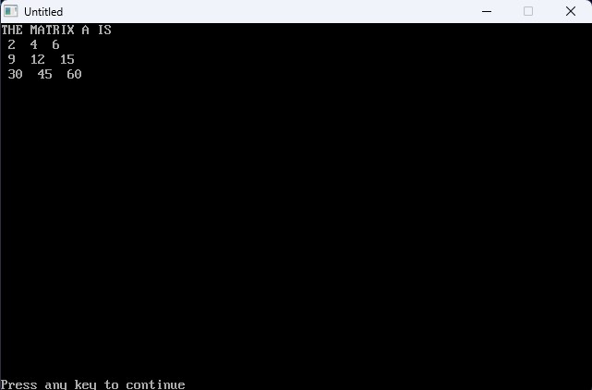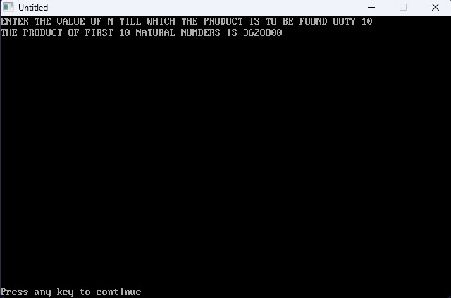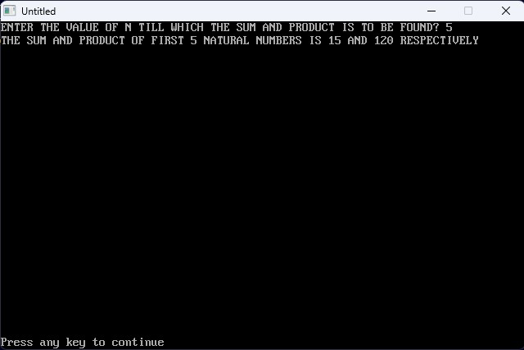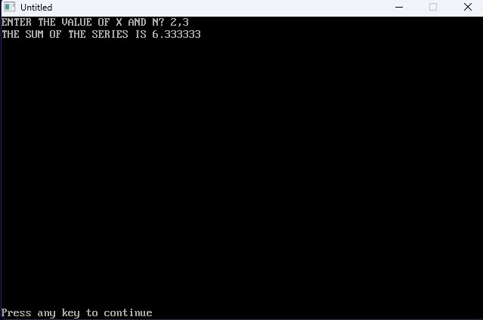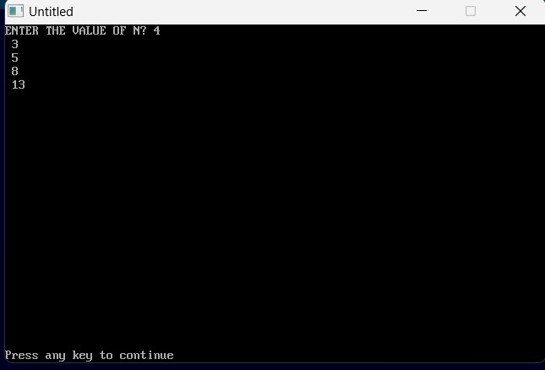

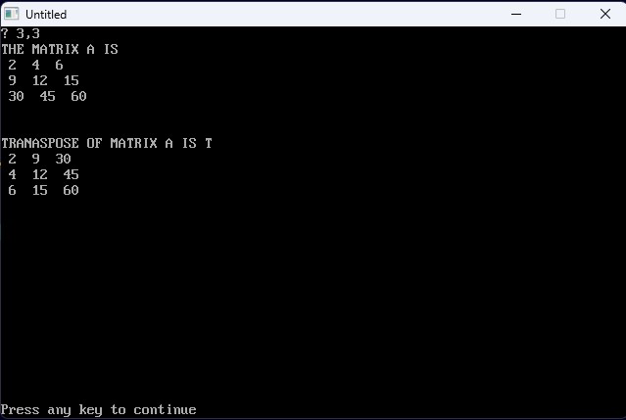

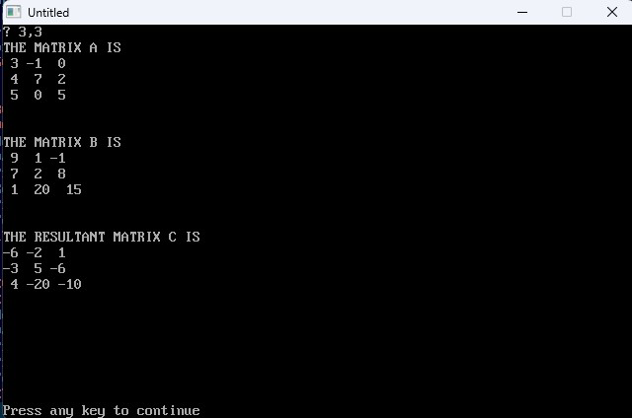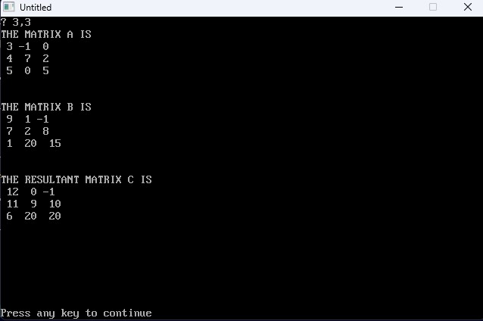

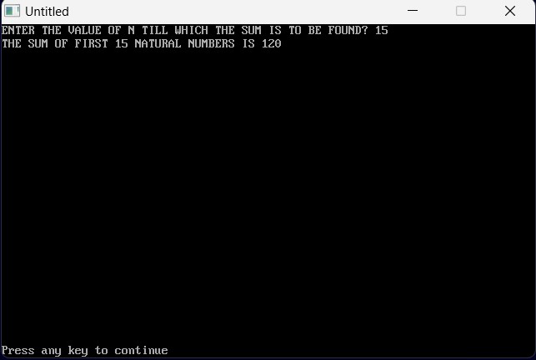

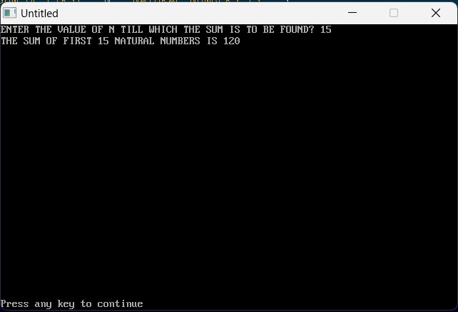

PROGRAM 24

10 Rem "TO CARRY OUT MULTIPLICATION OF TWO MATRICES"

20 Cls

30 Print "MULTIPLICATION OF TWO MATRICES"

40 Dim A(3, 3), B(3, 3), C(3, 3)

50 Print "THE MATRIX A IS"

60 For I = 1 To 3

70 For J = 1 To 3

80 Read A(I, J)

90 Print A(I, J);

100 Next J

110 Print

120 Next I

130 Data 9,8,7,6,5,4,3,2,1

140 Print "THE MATRIX B IS"

150 For I = 1 To 3

160 For J = 1 To 3

170 Read B(I, J)

180 Print B(I, J);

190 Next J

200 Print

210 Next I

220 Data 1,2,3,4,5,6,7,8,9

230 Print "THE MATRIX C IS"

240 For I = 1 To 3

250 For J = 1 To 3

260 Let C(I, J) = 0

270 For K = 1 To 3

280 Let C(I, J) = C(I, J) + A(I, K) \* B(K, J)

290 Next K

300 Print C(I, J);

310 Next J

320 Print

330 Next I

340 End

PROGRAM 25

10 Rem "TO PERFORM ADDITION AND SUBTRACTION OF TWO MATRICES"

20 Cls

30 Print "TO ADD AND SUBTRACT TWO MATRICES"

40 Dim A(3, 3), B(3, 3), C(3, 3), D(3, 3)

50 Print "THE MATRIX A IS"

60 For I = 1 To 3

70 For J = 1 To 3

80 Read A(I, J)

90 Print A(I, J);

100 Next J

110 Print

120 Next I

130 Data 1,2,3,4,5,6,7,8,9

140 Print "THE MATRIX B IS"

150 For I = 1 To 3

160 For J = 1 To 3

170 Read B(I, J)

180 Print B(I, J);

190 Next J

200 Print

210 Next I

220 Data 10,11,12,13,14,15,16,17,18

230 Print "THE SUM OF THE TWO MATRICES, C IS"

240 For I = 1 To 3

250 For J = 1 To 3

260 C(I, J) = A(I, J) + B(I, J)

270 Print C(I, J);

280 Next J

290 Print

300 Next I

310 Print "THE DIFFERENCE OF THE TWO MATRICES, D IS"

320 For I = 1 To 3

330 For J = 1 To 3

340 D(I, J) = B(I, J) - A(I, J)

350 Print D(I, J);

360 Next J

370 Print

380 Next I

390 End

PROGRAM 26

10 Rem "TO FIND THE ROOT OF A QUADRATIC EQUATION BY ITERATIVE METHOD"

20 Cls

30 Print "ROOTS OF THE QUADRATIC EQUATION BY ITERATIVE METHOD"

40 Input "ENTER THE VALUE OF COEFFICIENT OF X^2"; A

50 Input "ENTER THE VALUE OF COEFFICIENT OF X"; B

60 Input "ENTER THE VALUE OF CONSTANT"; C

70 Input "ENTER THE GUESS VALUE"; Xo

80 Input "ENTER THE VALUE OF N"; N

90 For I = 1 To N Step 1

100 Let X = (((-A) \* (X ^ 2)) - C) / B

110 If Abs(X - Xo) < 0.001 Then GoTo 140 Else GoTo 120

120 Xo = X

125 Next I

130 Print "THE VALUE OF X IS"; X

140 Print "THE VALUE OF Xo IS"; Xo

150 Print "THE VALUE OF I IS"; I

160 End

PROGRAM 27

10 Rem "TO FIND THE pH OF A WEAK ACID BY ITERATIVE METHOD"

20 Cls

30 Print "THE pH OF WEAK ACID IS"

40 Input "ENTRER THE VALUE OF N"; N

50 For I = 1 To N Step 1

60 Let C = 0.1 'M

70 Let K = 0.00018

80 Xo = Sqr(K / C)

90 Let X = Sqr((K \* (1 - Xo)) / C)

100 If Abs(X - Xo) < 0.001 Then GoTo 130 Else GoTo 110

110 Let X = Xo

120 Next I

130 Let pH = (-Log(C \* X)) / 2.303

140 Print "THE pH OF WEAK ACID IS"; pH

150 Print "THE VALUE OF ITERATIONS IS"; I

160 End

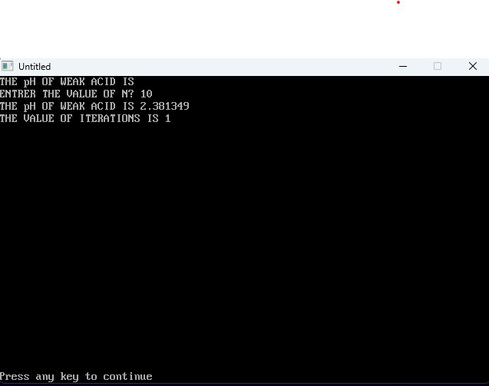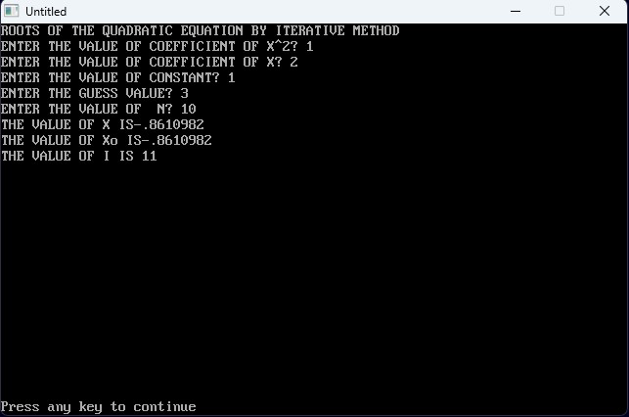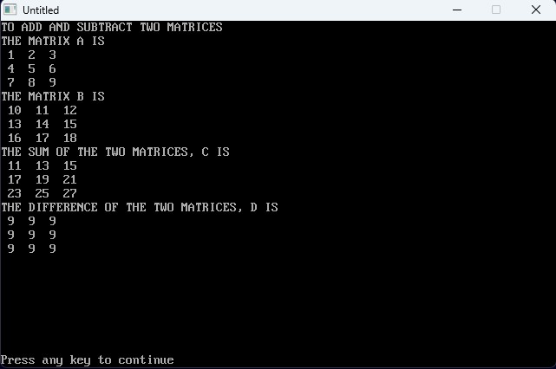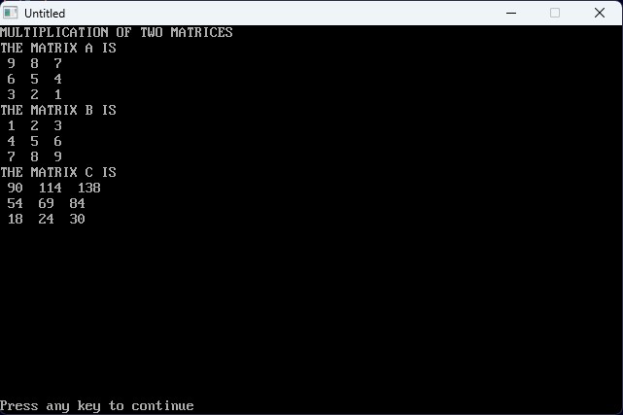

PROGRAM 28

10 Rem "TO FIND THE ROOTS OF QUADRATIC EQUATION USING NEWTON RAPHSON METHOD"

20 Cls

30 Input "ENTER THE COEFFICIENT OF X^2"; A

40 Input "ENTER THE COEFFICIENT OF X"; B

50 Input "ENTER THE VALUE OF CONSTANT"; C

60 DEF FNA(X) = A \* X ^ 2 + B \* X + C

70 DEF FND(X)= 2\*A\*X+B

80 Input "ENTER THE GUESS VALUE"; Xo

90 Input "ENTER THE VALUE OF N"; N

100 For I = 1 To N Step 1

110 X = Xo - (FNA(Xo) / FND(Xo))

120 If Abs(X - Xo) < 0.0001 Then 150 Else GoTo 130

130 Let Xo = X

140 Next I

150 Print "THE VALUE OF GUESS VALUE"; Xo

160 Print "THE VALUE OF I IS"; I

170 End

PROGRAM 29

10 Rem "to find the line of best fit"

20 Cls

30 Print "the line of best fit"

40 Dim x(12), y(12)

50 Let n = 5

60 For i = 1 To n

70 Read x(1), y(1)

80 Let sx = sx + x(1)

90 Let sy = sy + y(1)

100 Let sxx = sxx + x(1) ^ 2

110 Let syy = syy + y(1) ^ 2

120 Let sxy = sxy + x(1) \* y(1)

130 Next i

140 Let d = n \* sxx - (sx) ^ 2

150 Let m = (n \* sxy - sx \* sy) / d

160 Let c = (sxx \* sy - sx \* sxy) / d

170 Print "slope of line , m"; m

180 Print "intercept,c"; c

190 Let vx = (sxx) / n - (sx / n) ^ 2

200 Let vx = (syy / n) - (sy / n) ^ 2

210 Print "variance of x , vx "; vx

220 Print "varience of y , vy "; vy

230 Let sdx = Sqr(vx)

240 Let sdy = Sqr(vy)

250 Let r = m \* (sdx / sdy)

260 Print "standard derivation of x,sdx "; sdx

270 Print "standard derivation of y,sdy"; sdy

280 Print "regression , r"; r

290 Print "y="; m, "x+"; c

300 Data 1,5,2,8,3,11,4,14,5,17

310 End

