A4.

You will implement and test a PriorityQueue class, where the items of the priority queue are stored on a linked list. The material from Ch1 ~ 8 of the textbook can help you tremendously. You can get a lot of good information about implementing this assignment from chapter 8.

There are couple notes about this assignment. 1. Using structure Node with a pointer point to Node structure to create a linked list, the definition of the Note structure is in the priority queue header file (pqueue1.h). 2. Using a typedef statement to define the underlying data type, we can easily change to a new data type on all the typedef data type by change one statement. 3. Abandoning the usage of linked list toolkit, all the needed function will be implemented in the class.

I want to mention it again you that you are welcome to use more advance skills than the techniques introduce in the textbook to do the assignment. But the implemented class needs to pass the examining file to get credit.

Following is an introduction to some files in this program.
- pqueue1.h is the headers file for this first version of the PriorityQueue class. You can start from this version and add your name and other documentation information at the top. Please look into and understand the structure Note. Without understanding this, you will have tough time to finish this project. Reading through this file carefully you need to know what functions you need to implement and the preconditions and postcondition of each function. This file should be a good guide to your implementation of the class. By the way if a member function of a class is an inline function, it is implemented in this file. You don’t need to redo it in the implementation file which is pqueue1.cpp.

- pqueue1.cpp is the implementation file for the PriorityQueue class. You need to create this file and implement all the function defined in the pqueue1.cpp. I want to bring to you attention that the PriorityQueue's linked list consists of allocating memory. So we have to define a copy constructor, an assignment operator, and also a destructor to cope with the demand of dynamic memories allocation.

- pqtest.cpp is the same style interactive test program that you used in the previous assignments. You can open it with your editor or import it to a compiler project to run with the pqueue1.cpp and pqueue1.h.
- pqexam1.cpp is the same style non-interactive examine program as you use in the previous assignment. You can add this file to a compiler to run with the pqueue1.cpp and pqueue1.h to grade your pqueue1.cpp implementation.

- CISP430V4A4Exam.exe is an executable file which you can generate this file by compiling and running the pqexam1.cpp, pqueue1.cpp (proper implemented) and pqueue1.h. When you click it you can see the following results.
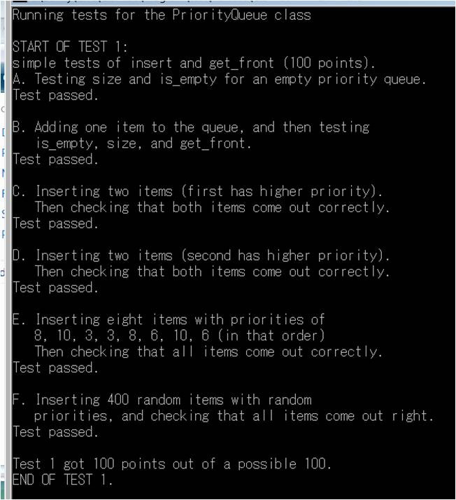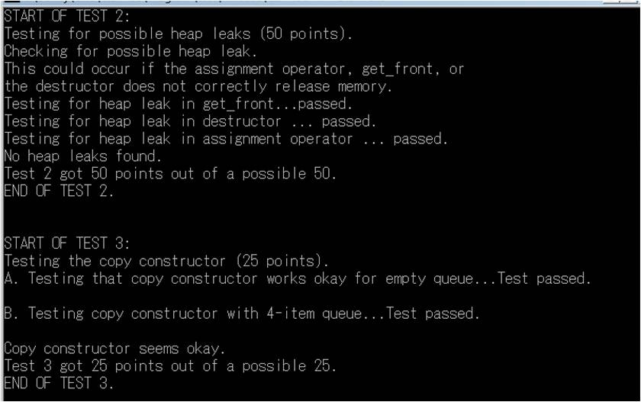
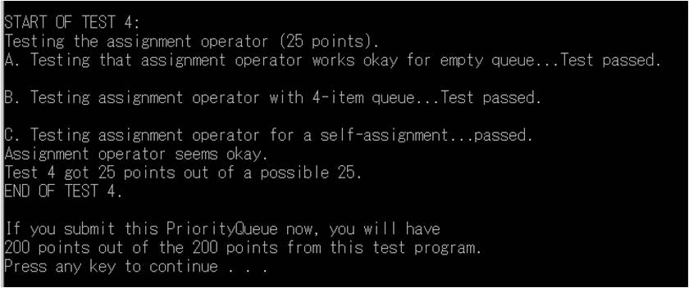
- CISP430V4A4Test.exe is an executable file which you can generate this interactive file by compiling and running pqtest.cpp, pqueue1.cpp (proper implemented) and pqueue1.h. When you click the CISP430V4A3Test.exe file and put in the proper information you should get to the following pictures.
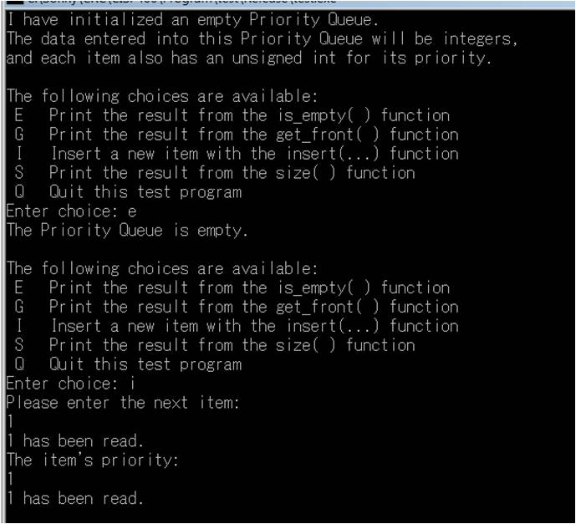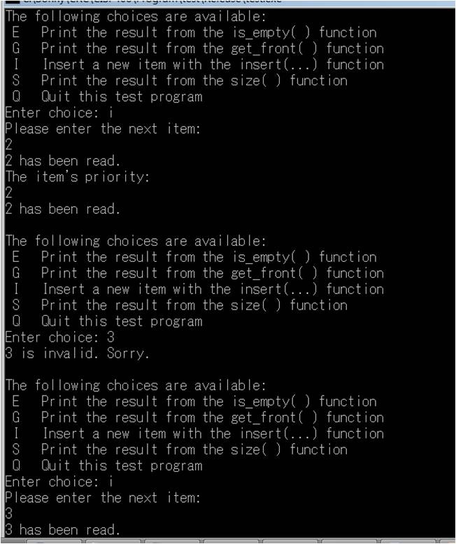
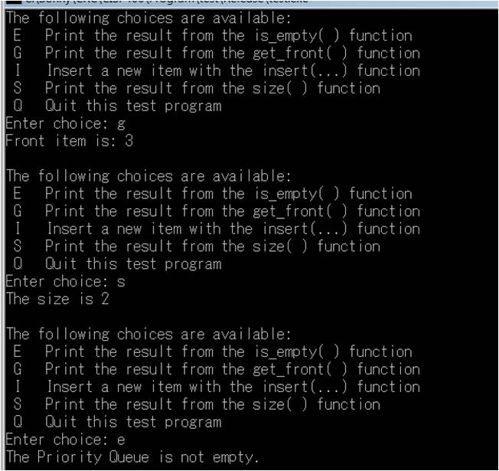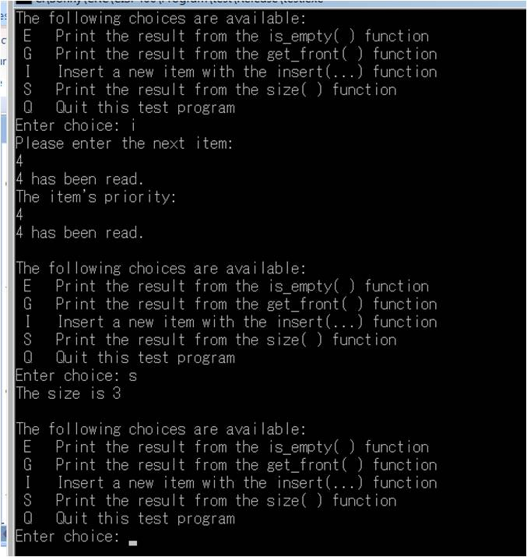
Please document the pqueue1.cpp and pqueue1.h files properly and zip them into a proper named zip file for the assignment (refer to the assignment section of the class syllabus) and submit it to the A4 folder of the Canvas Website.

Worth 200 points

