A5

The main focus of this assignment is recursive call and placing strings in link list nodes. The material from Ch1 ~ 9 of the textbook can help you tremendously. You can get a lot of good information about implementing this assignment from chapter 9.

You need to write a permute class that will take first and second strings to rearrange letters in first, followed by second. For example, if the first is “CAT” string and second is “MAN” string, then the program would print the strings TACMAN, ATCMAN, CTAMAN, TCAMAN, ACTMAN, and CATMAN. The first and second strings can be any length of string or a null.

The permute class uses a Node class as link list node to link all letters arrangement. The permute class has Node pointers, firstNode and lastNode, to point to the beginning and ending Nodes of the link list as private data members. There are three other private data members (total, firstString and secondString) to store the total possible number of arrangements and strings pass into the class.

Write a driver to test the permute class to pass in any two strings of any sizes.

Other than mention in the following, you can add more classes, functions, and private data members to this program.

Node class
The Node class needs to have two private data members and a constructor. The two private data members are data and p pointer. The data’s data type is string and p pointer is Node. The Node class constructor has two parameters, one is string and the other is Node pointer.

Permute class
The Permute class has five private data members (*firstNode, *lastNode, total, firstString and secondString). The firstNode and lastNode pointers are point to Node. The total has integer data type. The firstString and secondString have string data type.

There should have at least three public member functions, Permute, permutation and print. The Permute function is the constructor which takes strings to initialize the private data members. The permutation function does the recursive call to arrange the strings and setup the link list. The print function will print out the private data member information.

Driver file
The driver file should declare a Permute eight elements pointer array. Instantiate eight Permute object with the following eight set of data and assign the object to the pointer array. Use a repetition to call the object’s print function to print out the private data member information. If the total of the permute private data member is less than 100 then print out the permutated letters four in a row, otherwise print out 9 in a row.
first = "", second="",
first = "", second ="CATMAN",
first = "C", second ="ATMAN",
first = "CA", second ="TMAN",
first = "CAT", second ="MAN",
first = "CATM", second ="AN",
first = "CATMA", second ="N",
first 1 = "CATMAN", second ="";

You are welcome to use more advance skills than the techniques introduced in the textbook to do the assignment. But the program need to do everything mentioned above. If the program coded properly you should be able to run to the following result. There is a CISP430V4A5.zip file comes with this assignment. The only program init is CISP430V4A5.exe, in it. You can double click on the file you can get to the following result.
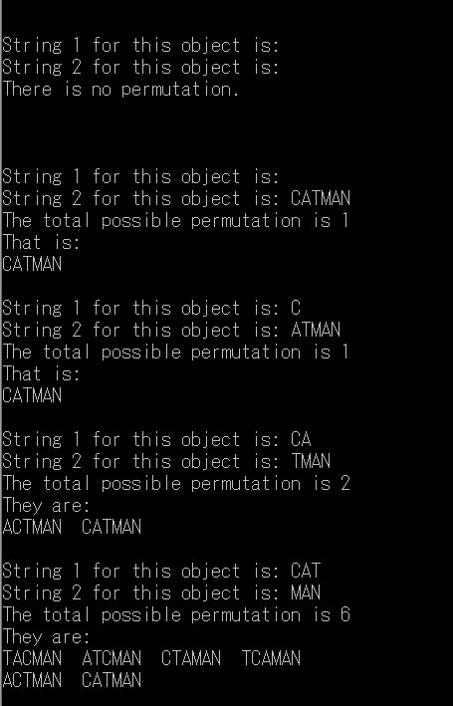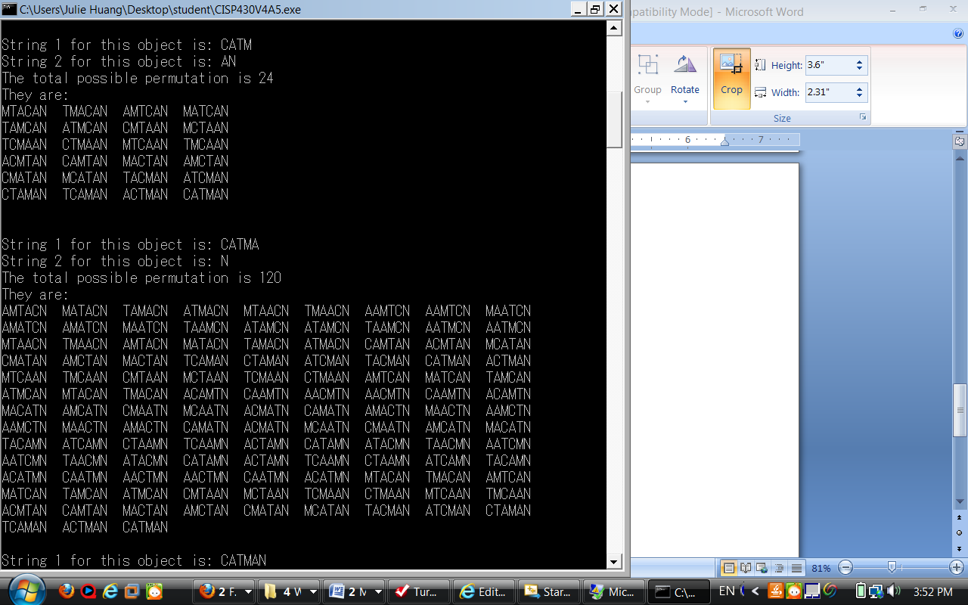
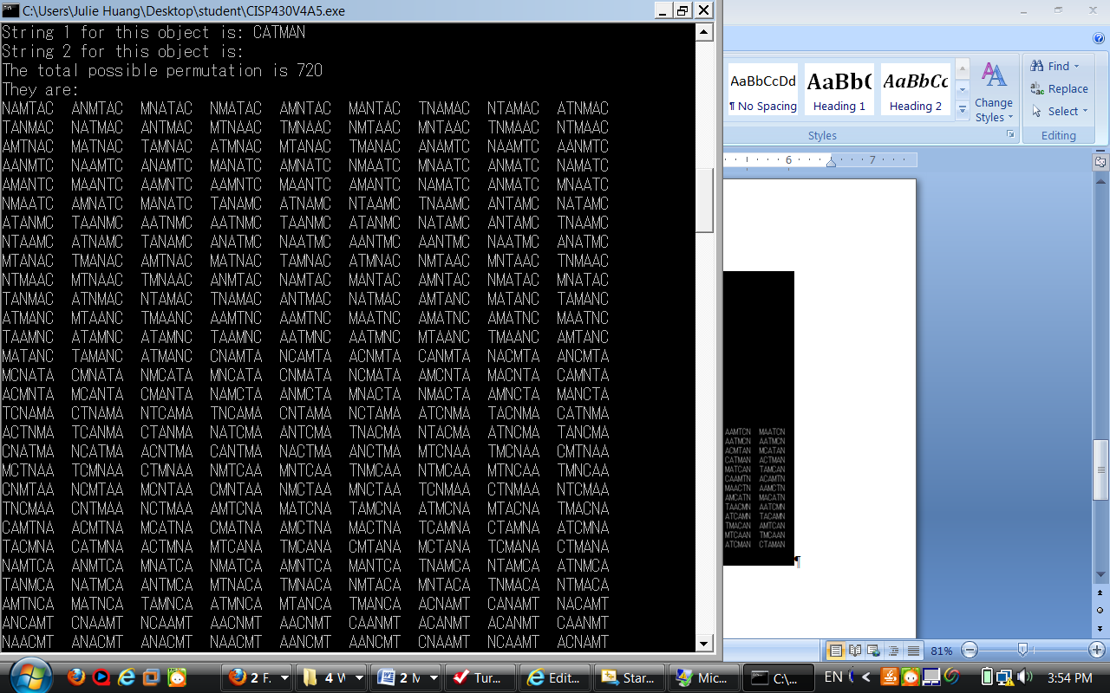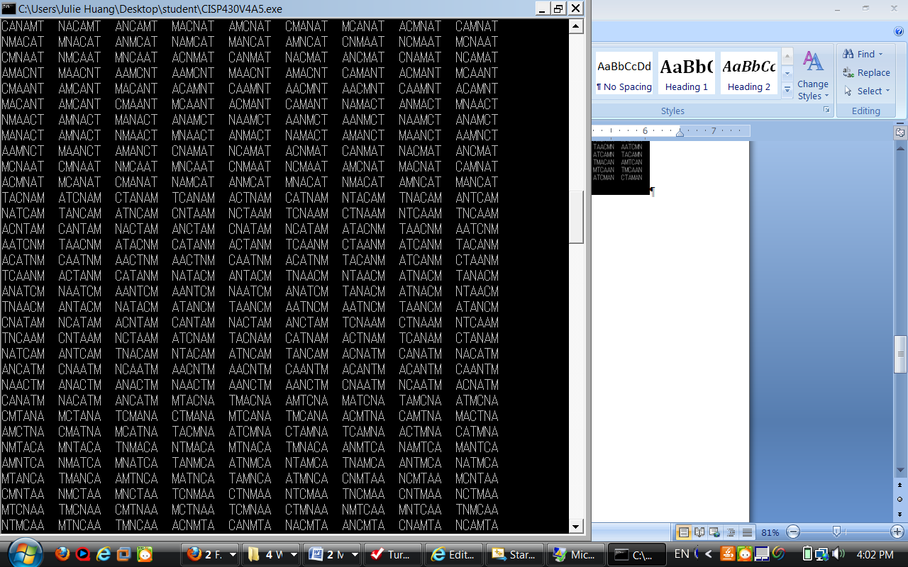
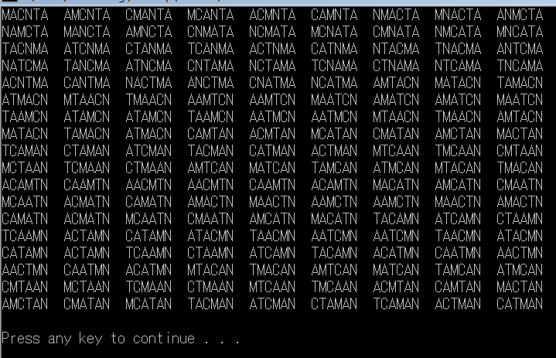

Please document all the files properly and zip them into a proper named zip file for the assignment (refer to the assignment section of the class syllabus) and submit it to the A5 folder of the Canvas Website.

