INTRODUCTION
The way consumers behave and act as regards their financial spending can be immensely rooted and attributed to various factors; whether these factors occur either naturally, environmentally or economically. These behavioral patterns exhibited and showcased by consumers are mostly a result of inflation, and this inflation has a critical and pivotal role to play; this means that inflation, to a great extent, impacts and influences the way and manner consumers act and react as regards their financial spending. Inflation, being the visible decrease and decline in the value of a country's currency, also leads to a high and tremendous escalation in the price of commodities, goods and services. As a result of this consistent , persistent and continuous escalation in the price of goods and services, consumers are now forced to make certain and precise decisions which are not detrimental to them as regards their finances and spending. Inflation also leads to series and various altered behaviors which can be visible and noticeable in these consumers who now have to make critical and wise decisions as regards how they distribute and spend their financial resources
These various and different issues and consequences associated with inflation are like and similar to the two sides of a coin, exhibiting both positive and negative implications for consumers. The positive angle of inflation as regards its impact on consumers spending includes a subtle increase in the wage of these consumers. Another positive side can also include the escalated and high increase in the demand and supply of intended goods and services due to the fact that consumers during the inflated period might and would want to explore certain alternatives and better options if any. On the other hand, the negative aspect of inflation involves and includes influencing consumers to have or make purchases that are only essential and necessary for livelihood; this, in turn, leads to elective and optional spending and curtailing unnecessary spending.
This report seeks to assess, probe and examine the impacts and effects inflation has on consumer spending whilst establishing both the positive dimensions and the negative implications. This report also seeks to examine the statistical relationship that exists between inflation and consumer spending, thereby making provisions for a deep understanding of how these two elements correlate and have affected and impacted our economy over time.
IMPACT OF INFLATION ON CONSUMER SPENDING
Inflation importantly and essentially affects and impacts consumer spending habits (Mishkin 2007) having an influence over them. These influences might be positive or negative.
Inflation exhibits and posits both negative and positive impacts and effects on individuals and how they control, handle and direct their finances when deciding on what purchases to make. It is, however, very important and essential to be conscious of the fact that in most cases, the negative implications of inflation tend to outweigh and overshadow the positive dimensions, hence having a potential and massive impact and effect on the entire behavioral patterns of consumer spending. The drastic rise in the price of goods and services can be detrimental to consumers spending in that it often leads to selective and optional spending and sharing of finances; this is a result of the fact that consumers are now wary and hypervigilant when sorting out what purchases should precede the other (in this case essential purchases are most likely to proceed and overshadow purchases for luxuries. This situation therefore leads to an economic environment which is worn out and drawn most especially for consumers whose income seems to be static and is low and not flexible.

POSITIVE IMPACT OF INFLATION ON CONSUMER SPENDING
A balanced level of inflation plays an important role in addressing the paradox of thrift, a concept introduced in 1936 ( John Maynard Keynes 1936). The proponent of this theory is of the opinion that consumers tend to save more and not spend recklessly during an inflationary period, thereby affecting and influencing consumers' spending positively.
The most important and essential positive dimension of inflation in an economic environment is the concurrent and proportional increment or rise in wages. Following the escalation of the decrease in the value of money, the income of consumers subsequently escalates, too. This escalation in the general income of consumers persuades, encourages and inspires them to consistently and continuously spend. Although the prices of goods and services increase rapidly, it is not much of a bother as the concurrent and contemporaneous increase in consumers income has the ability to sustain the purchasing habits of these consumers to some extent hence ensuring a low and minimal disruption in the economic activity of the country

NEGATIVE IMPACT OF INFLATION ON CONSUMER SPENDING
As stated earlier, inflation tremendously affects consumers spending patterns in a manner that is disadvantageous, inauspicious and not so favorable and subsequently outweighs its positive faction.
Inflation sabotages and impairs the financial flexibility, consistency and sturdiness of consumers in different varieties, hence leading consumers to be hypervigilant. These adverse impacts exhibit themselves in numerous ways and areas. These ways and areas include but are not limited to the following;

- UNWILLINGNESS TO BUY
In an inflationary environment where there is a consistent decrease and decline in the value of money, consumers become tentative and uncertain as to investing in goods and services. This occurrence takes place due to the fact that an inflationary environment immediately affects the purchasing strength of consumers. During this period, the same amount of money can only purchase relatively low and fewer products and services than usual (Khan et al., 2007). As a rapid increment in the prices of goods and services becomes obvious, consumers, therefore, become aware of the unsavory and peculiar situation they find themselves in, which is the fact that there is a massive shrinkage in capability and capacity to make certain purchases as they once did before. This therefore leads to an obvious but unsatisfying decrease in overall purchasing power
As prices take to the hill, consumers become conscious of the fact that there is a need to reconstruct and reevaluate their financial budgets and decisions, dismissing needs that are not indispensable and important, hence changing and reorganizing their spending habits in order to salvage the effects and impact of the economy on them.
A clear illustration of this effect on consumers can be seen in recent happenings in the Nigerian economy.
Example 1:
Pre-Inflation Period (2011): #10000 can be used to purchase 3 bags of cement.
Post-Inflation Period (2024): #10000 can only be used to purchase 1 bag of cement.
From the above example, it becomes obvious that in 2024, #1000 can only obtain and secure approximately 33.33 % of what it would normally have purchased in 2011. This therefore amounts to and constitutes a 66.67 % decline in the spending strength and such a decline is associated with inflation
Example 2:
Pre-Inflation Period (2011): #1250 can be used to purchase 12 liters of fuel
Post-inflation Period (2024): #1250 can only purchase 1 liter of fuel.
From the above example, it becomes obvious that in 2024, #1250 can only obtain and secure approximately 8.33 % of what it would normally have purchased in 2011. This therefore amounts to and constitutes a 91.67% decline in the spending strength and such a decline is associated to inflation
This impact or effect of inflation on consumer spending subsequently leads to a rapid decline and contributes immensely to the drop and slump in the production of goods and services. Studies have shown a significant and headline decrease in consumer spending in Nigeria over the past few years, which can be associated with inflation. These decreases are averaged at 10633952.40 NGN Million from 2010 until 2023, reaching an all-time high of 14747327.04 NGN Million in the fourth quarter of 2021 and a record low of 7205430.82 in the fourth quarter of 2011 (National Bureau of Statistics, Nigeria).

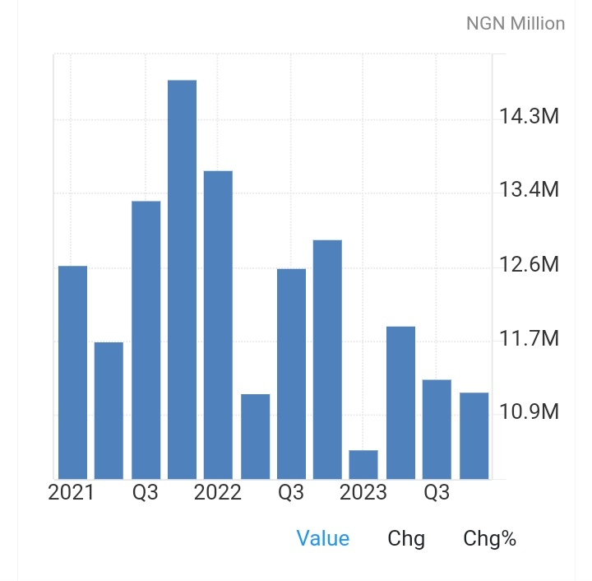

2. ALTERED CHANGES IN CONSUMER BEHAVIOUR
Studies have demonstrated that an inflationary environment influences consumer behavior (Brito & William, 2013)
There are various visible alterations in consumer spending during inflation. These alterations include:
Opting for Alternatives
Amid the escalating and rapid decrement in the value of money, consumers now showcase an obvious deviation in their spending habits. Consumers, therefore, pick out and plump for alternatives that are low and lesser in cost; either that or they defer and reschedule the purchases altogether(Decon & Norton, 2013). This shift is propelled by the persuasions and influence of inflation. These alternatives, in most cases, demand a reduction in spending, showcasing, however, the broader trend towards frugality. Due to this, consumers become hypervigilant about certain prices, making sure that they spend their income on resources that are essential and not over luxuries. During this period prices are given keen considerations as consumers focus and input their financial resources on significant and important purchases. An inflationary environment also sharpens consumers' approach towards shopping.

Price Shock
In times of inflation, consumers find themselves trapped as they wrestle and scuffle to adapt to the rapid increment in prices of goods and services. This adapting process or time prolongs to a great amount of time during which these consumers and their respective families adjust their spending relate with the sudden emergence of inflation in the economy. Using Nigeria as an example; the newly added increment in the price of petrol has had a devastating effects on the society. As fuel prices increased, various motorists (both private and public) were forced to reevaluate their financial decisions as regards that. Private motorists had to cut down their movements and therefore seek other available options, one of which is public transportation, which appears to be more economically advantageous.
Postponement of non-essential purchases
Amid the pressures of an inflationary environment, consumers are now willing to halt the purchasing of non-essentials and commodities. Luxuries, discretionary travel, expenses relating to entertainment, finances and for home improvement projects are hence deemed unnecessary and not substantial and therefore all purchases as to their regards are halted. This is due to the reduction of the spending strength of these consumers. As they push through these financial setbacks, many consumers are forced to create scale of preference and prioritize essential necessaries whilst taking out the unnecessary ones.This turnout of events has now resulted to inventory buildup and accumulation of stock among businesses.
Brand Disloyalty
An inflationary environment makes many consumers disloyal to various brands. This is necessitated by the fact that many consumers now seek brands which are on sales or on paid promotions. They do this in the bid to manage their expenses while in their inflationary environment.
Consumers prioritize value for money
In an inflationary environment, consumers distinguish and make discriminate spendings placing great accentuation on value for their money. Consumers no compare and contrast prices from stores and online in the bid to fine products that provide quality, durability and performance for a low cost.
As the escalation persists, consumers are now choosing essential purchases whilst abandoning the purchase of non-essentials. To sail through inflation, consumers now adopt various ways to manage their budget properly. These ways include looking for discounts and promotions, making bulk purchases, using cashback sand also making use of coupons. Consumers in an inflationary environment limit their purchases to only sales period, paying less for more. These strategies now make consumers make wise decisions and choices in their inflationary environment
CONCLUSION
Inflation showcases a complex and varied effect on consumer sending, determining how flexible consumers can be with their spendings. As price in commodities escalates, the spending strength of consumers fades; the extent to which it fades is determinant on various factors. In the climax of inflation, there is an decreased request for good that are not necessaries. The focus of consumers moves then to the basic amenities of survival.
During this period, consumers in their bid to scale through make various discerning decisions that tend to hold them over time. Amid inflation, consumers are forced to promise value for their money ; this leads to them making discriminate purchases placing great focus on essential purchases.

REFERENCES
Brito, R. D., & Williamson, J. G. (2013). Inflation and consumer spending. Journal of Economic Issues, 47(2), 341-354.

Deacon, R. T., & Norton, W. E. (2013). Inflation and consumer behavior. Journal of Consumer Research, 40(2), 267-281.

John Maynard Keynes (1936). The general theory of employment, interest and money

Khan, M. S., et al. (2017). The impact of inflation on consumer spending. International Journal of Economics and Finance, 9(5), 14-23.

Mishkin, F. S. (2007). The economics of money, banking, and financial markets. Pearson.

National Bureau of Statistics Nigeria.

Taylor, J. B. (2010). The role of inflation targeting in monetary policy. Journal of Economic Perspectives, 24(3), 3-15.
www.statista.com
www.tradingeconomics.com
www.investopedia.com

