Teaching a Diagnostic System to Reason Like a Clinician
Bayesian Inference for Coronary Heart Disease Prediction on the UCI Heart Disease Data
Assignment 3: Bayesian Inference Exercise
[Student Name]
[Course Code and Name]
[Instructor Name]
October 2026

Abstract
Doctors rarely start from a blank slate. Before a test result comes back they already have a sense of how likely heart disease is, based on the patient's age, sex, symptoms and what the medical literature says. We wanted our diagnostic model to work the same way. Using the Cleveland portion of the UCI Heart Disease data (303 patients, 46% with angiographic disease), we built a Bayesian logistic regression in PyMC whose priors come from published studies: a 37.6% base rate from a U.S. registry of nearly 400,000 angiograms, and effect sizes for sex, age, chest-pain type, exercise ECG findings and imaging from classic diagnostic research.
On a held-out test set of 61 patients, the literature-informed model reached 88.5% accuracy and an AUC of 0.961, compared with 85.2% and 0.955 for the same model with vague priors. A prior-data conflict check showed that the published chest-pain effects do not hold in this dataset, so we relaxed those two priors and added a likelihood that tolerates a small share of mislabelled cases. The refined model had the best leave-one-out score (ELPD -94.7 vs -101.3 for vague priors). We also show that feeding patients to the model in batches, with each posterior becoming the next prior, ends up in the same place as fitting everything at once, which is what a system that keeps learning needs. The gains from good priors are real but modest, and we are honest about where the test set is too small to separate the models.

1. Introduction
Coronary heart disease is still one of the leading causes of death worldwide, and invasive coronary angiography remains the reference test for confirming it. Angiography is expensive and carries a small but real risk, and a large registry study found that only 37.6% of patients sent for elective angiography actually had obstructive disease (Patel et al., 2010). A tool that estimates a patient's probability of disease from cheaper information could help decide who really needs the invasive test.
Our startup scenario asks for exactly that: a diagnostic engine that combines what is already known with new patient data and keeps updating as cases arrive. Bayesian inference is a natural fit for three reasons.
- It starts from prior knowledge. Decades of research on chest pain and stress testing would be wasted if the model learned only from a few hundred local patients.
- It reports uncertainty. A clinician deciding whether to refer someone needs to know whether "45% risk" means "somewhere between 40 and 50" or "we really have no idea".
- It updates naturally. Today's posterior can serve as tomorrow's prior, so the system can learn continuously without retraining from scratch.
This idea is not new to cardiology. Diamond and Forrester (1979) showed more than forty years ago that the meaning of a stress test result depends heavily on the pre-test probability, which is Bayes' theorem in a clinical setting. The team that collected the very data we use built a probability algorithm along the same lines. Our contribution is to do it with modern probabilistic programming, check it carefully, and see where the literature and the data agree or disagree.
The rest of the report covers the data (Section 2), how we built the priors (Section 3), the model (Section 4), validation (Section 5), refinement (Section 6), dynamic updating (Section 7), and a discussion of what we learned and what we would do next (Sections 8 and 9). All code is in the accompanying Jupyter notebook and helper module.

2. Dataset and Preprocessing

2.1 Source
We used the UCI Heart Disease dataset (Janosi et al., 1989), which holds patients referred for coronary angiography at four centres: the Cleveland Clinic, the Hungarian Institute of Cardiology in Budapest, University Hospitals in Zurich and Basel, and the V.A. Medical Center in Long Beach. The outcome is the angiographic result, coded 0 (less than 50% diameter narrowing in every major vessel) up to 4. Like most studies of this data, we treated any value above 0 as "disease present".
Each patient has 13 predictors that line up with what the assignment asks for. Symptoms: chest-pain type and exercise-induced angina. Medical history and risk factors: age, sex, resting blood pressure, cholesterol and fasting blood sugar. Test results: resting ECG, maximum heart rate, ST depression and ST slope during exercise, the number of major vessels coloured by fluoroscopy, and the thallium perfusion scan result.
Table 1
Patients, disease prevalence and missing test data by site
Site | Patients | With disease | Prevalence | Missing ca | Missing thal
Hungary | 294 | 106 | 36.1% | 99% | 90%
Cleveland | 303 | 139 | 45.9% | 1% | 1%
Long Beach VA | 200 | 149 | 74.5% | 99% | 83%
Switzerland | 123 | 115 | 93.5% | 96% | 42%
Note. ca = number of major vessels coloured by fluoroscopy; thal = thallium scan result.
Table 1 explains why we built the main model on Cleveland. The other three sites are missing the fluoroscopy and thallium results for almost every patient, and those turn out to be two of the strongest predictors. The table also shows something worth remembering: disease prevalence ranges from 36% in Hungary to 93% in Switzerland (Figure 1). The base rate depends on who gets referred, so a prior for prevalence should not be held too tightly.
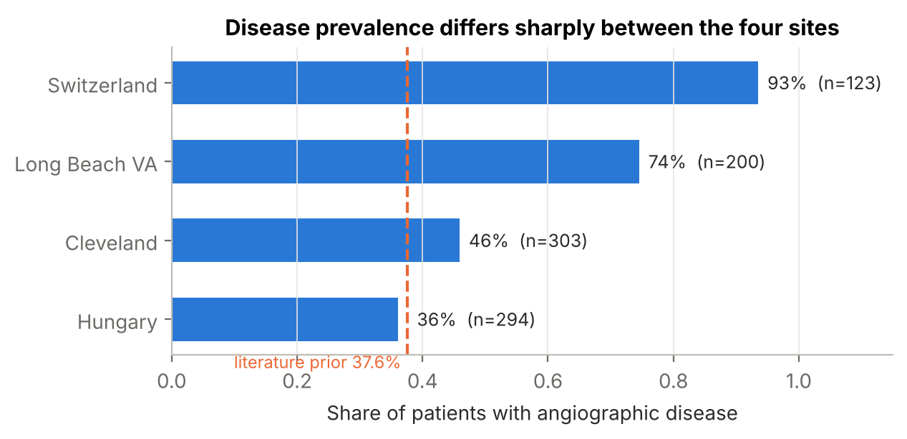
Figure 1. Share of patients with angiographic disease at each site. The dashed line marks the literature-based prior of 37.6% (Patel et al., 2010).

2.2 Exploration
Figure 2 compares patients with and without disease. Exercise test and imaging results separate the groups clearly: people with disease reach lower peak heart rates, show more ST depression, and are far more likely to have a reversible thallium defect or calcified vessels. Cholesterol barely separates them, which makes sense; it is a long-term risk factor, not a diagnostic sign.
One result surprised us. Patients coded as having asymptomatic chest pain had the highest disease rate (73%), while patients with typical angina had only 30%. Textbook teaching, and the Diamond and Forrester tables, say the opposite. We return to this in Section 6 because it ended up shaping the refined model.
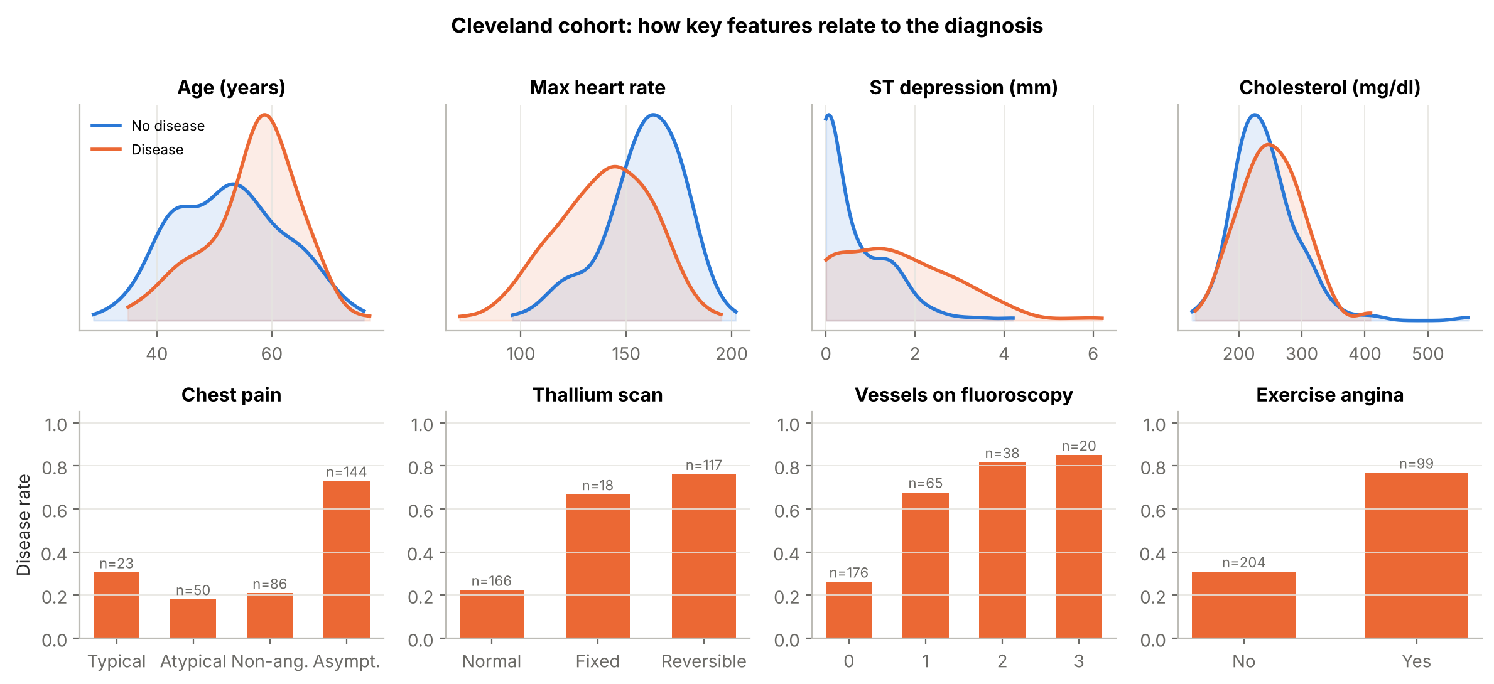
Figure 2. Cleveland cohort. Top row: distributions of four continuous features by diagnosis. Bottom row: disease rate by category, with group sizes above each bar.

2.3 Cleaning and encoding
The Cleveland file is fairly clean. Only the vessel count (4 patients) and the thallium result (2 patients) were missing, so we filled them with the most common value in the training set. The other steps were:
- Split. A stratified 80/20 split (242 training, 61 test patients, both 46% diseased) with a fixed random seed. The test set was not touched until validation.
- Categorical features. Chest pain, resting ECG, ST slope and thallium were one-hot encoded against a clinically "normal" reference level (typical angina, normal ECG, upsloping ST, normal scan). One resting ECG category had only four patients, so we merged it with the other abnormal category.
- Scaling. Continuous features were standardised, so their coefficients mean "per one standard deviation". Binary flags and the vessel count were only centred, which keeps each coefficient an ordinary log odds ratio and makes the literature priors easy to state.
- No leakage. All imputation values, means and standard deviations came from the training rows only, and were recomputed inside each fold during cross-validation.

3. Prior Knowledge

3.1 The base rate
The single most important piece of prior knowledge is how common the disease is among people like ours. The best match we found is Patel et al. (2010), who looked at 398,978 patients without known heart disease who underwent elective angiography across 663 U.S. hospitals. Only 37.6% had obstructive coronary disease. Our patients were also referred for angiography, so this is a sensible starting point.
We expressed this as a Beta distribution with mean 0.376 and an "effective sample size" of 50, that is, Beta(18.8, 31.2). The effective sample size is a judgement call. A registry of 400,000 patients is strong evidence about its own population, but referral habits in 1980s Cleveland were different, and Table 1 shows how much prevalence varies between centres. Giving the prior the weight of 50 patients lets the data overrule it quickly if they disagree. Because the Beta prior is conjugate to the Binomial likelihood, the update is just counting:
p(π | data) = Beta(a₀ + k, b₀ + n − k)
With k = 111 diseased patients out of n = 242 in the training set, the posterior is Beta(129.8, 162.2), with a mean of 44.5% and a 95% credible interval of 38.8% to 50.2% (Figure 3). The data pulled the estimate up from 37.6%, which matches what we would expect for a hospital that took more complex referrals than the national average.
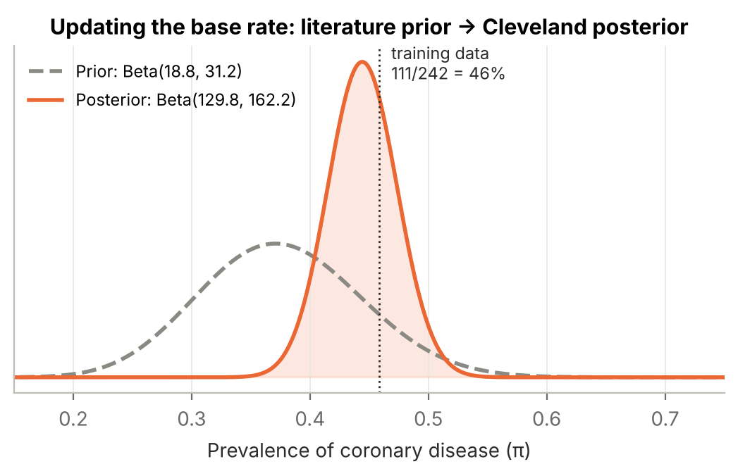
Figure 3. Prior and posterior for the prevalence of coronary disease. The dotted line is the raw rate in the training data.
As a side experiment we kept absorbing the other sites into the same Beta posterior. Adding Hungary moved the mean to 40.2%, adding Long Beach moved it to 49.0%, and adding Switzerland moved it to 55.0%. Each interval was narrow, yet the estimates kept jumping. That is a useful warning: when the populations really differ, a single pooled base rate is misleading, and a deployed system should track prevalence per site (Section 9).

3.2 Priors on risk-factor effects
The diagnostic model is a logistic regression, so every prior lives on the log odds scale. We compared two prior sets:
- M1, weakly informative. Every coefficient gets a Normal(0, 2.5²) prior, the style of default suggested by Gelman et al. (2008). It only says that enormous effects are unlikely.
- M2, literature informed. Each prior mean comes from a published odds ratio or likelihood ratio, and each standard deviation is set wide enough (0.3 to 0.75 on the log odds scale) to allow for differences between the studied populations and ours.
Turning a published number into a prior is easier than it sounds. A test with sensitivity Se and specificity Sp multiplies the odds of disease by the positive likelihood ratio, LR⁺ = Se / (1 − Sp). On the log odds scale that is simply an addition, which is exactly what a logistic regression coefficient is. For example, Gianrossi et al. (1989) pooled 147 studies of exercise ST depression and found an average sensitivity of 68% and specificity of 77%. That gives LR⁺ ≈ 3 and a log odds shift of about 1.1. Because ST depression is a continuous feature here and overlaps with exercise angina and ST slope, we centred its prior at 0.6 per standard deviation instead of the full 1.1.
Table 2 lists every prior and where it came from. Some priors rest directly on a published figure; others are our own judgement, guided by the same studies, and the table marks them as such. Where we could not find a defensible number at all, we said so and used a vague prior. The clearest case is "asymptomatic" chest pain, which has no clean equivalent in the clinical literature.
Table 2
Literature-informed priors used in M2 (Normal distributions on the log odds scale)
Feature | Prior mean | Prior SD | Prior odds ratio | Source
Age (per SD) | 0.40 | 0.30 | 1.49 | Diamond & Forrester (1979)
Resting blood pressure (per SD) | 0.20 | 0.30 | 1.22 | Judgement: small risk-factor effect
Cholesterol (per SD) | 0.20 | 0.30 | 1.22 | Judgement: small risk-factor effect
Max heart rate (per SD) | -0.30 | 0.50 | 0.74 | Judgement, guided by Gianrossi et al. (1989)
ST depression (per SD) | 0.60 | 0.40 | 1.82 | Gianrossi et al. (1989)
Male sex | 0.92 | 0.50 | 2.51 | Diamond & Forrester (1979)
Fasting blood sugar > 120 | 0.30 | 0.50 | 1.35 | Judgement: small risk-factor effect
Exercise-induced angina | 0.80 | 0.50 | 2.23 | Judgement, guided by Gianrossi et al. (1989)
Abnormal resting ECG | 0.20 | 0.50 | 1.22 | Judgement: small effect
Chest pain: atypical | -1.00 | 0.75 | 0.37 | Diamond & Forrester (1979)
Chest pain: non-anginal | -1.50 | 0.75 | 0.22 | Diamond & Forrester (1979)
Chest pain: asymptomatic | 0.00 | 1.50 | 1.00 | No clear analogue; kept vague
ST slope: flat | 0.50 | 0.50 | 1.65 | Judgement, guided by Gianrossi et al. (1989)
ST slope: downsloping | 0.70 | 0.60 | 2.01 | Judgement, guided by Gianrossi et al. (1989)
Thallium: fixed defect | 0.70 | 0.60 | 2.01 | Knuuti et al. (2018)
Thallium: reversible defect | 1.00 | 0.50 | 2.72 | Knuuti et al. (2018)
Calcified vessels (per vessel) | 0.80 | 0.40 | 2.23 | Judgement, guided by Knuuti et al. (2018)
Note. M1 uses Normal(0, 2.5²) for every coefficient. Both models use an intercept prior; M2 centres it on logit(0.376) = −0.51 with SD 0.5.

3.3 How the priors enter the model, and what we assumed
Because all predictors are centred, the intercept is the log odds of disease for an "average" patient in the sample. That lets us tie the intercept prior directly to the base rate: Normal(logit(0.376), 0.5²). The coefficient priors then shift each patient's log odds up or down from that starting point. Bayes' rule combines everything:
p(α, β | y, X) ∝ p(y | X, α, β) × p(α) × ∏ⱼ p(βⱼ)
The main assumptions behind this set-up are worth stating plainly:
- Published effects measured in other populations are roughly transportable to Cleveland. The wide prior SDs are our hedge against this being only partly true.
- Each prior is independent of the others. In reality some effects overlap (exercise angina, ST depression and ST slope all describe the same stress test), so the joint prior may count some evidence twice. We reduced the prior means for overlapping features for this reason.
- Effects are additive and linear on the log odds scale, with no interactions.
- Angiography is treated as ground truth, although it is itself imperfect. Model M4 relaxes this assumption.

3.4 Prior predictive check
Before fitting anything, we asked what each prior set implies about patient risk. Figure 4 shows predictions for the training patients drawn from the priors alone. The "vague" M1 prior turned out to be far from neutral. With 17 predictors, Normal(0, 2.5²) effects add up to huge log odds, so 57% of its prior predictions are below 2% or above 98%. In effect it assumes, before seeing any data, that most patients are either certainly sick or certainly healthy. The literature prior puts 20% of predictions in those extremes and spreads the rest across the plausible range. This is a good example of why "uninformative" priors deserve a second look in models with many predictors.
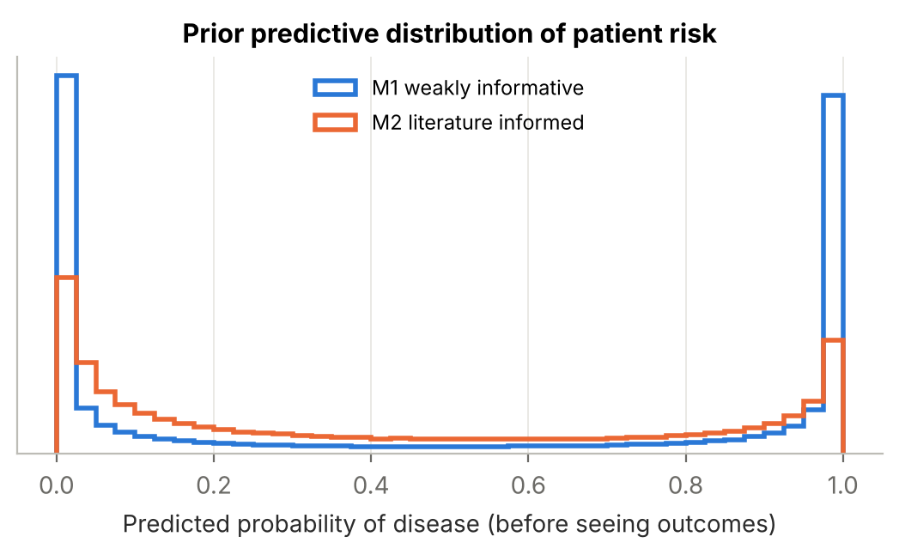
Figure 4. Prior predictive distribution of the probability of disease for training patients, before any outcomes are seen.

4. The Bayesian Model

4.1 Specification
Each patient's diagnosis is a Bernoulli outcome whose probability depends on their features through the logistic function:
yᵢ ~ Bernoulli(pᵢ), logit(pᵢ) = α + Σⱼ βⱼ xᵢⱼ
α ~ Normal(μ_α, σ_α²), βⱼ ~ Normal(μⱼ, σⱼ²)
We implemented the model in PyMC version 5 (Abril-Pla et al., 2023) and drew samples with the No-U-Turn Sampler: four chains, 1,500 tuning steps and 2,000 draws each, giving 8,000 posterior draws. Diagnostics and model comparison used the ArviZ library.
For a new patient with features x*, the system does not report a single number from a single "best" set of coefficients. Instead it averages over every plausible set of coefficients, weighted by how well each fits the data:
P(y* = 1 | x*, data) ≈ (1/S) Σₛ σ(α⁽ˢ⁾ + β⁽ˢ⁾ᵀ x*)
The spread of the S individual values gives a credible interval for that patient's risk. The function diagnose() in the notebook wraps this so a raw patient record goes in and a probability with a 95% interval comes out (Section 7.3).

4.2 Convergence
All four models converged cleanly. Every R-hat was 1.00, the smallest bulk effective sample size was 4,854, and none of the models had a single divergent transition. Figure 5 shows the trace plots for M2: the chains overlap and look like random noise with no trends, which is what good mixing looks like.
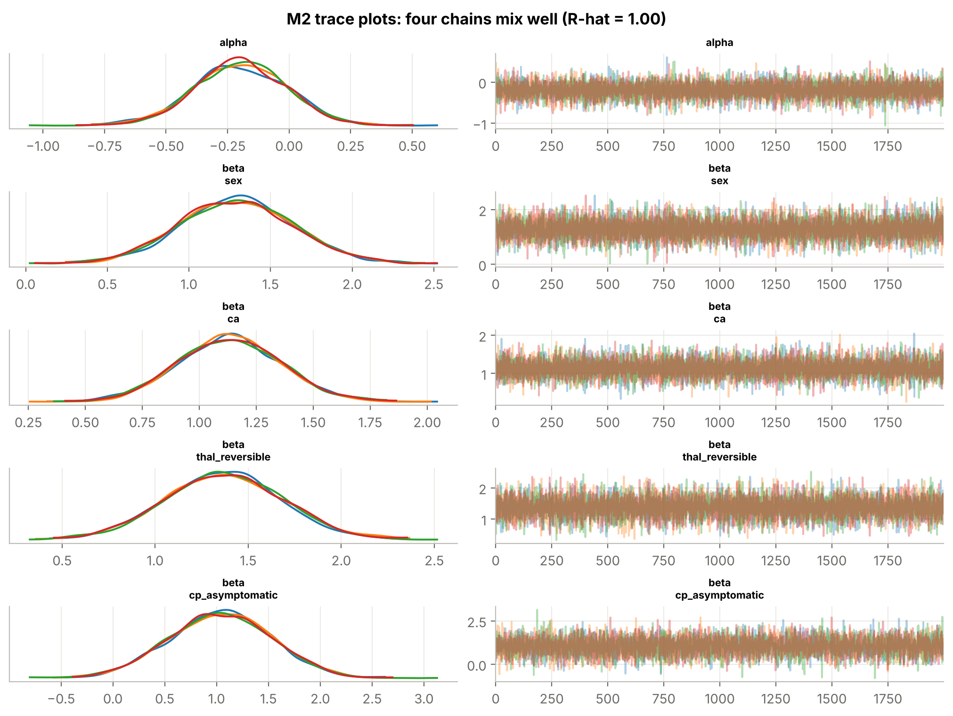
Figure 5. Trace plots for the intercept and four coefficients of M2. Left: posterior density per chain. Right: sampled values across iterations.

4.3 Posterior distributions
Figure 6 shows how the data changed our beliefs about six key coefficients. For most features, including male sex, reversible thallium defects and calcified vessels, the posterior sits close to or a little beyond the literature prior and is much narrower. That means the data agreed with the literature and sharpened it. The chest-pain coefficients look different. For atypical chest pain, the prior says "lower risk than typical angina", the data alone (the M1 posterior, dotted) say "higher risk", and the M2 posterior ends up as a compromise between the two. A compromise between two things that disagree is not always a good answer, and that observation led to the refinement in Section 6.
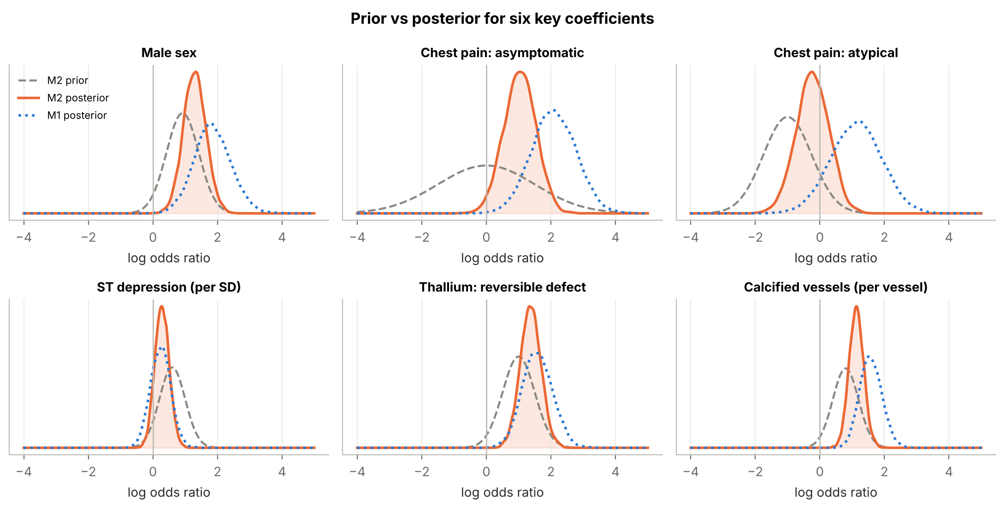
Figure 6. Prior (grey dashed), M2 posterior (orange) and M1 posterior (blue dotted) for six coefficients on the log odds scale.

5. Validation Results
We evaluated every model on the 61 test patients it had never seen. A patient was classed as diseased when their posterior predictive probability was at least 0.5. Alongside the usual classification metrics we report the Brier score (mean squared error of the probabilities; lower is better) and the test log-likelihood, computed the Bayesian way as the log pointwise predictive density, lppd = Σᵢ log[(1/S) Σₛ p(yᵢ | θ⁽ˢ⁾)]. A value closer to zero means the model put more probability on what actually happened. As a frequentist reference we also fitted an ordinary maximum-likelihood logistic regression (MLE) on the same features.
Table 3
Test-set performance (n = 61; 28 with disease)
Model | Accuracy | Sensitivity | Specificity | AUC (95% CI) | Brier | Test log-lik.
Baseline (MLE) | 85.2% | 89.3% | 81.8% | 0.955 (0.89–1.00) | 0.086 | -18.15
M1 | 85.2% | 89.3% | 81.8% | 0.955 (0.89–1.00) | 0.086 | -17.92
M2 | 88.5% | 92.9% | 84.8% | 0.961 (0.91–1.00) | 0.081 | -16.59
M3 | 88.5% | 92.9% | 84.8% | 0.962 (0.91–1.00) | 0.080 | -16.70
M4 | 88.5% | 92.9% | 84.8% | 0.962 (0.91–1.00) | 0.081 | -16.91
Note. AUC intervals come from 2,000 bootstrap resamples of the test set. M3 and M4 are the refined models described in Section 6.
Table 3 tells a consistent story. The literature-informed M2 beats both the vague-prior M1 and the MLE baseline on every metric: two more patients classified correctly, a higher AUC, a lower Brier score and a better test log-likelihood. The improvement in log-likelihood (-16.6 vs -17.9) matters most to us, because it measures the quality of the probabilities themselves, which is what a clinician would actually use.
At the same time, we should not oversell it. All five models have overlapping AUC intervals, and with 61 patients one or two cases decide the ranking. That is why we also relied on leave-one-out and five-fold cross-validation in Section 6.
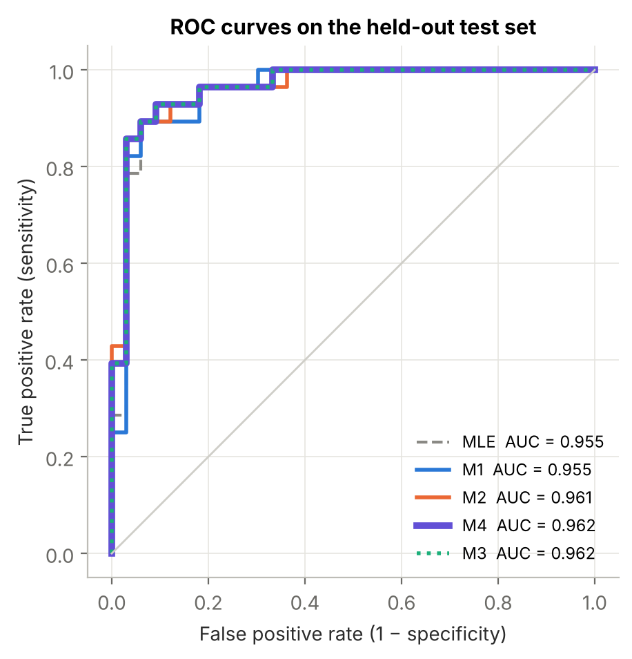
Figure 7. ROC curves on the test set. M3 (dotted) lies on top of M4.
The ROC curves (Figure 7) are all high and close together, with AUCs between 0.955 and 0.962. The confusion matrices (Figure 8) show where the gain from priors comes from: M2 picks up one more true case of disease and avoids one false alarm compared with M1. From a clinical point of view the two missed cases (false negatives) are the more worrying errors, and Section 8 discusses how the decision threshold could be moved to reduce them.
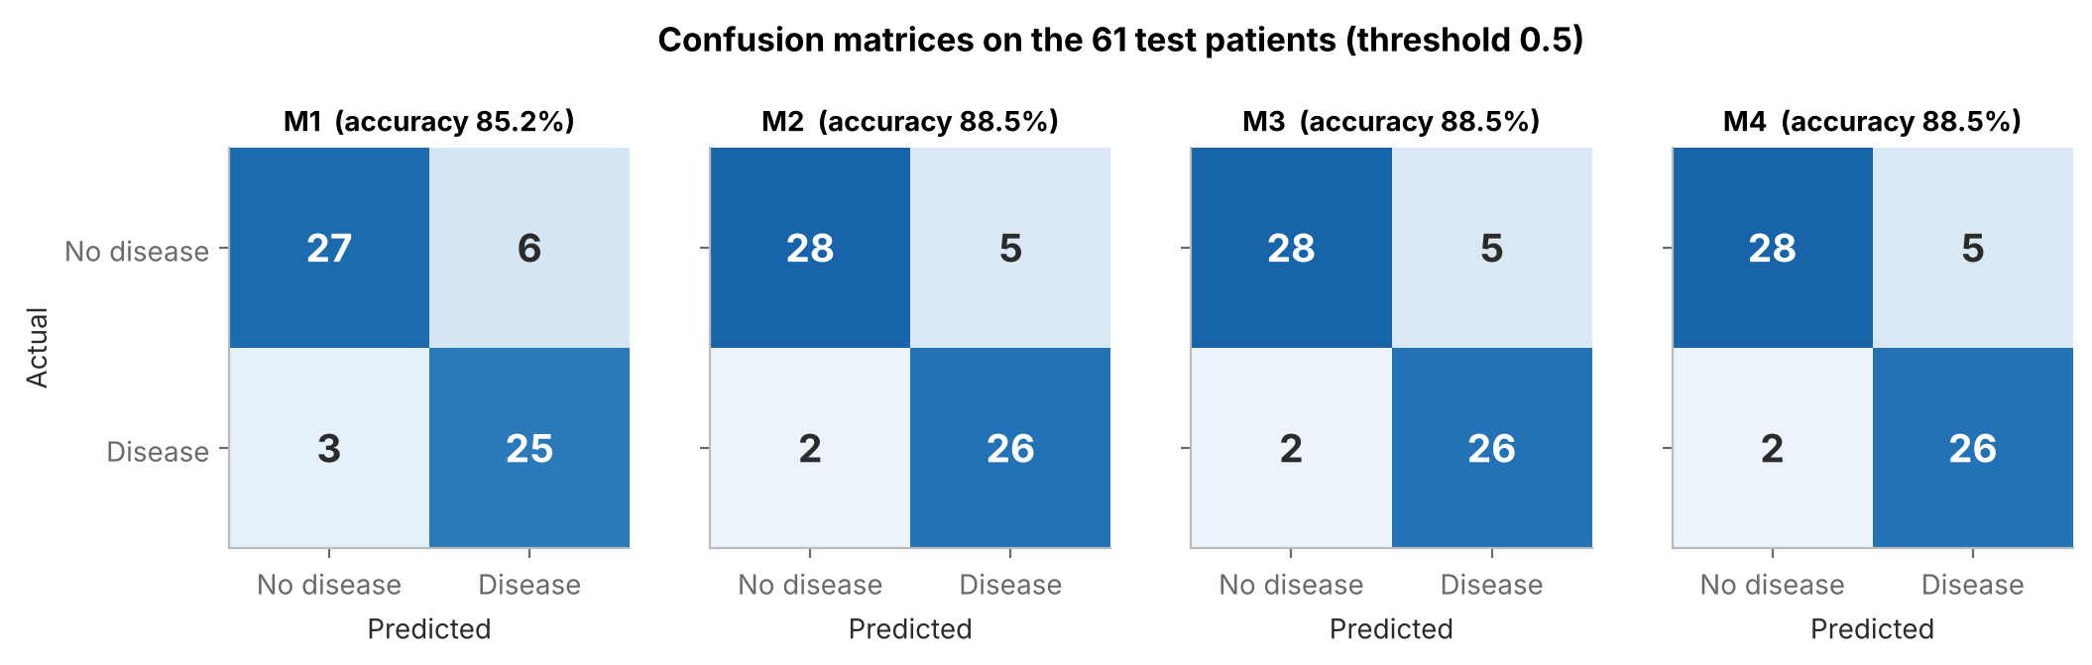
Figure 8. Confusion matrices for the four Bayesian models on the 61 test patients (threshold 0.5).
Calibration (Figure 9) checks whether a predicted 70% really means that about 70% of such patients have disease. All models track the diagonal reasonably well. They are slightly over-confident in the middle range, which is common for logistic models trained on a few hundred patients and is hard to judge with only about 12 patients per bin.
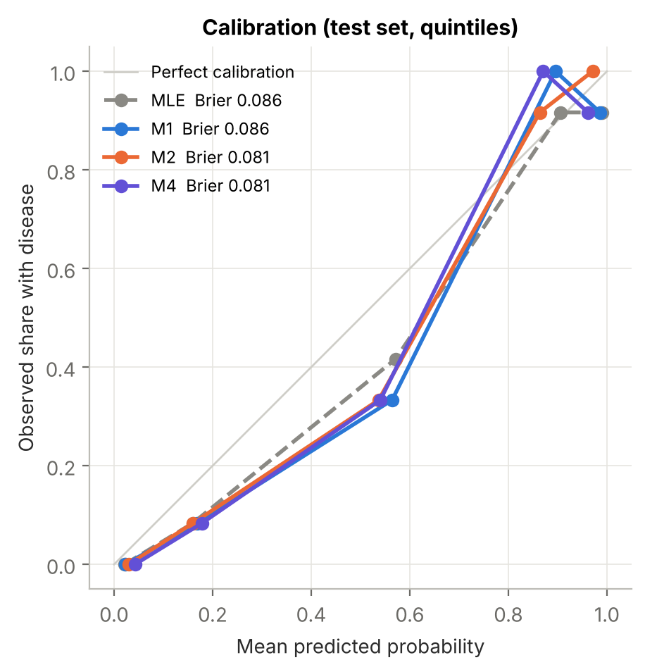
Figure 9. Calibration on the test set, using predicted-probability quintiles.

6. Iteration and Refinement

6.1 Finding where the priors and the data disagree
Section 4 suggested that the chest-pain priors were fighting the data. To check this formally (Figure 10), without peeking at the test set, we compared each literature prior with what the training data say on their own (the M1 posterior, which is barely affected by its vague prior). For each coefficient we computed
zⱼ = (data meanⱼ − prior meanⱼ) / √(data SDⱼ² + prior SDⱼ²)
A large |z| means the published effect and the local data disagree by more than their combined uncertainty can explain. We used a deliberately sensitive cut-off of |z| > 1.645 (two-sided p < .10), since the cost of missing a conflict is higher than the cost of relaxing a prior unnecessarily.
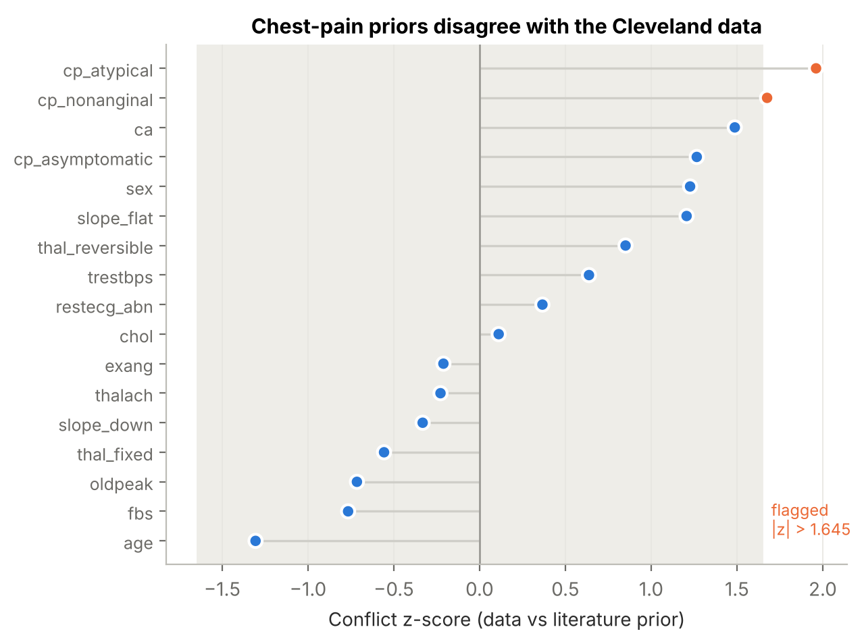
Figure 10. Conflict z-scores for every literature prior. The shaded band is |z| ≤ 1.645.
Only two priors were flagged, and both are chest-pain categories: atypical (z = 1.96) and non-anginal (z = 1.68). Every other prior, including the imaging and exercise-test priors, was consistent with the Cleveland data. We think there are a few possible reasons for the chest-pain mismatch. The typical-angina group is small (23 patients), the dataset's chest-pain coding may not match modern clinical definitions, and referral patterns may have sent many low-risk typical-angina patients to angiography. We cannot tell which explanation is right, but the practical conclusion is the same: the published chest-pain effects should not be imposed on this data.

6.2 Two refinements
M3, adjusted priors. We replaced the two conflicting priors with a neutral Normal(0, 1.5²) and kept every other literature prior unchanged. This keeps the useful information and stops the model from forcing a relationship that the data do not support.
M4, adjusted priors and a modified likelihood. Angiography is not perfect, and a research file from the 1980s probably contains a few recording errors. In a standard logistic model, a single mislabelled patient with extreme features can pull the coefficients noticeably. M4 uses a mislabel-robust likelihood:
P(yᵢ = 1) = ε × 0.5 + (1 − ε) × σ(α + βᵀxᵢ), ε ~ Beta(1, 19)
Here ε is the share of outcomes that behave like coin flips. The Beta(1, 19) prior expects about 5%. The posterior estimate was ε = 0.037 (94% HDI 0.00 to 0.09), so roughly 3 to 4% of labels look like noise. That is reassuring about the data and also explains why the robust model changes the predictions only slightly.

6.3 Re-evaluation
We compared all four models with Pareto-smoothed importance sampling leave-one-out cross-validation (PSIS-LOO; Vehtari et al., 2017). It estimates out-of-sample predictive accuracy from the training data and is far less noisy than our small test set. All Pareto k values were below 0.7, so the estimates are reliable. Table 4 and Figure 11 summarise the comparison.
Table 4
Leave-one-out comparison on the training data
Model | ELPD-LOO | SE | Difference from best | SE of difference | Effective parameters (p_loo)
M4 | -94.69 | 9.07 | 0.00 | 0.00 | 10.8
M3 | -95.25 | 9.55 | 0.56 | 0.71 | 11.8
M2 | -96.50 | 9.77 | 1.81 | 1.65 | 11.5
M1 | -101.32 | 11.56 | 6.63 | 3.29 | 19.9
Note. ELPD = expected log pointwise predictive density; higher is better.
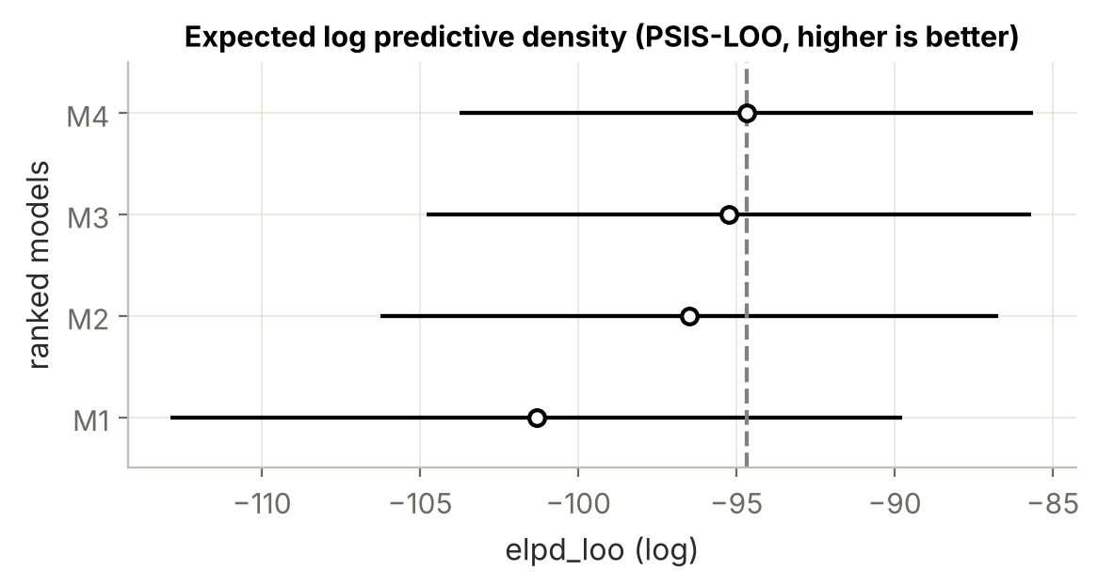
Figure 11. PSIS-LOO estimates with standard errors. The dashed line marks the best model.
The ranking is M4, M3, M2, M1. The biggest single gain comes from using literature priors at all: M2 improves on M1 by 4.8 ELPD points, and M1 trails the best model by 6.6 points, about two standard errors of that difference. The priors also nearly halve the effective number of parameters, from 19.9 to 11.5. In other words, they act as sensible regularisation and stop the model from chasing noise. The two refinements add smaller, steady gains that are within one standard error. On the test set (Table 3), M3 and M4 classify exactly the same patients as M2, with a marginally higher AUC.
To make sure the ranking did not depend on one lucky split, we also re-ran the whole pipeline with five-fold stratified cross-validation on all 303 patients (Table 5).
Table 5
Five-fold cross-validation on the full Cleveland cohort (mean ± SD across folds)
Model | Accuracy | Sensitivity | Specificity | AUC | Brier | Log-loss
Baseline (MLE) | 0.838 ± 0.021 | 0.777 ± 0.032 | 0.891 ± 0.046 | 0.912 ± 0.021 | 0.119 ± 0.016 | 0.388 ± 0.056
M1 | 0.851 ± 0.039 | 0.791 ± 0.042 | 0.903 ± 0.049 | 0.912 ± 0.021 | 0.117 ± 0.016 | 0.382 ± 0.057
M2 | 0.845 ± 0.041 | 0.806 ± 0.040 | 0.879 ± 0.060 | 0.919 ± 0.024 | 0.116 ± 0.017 | 0.369 ± 0.048
M3 | 0.855 ± 0.034 | 0.784 ± 0.038 | 0.915 ± 0.039 | 0.917 ± 0.023 | 0.113 ± 0.016 | 0.363 ± 0.044
M4 | 0.855 ± 0.029 | 0.784 ± 0.038 | 0.915 ± 0.039 | 0.918 ± 0.023 | 0.113 ± 0.016 | 0.363 ± 0.041

Cross-validation confirms the picture with one useful nuance. The literature priors (M2, M3, M4) give lower log-loss and Brier scores than either vague priors or MLE, so their probabilities are more trustworthy. Accuracy at the fixed 0.5 threshold is very similar across all models (about 84 to 86%), and M2 is actually a touch below M1 on accuracy. The refined M3 and M4 have the best accuracy, specificity, Brier score and log-loss of the group. Priors improve the quality of the probabilities more than the yes/no calls, and for a clinical decision tool the probabilities are what matter.

6.4 What the final model learned
Table 6 lists the posterior odds ratios from M4. The strongest signals are the ones a cardiologist would expect from tests: a reversible thallium defect (odds ratio about 4.5), each additional calcified vessel (about 3.5 per vessel), a flat ST slope, and exercise-induced angina. Male sex roughly quadruples the odds. The "asymptomatic" chest-pain category has the largest effect of all, a quirk of this dataset that the model learned once we stopped forcing the literature prior on it. Classic risk factors such as cholesterol, blood pressure and blood sugar add little once test results are known, which fits the view that they predict who will develop disease rather than who has it today.
Table 6
Posterior odds ratios from the final model M4 (median and 94% highest density interval)
Feature | Odds ratio | 94% HDI | P(effect > 0)
Chest pain: asymptomatic | 5.61 | 1.84 – 17.45 | 1.00
Thallium: reversible defect | 4.48 | 2.27 – 8.29 | 1.00
Male sex | 3.82 | 1.95 – 7.90 | 1.00
Calcified vessels (per vessel) | 3.45 | 2.17 – 5.82 | 1.00
ST slope: flat | 2.43 | 1.27 – 4.67 | 0.99
Exercise-induced angina | 2.12 | 1.07 – 4.08 | 0.98
Chest pain: atypical | 2.08 | 0.54 – 7.61 | 0.85
Thallium: fixed defect | 1.68 | 0.67 – 4.44 | 0.85
ST slope: downsloping | 1.59 | 0.61 – 4.30 | 0.81
ST depression (per SD) | 1.45 | 0.92 – 2.32 | 0.94
Abnormal resting ECG | 1.42 | 0.78 – 2.62 | 0.86
Resting blood pressure (per SD) | 1.30 | 0.92 – 1.79 | 0.93
Cholesterol (per SD) | 1.20 | 0.86 – 1.68 | 0.84
Fasting blood sugar > 120 | 1.13 | 0.54 – 2.35 | 0.62
Age (per SD) | 1.11 | 0.78 – 1.59 | 0.71
Chest pain: non-anginal | 0.85 | 0.25 – 2.72 | 0.40
Max heart rate (per SD) | 0.70 | 0.43 – 1.11 | 0.07

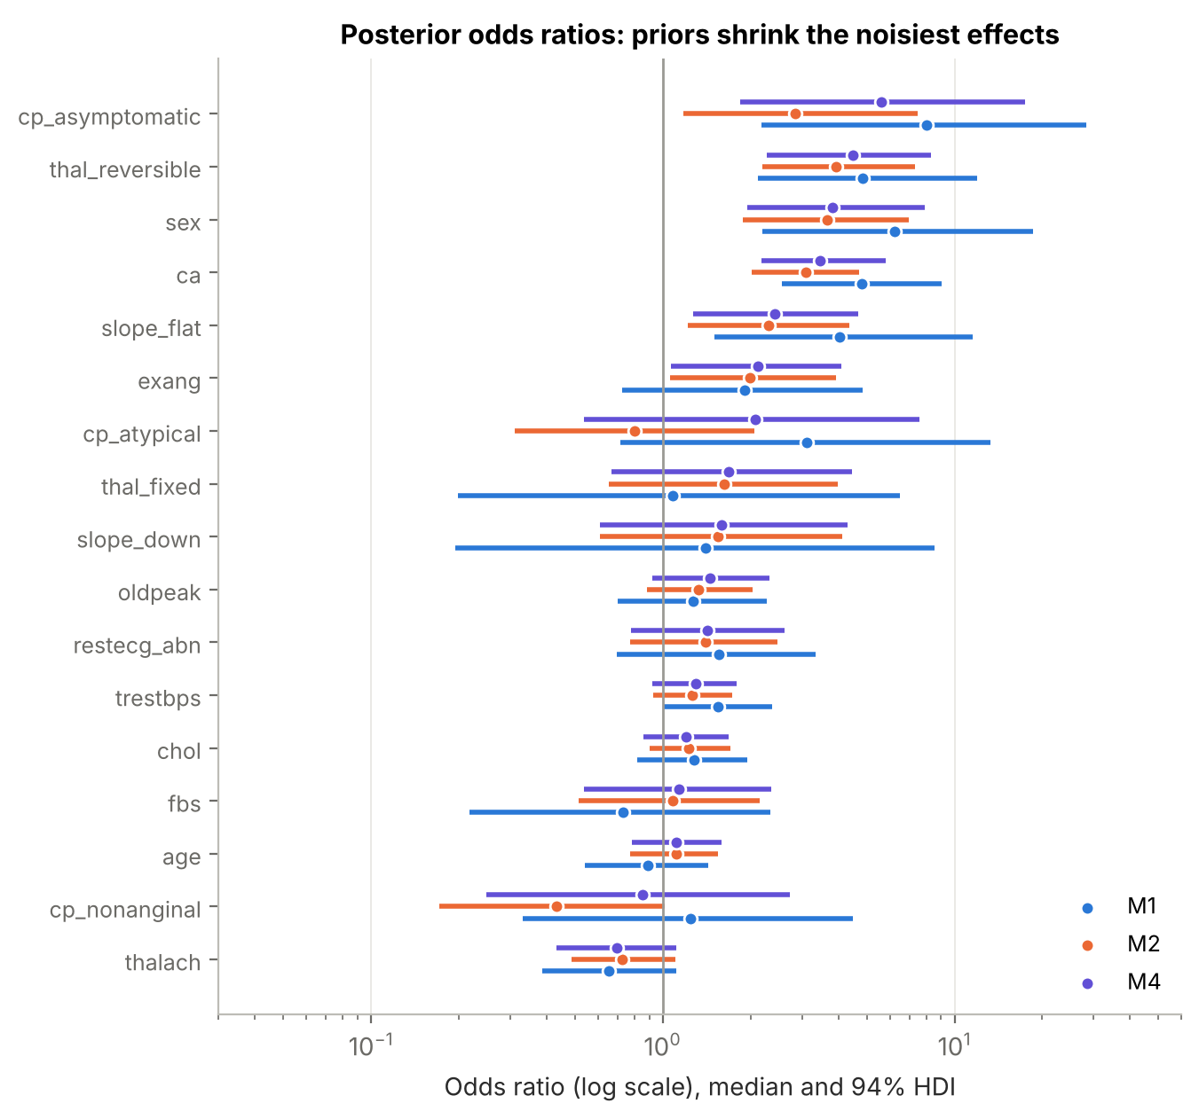
Figure 12. Posterior odds ratios (log scale) for M1, M2 and M4. Literature priors narrow the intervals, especially for features with few patients.
Figure 12 shows the effect of the priors visually. M1's intervals (blue) are wide for features with few patients, such as fasting blood sugar, fixed thallium defects and downsloping ST segments. The literature priors pull these toward sensible values and narrow them, which is exactly the "borrowing strength from prior research" that Bayesian methods promise.

7. Dynamic Updating

7.1 Learning one batch at a time
A real diagnostic system does not receive all its patients on day one. Bayes' theorem handles this directly, because the posterior after the first batch of data is the right prior for the second:
p(θ | D₁, D₂) ∝ p(D₂ | θ) × p(θ | D₁)
To show this, we fed the 242 training patients to the model in five batches of about 48. After each batch, we summarised the joint posterior of all 18 parameters as a multivariate Normal distribution (its mean vector and full covariance matrix) and used that as the prior for the next batch. We started from the refined M3 priors and scored the model on the same test set after every update.
Table 7
Test-set performance as patients are absorbed sequentially
Patients seen | Accuracy | AUC | Log-loss | Brier | Test log-lik.
0 (priors only) | 88.5% | 0.942 | 0.361 | 0.106 | -21.99
49 | 88.5% | 0.951 | 0.301 | 0.088 | -18.39
98 | 91.8% | 0.960 | 0.285 | 0.082 | -17.41
146 | 88.5% | 0.955 | 0.291 | 0.084 | -17.74
194 | 88.5% | 0.959 | 0.278 | 0.083 | -16.99
242 | 88.5% | 0.960 | 0.275 | 0.081 | -16.77

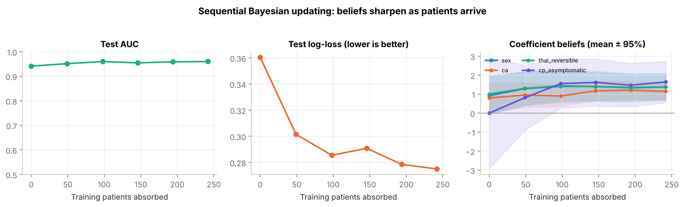
Figure 13. Sequential updating. Left and middle: test AUC and log-loss after each batch. Right: posterior mean and 95% interval of four coefficients.
Two results stood out. First, the literature priors on their own, before a single Cleveland outcome was seen, already ranked the test patients with an AUC of 0.942. That is strong evidence that the published knowledge is genuinely useful. Second, the probabilities kept improving as data arrived: log-loss fell from 0.361 to 0.275, and the coefficient intervals narrowed steadily (Figure 13, right). The "asymptomatic" coefficient shows the process most clearly. It started at zero with a wide interval and moved up to about 1.6 as evidence accumulated.
We also checked whether the batch-by-batch posterior matches a model fitted to all 242 patients at once. The largest difference in any coefficient's posterior mean was 0.06 on the log odds scale, much smaller than the posterior standard deviations (0.17 to 0.67). The Gaussian summary between batches therefore loses very little, so a deployed system could update cheaply as new cases come in without refitting on its full history.

7.2 What updating means for one patient
Figure 14 follows one borderline test patient through the updates: a 58-year-old man with atypical chest pain, a flat ST slope, a reversible thallium defect and no calcified vessels, whose angiogram turned out negative. With only the priors, the model's belief about him was spread across nearly the whole range (95% interval width 0.92). After all 242 patients the interval had shrunk to 0.56, centred near 45 to 50%.
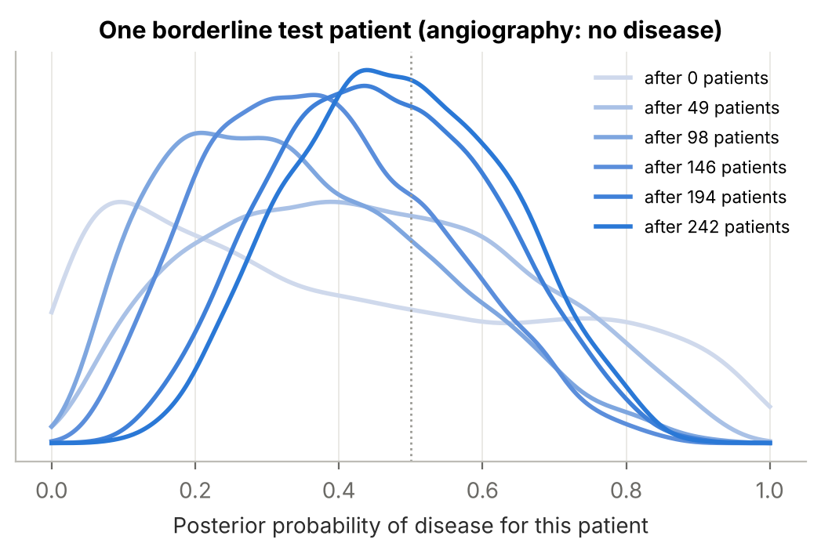
Figure 14. Posterior distribution of the probability of disease for one test patient after each batch of training data.
This is an honest answer. Even after learning from all the data, the model is genuinely unsure about this man, and it says so. A point-estimate model would simply output a number like 0.49 and leave the clinician to guess how much to trust it. Here the clinician can see that the evidence is mixed and that a further test may be worth ordering.

7.3 Using the system
The notebook's diagnose() function takes a raw patient record and returns the posterior probability with a 95% credible interval from the final model. Three made-up example patients show the range of outputs:
Table 8
Example outputs from the final model for three hypothetical patients
Patient | Posterior probability | 95% credible interval
55-year-old woman, non-anginal pain, normal tests | 2.7% | 0.7% – 5.9%
60-year-old man, asymptomatic, 1 mm ST depression, reversible defect | 96.2% | 92.4% – 98.6%
48-year-old man, atypical pain, flat ST slope, otherwise normal | 20.7% | 7.0% – 42.9%

The model is confident at both ends and appropriately uncertain in the middle. The 48-year-old man with atypical pain and a flat ST slope gets a best estimate of about 21%, but with an interval from 7% to 43%, which is exactly the middle range where a non-invasive test adds the most information (Knuuti et al., 2018).

8. Discussion

8.1 What we found
Prior knowledge helps, and it helps the probabilities most. Literature-informed priors improved every measure of probability quality we looked at: test log-likelihood, Brier score, LOO and cross-validated log-loss. Their effect on raw accuracy was smaller and partly within noise. Since the value of a diagnostic tool lies in its probabilities (they feed into referral thresholds, shared decisions and cost-benefit calculations), this is the more important result.
"Uninformative" priors are not harmless. The prior predictive check showed that the default Normal(0, 2.5²) prior, spread across 17 predictors, assumes extreme risks for most patients before seeing any data. It also needed about 20 effective parameters against 11 to 12 for the informed models.
Literature does not always transfer, and the model should notice. The conflict check caught the one place where the published evidence clashed with our data. Without that check we would have kept a prior that quietly worsened the fit. We think this is the most practically useful part of the workflow: priors from the literature are a starting point to be tested, not a fact to be imposed.
Bayesian updating works as advertised. Sequential updating reached the same answer as batch fitting, and the priors alone already gave useful predictions. A system built this way can be useful from its first day and keep improving as cases come in.

8.2 Limitations
- Small test set. With 61 test patients, differences of one or two patients decide the ranking. We addressed this with LOO and cross-validation, but a larger external test would be far more convincing.
- Old, single-centre data. The Cleveland data were collected in the 1980s. Testing practices, imaging technology and referral patterns have changed a great deal since then, and contemporary cohorts show a lower prevalence of obstructive disease than older ones.
- Prior construction involves judgement. Turning published odds ratios into priors required choices about overlap between features and how much to widen the SDs. Someone else could reasonably make different choices. We tried to make ours transparent (Table 2) so they can be challenged.
- Independent priors. We treated prior effects as independent, although exercise-test features clearly overlap. A joint prior built from a multivariable study would be more principled.
- Threshold choice. We used a 0.5 cut-off for classification. In practice, missing disease is usually worse than a false alarm, so a lower threshold would be preferred. The posterior probabilities make it easy to choose a threshold based on the costs of each error.
- Linear effects only. We did not model interactions (for example, age by sex) or non-linear effects of continuous variables.

8.3 Potential improvements
- Hierarchical model across sites. Let each hospital have its own intercept (base rate), drawn from a shared distribution. This would use all 920 patients and directly address the prevalence differences in Table 1. Missing test results at the other sites could be handled through Bayesian imputation within the model.
- Better-structured priors. Use a multivariate prior derived from a modern multivariable prediction model, or a shrinkage prior such as the regularised horseshoe for features without good literature.
- Decision analysis. Combine the posterior probabilities with the costs and risks of angiography to recommend "refer", "test further" or "reassure", instead of a single yes/no.
- Ordinal outcome. Use the full 0 to 4 severity scale with an ordinal logistic model, so the system can also estimate how many vessels are likely to be affected.
- Monitoring for drift. Re-run the prior-data conflict check regularly in deployment, so the system notices when a new hospital's patients behave differently from the ones it learned from.

9. Conclusion and Next Steps
We set out to build a diagnostic model that reasons the way a careful clinician does: start from what is known, look at the evidence, and update. The Bayesian logistic regression we built does this. Literature-based priors gave it a head start (AUC 0.94 before seeing any local outcomes), improved the quality of its probabilities compared with vague priors and a standard logistic regression, and acted as sensible regularisation. A simple prior-data conflict check identified the one area where the literature did not fit, and relaxing those priors together with a mislabel-robust likelihood produced the best model by leave-one-out cross-validation. Sequential updating produced the same answer as fitting all the data at once, so the system can keep learning as cases arrive.
The improvements are real but modest, and we would not claim more than the data support. For next steps, we would prioritise the following:
- Build a hierarchical version across all four sites, with site-specific base rates and in-model imputation of missing test results.
- Validate the model on a modern external cohort before any clinical use.
- Replace the fixed 0.5 threshold with a cost-sensitive decision rule developed with clinicians.
- Package the sequential update and conflict check into a monitoring routine that runs as each new batch of confirmed diagnoses arrives.

References
Abril-Pla, O., Andreani, V., Carroll, C., Dong, L., Fonnesbeck, C. J., Kochurov, M., Kumar, R., Lao, J., Luhmann, C. C., Martin, O. A., Osthege, M., Vieira, R., Wiecki, T., & Zinkov, R. (2023). PyMC: A modern, and comprehensive probabilistic programming framework in Python. PeerJ Computer Science, 9, e1516. https://doi.org/10.7717/peerj-cs.1516
Diamond, G. A., & Forrester, J. S. (1979). Analysis of probability as an aid in the clinical diagnosis of coronary-artery disease. New England Journal of Medicine, 300(24), 1350–1358. https://doi.org/10.1056/NEJM197906143002402
Gelman, A., Jakulin, A., Pittau, M. G., & Su, Y.-S. (2008). A weakly informative default prior distribution for logistic and other regression models. The Annals of Applied Statistics, 2(4), 1360–1383. https://doi.org/10.1214/08-AOAS191
Gianrossi, R., Detrano, R., Mulvihill, D., Lehmann, K., Dubach, P., Colombo, A., McArthur, D., & Froelicher, V. (1989). Exercise-induced ST depression in the diagnosis of coronary artery disease: A meta-analysis. Circulation, 80(1), 87–98. https://doi.org/10.1161/01.CIR.80.1.87
Janosi, A., Steinbrunn, W., Pfisterer, M., & Detrano, R. (1989). Heart disease [Data set]. UCI Machine Learning Repository. https://doi.org/10.24432/C52P4X
Knuuti, J., Ballo, H., Juarez-Orozco, L. E., Saraste, A., Kolh, P., Rutjes, A. W. S., Jüni, P., Windecker, S., Bax, J. J., & Wijns, W. (2018). The performance of non-invasive tests to rule-in and rule-out significant coronary artery stenosis in patients with stable angina: A meta-analysis focused on post-test disease probability. European Heart Journal, 39(35), 3322–3330. https://doi.org/10.1093/eurheartj/ehy267
Patel, M. R., Peterson, E. D., Dai, D., Brennan, J. M., Redberg, R. F., Anderson, H. V., Brindis, R. G., & Douglas, P. S. (2010). Low diagnostic yield of elective coronary angiography. New England Journal of Medicine, 362(10), 886–895. https://doi.org/10.1056/NEJMoa0907272
Vehtari, A., Gelman, A., & Gabry, J. (2017). Practical Bayesian model evaluation using leave-one-out cross-validation and WAIC. Statistics and Computing, 27(5), 1413–1432. https://doi.org/10.1007/s11222-016-9696-4

Appendix: Code and Reproducibility
All analysis code is provided with this report:
- Bayesian_Heart_Disease_Diagnosis.ipynb runs the full analysis from data loading to dynamic updating, with markdown explanations between steps. It saves every figure in this report to figures/ and every table to results/.
- bayes_heart.py is a helper module with commented functions for preprocessing, prior specifications, model construction (standard and robust likelihood), prediction, metrics, the prior-data conflict check and sequential updating.
- data/ contains the four processed UCI files and the original variable description.
Software: Python 3, PyMC 5, ArviZ 0.22, scikit-learn, NumPy, pandas, SciPy and matplotlib. A fixed random seed (42) is used throughout. The full notebook runs in about six minutes on a four-core laptop, most of it in the five-fold cross-validation.
To reproduce: install the packages in requirements.txt, then run "jupyter nbconvert --to notebook --execute Bayesian_Heart_Disease_Diagnosis.ipynb" from the project folder.

