Modelling Stock Price Movements with Stochastic Processes
A Monte Carlo comparison of Geometric Brownian Motion, Ornstein–Uhlenbeck mean reversion and Merton jump-diffusion for AAPL, JPM and KO
Quantitative Research · Stochastic Processes Problem Set

Executive summary
We calibrated three stochastic models to two years of daily closing prices (8 February 2016 – 7 February 2018) for Apple (AAPL), JPMorgan Chase (JPM) and Coca-Cola (KO), simulated 1,000 price paths per model over 30, 60 and 180 trading days, and evaluated every model out of sample at 70 rolling forecast origins per stock. The main findings are:
- Returns are fat-tailed. Excess kurtosis is 5.1–7.0 and the Jarque–Bera test rejects normality for all three stocks. The Merton jump-diffusion fits the daily data far better than GBM (likelihood-ratio statistics 85–121, p < 0.001).
- There is no reliable evidence of mean reversion in price levels. The Augmented Dickey–Fuller test does not reject a unit root (p = 0.21–0.84). Consistently, the mean-reverting OU model produced the worst calibrated forecasts: its nominal 90% intervals contained the realised price only 75% of the time at 60 days, against 92% for GBM.
- GBM and Merton give well-calibrated short-horizon risk ranges for AAPL and JPM, and conservative (too wide) ranges for KO. Over 30–60 days their forecasts are almost indistinguishable: jumps matter for daily tail risk, not for monthly distributions.
- Long-horizon forecasts are dominated by the assumed drift. With the same volatility, AAPL's 180-day probability of loss is 13% under its historical drift (28% a year) but 40% under a more defensible 8% drift.
- Recommendation: use GBM or Merton with a conservative drift to size positions and set risk limits (VaR, expected shortfall) over horizons up to a quarter; do not use any of these models to forecast direction; and treat OU price targets with caution.

1. Introduction and objectives
Investment decisions are made under uncertainty about future prices. Instead of producing a single point forecast, stochastic process models describe the whole distribution of possible future prices, from which an investor can read off expected outcomes, ranges and the probability and size of losses. The objectives of this study are to (a) apply continuous-time stochastic models to real equity data; (b) compare a random-walk model (Geometric Brownian Motion), a mean-reverting model (Ornstein–Uhlenbeck) and a model with discontinuous jumps (Merton jump-diffusion); (c) implement them in modular Python code with Monte Carlo simulation; and (d) interpret the results in terms of volatility, trend, risk of loss and forecast horizon, and translate them into recommendations for investors.
The three stocks were chosen to span different risk profiles: AAPL (large-cap technology, growth), JPM (large bank, sensitive to interest rates and macro news) and KO (consumer staple, traditionally defensive and the most plausible candidate for mean reversion).

2. Data and preprocessing

2.1 Source
Daily prices come from the Kaggle S&P 500 stock data dataset (Nugent, 2018), which covers all S&P 500 constituents from 8 February 2013 to 7 February 2018 (1,259 trading days). We use the daily closing price of AAPL, JPM and KO. The full five years are used for descriptive statistics and backtesting; the most recent two years (504 trading days) are used to calibrate the models for the forward simulation. Two years balance two needs: enough observations to estimate volatility and jump parameters, and recent enough data to reflect the current regime. The forecast origin is therefore the last observation, 7 February 2018; because the data end there, the forward simulation is best read as a case study, while the rolling backtest (Section 5) provides the real out-of-sample test. The code can also download current data from Yahoo Finance (--source yfinance) so the same analysis can be repeated today.

2.2 Cleaning
The cleaning routine sorts by date, removes duplicate dates, treats non-positive prices as missing, forward-fills gaps of at most three days and drops incomplete rows. The dataset proved clean: there were 0 duplicate dates, 0 non-positive prices and 0 missing values. Prices are adjusted for AAPL's 7-for-1 split of June 2014 (no artificial jump appears in the series) but not for dividends, which slightly understates total return, most for KO (dividend yield of about 3%). Anomaly screening flagged 9 daily returns with a robust z-score above 6 (for example AAPL −8.3% on 28 January 2014 after earnings and JPM −7.2% on 24 June 2016 after the Brexit referendum). These are genuine market reactions, so they were kept: removing them would hide precisely the tail risk the models are meant to capture.
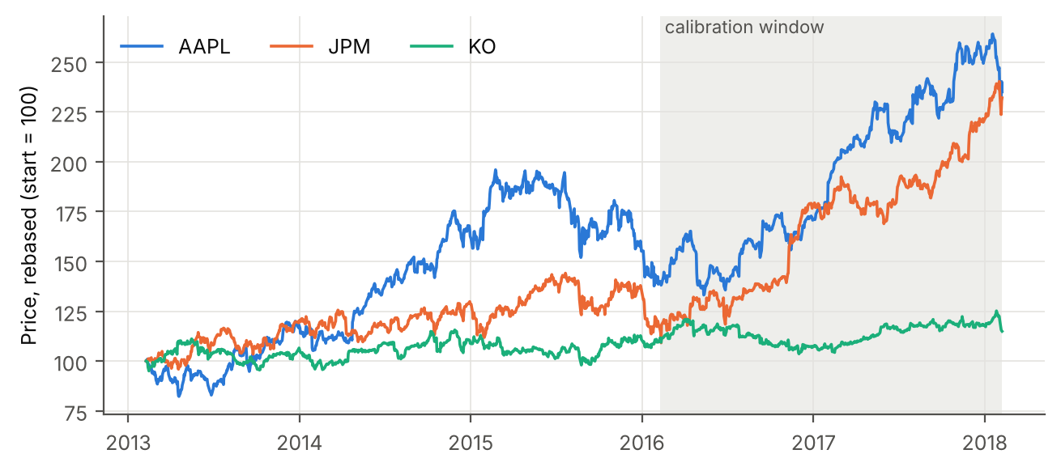
Figure 1. Daily closing prices of AAPL, JPM and KO, rebased to 100 on 8 February 2013. The shaded area marks the two-year calibration window used for the forward simulation.

2.3 Statistical properties
Table 1. Descriptive statistics and diagnostic tests of daily log returns and log prices, calibration window 8 February 2016 – 7 February 2018 (n = 504 returns per stock) unless stated otherwise.
Statistic (calibration window) | AAPL | JPM | KO
Annualised log drift | 25.9% | 34.6% | 2.2%
Annualised volatility | 19.8% | 20.0% | 12.3%
Skewness | 0.26 | 0.17 | -1.35
Excess kurtosis | 5.09 | 6.95 | 6.11
Jarque-Bera p-value | < 0.001 | < 0.001 | < 0.001
ADF p-value (log price) | 0.71 | 0.84 | 0.21
ADF p-value, full 5 years | 0.778 | 0.953 | 0.046
AR(1) half-life (trading days) | 237 | 346 | 38
Ljung-Box p, squared returns | 0.87 | < 0.001 | 0.32
Maximum drawdown | -19.4% | -12.5% | -14.3%

Table 1 and Figure 2 summarise the features that guide model choice. All three return series are strongly leptokurtic and fail the Jarque–Bera normality test (Jarque & Bera, 1980), with KO also markedly negatively skewed: large daily moves occur far more often than a normal distribution allows, a well-documented stylised fact of asset returns (Cont, 2001). The Augmented Dickey–Fuller test (Dickey & Fuller, 1979) does not reject a unit root in the log price of any stock over the calibration window; only KO over the full five years is borderline (p = 0.046), consistent with its range-bound behaviour in Figure 1. Finally, the Ljung–Box test on squared returns (Ljung & Box, 1978) detects volatility clustering for JPM over the calibration window and for all three stocks over the full sample, a feature none of the constant-volatility models below can reproduce.
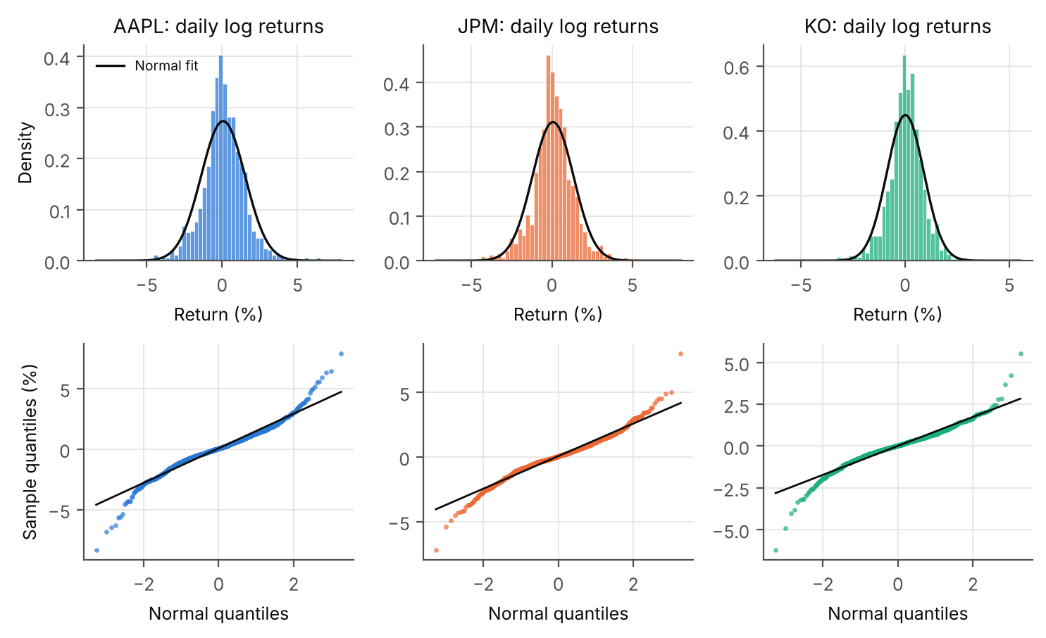
Figure 2. Top: histograms of daily log returns over the full sample with a fitted normal density. Bottom: normal quantile-quantile plots. Points bending away from the line in both tails show that extreme returns are more frequent than under normality (fat tails).

3. Models and implementation

3.1 Geometric Brownian Motion (GBM)
GBM is the benchmark model of Black and Scholes (1973):
dS_{t} = μ S_{t} dt + σ S_{t} dW_{t},
where μ is the expected rate of return, σ the volatility and W a standard Brownian motion. Log returns are independent and normal with mean (μ − σ²/2)Δt and variance σ²Δt, so prices are log-normal, stay positive and have no memory. Parameters are estimated by maximum likelihood from daily log returns, and paths are simulated with the exact solution S_{t+Δt} = S_{t} exp[(μ − σ²/2)Δt + σ√Δt Z], Z ~ N(0,1). Justification: the ADF tests cannot reject a random walk in log prices, which is exactly the GBM hypothesis, and GBM is the industry baseline against which other models are judged.

3.2 Ornstein–Uhlenbeck process on the log price (OU)
dX_{t} = κ(θ − X_{t}) dt + σ dW_{t}, X_{t} = ln S_{t}.
The log price is pulled towards a long-run level θ at speed κ (half-life ln 2/κ) (Uhlenbeck & Ornstein, 1930; Schwartz, 1997). Its exact discretisation is an AR(1) model, X_{t+Δt} = a + bX_{t} + ε, with b = e^{−κΔt} and a = θ(1 − b), so (κ, θ, σ) follow from an ordinary least-squares regression; simulation uses the exact Gaussian transition. Justification: some evidence of mean reversion in stock prices exists at long horizons (Poterba & Summers, 1988), and a defensive stock such as KO, which traded in a narrow range for five years, is the natural candidate. The OU model is included to test this hypothesis directly against the random walk.

3.3 Merton jump-diffusion
dS_{t}/S_{t−} = (μ − λk) dt + σ dW_{t} + (J − 1) dN_{t}, ln J ~ N(μ_{J}, σ_{J}²),
where N is a Poisson process with intensity λ (jumps per year) and k = E[J − 1] (Merton, 1976). The compensator λk keeps μ as the total expected return, so it is directly comparable to GBM. A daily return is then a Poisson mixture of normal distributions; we maximise this likelihood numerically (L-BFGS-B, several starting values, the Poisson sum truncated at 10 jumps a day). Unconstrained, the likelihood pushes λ to implausibly high values (many tiny ‘jumps’ acting as a generic fat-tail mixture), so λ is capped at 12 per year, about one jump per month (four earnings releases plus a few macro shocks). Justification: the fat tails in Table 1 and the earnings- and news-driven gaps flagged in Section 2.2 are exactly what a jump component is designed to capture.

3.4 Implementation
The code is organised in two modules. stochastic_models.py contains data loading and cleaning, diagnostics, one class per model with a common fit(prices) / simulate(s0, n_steps, n_paths, rng) interface, risk metrics, the backtest and plotting functions. run_analysis.py runs the pipeline and writes all figures and tables; an executed Jupyter notebook walks through the same steps. Time is measured in years with Δt = 1/252. Each model is simulated with 1,000 Monte Carlo paths per stock over 180 trading days, with a fixed random seed (42) for exact reproducibility. Simulation is fully vectorised in NumPy (Harris et al., 2020); calibration uses SciPy (Virtanen et al., 2020) and statsmodels (Seabold & Perktold, 2010).
Table 2. Calibrated model parameters (two-year calibration window). The likelihood-ratio statistic compares Merton with the nested GBM (3 extra parameters; the 0.1% critical value of χ²(3) is 16.3).
 | Parameter | AAPL | JPM | KO
GBM | μ (drift, p.a.) | 27.9% | 36.6% | 3.0%
 | σ (volatility, p.a.) | 19.8% | 20.0% | 12.3%
OU | κ (reversion speed, p.a.) | 0.74 | 0.51 | 4.60
 | e^{θ} (long-run price, USD) | 182.68 | 158.31 | 44.34
 | Half-life (trading days) | 237 | 346 | 38
 | σ (p.a.) | 19.8% | 20.0% | 12.4%
Merton | μ (total drift, p.a.) | 26.7% | 33.9% | 8.5%
 | σ (diffusion vol, p.a.) | 15.3% | 14.0% | 9.2%
 | λ (jumps per year) | 12.0 | 12.0 | 12.0
 | μ_{J} (mean log jump) | 0.30% | 0.39% | -1.33%
 | σ_{J} (jump size s.d.) | 3.22% | 3.36% | 1.56%
 | Total volatility (p.a.) | 19.0% | 18.2% | 11.6%
 | LR statistic vs GBM | 85 | 121 | 105
Start | S₀ (USD, 7 Feb 2018) | 159.54 | 112.87 | 44.56

Table 2 shows two points that shape all later results. First, the historical drifts of AAPL (28%) and JPM (37%) reflect an exceptional two-year rally and are far above any sensible long-run expected return; the drift of an equity is notoriously hard to estimate because its standard error over a two-year window is about σ/√2, i.e. roughly 14 percentage points here (Merton, 1980). Second, the OU fit implies very slow mean reversion for AAPL and JPM (half-lives of about one year or more), with long-run levels above the current price, but fast reversion for KO (half-life 38 days) towards USD 44.34, almost exactly its current price. Because the ADF tests cannot reject a unit root, these OU estimates are fragile; AR(1)-based estimates of κ are also biased upwards in short samples. The Merton model splits volatility into a smaller diffusion part plus monthly jumps of a few per cent; total volatility stays close to the GBM value, and the likelihood improvement is highly significant for every stock.

4. Simulation results
Figures 3–5 show the simulated price paths from the forecast origin of 7 February 2018, and Table 3 lists the risk statistics at the three horizons. The 90% interval is the range between the 5th and 95th percentiles of the simulated price; VaR₉₅ is the loss not exceeded with 95% probability and ES₉₅ (expected shortfall) is the average loss in the worst 5% of scenarios.
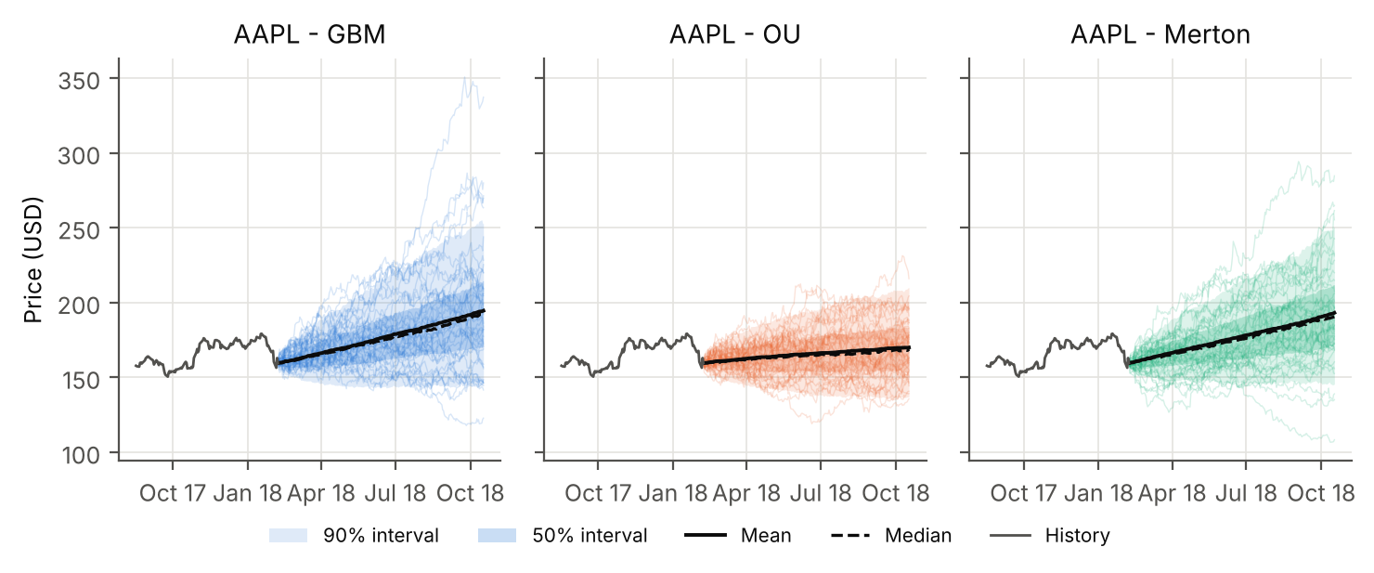
Figure 3. Simulated Apple (AAPL) price paths for 180 trading days under each model (1,000 paths; 40 shown). Shaded bands are the 50% and 90% intervals; solid and dashed black lines are the mean and median paths; the grey line is the last 120 days of history.
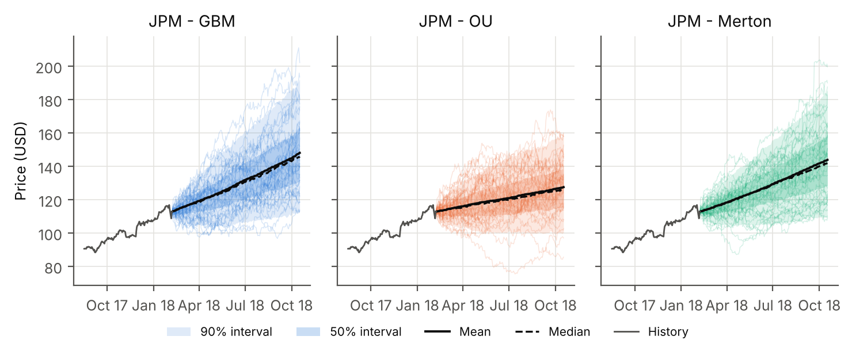
Figure 4. Simulated JPMorgan Chase (JPM) price paths for 180 trading days under each model (1,000 paths; 40 shown). Shaded bands are the 50% and 90% intervals; solid and dashed black lines are the mean and median paths; the grey line is the last 120 days of history.
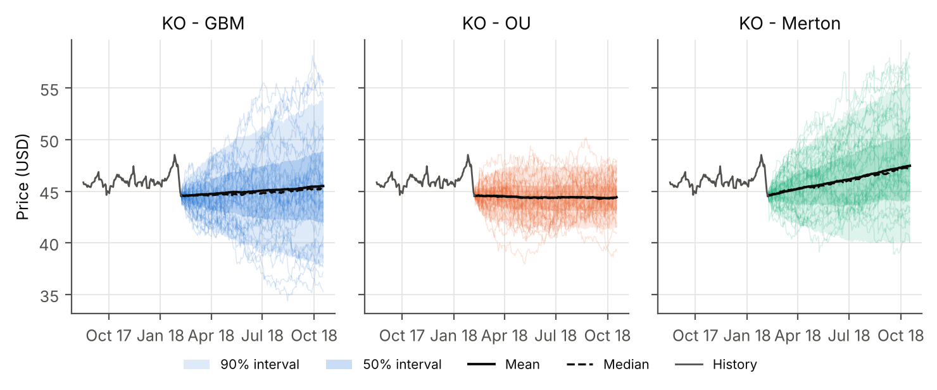
Figure 5. Simulated Coca-Cola (KO) price paths for 180 trading days under each model (1,000 paths; 40 shown). Shaded bands are the 50% and 90% intervals; solid and dashed black lines are the mean and median paths; the grey line is the last 120 days of history.
Table 3. Monte Carlo risk statistics of the simulated price (1,000 paths per model). P(loss) is the probability that the price ends below the current price S₀; VaR and ES are expressed as a percentage loss of S₀. The Monte Carlo standard error of a probability near 50% is about 1.6 percentage points.
Stock | Model | Days | Median (USD) | 90% interval (USD) | P(loss) | P(drop > 10%) | VaR₉₅ | ES₉₅
AAPL | GBM | 30 | 164.44 | 146.86 – 184.39 | 32.6% | 2.0% | 7.9% | 10.2%
 |  | 60 | 169.35 | 144.79 – 199.47 | 27.7% | 4.3% | 9.2% | 12.9%
 |  | 180 | 192.36 | 144.89 – 252.58 | 14.7% | 3.9% | 9.2% | 14.6%
 | OU | 30 | 161.49 | 145.87 – 179.03 | 42.0% | 3.1% | 8.6% | 11.4%
 |  | 60 | 163.59 | 142.87 – 187.97 | 39.2% | 6.1% | 10.4% | 13.4%
 |  | 180 | 168.99 | 137.08 – 210.04 | 32.7% | 10.4% | 14.1% | 18.2%
 | Merton | 30 | 164.20 | 148.41 – 184.18 | 31.5% | 1.9% | 7.0% | 9.9%
 |  | 60 | 169.13 | 147.66 – 198.32 | 26.0% | 2.4% | 7.4% | 10.5%
 |  | 180 | 190.57 | 145.58 – 250.29 | 12.5% | 4.3% | 8.8% | 14.8%
JPM | GBM | 30 | 117.76 | 105.05 – 131.95 | 27.6% | 1.4% | 6.9% | 9.4%
 |  | 60 | 122.54 | 104.60 – 143.34 | 19.4% | 2.2% | 7.3% | 10.3%
 |  | 180 | 145.89 | 112.65 – 192.05 | 5.5% | 1.1% | 0.2% | 6.8%
 | OU | 30 | 115.05 | 103.50 – 128.69 | 37.5% | 2.5% | 8.3% | 10.7%
 |  | 60 | 117.40 | 101.45 – 135.92 | 32.8% | 5.4% | 10.1% | 13.4%
 |  | 180 | 126.08 | 100.18 – 158.30 | 19.9% | 6.0% | 11.2% | 15.8%
 | Merton | 30 | 116.75 | 104.90 – 129.95 | 26.4% | 1.9% | 7.1% | 9.8%
 |  | 60 | 121.79 | 105.41 – 139.97 | 19.8% | 2.6% | 6.6% | 11.6%
 |  | 180 | 141.97 | 109.52 – 184.96 | 8.2% | 2.2% | 3.0% | 11.0%
KO | GBM | 30 | 44.60 | 41.69 – 47.85 | 48.7% | 0.4% | 6.5% | 8.1%
 |  | 60 | 44.74 | 40.59 – 49.60 | 47.8% | 3.1% | 8.9% | 10.8%
 |  | 180 | 45.14 | 38.07 – 53.97 | 45.3% | 12.5% | 14.6% | 17.7%
 | OU | 30 | 44.46 | 42.08 – 47.10 | 52.3% | 0.4% | 5.6% | 7.0%
 |  | 60 | 44.36 | 41.57 – 47.27 | 54.3% | 0.6% | 6.7% | 8.3%
 |  | 180 | 44.39 | 41.37 – 47.44 | 54.2% | 1.0% | 7.2% | 8.8%
 | Merton | 30 | 45.15 | 42.00 – 48.21 | 38.9% | 0.7% | 5.7% | 7.7%
 |  | 60 | 45.34 | 41.06 – 50.10 | 37.6% | 2.0% | 7.8% | 10.0%
 |  | 180 | 47.35 | 40.04 – 55.42 | 28.2% | 5.1% | 10.1% | 14.5%

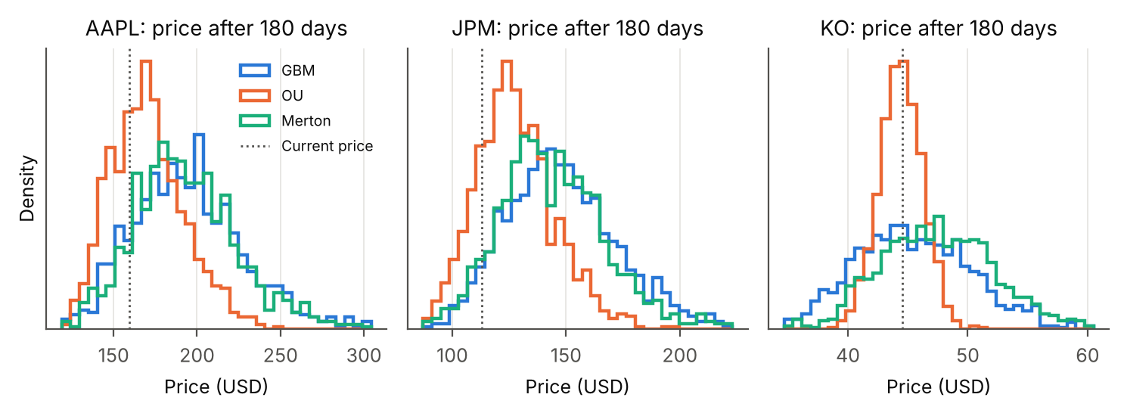
Figure 6. Distribution of the simulated price after 180 trading days under each model. The dotted line marks the current price. OU distributions are narrower and centred closer to the estimated long-run level; GBM and Merton distributions are right-skewed (log-normal-like).
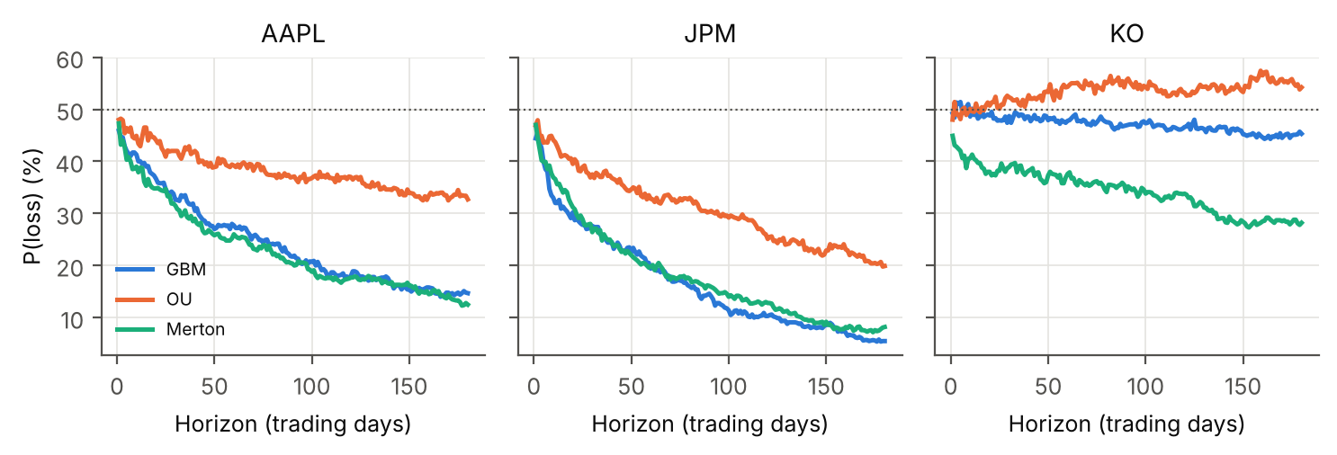
Figure 7. Probability that the simulated price is below the current price, as a function of the horizon. A positive drift pushes the probability below 50% as the horizon grows.

4.1 Interpretation
Volatility and trend. Over short horizons the spread of outcomes is governed by volatility and grows with the square root of time; over longer horizons the drift takes over, because the expected log return grows linearly in time. This is visible in Figure 5: for AAPL and JPM, whose calibrated drifts are high, GBM's probability of loss falls from close to 50% at one day to 15% (AAPL) and 6% (JPM) at 180 days. For KO, whose drift is close to zero, it stays near 50% (45%) while the 90% interval widens to USD 38.07–53.97.
Model differences. The OU model produces markedly narrower long-horizon distributions (KO 180-day 90% interval USD 41.37–47.44 versus USD 38.07–53.97 under GBM) because mean reversion caps the variance of the log price at σ²/(2κ). For AAPL and JPM, OU's drift is a pull towards a level estimated from the same rally, so its central forecast lies between ‘no change’ and the GBM trend, and its tail risk is actually higher than GBM's (AAPL 180-day ES₉₅ 18% vs 15%). The Merton model is very close to GBM at all three horizons for AAPL and JPM: with roughly one jump a month, jumps of a few per cent average out over 30+ days and the distribution of the sum is again close to normal. For KO, the estimated negative jumps (mean -1.3%) combine with a higher estimated total drift (8% vs 3% for GBM), which lowers the probability of loss; this difference reflects drift-estimation noise rather than a robust property of the jump model.
Short-term versus long-term prediction. Short-horizon risk numbers are robust: the 30-day VaR₉₅ lies between 5.6% and 8.6% across all stocks and models, because it is driven mainly by volatility, which is estimated precisely. Long-horizon numbers are fragile because they depend on the drift. Table 4 makes this explicit: keeping GBM's volatility fixed and replacing the historical drift by a long-run equity return of 8% or by zero changes the 180-day risk profile dramatically for AAPL and JPM.
Table 4. Sensitivity of the 180-day GBM risk statistics to the drift assumption (volatility fixed at its calibrated value).
Stock | Drift assumption | μ (p.a.) | Median (USD) | P(loss) | P(drop > 10%) | VaR₉₅ | ES₉₅
AAPL | historical | 27.9% | 193.00 | 12.9% | 4.0% | 8.8% | 14.8%
 | 8% long-run | 8.0% | 165.96 | 40.2% | 19.8% | 21.0% | 27.1%
 | zero | 0.0% | 159.35 | 50.2% | 27.6% | 24.8% | 29.1%
JPM | historical | 36.6% | 143.00 | 5.9% | 2.0% | 1.3% | 9.8%
 | 8% long-run | 8.0% | 118.13 | 39.5% | 19.3% | 20.0% | 26.4%
 | zero | 0.0% | 110.86 | 55.4% | 28.8% | 24.7% | 29.0%
KO | historical | 3.0% | 45.13 | 44.8% | 13.1% | 15.3% | 18.7%
 | 8% long-run | 8.0% | 46.95 | 29.3% | 6.2% | 11.9% | 15.6%
 | zero | 0.0% | 44.25 | 52.8% | 16.8% | 16.1% | 19.8%

5. Out-of-sample validation
In-sample fit does not show whether a model forecasts well. We therefore ran a rolling-origin backtest: every 10 trading days from February 2015 onwards (70 origins per stock), each model was re-calibrated on the preceding 504 days only, 1,000 paths were simulated, and the forecast was compared with the realised price 30 and 60 days later. Three scores are reported: the coverage of the 90% interval (ideal: 90%), the continuous ranked probability score (CRPS, in % of the starting price; lower is better; Gneiting & Raftery, 2007), which rewards forecasts that are both sharp and correct, and the Brier score of the predicted probability of a loss (lower is better; 0.25 is the score of always predicting 50%).
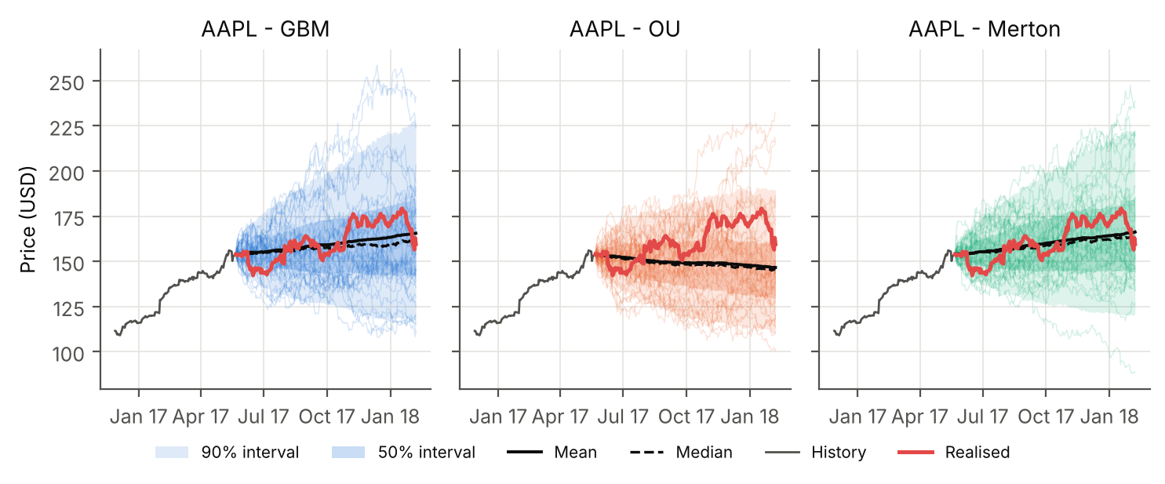
Figure 8. Example out-of-sample forecast for AAPL from 22 May 2017: each model is calibrated on the preceding two years only and simulated forward for 180 trading days; the red line is the price that was actually realised.
Figure 6 gives one illustration. From 22 May 2017, the realised AAPL price ended at the 48th percentile of the GBM forecast and the 45th of Merton's, i.e. near the centre, but at the 73th percentile of the OU forecast, which expected the price to drift down towards its estimated mean. For JPM the realised price ended at the 97th percentile of the OU forecast, almost outside its 90% range.
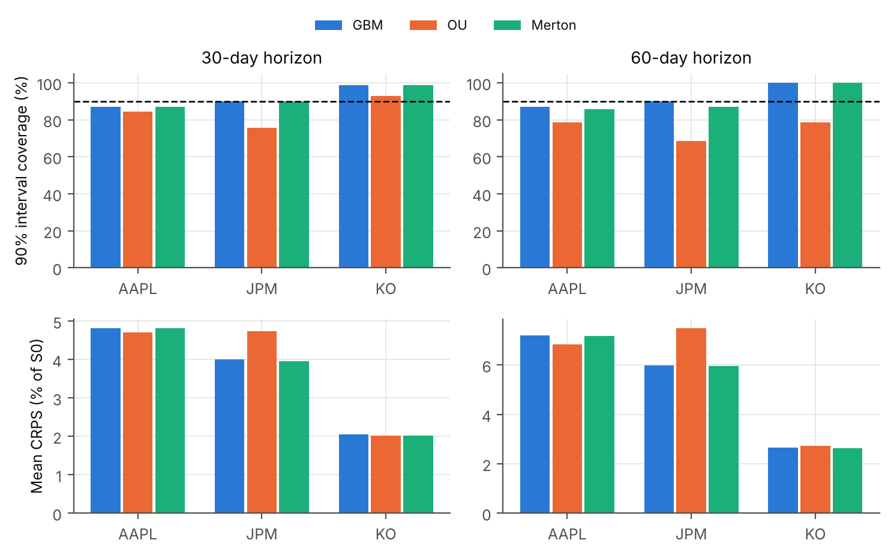
Figure 9. Rolling backtest scores (70 forecast origins per stock). Top: share of realised prices inside the model's 90% interval (dashed line = 90% target). Bottom: mean CRPS as a percentage of the starting price (lower is better).
Table 5. Backtest scores averaged over the three stocks (per-stock values in Figure 7 and results/backtest_summary.csv).
Model | Horizon | Coverage of 90% interval | Mean CRPS (% of S₀) | Brier score, P(loss)
GBM | 30 days | 91.9% | 3.62 | 0.247
 | 60 days | 92.4% | 5.28 | 0.255
OU | 30 days | 84.3% | 3.82 | 0.284
 | 60 days | 75.2% | 5.68 | 0.310
Merton | 30 days | 91.9% | 3.60 | 0.245
 | 60 days | 91.0% | 5.25 | 0.252

The results are consistent with the diagnostics. GBM and Merton intervals are close to nominal for AAPL (87% at 60 days) and JPM (90%), and too wide for KO (100%), whose volatility fell to about 9% in 2017, well below the 14–16% of 2013–2016 that dominated its calibration windows. The OU model is systematically overconfident: its 60-day coverage is only 69% for JPM and 79% for KO, even though KO is the stock for which mean reversion was most plausible. OU obtains a slightly lower CRPS for AAPL, where its narrower distribution happened to be centred well, but it has the worst Brier score on average: its directional calls (based on the distance to an estimated mean) were wrong more often than a coin flip. Merton and GBM are practically tied, with Merton marginally ahead on CRPS and Brier for JPM and KO. No model predicts direction reliably: Brier scores range from 0.22 to 0.33, close to or worse than the 0.25 of a coin flip.

6. Realism and limitations of the models
Table 6. Qualitative comparison of the three models.
 | GBM | OU (log price) | Merton jump-diffusion
Captures | Positive prices; uncertainty growing with √t; compounding | Range-bound behaviour; bounded long-run variance | Fat tails, sudden gaps (earnings, macro news); negative skew
Misses | Fat tails, jumps, volatility clustering | No unit-root rejection in the data; no long-run growth; fat tails | Volatility clustering; jumps not identifiable without constraints
Evidence here | Well-calibrated 30/60-day intervals (AAPL, JPM) | Overconfident intervals (69–93% coverage) | Best in-sample fit; out-of-sample scores ≈ GBM
Best use | Baseline risk ranges and position sizing | Spreads, ratios, rates or commodities, not single stocks | Short-horizon tail risk (VaR/ES), event risk, option pricing

- Constant parameters. All three models assume volatility is constant, while the Ljung–Box tests show volatility clustering. In calm periods the models overstate risk (KO), and in turbulent periods they would understate it. GARCH-type (Bollerslev, 1986) or stochastic-volatility models (Heston, 1993) address this.
- Drift uncertainty. Two years of data cannot pin down the expected return (Table 4). Long-horizon outputs inherit this uncertainty; the drift is better set from an economic view (e.g. risk-free rate plus equity premium) than estimated from recent returns.
- Identification of jumps. With daily data, frequent small jumps and fat-tailed diffusion are hard to tell apart, so the jump intensity had to be constrained. The jump parameters should be read as a description of tail shape rather than of discrete events.
- Mean reversion in price levels is not supported for these stocks. Treating an OU level as a price target creates false confidence; the backtest confirms this.
- Single-asset view. The stocks are simulated independently. A portfolio analysis would need correlated Brownian motions (and common jumps), since correlations rise in sell-offs.
- Data. Prices are not dividend-adjusted and the sample ends in February 2018, so the numbers illustrate the method rather than describe today's market.

7. Recommendations for investors
- Use the models for ranges and risk, not for direction. None of the models beat a coin flip at predicting whether a stock would rise or fall. Their value lies in quantifying how much prices can move: base position sizes and stop-loss levels on the 90% intervals and on VaR/ES, not on the mean path.
- Prefer GBM or Merton for horizons up to about three months, where their intervals were well calibrated. Use Merton (or historical/filtered simulation) when daily tail risk matters, e.g. around earnings. On these numbers, a 30-day 95% VaR of roughly 7% for AAPL and JPM and 6% for KO is a reasonable planning figure for a one-month holding.
- Do not extrapolate recent trends. The 180-day probability of loss for AAPL and JPM is below 15% only under their historical drifts; under a plausible 8% drift it is about 40%. Investors with a six-month horizon should plan for a roughly 2-in-5 chance of being under water and a 1-in-5 chance of a loss of more than 10%.
- Match the stock to the risk budget. KO's volatility is about two-thirds of AAPL's and JPM's, so its 180-day ES₉₅ is lower (18% vs 15% for AAPL under GBM), but it also offers little expected price growth: it suits capital preservation and income (dividends), while AAPL and JPM suit investors able to bear larger drawdowns for higher expected growth.
- Treat mean-reversion signals with caution. Buying a stock because an OU model says it is below its ‘fair’ level was not supported by the data; mean-reversion strategies are better applied to spreads between related assets than to single-stock prices.
- Re-calibrate regularly and stress test. Re-estimate volatility at least monthly, complement the models with scenario analysis (e.g. a 2008- or 2020-type shock), and consider volatility-clustering models before relying on any single number.

8. Conclusion
Stochastic process models turn price uncertainty into explicit probabilities. For the three stocks studied, the random-walk family (GBM and its jump extension) described the data and forecast future ranges well, whereas mean reversion in price levels was neither supported statistically nor useful out of sample. Jumps improve the description of daily tail risk but add little at monthly horizons. The single most important input for long-horizon conclusions is the drift, which history estimates poorly; investors should therefore rely on these models for the width of the distribution and treat its centre as an assumption.

References
Black, F., & Scholes, M. (1973). The pricing of options and corporate liabilities. Journal of Political Economy, 81(3), 637–654. https://doi.org/10.1086/260062
Bollerslev, T. (1986). Generalized autoregressive conditional heteroskedasticity. Journal of Econometrics, 31(3), 307–327. https://doi.org/10.1016/0304-4076(86)90063-1
Cont, R. (2001). Empirical properties of asset returns: Stylized facts and statistical issues. Quantitative Finance, 1(2), 223–236. https://doi.org/10.1080/713665670
Dickey, D. A., & Fuller, W. A. (1979). Distribution of the estimators for autoregressive time series with a unit root. Journal of the American Statistical Association, 74(366a), 427–431. https://doi.org/10.1080/01621459.1979.10482531
Glasserman, P. (2004). Monte Carlo methods in financial engineering. Springer. https://doi.org/10.1007/978-0-387-21617-1
Gneiting, T., & Raftery, A. E. (2007). Strictly proper scoring rules, prediction, and estimation. Journal of the American Statistical Association, 102(477), 359–378. https://doi.org/10.1198/016214506000001437
Harris, C. R., Millman, K. J., van der Walt, S. J., Gommers, R., Virtanen, P., Cournapeau, D., Wieser, E., Taylor, J., Berg, S., Smith, N. J., Kern, R., Picus, M., Hoyer, S., van Kerkwijk, M. H., Brett, M., Haldane, A., del Río, J. F., Wiebe, M., Peterson, P., … Oliphant, T. E. (2020). Array programming with NumPy. Nature, 585(7825), 357–362. https://doi.org/10.1038/s41586-020-2649-2
Heston, S. L. (1993). A closed-form solution for options with stochastic volatility with applications to bond and currency options. The Review of Financial Studies, 6(2), 327–343. https://doi.org/10.1093/rfs/6.2.327
Hull, J. C. (2018). Options, futures, and other derivatives (10th ed.). Pearson.
Hunter, J. D. (2007). Matplotlib: A 2D graphics environment. Computing in Science & Engineering, 9(3), 90–95. https://doi.org/10.1109/MCSE.2007.55
Jarque, C. M., & Bera, A. K. (1980). Efficient tests for normality, homoscedasticity and serial independence of regression residuals. Economics Letters, 6(3), 255–259. https://doi.org/10.1016/0165-1765(80)90024-5
Ljung, G. M., & Box, G. E. P. (1978). On a measure of lack of fit in time series models. Biometrika, 65(2), 297–303. https://doi.org/10.1093/biomet/65.2.297
McKinney, W. (2010). Data structures for statistical computing in Python. In S. van der Walt & J. Millman (Eds.), Proceedings of the 9th Python in Science Conference (pp. 56–61). https://doi.org/10.25080/Majora-92bf1922-00a
Merton, R. C. (1976). Option pricing when underlying stock returns are discontinuous. Journal of Financial Economics, 3(1–2), 125–144. https://doi.org/10.1016/0304-405X(76)90022-2
Merton, R. C. (1980). On estimating the expected return on the market: An exploratory investigation. Journal of Financial Economics, 8(4), 323–361. https://doi.org/10.1016/0304-405X(80)90007-0
Nugent, C. (2018). S&P 500 stock data [Data set]. Kaggle. https://www.kaggle.com/datasets/camnugent/sandp500
Poterba, J. M., & Summers, L. H. (1988). Mean reversion in stock prices: Evidence and implications. Journal of Financial Economics, 22(1), 27–59. https://doi.org/10.1016/0304-405X(88)90021-9
Schwartz, E. S. (1997). The stochastic behavior of commodity prices: Implications for valuation and hedging. The Journal of Finance, 52(3), 923–973. https://doi.org/10.1111/j.1540-6261.1997.tb02721.x
Seabold, S., & Perktold, J. (2010). Statsmodels: Econometric and statistical modeling with Python. In S. van der Walt & J. Millman (Eds.), Proceedings of the 9th Python in Science Conference (pp. 92–96). https://doi.org/10.25080/Majora-92bf1922-011
Uhlenbeck, G. E., & Ornstein, L. S. (1930). On the theory of the Brownian motion. Physical Review, 36(5), 823–841. https://doi.org/10.1103/PhysRev.36.823
Virtanen, P., Gommers, R., Oliphant, T. E., Haberland, M., Reddy, T., Cournapeau, D., Burovski, E., Peterson, P., Weckesser, W., Bright, J., van der Walt, S. J., Brett, M., Wilson, J., Millman, K. J., Mayorov, N., Nelson, A. R. J., Jones, E., Kern, R., Larson, E., … SciPy 1.0 Contributors. (2020). SciPy 1.0: Fundamental algorithms for scientific computing in Python. Nature Methods, 17(3), 261–272. https://doi.org/10.1038/s41592-019-0686-2

Appendix: Reproducibility
All code, data and outputs are in the stock_stochastic_models/ folder. Install the dependencies with pip install -r requirements.txt, then run python run_analysis.py (about 1–2 minutes, including the backtest) and python build_report.py to regenerate this report. The notebook Stock_Price_Stochastic_Models.ipynb walks through the same steps with explanations. Monte Carlo and backtest settings (tickers, calibration window, horizons, number of paths, seed) are constants at the top of run_analysis.py. The general Monte Carlo methodology follows Glasserman (2004) and Hull (2018); data handling uses pandas (McKinney, 2010) and figures Matplotlib (Hunter, 2007).

