**A08 Communicating Vessels**

[Subject symbol: Ma]

Time:

5-15 minutes

Level:

Grades 3 and 4

Concepts: Density, pressure

[Introduction Box]

The situation seems very normal - a U-tube filled with a clear liquid, with both sides at the same height. It's unclear what the cork on one side is for. That becomes apparent when you remove it, and the situation becomes incomprehensible if you don't realize that there are not one but two liquids at play here. In the lower grades, this simple experiment challenges students to think about material properties. In the upper grades, it's a conceptual challenge regarding density and pressure, and a framework for some solid calculations.

[End box]

[A08-PD12_fig1and2 side by side; captions]

*U-tube with liquid and stopper.*

*U-tube after removal of the stopper.*

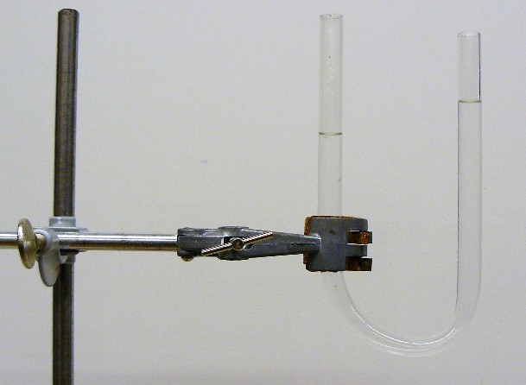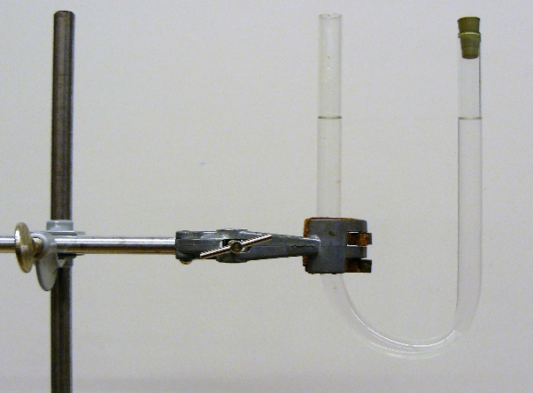

**Needed:**

U-tube; cork that can seal one side of the U-tube; ethanol (as pure as possible); water; stand with clamp; if possible, a camera that projects onto the smartboard.

**Preparation:**

Attach the tube to the stand with the openings at the top and fill roughly one-third of the volume with ethanol.

Carefully add about a quarter of the tube volume of water to one side. Tilt the tube to prevent the liquids from mixing.

The level is higher on the ethanol side. Push a cork onto the end there (not too tight because it will need to be removed later, but airtight). The level should still be higher there afterward, or at most equal. Otherwise, start over with less water.

Now carefully add water until both levels are equal.

**Execution:**

Conduct a conversation with the students along the following lines:

[Note bullet points]

• What do you notice about this situation? What can you see here?

• Do you see that the liquid levels on both sides are the same height? Why is that?

• Why is there a stopper? Does that make a difference?

• What do you think will happen if I remove the stopper? Will anything change, or will everything stay the same?

Once it's clear what the class thinks, remove the stopper. The liquid level rises on the side where the stopper was, and it decreases on the other side. In communicating vessels, the liquid levels are at unequal heights!

[Note bullet points]

• Explain what's happening here and how the liquid levels can be at unequal heights.

A suitable activity for this question is, for example, Think-Pair-Share, in which students first individually, then in pairs, and finally as a class come up with and share answers. As a teacher, maintain balance between supporting (hints) and encouraging, only provide your own answer if they can't figure it out, or as a summary at the end.

**Physical Background:**

In communicating vessels, the liquid levels are always at the same height. This is because the same air pressure pushes on the surface of all vessels - for an equally large force upwards, liquid columns of equal height are needed. If they aren't there, the water would flow until they are. So how can the liquid in these vessels be at unequal heights?

The situation is easiest to understand by looking at the bottom point of the tube. The liquid there is stationary, so the pressure from the right and from the left is equal. Then the liquid mass must be equal on both sides, so the density is different. It seems there's only one liquid in the tube, but there are two, with different densities. In this situation, the liquid should have flowed initially when the liquid levels were at the same height, but the cork prevented that.

In grade V/H5 or V6, you can calculate together where the separation should be: with dh the height difference and h the height at the water side it applies:

ρe (h+dh) = ρw (h–x) + ρe x thus

x = ((ρe–ρw)h + ρe dh) / (ρw+ρe)

If a negative value for x is obtained, the interface is on the ethanol side; if a positive value is obtained, x is on the water side. If you look closely, you can see the interface between the ethanol and the water as a slight cloudiness in the liquid. (Presumably, the refractive index varies irregularly there because the ethanol dissolves in the water.)

**Tips:**

Don't forget to come back to the initial situation after discussing the final situation. Students who have the necessary prior knowledge will mostly have said that the liquid levels were initially at the same height *because the pressure on both sides was equal*. But that's only the case after the cork is removed: then atmospheric pressure prevails on both sides. Yet the liquid levels were initially at the same height - how can that be? Hopefully, they can figure it out themselves, based on the description of the final situation found: there must have been overpressure in the air under the cork to compensate for the extra weight of the water in the other leg. Water was poured into the tube until that was the case. So the fact that the levels were the same height didn't happen 'by itself,' you deliberately misled your students (to teach them something about pressure and density, of course).

**Further Research:**

You could calculate together and test what the greatest height difference is that you can achieve with water and ethanol in this tube. It's also interesting that a candle floats in water but not in ethanol.

**Safety and Environment:**

Be careful with ethanol. Keep the bottle in the cabinet and the tube away from the students.

[Begin box]

The demonstration was previously described by Liem (1987).

[End box]