**A12 The Can that Comes Back**

[Subject symbol Mech]

Time  
5-15 minutes

Level  
From grade 1

Concepts: torque, spring energy, kinetic energy, equilibrium

[Introductory box]

The originator of this demonstration is unknown. You can evoke fascination and amazement with it and illustrate the nature of science. Physics in school may seem like a subject where all the answers are already known, and where you can't express much imagination or creativity. But in this demonstration, it's about the suggestions, ideas, and solutions that the students come up with, and the correct answer is less important.

[end box]

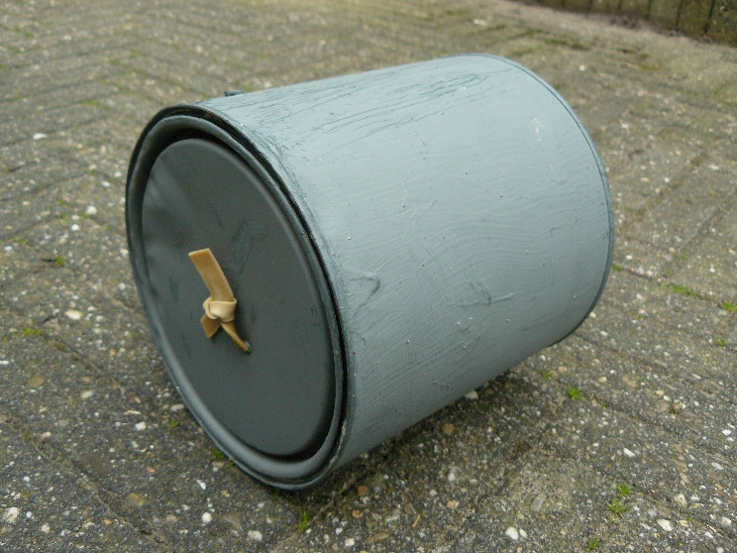

[A12_PD01_figure1; caption]

*This can comes back when rolled away.*

**Required**

Empty can with opaque lid; some rubber bands; a heavy, small object; awl or sharp screwdriver.

**Preparation**

Elastiek (stippellijn)

Gewichtje (stippellijn)

2. Schematische binnenkant van het blik

Puncture two holes about ½ cm apart in the center of the lid and also in the center of the bottom of the can.

Cut one or two rubber bands, thread them through the holes, and tie them tightly to create a taut elastic ring: see figure 2.

[A12_PD01_figure2; caption]

*Inside of the can: schematic.*

Attach the weight or stone to one side of the ring.

Close the lid.

Elastiek ontspannen – gewicht boven draaipunt

Elastiek opgewonden –   
gewicht naast draaipunt

Gewicht

Elastiek

Draaipunt

Blik wordt in deze richting gerold

[A12_PD01_figure3; caption]

*Explanation - torque explains the return.*

Carefully but firmly roll the can away, then it will stop and return after a few meters. Try it with a smaller or larger weight and a tighter or looser elastic until you get the optimal effect. In the returning can of figure 1, the weight is the heaviest cap from my socket set.

**Execution**

Roll the can away on a horizontal, smooth surface. Catch it upon return. Repeat this a few times. Also, stand at the other end to show that the floor doesn't slope. Or demonstrate that with a spirit level if your students are as critical as those of tester Karin Zeeuwen: standing at the other end doesn't help *"because then you also turn the can around."*

Try not catching it once: the can will roll back and forth several times before stopping. If you roll it away too hard, you usually hear a few bangs in the can, and it doesn't come back.

Get the students thinking by keeping the can closed a little longer and asking:

[attention to bullet points]

• What do you think is inside this can? Make a drawing of it.

• Explain (to each other) how it works.

Then discuss the solutions. Some solutions will be more creative, some simpler, others more technical. Which one is scientifically the best? It's likely that everyone thinks their own solution is the best. But why is it the best? You can often judge someone else's solution much better than your own.

Here, you can delve into the role of amazement, imagination, and creativity in science. It's strange that the can comes back. Scientists get excited because if you don't understand something, there's something to learn! That's why they do research, starting by coming up with all sorts of solutions and thinking about how it might work. They usually think their own solutions are the best too and evaluate others' work to find the best solutions. Often, they conduct new research for that.

The best solutions fit what is observable and measurable. For example, it would be odd if the explanation involved an electric motor because there's no button or plug on the can. It also helps if the solution is recognizable. Are there situations similar to this one, and does the solution resemble what happens there? For example, there might be something like a spring in the can that gets wound up. The solution can also be replicated to see if it works. Scientists use these and other methods to find the best solutions.

Scientists are never entirely sure of their solutions. Your class is when you open the can and see the solution. But, for example, you can't open up the Earth to see how gravity works or an electron to see what electricity is. That's why physics knowledge is never entirely certain; in principle, there could always be a better solution that will replace the old one.

**Physics Background**

Inside the can, there is an elastic band with a weight attached to one end (left in figure 3). When you roll the can away, the sides of the elastic band wind around each other because the weight doesn't rotate but hangs at the bottom. The elastic band tightens, causing the weight to be pulled upward and backward. When the can stops, the elastic band is wound up, and the weight hangs behind the point where the can touches the ground (right in figure 3). This creates a backward torque relative to that pivot point. Thus, the can begins to move back.

If you don't catch the can, this process repeats in the opposite direction. If you roll it away too hard, the weight will jump over the elastic band, the elastic won't wind up further, and the can won't roll back (completely).

**Tips**

Store the can for reuse. Release the tension from the elastic for that.

**Further Research**

Possible homework assignment: try making such a thing yourself / with your group. It's advisable to provide cans with holes for that.