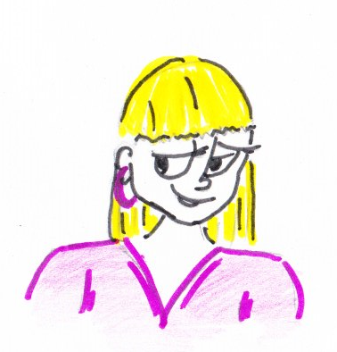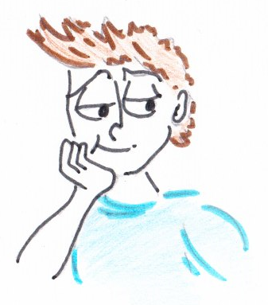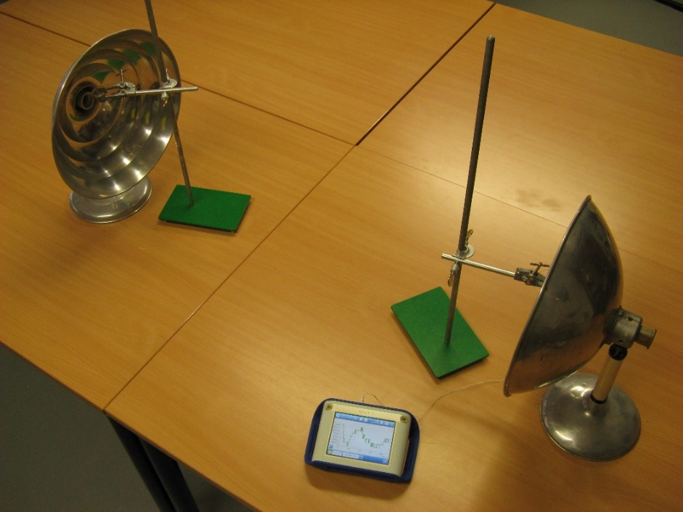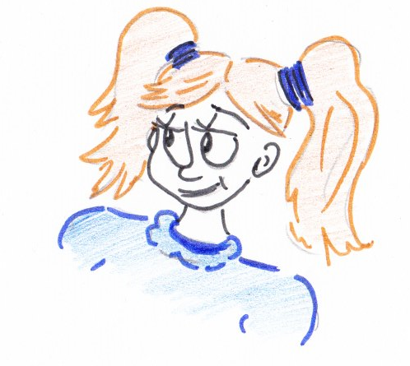

Place the thermometer first, and only place the ice cube when the thermometer measures a constant temperature.

You need to measure the temperature in a second location.

**Who do you agree with?  
Write down what you think and why, and compare it with your neighbour.**

We are certain that the ice cube is the cause of the temperature decrease.

**An ice cube is placed in the focal point of one mirror.  
In the focal point of the other mirror, the temperature decreases.  
Is the ice cube the cause of the decrease in temperature?**