

Download Your Free Guide Now

[INSERT IMAGE]

**FREE GUIDE:**

**5 Essential Steps to Choosing Your Workplace Panic Alarm System**

*Your roadmap to improving workplace safety and workforce peace of mind.*

Everyone has the right to feel safe at work, and employers are responsible for making that happen. A panic alarm system can help to prevent workplace violence and ensure that support is at hand should a threat or incident occur.

Learn 5 steps that can help you choose the best panic alarm system for your organisation.

|  |  |  |
| --- | --- | --- |
| First Name: |  | Last Name: |
|  |  |  |
| Business email: |  | Phone number: |
|  |  |  |

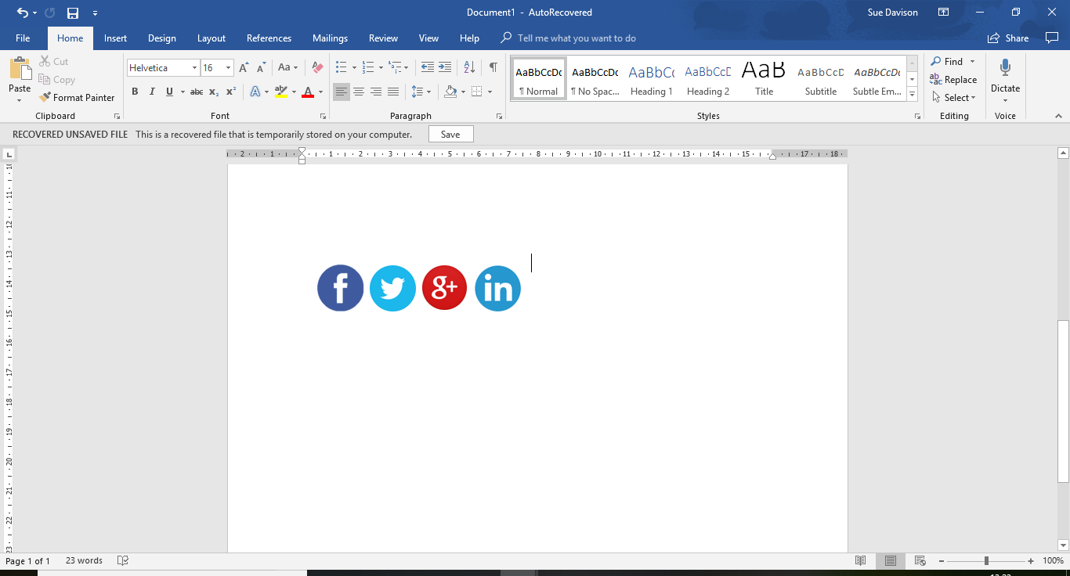

Download Now

|  |  |  |
| --- | --- | --- |
| INSERT IMAGE |  | **Make an informed decision**  This 6-minute read focuses on the 5 critical things to consider when choosing a duress alarm system for your organization.  Download this guide to learn:   * The benefits of adopting a panic alarm system within your organization. * The questions to ask yourself when choosing a system. * The options open to you on the market and their pros and cons. |

|  |  |  |
| --- | --- | --- |
|  |  |  |