PROGRAMMING THEORY QUESTIONS
- How do you perform class inheritance when you construct a new class? Explain with example.

Vehicle.cs
class Vehicle // base class (parent)
{
public string brand = "Ford"; // Vehicle field
public void honk() // Vehicle method
{
Console.WriteLine("Tuut, tuut!");
}
}

Car.cs
class Car : Vehicle // derived class (child)
{
public string modelName = "Mustang"; // Car field
}

Program.cs
class Program
{
static void Main(string[] args)
{
// Create a myCar object
Car myCar = new Car();

// Call the honk() method (From the Vehicle class) on the myCar object
myCar.honk();

// Display the value of the brand field (from the Vehicle class) and the value of the modelName from the Car class
Console.WriteLine(myCar.brand + " " + myCar.modelName);
}
}

OUTPUT
Tuut, tuut!
Ford Mustang

- Explain what is function Overriding? Explain with example.
>>When the base class and derived class have member functions with exactly the same name, same return-type, and same arguments list, then it is said to be function overriding.
class A {
public:
void display() {
cout<<"Base class";
}
};

class B:public A {
public:
void display() {
cout<<"Derived Class";
}
};

int main() {
B obj;
obj.display();
return 0;
}

OUT PUT :- Derived Class

- Please highlight any error in the program below:
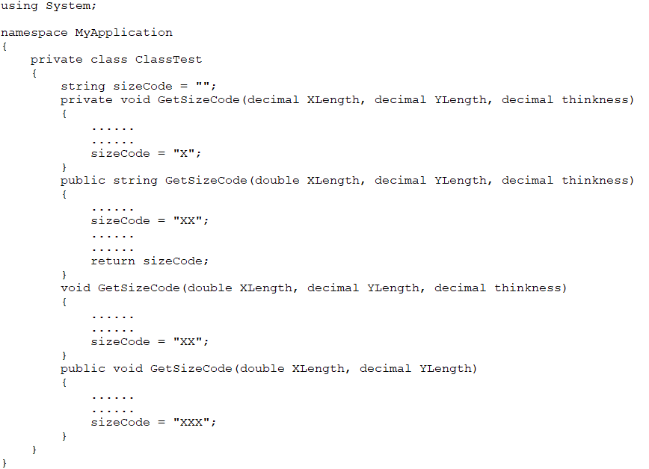
>>Function name with same parameter type.
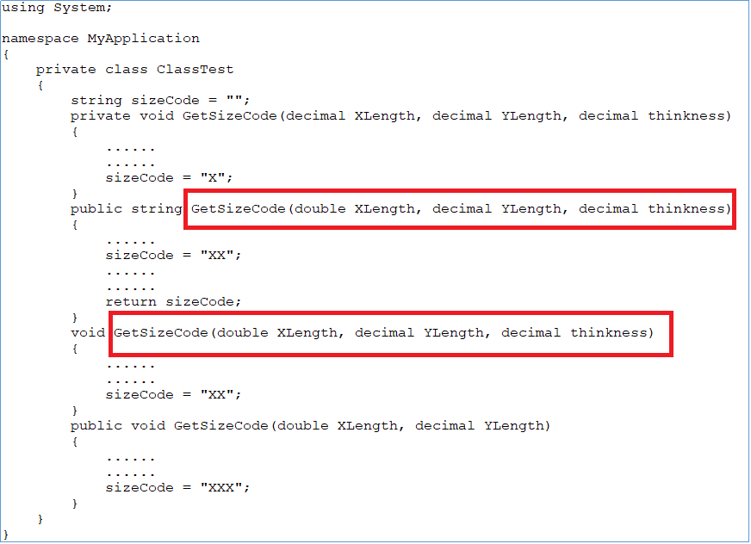

- Which of the following statements are correct for the given code snippet?
food obj;
obj = new food();

- Creates an object of class food.
- To create an object of type food on the heap or stack depending on its size.
- Create a reference obj of the class food and an object of type food on the heap.
- Create an object of type food on the stack.

- Which of the following operators can be used to access the member function of a Class?
- :
- ::
- .
- #
- ->

- Answer the followings:
- What is the difference(s) between Array and Arraylist in C#?

Array | ArrayList
Must include System namespace to use array. | Must include System.Collections namespace to use ArraList.
Array Declaration & Initialization:  int[] arr = new int[5]  int[] arr = new int[5]{1, 2, 3, 4, 5};  int[] arr = {1, 2, 3, 4, 5}; | ArrayList Declaration & Initialization:  ArrayList arList = new ArrayList();  arList.Add(1);  arList.Add("Two");  arList.Add(false);
Array stores a fixed number of elements. The size of an Array must be specified at the time of initialization. | ArrayList grows automatically and you don't need to specify the size.
Array is strongly typed. This means that an array can store only specific type of items\elements. | ArrayList can store any type of items\elements.
Performs faster than ArrayList because it is strongly typed. | Performs is slows.

- What is the difference(s) between Array (type[]) and List (list<T>)in general?

- Write SQL query that performs self-join? Explain with example
>> A self join is a join in which a table is joined with itself.
Ex. The following SQL statement matches customers that are from the same city:
SELECT A.CustomerName AS CustomerName1, B.CustomerName AS CustomerName2, A.City
FROM Customers A, Customers B
WHERE A.CustomerID <> B.CustomerID
AND A.City = B.City
ORDER BY A.City;

- Explain what does an UNION command do in SQL query?
>>The SQL UNION operator is used to combine the result sets of 2 or more SELECT statements. It removes duplicate rows between the various SELECT statements.
Each SELECT statement within the UNION must have the same number of fields in the result sets with similar data types.

- What is the difference(s) between UNION and UNION ALL in SQL query?
>> UNION removes duplicate rows.
UNION ALL does not remove duplicate rows.

