Final_Project_C++

Classes :

* Nœud :

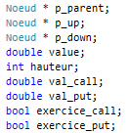This object contains all those parameters:

All pointers serve to create and navigate in the binomial tree which is create in the classe “Arbre_Bin_Ptr “.

And for the BinLattice Classe, we need to store the value of the payoff for each step. It’s why we have all those parameters.

* Option :

Option contains all financial value of an option:

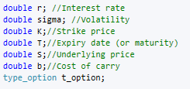

* American_Option & Europeen_Option :

Those two Classe are daughter classe of Option classe.

* Arbre_Bin_Ptr :

This classe who contains all this parameters, allows to create a binomial tree to compute the price of an option.

The binomial tree is create only with pointers.

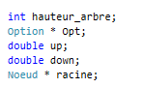

* Arbre_BinLattice :

This classe who contains all this parameters, allows to create a binomial tree to compute the price of an option.

The binomial tree is create with matrix of pointers and work like a vector of vector.

* Black_Scholes :

This classe compute the payoff of an option with the model black scholes.

* Monte_Carlo :

This classe compute the payoff of an option with the model Monte Carlo.

Diagramme of Classes :

