# Contents

Contents I

Preface 1

Installing CH340 Driver on Windows 1

Check the Installation 1

Installing Driver 2

Installing CH340 Driver on MAC 9

Supported System 9

Installing Driver 9

# Preface

Most computers have built-in or can install this driver automatically when you first connect the control board.

If your computer cannot recognize the control board, follow this document to install the driver.

# Installing CH340 Driver on Windows

## Check the Installation

1. Connect your computer and control board with a USB cable.
2. Go to desktop of your computer, select “This PC” and right-click to select “Manage”.

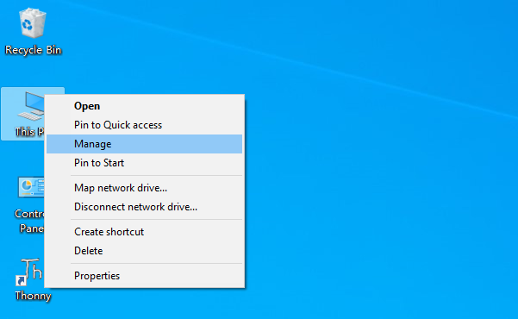

1. Click “Device Manager”. If your computer has installed CH340, you can see“USB-SERIAL CH340 (COMx)”. Then there is no need to install it again.

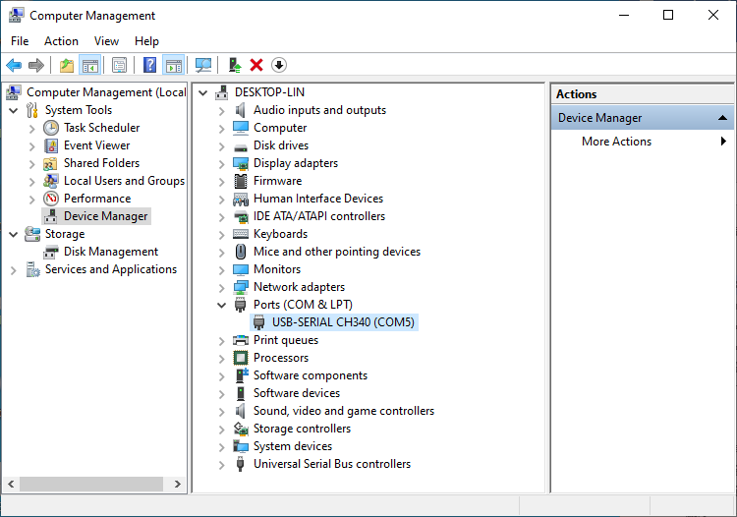

CH340 Port

## Installing Driver

### Method 1

1. If you have not yet installed CH340 driver, you will see the following.

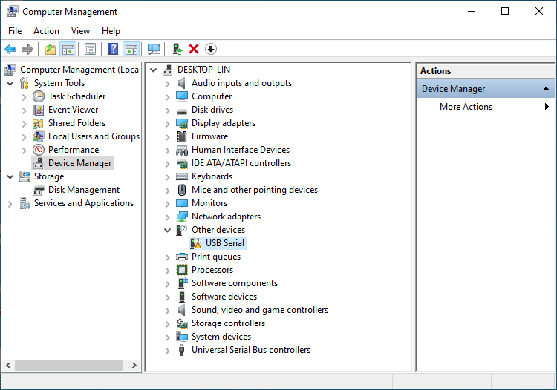

1. Click “USB Serial” and right-click to select “Update driver”.

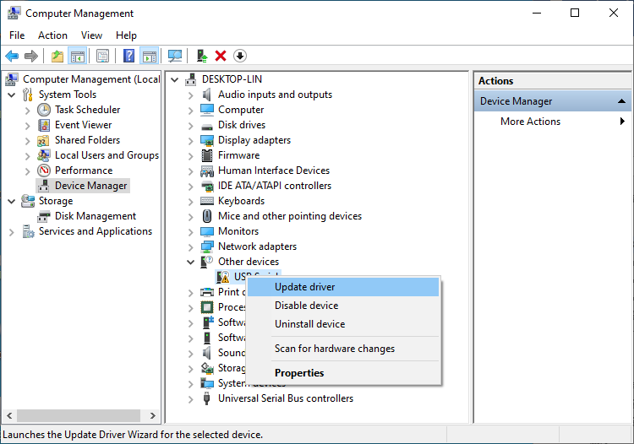

1. Click “Search automatically for updated driver software”。

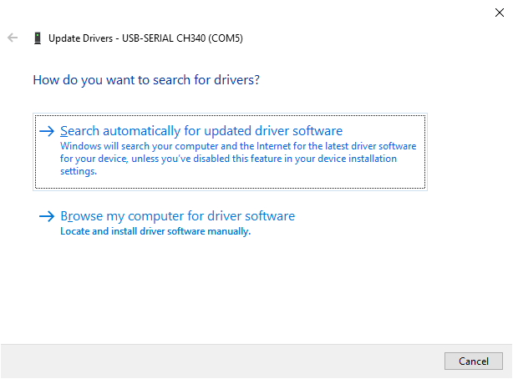

1. Wait for CH340 to finish installation.

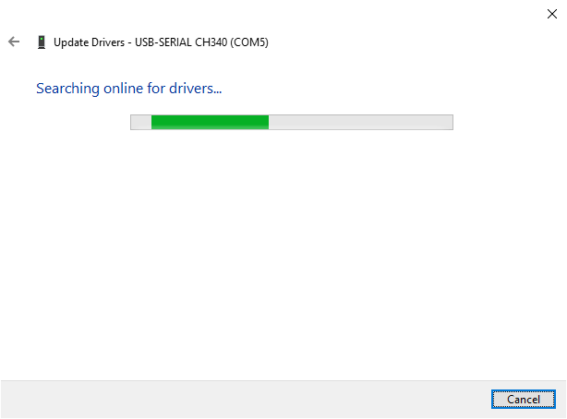

1. When you see the following interface, it indicates that CH340 driver has been installed to your computer. You can close the window.

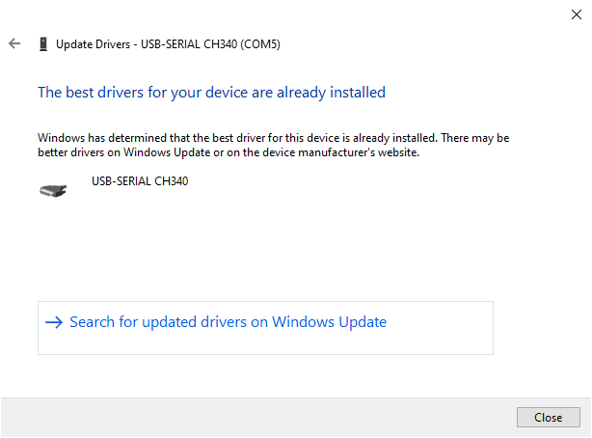

1. When control board is connected to computer, you can see the following.



### Method 2

1. First, download CH340 driver, click <http://www.wch-ic.com/search?q=CH340&t=downloads> to download the appropriate one based on your operating system.

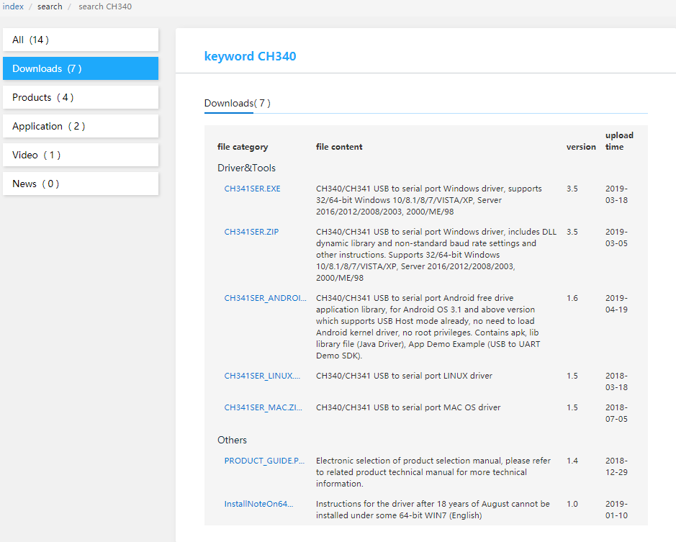

MAC

Windows

Linux

You can also find the installation package in “Drivers” folder.

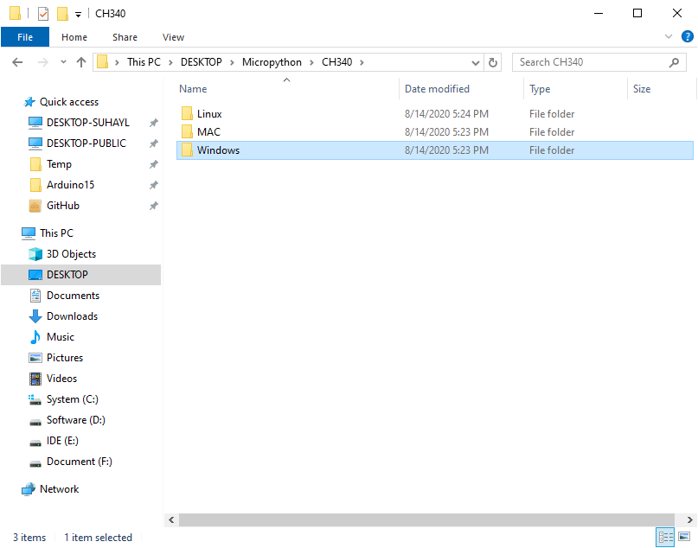

1. Open the folder “**Windows/ch341ser**”.

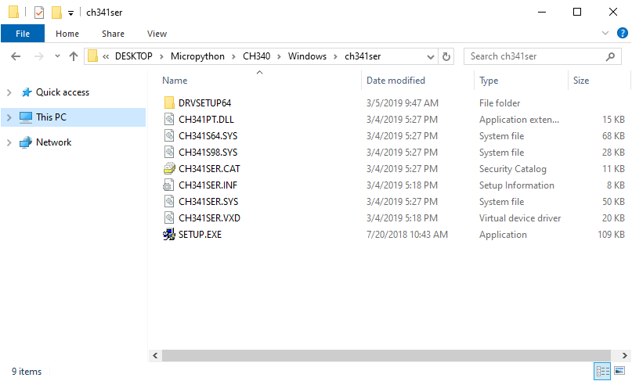

1. Double click “SETUP.EXE”.

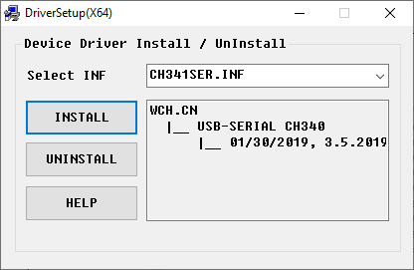

1. Click “INSTALL” and wait for the installation to complete.

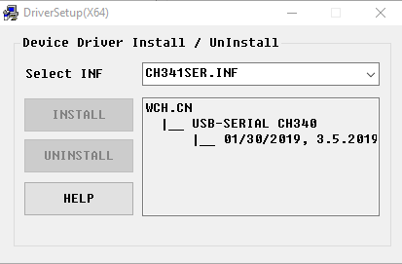

1. Install successfully. Close all windows.

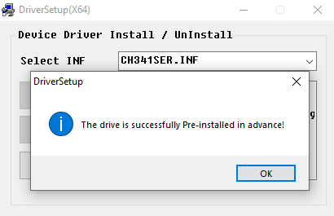

1. When control board is connected to computer, select “This PC”, right-click to select “Manage” and click “Device Manager” in the newly pop-up dialog box, and you can see the following.



1. So far, CH340 driver has been installed successfully. Close all dialog boxes.

Please try to upload a sketch again. If the issue remains, please contact us via [**support@freenove.com**](mailto:support@freenove.com)

# Installing CH340 Driver on MAC

## Supported System

OS X 10.9 and later version.

## Installing Driver

1. unzip the driver file (you can find it in “Drivers” folder) to a local installation directory.
2. Double-click CH34x_Install.pkg.
3. Install according to the installation instructions.
4. Restart after finishing installing.
5. After the installation is completed, you will find serial device in the device.
6. list(/dev/tty.wchusbserial*), and you can access it with serial tools.

If you can’t find the serial port , you can follow the steps below:

1. Open terminal and type ‘ls /dev/tty*’ and then you will see devices like tty.wchusbserial;
2. Open ‘System Report’->Hardware->USB, the right side is “USB Device Tree” there will be device named “Vendor-Specific Device” and check if the Current is normal.

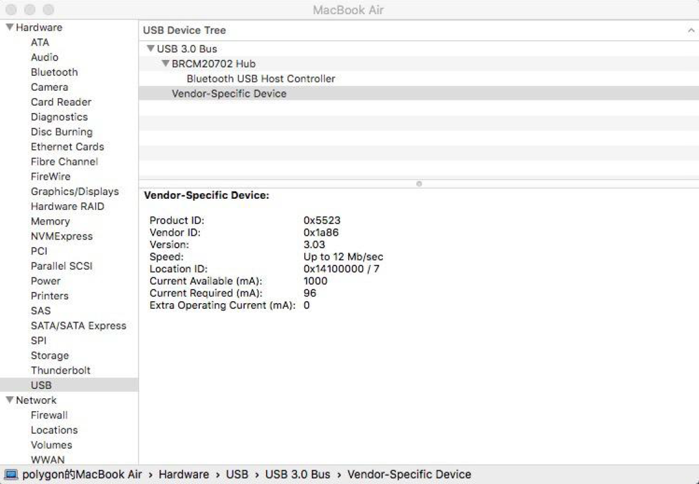

If the steps below don’t work at all, please follow the installation steps and try again.

**Note:**

1. Please enter “System Preferences”->”Security & Privacy”->”General” page, below the title ”Allow apps downloaded from:” you should choose the choice 2->”Mac App Store and identified developers” so that our driver will work normally.

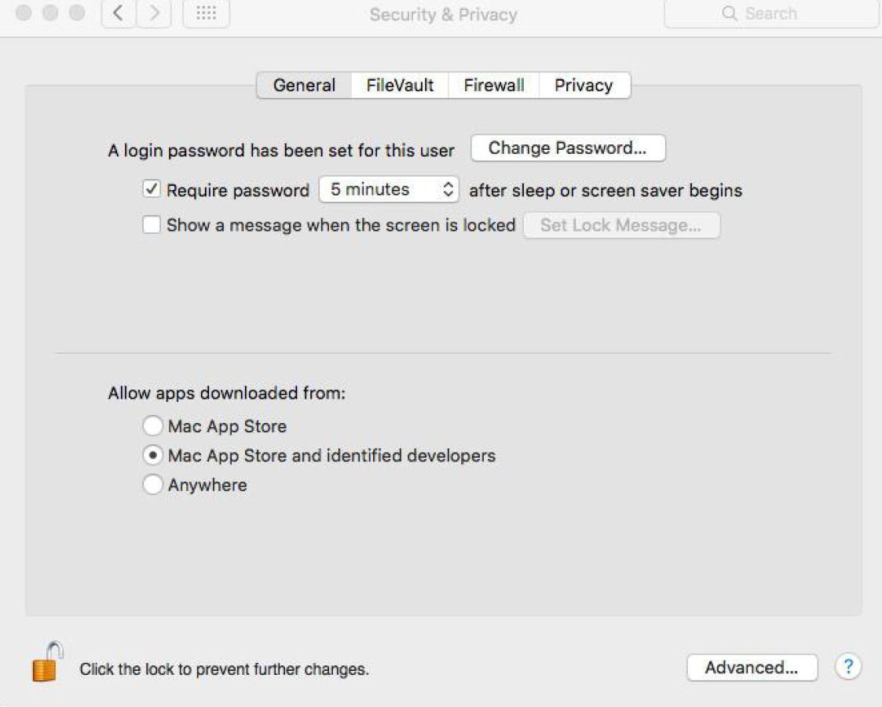

1. If old version of unsigned driver is now existing in your PC, please uninstall it first. Open Application “Terminal” and type commands below step by step:
   1. “sudo su” and input your password;
   2. “rm -rf /System/Library/Extensions/usbserial.kext”;
   3. If you cannot find the kext in step2, please try to type:

“rm -rf /Library/Extensions/usbserial.kext”

Please try to upload a sketch again. If the issue remains, please contact us via [**support@freenove.com**](mailto:support@freenove.com)