# Contents

Contents I

Preface 1

Installing CH340 Driver on Windows 1

Check the Installation 1

Installing Driver 2

Installing CH340 Driver on MAC 9

# Preface

Most computers have built-in or can install this driver automatically when you first connect the control board.

If your computer cannot recognize the control board, follow this document to install the driver.

# Installing CH340 Driver on Windows

## Check the Installation

1. Connect your computer and control board with a USB cable.
2. Go to desktop of your computer, select “This PC” and right-click to select “Manage”.

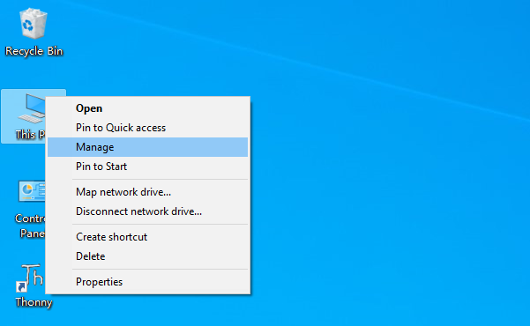

1. Click “Device Manager”. If your computer has installed CH340, you can see“USB-SERIAL CH340 (COMx)”. Then there is no need to install it again.

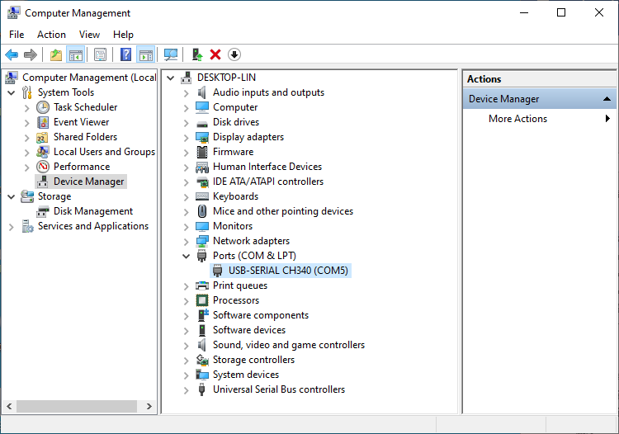

CH340 Port

## Installing Driver

### Method 1

1. If you have not yet installed CH340 driver, you will see the following.

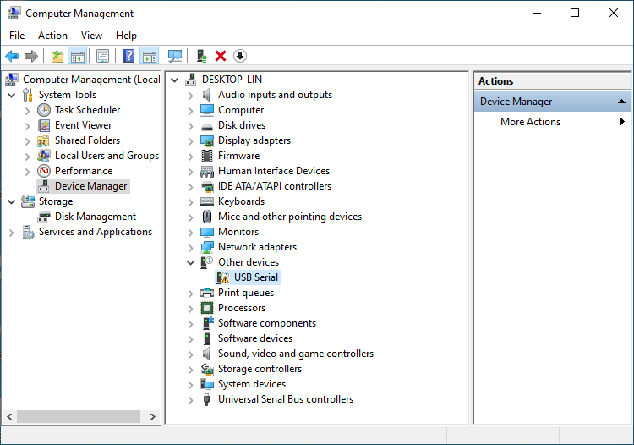

1. Click “USB Serial” and right-click to select “Update driver”.

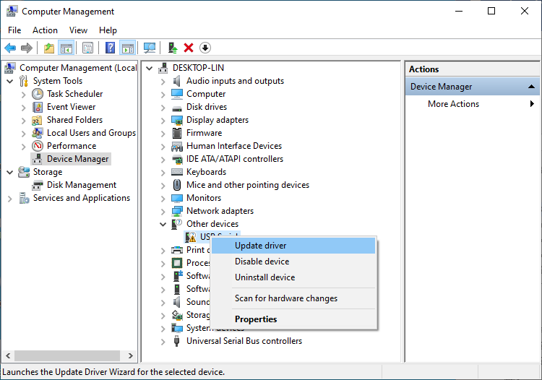

1. Click “Search automatically for updated driver software”。

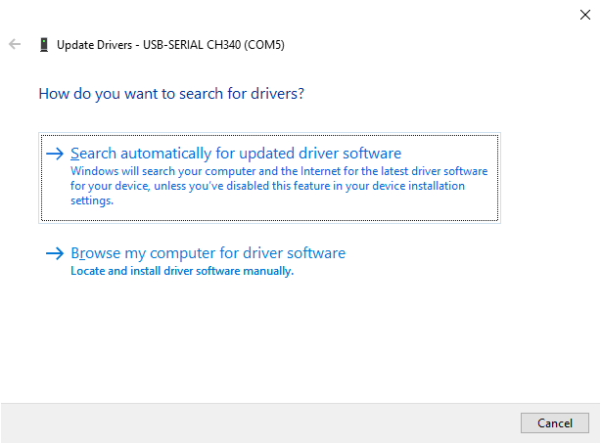

1. Wait for CH340 to finish installation.

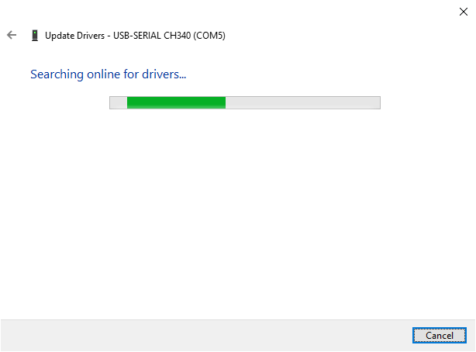

1. When you see the following interface, it indicates that CH340 driver has been installed to your computer. You can close the window.

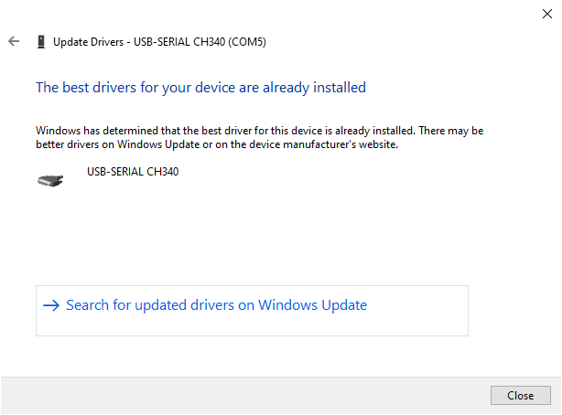

1. When control board is connected to computer, you can see the following.



### Method 2

1. First, download CH340 driver, click <http://www.wch-ic.com/search?q=CH340&t=downloads> to download the appropriate one based on your operating system.

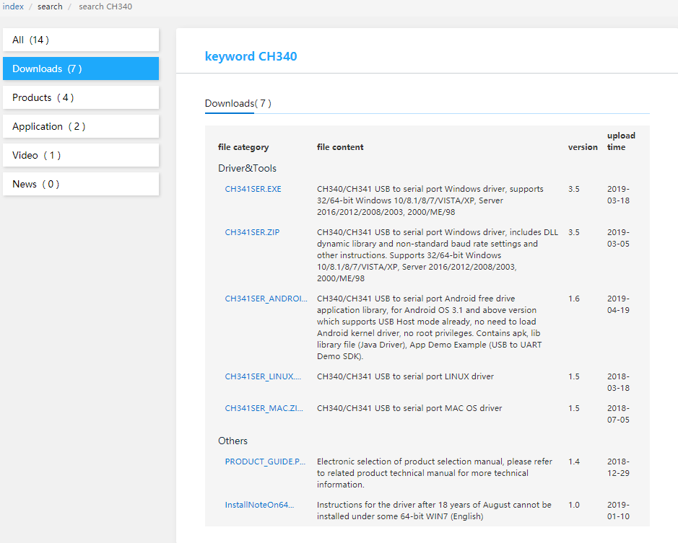

MAC

Windows

Linux

You can also find the installation package in “Drivers” folder.

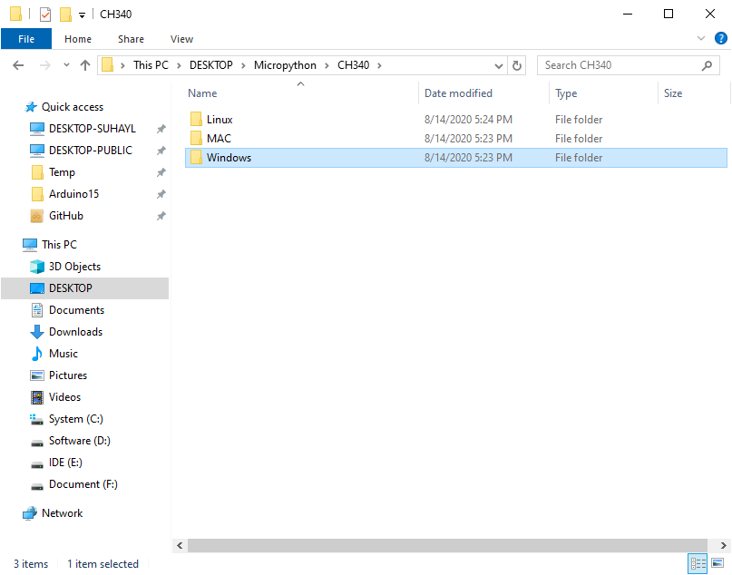

1. Open the folder “**Windows/ch341ser**”.

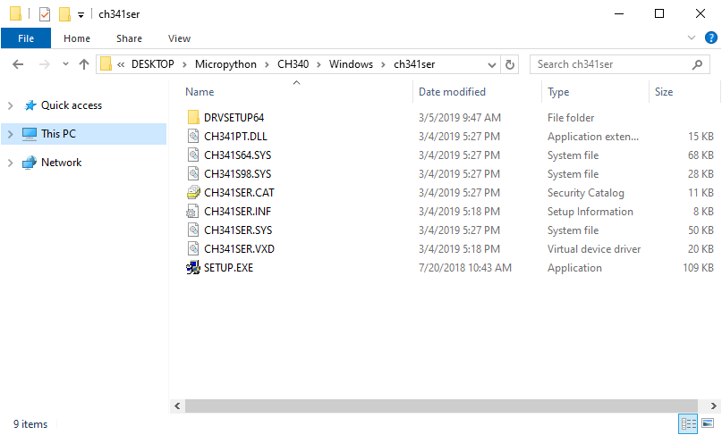

1. Double click “SETUP.EXE”.

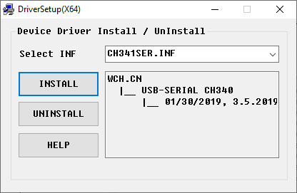

1. Click “INSTALL” and wait for the installation to complete.

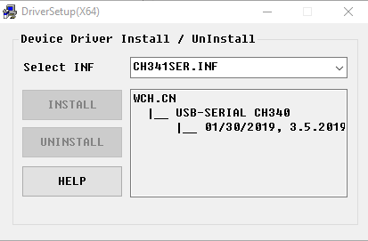

1. Install successfully. Close all windows.

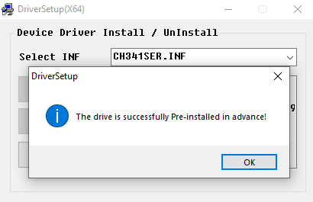

1. When control board is connected to computer, select “This PC”, right-click to select “Manage” and click “Device Manager” in the newly pop-up dialog box, and you can see the following.



1. So far, CH340 driver has been installed successfully. Close all dialog boxes.

Please try to upload a sketch again. If the issue remains, please contact us via [**support@freenove.com**](mailto:support@freenove.com)

# Installing CH340 Driver on MAC

Please refer to **Drivers\MAC\CH341SER_MAC\ReadMe.pdf**

Please try to upload a sketch again. If the issue remains, please contact us via [**support@freenove.com**](mailto:support@freenove.com)