Freeseer Project Proposal

Project Title

Project start date: Replace with today's date
Project completion date: Month, Day, Year when you'll be done
Project implementer: Developer Name
Sponsor organization: UCOSP/GSoC/FOSSLC/FSC, etc.
Last modified: 01/22/11

Table of Contents
Abstract 3
Document Version 3
Approvals 3
Background 4
Requirements 5
Design approach 5
User interface changes 5
Program logic changes 5
Platform considerations 5
Code location 5
Packaging changes 5
Third party component dependencies 5
Test considerations 6
Schedule 6

Abstract

Describe the project in 1 concise paragraph. What will you do and how does it make Freeseer better?

Document Version
Version | Date | Changed by | Description of change
0.1 | Jan. 22/2011 | A. Ross | Initial version

Approvals
Approver | Approved Y/N | Comment
Andrew Ross
Thanh Ha

Background

Freeseer is a portable presentation recording station. In other words, it is an application which can record presentations, lectures, or demos for hosting in a video hosting service such as YouTube. The following diagram depicts a typical use of Freeseer.

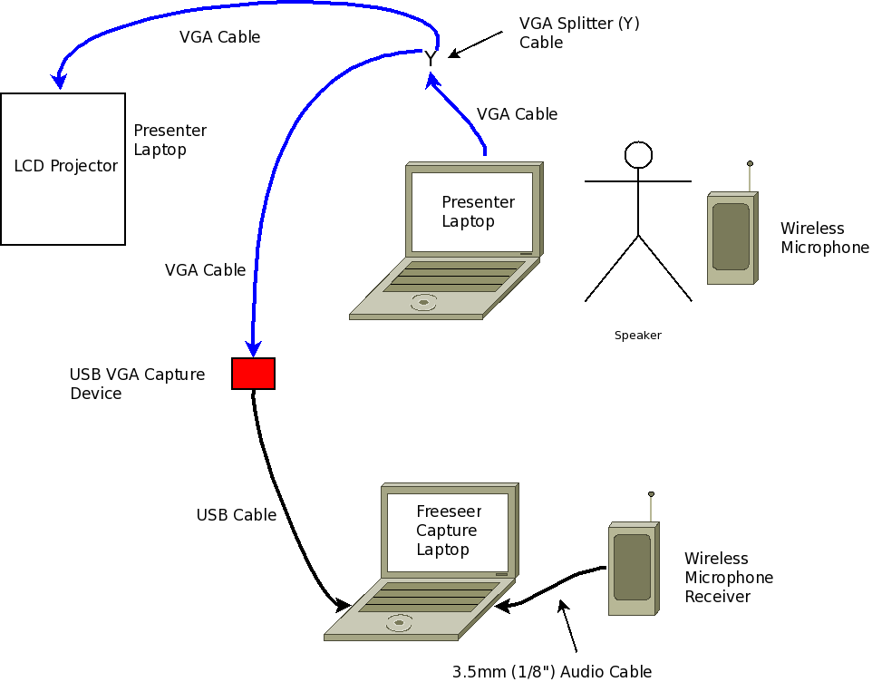
Freeseer itself is licensed under the GPL license version 3. Freeseer itself is implemented using open source software such as Python, Qt, and Gstreamer. Since 2009, it has been used to record over 250 presentations including major conferences. This includes talks on Python, Perl, Ruby, Java, Eclipse, Fedora, Mozilla, OSGeo, and many more. Visit the videos section of http://fosslc.org to view these videos for free.

Example videos for reference:
- Beyond Nerds Bearing Gifts: The future of the Open Source Economy
- The KDE Show: An Overview of Where the Free Software Desktop Is Heading

Freeseer is optimized for recording large conferences. A powerful feature it has today is a locally cached list of talks, thus the person operating the recording station can simply pick the talk from a drop down list rather than having to type it in between talks or somehow figure out which video is which talk later. The meta data for the talk is encoded into the video itself and can be automatically retrieved later.

Requirements
Please provide all requirements for your feature as you understand them. If you are citing external specifications such as standards documents or tickets in the issue tracker, please cite them and link to them.

Design approach
In this section, describe the changes from a technical perspective. Feel free to make additional headings if these headings do not fit.

User interface changes
Are you changing the existing interfaces? Are you adding new interfaces. If so, how. Ideally provide a prototype/screen mock-up to demonstrate what it will look like when you're done.

Program logic changes

Will you be changing how the user interacts with the software? If so, how. Ideally provide a concise but clear description. Diagrams are encouraged.

Platform considerations
We intend to support Windows, Mac, and Linux – both 32 bit and 64 bit. Will your code work on all of these platforms with exactly the same code? Do you need some code to be different across the platforms? Explain in either case.

Code location
Where will you put your code in the source code tree? Which files do you expect to modify? What do you plan to call any new files?

Stream strategy
Is your code self contained, or do you need to coordinate tightly with other projects? Which branch/fork/etc. will you use for your development?

Packaging changes
Are you creating new files that need to be packaged? Are you moving the location files are installed to? Explain.

Third party component dependencies
Are you adding a new dependency on external code. If so, state it. Is this component packaged and easily available for all platforms? What about Windows?

Test considerations

How do you plan to test your code changes to make sure they work properly? How do you plan to test the rest of Freeseer to make sure it hasn't been broken by your changes? Will you test all supported platforms?

Schedule
Please include the major milestones in your schedule. Roughly when do you expect to complete each of your key milestones? Please highlight any help or assistance you and roughly when you expect you need it. For instance, when will your code be ready for code inspection?
Recommended framework:
1) Project proposal (this) document agreed upon (Andrew & Thanh approve)
2) Update duties completed
- One blog to start to share the draft document (week 1)
- One blog to update the document and finalize the schedule (week 3)
- One blog to update status and report progress (week 6)
One final blog + a short screencast video to report on work done (week 10)
- One IM per week minimum to Andrew to touch base
Participate in email mailing list. To achieve full/best feedback (i.e. A, positive progress in other projects), you must participate in emails outside your project also.
- Code committed to github regularly for backups & progress tracking
- Calls/Meetings as needed.
3) Project completed
- Code submitted for review into Reviewboard
- All issues reported as part of code review fixed or addressed via. email discussion and agreed upon by Andrew/Thanh
- Document updated and submitted into github (docs/features directory)
  - Any outstanding issues should be documented and include a bug in the issue tracker
  - Please refer to the issue in the document so one can cross reference quickly

