Hi, CrimsonTome here. Just making a little document to show you how to get the game and Godot working. You’ll need to go to https://github.com/FreesideHull/climax-game-jam

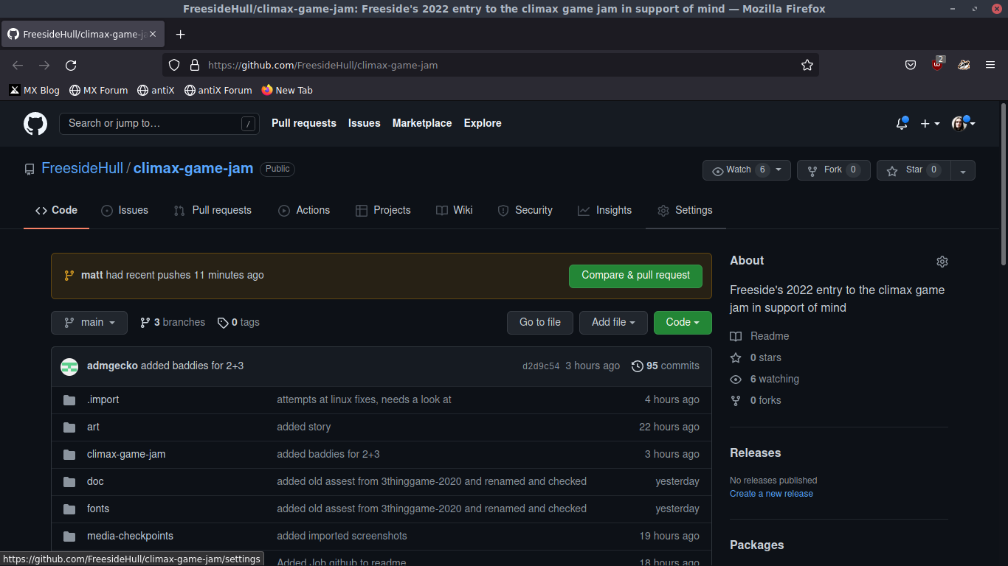
You should see a page that looks something like this.
Click on code and then Download ZIP, open that in whatever file manager you use and extract it.
Open Godot, click on import on the right and select the folder that you extracted, find and open the .godot file and the project should load.

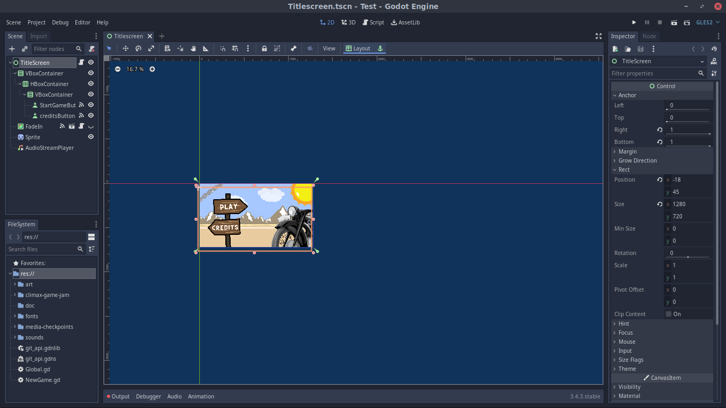
Click on the play button on the top right and the game ‘should’ load.

