**Hardware Planning and Choice**

**Of OpenGameConsoleMK1**

**Hardware Planning**

* **Output devices**

**A main screen**: image display of game elements (large, enough refresh rate)

**A secondary screen**: display of text information (relatively small, high resolution)

**8-segment numeric LEDs:** display of numeric information such as remaining time and score.

**Sound generator:** output of sound feedback of game events. (adjustable frequency and volume)

**Hardware Choices**

* **Main screen: 8*16 LED matrix with MAX7219 (SPI mode)**

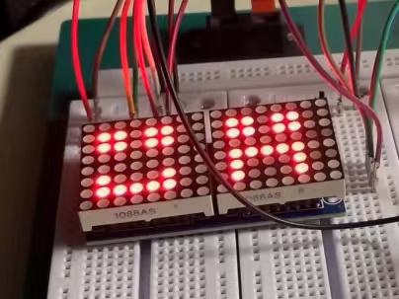 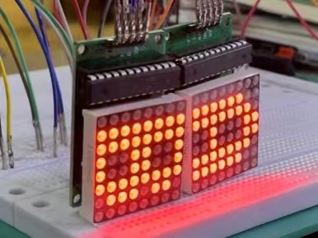

Although there are only 128 LEDs, it is enough for simple pixel games.

When micropython is used, computing power and diversity of program structure is limited. Hence low resolution is a advantage in this situation.

Also, designing images of game spirits will be easy and quickly (just different arrangement of pixels) so that development period could be shortened.

In terms of reflash rate, the maximum rate of sclock signal for MAX7219 is 10MHz. Information of image can be transmitted by just writing bytes into registers without any processing in the display module, so this display method is fast enough.

The led matrices module shown in the left picture is not used eventually due to connection type of the two max7219 chips. They are daisy-chained together, which means data for the last chip must flow through the previous ones. In addition, chip selection pins are also parallelly connected, this leads to interference to registers in the first chip when writing data to the second chip.

Therefore, the connection type shown in the right picture is used. They are two discrete led matrices module. Then altering one of the two chips with out disturb the other one is allowed.

For more information, please visit the description docx file in the HardwareDrivers directory.

* **Secondary screen: Integrated 12864 LCD screen**

