**Wire Connection for Test**

**Of OpenGameConsoleMK1**

**Hardware SPI bus**

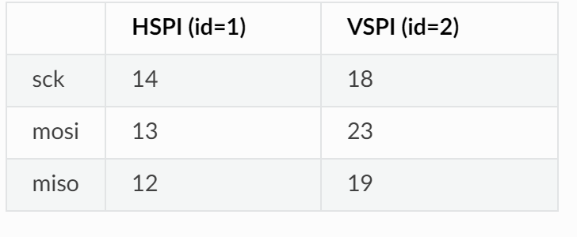

**Hardware I2C bus**

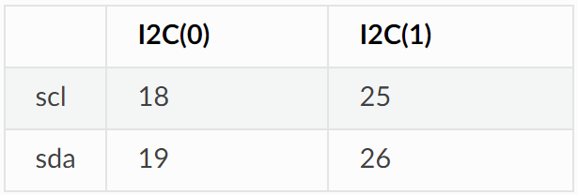

**Wire Connection**

* **MAX7219 LED matrices**

VCC – 5V

DIN - GPIO13

CLK – GPIO14

CS_1 – GPIO33

CS_2 – GPIO32

* **TM1650 4-digital LEDs for timer**

VCC - 5V

SCL – GPIO18

SDA – GPIO19

* **TM1650 4-digital LEDs for scorer**

VCC – 5V

SCL – GPIO25

SDA – GPIO26

* **Buzzer**

VCC – 5V

IO – GPIO0

* **Buttons**

VCC – 3.3V

UP – GPIO2

DOWN – GPIO4

LEFT – GPIO5

RIGHT – GPIO22

OK – GPIO23

BACK - GPIO27