**Instruction for Chained MAX7219 LED Matrices Driver**

**Of OpenGameConsoleMK1**

**Class methods**

* **_init**

In this method, arguments for SPI, pin of chip selection and default values of registers in max7219 is clarified and provided.

This internal method will be called by __init__ which runs once instance of the class is constructed.

Values of baud rate, polarity, phase for SPI and other terms is set according to datasheet of max7219.

* **_writeall**

This is a internal method which is responsible for writing same data to specified register of each max7219.

This method is called when setting information needs to be written into all chips.

Pin of chip selection is pulled down initially for loading data into storing registers from shift resister. Then signals will be transmitted repeatedly according to the number of chips so that every shift register can receive. Finally, pin of chip selection (parallelly connected to every chip) will be pulled up and data is loaded.

* **writerow**

Write data for one row according to two arguments: row, data

row: an integer in interval [0, 7] represents the index of row

data: a tuple or list with length of 8 times number of chained matrix. Each element is 0 or 1.

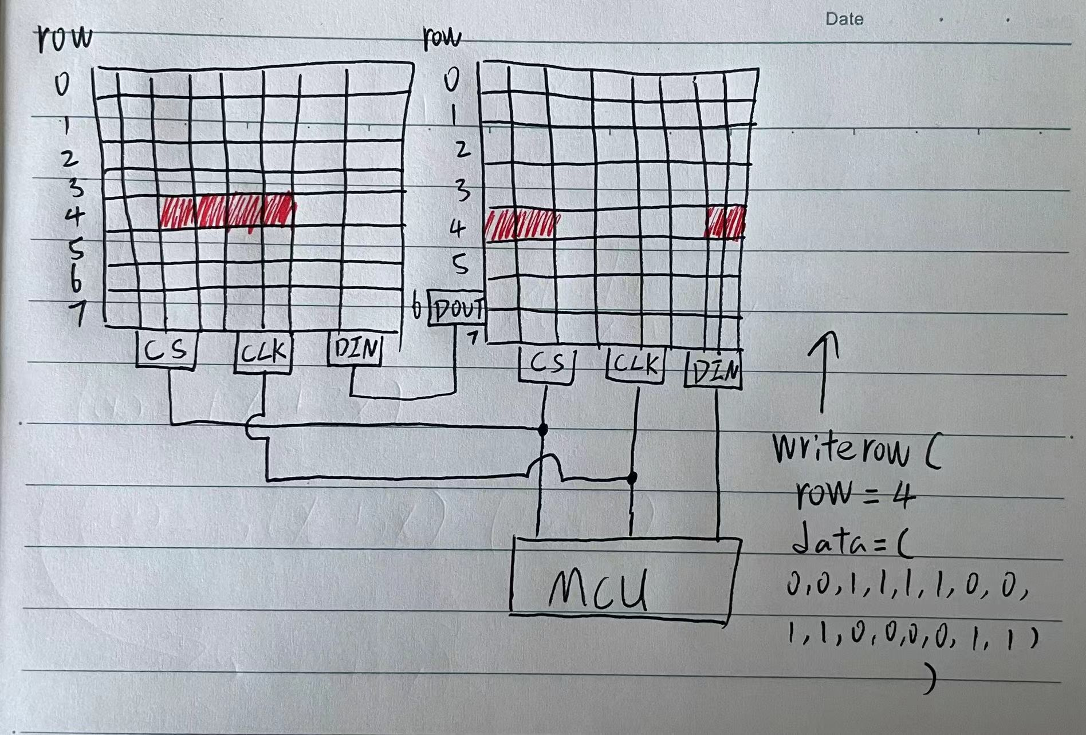

* **fill**

accepts one or several arguments as the indexes of rows needs to be filled.

If no argument is provided, every row will be filled.

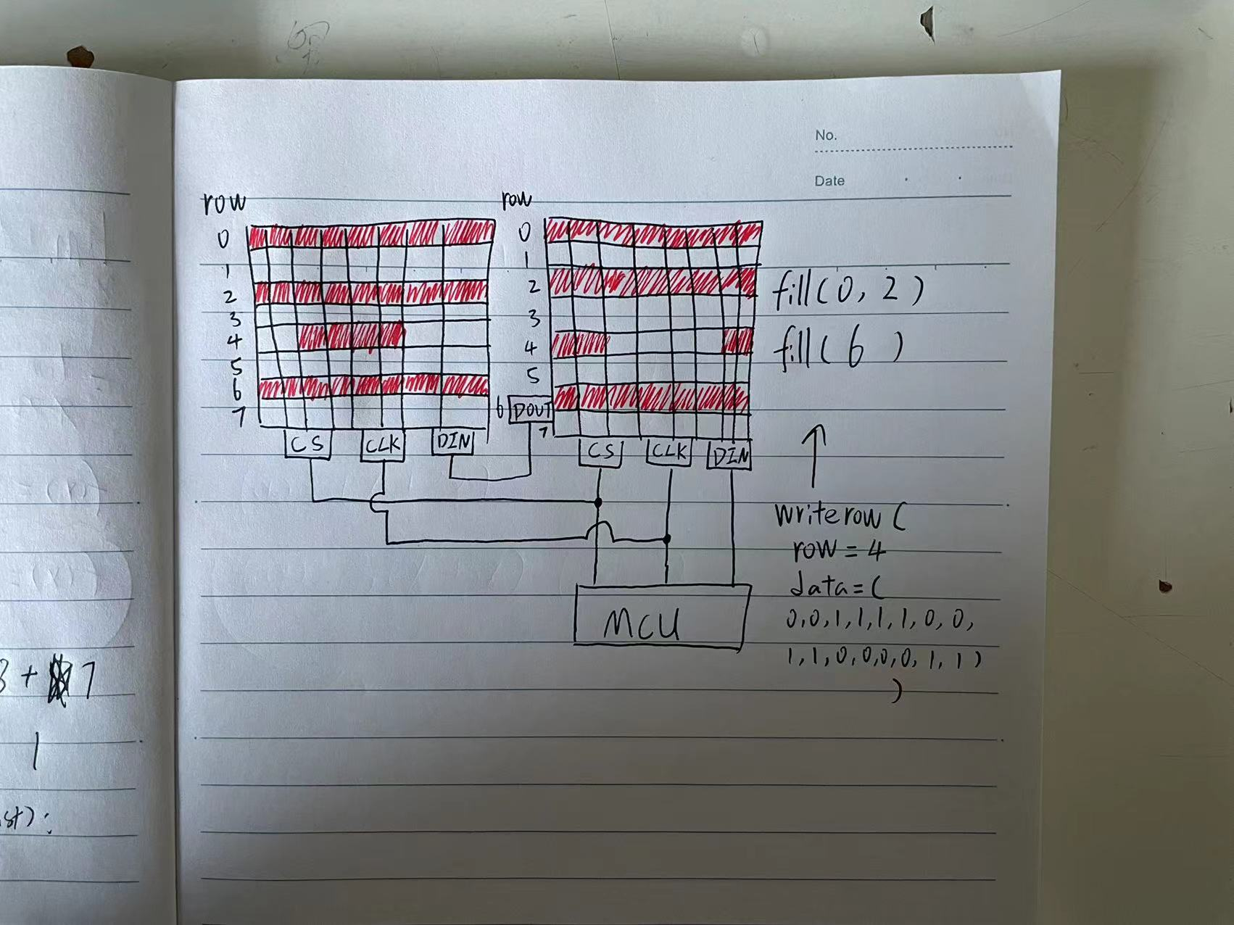

* **clear**

It has the opposite effect to method “fill” and same way of accepting arguments.

* **test**

Turn on / off the display test mode by writing 0 or 1 into the display test register.

* **intensity**

Adjust intensity of LEDs according to provided degree “i” (must in the interval [0, 15])

* **switch**

Turn on / off the power supply of LEDs in the matrices.

(display test mode still works in the off state)