**Instruction for Discrete MAX7219 LED Matrices Driver**

**Of OpenGameConsoleMK1**

**Hardware Connection**

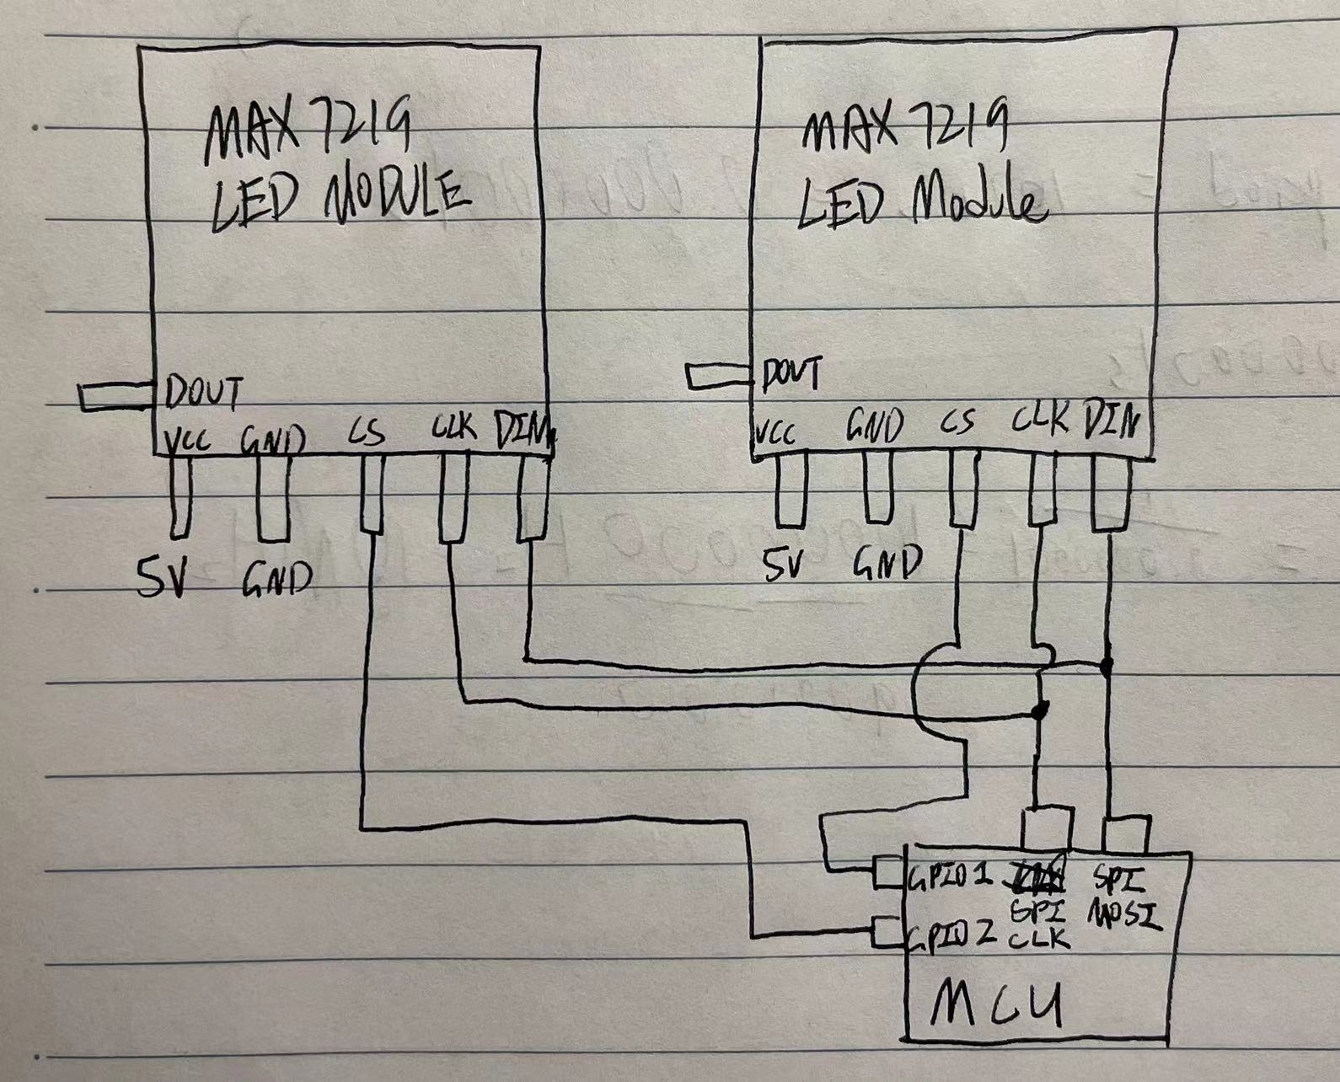

**Class methods**

* **__init__**

To construct a instance of the class, two arguments should be provided.

spi: instance of machine.SPI for data transmission

cs_pins: a tuple containing instances of machine.Pin for selecting a specific max7219

* **_init**

In this method, arguments for SPI, pins of chip selection and default values of registers in max7219 is clarified and provided.

This internal method will be called by __init__ which runs once instance of the class is constructed.

Values of baud rate, polarity, phase for SPI and other terms is set according to datasheet of max7219.

* **_writeall**

Write same data into each max7219

All pins of chip selection is pulled down initially.

Then use spi.write to write specific data to shift register of all max7219.

After writing data, pull up all pins so that data will be loaded at the rising edge of pins of chip selection.

This internal method is called by other methods about uploading setting information.

* **writerow**

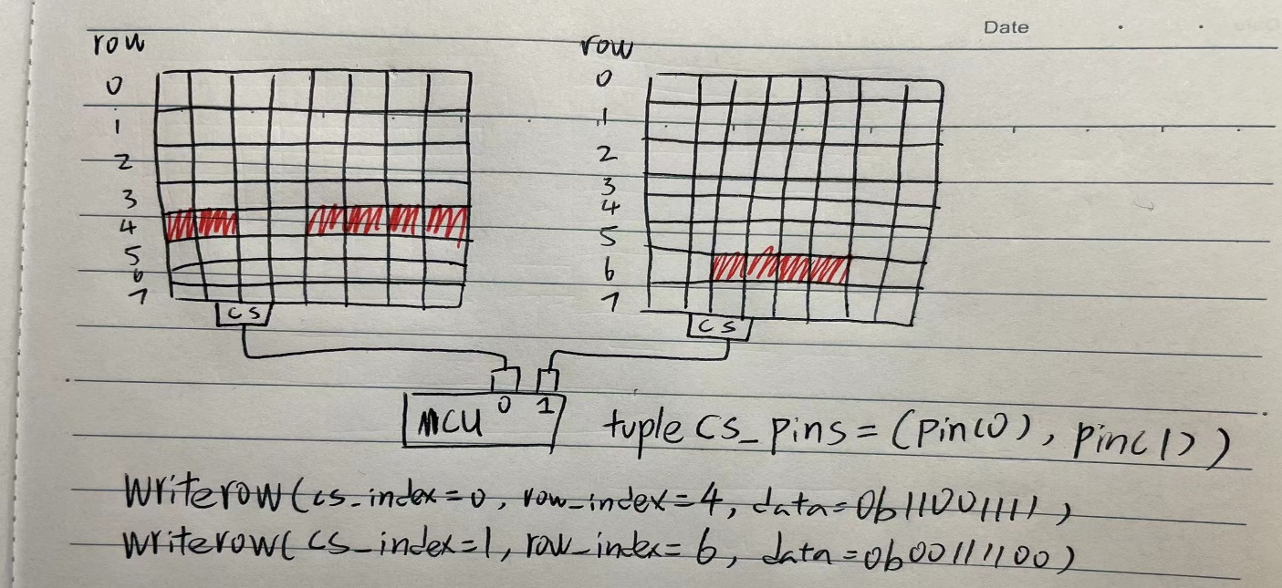

Write data for a row of LED according to chip index (cs_index) and row index (row_index).

The only difference between this method and _writeall is that only one specific pin of chip selection will be pulled down rather than all pins, so that only one max7219 can be selected and upload data.

* **clear**

Turn off all LEDs of each discrete

* **test**

Turn on / off the display test mode by writing 0 or 1 into the display test register.

* **intensity**

Adjust intensity of LEDs according to provided degree “i” (must in the interval [0, 15])

* **switch**

Turn on / off the power supply of LEDs in the matrices.

(Display test mode still works in the off state)