**Wire Connection for Test**

**Of OpenGameConsoleMK1**

**Hardware SPI bus**

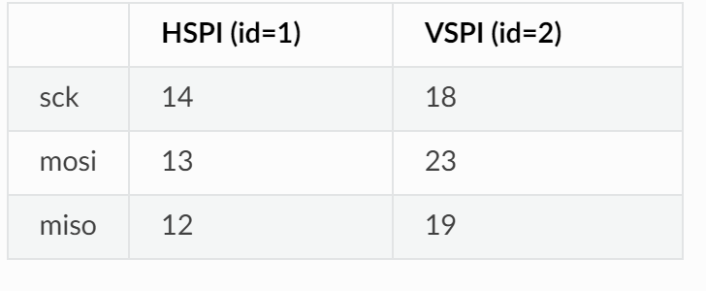

**Hardware I2C bus**

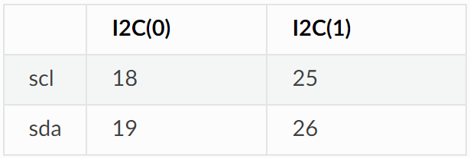

**Wire Connection**

* **MAX7219 LED matrices**

VCC – 5V

DIN - GPIO13

CLK – GPIO14

CS_1 – GPIO33

CS_2 – GPIO32

* **TM1650 4-digital LED**

VCC - 5V

SCL – GPIO5

SDA – GPIO4