**Freewheelin’**

*Process Documentation*

*1st iteration*

Zihan Zhou

Leeds id: 201487560

Date added: 2022-12-5

1. **Prototypes**
   1. Goal of current cycle and priority selections

The goal of this iteration is to produce a version of the **wireframes** based on the first round of questionnaires and team brainstorming discussions, as well as **an interactive executable software (MVP)** that will incorporate the data and information we gathered during the questionnaires and requirements analysis which aim to refine the naive initial version of the Tomeo software.

The reason why we set paper wireframing and executable software as the priority goal of this round is that we can **further collect feedback** after this iteration, as well as better analyze the potential user needs in the general direction after **comparing with similar software**. Writing a complete piece of software also helps to provide a **template** for later stages of design and development, ensuring a better understanding of development **feasibility**.

1.2 Prototyping techniques and software utilizations

Prototyping techniques: wireframing, native (a completed interactive executable software)

Software utilizations: good notes, Qt designer, Clion.

(More techniques and software will be incorporated on the latter iterations.)

1.3 Theoretical motivations

Since this is the 1st iteration, we cannot gather enough information and feedback from the user, so the theoretical motivation involved would not be concerning about the detailed UX (a good amount of this will be incorporated on the latter iterations).

1. Lay the foundation for a robust **interaction design lifecycle**. We designed the structure of the video player which leaves spaces to discuss, like the play button and play back button, which can import design principles like **constructivism (the similarity and invariant)** on the latter iterations according to the user feedback.

The **approximation** in **constructivism** is also included, like the scroll area for imported video folder. (Which can be extend on the latter iterations)

1. Take good advantage of **Affordance Theory**. We carefully select the icons so that they can be instructive and perceptive.
2. Fix the **design pattern,** which provides **recurring solution** that solves a common problem on the development process of the software (providing templates which can be reused by the programmer).
3. Distinguish the **fidelity**. We first finished a low fidelity prototype, a paper wireframe, helping us to agilely experiment our ideas. A relatively high-fidelity prototype like the software, which can better model the real usage of the software.

1.4 Working technique chosen

We chose the agile development as our main working Principe and Disruptive innovation as our philosophy guidance and theoretical support.

1.4.1 Justifications

We choose the **Agile development** as our team working technique. Agile development is an incremental delivery approach where each iteration is a fully usable product. Agile development is a great way to embrace user needs and changes, and it is easy for the team to explore user needs and pain points step by step because it receives immediate feedback after each iteration.

We choose the **disruptive innovation** as our philosophy guidance and theoretical support. First, we investigate similar products. After identifying user needs and pain points, we first design and code a minimal software that satisfy their specified needs, and then expand software functions and refine the interactions step by step taken advantages of the feedbacks after each iteration (the development of SpaceX has well integrated this concept).

1.4.2 Evidence

1.5 Exploration and discussions

1.5.1 The Design, Process, and evolution

Above shows the wireframe prototype of the interactive software. The basic wireframing design, as shown above, was achieved after a questionnaire, a market software survey, and a brainstorming session within the team. The illustration on the left is the main interface of the software, and on the right is the top menu bar, which realizes the requirement of internationalization. Software is developed step by step according to the wireframes. The first is the use of Qt Designer(native) for software interface development, then the corresponding functions are achieved, such as play, pause, fast forward and so on.

**2.Code**

2.1 Illustrating the UI improvements

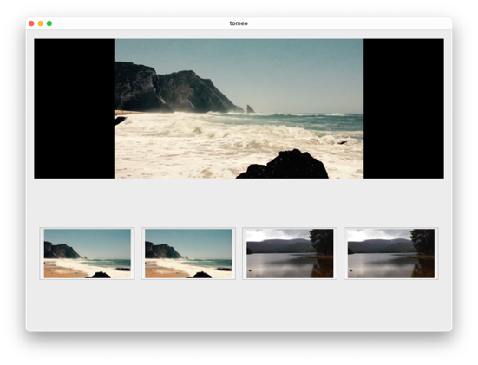 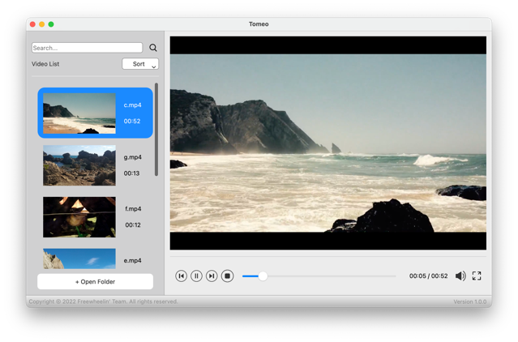

The main interface of the software has changed a lot compared with the original Tomeo codebase. After the initial collection of user requirements, we followed the **approximation principle**, allowing users to visually open the folder with a graphical interface and store their thumbnails in the form of a scroll area. At the same time, we have greatly enhanced the interactive degree of video playback functions. In accordance with the **Affordance theory**, we have designed a set of intuitive interactive interfaces, allowing users to manipulate the playing process easily. Also, our design faithfully obeyed the rule of **Schneiderman's 'Eight Golden Rules,** allowing the frequent users to have short cuts, undo their operations, and get immediate informative feedbacks. Also, based on preliminary market research, in this version we added a simple clip function, and provided shortcuts for it.

2.2 Scrutinize the differences

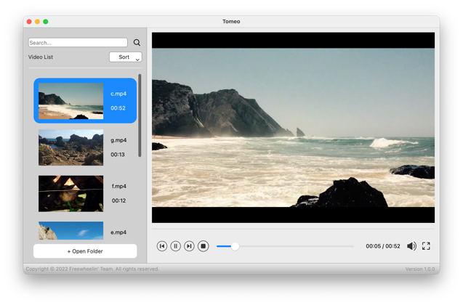

|  |  |
| --- | --- |
|  |  |
| Designed Interface | **The implementation** |
| Thumbnail area | Based on the wireframe, the implementation enhanced the readability and accessibility |
| Functional bar | Implemented according to the design |
| Playback area | Based on the wireframe, the implementation enhanced some details such as optimized the interface when no video file is imported, giving the user more controls and feedback |
| Open file function | Implemented according to the design |

**3.Evaluation**

3.1 Evaluation techniques

Techniques that applied in this iteration:

* Cognitive walkthrough
* Heuristic evaluation (by UI- knowledge backed cs students)
* Usability Tests

3.2 Justifications on evaluation techniques

Cognitive walkthrough is chosen because it is very efficient and fast, which is very suitable for the early iteration prototype. At the same time, developers and designers can explore the deeper needs based on the ideas of the interviewee.

Since we are not able to collect large amounts of user data early on, it is necessary to use the classic UI model properly. Here, the heuristic evaluation method is used to check whether the software prototype meets 10 basic design criteria.

In the end, we selected a representative sample of real users for usability tests and were able to gather the hidden requirements for the next iteration

3.3 Outcomes of the evaluation

The general outcome of this iteration is accepted. Evidence is attached below.

3.4 Evidence of the evaluation

We invited all team members and some interested users to evaluate our software (10 peoples), and we prompt some basic tables for them. The anonymous result is presented as follows.

|  |  |  |
| --- | --- | --- |
| Criterion | Accept | Reject |
| Cognitive walkthrough | 10 | 0 |
| Heuristic evaluation | 8 | 2 |
| Usability Tests | 9 | 1 |
| General Evaluation | 10 | 0 |

We Also gathered their ideas and requirements during the process of evaluation, which will be present on our next process documentation.