**Freewheelin' Process Document**

2nd Iteration

Author: Yuheng Liu

Date: 8/12/2020

# 1 Prototypes

## Goal of Cycle

For the second generation of software, we changed the name Tomeo to Freewheelin to build a brand image. And in the second generation of software, we will officially adapt to the tablet end, to the software replacement of a new interface. The tablet adaption will help outdoor users to play and edit videos easily on their mobile devices, and the new design interface will not only make the software more beautiful but also give more consideration to user experience, in line with the basic principles of UI design. At the same time, we will also add the functions of double-speed playback and full-screen playback to the playback function, and to meet the needs of a large number of users, we will also add rich editing functions to the software.

## Prototyping Technique

### 1.2.1 The name of the techniques

1. Sketches

We use GoodNotes on iPad to illustrate rough ideas.

1. Wireframes

According to the sketches we illustrate, we use Moqups ([https://app.moqups.com/](https://app.moqups.com/eXGza5OvBmfH1ClW9qD0drzESugDp9BK/edit/page/a46880d1a)) a web application to draw the wireframe as the low-fidelity digital prototypes.

1. Paper Prototypes (Video)

We shoot a video to show the process of the click events in our software to make the user interface and the developers understand the whole procedure clearly.

You can see this video in our resources folder or via this link:

<https://leeds365-my.sharepoint.com/:v:/g/personal/sc20yl2_leeds_ac_uk/EQ5BC5RNZZFHlG2AqJ7s5kkBLGWx7scntmUIgxL34MNIOA?e=2SK5mK>

1. Native

After these processes, we use Qt Designer and Clion to develop the executable software.

### 1.2.2 Software used

In these four techniques, there is plenty of software we used. All software has been listed below.

|  |  |
| --- | --- |
| **Software** | **Usage** |
| GoodNotes | It is used to illustrate the rough ideas with iPad and Apple Pencil. |
| Moqups | A software to sketch the wireframe in a web. |
| Adobe Premiere | We use Adobe Premiere to edit our paper prototypes (video). |
| Qt Designer | It is used to design the UI of software and create the QSS file. |
| Clion | It is used to develop the Software. |

## Theoretical Motivation

After the release of the first generation of software, we obtained the user experience of more than 20 users in the form of a questionnaire survey. Most people think our playback features are pretty good, but a lot of people want us to adapt it specifically to the tablet, and they think the tablet has a bigger screen, so we can add some video editing capabilities to the software. Another group of users also think that our software interface is too simple, and the function arrangement is not suitable. So after taking all the user feedback into account, we decided to redesign the software's interface and give more consideration to the user experience. At the same time, we will also develop a version of the software for the tablet side, which not only retains the original playback function but also adds some adjustment and editing functions to the software.

## Group Working Technique

In this release, we are still using Agile development as our team's development technique.

### Justification

Agile development is a human-centered, iterative, step-by-step development method. In Agile development, the construction of our software projects is broken up into subprojects, each of which is tested, integrated, and runnable, and the software is always in a usable state. In our software development process, using agile development can timely adjust the demand for software and maximize the utilization of resources. Short cycles and timely feedback are also a feature of Agile development, as Agile development can deliver stand-alone results after each iteration (PlanView, 2022).

### Evidence

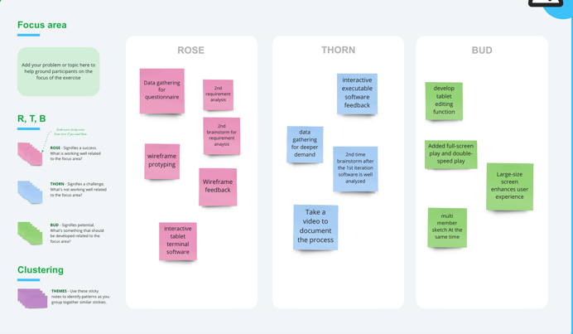

Figure 1. screenshots of the Kanban board

## Exploring the Design and Process and Evolution

When we design software, we often choose to collaborate offline. Our team members would sit together, each designing their software interface, and finally discuss with each other what good design points should be kept and what redundant design points should be discarded. To design software more in line with market demand and user demand, we will also refer to much existing software on the market, combined with the advantages and disadvantages of these software to complete the design of our software.

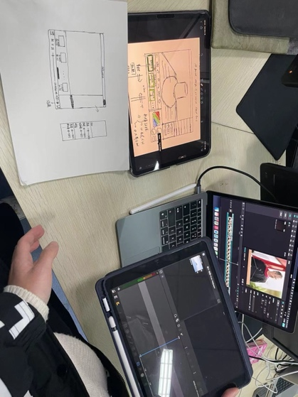

Figure 2. Offline cooperative photos

### Sketches

In the second generation of software design, to improve the software interface and functions, and improve the user experience of the software, all five members of our team first designed the software interface with blank paper or iPad. And discuss it with each other in subsequent meetings. Choose everyone's good ideas to keep, and redundant content to cut.

The table below lists each person's sketch, along with the comments made through the meeting.

|  |  |  |
| --- | --- | --- |
| **Designer** | **Sketch** | **Comments** |
| **Lei Zhou** |  | The software interface is too rough, and the function is not much different from the first version of the software. But added video track and audio track clip function. |
| **Pangyu Li** |  | The software interface is simple, but also contains a lot of functions. Rich editing features were added to the software design, but this led to a shift in focus from a video player to a professional editing software. |
| **Xiangyu Shen** |  | According to the design sketch, the designer prefers to make a video player with fewer editing functions. |
| **Yuheng Liu** |  | The software also has the function of video playback and clip, and the playback area and clip area are distinguished, which may be more convenient for users to use. However, too much content in the clip workspace will cause problems such as difficulties for users to use for the first time. |
| **Zihan Zhou** |  | The software area is clearly divided, and the function of the editing area is relatively moderate. And added the function of timeline to the video clip area, but this also makes the video development more difficult. |

### Wireframe

At the beginning of software design, we all choose to sketch the software on blank paper or the iPad. After determining the general interface design and software functions, the sketched sketch is converted to wireframing on the computer, which can help developers build software interfaces and functions more conveniently and intuitively.

|  |  |
| --- | --- |
|  |  |
| Figure 3. sketches index page | Figure 4. wireframe index page |
|  |  |
| Figure 5. sketches full screen | Figure 6. wireframe full screen |

# Code

## The UI Improvement

We made a lot of UI improvements in this iteration. Most of the improvements are listed in the table below.

|  |  |
| --- | --- |
| **Previous Version** | **Current Version** |
|  |  |
| The homepage of the software has changed a lot, from the original light tone to dark tone, which will make people feel more professional design of the software. In the new design, the left side of the software is the video playing area and the right side is the working area of the clip. The division of regions can help improve user experience. And the new version of the software adds a lot of features but can give people a lot of experience without clutter. | |
|  |  |
| This is how the video list looks after the first and second versions of the software have loaded the video. The first version of the video list will be fixed in the left side of the software, but we have made some changes in the second version of the video list. By default, the following list will be hidden, and when the user clicks the button icon in the lower left corner, the list will be opened. Since users do not use the video list frequently, if the list is displayed permanently, it will occupy certain visual space, so we choose to hide it. When the user has the need to use, the video list is opened for video selection. | |
| NONE |  |
| The new version also includes a full-screen mode for video projection, which was not available in the first version. In the full-screen mode, the video will occupy the whole computer window of the user, and the video controls, such as play and pause buttons, will be displayed after monitoring the movement of the user's mouse pointer, and will be automatically hidden after a certain period. This design can make the user more immersed in the video, without affecting the user's viewing experience. | |

## Prototypes and Implementation

|  |  |
| --- | --- |
| **Prototypes** | **Implementation** |
|  |  |
| From this set of comparison diagrams, we can see that the actual implementation effect of the software is basically consistent with the expected wireframing design. | |
|  |  |
| From this set of comparisons, we can see that there are some differences between wireframes and the design and the final shape of the software. Specifically, the button control area is suspended above the video in the wireframe diagram, but in the actual implementation process, we put the button control at the bottom of the page. This is because in our development process, we considered that the video control suspended in the video screen will block part of the user interface, and then affect the user experience. | |

# Evaluation

## Evaluation Technique

We use two same evaluation techniques as the first iteration, cognitive walkthrough, and Heuristic evaluation. And one new evaluation technique is an interview.

We choose interview as the new evaluation method of our generation of software because an interview is a way to directly understand the degree of users' preference for software (Indeed Editorial Team, 2022). We interviewed two students in total, all of whom have used our software for some time. During the interview, they also gave their intuitive experience and some suggestions to help us make better software.

### Outcomes of the Evaluation

According to the result of the interview, we can conclude that users all think that our current tablet software meets the user's needs, no matter the function of playing or editing. However, some users have mentioned that they believe that not all sports fans have tablet devices, so they hope we can iterate on a mobile version. Mobile phones are not only available to everyone but also very convenient to use, because users only need to shoot on the phone and then edit on the phone, instead of importing to the tablet device for editing, which saves a lot of time for users.

### Evidence of the Evaluation

Our interview is a video, and we have uploaded it to the folder, or you can access this video via:

<https://login.microsoftonline.com/bdeaeda8-c81d-45ce-863e-5232a535b7cb/oauth2/authorize?client%5Fid=00000003%2D0000%2D0ff1%2Dce00%2D000000000000&response%5Fmode=form%5Fpost&response%5Ftype=code%20id%5Ftoken&resource=00000003%2D0000%2D0ff1%2Dce00%2D000000000000&scope=openid&nonce=453F9D9195B99DF6A1D6CBA7F6B81F1FE642B8C55E78E430%2DFAB68A748AE71CA088D1D0EE83EAF9451EDB7E4486585B269D4C58E1E2501589&redirect%5Furi=https%3A%2F%2Fleeds365%2Dmy%2Esharepoint%2Ecom%2F%5Fforms%2Fdefault%2Easpx&state=OD0w&claims=%7B%22id%5Ftoken%22%3A%7B%22xms%5Fcc%22%3A%7B%22values%22%3A%5B%22CP1%22%5D%7D%7D%7D&wsucxt=1&cobrandid=11bd8083%2D87e0%2D41b5%2Dbb78%2D0bc43c8a8e8a&client%2Drequest%2Did=9acc84a0%2D50e0%2D6000%2D02d5%2D9e2c2e7bcd42>

# Reference

app.moqups.com. (n.d.). *Sign Up & Log In - Moqups App*. [online] Available at: https://app.moqups.com/eXGza5OvBmfH1ClW9qD0drzESugDp9BK/edit/page/a46880d1a [Accessed 5 Dec. 2022].

Indeed Editorial Team (2022). *Advantages And Disadvantages Of Interviews (And Useful Tips)*. [online] Indeed Career Guide. Available at: https://in.indeed.com/career-advice/interviewing/advantages-and-disadvantages-of-interviews [Accessed 5 Dec. 2022].

Planview. (n.d.). *Benefits of Agile*. [online] Available at: https://www.planview.com/resources/guide/agile-methodologies-a-beginners-guide/benefits-agile/ [Accessed 23 Dec. 2022].