Mid Sweden University
The Department of Information Technology and Media (ITM)
Author:Mattias Majetic
E-mail address: mama1004@student.miun.se
Study programme: Independent course, 7.5 HP
Examiner: Felix Dobslaw, felix.dobslaw@miun.se
Scope: 3110 words inclusive of appendices
Date: 2012-02-0101

Project report
within Computer Engineering AV, course, 7.5 points

Java for Distributed Services
The development of an enterprise application

Mattias Majetic

Abstract
This report describes the details of developing a distributed application in Java EE, targeted for the business industry. The main purpose is to develop a fully functional application that should provide social services to users through a web site. The specifications for the application are set and must be fulfilled, with specific restrictions and requirements for the tools and brands used, although the developer is partly able to implement the solutions freely. The application was developed step-by-step through sub-specifications, over the course of half a semester. It was developed using Eclipse and the Java programming language.

Table of Contents
Abstract ii
1 Introduction 1
1.1 Background and problem motivation 1
1.2 Overall aim 1
1.3 Concrete and verifiable goals 2
1.4 Contributions 5
2 Methodology 6
3 Results 10
4 Conclusions / Discussion 11
References 13
Appendix A: User manual 14

- Introduction
The main goal of this project is to develop a distributed application based on Java Enterprise Edition (Java EE) standards and open source tools. The application should let a user quickly scan what social activities are happening in his home town. This should be done by using already available services. Such an application is called a mashup.

Background and problem motivation
Distributed applications that provide remote services are more important than ever. The Internet is nowadays widespread and available almost everywhere, and looking at how much the mobile market has grown since products such as iPhone and Androids were introduced shows that it will just be more and more important for companies to reach out to their customers. Enterprise applications used in the business such as bank systems are however often highly complex, spanning multiple tiers of separate logic that needs to be connected together and still be able to work reliably and securely while maintaining good flexibility and modularity. These applications are often provided on the server through the cloud, but should be able to run on web browsers on the client side.

Overall aim
The project’s overall aim is to gain knowledge about the process of developing an enterprise application from the start to the finished product. This includes designing, implementing, maintaining and extending the application. All of the different tiers of an enterprise application should be explored separately as well as seeing how they relate to each other and how they can be connected together. The outcome of the project should be a fully functional distributed application developed in Java EE, following already set specifications. While the product itself may not be of huge interest, the knowledge gained will hopefully allow developing similar distributed applications, as well as having better insight in how the market works, and which technologies are of importance right now.

Concrete and verifiable goals
The project’s objective is to step-by-step creating an application that provides social services to users through a website. In the end, users should be able to search for social events in any town, add their own events, and be able to visit other user’s profiles. The application is developed in six different steps in sequential order, each one extending the application and providing further services. Eclipse is used as the IDE of choice. The six different steps involve the following areas:
- Object Relational Mapping
Given a relational database schema (Figure 1.1), simplify it by recommending an object model with the same expressiveness. List suitable Java data-types to model the content. Based on these models, build a Java object model and connect it to a relational database management system (Derby) through OpenJPA with annotations.
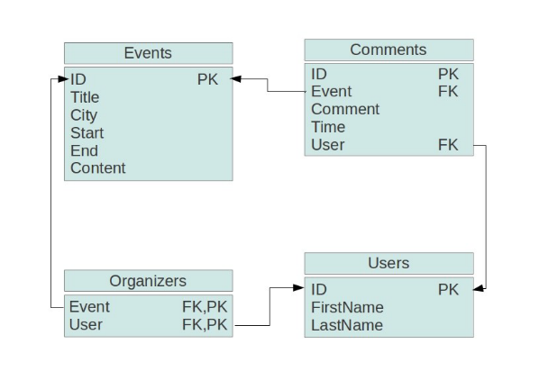
Figure 1.1: The relational database schema[2].

- Remote Invocation
Implement a small client server scenario with the previously developed application being the server. It should be possible to remotely add, remove and manipulate the database entries using a given Data Access Interface (Figure 1.2) and RMI for remote access.
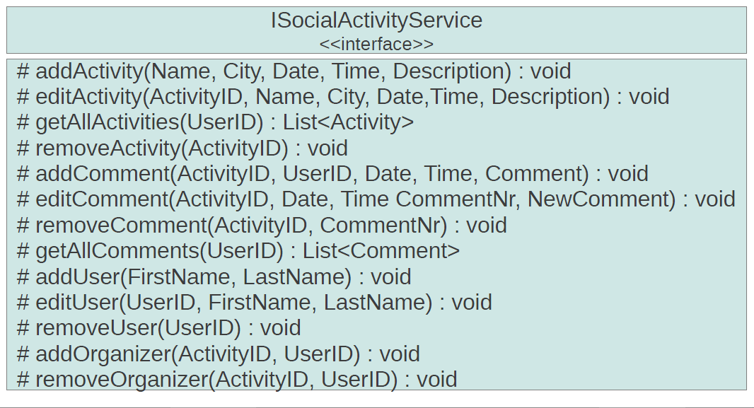
Figure 1.2: The Data Access Interface.

- Web Application Design
Implement a web application consisting of a web site with three pages, following included specifications: one page for listing and letting users search for upcoming events, one page for adding new events, and one page which lists information about a specific user, including a profile image (Figure 1.3). A few more requirements are needed, but are left out here. The web site should be realized with Java Servlets and JSP technology following the model 2 architecture pattern, using Tomcat as the servlet container.
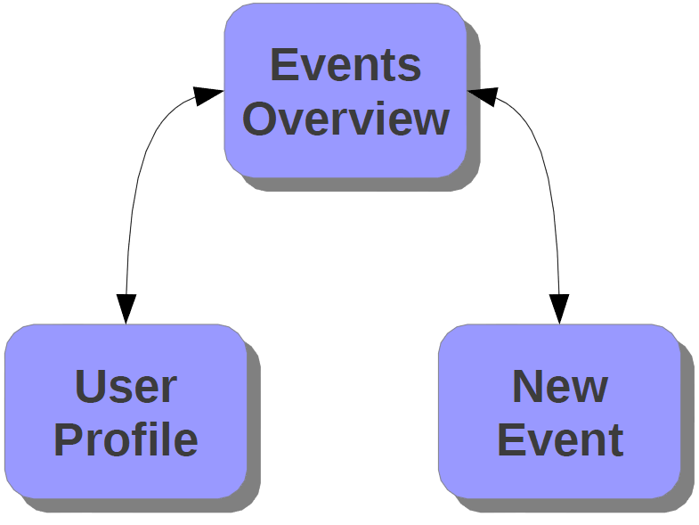
Figure 1.3: The relation of the different pages.
- Shared/Distributed Objects
The application should be migrated to Geronimo, adding a business layer to the application using EJB. The DAO should be managed by EJB through session beans and the persistent business classes through entity beans. Additionally, identify and implement two meaningful services from the application that could be extracted and reused by other more complex services.

- Transactions
Integrate the Google Calendar API into the session beans in a way that guarantees data consistency. All methods have to guarantee that either the update is stored in both the Google Calendar and the Derby database, or not at all. When a user searches for events in a specific town, a Google Calendar with all events in that town should appear in addition to the event list.
- Security
Download the ESAPI library and use it for input validation and output sanitation in ways recommended by provided articles [1]. Implement a new stateless session bean with two methods: one that lets a user provide a new password, and one that authenticates a user given a provided username/password. An exception should be thrown if a user fails to authenticate too many times. The session bean should use encryption of the password with a salt.

Contributions
The application and this project report were done by me.

- Methodology
Object Relational Mapping
The relational schema was simplified to the object model in figure 3.1, using objects and one-to-many and many-to-many relational mappings. For instance, an event can have zero or more comments, but a comment can only be part of one event. Event, Comment and User were therefore made as Java objects, with collections acting as the relational mappings. Event and User were mapped to form an Organizer table through the @JoinTable and @JoinColumn annotations. The Java data types used were: long for IDs, Date objects for start and end times, lists for mapping the relations, and String for the rest.
OpenJPA was configured in a persistence.xml file to automatically create a new database in Derby, connect to it and persist the business data specified as Java objects. Runtime enhancement was used for OpenJPA. The A test program was created to fill the database with test data consisting of four users, two events, and four comments, connected to each other in various ways. This was done using the Java persistence classes EntityManagerFactory/EntityManager/EntityTranscation. The program also fetched the persisted objects from the database and printed them out.
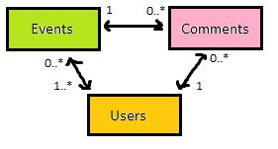
Figure 3.2: The proposed object model.

Remote Invocation
Aside from the server application previously developed, a client application was created, as well as a web server. The Data Access Interface was created according to the specification, and distributed to both the server and client applications. It was later implemented as a DAO called SocialEventService, which is provided an EntityManager upon initialization. It is responsible for handling the persistence of data in every DAO method, such as addEvent, getAllEvents, editUser, and removeOrganizer.
The web server is a simple file server taken from Sun [2], which purpose is to only share the DAO files remotely to the client through a so called codebase. The main program in the server setups a SecurityManager, required by RMI, and adds the SocialEventService to the RMI registry. Configurations such as the location of the codebase and the hostname of the server is specified as runtime parameters. The client main program looks up the SocialEventService in the RMI registry of the server and performs the same test operations as in previous application, with the addition of editing and removing data.
The server, client and web server were finally distributed to three separate computers in order to test the remote invocation.
Web Application Design
Tomcat was setup and a web application was created according to the specifications. Three JSP files were created: EventsOverview, NewEvent, and UserProfile. A Servlet controller was implemented to handle HTTP requests and persist data. On initialization, the Servlet initializes an EntityManager and fills the database with test data, which now consist of one user and three events. In addition, an image file was loaded from disk, converted into a byte array, and applied to the test user. The Servlet and JSP interaction was done through HTTP request parameter names and attributes, sent via forms, such as buttons and text fields. OpenJPA enhancement is now done during build time with ANT instead of during runtime.

EventsOverview receives a list of all events from the Servlet and lists these by their title. When clicking on a title, additional information is enveloped such as start and end times, content, and the organizers. The organizers are clickable and will open up the user profile for that organizer. A search field is located at the top which can be used to filter the event list by searching for a specific city. There is also a New Event button which takes the user to the NewEvent page.
NewEvent receives a list of all users from the Servlet. Any user can add a new event by entering information through text fields and text areas, as well as choosing an organizer for the event from a drop-down menu. There are no restrictions on any inputs, but the specific date format to use is listed as text. When clicking the submit button, the user is taken back to the EventsOverview.
UserProfile receives a user object and lists of all past and future events that the user has or is organizing. These lists are sorted and created by the Servlet. Statistics for the user is then printed out, including: the first and last name, the number of past and future events, and the number of comments. The user profile image is also displayed with the help of a ViewImage Servlet. However, this Servlet creates a fake user and repeats the loading process of the image done in the controller Servlet, as a way of receiving the EntityManager in the controller and fetching the user from the database was not found.
Shared/Distributed Objects
The application was migrated to Geronimo and was now using Derby, Tomcat, OpenJPA, and EJB. The business layer was added through the entity beans and session beans, using Bean-Managed Transactions. The SocialEventService was changed to a stateless session bean, meaning there was no longer any need to inject the EntityManager. This was all done by the EJB container. The problem with the ViewImage not able to interact with the database was therefore solved simply by adding the @EJB annotation to the SocialEventService object. SocialEventService was extended with a method for adding a profile image to a user.

Transactions
A GoogleCalendarService class was implemented as a singleton, which upon initialization logs in to a test Gmail account. It provides methods for adding and removing events to Google Calendars. If there exists no Google Calendar with the specific event city name as its title, a new one is created, and a new event is then added to the calendar. Otherwise it fetches the correct calendar from the Gmail account and uses that one. A Google Calendar is removed if the last event on that calendar is removed.
This service is used by the SocialEventService when adding and removing events. Transactions are handled by the EJB container through UserTransaction objects, with manual begin and commit calls. If any exception is caught when persisting new events to the database, or adding them to the Google Calendar, the database is rolled back and the calendar is removed. However, tests by running the application offline have shown that this does not work as intended. Finally, when the user is searching for a city in the EventsOverview, the controller fetches the corresponding Google Calendar and displays it below the list of events.
Security
ESAPI is used for input validation in all of the intractable text fields. The controller uses the validator for limiting the title, city, and content fields when entering a new event, as well as checking if the correct date format is used when entering start and end dates. It also checks if a positive integer for the user ID is received when entering the UserProfile page. Finally, the EventsOverview encodes the event city parameter received for URL. These were all tested by manual inputs.
A UserSecretService was created, containing the two methods listed in the specifications. resetSecret creates a new password for the user, using a 64 bits salt and the SHA-1 encryption algorithm. The username, encrypted password, and encrypted salt are all stored in the class for testing purposes. checkSecret tries to authenticate a user. If the wrong password was entered more than three times, a TooManyFailedTriesException was thrown. The amount of failed tries for each user is stored in a dictionary. If the authentication was successful, true is returned. Testing of the service was done by calling the methods test data, to see if the password and salt were encrypted correctly and that the authentication worked as it should.
- Results
A lot of knowledge was gained through developing the distributed application, and the application itself works as intended – to provide users with a service for looking up past and future events situated in different towns.
The application frontend is a web site which lists all events, information about them, a search field for filtering events by city, the ability to go to an organizer’s user profile, and a button which takes the user a page for creating new events. There is also a Google Calendar displayed when searching for a city, listing all the events in that city.
A new event can be made by any user, and input validation is used to restrict user input when entering information about the new event. A drop-down menu with all users is in place to be sure an organizer is picked.
Users can check out other user’s profiles, where they find information such as first and last name, amount of comments, past and future events held by this user, and the user’s profile image.
The application fails to synchronize the local database with the Google Calendar database. It does not fetch all events from the database; instead it uses fresh test data accessed from a local list. The listing of the events does not happen immediately, the page has to be updated once for the controller Servlet to initialize and fill the database.
- Conclusions / Discussion
The overall aim of the project was met. The primary goal was to learn about enterprise development after all. There were a lot of problems encountered during the development, and many, many hours went into error handling, debugging, and configuring the application. However, in the end, I am happy about the results.
The problems described in the results section could probably easily be solved. For the synchronization, I was doing it in the way described in an article by Sun, so I’m pretty confused and frustrated to why it’s not working. Whether the application was supposed to fetch all events from the database or not was actually not in the specifications, so I’m thinking it was okay to use a local list. This is because there was simply no method for doing this in the SocialEventService interface.
Fetching all events from the database would not be so hard if it wasn’t for OpenJPA’s illogical but apparently effective ordering of the IDs (insert a user and an event into the database - the user will have an ID of 1, while the event will have an ID of 51). However, this is supposedly easy to fix by turning on sequential ordering of IDs in the persistence.xml, and perform a select all query on the event table and go from there.
I’m happy to say that the quality of the course has been extremely high. It has definitely been one of the most difficult and time consuming courses I’ve ever read, but at the same time also one of the most giving. Not only in terms of enterprise development, but in the fact that no matter how many errors and problems you face when developing something you’re not completely familiar with, there are always solutions. It just takes time and tolerance to overcome. The Internet really is indefinitely powerful and there’s so much knowledge through not only the search engines, but also from all the developers that have done and are doing the same thing as you are.

Given it’s an online course, Felix has done a great job of always being accessible to other students, and actively discussing and answering questions in the forum and by e-mails. During this same period as I took this course, I did also take other online courses. The quality of these courses and this one is like night and day. I was really frustrated by how the teachers in the other courses would not even visit the forums or answer e-mails, especially since it’s an online course. I thought online courses simply could not hold as high standards as normal courses do, but this course proved me wrong and I honestly wish every teacher was like Felix.
The final application is definitely not useful for the public in its current state, but I believe with some work it would not be hard to turn it into a fully functional enterprise application. Things like registering to the site, logging in, uploading profile image and so on would be the next things to deal with. Anyway, I’m now interested in developing a similar system in .NET and will try to do so in the near future.

References
- Sun, ”ClassFileServer”,
http://www.cs.umd.edu/class/fall2004/cmsc433/projects/p5/part2/ClassFileServer.java
Published 1996. Retreived 2012-02-01.

- OWASP, ”XSS (Cross Site Scripting) Prevention Cheat Sheet”,
https://www.owasp.org/index.php/XSS_%28Cross_Site_Scripting%29_Prevention_Cheat_Sheet
Published 2012-01-02. Retreived 2012-02-01.

Appendix A: User manual
- Create a database named mydb in Geronimo.
- Create a new Database Pool named AccountDS with user/password admindb/manager and connect it to mydb.
- Place the ESAPI folder in your classpath.
- Deploy the EAR file and enter http://localhost:8080/Assignment6EAR.

