SCREENSHOTS
Ply models used : apple.ply and trashcan.ply.
Three light sources used: point source, directed light and a spotlight as headlight.
Intermediate maps used : Spherical Maps for apple
Cylindrical Maps for trashcan

The models are bounded in a wooden room and are placed on the floor.
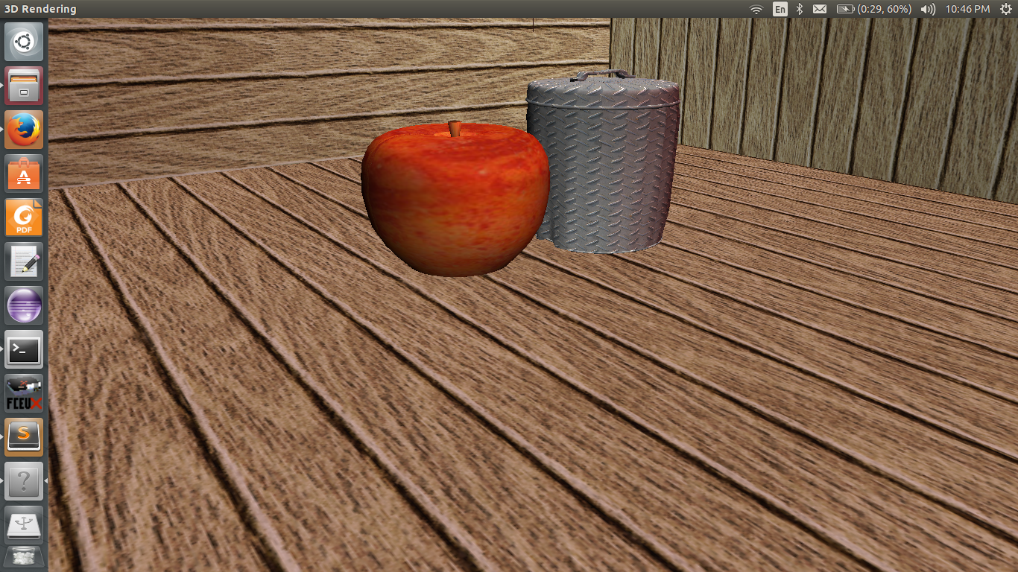
Fig 1: All three light sources present

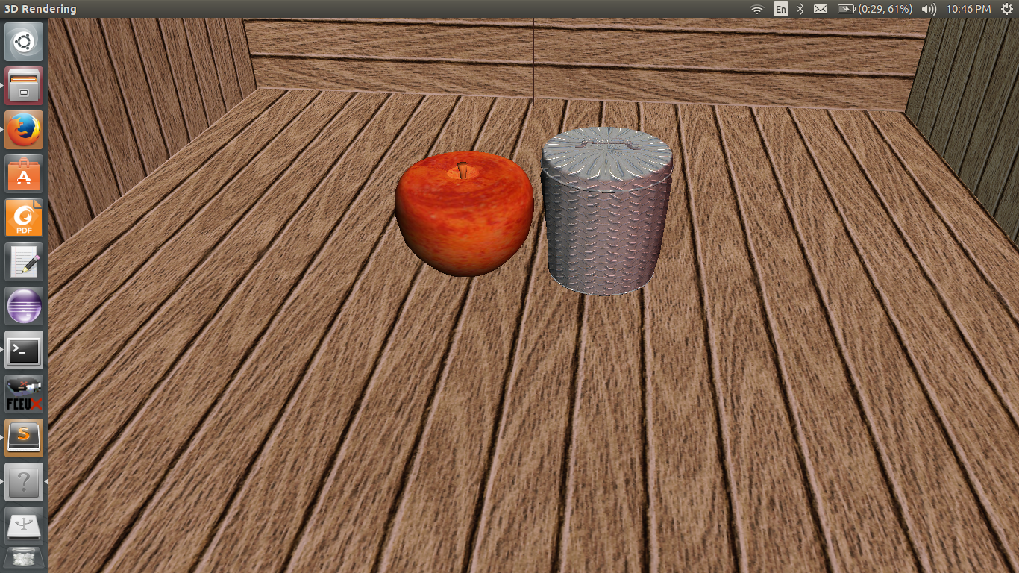
Fig 2: Moved the camera using mouse motion

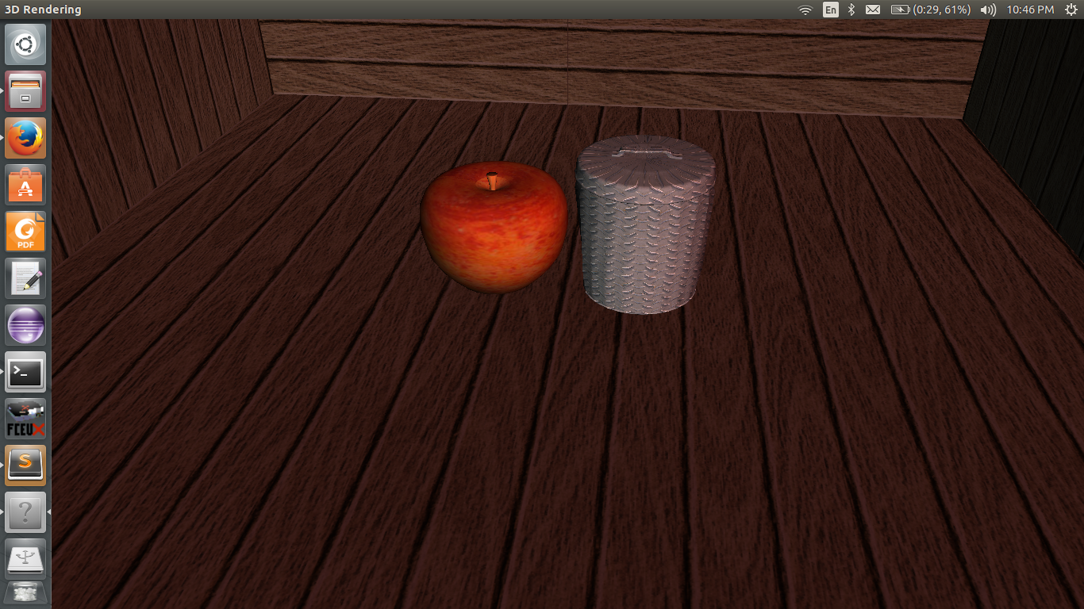
Fig 3: Point light source turned OFF

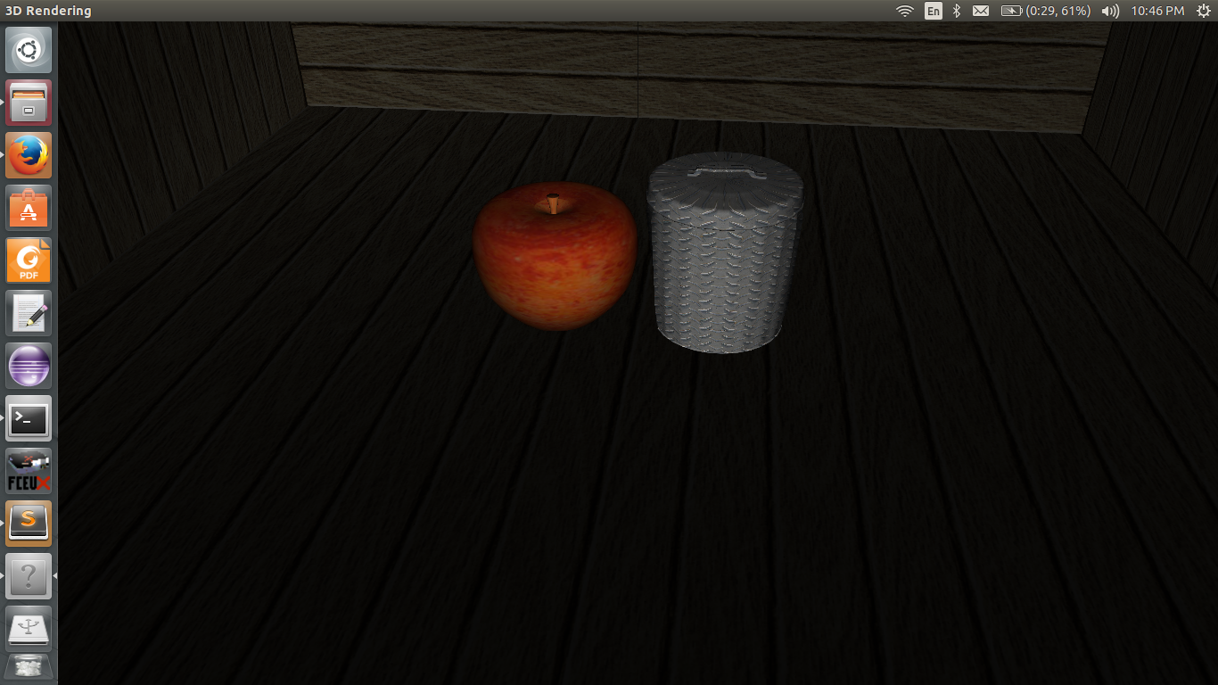
Fig 4: Both point source and directed light sources OFF.
Only headlight ON.

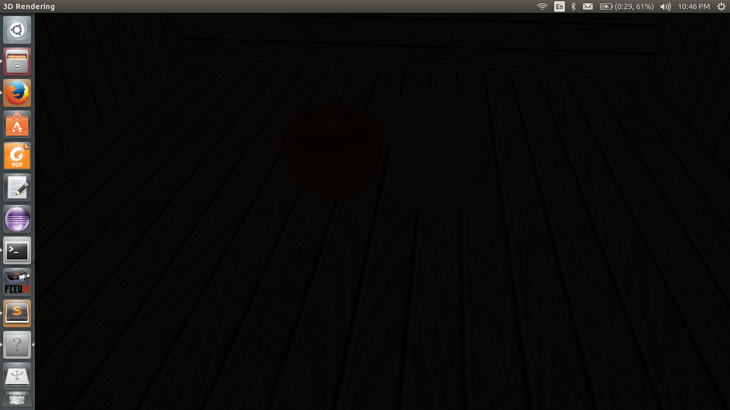
Fig 5: All lights turned OFF.

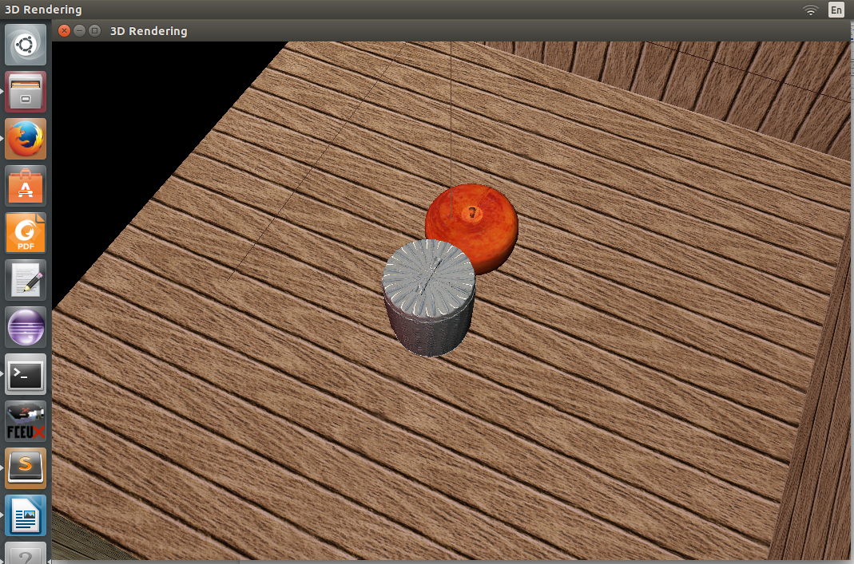
Fig 6: Altered camera position using arrow keys

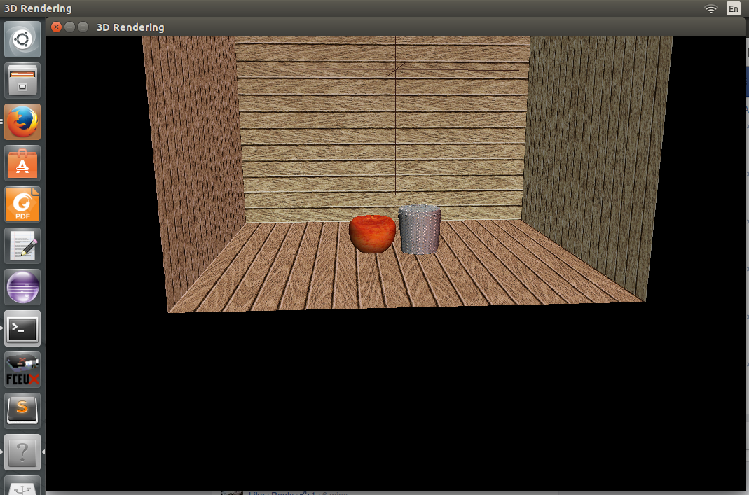
Fig 7: A distant view of the scene.

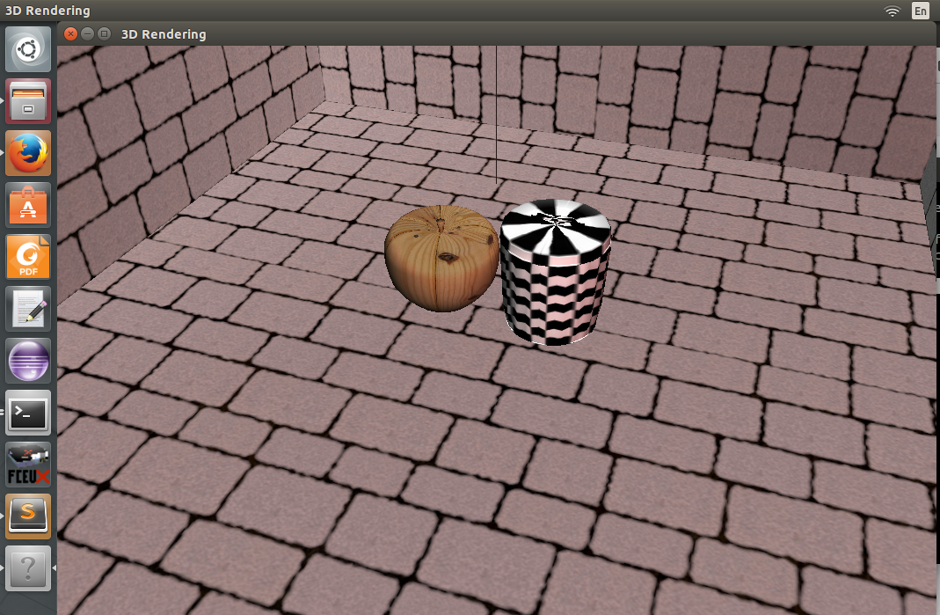
Fig 8: Dynamically changed textures using stencil buffer

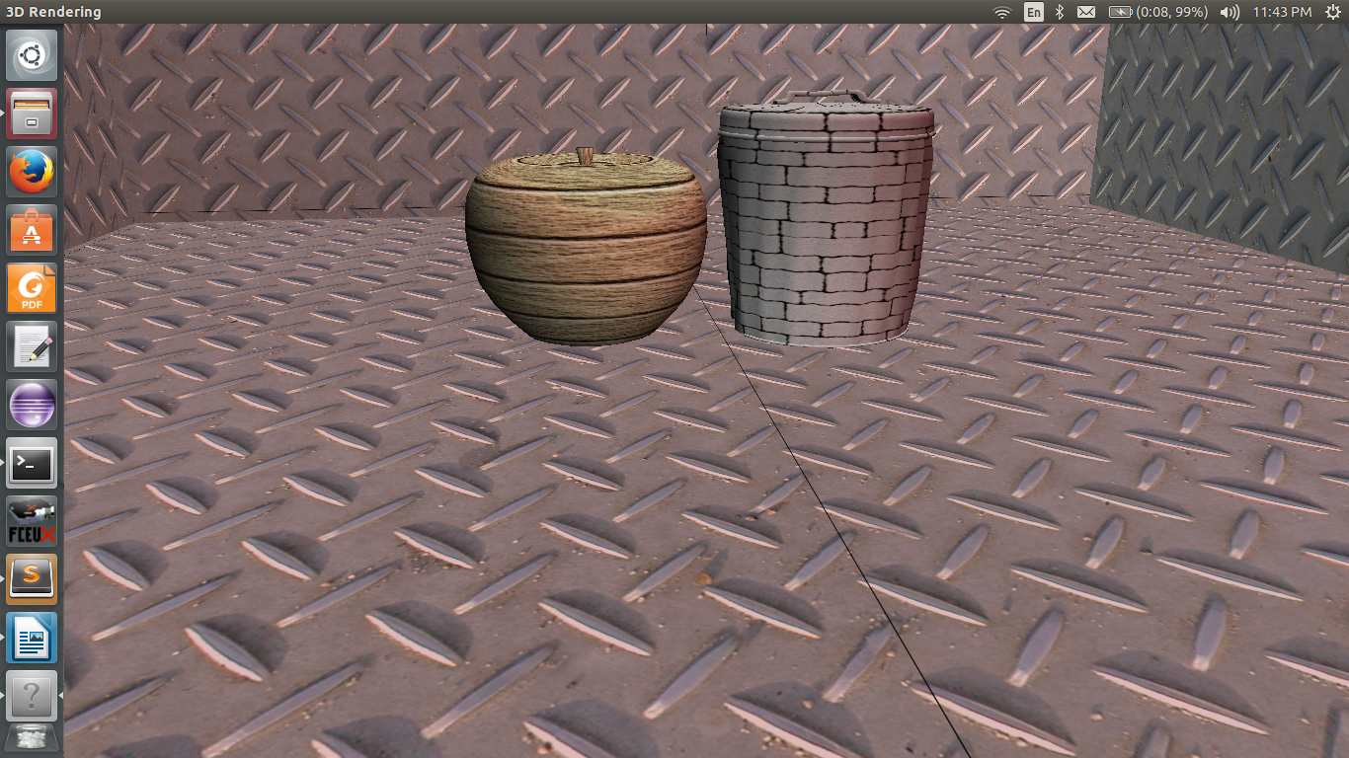
Fig 9: Dynamic texturing

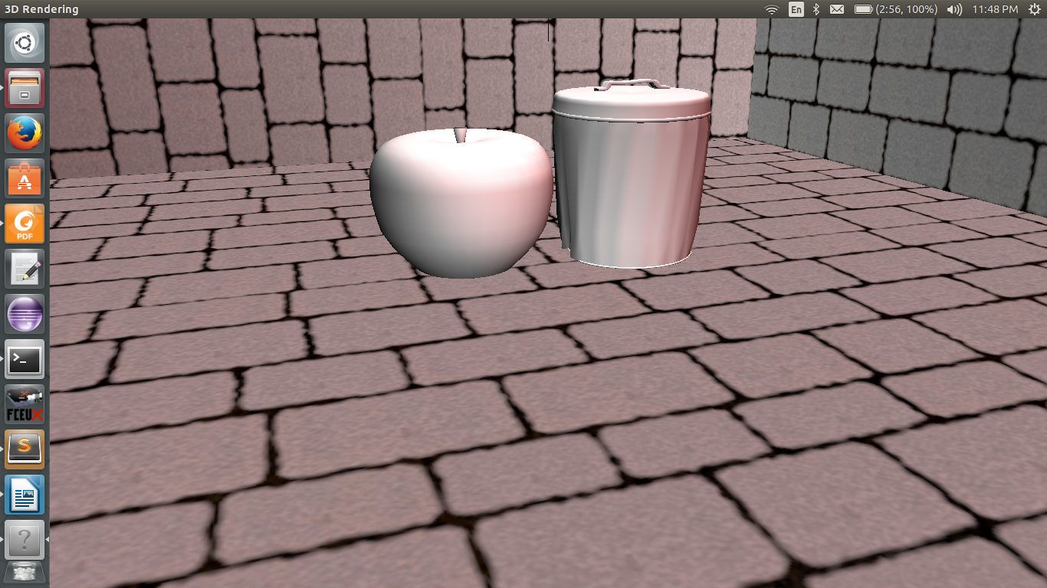
Fig 10: No texture used for models

